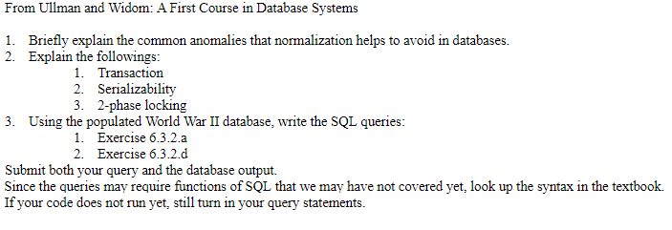  
**1. Briefly explain the common anomalies that normalization helps to avoid in databases.**  
  
The three major types of anomalies that we may encounter are *Redundancy, Update Anomalies, and Deletion Anomalies.*

**Redundancy:** Information may be repeated unnecessarily in several tuples.  
**Update:** We may change information in one tuple and leave the same information unchanged in another tuple.  
**Deletion**: If a set of values becomes empty, we may lose other information as a side effect.

**2. Explain the following:**

**a) Transaction**: A process involving database queries and or modifications. Independently executed, and normally utilizes some strong properties regarding concurrency (ACID).

**b) Serializability:** Grouping similar transactions, or transactions working on the same data, and running them one at a time with no overlap to ensure no errors occur.

**c) 2-phase locking:** Concurrency control method that guarantees serializability. Consists of an expanding phase (or growing phase) in which all locks are acquired an no locks are released, followed by a shrinking phase in which all locks are released one by one.

3. Using the WWII database, write the following SQL queries:

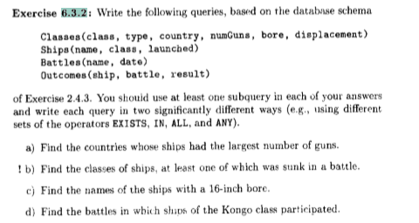

1. **6.3.2.a : Find the countries whose ships had the largest number of guns.**

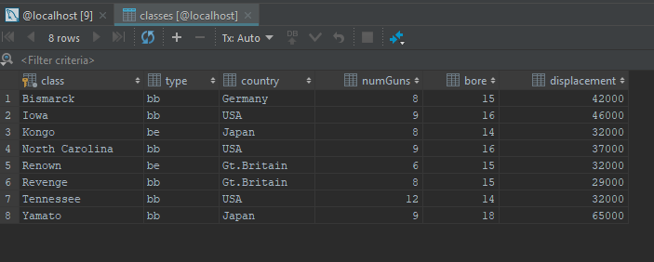

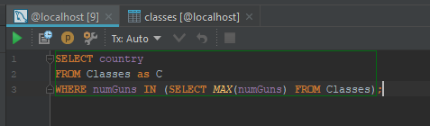

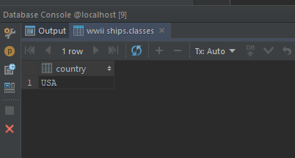

1. **6.3.2.d : Find the battles in which the ships of the Kongo class participated.**

