

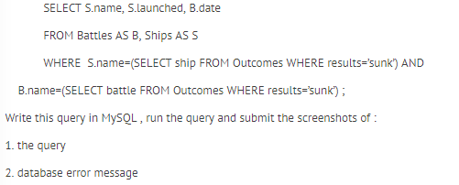

This is just the data from the datagrip tables.

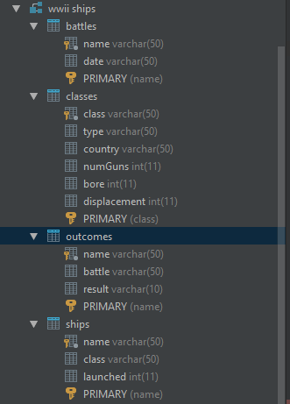

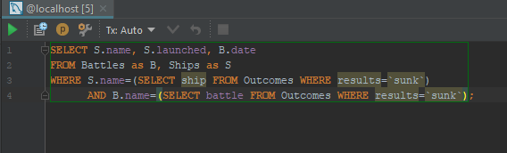

One problem here is that in the homework, Outcomes.ship is actually called Outcomes.name. So we get this error, which is fixed in the next query.

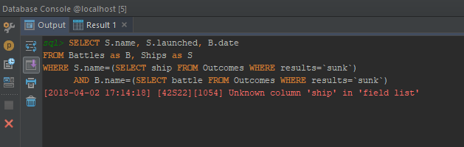

This is the correct (wrong) query with the name correct.

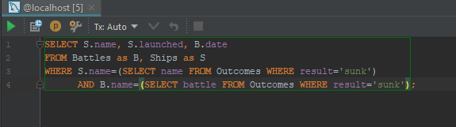

And this is the result from the (wrong) query.  
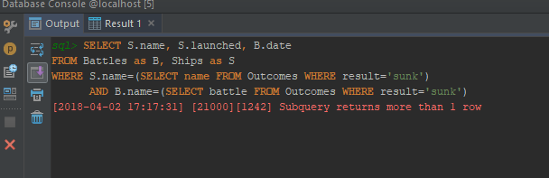

This is the corrected query.  
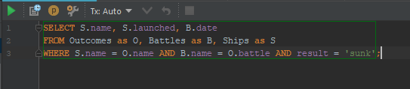

And the result of the corrected query.

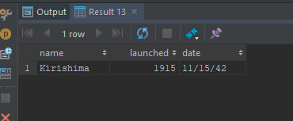

This is the data from the outcomes table. Looking at this data only, we should get information for :  
  
Arizona, Bismarck, Fuso, Hood, Kirishima, Schanrhorst, Yamashiro were all ‘sunk’.

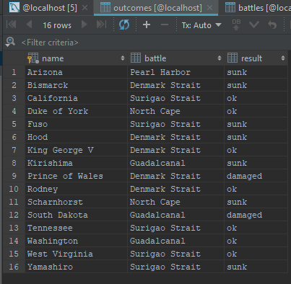

However, we only have the dates for Denmark Strait, Guadalcanal, North Cape, and Surigao Strait battles. So, this will have our list be smaller…

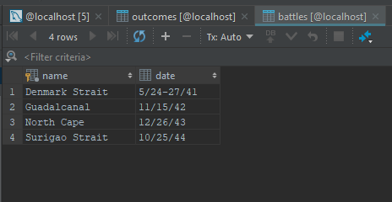

And smaller still since we don’t have launched dates for some of the ships…

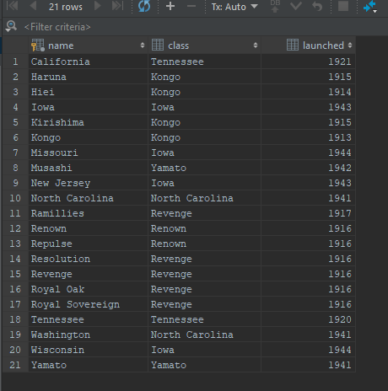

Therefore,  should be the correct query.