Q1: 15 points

List three popular mobile apps and explain why they are so popular

a)

b)

c)

Q2: 10 points .

1. Describe **three** advantages of Hybrid Apps.
2. Give two example application areas that Hybrid Apps are suitable for

Q3: 20 points

Given the following form input for a phone number, implement the following function using jquery keydown/keyup function.

1. When user start typing, turn the background of the input entry to yellow.
2. When user typed an invalid character (non-digit and -), turn the background to red, and delete that invalid character.

Enter your name: <input type="text" id="phone">

Q4: 15 points

Write the HTML/CSS code to implement three buttons on the same row, each occupying 1/3 of the screen width and the text of the button sit in the middle of the button.

|  |  |  |
| --- | --- | --- |
| New | Save | Delete |

Q5: 15 points CSS

Use HTML and CSS to define the following search result view. Search box must be centered with 80% width of screen. You can assume images to be pic1/2/3/4.png. The Tabs can be implemented with two separate overlapping divs with two buttons on top. When Gifts clicked, show one div. When Guides button clicked, hide first div and show another div.

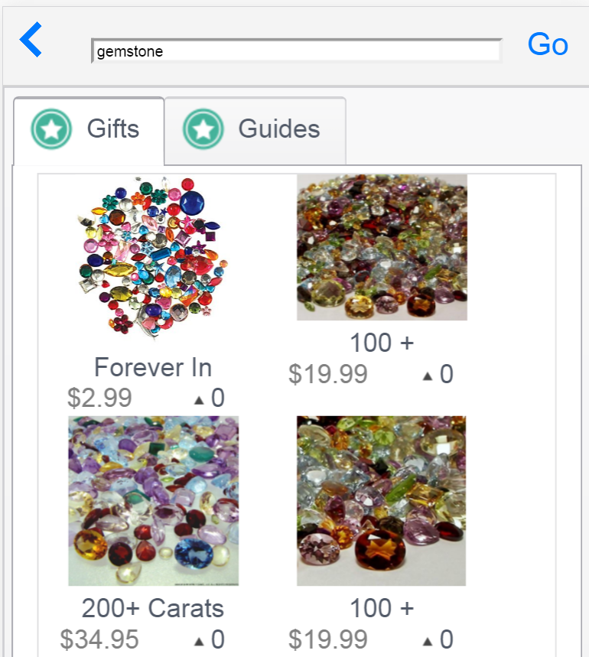

Q6:15 points

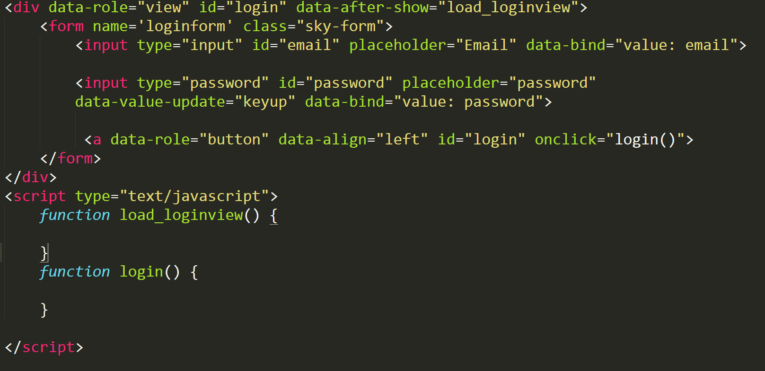

The above code implements a Kendo login view. Your task is to add the following functionality by implementing the load_loginview() and login() functions. 1) when the login is called after user type email and password, save the information to localStorage 2). When the form is loaded, fill the email and password fields with value from localStorage if available. This function allows users to save their passwords to their phone without future typing again.

Q7: 10 points

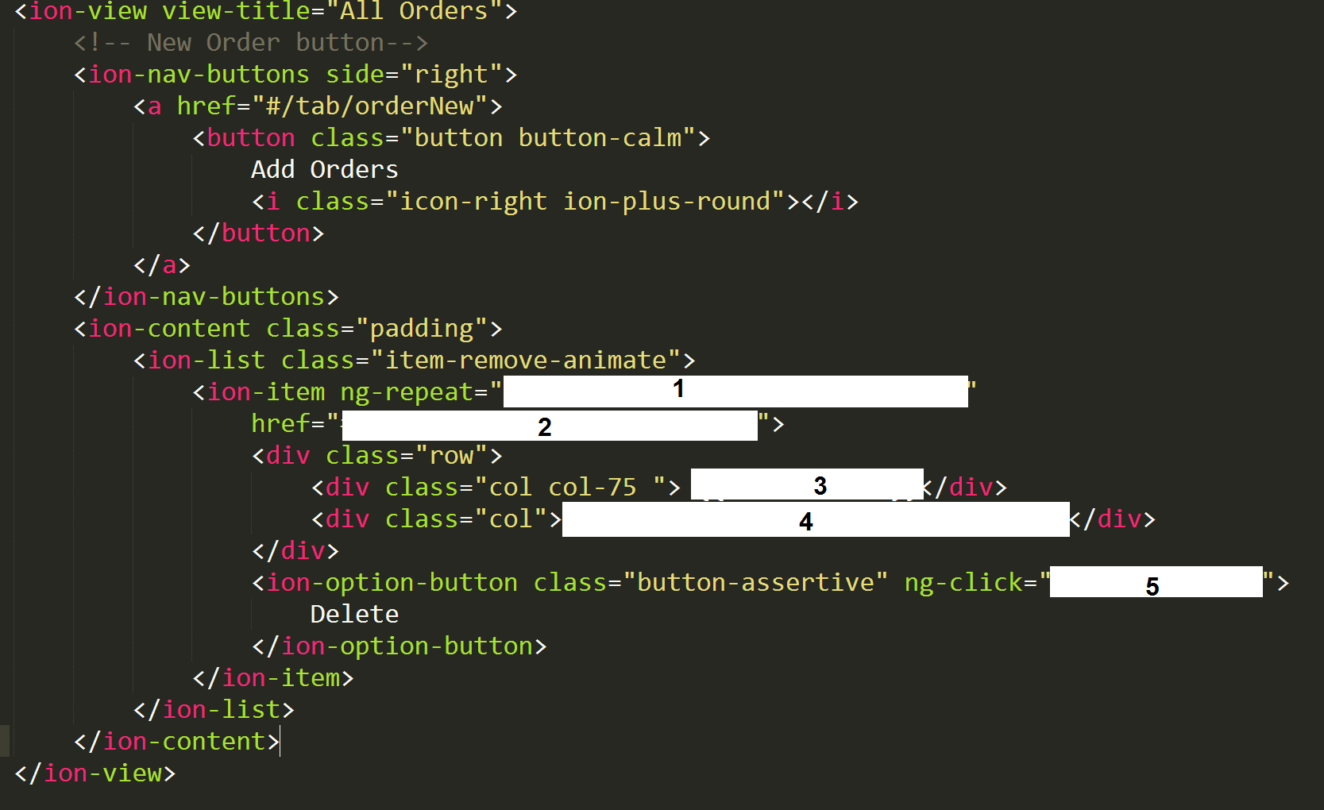

This is an ionic template file that shows a list of orders with an add order button on top right.

The Order object has fields of name, date, id. Fill the empty spaces with statements so that it can show a list of orders (assume orders is the array that passed from controller), when clicked, it goes to a detail page (whose url is /tab/order/id), and when slided, it will disclose a delete button, which can call a remove($index) function in the controller to remove the order at index position of the list.

1)

2)

3)

4)

5)