STAT 509 SECTION E01 HOMEWORK 5

DUE APRIL 12

Instruction: Please attach your R code and output

1. The deflection temperature under load for two different types of plastic pipe is being investigated. Two random samples of 15 pipe specimens are tested, and the deflection temperatures observed are as follows (in Fahrenheit ):

Type 1: 206, 188, 205, 187, 194, 193, 207, 185, 189, 213, 192, 210, 194, 178, 205

Type 2: 353, 393, 411, 401, 359, 351, 369, 399, 393, 383, 395, 375, 377, 405, 383

1. Construct box plots and normal probability plots for the two samples. Do these plots provide support of the assumptions of normality and equal variances? Write a practical interpretation for these plots.

> Type1 = c(206, 188, 205, 187, 194, 193, 207, 185, 189, 213, 192, 210, 194, 178, 205)

> Type2 = c(353, 393, 411, 401, 359, 351, 369, 399, 393, 383, 395, 375, 377, 405, 383)

> boxplot(Type1, Type2, xlab="", names=c("Type 1", "Type 2"),ylab="Deflection Temperatures (in Farenheit)",ylim=c(0,450),col="grey")

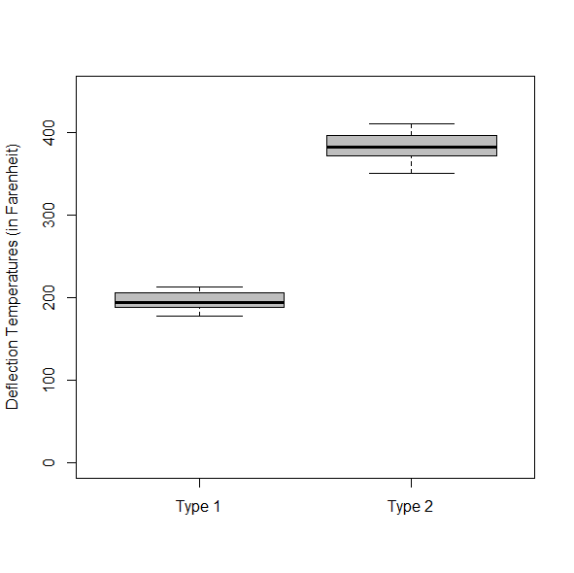

qqnorm(Type1); qqline(Type1, col = 2)

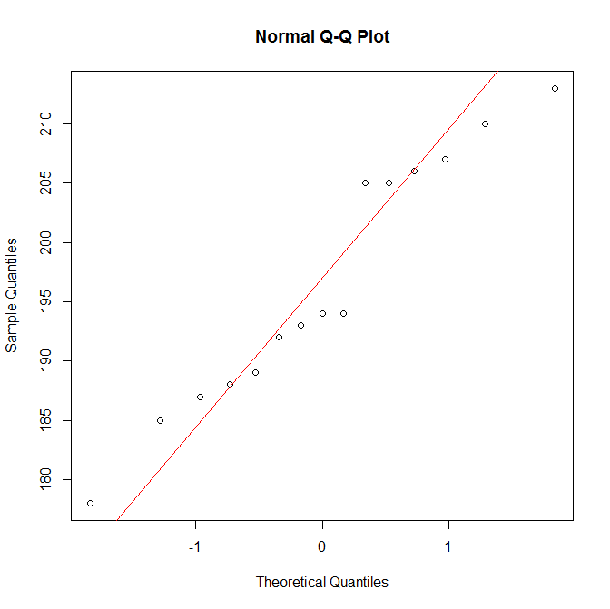

qqnorm(Type2); qqline(Type2, col = 2)

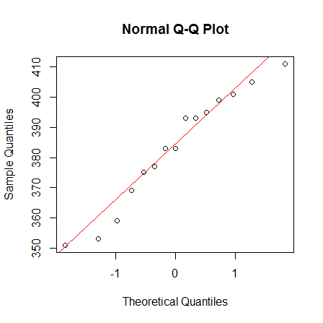

Yes, there do not seem to be many outliers on the QQ plot and the box plots are relatively compact.

1. Do the data support the claim that the mean deflection temperature under load for type 2 pipe exceeds that of type 1? Use α = 0.05. Do the analysis in R.

> t.test(Type1,Type2)

Welch Two Sample t-test

data: Type1 and Type2

t = -33.499, df = 21.883, p-value < 2.2e-16

alternative hypothesis: true difference in means is not equal to 0

95 percent confidence interval:

-198.2974 -175.1693

sample estimates:

mean of x mean of y

196.4000 383.1333

Mean of Type2 > Mean Type1 is true.

1. According to research published in Science (Feb 20, 2004), the mere belief that you are receiving an effective treatment for pain can reduce the pain you actually feel. Researchers tested the placebo effect on 24 volunteers. Each volunteer was put inside an MRI for two consecutive sessions. During the first session electric shocks were applied to their arms and the blood oxygen level-dependent (BOLD) signal (a measure related to neural activity in the brain) was recorded during pain. The second session was identical to the first, except that prior to applying the electric shocks the researchers smeared a cream on the volunteer’s arms. The volunteers were informed that the cream would block the pain, when, in fact, it was just a regular skin lotion (ie, placebo).If the placebo is effective in reducing pain, the BOLD measurements should be higher on average, in the first MRI session then in the second MRI session. Calculate differences by subtracting second MRI measurement from first MRI measurement.
2. Let µD = µ1 − µ2, where µ1 is the population mean bold measurements without placebo, and µ1 is the population mean bold measurements with placebo. State the null and alternative hypotheses.

H0: µ1 − µ2 > 0 H1: = µ1 − µ2 >|=0

1. The differences between the first BOLD measurements and the second were computed and the summarized results is as follows:

Variable n y(BAR)D sD

size 24 0.21 0.47

Calculate the test statistic.

Zd = Y(Bar) / (sqrt ( (sd^2 / n ) + (sd^2 / n ) )

Zd = 0.21 / sqrt ( (0.47/24) + (0.47/24) )

Zd = 1.0611

1. Calculate the p-value.

> pnorm(1.0611, mean = 0.21, sd = 0.47)

P ( Z > Zd ) = P ( Z > 1.0611) = 1 – ф(1.0611) = 0.964918

1. State your conclusion.

Do not reject

1. Data on pH for 16 random batches of low and high volt electrolyte were collected. The data are given by

Low volt: 7.78 5.77 7.08 6.75 7.09 8.27 6.5 5.16 6.81 7.28 7.88 7.87 7.2 5.95 6.58 6.99

high volt: 4.54 5.04 5.07 6.18 8.62 6.28 7.41 6.17 6.25 4.25 6.08 7.23 4.68 6.19 5.85 5.83

1. ) Use boxplot(sample1,sample2) to draw the side-by-side boxplot, where sample1 and sample2 are the names of the data vector your give in R. Do you think it is reasonable to assume σ 2 1 = σ 2 2 based on the plot?

> LowVolt = c(7.78, 5.77, 7.08, 6.75, 7.09, 8.27, 6.5, 5.16, 6.81, 7.28, 7.88, 7.87, 7.2, 5.95, 6.58, 6.99)

> HighVolt = c(4.54, 5.04, 5.07, 6.18, 8.62, 6.28, 7.41, 6.17, 6.25, 4.25, 6.08, 7.23, 4.68, 6.19, 5.85, 5.83)

> boxplot(LowVolt, HighVolt, xlab="", names=c("Low Volt", "High Volt"),ylab="Electroylte volt levels",ylim=c(0,9),col="grey")

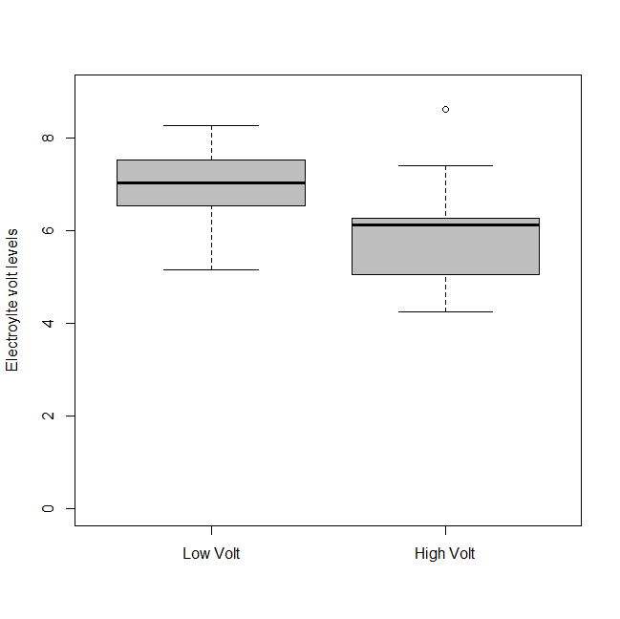

No, there seems to be a difference in the number so that σ 2 1 = σ 2 2 is not true based on the box plot

1. ) In R, command var.test(sample1, sample2) can be used to test equal variance assumption, where sample1 and sample2 are the names of the data vector your give in R. Compare the R output with your calculation in part (a).

> var.test(LowVolt, HighVolt)

F test to compare two variances

data: LowVolt and HighVolt

F = 0.53381, num df = 15, denom df = 15, p-value = 0.2356

alternative hypothesis: true ratio of variances is not equal to 1

95 percent confidence interval:

0.1865103 1.5278126

sample estimates:

ratio of variances

0.5338097

1. The engineer want to test that the low volt average pH is greater than the high volt average pH. Let µL be the average pH of low volt electrolyte and µH be the average pH of high volt electrolyte. State the null and alternative hypotheses.

H0: µL > µH H1: µL < µH

1. Calculate the appropriate test statistic for the test.

t.test(LowVolt,HighVolt,conf.level=0.95,var.equal=FALSE,alternative="greater")

Welch Two Sample t-test

data: LowVolt and HighVolt

t = 2.7155, df = 27.463, p-value = 0.005653

alternative hypothesis: true difference in means is greater than 0

95 percent confidence interval:

0.35658 Inf

sample estimates:

mean of x mean of y

6.935000 5.979375

1. Use R to calculate the p-value of the test

p-value = 0.005653

1. State your conclusion at a 0.05 level of significance.

p-value = 0.005653 < 0.05; Reject H0

1. 4. A programmable lighting control system is being designed. The purpose of the system is to reduce electricity consumption costs in buildings. The system eventually will entail the use of a large number of transceivers (a device comprised of both a transmitter and a receiver). Two types of transceivers are being considered. In life testing, 200 transceivers (randomly selected) were tested for each type. Transceiver 1: 20 failures were observed (out of 200) Transceiver 2: 14 failures were observed (out of 200). The engineers want to test for the equality of the proportions. Define p1 (p2) to be the population proportion of Transceiver 1 (Transceiver 2) failures.
2. State the null and alternative hypotheses.

H0: p1 – p2 = 0 H1: p1 – p2 ≠ 0

1. Calculate the test statistic to 4 decimal places.

ṕ1 = Y1 / N1 = 20 / 200 = 0.1

ṕ2= Y2 / N2 = 14 / 200 = 0.07

z = (ṕ1 - ṕ2) – ( p1 – p2 ) / sqrt [ (ṕ1 ( 1 – ṕ1) / n1 ) + (ṕ2 (1 - ṕ2 ) ]

z = ( 0.1 – 0.07 ) – 0 / sqrt [ 0.1 ( 0.9 ) + 0.07 ( 0.93) ]

z = 0.0761755074

1. Given α = 0.05, what is the critical value(s) of the test statistic?

ṕ1 - ṕ2 +- Z α/2 sqrt [[ (ṕ1 ( 1 – ṕ1) / n1 ) + (ṕ2 (1 - ṕ2 ) ]

* 1. – 0.07 +- 1.960 \* 0.3938273734

.03 +- 0.7719016518

(-0.7419016518 , 0.8019016518)

1. What is your conclusion at α = 0.05?
2. Use prop.test in R to check your work.

prop.test(c(20,24),c(200,200),correct=F)

2-sample test for equality of proportions without continuity correction

data: c(20, 24) out of c(200, 200)

X-squared = 0.40858, df = 1, p-value = 0.5227

alternative hypothesis: two.sided

95 percent confidence interval:

-0.08129394 0.04129394

sample estimates:

prop 1 prop 2

0.10 0.12