**DBMS (CS-232-Lab) Project Readme**

**First:**

Make a user on application express by the name of fitnessapp and password must be 123.

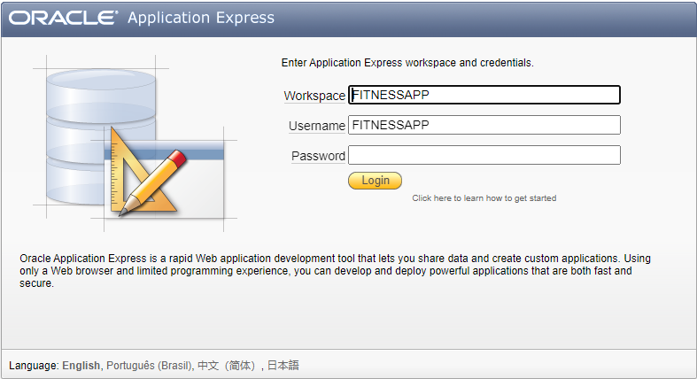

**Second:**

Run the following scripts once your database is established.

1:

create table userr  
  (  
    id varchar2(30) primary key,  
    name varchar2(30) not null,  
    pass varchar2(30) not null,  
    age number(3),  
    weight number(3),  
    address varchar2(100),  
    email varchar2(30) unique,  
    phonenumber number,  
    foodpreference varchar2(30)  
  );

**2:**

create table trainer(  
id varchar2(30) primary key,  
name varchar2(50),  
pass varchar2(30) not null,  
age number(3),  
address varchar2(100),  
email varchar2(30) unique,  
phonenumber number(30),  
hiredate date,  
monthlysalary number  
);

**3:**

create table user_trainer(  
userrid  varchar2(30),  
trainerid varchar2(30),  
constraint userid_fk foreign key(userrid) references userr(ID),  
constraint trainerid_fk foreign key(trainerid) references trainer(id)  
);

**4:**

create or replace trigger update_table  
    after insert on userr  
    for each row  
    when (new.id is not null)  
    declare  
    temp trainer.id%type;  
    cursor c_trainerid is select id from trainer sample(50);  
    begin  
    open c_trainerid;  
    fetch c_trainerid into temp;  
    insert into user_trainer (userrid,trainerid) values(:new.id,temp);  
    close c_trainerid;  
    end;  
/

**5:**

insert into trainer values('john1','john','123',20,'abc,def','abc1@xyz.com',11111111,'02/02/2020',20000);  
insert into trainer values('victor2','victor','123',21,'abc,def1','abc2@xyz.com',11111112,'02/02/2020',20000);  
insert into trainer values('kate3','kate','123',22,'abc,def2','abc3@xyz.com',11111113,'02/02/2020',20000);  
insert into trainer values('emily3','emily','123',23,'abc,def3','abc4@xyz.com',11111114,'02/02/2020',20000);  
insert into trainer values('mona4','mona','123',24,'abc,def4','abc5@xyz.com',11111115,'02/02/2020',20000);  
insert into trainer values('william5','william','123',25,'abc,def5','abc6@xyz.com',11111116,'02/02/2020',20000);  
insert into trainer values('calvin6','calvin','123',26,'abc,def6','abc7@xyz.com',11111117,'02/02/2020',20000);  
insert into trainer values('sara7','sara','123',27,'abc,def7','abc8@xyz.com',11111118,'02/02/2020',20000);  
insert into trainer values('philip8','philip','123',28,'abc,def8','abc9@xyz.com',11111119,'02/02/2020',20000);  
insert into trainer values('patrick9','patrick','123',29,'abc,def9','abc10@xyz.com',111111110,'02/02/2020',20000);  
insert into trainer values('rayan10','rayan','123',30,'abc,def10','abc11@xyz.com',111111111,'02/02/2020',20000);  
insert into trainer values('sam11','sam','123',31,'abc,def11','abc12@xyz.com',111111112,'02/02/2020',20000);  
insert into trainer values('tom12','tom','123',32,'abc,def12','abc13@xyz.com',111111113,'02/02/2020',20000);  
insert into trainer values('peter13','peter','123',33,'abc,def13','abc14@xyz.com',111111114,'02/02/2020',20000);  
insert into trainer values('marry14','marry','123',34,'abc,def14','abc15@xyz.com',111111115,'02/02/2020',20000);

**6:**

create table workout(  
day varchar2(50),  
exr1 varchar2(50),  
exr2 varchar2(50),  
exr3 varchar2(50),  
exr4 varchar2(50),  
exr1tut varchar2(100),  
exr2tut varchar2(100),  
exr3tut varchar2(100),  
exr4tut varchar2(100)  
);

**7:**

insert all  
  
 into workout values ('monday','Do 10 pullups','Do 10 pushups','Squat 10 times','Deadlift 50kg, 10 times','https://www.youtube.com/watch?v=Qxx0EE4evyI','https://www.youtube.com/watch?v=VQKqjHtY8jA','https://www.youtube.com/watch?v=E_bN4wT0ybg','https://www.youtube.com/watch?v=ytGaGIn3SjE')  
 into workout values ('tuesday','Benchpress 20 times','Do 30 bicep curls','Do 15 crunches','Do 100 situps','https://www.youtube.com/watch?v=SCVCLChPQFY','https://www.youtube.com/watch?v=ykJmrZ5v0Oo','https://www.youtube.com/watch?v=5ER5Of4MOPI','https://www.youtube.com/watch?v=hNoqupytA8g')  
 into workout values ('wednesday','Shadowbox 25 times','Do 20 planks','Do 55 jumping jacks','Do 10 burpees','https://www.youtube.com/watch?v=br8VDXWr0_8','https://www.youtube.com/watch?v=Z90xpWvuUPs','https://www.youtube.com/watch?v=iSSAk4XCsRA','https://www.youtube.com/watch?v=qLBImHhCXSw')  
 into workout values ('thursday','Do 30 bridges','Do 40 dips','Do 100 dumbell rows','Do 15 split squats','https://www.youtube.com/watch?v=d7IRDv8cvYw','https://www.youtube.com/watch?v=6kALZikXxLc','https://www.youtube.com/watch?v=-koP10y1qZI','https://www.youtube.com/watch?v=9Sk__yZ2DQY')  
 into workout values ('friday','Leg press 20 times','Do 30 triceps extensions','Wall stand 30 times','Mew 150 times','https://www.youtube.com/watch?v=IZxyjW7MPJQ','https://www.youtube.com/watch?v=1-mMN7tCYLQ','https://www.youtube.com/watch?v=cjx7SREOtz4','https://www.youtube.com/watch?v=Om3o9NXrITE')  
 into workout values ('saturday','Do 10 pushups','Deadlift 50kg','Do 30 bicep curls','Do 50 situps','https://www.youtube.com/watch?v=VQKqjHtY8jA','https://www.youtube.com/watch?v=ytGaGIn3SjE','https://www.youtube.com/watch?v=ykJmrZ5v0Oo','https://www.youtube.com/watch?v=hNoqupytA8g')  
 into workout values ('sunday','Do 25 planks','Do 20 burpees','Do 41 dips','Do 20 split squats','https://www.youtube.com/watch?v=Z90xpWvuUPs','https://www.youtube.com/watch?v=Z90xpWvuUPs','https://www.youtube.com/watch?v=6kALZikXxLc','https://www.youtube.com/watch?v=9Sk__yZ2DQY')  
  
  
 select * from dual;

**8:**

create table Diet  
(diet_type varchar2(50),  
 item1 varchar2(50),  
 item2 varchar2(50),  
 item3 varchar2(50),  
 meal_type varchar2(50)  
);

**9:**

insert all  
      
into Diet values ('keto','seafood','meat','eggs','breakfast')  
      
into Diet values ('keto','dairy','cheese','cream','lunch')  
      
into Diet values ('keto','vegies','nuts','berries','dinner')  
      
      
into Diet values ('vegetarian','soup','maple','avacado','breakfast')  
      
into Diet values ('vegetarian','potaoes','cheese','spring_salad','lunch')  
      
into Diet values ('vegetarian','green_curry','salad','goat_cheese','dinner')  
      
      
into Diet values ('pescatarian','lemon_shrimp','tuna','pasta','breakfast')  
      
into Diet values ('pescatarian','grilled_shrimp','catfish','fish_n_chips','lunch')  
      
into Diet values ('pescatarian','Asparagus_n_shrimp','salmon','chicken','dinner')  
      
      
into Diet values ('buff','eggs','olive_oil','fruits','breakfast')  
      
into Diet values ('buff','red_meat','cheese','nuts','lunch')  
      
into Diet values ('buff','fish','beans','yoghurt','dinner')  
      
      
into Diet values ('lean','egg_whites','oatmeal','veggies','breakfast')  
      
into Diet values ('lean','salad','chicken','strawberries','lunch')  
      
into Diet values ('lean','brown_rice','lean_steak','brocolli','dinner')  
      
Select * from dual;

**10:**

create table Food_Pricing  
(diet_type varchar2(50),  
 meal_type varchar2(50),  
 total_price number  
);

**11:**

insert all  
into Food_Pricing values ('Keto','breakfast',500)  
      
into Food_Pricing values ('Keto','lunch',800)  
      
into Food_Pricing values ('Keto','dinner',1000)  
      
      
into Food_Pricing values ('vegetarian','breakfast',700)  
      
into Food_Pricing values ('vegetarian','lunch',900)  
      
into Food_Pricing values ('vegetarian','dinner',1200)  
      
      
  
      
      
into Food_Pricing values ('pescatarian','breakfast',1800)  
      
into Food_Pricing values ('pescatarian','lunch',2200)  
      
into Food_Pricing values ('pescatarian','dinner',2935)  
      
      
into Food_Pricing values ('buff','breakfast',1385)  
      
into Food_Pricing values ('buff','lunch',1859)  
      
into Food_Pricing values ('buff','dinner',2540)  
      
      
into Food_Pricing values ('lean','breakfast',1450)  
      
into Food_Pricing values ('lean','lunch',1700)  
      
into Food_Pricing values ('lean','dinner',2580)  
      
      
  
  
      
  
      
Select * from dual;

**12:**

create table Receipt  
 (  
      
    user_id varchar2(30),  
    order_id int,  
    meal_type varchar2(50),  
    order_date date,  
    constraint pk_Receipt primary key(order_id)  
      
);

**Third:**

After making these tables and inserting some values. Proceed to the command prompt and type the following:

lsnrctl status

Press Enter and now do the following:

<https://www.youtube.com/watch?v=97E0GzkQN5A&t=156s>

follow the instructions given in the above link and note down your port number.

**Fourth:**

**Download the following libraries PyQt5, cx_Oracle, and webbrowser and then** open Conn_database.py in an editor and replace your port number with the port number given in line #4, 20, 37, 46, 57, 79, 102, 136, and 157 as shown below.

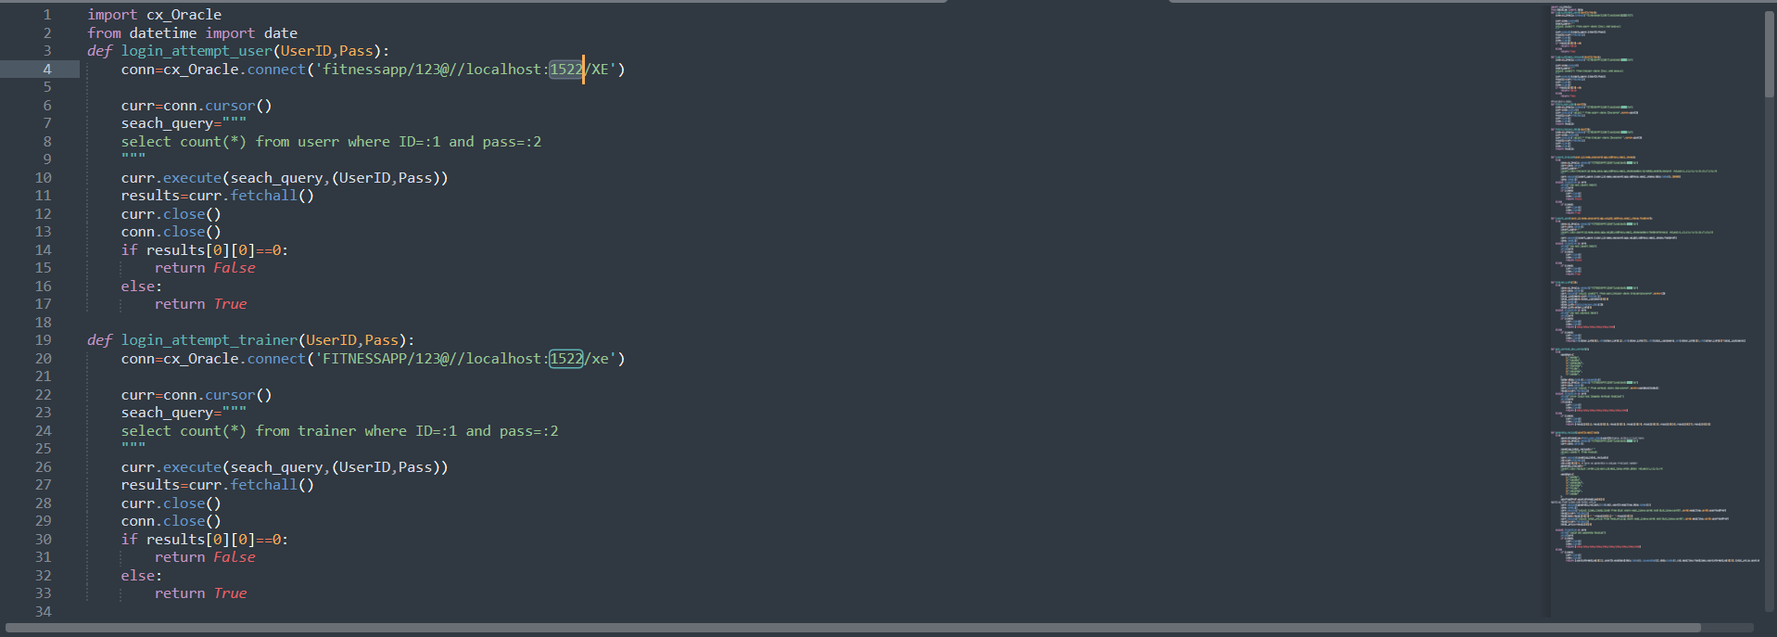

**Fifth:**

The main file is login_.py in the zip folder. Open it and sign up as a user (Make sure to fill every domain in the sign up form). And after that login and the rest is explained in the presentation titled as: cs232 project presentation.pdf

Thank You