|  |  |
| --- | --- |
| Race: | Age: |
| Class: | Profession: |

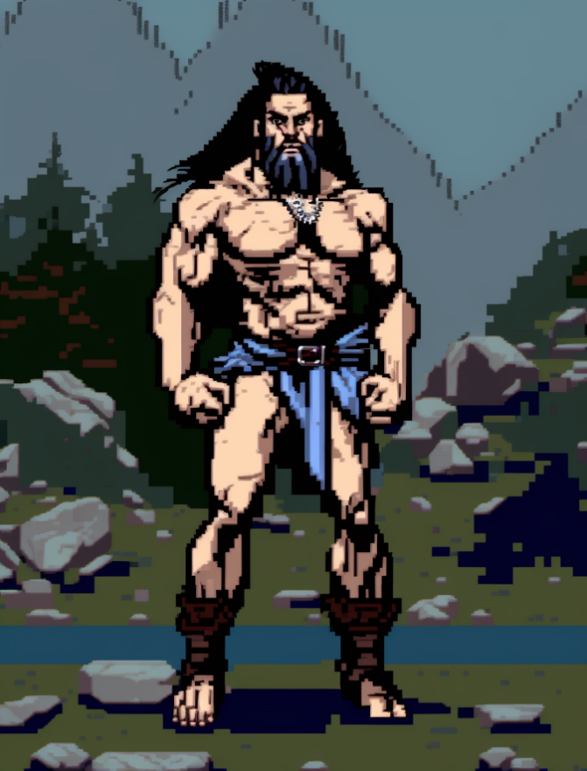

|  |  |  |  |  |  |
| --- | --- | --- | --- | --- | --- |
| Skills | | | | | |
| Acrobatics: 0 | Animal Handling: 0 | Arcana: 0 | Athletics: 0 | Botany: 0 | Carpentry: 0 |
| Combat (Close): 0 | Combat (Ranged): 0 | Cooking: 0 | Deception: 0 | First Aid: 0 | Fishing: 0 |
| Hunting: 0 | Intimidation: 0 | Navigation: 0 | Performance: 0 | Perception: 0 | Persuasion: 0 |
| Religion: 0 | Scavenging: 0 | Sleight of Hand: 0 | Stealth: 0 | Tracking: 0 | Tinkering: 0 |

Biography:

|  |  |
| --- | --- |
| Trail Health: 8**/8** | Trail Stamina: 8**/8** |
| Combat Health: 30**/30** | Starvation: |

|  |  |  |  |  |  |
| --- | --- | --- | --- | --- | --- |
| |  | | --- | | **Gold: 0** |   Inventory | | | | |
| X | X | X | X | X |
| X | X | X | X | X |
| X | X | X | X | X |
| X | X | X | X | X |
| X | X | X | X | X |
| X | X | X | X | X |
| X | X | X | X | X |
| X | X | X | X | X |
| X | X | X | X | X |
| X | X | X | X | X |

|  |  |  |
| --- | --- | --- |
| Equipment | | |
| Head | X | X |
| Body | X | X |
| Arms | X | X |
| Legs | X | X |
| Left Hand | X | X |
| Right Hand | X | X |
| Both Hands | X | X |

|  |  |
| --- | --- |
| Armor Rating: X | Weapon Rating: X |

|  |  |
| --- | --- |
| Effects | |
| X | X |
| X | X |
| X | X |
| X | X |
| X | X |
| X | X |
| X | X |

|  |  |  |
| --- | --- | --- |
| Spells | | |
| Cantrip | X | X |
| Slot One (1-3) Lock outline | X | X |
| Slot Two (4-6) Lock outline | X | X |
| Slot Three (7-9) Lock outline | X | X |
| Slot Four (Mega) Lock outline | X | X |