|  |  |
| --- | --- |
| Race: Bugbear | Age: 39 |
| Class: Ranger | Profession: Hunter |

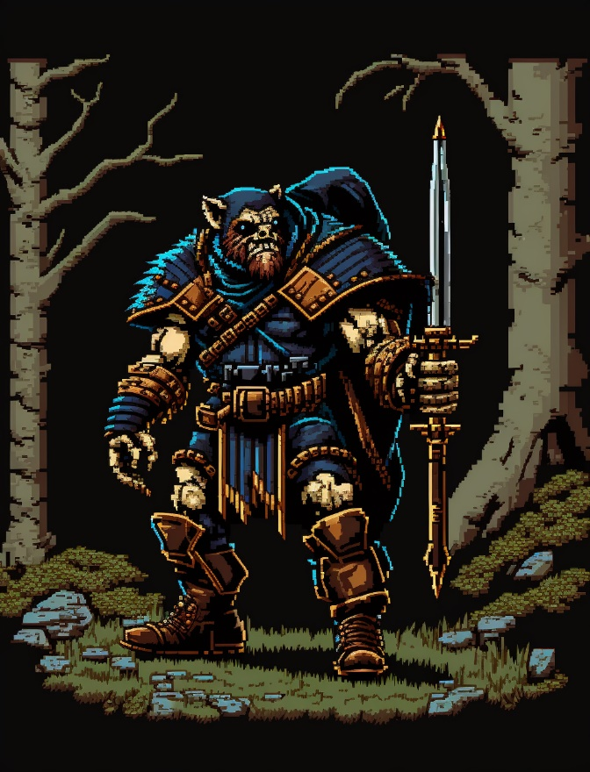

|  |  |  |  |  |  |
| --- | --- | --- | --- | --- | --- |
| Skills | | | | | |
| Acrobatics: 0 | Animal Handling: 2 | Arcana: 1 | Athletics: 1 | Botany: 2 | Carpentry: 0 |
| Combat (Close): 2 | Combat (Ranged): 2 | Cooking: 0 | Deception: 0 | First Aid: 0 | Fishing: 1 |
| Hunting: 4 | Intimidation: 0 | Navigation: 1 | Performance: 0 | Perception: 1 | Persuasion: 0 |
| Religion: 0 | Scavenging: 2 | Sleight of Hand: 0 | Stealth: 2 | Tracking: 2 | Tinkering: 0 |

Biography: Mickey Mack was born to a small clan of bugbears in the deep forests. From an early age, he showed an uncanny ability to track prey and was often the one sent out to bring back food for the clan. As he grew older, he became a skilled hunter and learned to rely on himself more than anyone else. One day while on a hunting trip, he stumbled upon the town of Newharbor and met a human woman named Marcy. The two fell in love and had a child together. However, tragedy struck when their child went missing, and despite Mickey's best efforts, he was never able to find him. The loss of his child hit Mickey hard, and soon after Marcy left him. Afterwards he left the clan to go on a never-ending quest to hopefully find his son again. He spent years wandering the forests and became even more skilled at hunting and survival. As he traveled, he found a new clue that leads Mickey to believe that his son is out west. With a reinvigorated spirit, he returned to Newharbor to set out on the trail to the west, determined to find his child and make a new life for himself.

|  |  |
| --- | --- |
| Trail Health: 0**/8** | Trail Stamina: 4**/8** |
| Combat Health: 40**/40** | Starvation: |

|  |  |  |  |  |  |
| --- | --- | --- | --- | --- | --- |
| |  | | --- | | **Gold: 0** |   Inventory | | | | |
|  | Sword | Hunting Knife |  | Fishing Rod |
|  |  | X | X | X |
| X | X | X | X | X |
| X | X | X | X | X |
| X | X | X | X | X |
| X | X | X | X | X |
| X | X | X | X | X |
| X | X | X | X | X |
| X | X | X | X | X |
| X | X | X | X | X |

|  |  |
| --- | --- |
| Effects | |
| Dark Vision | Can see well in the dark |
| Naked | Receive more damage |
| Slightly More Cannibal | Further Negative Negative Social Status |
| Drowned | Might Die due to a lack of air. Roll D15. If you 3 or 4 you die. If you roll a 13 or more, |
| Dead | You are now dead |
| X | X |
| X | X |

|  |  |  |
| --- | --- | --- |
| Spells | | |
| Cantrip | NA | NA |
| Slot One (1-3) | X | X |
| Slot Two (4-6) Lock outline | X | X |
| Slot Three (7-9) Lock outline | X | X |
| Slot Four (Mega) Lock outline | X | X |