|  |  |
| --- | --- |
| Race: Half-Elf | Age: 24 |
| Class: Rogue | Profession: Thief |

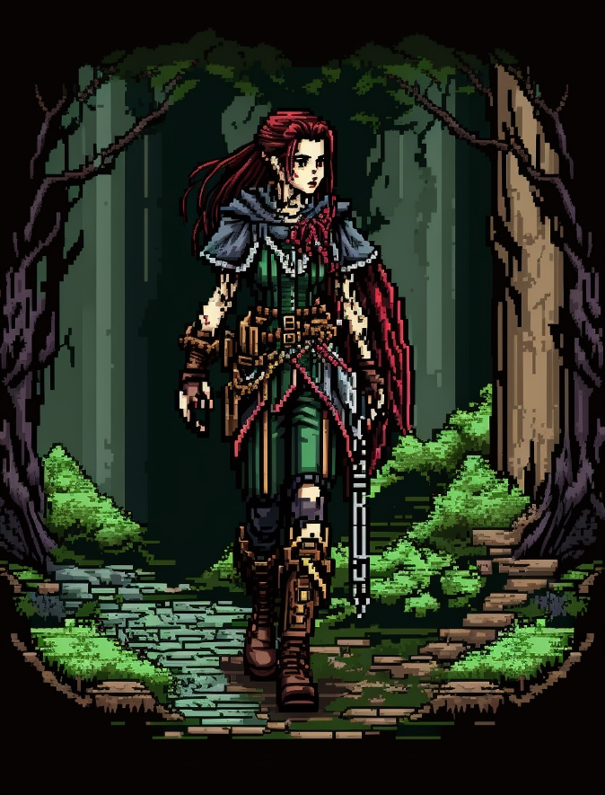

|  |  |  |  |  |  |
| --- | --- | --- | --- | --- | --- |
| Skills | | | | | |
| Acrobatics: 2 | Animal Handling: 0 | Arcana: 0 | Athletics: 2 | Botany: 0 | Carpentry: 0 |
| Combat (Close): 2 | Combat (Ranged): 0 | Cooking: 0 | Deception: 3 | First Aid: 3 | Fishing: 0 |
| Hunting: 0 | Intimidation: 0 | Navigation: 1 | Performance: 0 | Perception: 1 | Persuasion: 1 |
| Religion: 0 | Scavenging: 0 | Sleight of Hand: 3 | Stealth: 1 | Tracking: 0 | Tinkering: 2 |

Biography: Nessa Zylkian, a resilient and street-savvy half-elf, has lived a life of survival since the tender age of seven. Abandoned and left to navigate the unforgiving streets, she quickly adapted to the harsh realities of her environment. Through sheer determination, Nessa acquired skills in thievery, stealth, and deception, becoming a master of blending into the shadows and outsmarting both the law and those who sought to exploit her. Over the years, she built a network of fellow street dwellers and misfits, forming unlikely alliances based on mutual trust and shared experiences. Now, guided by a kind-hearted rogue named Rylan, Nessa has set foot on a new path. Mentored by Rylan, she seeks to channel her street-honed skills into more constructive endeavors. With a keen wit, a touch of mischief, and an unwavering loyalty, Nessa embarks on adventures beyond the shadows, aiming to make a difference in the lives of the downtrodden. Empathy for the suffering and a desire to protect the vulnerable drive her forward, as she strives to create a world where no child endures the hardships she once did. Nessa Zylkian, a survivor who thrives on resourcefulness, agility, and a dash of street-smart ingenuity, is determined to carve a new destiny, and bring about positive change.

|  |  |
| --- | --- |
| Trail Health: 8**/8** | Trail Stamina: 5**/8** |
| Combat Health: 30**/30** | Starvation: |

|  |  |  |  |  |  |
| --- | --- | --- | --- | --- | --- |
| |  | | --- | | **Gold: 90** |   Inventory | | | | |
| Leather Armor | Short Sword | Short Bow | Arrows 30 | Dagger 2 |
| Small File | Lockpick 3 | Scissors | Pliers | Tiny Mirror |
| Steel Ball Bearings 400 | String 10ft | Bell | Crowbar | Hammer |
| Piton 10 | Hooded Lantern | Oil Flask 2 | Tinderbox | Rope 50ft |
| X | X | X | X | X |
| X | X | X | X | X |
| X | X | X | X | X |
| X | X | X | X | X |
| X | X | X | X | X |
| X | X | X | X | X |

|  |  |
| --- | --- |
| Effects | |
| X | X |
| X | X |
| X | X |
| X | X |
| X | X |
| X | X |
| X | X |

|  |  |  |
| --- | --- | --- |
| Spells | | |
| Cantrip | Minor Illusion | You create a sound (any) or an image (5ft or smaller) of an object within range that lasts for 1 min. Objects don’t interact. |
| Slot One (1-3) Lock outline | X | X |
| Slot Two (4-6) Lock outline | X | X |
| Slot Three (7-9) Lock outline | X | X |
| Slot Four (Mega) Lock outline | X | X |