|  |  |
| --- | --- |
| Race: Half-Elf | Age: 38 |
| Class: Artificer | Profession: Craftsman |

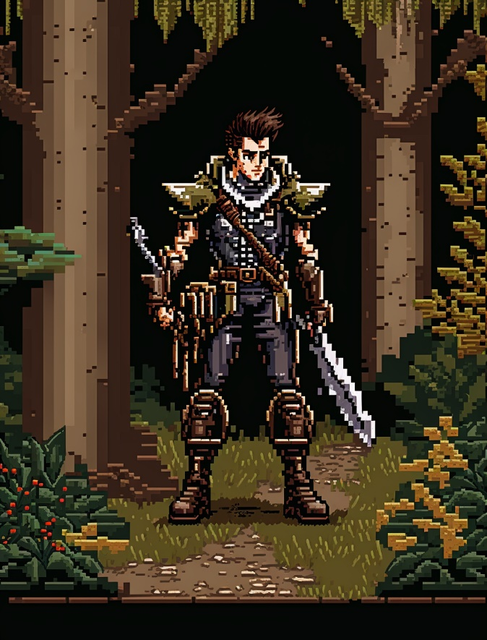

|  |  |  |  |  |  |
| --- | --- | --- | --- | --- | --- |
| Skills | | | | | |
| Acrobatics: 1 | Animal Handling: 0 | Arcana: 1 | Athletics: 1 | Botany: 0 | Carpentry: 3 |
| Combat (Close): 2 | Combat (Ranged): 5 | Cooking: 0 | Deception: 1 | First Aid: 0 | Fishing: 0 |
| Hunting: 0 | Intimidation: 0 | Navigation: 3 | Performance: 4 | Perception: 0 | Persuasion: 5 |
| Religion: 0 | Scavenging: 2 | Sleight of Hand: 0 | Stealth: 1 | Tracking: 0 | Tinkering: 2 |

Biography: Thalion Oakenheart was born to a human father and an elven mother, who were both traveling scholars. They settled in the up-and-coming town of Newharbor in Avaria when Thalion was still a child, and it was there that he discovered his love for tinkering. Thalion's first invention was a small mechanical owl named Orion, which he created when he was just ten years old. As he grew older, Thalion's tinkering skills only improved, and he began to create more and more complex machines. Despite his success as a craftsman, Thalion felt restless in Newharbor. He longed for new challenges and opportunities to grow his business. After much consideration, he decided to join a wagon train heading west. Thalion is determined to start his own business once he reaches the new frontier, and he hopes to use his tinkering skills to help build a better life for himself and others. Though he is excited about the journey ahead, Thalion is also nervous about the dangers that lie on the trail, especially the threat of bandits and dangerous creatures. Nonetheless, he is confident that his ingenuity and quick thinking will see him through any challenges that come his way.

|  |  |
| --- | --- |
| Trail Health: 6**/8** | Trail Stamina: 4**/8** |
| Combat Health: 30**/30** | Starvation: |

|  |  |  |  |  |  |
| --- | --- | --- | --- | --- | --- |
| |  | | --- | | **Gold: 86** |   Inventory | | | | |
| Leather Armor | Rifle | 20 Bullets | Dagger | Lockpicks 3 |
| Wrench | Tiny Mirror | Mechanical Bees in a Jar | Hammer | Rope 40ft |
| Torch | Tinderbox | X | X | X |
| X | X | X | X | X |
| X | X | X | X | X |
| X | X | X | X | X |
| X | X | X | X | X |
| X | X | X | X | X |
| X | X | X | X | X |
| X | X | X | X | X |

|  |  |
| --- | --- |
| Effects | |
| Extended Loan | Must pay 75 gold in Wagonshire to avoid bounty hunters |
| X | X |
| X | X |
| X | X |
| X | X |
| X | X |
| X | X |

|  |  |  |
| --- | --- | --- |
| Spells | | |
| Cantrip | Acid Splash | Hurl an acid bubble. Choose up to two creatures you can see. If two, they must be within 5 feet. |
| Slot One (1-3) Lock outline | X | X |
| Slot Two (4-6) Lock outline | X | X |
| Slot Three (7-9) Lock outline | X | X |
| Slot Four (Mega) Lock outline | X | X |