|  |  |
| --- | --- |
| Race: Elf | Age: 30 |
| Class: Druid | Profession: Herbologist |

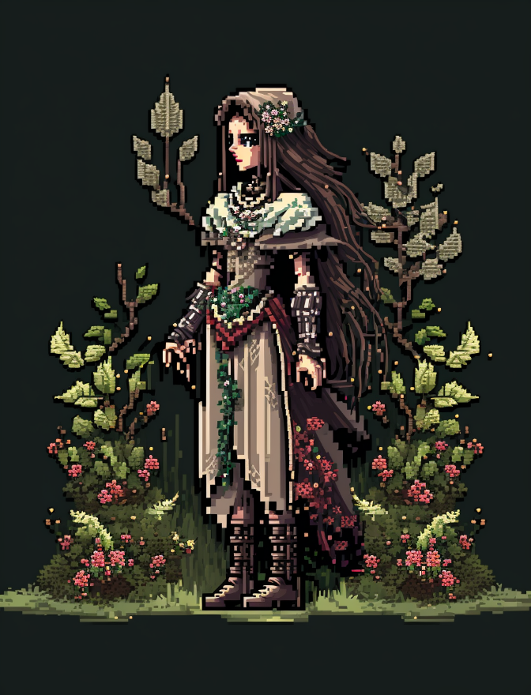

|  |  |  |  |  |  |
| --- | --- | --- | --- | --- | --- |
| Skills | | | | | |
| Acrobatics: 0 | Animal Handling: 2 | Arcana: 3 | Athletics: 0 | Botany: 5 | Carpentry: 0 |
| Combat (Close): 1 | Combat (Ranged): 0 | Cooking: 0 | Deception: 0 | First Aid: 1 | Fishing: 0 |
| Hunting: 0 | Intimidation: 0 | Navigation: 2 | Performance: 0 | Perception: 2 | Persuasion: 0 |
| Religion: 0 | Scavenging: 2 | Sleight of Hand: 0 | Stealth: 1 | Tracking: 2 | Tinkering: 0 |

Biography:

|  |  |
| --- | --- |
| Trail Health: 8**/8** | Trail Stamina: 8**/8** |
| Combat Health: 30**/30** | Starvation: |

|  |  |  |  |  |  |
| --- | --- | --- | --- | --- | --- |
| |  | | --- | | **Gold: 90** |   Inventory | | | | |
| Leather Armor | Wooden Shield | Basic Staff | Dagger | Bedroll |
| Tinder Box | Torches 10 | Waterskin | Rope 50ft | Journal |
| Eastern Seeds 20 | X | X | X | X |
| X | X | X | X | X |
| X | X | X | X | X |
| X | X | X | X | X |
| X | X | X | X | X |
| X | X | X | X | X |
| X | X | X | X | X |
| X | X | X | X | X |

|  |  |
| --- | --- |
| Effects | |
| Dark Vision | Can see well in the dark |
| X | X |
| X | X |
| X | X |
| X | X |
| X | X |
| X | X |

|  |  |  |
| --- | --- | --- |
| Spells | | |
| Cantrip | Infestation | A cloud of bugs appear on one creature you can see. The target takes 1d6 poison damage and moves 5 ft in a random. Roll a d4 for the direction: 1, north; 2, south; 3, east; or 4, west |
| Slot One (1-3) | X | X |
| Slot Two (4-6) | X | X |
| Slot Three (7-9) Lock outline | X | X |
| Slot Four (Mega) Lock outline | X | X |