Austin Freeman
8/16/2026
CS-340

About the Project
Name - Grazioso Salvare Rescue Dashboard

Motivation
The main goal of this project is to create a dashboard that can be used to interact with a MongoDB database we’ve created that holds the information for and help identify animals from the Austin Animal Center dataset that meet specific requirements. This dashboard includes filters for things like Water Rescue, Mountain and Wilderness Rescue, and Disaster Rescue. The dashboard connects to a MongoDB database via a custom-built CRUD Python module developed for a previous project.

Required Functionality
This dashboard provides four filtering methods via RadioItems that let you filter the given list by a variety of rescue specializations. Using various MongoDB queries, we’re able to search for specific characteristics that would be most useful in each scenario. We’re also able to clear each of the search filters by utilizing the reset RadioItem which clears the search and returns the user to the initial state.
Each record is displayed in a Dash DataTable, and supports pagination, native filtering, multi-column sorting, and single-row selection.
There are two elements that dynamically display the information given by the query’s, a map that shows the precise location of the animal in question and a pie chart that shows either the breed breakdown of the specific query or the animal type, in the example of the reset RadioItem.

Filter Options

Water Rescue
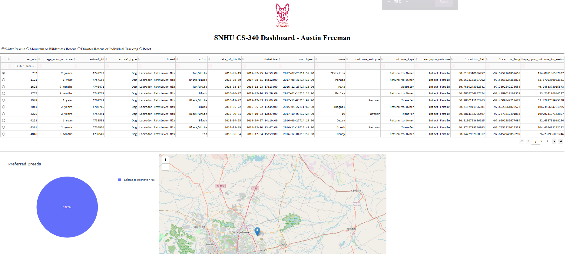
Description – This filter restricts the dataset to preferred water rescue dog breeds that are intact females, who are between the age of 26 and 156 weeks old.

Mountain or Wilderness Rescue
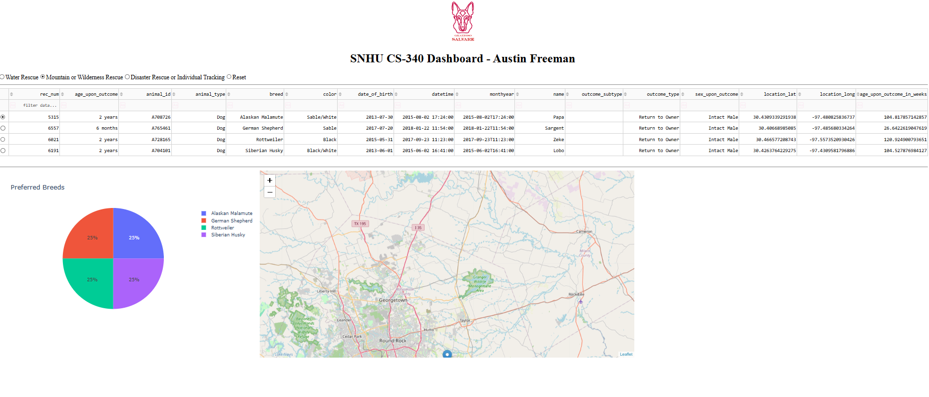
Description – This filter displays wilderness rescue breed that are intact males between the ages of 26 and 156 weeks old.

Disaster Rescue
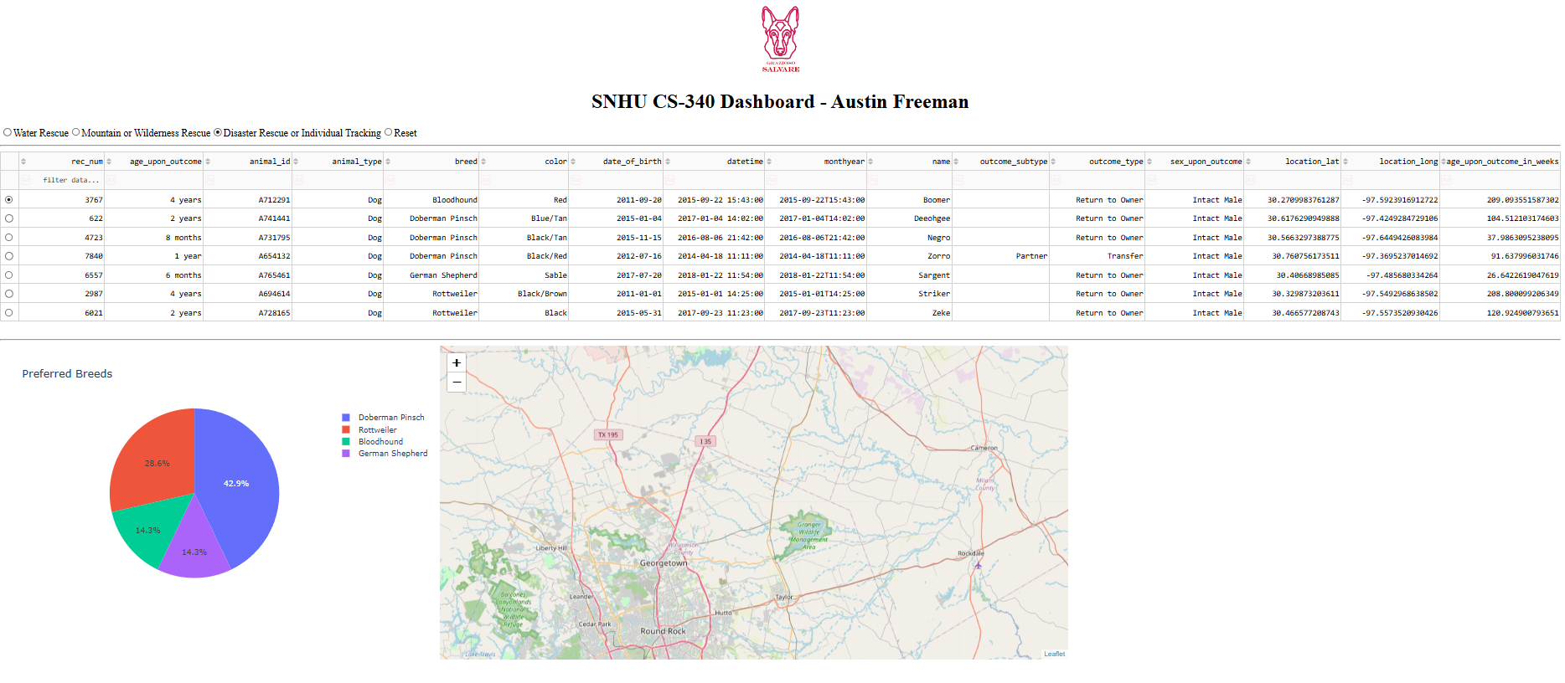
Description – This filter displays breeds that excel in disaster rescue and filters for intact males between the age of 20 and 300 weeks old.

Reset
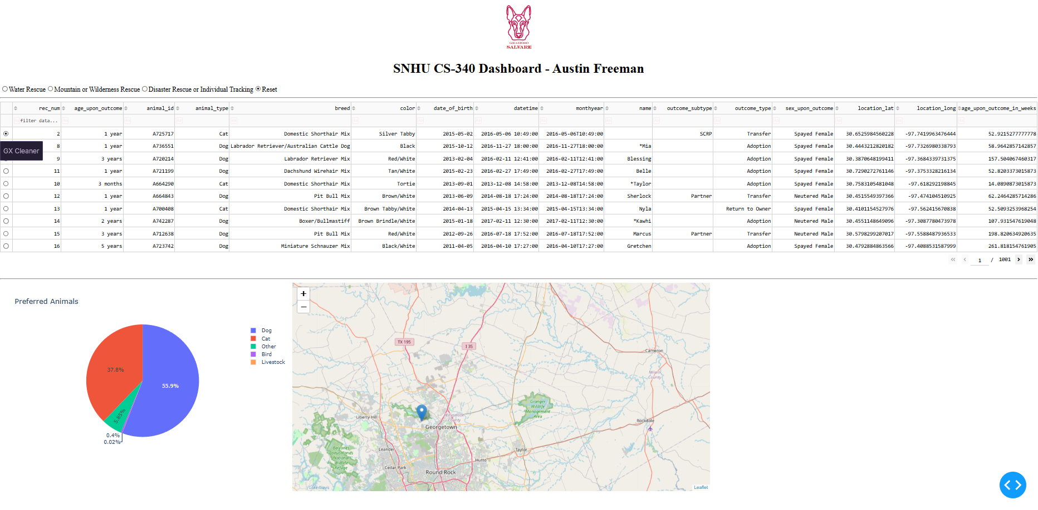
Description – This filter displays all animals in the Austin Animal Center dataset and shows the breakdown of animal type in the pie chart.

Note: While not specified in the requirements, an additional filter was added to the breed restriction to filter out dogs that were labeled as Euthanized

Tools and Rationale

MongoDb and CRUD Python

Rationale – MongoDB was chosen as the model component because of the size of the Austin Animal Center dataset. By using MongoDB, we’re able to filter and sort the available options, convert the data using Pandas, and present it to a graphing function in a DataFrame to create an easy-to-read interface.

Installation
Downloading the PyMongo tool is enough to get the ball rolling when it comes to general usage. After you’ve downloaded the file and moved it to the project that you’ve created you can simply add the

From CRUD_Python import Animal Shelter

This will allow you to use the file in your code which can then be followed up with

crudObj = AnimalShelter(USER, PASS)
where the username and password of the login is input to connect you to the corresponding user account. Also, the default for the aac test database is USER: aacuser and PASS: SNHU1234

After all of that’s been taken care of you can use the create(db, collection, data) function to input various entries into whatever database you’ve chosen. Currently the only database that the aacuser has access to is the aac database but this can be adjusted to fit the users needs

Finally, you can use the read(db, collection, data) function to find and display various entries that the user has access to. Again the default aacuser can only use the aac database, but the needs of the user can easily be met by changing these various method variables.

Installation
To utilize this tool the user is going to need a pymongo imports to meet the needs of the CRUD_Python file. First, you will need to download the pymongo module. This can be achieved by using two different methods:
METHOD 1: After ensuring that your project has been created, go to the command line and type the following:
pip install pymongo
Once the download process has completed you should be able to add the import statement without any issue.
METHOD 2: Assuming you have access to a modules section in your project, you can simply search PyMongo in the search bar. Once it’s been found, hit the install and wait for the download to complete.
Usage
For the first step you’ll need to import a dataset into your MongoDB environment using the mongoimport command

Next you’ll need to create user credentials to use in the tool itself.
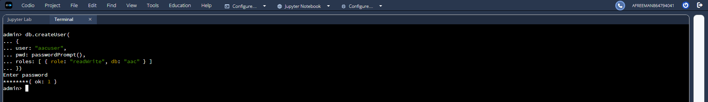

The db.createUser() function is what is used in this process and you’ll need to fill out the user’s name, the password, the role they intend on using. Note: using the passwordPrompt() method will allow you to fill this out and obscure the input from prying eyes.

Now that this portion is finished you can move on to the various methods that exist within the CRUD_Python file. The first portion I’d like to cover is the initial object call
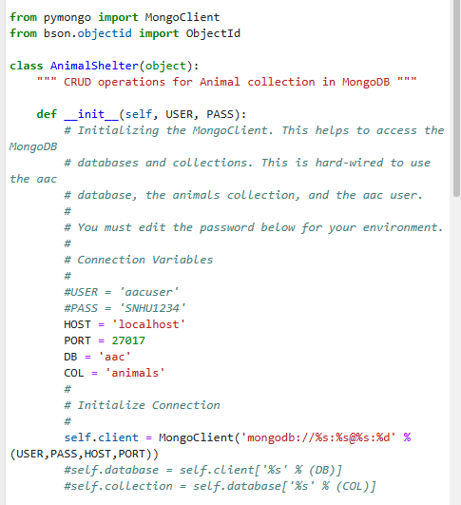

As you can see when you first call the CRUD_Python file Object you’ll be asked to provide a username and password. This will create a client that can be used for the preceding method calls.
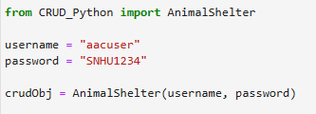

Something simple like this will do, or if you want to make it available to different users you can prompt using input()

Moving down the file we have the Create() function call

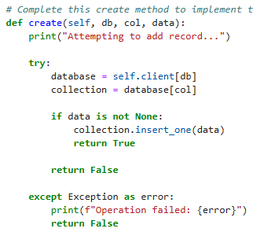

While using this method call we specify the database, and collection we intend on accessing and then feed in the data we want.
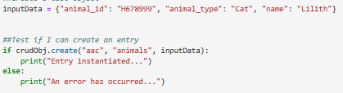
Here’s a solid example of that being done in practice. If all goes well the database will send back a Boolean that tells you whether your entry was successfully inserted or not.

From here, we have the READ() function call. This function can be used to query the database for either a single, or multiple entries using the find() keyword
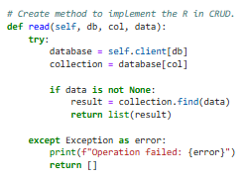

As you can see we also specify the database and the collection that we intend on targeting and then feed the data in and receive either a result, or an empty list.

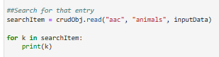
Since this function has ample error handling we can simply read from the returned list.

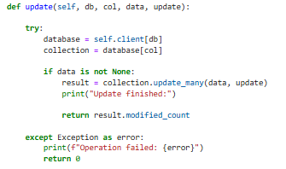

Now, we have the UPDATE() function. Like the others this takes in various methods specifying where we need to look and then returns the modified count

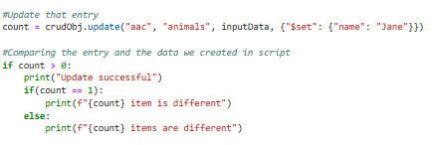

Using the returned modified count we can display the amount of entries changed.

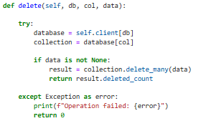

Next, we have the DELETE() function, we pass the same method calls.
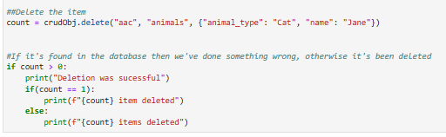

In practice, we use the delete count to check how many entries we’ve affected.

Tests

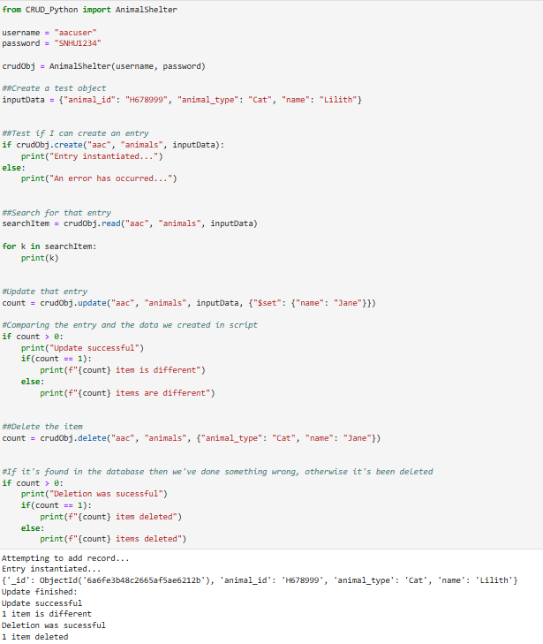

Dash

Rationale
Dash was used in this project to create a view and controller portion of the application. The framework makes it easy to create interactive web interfaces while also providing various input methods such as RadioItems, DataTable, and various other useful widgets that can be used to filter and update the charts present on the page.

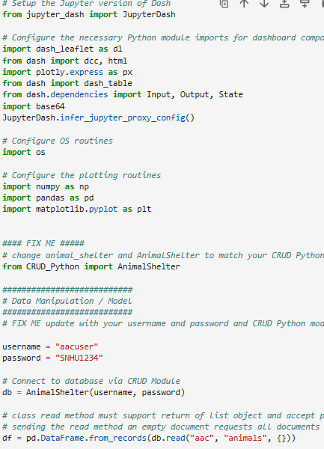

Usage
Now that we’ve gone over the basic information of the module we can now speak about it’s usage in Dash. By using:
We can import the CRUD module's functionality and implement it in the Dash framework. Then we need to define which user we will be using in the program
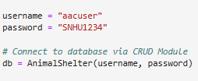

After that’s been entered we can then import out data:

After the dataset has been loaded, we can create the dashboard layout using Dash. We define the logo and RadioButtons in this area to have a filtering method later and assign the id of filter-type which can later be used in a callback.
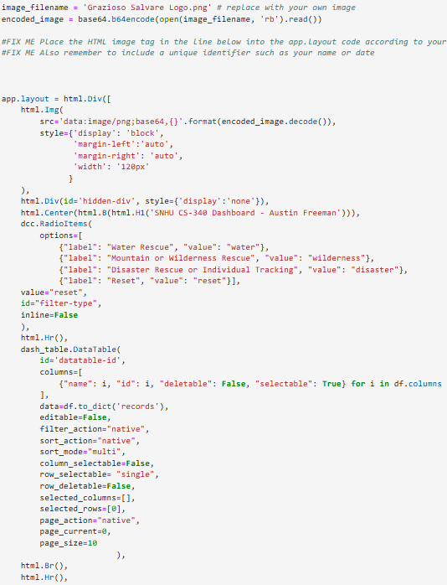
Now that the layout has been determined we can easily add callbacks that help filter for various rescue types. We’re looking for filter-type as previously mentioned. When we receive a filter type we have a branching if statement that pulls a read query from the database using our credentials and returns the information we find.
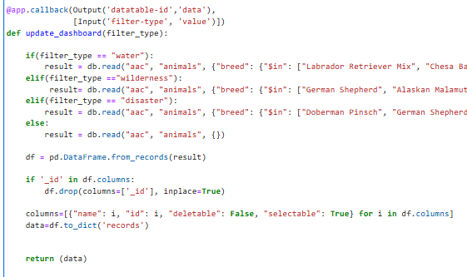

Once that data is filtered we send it to the graph and depending on the values we either have a graph that presents the breakdown of animal type or the breakdown of breed.
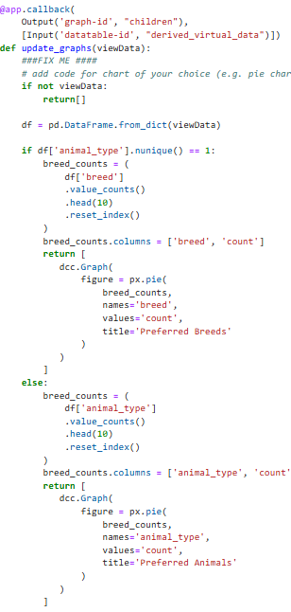
Finally, we’re left with our final widget
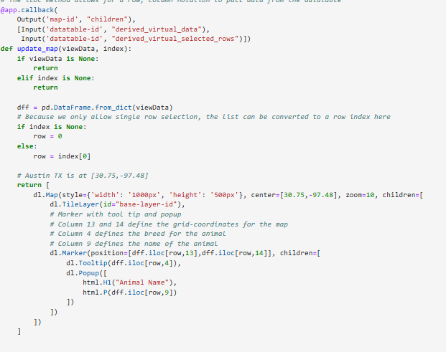

Once everything is filtered the table updates, we can then select specific elements within that table to search on our map. Clicking each element zeroes in on the coordinates present in that entry.

Once all of these elements are in place we can then run the script and we will be presented with a url hosted locally that can be used to interact with the datatable
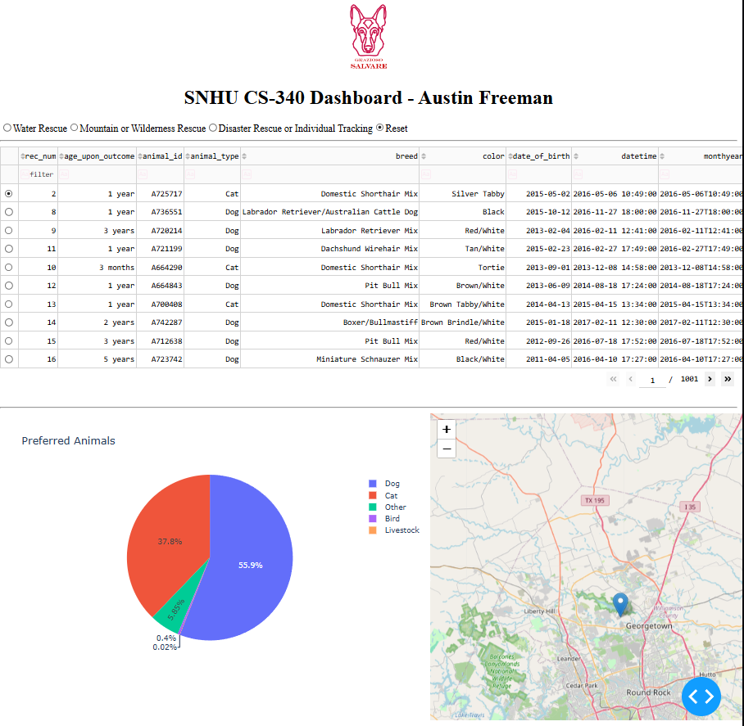

Steps Taken
I began by reusing the AnimalShelter CRUD_Python module created during project one to connect the dashboard to MongoDB. Once the dashboard was functional and populated the dataframe with the relevant information I then created custom filters that would allow me to filter various breeds and requirements that might be needed in specific rescues and connected the callback to the RadioItems responsible for handling this filtering. Once that worked we were able to then connect that callback to a separate callback that allowed me to filter the preferred animal, or preferred breed depending on the input.
Once everything was said and done I added the Grazioso Salvare logo and tested each individual element to ensure that it all worked together well.
Challenges
Throughout the process of creating the application I ran into multiple scenarios where I hit a brick wall. The primary challenge for me was getting the map to work correctly, while a lot of the functionality needed was present in the file it was hard to wrap my head around something I hadn’t created. A few hours of reading later, and plenty of trial and error I was able to grasp exactly what was happening in the callback, to the point where I was able to bend what was happening to my needs, for example by changing the pie graph to fit what I thought was appropriate.

Contact: Austin Freeman

