**Dear Applicant,**

Thank you for applying to participate in DataHack4FI Season 3 as a ‘Data Enthusiast’. We have reviewed the large number of applications from candidates across 7 countries, and on this occasion your application was **SUCCESSFUL**. Congratulations!

Participation in Season 3 presents a wonderful opportunity to improve your data science knowledge and skills by enrolling in the Microsoft Professional Program in Data Science. You will be awarded an official data science certification (valued at $1000 USD) provided you meet the course requirements and complete the final Capstone project. *It is important to note that the course is being used as a pre-selection tool, with the final pool of data enthusiasts to be paired with an emerging tech company selected based on their coursework and Capstone project results*. *The final number of data enthusiasts to be paired will be limited, so it is important you apply yourself fully and strive to complete the course to the best of your ability!*

**Please follow the link below which will direct you to the e-learning platform where you will sign-up, enroll and begin the Microsoft Professional Program in Data Science.** Although the course is self-paced, you are expected to dedicate between 10-12 hours per week in order to complete the course within the allocated *4-month period* *(before Friday 29th March 2019*).

<https://datahack4fi.21cskills.africa/register>

We are working with each of our in-country DataHack4FI partners to provide supplementary content and support to help you to complete the course. However, we further encourage you to engage fellow data enthusiasts enrolled in the course via our DataHack4FI Slack channel (<https://goo.gl/w8mJ96>), form in-person study groups (add your details to the study group sign-up spreadsheet: <https://goo.gl/PcZCh8>), and post questions on the DataHack4FI Facebook Community as you progress through the program. *Please follow the course outline provided below, making note of some module choices as you advance.*

WE WISH YOU LUCK AS YOU BEGIN YOUR JOURNEY TO DATA SCIENCE EXCELLENCE!

Yours faithfully,

**The i2i team**

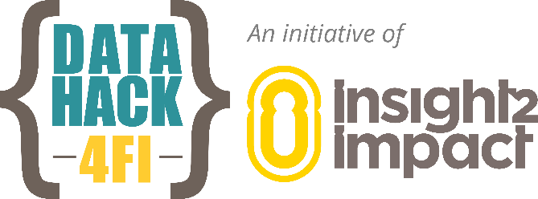

**Microsoft Professional Program in Data Science**

Please follow the module progression outlined below as you advance through the coursework.

1. Introduction to Data Science

2. Analyzing and Visualizing Data with Power BI *or* Analyzing and Visualizing Data with Excel

3. Analytics Storytelling for Impact

4. Ethics and Law in Data and Analytics

5. Querying Data with Transact-SQL

6. Introduction to R for Data Science *or* Introduction to Python for Data Science

7. Essential Math for Machine Learning: R Edition *or* Essential Math for Machine Learning: Python Edition *or* Essential Statistics for Data Analysis using Excel

8. Data Science Research Methods: R Edition *or* Data Science Research Methods: Python Edition

9. Principles of Machine Learning: R Edition *or* Principles of Machine Learning: Python Edition

10. Developing Big Data Solutions with Azure Machine Learning *or* Analyzing Big Data with Microsoft R *or* Implementing Predictive Analysis with Spark in Azure HDInsight

11. CAPSTONE PROJECT

***NOTE:***

- The final number of data enthusiasts to be paired will be limited, so it is important you apply yourself fully and strive to complete the course to the best of your ability!

- The final pool of data enthusiasts to be paired with an emerging tech company will be selected based on their coursework and Capstone project results

- Some modules have more than one option, in these instances you can choose the module you prefer (2, 6, 7, 8, 9, 10)

- You are expected to dedicate between 10-12 hours per week in order to complete the course within the allocated 4-month period

***Completion deadline: 29 March 2019***