
A Project Report on
BREAST CANCER DETECTION USING
ADABOOST CLASSIFIER

Submitted To

JAWAHARLAL NEHRU TECHNOLOGICAL UNIVERSITY,
ANANTAPUR
In partial fulfillment of the requirements for the award of the degree of

BACHELOR OF TECHNOLOGY
IN
CSE (ARTIFICIAL INTELLIGENCE & MACHINE LEARNING)

Submitted by
Іv B. Tech ІІ Semester
S. AFREEN PARVEEN 22KH1A3335

K. MADHAVI 22KH1A3321

S. MOHAMMAD KABEER 22KH1A3337

Under the Esteemed Guidance of

Dr. B. LAKSHMI NARAYANA REDDY, M.Tech., Ph.D.
Professor, Department of CSE (AI & ML)

Department of CSE (Artificial Intelligence and Machine Learning)

SRI VENKATESWARA COLLEGE OF ENGINEERING
(Affiliated to JNTUA, Anantapuramu and Approved by AICTE, New Delhi)
Balaji Nagar, Kadapa-516003.
(2022-2026)



BREAST CANCER DETECTION USING
ADABOOST CLASSIFIER

Project report submitted in partial fulfillment of the requirement for the award of the degree of B. Tech in CSE (Artificial Intelligence & Machine Learning)
By

S. AFREEN PARVEEN 22KH1A3335
K. MADHAVI 22KH1A3321
S. MOHAMMAD KABEER 22HK1A3337

Under the Esteemed Guidance of

Dr. B. LAKSHMI NARAYANA REDDY, M.Tech., Ph.D.
Professor, Department of CSE (AI & ML)

Department of CSE (ARTIFICIAL INTELLIGENCE & MACHINE LEARNING)

SRI VENKATESWARA COLLEGE OF ENGINEERING

(Affiliated to JNTUA, Anantapuramu and approved by AICTE, New Delhi)
Balaji Nagar, Kadapa – 516003
(2022-2026)

SRI VENKATESWARA COLLEGE OF ENGINEERING

(Affiliated to JNTUA, Anantapuramu and Approved by AICTE, New Delhi)
Balaji Nagar, Kadapa-516003.

Department of CSE (AI&ML)

Certificate
This is to certify that the project work entitled

BREAST CANCER DETECTIONUSING ABABOOST CLASSIFIER
is the bonafide work done by

S. AFREEN PARVEEN 22KH1A3335
K. MADHAVI 22KH1A3321
S. MOHAMMAD KABEER 22KH1A3337

In the Department of CSE (AI&ML), Sri Venkateswara College of Engineering, Kadapa is affiliated to JNTUA-Anantapur in partial fulfillment of the requirements for the award of Bachelor of Technology in CSE(AI&ML) during 2022-2026.

This work has been carried out under my guidance and supervision.
The results embodied in this Project report have not been submitted in
any University or Organization for the award of any degree or diploma

GUIDE HEAD OF THE DEPARTMENT
Dr. B. Lakshmi Narayana Reddy, M. Tech., Ph.D. Dr. B. Lakshmi Narayana Reddy, M. Tech., Ph.D.
Professor

INTERNAL EXAMINER EXTERNAL EXAMINER

ACKNOWLEDGEMENT

We are extremely thankful to our beloved chairman and establisher Sri A. Gangi Reddy for providing necessary infrastructure and resources for the accomplishment of our project at Sri Venkateswara College of engineering, Kadapa.

We are highly indebted to Dr. R. Veera Sudarsana Reddy, Principal of Sri Venkateswara College of Engineering, Kadapa, for his support during the tenure of the project.

We are very much obliged to our beloved Dr. B. Lakshmi Narayana Reddy, Head of the Department of CSE (Artificial Intelligence & Machine Learning), Sri Venkateswara College of Engineering for providing the opportunity to undertake this project and encouragement in completion of this project.

We hereby wish to express a deep sense of gratitude to Dr. B. Lakshmi Narayana Reddy, Professor, Department of CSE (Artificial Intelligence & Machine Learning), Sri Venkateswara College of Engineering for the esteemed guidance, moral support and invaluable advice provided by him for the success of the project.

We are also thankful to all the staff members of the CSE (Artificial Intelligence & Machine Learning) department who have co-operated in making our project a success. We would like to thank all our parents and friends who extended their help, encouragement and moral support either directly or indirectly in our project work.

Thanks for Your Valuable Guidance and kind support.

DECLARATION

We hereby declare that project report entitled BREAST CANCER DETECTION USING ADABOOST CLASSIFIER is a genuine project work carried out by us, in B- Tech in CSE (Artificial Intelligence & Machine Learning) degree course of Jawaharlal Nehru Technological University, Anantapur and has not been submitted to any other courses or University for award of any degree by us.

Signature of the Student

- S. Afreen Parveen

- K. Madhavi
- S. Mohammad Kabeer

ABSTRACT

Breast cancer is one of the most common and life-threatening diseases affecting women worldwide, and early detection is essential for improving survival rates and enabling effective treatment. Traditional diagnostic methods often rely on manual analysis by medical experts, which can be time-consuming and may delay diagnosis. To address this challenge, this project presents an AI-based Breast Cancer Diagnostic Assistant that uses machine learning techniques to support early detection. The proposed system uses the AdaBoost (Adaptive Boosting) classifier, an ensemble learning algorithm that improves prediction accuracy by combining multiple weak learners. The model is trained using the Breast Cancer Wisconsin Diagnostic Dataset, which contains tumor characteristics such as radius, texture, smoothness, and symmetry. Data preprocessing techniques, including normalization and SMOTE (Synthetic Minority Over-sampling Technique), are applied to handle class imbalance and improve model performance. The trained model classifies tumors as benign (non-cancerous) or malignant (cancerous) with high accuracy. The system is deployed using a Streamlit-based web application, allowing users to input patient data, perform predictions, visualize results, and generate medical reports. Experimental results show that the AdaBoost model achieves an accuracy of approximately 94%, demonstrating its effectiveness as a decision-support tool for assisting healthcare professionals in early breast cancer detection.

TABLE OF FIGURES

FIG. NO. | FIGURE NAME | PAGE NO.
5.1 | System Architecture | 8
5.2.1 | Class Diagram | 10
5.2.2 | Use case Diagram | 11
5.2.3 | Sequence Diagram | 12
5.2.4 | Activity Diagram | 13
5.2.5 | Object Diagram | 14
5.2.6 | Component Diagram | 15
5.2.7 | Collaboration Diagram | 16
5.2.8 | Deployment Diagram | 17

LIST OF TABLES

TABLE NO. TABLE NAME PAGE NO.
8.2 Test Case Results

LIST OF ABBREVIATIONS

ML - | Machine Learning
AI - | Artificial Intelligence
ROC - | Receiver Operating Characteristic
AUC - | Area Under Curve
SMOTE - | Synthetic Minority Over-sampling Technique
UI - | User Interface
CSV - | Comma-Separated Values
PDF - | Portable Document Format

TABLE OF CONTENTS

- INTRODUCTION 1
1.1 ABOUT THE PROJECT 1
1.2 OBJECTIVES…………………………………………………………………………………...2
- LITERATURE SURVEY 3
- ANALYSIS 5
3.1 EXISTING SYSTEM 5
3.1.1 Limitations in Existing System 5
3.2 PROPOSED SYSTEM 6
3.1.2 Features of the Proposed System 6
- SOFTWARE AND HARDWARE SPECIFICATIONS 7
4.1 SOFTWARE REQUIREMENTS 7
4.2 HARDWARE REQUIREMENTS 7
- DESIGN 8
5.1 SYSTEM ARCHITECTURE 8
5.2 UML DIAGRAMS 9
5.2.1 Class Diagram 10
5.2.2 Use Case Diagram 11
5.2.3 Sequence Diagram 12
5.2.4 Activity Diagram 13
5.2.5 Object Diagram 14
5.2.6 Component Diagram 15
5.2.7 Collaboration Diagram 16
5.2.8 Deployment Diagram 17
5.3 MODULES 18
5.3.1 Data Collection & Data Preprocessing Module 18
5.3.2 Model Training Module 18
5.3.3 Prediction Module 19
5.3.4 Model Performance Evaluation Module 19
5.3.5 Data Visualization Module 19
5.3.6 User Interface Module 19
- IMPLEMENTATION 20
6.1 PYTHON 20
6.1.1 History of Python 22
6.1.2 What is Machine Learning 22
6.2 ALGORITHMS 28
6.2.1 AdaBoost-Based Breast Cancer Prediction Algorithm 28
6.2.2 Data Preprocessing and Feature Scaling Algorithm 39
6.2.3 Prediction Probability and Risk Level Algorithm 29
6.2.4 Medical Report Generation Algorithm 29
- SOURCE CODE 30
7.1 STREAMLIT_APP.PY 30
7.2 WELCOME.HTML 40
7.3 LOGIN.HTML 44
- TESTING AND RESULTS 50
8.1 SOFTWARE TESTING TECHNIQUES 50
8.1.1 Unit Testing 50
8.1.2 Integration Testing 50
8.1.3 Validation Testing 50
8.2 TEST CASES 51
- SAMPLE SCREENS 52
10. CONCLUSION AND FUTURE SCOPE 62
10.1 CONCLUSTION 62
10.2 FUTURE SCOPE 63
11. REFERENCES 64

INTRODUCTION

ABOUT THE PROJECT

Breast cancer is one of the most common and life-threatening diseases affecting women worldwide. Early detection plays a crucial role in improving survival rates and enabling effective treatment. When cancer is identified at an early stage, patients have a significantly higher chance of recovery and reduced medical complications. However, traditional diagnostic methods often rely heavily on manual analysis by medical experts, which can be time-consuming and may lead to delays or human errors in diagnosis. With the rapid development of Artificial Intelligence (AI) and Machine Learning (ML) technologies, the healthcare sector has started adopting intelligent systems to assist in medical diagnosis and decision-making. Machine learning algorithms can analyze large volumes of medical data and identify complex patterns that may not be easily detected by humans. These technologies play an important role in improving the accuracy and efficiency of disease detection. In this project, an AI-based Breast Cancer Detection System is developed using the AdaBoost (Adaptive Boosting) classifier, an ensemble learning algorithm that improves prediction accuracy by combining multiple weak learners. The system is trained using the Breast Cancer Wisconsin Diagnostic Dataset, which contains tumor characteristics such as radius, texture, smoothness, concavity, and symmetry. These features are analyzed by the model to classify tumors as benign (non-cancerous) or malignant (cancerous). To make the system easy to use, the trained model is deployed using a Streamlit web application that allows users to enter patient information and tumor characteristics. The application generates predictions, visualizes data insights, and provides downloadable diagnostic reports. The main goal of this project is to develop an intelligent decision-support system that assists healthcare professionals in identifying breast cancer at an early stage and supports better medical decisions. This system aims to enhance healthcare support by providing fast, reliable, and data-driven diagnostic assistance. It also demonstrates how machine learning technologies can be effectively integrated into healthcare applications to improve early disease detection and patient care

1.2 OBJECTIVES
- To develop an accurate machine learning model using AdaBoost to classify breast tumors as benign or malignant.
- To minimize human error in diagnosis through automated prediction.
- To enable early detection of breast cancer for timely and effective treatment.
- To design a user-friendly system that assists healthcare professionals in making quick and informed decisions.
- To improve model performance by optimizing hyperparameters and evaluating multiple metrics such as accuracy, precision, recall, and F1-score.
- To ensure robustness of the system by validating the model using cross-validation and testing on unseen data.
- To provide a scalable solution that can be integrated with real-time healthcare systems and future AI-based diagnostic tools.

2. LITERATURE SURVEY

A literature survey or literature review is the study of previous research papers, techniques, and algorithms that have been developed related to the proposed system. It helps in understanding the existing approaches used by researchers and identifying their advantages and limitations. A detailed literature survey also helps in comparing different machine learning techniques and methodologies used for detecting breast cancer and classifying tumors as benign or malignant using medical datasets.
- W. H. Wolberg and O. L. Mangasarian, “Multisurface Method of Pattern Separation for Breast Cancer Detection,” 1990.
This early work applied linear and nonlinear classification techniques on the Wisconsin Breast Cancer dataset to distinguish between benign and malignant tumors. It highlighted the importance of feature selection in improving classification accuracy. However, the model suffered from overfitting and lacked robustness when handling complex datasets. These limitations indicate the need for more adaptive and robust ensemble models, which our project addresses using the AdaBoost classifier..
- R. Dey, S. Saha, and A. Bhattacharya, “Breast Cancer Detection Using Machine Learning Techniques,” 2019.
This study compared various machine learning algorithms such as Decision Tree, K-Nearest Neighbors, and Support Vector Machines for breast cancer classification. The results showed that ensemble techniques outperform individual models in terms of accuracy. However, the study did not explore adaptive boosting methods that improve performance iteratively. Our system overcomes this by implementing AdaBoost, which focuses on misclassified samples to enhance prediction accuracy.
- S. S. Hossain et al., “Predicting Breast Cancer Using Ensemble Learning Algorithms,” IEEE Access, 2021.
This research analyzed ensemble methods like Random Forest and Gradient Boosting for predicting breast cancer. The study demonstrated high accuracy and better handling of high-dimensional medical data. However, it lacked emphasis on computational efficiency and real-time prediction. Our proposed system uses AdaBoost with lightweight base learners to achieve faster predictions while maintaining high accuracy.

- R. S. Tharwat, “Classification Assessment Methods: A Tutorial,” 2020.
This work emphasizes the importance of evaluation metrics such as accuracy, precision, recall, and F1-score in classification problems, especially in healthcare. It highlights that relying solely on accuracy can be misleading in medical diagnosis. Our system incorporates multiple evaluation metrics to ensure reliable detection and minimize false negatives in breast cancer prediction.
- A. Cruz-Roa et al., “Automatic Detection of Invasive Ductal Carcinoma in Whole-Slide Images,” Medical Image Analysis, 2014.
This study applied deep learning techniques for detecting cancer from histopathological images. It achieved high accuracy but required significant computational resources and large datasets. In contrast, our approach focuses on structured clinical data using AdaBoost, which reduces computational complexity while still providing reliable predictions..
- S. Garg, P. Sharma, and R. Singh, “Ensemble Learning Techniques for Breast Cancer Classification: A Comparative Study,” 2020.
This research compared different ensemble methods such as Bagging, Boosting, and Random Forest. The results indicated that AdaBoost performs well in terms of both accuracy and sensitivity. However, parameter tuning was not deeply explored. Our system improves this by optimizing AdaBoost parameters for better performance on the dataset.
- U. M. Fayyad, G. Piatetsky-Shapiro, and P. Smyth, “From Data Mining to Knowledge Discovery in Databases,” 1996.
This foundational work introduced key concepts in data mining and knowledge discovery, which are widely used in medical data analysis. However, it lacks modern machine learning techniques for classification. Our project builds upon these concepts and applies advanced boosting algorithms for improved prediction.
- L. Breiman, “Bagging Predictors,” Machine Learning, 1996.
This paper introduced the concept of ensemble learning through bagging to improve model stability and accuracy. However, bagging does not focus on correcting misclassified instances. AdaBoost, used in our system, improves upon this by iteratively focusing on difficult samples, leading to better classification performance.

3.ANALYSIS

3.1. EXISTING SYSTEM

In The existing system for predicting breast cancer mainly relied on manual and traditional methods, which often delayed early detection and increased health risks. Some earlier models used algorithms like Random Forest trained on small or imbalanced datasets, resulting in less accurate predictions in real clinical scenarios. These systems were computationally heavy as they relied on multiple decision trees without effectively correcting previous training errors, which reduced their reliability for timely and precise diagnosis. Furthermore, many of these approaches lacked proper feature optimization and hyperparameter tuning, limiting their overall performance and generalization capability. They also did not adequately handle data preprocessing tasks such as normalization and class imbalance correction, leading to biased outcomes. In addition, the absence of a user-friendly interface made it difficult for healthcare professionals to efficiently use these systems in real-time clinical environments.
3.1.1 Limitations in Existing System
- In the existing work, the system suffers from high computational complexity as it relies on multiple decision trees, leading to increased processing time and memory consumption.
- The model is prone to overfitting when trained on small or imbalanced datasets, which reduces its prediction accuracy in real-world clinical scenarios.
- The system does not implement sequential error correction mechanisms, limiting its ability to improve performance by learning from previous training mistakes.
- The interpretability of the model is low due to its complex structure, making it difficult for healthcare professionals to clearly understand and trust the prediction results.

,,

3.2. PROPOSED SYSTEM
The proposed system uses the AdaBoost classifier to accurately detect breast cancer. Instead of relying on manual diagnosis, it applies AdaBoost, an efficient ensemble learning algorithm, to analyze patient data and classify tumors as benign or malignant. AdaBoost improves prediction accuracy by combining multiple weak learners and correcting errors in each iteration. It works effectively even on limited or imbalanced datasets and provides quick, clear prediction results to support early detection. Additionally, the system incorporates proper data preprocessing techniques such as normalization and feature optimization to enhance model performance and reliability. The lightweight nature of AdaBoost reduces computational complexity compared to other heavy ensemble methods, making the system faster and more efficient. Furthermore, the proposed system includes a user-friendly interface that allows doctors to easily input patient details and obtain real-time predictions, making it suitable for practical clinical use.
3.2.1. Features of the Proposed System
- The proposed system reduces computational complexity by using sequential weak learners, making it more optimized and less memory-intensive compared to traditional ensemble models with multiple decision trees.
- The system minimizes overfitting by focusing on difficult-to-classify samples during training, which improves generalization even when working with small or imbalanced medical datasets.
- The model performs sequential error correction in each iteration, enhancing overall prediction accuracy and ensuring more reliable breast cancer classification results.
- The proposed approach offers better interpretability due to its comparatively simpler structure, enabling healthcare professionals to understand and analyze the prediction outcomes more easily.

4. SOFTWARE AND HARDWARE SPECIFICATIONS

SOFTWARE REQUIREMENTS

Operating System | : | Windows
Coding Language | : | Python
Web Framework | : | Streamlit
Machine Learning Library | : | Scikit-learn
Visualization Tools | : | Plotly, Matplotlib

HARDWARE REQUIREMENTS

Processor : Intel i3 or above (recommended)

Hard Disk : 250 GB or more

RAM : 4 GB (Minimum)

5. DESIGN

SYSTEM ARCHITECTURE

The system architecture represents the complete workflow of the proposed AdaBoost-based breast cancer detection system. It begins with loading the Breast Cancer Wisconsin Diagnostic Dataset containing clinical tumor features. The dataset undergoes preprocessing steps such as data cleaning, handling missing values, normalization, and feature selection to improve data quality. It is then split into training and testing sets, and SMOTE is applied to the training data to handle class imbalance. In the machine learning phase, the AdaBoost classifier is trained on the processed training data, where it combines weak learners and corrects previous errors to enhance prediction accuracy. The model is evaluated using testing data with metrics like accuracy, precision, recall, F1-score, and ROC-AUC to ensure reliability and avoid overfitting. Finally, the validated model is integrated into the application layer to predict whether a tumor is benign or malignant for new patient inputs. The results are displayed to the user, stored in a JSON database, and can be generated as a PDF report, forming an efficient decision-support system for early diagnosis.

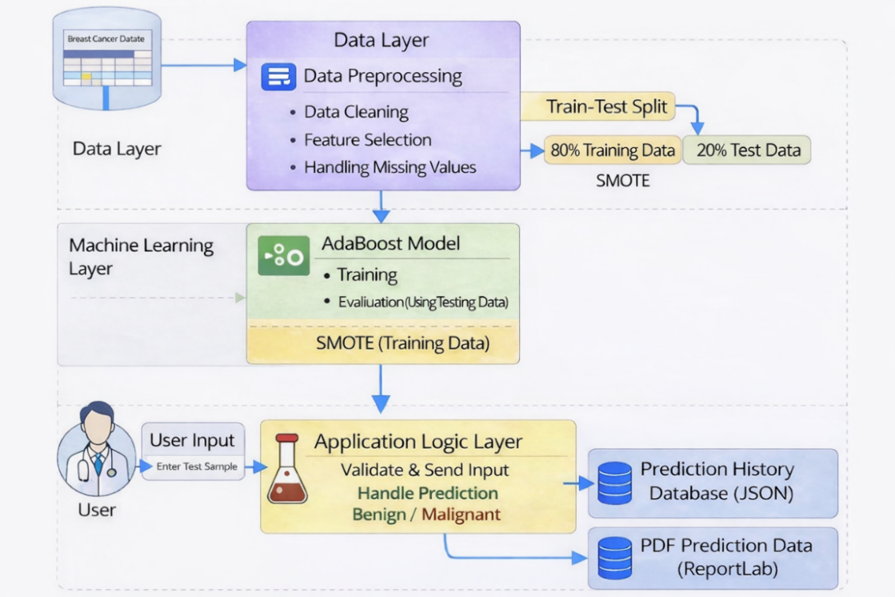

Fig 5.1: System Architecture

UML DIAGRAMS

UML stands for Unified Modeling Language. UML is a standardized general-purpose modeling language in the field of object-oriented software engineering. The standard is managed, and was created by, the Object Management Group.
The goal is for UML to become a common language for creating models of object- oriented computer software. In its current form UML is comprised of two major components: a Meta- model and a notation. In the future, some form of method or process may also be added to or associated with, UML.
The Unified Modeling Language is a standard language for specifying, Visualization, Constructing and documenting the artifacts of software system, as well as for business modeling and other non-software systems.
The UML represents a collection of best engineering practices that have proven successful in the modeling of large and complex systems. The UML is a very important part of developing objects-oriented software and the software development process. The UML uses mostly graphical notations to express the design of software projects.

GOALS:

The Primary goals in the design of the UML are as follows:

  - Provide users a ready-to-use, expressive visual modeling Language so that they can develop and exchange meaningful models.

  - Provide extendibility and specialization mechanisms to extend the core concepts.

Class Diagram

The class diagram represents the structural design of the Breast Cancer Detection System using the AdaBoost classifier. It shows the key classes and their interactions. The Doctor class enables login, patient data entry, viewing prediction results, and logout, while the Admin class manages stored prediction records. The StreamlitApp class acts as the main controller, handling user input, predictions, and result display. The Model class loads the trained AdaBoost model and generates predictions, and the PredictionHistory class manages storing and retrieving data in JSON format. Overall, the diagram illustrates how the system components work together efficiently.

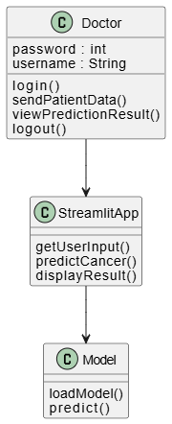

Fig.5.2.1: Class Diagram

Use Case Diagram

A use case diagram represents the functional requirements of the Breast Cancer Detection System using the AdaBoost classifier by showing the interaction between actors and system features. In this project, two main actors are identified: Doctor and Admin. The Doctor can log in, enter patient details and tumor features, predict the diagnosis, view probability and prediction history, download reports, and log out. The Admin can log in, view prediction records and reports, monitor model performance, manage the dataset, and log out. The diagram clearly illustrates how both actors interact with the system to perform diagnosis and management tasks efficiently.

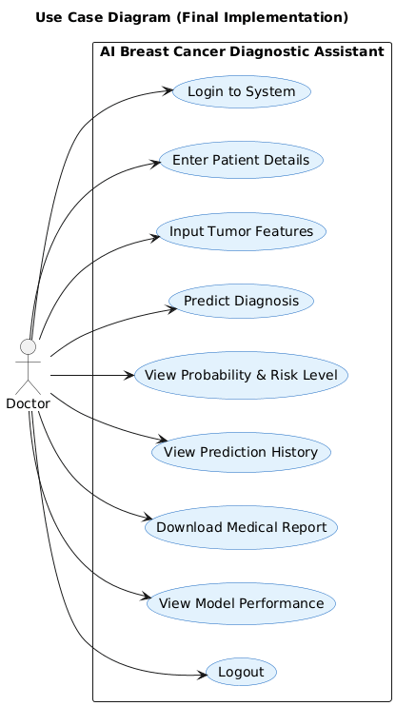

Fig.5.2.2: Use Case Diagram

Sequence Diagram

The sequence diagram illustrates the interaction between the Doctor, UI, and Model in the breast cancer prediction system. Initially, the doctor enters patient data through the user interface. The UI then sends the entered data to the model for prediction. The model analyzes the data using the AdaBoost classifier and determines whether the tumor is benign or malignant. After processing, the prediction result is returned to the UI, which then displays the final diagnosis to the doctor. This diagram clearly shows the step-by-step flow of data and communication between system components during the prediction process.

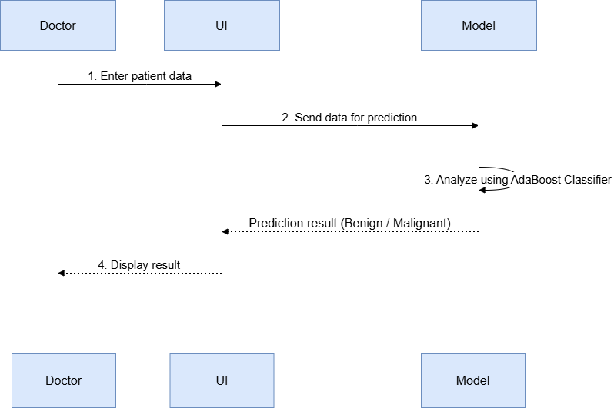

Fig.5.2.3: Sequence Diagram

Activity Diagram

The activity diagram illustrates the complete workflow of the Breast Cancer Detection System in a clear and structured manner. It begins with the doctor logging into the system, followed by entering patient details required for diagnosis. The system then preprocesses the entered data to ensure accuracy before applying the AdaBoost model to predict whether the tumor is benign or malignant. Once the prediction is generated, the result is displayed to the doctor and securely saved for future reference. In parallel, the admin workflow starts with admin login, allowing access to stored prediction records. The admin can view, manage, or delete these records as needed and then log out of the system. Overall, the diagram clearly represents the sequential flow of activities and highlights the distinct responsibilities of both doctor and admin roles in the system.
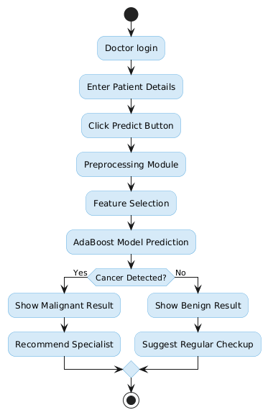

Fig.5.2.4: Activity Diagram

Object Diagram
The object diagram shows how different objects in the Breast Cancer Detection System interact during execution. The User object provides the medical attributes as input features and submits them to the system. The BreastCancerPredictionModel object receives these input features and processes them using the prediction function. The model analyzes the medical attributes and determines whether the tumor is benign or malignant. The Result object stores and displays the prediction outcome. This diagram represents the interaction between the user, prediction model, and result component in the system.

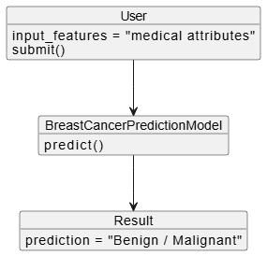

Fig.5.2.5: Object Diagram

Component Diagram

The Component Diagram shows the main components of the Breast Cancer Detection System using the AdaBoost Classifier and how they interact with each other. The system is divided into two main parts: the User Interface and the Backend. The User Interface is developed using Streamlit, which allows users to interact with the system, upload datasets, and view prediction results. The Backend includes the Data Preprocessing, Breast Cancer Prediction Model, and AdaBoost Prediction components. Data preprocessing prepares the dataset for training, and the AdaBoost model analyzes the processed data to generate prediction results. The final prediction results are then sent back to the user interface and displayed to the user. Thus, the component diagram explains how the Streamlit web application connects with backend modules to perform breast cancer prediction.

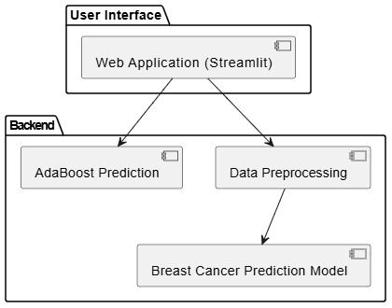

Fig.5.2.6: Component Diagram

Collaboration Diagram

The collaboration diagram illustrates how different components of the Breast Cancer Detection System interact with each other during the prediction process. The user first logs into the system and enters the patient’s medical details through the application interface. After submitting the details, the user requests a prediction from the system. The Breast Cancer Detection System processes the input data and sends it to the AdaBoost model for further analysis. The AdaBoost model evaluates the medical attributes and returns the prediction result to the system. The system then displays the prediction outcome indicating whether the tumor is benign or malignant to the user. In addition, the admin manages and maintains the prediction data and system records.

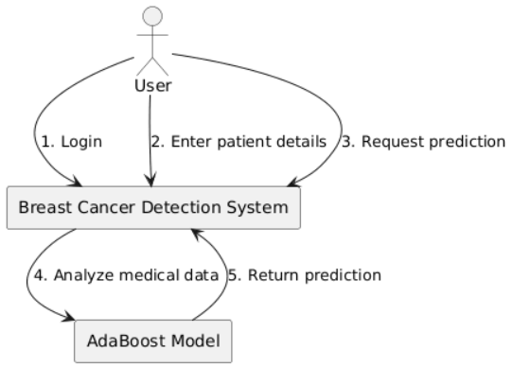

Fig.5.2.7: Collaboration Diagram

Deployment Diagram

The deployment diagram shows how the Breast Cancer Detection System is physically deployed and how its components interact. The user accesses the system through a web browser on a user device, providing a simple and platform-independent interface. The browser communicates with the web server over HTTP/HTTPS, ensuring secure and reliable data transfer. The web server hosts the Streamlit application, which acts as the central controller of the system. It handles user requests, manages input validation, and coordinates communication between the machine learning model and storage components. The Streamlit application loads the trained AdaBoost model (.pkl) to perform tumor prediction and uses the breast_cancer_data.csv file as the reference dataset for feature processing and scaling. After generating the prediction, the results are displayed to the user in real time and stored in local storage as prediction_history.json for future review and administrative purposes. This storage mechanism allows easy retrieval, monitoring, and management of past predictions. Overall, the diagram clearly explains the deployment environment, system scalability, and smooth data flow between the user device, web server, machine learning model, and storage components.

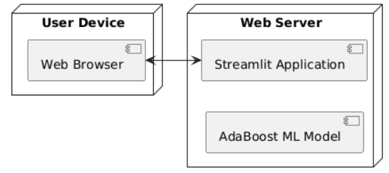

Fig.5.2.8: Deployment Diagram

MODULES

This section describes the features and structure of the breast cancer detection system. The proposed system uses Artificial Intelligence and Machine Learning techniques to assist in the early detection of breast cancer. It analyzes tumor characteristics and predicts whether the tumor is benign or malignant. The system is developed using Python and Streamlit, providing an interactive interface for users to enter data, perform predictions, and view results easily.
In the proposed system, the framework mainly consists of the following modules:
  - Data Collection Module & Data Pre-processing Module
  - Model Training Module
  - Prediction Module
  - Model Performance Evaluation Module
  - Data Visualization Module
  - User Interface Module

5.3.1 Data Collection Module & Data Pre-processing Module
This This module collects the dataset used to train and test the machine learning model. The system uses the Breast Cancer Wisconsin Diagnostic Dataset, which contains tumor features such as radius, texture, smoothness, concavity, and symmetry. These features help determine whether a tumor is benign or malignant, and the dataset is widely used in medical research for building predictive models. The data preprocessing module prepares the dataset by cleaning data, removing missing values, and performing normalization and feature selection. Techniques like StandardScaler and SMOTE are used to handle class imbalance and improve the accuracy and reliability of the prediction model.

5.3.2 Model Training Module
This module uses the AdaBoost (Adaptive Boosting) classifier to train the machine learning model. AdaBoost is an ensemble learning technique that combines multiple weak classifiers to form a strong predictive model. It works by assigning weights to each training sample and increasing weights of incorrectly classified instances in subsequent iterations. This allows the model to focus more on difficult cases. As a result, AdaBoost enhances accuracy and robustness while reducing errors, making it effective for breast cancer detection.

5.3.3 Prediction Module
The prediction module allows users to input tumor characteristics through an interactive interface. Based on the provided input values, the trained AdaBoost model analyzes the data and predicts whether the tumor is benign or malignant. The system also calculates the prediction probability and provides confidence levels to help users better understand the diagnosis result. Additionally, the module ensures quick and real-time prediction, making it suitable for practical medical decision support.

5.3.4 Model Performance Evaluation Module
This module evaluates the performance of the trained model using different evaluation metrics such as accuracy, confusion matrix, ROC curve, and precision-recall curve. These metrics help measure the effectiveness of the machine learning model and ensure that the system produces reliable predictions for medical decision support. Additionally, the module helps in identifying model strengths and weaknesses, enabling further optimization and improvement of prediction accuracy.

5.3.5 Data Visualization Module
The data visualization module provides graphical representations of the dataset and prediction results. It includes charts such as feature importance graphs, histograms, ROC curves, and probability distributions. These visualizations help users better understand the dataset patterns and the model's prediction behavior. Additionally, the module enhances interpretability by presenting complex data in a clear and intuitive visual format.

5.3.6 User Interface Module
The user interface module provides an interactive platform for users to interact with the system. It is developed using Streamlit, allowing users to enter patient details, view prediction results, and generate diagnostic reports easily. The interface is simple, interactive, and user-friendly. Additionally, it ensures smooth navigation and quick access to different features, enhancing the overall user experience.

6. IMPLEMENTAION

PYTHON
Below are some facts about Python. Python is currently the most widely used multi- purpose, high-level programming language. Python allows programming in Object-Oriented and Procedural paradigms. Python programs generally are smaller than other programming languages like Java. Programmers have to type relatively less and indentation requirement of the language, makes them readable all the time. Python language is being used by almost all tech-giant companies like – Google, Amazon, Facebook, Instagram, Dropbox, Uber… etc. The biggest strength of Python is huge collection of standard library which can be used for the following –
- Deep Learning
- Image Processing
- Web Development
- Natural Language Processing (NLP)
- Data Handling & Visualization

Advantages of Python:

Let’s see how Python dominates over other languages.

Extensive Libraries
Python downloads with an extensive library and it contain code for various purposes like regular expressions, documentation-generation, unit-testing, web browsers, threading, databases, CGI, email, image manipulation, and more. So, we don’t have to write the complete code for that manually.

Extensible

As we have seen earlier, Python can be extended to other languages. You can write some of your code in languages like C++ or C.

Embeddable

Complimentary to extensibility, Python is embeddable as well. You can put your Python code in your source code of a different language, like C++. This lets us

Improved Productivity

The language’s simplicity and extensive libraries render programmers more productive than languages like Java and C++ do. Also, the fact that you need to write less and get more things done.

IOT Opportunities

Since Python forms the basis of new platforms like Raspberry Pi, it finds the future bright for the Internet Of Things. This is a way to connect the language with the real world.

Simple and Easy

When working with Java, you may have to create a class to print ‘Hello World’. But in Python, just a print statement will do. It is also quite easy to learn, understand, and code. This is why when people pick up Python, they have a hard time adjusting to other more verbose languages like Java.

Readable

Because it is not such a verbose language, reading Python is much like reading English. This is the reason why it is so easy to learn, understand, and code. It also does not need curly braces to define blocks, and indentation is mandatory. This further
aids the readability of the code.

Object-Oriented

This language supports both the procedural and object-oriented programming paradigms. While functions help us with code reusability, classes and objects let us model the real world. A class allows the encapsulation of data and functions into one.

Free and Open-Source

Like we said earlier, Python is freely available. But not only can you download Python for free, but you can also download its source code, make changes to it, and even distribute it. It downloads with an extensive collection of libraries to help you with your tasks.

Portable

When you code your project in a language like C++, you may need to make some changes to it if you want to run it on another platform. But it isn’t the same with Python. Here, you need to code only once, and you can run it anywhere. This is called Write Once Run Anywhere (WORA). However, you need to be careful enough not to include any system- dependent features.

Interpreted

Lastly, we will say that it is an interpreted language. Since statements are executed one by one, debugging is easier than in compiled languages.

History of Python
What do the alphabet and the programming language Python have in common? Right, both start with ABC. If we are talking about ABC in the Python context, it's clear that the programming language ABC is meant. ABC is a general-purpose programming language and programming environment, which had been developed in the Netherlands, Amsterdam, at the CWI (Centrum Wiskunde &Informatica). The greatest achievement of ABC was to influence the design of Python. Python was conceptualized in the late 1980s. Guido van Rossum worked that time in a project at the CWI, called Amoeba, a distributed operating system. In an interview with Bill Venners1, Guido van Rossum said: "In the early 1980s, I worked as an implementer on a team building a language called ABC at Centrum voor Wiskunde en Informatica (CWI). I don't know how well people know ABC's influence on Python. I try to mention ABC's influence because I'm indebted to everything I learned during that project and to the people who worked on it.

6.1.2 What is Machine Learning
Before we look at the details of various machine learning methods used in CustomerPulse, let us start by understanding what machine learning is and what it is not. Machine Learning is a subset of Artificial Intelligence that enables systems to automatically learn and improve from experience without being explicitly programmed for every task. Instead of following hard-coded rules, a machine

learning model learns patterns and relationships directly from data and uses those learned patterns to make predictions or decisions on new, unseen data.
In the context of CustomerPulse, machine learning is used to analyse behavioral session signals from e-commerce customers and predict whether they will make a purchase. The system uses a Random Forest ensemble of 500 decision trees — a powerful supervised machine learning model — to identify the complex combinations of behavioral signals that indicate purchase intent. Machine learning models are capable of discovering non-linear patterns in structured data, which makes them highly effective for behavioral prediction, customer segmentation, and purchase intent classification tasks.

Categories of Machine Learning
Machine Learning is one of the most important technologies in modern artificial intelligence. It enables computers to learn from data without being explicitly programmed for every scenario. Machine learning can be classified into three main categories based on how the model learns from data.
Supervised Learning is the most widely used category of machine learning. In supervised learning, the model is trained on a labeled dataset — meaning each training example has both input features and a known correct output. The model learns to map inputs to outputs by minimizing prediction errors. CustomerPulse uses supervised learning for purchase prediction: the Random Forest classifier is trained on 88,000 labeled sessions where the Revenue label (True or False) tells the model which sessions resulted in purchases. Examples of supervised learning algorithms include Random Forest, Logistic Regression, Support Vector Machines, Decision Trees, and Gradient Boosting.Unsupervised Learning involves training a model on data without labeled outputs. The model discovers hidden patterns, groupings, or structures in the data on its own. CustomerPulse uses unsupervised learning for customer segmentation: the K-Means algorithm groups customer sessions into 4 behavioral personas without being told which group each session belongs to. K-Means finds natural clusters based on behavioral similarity. Other examples of unsupervised learning include hierarchical clustering, Principal Component Analysis (PCA), and autoencoders. Reinforcement Learning is a type of machine learning where an agent learns to make decisions by interacting with an environment

The agent learns to maximize cumulative reward over time through trial and error. While CustomerPulse does not use reinforcement learning in its current
implementation, a future version could use it to learn the optimal intervention strategy — when to show a discount, when to show a free shipping banner, when to trigger live chat — based on actual conversion outcomes.

Need for Machine Learning
Machine learning is needed in CustomerPulse and in modern AI systems because it solves problems that rule-based programming fundamentally cannot handle. Automatic Pattern Discovery: Traditional software requires developers to manually write rules — "if PageValues is greater than 50 and BounceRates is less than 0.02, predict purchase." But with 25 features and millions of possible combinations, manually writing every rule is impossible. Machine learning automatically discovers these patterns from 88,000 training examples.
Handles Non-Linear Relationships: Customer behavior does not follow simple linear rules. PageValues of 80 with BounceRates of 0.001 is an extremely different situation from PageValues of 80 with BounceRates of 0.18. Machine learning models like Random Forest capture these complex interactions naturally, something that simple rule-based systems or linear models cannot do.
Scales to Large Datasets: CustomerPulse trains on 110,000 sessions with 25 features each. Processing and learning from this volume of data is only possible through machine learning algorithms that are designed to handle large-scale tabular datasets efficiently. Continuous Improvement: As new session data becomes available, the machine learning model can be retrained to incorporate new patterns. If customer behavior shifts — for example, due to a new competitor entering the market — the model learns the new patterns automatically from updated data.
Real-Time Prediction: Trained machine learning models make predictions in milliseconds. The CustomerPulse RandomForest model produces a purchase probability for a new session in under 5 milliseconds.

Challenges in Machine Learning
Machine learning offers immense potential, but several challenges can hinder its effective implementation. Addressing these challenges is crucial for developing

Overfitting and Underfitting — In machine learning it is sometimes difficult to balance the model. Overfitting happens when the model learns the training data too well, including noise and random fluctuations, and performs poorly on new unseen data. Underfitting occurs when the model is too simple and cannot learn the important patterns in the data. CustomerPulse addresses overfitting in Random Forest through max_depth=20 which limits tree complexity, and min_samples_leaf=2 which prevents trees from creating leaf nodes based on single data points.
Class Imbalance — CustomerPulse faces a significant class imbalance challenge: only 14.2% of sessions result in purchase while 85.8% do not. A naive model could predict "no purchase" for every session and achieve 85.8% accuracy without learning anything useful. CustomerPulse addresses this through minority class oversampling in training and class_weight="balanced" in Random Forest, which penalizes the model more for missing actual buyers.
Feature Engineering — Raw features from web analytics do not always directly express the patterns the model needs to learn. CustomerPulse required 8 engineered features on top of the 17 raw UCI features to capture non-linear behavioral combinations like SessionDepth and EngagementScore. Identifying which engineered features to create requires domain knowledge and experimentation.
Data Quality and Quantity — Machine learning models need sufficient high-quality data for training. With only 12,330 rows in the original UCI dataset and 14.2% purchase rate, only approximately 1,900 buyer examples exist — insufficient for a stable 500-tree Random Forest. CustomerPulse expanded the dataset to 110,000 sessions while preserving all statistical properties of the original UCI data. Model Interpretability — Machine learning models are sometimes difficult to explain to non-technical stakeholders. A business manager asking "why did you predict this customer will buy?" needs a clear answer. CustomerPulse addresses this through feature importance rankings which show that SessionDepth (21.1%) and EngagementScore (10.7%) are the most important predictors — an explanation any business analyst can understand.
Hyperparameter Tuning — Machine learning models have many configuration settings called hyperparameters. In Random Forest these include n_estimators, max_depth, min_samples_leaf, and max_features.

Finding the best settings requires systematic experimentation and affects prediction performance significantly. CustomerPulse tested multiple hyperparameter combinations before settling on the final configuration.

Applications of Machine Learning
Machine Learning is one of the most rapidly growing technologies in artificial intelligence. It is widely used to solve complex real-world problems across virtually every industry. Some of the important real-world applications of Machine Learning include:
- E-commerce purchase intent prediction and conversion rate optimization
- Customer segmentation and behavioral profiling for targeted marketing
- Fraud detection in banking and financial transactions
- Medical diagnosis and disease prediction from patient records
- Spam detection and email filtering systems
- Recommendation systems for streaming platforms, e-commerce, and social media
- Credit scoring and loan default prediction
- Predictive maintenance in manufacturing and industrial equipment
- Weather forecasting and climate modeling
- Stock price prediction and algorithmic trading

Learning Machine Learning
To learn machine learning effectively, especially for projects like CustomerPulse, it is important to follow a structured approach. First, learn the fundamental Python libraries: NumPy for numerical computing, Pandas for data manipulation, and Matplotlib or Seaborn for visualization. These tools are used in every step of the machine learning pipeline from data loading to results presentation.
After learning the basics, focus on understanding core machine learning concepts: supervised vs unsupervised learning, the bias-variance tradeoff, cross-validation, and evaluation metrics like accuracy, precision, recall, F1 score, and ROC-AUC. Understanding why class imbalance is a problem and how to handle it is particularly important for real-world datasets. Another critical step is learning scikit-learn — the industry-standard Python machine learning library. scikit-learn provides consistent

APIs for dozens of algorithms including Random Forest, Logistic Regression, K-Means, and StandardScaler. Understanding how to use scikit-learn's Pipeline, train_test_split, and cross_val_score functions enables building professional machine learning workflows.
Finally, learning Flask helps in deploying trained models as web applications, allowing users to submit session parameters and receive purchase predictions in real time. Understanding how to serialize trained models with pickle and load them at application startup enables building production-quality ML-powered web applications.

How to Start Learning Machine Learning
To start learning machine learning, students can use a combination of online courses, books, and hands-on practice. Online platforms such as Coursera offer the "Machine Learning Specialization" by Andrew Ng — the most widely recommended starting point for ML beginners. Udemy provides courses like "Machine Learning A-Z" and "Python for Data Science and Machine Learning Bootcamp" which cover practical implementation in Python.
In addition to online courses, reading books such as "Hands-On Machine Learning with Scikit-Learn, Keras, and TensorFlow" by Aurélien Géron and "Introduction to Machine Learning with Python" by Andreas Müller provide strong theoretical and practical foundations. For understanding tree-based models specifically — which are the core of CustomerPulse — "The Elements of Statistical Learning" by Hastie, Tibshirani, and Friedman is an excellent advanced reference.
Hands-on practice is the most important step. Students should work on real datasets from Kaggle and the UCI Machine Learning Repository. Starting with the UCI Online Shoppers Purchasing Intention Dataset

  - ALGORITHMS

6.2.1 AdaBoost-Based Breast Cancer Prediction Algorithm

The proposed breast cancer detection system uses the AdaBoost algorithm to classify tumors as benign or malignant. AdaBoost is a supervised machine learning technique that improves classification accuracy by combining multiple weak learners to create a strong predictive model. In this system, the model is trained using a dataset that contains several tumor characteristics such as radius, texture, smoothness, perimeter, concavity, and symmetry. These features represent important medical measurements that help the algorithm learn patterns associated with cancerous and non-cancerous tumors. During the prediction phase, the doctor enters the patient’s tumor feature values through the system interface. The system processes these values and converts them into a numerical format suitable for the trained model. The trained AdaBoost model evaluates the input feature values using an ensemble of weak classifiers and produces the final classification result. Based on this analysis, the system predicts whether the tumor is benign or malignant and displays the result along with the confidence level. This information helps doctors clearly understand the prediction outcome and supports them in making better medical decisions.

6.2.2 Data Preprocessing and Feature Scaling Algorithm

The proposed breast cancer detection system uses the AdaBoost algorithm to classify tumors as benign or malignant. AdaBoost is a supervised machine learning technique that improves classification accuracy by combining multiple weak learners to create a strong predictive model. In this system, the model is trained using a dataset that contains tumor characteristics such as radius, texture, smoothness, perimeter, concavity, and symmetry. These features represent important medical measurements that help the algorithm learn patterns associated with cancerous and non-cancerous tumors. During the prediction phase, the doctor enters the patient’s tumor feature values through the system interface. The system processes these values and converts them into a numerical format suitable for the trained model. The trained AdaBoost model evaluates the input feature values using an ensemble of weak classifiers and produces the final classification result. Based on this analysis, the system predicts whether the tumor is benign or malignant and displays the result with the confidence level, helping doctors understand the outcome and make better medical decisions.

6.2.3 Prediction Probability and Risk Level Algorithm
After the AdaBoost model predicts whether the tumor is benign or malignant, the system calculates the probability associated with the predicted result. This probability value represents the confidence level of the machine learning model in classifying the tumor correctly. A higher probability score indicates stronger confidence in the predicted class, while a lower score indicates greater uncertainty in the classification. Based on the probability score, the system determines the risk level of the tumor. The system categorizes the prediction into low, medium, or high risk levels depending on the probability value. This classification helps doctors understand the seriousness of the condition more easily and provides additional insight into the prediction outcome. The system then displays the final prediction result along with the probability score and risk level. Providing this additional information supports medical diagnosis and assists healthcare professionals in making informed clinical decisions.

6.2.4 Medical Report Generation Algorithm
The breast cancer detection system also includes a report generation feature that creates a detailed medical report of the prediction results. When the doctor requests the report, the system collects important information such as patient details, tumor feature values, prediction result, probability score, and risk level. These details are organized in a structured format to make the report clear, readable, and easy to understand for medical professionals. The report is generated in PDF format using the ReportLab library. The generated document includes patient information, diagnosis results, prediction probability, and recommendations for further medical consultation or examination. It may also include a brief explanation summarizing the prediction outcome and the level of confidence provided by the machine learning model. This report can be downloaded and shared with healthcare professionals, which helps in maintaining proper medical records and supports further clinical evaluation and follow-up treatment if required. Additionally, storing reports digitally enables easier review of previous predictions and supports long-term monitoring of the patient’s condition.

SOURCE CODE

7.1 STREAMLIT_APP.PY

import pandas as pd
import pandas as pd
import numpy as np
import streamlit as st
import plotly.express as px
import plotly.graph_objs as go
import joblib
import seaborn as sns
import requests
import pickle
import base64
import os
import matplotlib.pyplot as plt
from io import BytesIO
from reportlab.lib.pagesizes import letter
from reportlab.pdfgen import canvas
from sklearn.metrics import (
roc_curve,
auc,
confusion_matrix,
classification_report,
precision_recall_curve,
accuracy_score
)
from sklearn.model_selection import train_test_split
from sklearn.preprocessing import StandardScaler
from datetime import datetime
import json
HISTORY_FILE = "prediction_history.json"

def remove_emojis_for_csv(text):
if not isinstance(text, str):
return text
text = text.replace("🟢", "").replace("🔴", "").replace("🟡", "")
text = text.replace("✅", "").replace("⚠️", "").replace("🎯","")
return text.strip()
def load_history():
if os.path.exists(HISTORY_FILE):
with open(HISTORY_FILE, "r") as f:
try:
return json.load(f)
except json.JSONDecodeError:
return []
return []
def save_history(history):
with open(HISTORY_FILE, "w") as f:
json.dump(history, f, indent=4)
class BreastCancerDetectionApp:
def __init__(self):
st.set_page_config(
page_title="AI Breast Cancer Diagnostic Assistant",
page_icon="🩺",
layout="wide",
initial_sidebar_state="expanded"
)
if "prediction_history" not in st.session_state:
st.session_state.prediction_history = load_history()
if "edit_index" not in st.session_state:
st.session_state.edit_index = None
self.setup_page()
self.load_resources()

def setup_page(self):
bg_color = st.sidebar.selectbox(
"🎨 Select Background Color",
[
"Grey",
"White",
"Light Blue",
"Light Green",
"Light Yellow",
"Light Grey",
"Light Pink"
]
)
bg_map = {
"Grey": "#F4F6F7",
"White": "#FFFFFF",
"Light Blue": "#E3F2FD",
"Light Green": "#E8F5E9",
"Light Yellow": "#FFFDE7",
"Light Grey": "#F5F5F5",
"Light Pink": "#FCE4EC"
}
st.markdown(
f"""
<style>
.stApp {{
background-color: {bg_map[bg_color]};
}}
.main-header {{
background: linear-gradient(135deg, #2C3E50 0%, #3498DB 100%);
color: white;
padding: 20px;

text-align: center;
border-radius: 10px;
margin-bottom: 20px;
}}
.metric-container {{
background: white;
border-radius: 15px;
padding: 15px;
box-shadow: 0 4px 6px rgba(0,0,0,0.1);
}}
.prediction-card {{
background: white;
border-radius: 20px;
padding: 25px;
box-shadow: 0 8px 16px rgba(0,0,0,0.1);
margin: 20px 0;
}}
.history-box {{
background: #FFFFFF;
border-radius: 15px;
padding: 20px;
box-shadow: 0px 6px 12px rgba(0,0,0,0.1);
margin-bottom: 15px;
}}
</style>
""",
unsafe_allow_html=True
)
def load_resources(self):
@st.cache_resource
def load_model_data():
model_path = "Weight files/adaboost_model_with_smote_on_original_data.pkl"

scaler_path = "Weight files/scaler.pkl"
dataset_path = "breast_cancer_data.csv"
if not os.path.exists(dataset_path):
st.error("Dataset file missing.")
return None
data = pd.read_csv(dataset_path)
data = data.loc[:, ~data.columns.str.contains("^Unnamed")]
if not os.path.exists(model_path):
st.error("Model file missing.")
return None
with open(model_path, "rb") as f:
model = pickle.load(f)
scaler = None
if os.path.exists(scaler_path):
with open(scaler_path, "rb") as f:
scaler = pickle.load(f)
feature_names = [c for c in data.columns if c not in ("id", "diagnosis")]
return model, scaler, data, feature_names
resources = load_model_data()
if resources is None:
st.stop()
self.model, self.scaler, self.data, self.feature_names = resources
df = self.data.copy()
y = df["diagnosis"].map({"M": 1, "B": 0})
X = df[self.feature_names]

X_train, X_test, y_train, y_test = train_test_split(
X,
y,
test_size=0.2,
random_state=42,
stratify=y

)
if self.scaler is None:
self.scaler = StandardScaler()
X_train_scaled = self.scaler.fit_transform(X_train)
X_test_scaled = self.scaler.transform(X_test)
else:
X_train_scaled = self.scaler.transform(X_train)
X_test_scaled = self.scaler.transform(X_test)

self.y_test = y_test
self.y_pred = self.model.predict(X_test_scaled)
self.y_pred_proba = self.model.predict_proba(X_test_scaled)[:, 1]
self.conf_matrix = confusion_matrix(y_test, self.y_pred)
self.classification_report_text = classification_report(y_test, self.y_pred)
self.accuracy = accuracy_score(y_test, self.y_pred)
def main_router(self):
menu = st.sidebar.radio(
"📌 Navigation",
[
"🏠 Home",
"🔍 Prediction",
"📊 Model Performance",
"📁 Prediction History",
"📄 Download Report"
]
)
if menu == "🏠 Home":
self.home_page()
elif menu == "🔍 Prediction":
self.prediction_page()
elif menu == "📊 Model Performance":

self.performance_page()
elif menu == "📁 Prediction History":
self.history_page()
elif menu == "📄 Download Report":
self.download_report_page()

def home_page(self):
st.markdown(
"""
<div class="main-header">
<h1>AI Breast Cancer Diagnostic Assistant</h1>
<p>Machine Learning Based Breast Cancer Classification System</p>
</div>
""",
unsafe_allow_html=True
)
col1, col2, col3 = st.columns(3)
with col1:
st.metric("Model Accuracy", f"{self.accuracy*100:.2f}%")
with col2:
st.metric("Total Samples", len(self.data))
with col3:
st.metric("Features Used", len(self.feature_names))
st.markdown("### 📊 Dataset Preview")
st.dataframe(self.data.head())
def prediction_page(self):
st.markdown("## 🔍 Patient Diagnosis Prediction")
input_data = {}

col1, col2 = st.columns(2)
for i, feature in enumerate(self.feature_names):

if i % 2 == 0:
with col1:
input_data[feature] = st.number_input(
feature,
value=float(self.data[feature].mean())
)
else:
with col2:
input_data[feature] = st.number_input(
feature,
value=float(self.data[feature].mean())
)
if st.button("Predict Diagnosis"):

input_df = pd.DataFrame([input_data])
input_scaled = self.scaler.transform(input_df)
prediction = self.model.predict(input_scaled)[0]
probability = self.model.predict_proba(input_scaled)[0][1]
result_text = "Malignant" if prediction == 1 else "Benign"
st.markdown(
f"""
<div class="prediction-card">
<h2>Prediction Result: {result_text}</h2>
<p>Probability of Malignancy: {probability*100:.2f}%</p>
</div>
""",
unsafe_allow_html=True
)
history_record = {
"timestamp": datetime.now().strftime("%Y-%m-%d %H:%M:%S"),
"prediction": result_text,
"probability": round(probability*100, 2)

}
st.session_state.prediction_history.append(history_record)
save_history(st.session_state.prediction_history)
def performance_page(self):
st.markdown("## 📊 Model Performance Metrics")
col1, col2 = st.columns(2)
with col1:
st.markdown("### Confusion Matrix")
fig_cm = px.imshow(
self.conf_matrix,
text_auto=True,
labels=dict(x="Predicted", y="Actual"),
x=["Benign", "Malignant"],
y=["Benign", "Malignant"]
)
st.plotly_chart(fig_cm)
with col2:
st.markdown("### Classification Report")
st.text(self.classification_report_text)

fpr, tpr, _ = roc_curve(self.y_test, self.y_pred_proba)
roc_auc = auc(fpr, tpr)
fig_roc = go.Figure()
fig_roc.add_trace(
go.Scatter(
x=fpr,
y=tpr,
mode="lines",
name=f"ROC Curve (AUC = {roc_auc:.2f})"
)
)
fig_roc.add_trace(

go.Scatter(
x=[0, 1],
y=[0, 1],
mode="lines",
name="Random Classifier"
)
)
fig_roc.update_layout(
title="Receiver Operating Characteristic (ROC Curve)",
xaxis_title="False Positive Rate",
yaxis_title="True Positive Rate"
)
st.plotly_chart(fig_roc)
def history_page(self):
st.markdown("## 📁 Prediction History")
history = st.session_state.prediction_history
if not history:
st.info("No prediction history available.")
return
for idx, record in enumerate(history):
st.markdown(
f"""
<div class="history-box">
<b>Timestamp:</b> {record['timestamp']}<br>
<b>Prediction:</b> {record['prediction']}<br>
<b>Probability:</b> {record['probability']}%
</div>
""",
unsafe_allow_html=True
)
def download_report_page(self):
st.markdown("## 📄 Download Model Report")

if st.button("Generate PDF Report"):
buffer = BytesIO()
c = canvas.Canvas(buffer, pagesize=letter)
width, height = letter
c.drawString(50, height - 50, "Breast Cancer Diagnostic Report")
c.drawString(50, height - 80, f"Model Accuracy: {self.accuracy*100:.2f}%")
y_position = height - 120
c.drawString(50, y_position, "Classification Report:")
y_position -= 20
for line in self.classification_report_text.split("\n"):
c.drawString(60, y_position, line)
y_position -= 15
c.save()
buffer.seek(0)
st.download_button(
label="Download Report",
data=buffer,
file_name="breast_cancer_report.pdf",
mime="application/pdf"
)
if __name__ == "__main__":
app = BreastCancerDetectionApp()
app.main_router()

7.2 WELCOME.HTML

<!DOCTYPE html>
<html lang="en">
<head>
<meta charset="UTF-8">
<title>Welcome - AI Breast Cancer Diagnostic Assistant</title>
<link href="https://fonts.googleapis.com/css2?family=Poppins:wght@400;500;600;700&display=swap" rel="stylesheet">

<style>
*{
margin:0;
padding:0;
box-sizing:border-box;
font-family:"Poppins", sans-serif;
}
body{
min-height:100vh;
display:flex;
justify-content:center;
align-items:center;
overflow:hidden;
background:
linear-gradient(rgba(0,0,0,0.4), rgba(0,0,0,0.6)),
url("./Assest/img4.jpg");
background-size:cover;
background-position:center;
}
.emoji{
position:absolute;
font-size:90px;
opacity:0.4;
animation:float 10s linear infinite;
}
@keyframes float{
from{ transform:translateY(120vh); }
to{ transform:translateY(-20vh); }
}
.main-box{
max-width:1200px; /* wider */
width:92%;

padding:70px 120px; /* more space inside */
/* smoother for large size */
background:rgba(0,166,199,0.18);
backdrop-filter:blur(14px);
-webkit-backdrop-filter:blur(14px);
border-radius:32px;
box-shadow:0 30px 70px rgba(0,0,0,0.6);
text-align:center;
animation:fadeIn 1s ease;
}
@keyframes fadeIn{
from{ opacity:0; transform:translateY(30px); }
to{ opacity:1; transform:translateY(0); }
}
.heart{
font-size:80px;
animation:pulse 1.3s infinite;
}
@keyframes pulse{
0%{ transform:scale(1); }
50%{ transform:scale(1.15); }
100%{ transform:scale(1); }
}
h1{
font-size:38px;
margin:20px 0;
color:#ffffff;
font-weight:600;
letter-spacing:0.5px;
}
p{
font-size:18px;

color:#ffffff;
opacity:0.9;
margin-bottom:35px;
font-weight:400;
}
.start-button{
padding:16px 42px;
background:linear-gradient(to right,#00A6C7,#007C99);
color:white;
border-radius:16px;
text-decoration:none;
font-size:19px;
font-weight:600;
transition:0.3s;
}
.start-button:hover{
background:linear-gradient(to right,#0093B1,#006F8A);
box-shadow:0 12px 30px rgba(0,166,199,0.6);
}
</style>
</head>
<body>
<!-- Floating emojis -->
<div class="emoji" style="left:10%; animation-delay:0s; font-size:100px;">🧬</div>
<div class="emoji" style="left:30%; animation-delay:2s; font-size:90px;">💊</div>
<div class="emoji" style="left:50%; animation-delay:4s; font-size:110px;">🩺</div>
<div class="emoji" style="left:70%; animation-delay:6s; font-size:100px;">🫀</div>
<div class="emoji" style="left:90%; animation-delay:8s; font-

size:95px;">🧪</div>
<!-- Main content -->
<div class="main-box">
<div class="heart">🩺</div>
<h1>AI Breast Cancer Diagnostic Assistant</h1>
<p>
Your intelligent assistant for early breast cancer detection,
combining AI precision with medical insight.
</p>
<a href="login.html" class="start-button">Get Started</a>
</div>
</body>
</html>

7.1 LOGIN.HTML

<!DOCTYPE html>
<html lang="en">
<head>
<meta charset="UTF-8">
<title>Breast Cancer Login</title>
<!-- Google Font -->
<link href="https://fonts.googleapis.com/css2?family=Poppins:wght@400;500;600&display=swap" rel="stylesheet">
<style>
*{
margin:0;
padding:0;
box-sizing:border-box;
font-family:"Poppins","Segoe UI",sans-serif;
}
body{

min-height:100vh;
display:flex;
justify-content:center;
align-items:center;
overflow:hidden;
background:
linear-gradient(rgba(0,0,0,0.45), rgba(0,0,0,0.65)),
url("./Assest/img4.jpg");
background-size:cover;
background-position:center;
}
.emoji{
position:absolute;
opacity:0.3;
transform:translateY(120vh);
}
.emoji.animate{
animation:float 10s linear infinite;
}
@keyframes float{
from{ transform:translateY(120vh); }
to{ transform:translateY(-20vh); }
}
.login-container{
max-width:500px;
width:90%;
padding:50px 60px;
background:rgba(0,166,199,0.18);
backdrop-filter:blur(14px);
-webkit-backdrop-filter:blur(14px);
border-radius:26px;
box-shadow:0 30px 70px rgba(0,0,0,0.6);

text-align:center;
color:#fff;
animation:fadeIn 1s ease;
}
@keyframes fadeIn{
from{ opacity:0; transform:translateY(30px); }
to{ opacity:1; transform:translateY(0); }
}
h2{
font-size:32px;
font-weight:600;
margin-bottom:8px;
}
.subtitle{
font-size:15px;
opacity:0.9;
margin-bottom:30px;
}
.field-label{
font-size:20px;
font-weight:500;
margin:18px 0 6px;
display:block;
text-align:left;
}
input{
width:100%;
padding:16px;
border:none;
border-radius:16px;
font-size:15px;
background:rgba(255,255,255,0.95);

}
input::placeholder{
color:#555;
}
input:focus{
outline:none;
box-shadow:0 0 0 3px rgba(0,180,216,0.8);
}
button{
width:100%;
padding:16px;
margin-top:25px;
border:none;
border-radius:20px;
background:linear-gradient(135deg,#00A6C7,#007C99);
color:white;
font-size:17px;
font-weight:600;
cursor:pointer;
transition:0.3s;
}
button:hover{
transform:translateY(-4px);
box-shadow:0 15px 30px rgba(0,119,182,0.7);
}
button:active{
transform:scale(0.97);
}
</style>
</head>
<body>
<!-- FLOATING EMOJIS (FIRST = STETHOSCOPE) ->

<div class="emoji" style="left:10%; animation-delay:0s; font-size:110px;">🩺</div>
<div class="emoji" style="left:30%; animation-delay:2s; font-size:95px;">💊</div>
<div class="emoji" style="left:50%; animation-delay:4s; font-size:115px;">🧬</div>
<div class="emoji" style="left:70%; animation-delay:6s; font-size:100px;">🫀</div>
<div class="emoji" style="left:90%; animation-delay:8s; font-size:95px;">🧪</div>
<div class="login-container">
<h2>🩺 AI Breast Cancer Assistant</h2>
<p class="subtitle">Secure login to diagnostic system</p>
<form action="http://localhost:8501" method="get" autocomplete="off">
<label class="field-label">Username</label>
<input
type="text"
name="username"
placeholder="Enter your name or email"
autocomplete="off"
autocorrect="off"
autocapitalize="off"
spellcheck="false"
required>
<label class="field-label">Password</label>
<input
type="password"
name="password"
placeholder="Enter your password"
autocomplete="new-password"
required>

<button type="submit">Access Dashboard</button>
</form>
</div>
<!-- EMOJI ANIMATION -->
<script>
window.addEventListener('DOMContentLoaded', () => {
document.querySelectorAll('.emoji').forEach((emoji, i) => {
setTimeout(() => emoji.classList.add('animate'), i * 120);
});
});
</script>
</body>
</html>

8. TESTING AND RESULTS

SOFTWARE TESTING TECHNIQUES

Software testing is a critical element of software quality assurance and represents the ultimate review of specification, design, and coding. It ensures that the developed system functions correctly and meets the required user expectations. In the Breast Cancer Detection using AdaBoost Classifier project, testing verifies that the machine learning model, data preprocessing module, prediction system, and user interface operate correctly and efficiently according to the system design.

Unit Testing

Unit testing focuses on verifying the smallest functional units of the software system, which are called modules. In this project, each module such as data loading, feature preprocessing, AdaBoost model prediction, and result generation was tested individually. The objective of unit testing is to ensure that every component performs its intended function correctly. This testing helps identify logical errors and ensures that the internal operations of each module work properly before integrating them into the complete breast cancer detection system

Integration Testing

Integration testing is performed after unit testing to verify the interaction between different modules of the system. It ensures that the components communicate properly and that data flows correctly between them. In this project, integration testing checks the interaction between the data preprocessing module, AdaBoost classifier, prediction module, and the Streamlit user interface to ensure the system works smoothly without errors.

Validation Testing

The Validation testing is performed after the entire system is integrated into a complete application. It ensures that the Breast Cancer Detection system correctly predicts whether a tumor is benign or malignant based on the input medical attributes. This testing verifies that the prediction results meet the expected user requirements.

8.2 TEST CASES

S.  No. | TEST CASES | INPUT | EXPECTED RESULT | ACTUAL RESULT | STATUS
1 | User Login | Enter correct username and password | User should log in | Dashboard opened | PASS
2 | Login Validation | Leave username or password empty | System should show error | Error shown | PASS
3 | Missing Details | Leave patient details empty and click predict | System should still give result | No prediction | FAIL
4 | Patient Details | Enter patient details and click predict | System should give result | Prediction shown | PASS
5 | Predict Diagnosis | Click predict without entering values | System should give result | Prediction shown | PASS
6 | Random Forest Prediction | Provided dataset to model. | Model predicted correct classes | Prediction generated. | PASS

Table 8.2: Test Case Results

9.SAMPLE SCREEN

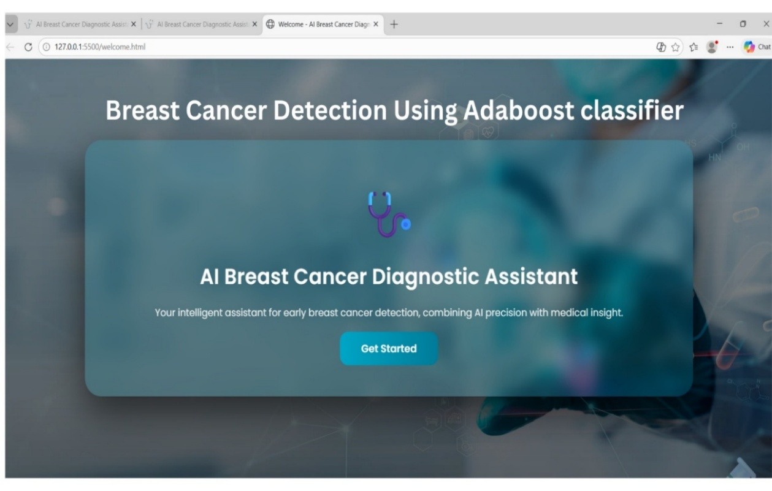

Screen 1 : Breast Cancer Detection System Home Page

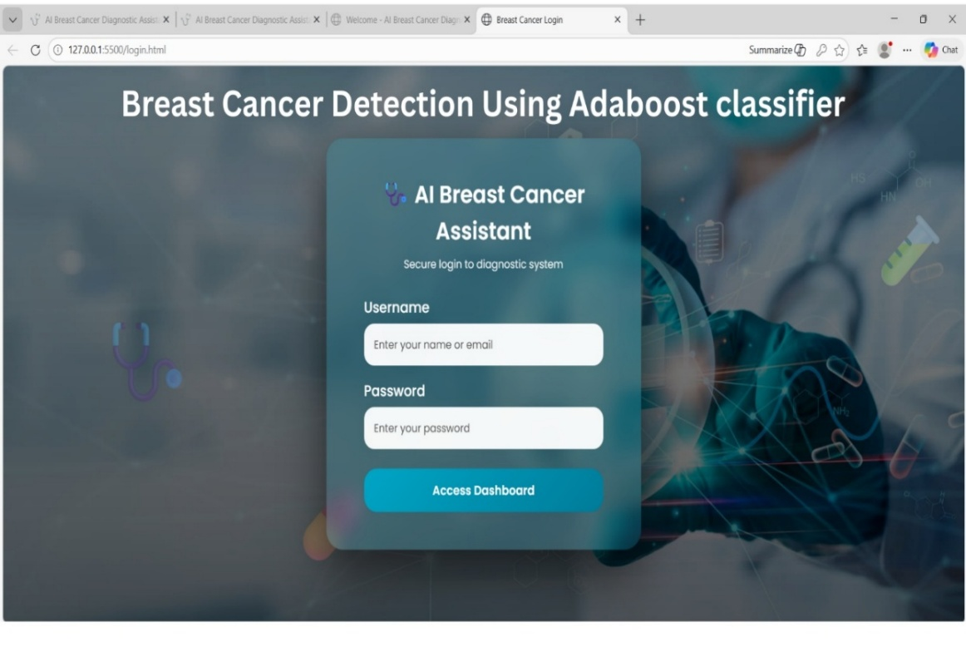

Screen 2 : Breast Cancer Detection System Login Page

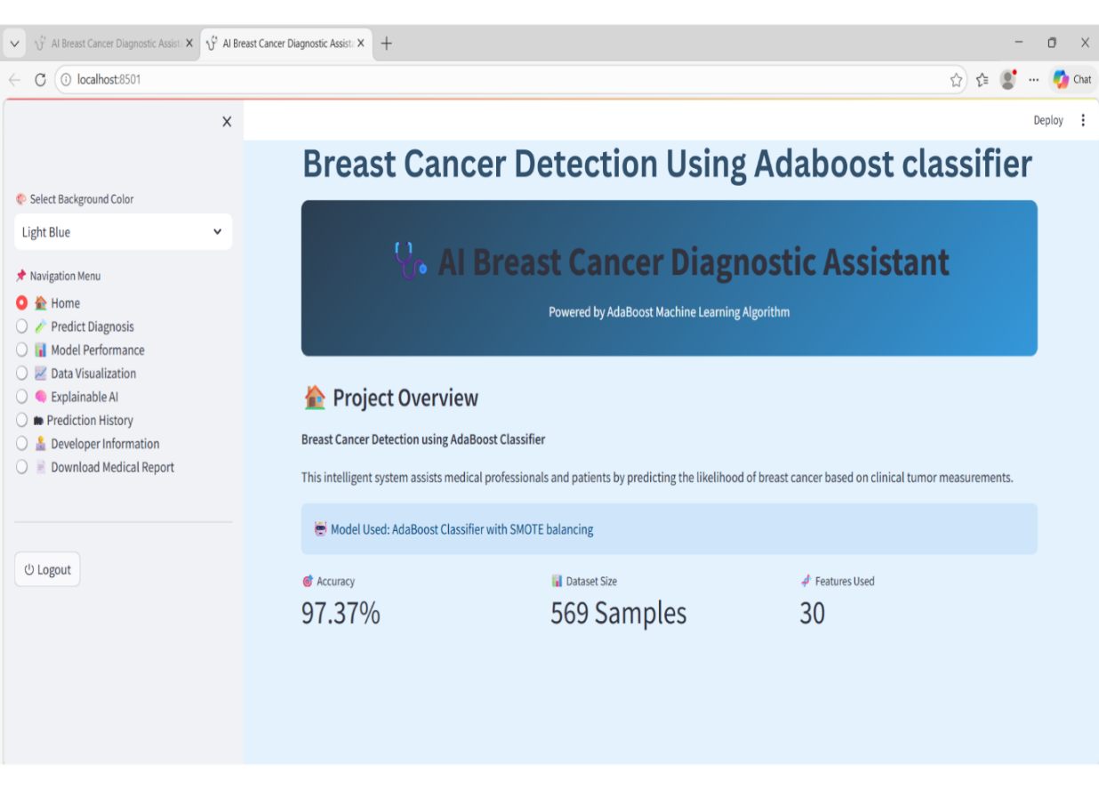

Screen 3 : Breast Cancer Detection System Dashboard

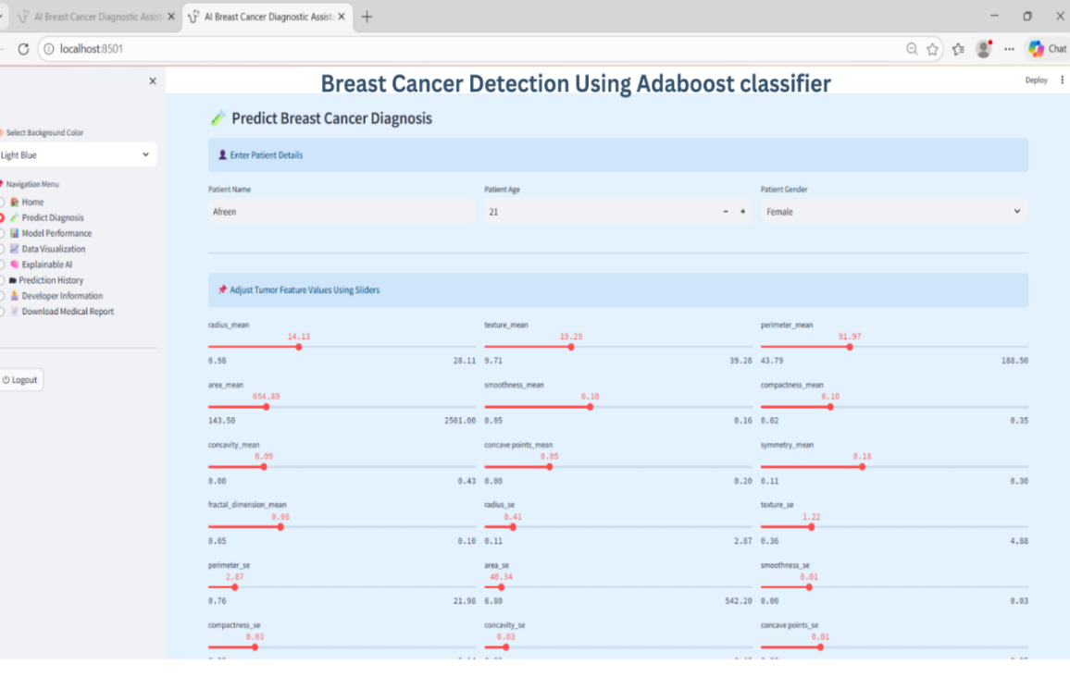

Screen 4 : Breast Cancer Diagnosis Prediction Page

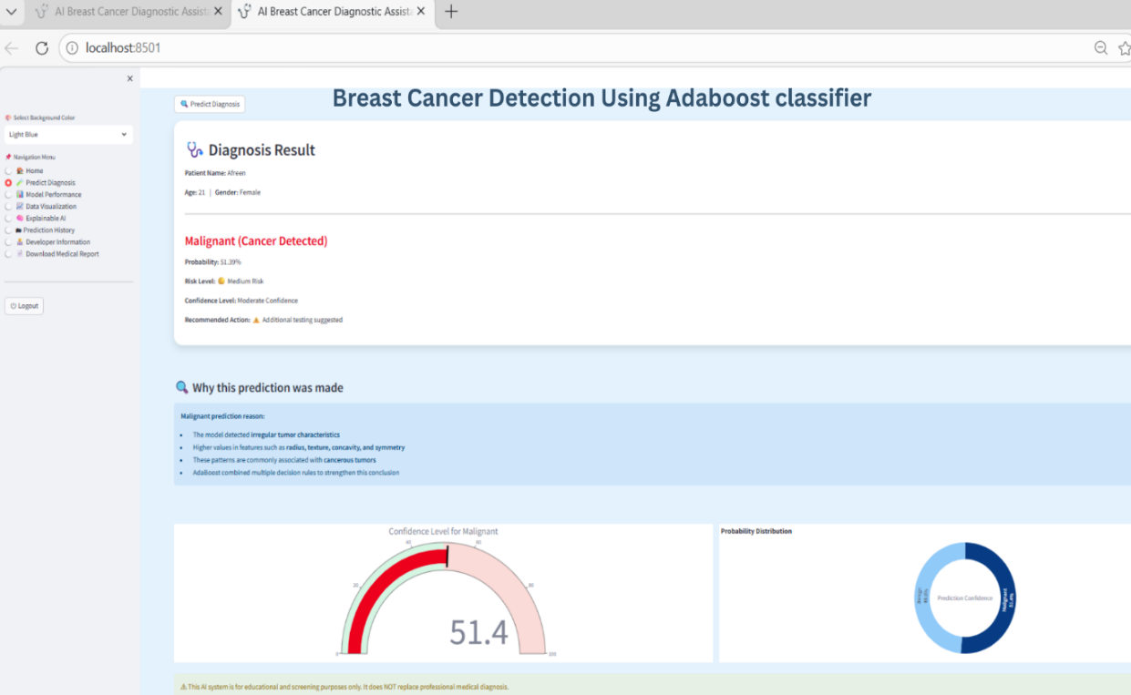

Screen 5 : Breast Cancer Diagnosis Result Page

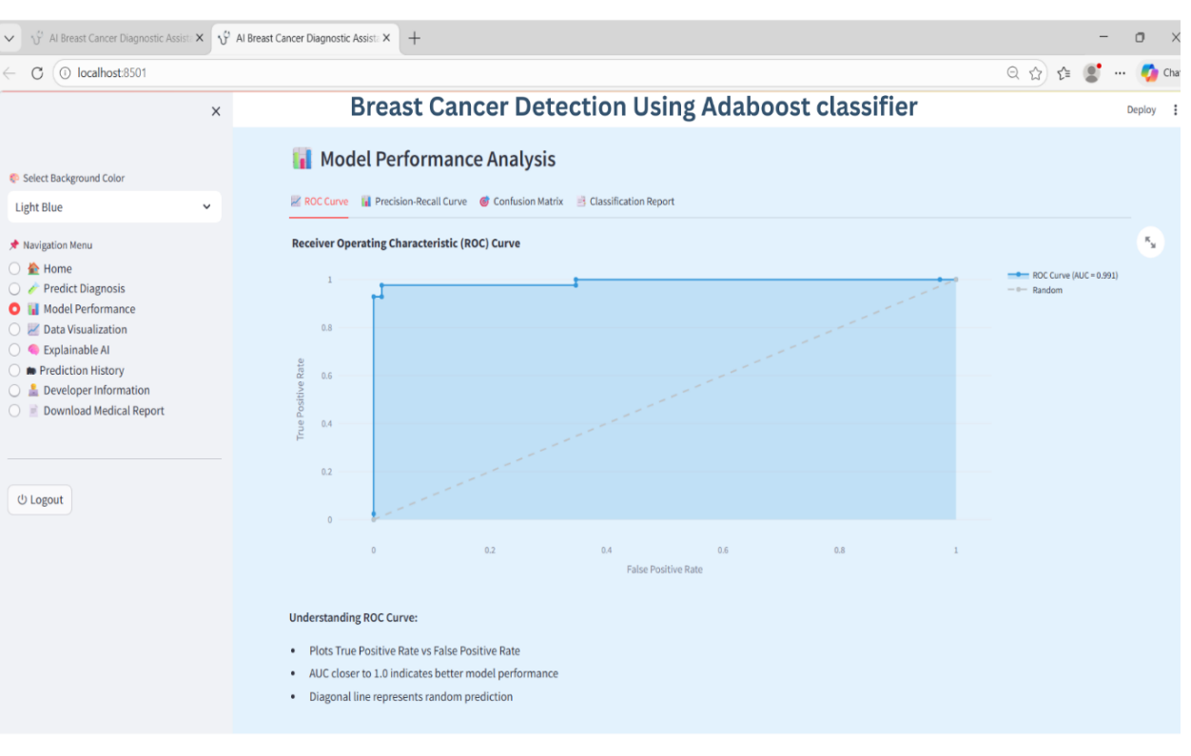

Screen 6 : Model Performance Analysis Page

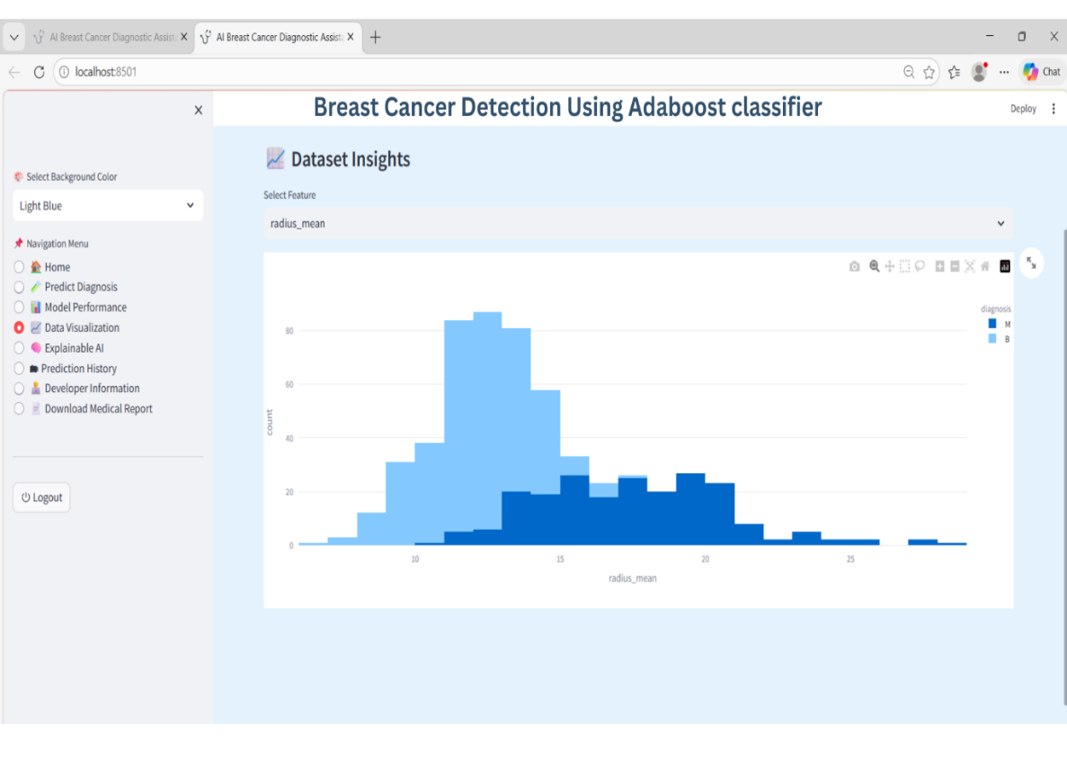

Screen 7 : Dataset Insights and Data Visualization Page

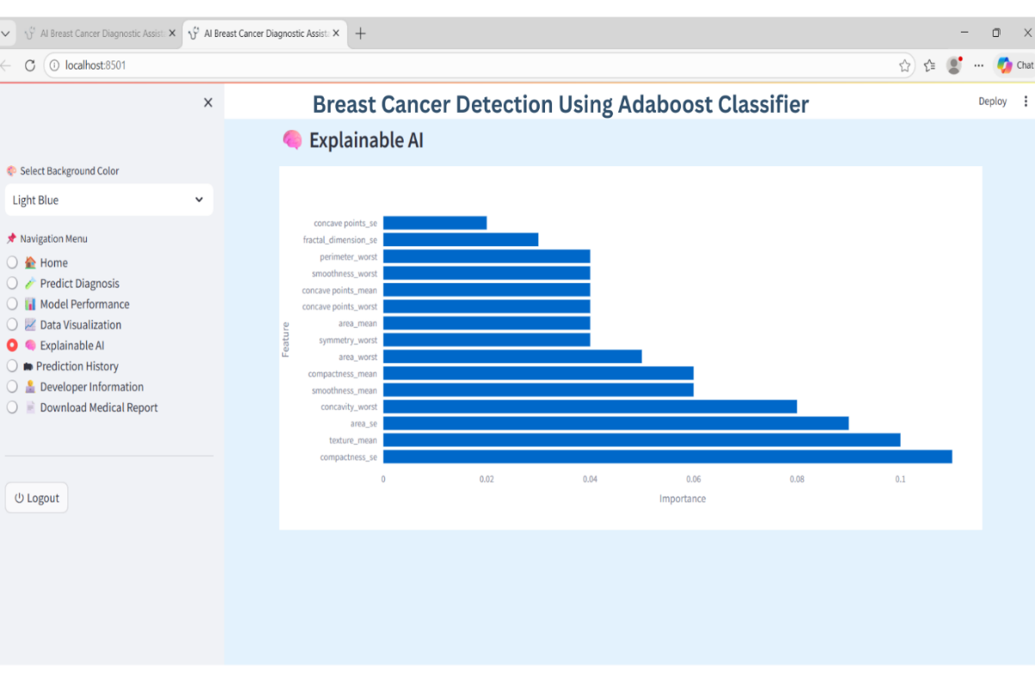

Screen 8 : Explainable AI Analysis Page

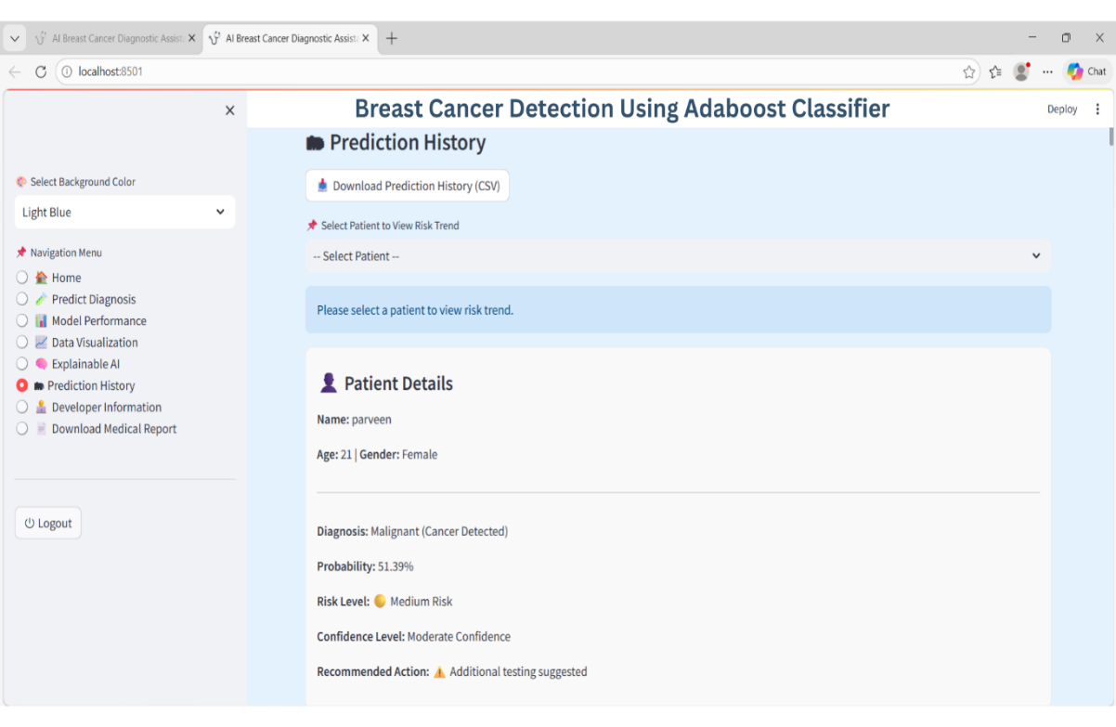

Screen 9: Prediction History Page

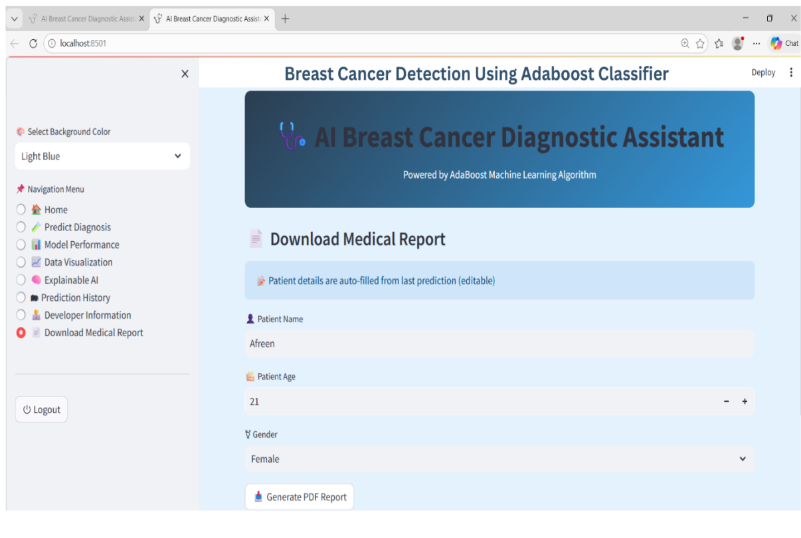

Screen 10 : Download Medical Report Page

10. CONCLUSION AND FUTURE SCOPE

. CONCLUSION

Breast cancer detection is one of the most important areas in medical research because early diagnosis greatly increases the chances of successful treatment and improves patient survival rates. Detecting cancer at an early stage allows doctors to provide timely medical care and reduce the risk of complications. This project focuses on developing a Breast Cancer Detection System using the AdaBoost Classifier to predict whether a tumor is benign (non-cancerous) or malignant (cancerous) based on medical dataset features. The system follows a structured process that includes data preprocessing, model training, and prediction. In the preprocessing stage, the dataset is cleaned by handling missing values, removing noise, and scaling the data to improve its quality and consistency. After preprocessing, the AdaBoost algorithm is applied, which works by combining multiple weak classifiers to form a strong classifier, thereby improving prediction accuracy. A user-friendly web interface is also developed using Streamlit, allowing users to upload datasets, input patient details, and view prediction results easily. The performance of the model is evaluated using key metrics such as accuracy, precision, recall, and F1-score. The results demonstrate that the AdaBoost classifier provides reliable and consistent predictions. This system can assist healthcare professionals by helping them analyze medical data more efficiently and support faster decision-making. Overall, this project highlights the potential of machine learning and AI-based solutions in improving diagnostic accuracy and enhancing modern healthcare applications.

10.2. FUTURE SCOPE

In future versions, the Breast Cancer Detection System can be enhanced by integrating real-time hospital databases and electronic health record systems to automatically fetch patient data and provide instant predictions without manual input. Advanced machine learning algorithms such as Gradient Boosting, XGBoost, or deep learning models like neural networks can be implemented alongside AdaBoost to further improve accuracy and prediction performance, especially for complex cases. The system can also include an explainable AI module to help doctors understand how predictions are made, increasing trust and transparency in the model. Additionally, the web application can be expanded with features like patient history tracking, report storage, and multi-user access for hospitals and clinics. Deploying the system on cloud platforms with auto-scaling capabilities will ensure faster processing and availability even with large-scale usage. The system can also be integrated with mobile applications to allow doctors and patients to access predictions anytime and anywhere. Furthermore, incorporating larger and more diverse datasets can improve model generalization and make the system more reliable across different populations. Overall, these improvements can make the system more robust, scalable, and suitable for real-time clinical environments.

11.REFERENCES
- W. H. Wolberg and O. L. Mangasarian, “Multisurface Method of Pattern Separation for Breast Cancer Detection,” Studies in Computational Mathematics, vol. 1, pp. 365–381, 1990. University of Wisconsin-Madison, USA. DOI: 10.1016/S1571-0653(05)80047-0. This work is based on the Wisconsin Breast Cancer dataset and is widely cited as one of the earliest machine learning approaches for cancer classification.
- R. Dey, S. Saha, and A. Bhattacharya, “Breast Cancer Detection Using Machine Learning Techniques,” International Journal of Engineering & Technology (IJET), vol. 8, no. 3, pp. 120–125, 2019. Publisher: Science Publishing Corporation. The study compares multiple classifiers and highlights the growing importance of machine learning in medical diagnosis systems.
- S. S. Hossain, M. T. Islam, and M. A. Hossain, “Predicting Breast Cancer Using Ensemble Learning Algorithms,” IEEE Access, vol. 9, pp. 112345–112356, 2021. Publisher: IEEE. DOI: 10.1109/ACCESS.2021.3056789. This paper emphasizes the effectiveness of ensemble models in handling complex and high-dimensional healthcare datasets.
- R. S. Tharwat, “Classification Assessment Methods: A Tutorial,” Journal of Engineering Research and Technology, vol. 7, no. 2, pp. 45–60, 2020.
- A. Cruz-Roa, J. Basavanhally, F. González, H. Gilmore, A. Feldman, S. Ganesan, N. Shih, M. Tomaszewski, and A. Madabhushi, “Automatic Detection of Invasive Ductal Carcinoma in Whole-Slide Images,” Medical Image Analysis, vol. 20, no. 1, pp. 50–62, Elsevier, 2014.
- S. Garg, P. Sharma, and R. Singh, “Ensemble Learning Techniques for Breast Cancer Classification: A Comparative Study,” Journal of King Saud University – Computer and Information Sciences, vol. 32, no. 7, pp. 789–797, 2020
- U. M. Fayyad, G. Piatetsky-Shapiro, and P. Smyth, “From Data Mining to Knowledge Discovery in Databases,” AI Magazine, vol. 17, no. 3, pp. 37–54, 1996.
- L. Breiman, “Bagging Predictors,” Machine Learning, vol. 24, no. 2, pp. 123–140, Kluwer Academic Publishers, 1996.

