Presentation Script – Version 1.3

### ****Slide 1: Introduction & Project Overview****

### 

**Speaker: Johnathan**  
Good evening, everyone. We’re excited to present our group project, which explores predicting future energy needs by analyzing historical consumption trends and current demand surges across the U.S. My name is Johnathan Marsh, and I’m joined by my teammates Austin French, Scott Horvath, and Eric Wang. Together, we’ve examined regional energy consumption patterns, identified key drivers of demand, and forecasted the ability of power producers to meet future energy requirements.

Our interest in this project was sparked by two insightful articles: AI Monthly’s 'Hungry for Power' and BBC.com’s 'Electricity Grids Creak as AI Demands Soar.' Both articles emphasize the growing energy consumption fueled by artificial intelligence, particularly with the expansion of data centers and machine learning applications. As AI's energy demands increase, they are placing significant strain on already burdened electricity grids. This prompted us to explore the implications for future energy needs in the U.S. and consider how this trend might impact AI and machine learning system designers moving forward.

**Slide 2: Project Questions & Objectives**



**Speaker: Johnathan**  
"The key questions we aimed to answer in this project are:

1. **Which regions consumed the most energy?**
2. **What is driving energy consumption?**
3. **Will power producers be able to meet the increasing demand for energy based on current growth trends?**
4. **What price per kWh is expected in 2035?**

Our objective was to use exploratory data analysis and predictive modeling to gain insights into these questions and offer thoughts for consideration for the future.”

**Slides 3 and 4: Data Collection**

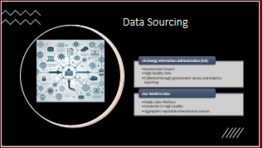 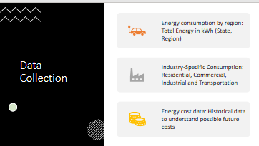

**Speaker: Scott**  
"For our analysis, we used several datasets:

* **Energy consumption by region**: This dataset provided total energy usage in kilowatt-hours (kWh) for each state and region across the U.S.
* **Industry-specific consumption**: This dataset included energy consumption in key sectors like residential, commercial, industrial, and transportation.
* **Energy pricing data**: Historical data was used to forecast future energy prices up to 2035.

**1. U.S. Energy Information Administration (EIA)**

* **Category**: **Government Source**
* **Data Quality**: **High**
* **Description**:
  + The EIA is a trusted and authoritative source of energy data, providing comprehensive, accurate, and up-to-date information on energy production, consumption, and prices in the U.S.
  + The data is collected through rigorous government surveys and industry reporting, making it **highly reliable** and widely used in energy policy decisions and academic research.
  + This source is updated regularly and offers historical data, making it ideal for **long-term analysis** and **predictive modeling**.

**2. Our World in Data**

* **Category**: **Public Data Platform**
* **Data Quality**: **Moderate to High**
* **Description**:
  + Our World in Data is a public platform that aggregates data from reputable international sources, including the World Bank, United Nations, and government agencies.
  + The platform focuses on making global datasets accessible and understandable for a broad audience.

### ****Slide 5, 6 and 7: Which Regions Consumed the Most Energy?****

### 

**Speaker: Eric**  
"Our analysis revealed that certain regions consume significantly more energy than others. The **Southwest** region, including Texas and Arizona, consumes the highest amount of energy, driven by factors such as extreme heat and industrial activity.

In contrast, the **Northeast** consumes the least, due to milder climates and more energy-efficient infrastructure.

Here’s a visualization showing energy consumption by region [point to the chart/map]. As we can see, [highlight key regions with the most/least consumption]."

**Slide 8, 9: What Is Driving Energy Consumption?**

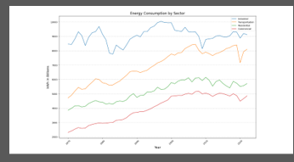 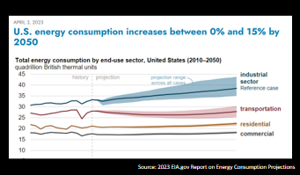

**Speaker: Scott**  
"The main drivers of energy consumption across regions include:

1. **Climate**: Areas with extreme heat, such as the Southwest, have a higher demand for air conditioning. Year-round cooling is required, leading to substantial energy usage.
2. **Population Growth**: Rapidly growing urban centers, particularly in Texas and Arizona, result in more residential and commercial energy demand.
3. **Industrial Activity**: The presence of energy-intensive industries, like petrochemical refineries in Texas, significantly drives up energy consumption. Additionally, tech hubs with large data centers in states like Nevada and Arizona contribute to higher demand.
4. **Lifestyle and Infrastructure**: The sprawling suburban developments and larger homes in these regions lead to increased residential energy use."
5. **New Arrivals**: The largest three (3) data centers used on average the same amount of energy as smaller, lower population states. Switch’s Citadel Campus in Nevada when fully operational can consume 7.45 terawatt-hours (TWh) annually.

**Slide 10, 11, 12: Will Industry Keep Up with Energy Demand?**

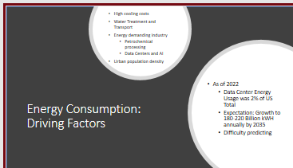 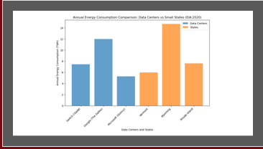

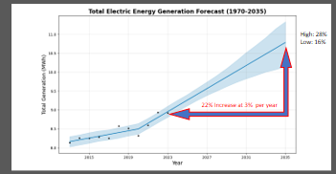

**Speaker: Austin**

“Our analysis indicates that new energy capacity could meet the demand by 2035, but this will depend on several key factors. These include how quickly outdated or inefficient facilities are decommissioned, the pace of electrification in transportation, the influence of political and economic conditions, and the speed at which renewable energy sources like wind and solar are adopted. Ensuring the energy supply keeps up with demand will require a coordinated effort across these areas.”

**Slide 13, 14: What Price per kWh is Expected 2035?**

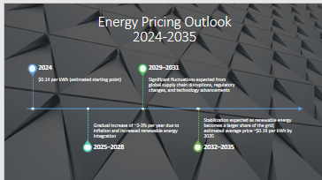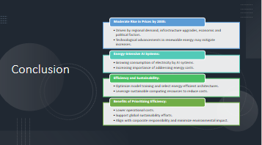

**Speaker: Johnathan**  
"Our final focus was on predicting the price of energy per kilowatt-hour (kWh) in 2035. Using historical data and forecasting models, we estimate the following:

* **Current Energy Prices**: As of 2024, the national average price of electricity is around **$0.13 per kWh**, with some regional variations depending on demand, infrastructure, and local policies.
* **Price Projections**: By 2035, energy prices are expected to increase moderately, with forecasts suggesting an average range of **$0.15 to $0.19 per kWh**, depending on the region. This represents an increase of roughly **15% to 35%** compared to current prices.
* **Regional Variations**: Regions with higher population growth and greater demand surges, such as the Southwest, are likely to see higher price increases compared to regions with slower growth rates. Factors like infrastructure improvements and regional energy policies will also play a role in price variations.
* **Economic Growth and Inflation Impact**: Future energy prices will also be influenced by broader economic conditions, such as inflation rates and economic growth. Regions experiencing rapid industrial expansion or urbanization may see sharper price hikes due to increased demand and strain on the energy grid.
* **Technological Advancements**: While developments in energy infrastructure and technologies could help reduce the pace of price increases, these advancements may not be sufficient to completely offset the rising demand and inflationary pressures.

By 2035, we expect the average cost of electricity to stabilize within the range of **$0.15 to $0.19 per kWh**, which is a significant increase compared to today’s average of **$0.135 per kWh**."

**Conclusion:** By 2035, electricity prices in the U.S. are expected to rise moderately, driven by a combination of regional demand, infrastructure upgrades, economic conditions, and political factors—many of which remain uncertain. While technological advancements, particularly in renewable energy, may temper some of these increases, the overall trend points toward higher costs.

As energy-intensive technologies like AI continue to scale, it will become crucial for AI professionals to address the financial and environmental implications of electricity consumption. Prioritizing efficiency through optimized model training, energy-efficient architectures, and sustainable computing practices will not only help mitigate rising operational costs but also contribute to global sustainability goals. These efforts will benefit organizations by reducing expenses, aligning with corporate responsibility standards, and supporting a more environmentally conscious approach to innovation.