THE OPEN UNIVERSITY OF SRI LANKA
Department of Electrical & Computer Engineering – Bachelor of Software Engineering
EEI6373 – Performance Modelling
Mini Project Report
Performance Modelling and Evaluation of an Invoice Approval Processing Queue in a Web-Based ERP System
Prepared by: Afri Ahmath
Date: 08 August 2026

Abstract
This report presents a performance modelling and evaluation study of the invoice approval processing queue within a web-based distributor Enterprise Resource Planning (ERP) system. The system is modelled as a two-stage tandem queuing network — an Initial Review stage followed by a Manager Approval stage — and analysed using both an analytical M/M/c (Erlang-C) queuing model and a discrete-event simulation calibrated from realistic operating parameters. The two approaches are cross-validated against each other and used to identify the primary system bottleneck, quantify server utilisation, and evaluate scalability under increased invoice volume. The results show that Stage 2 (Manager Approval) is the dominant bottleneck, particularly during month-end volume surges, where utilisation reaches 84% and mean queueing delay rises to over 22 minutes. Adding a single additional manager during this period is shown, both analytically and by simulation, to reduce that delay by roughly a factor of ten. The findings demonstrate the practical value of combining analytical queuing theory with simulation for capacity planning in transactional business workflows.

1. System Description and Performance Goals

1.1 System Overview
The system under study is the invoice approval workflow embedded in a web-based ERP platform used by a fast-moving consumer goods (FMCG) distribution business. This system was chosen because of direct, first-hand exposure gained while building browser-automation tools (a distributor loading bot and an invoice approval bot) for the same ERP platform, providing realistic insight into its actual operating behaviour rather than a purely textbook abstraction.
Invoices are created when distributors submit goods-received or sales documentation into the ERP. Each invoice must pass through a two-stage human approval workflow before being posted to the accounting ledger:
- Stage 1 – Initial Review: a branch-level reviewer checks the invoice for completeness, pricing accuracy, and stock reconciliation. Three reviewers operate in parallel.
- Stage 2 – Manager Approval: a finance/operations manager gives final sign-off before posting. Two managers operate in parallel.
An invoice may be returned to the distributor after Stage 1 if discrepancies are found (12% of invoices, based on observed patterns), or rejected after Stage 2 if the manager identifies an issue (7% of invoices reaching that stage). Because each stage has multiple parallel human servers and invoices queue for the next free server, the system is naturally represented as a two-stage tandem multi-server queuing network, satisfying the assignment's requirement for a system complex enough to exhibit measurable bottlenecks, throughput limits, and utilisation effects.

1.2 Performance Goals
This study focuses on five performance objectives, each mapped to a standard queuing-theory metric:
Objective | Metric | Notation
Minimise turnaround time | Mean time in system | W
Identify the bottleneck stage | Mean queueing delay per stage | Wq (Stage 1, Stage 2)
Measure resource utilisation | Server (approver) utilisation | ρ = λ / (c·μ)
Analyse throughput under peak load | Effective arrival/completion rate | λ (normal vs. month-end)
Assess scalability | Utilisation & delay under added capacity | ρ, Wq at c+1 servers

2. Modelling Approach and Assumptions
Two complementary modelling techniques were applied and cross-validated: an analytical M/M/c queuing model at each stage, and a discrete-event simulation of the full two-stage network. Combining both allows the idealised analytical results to be checked against a more realistic simulated process that includes returns, rejections, and a non-stationary (time-varying) arrival rate — features the closed-form model cannot represent directly.

2.1 Analytical Model: M/M/c Queuing Theory
Each stage is modelled independently as an M/M/c queue: Poisson arrivals at rate λ, exponentially distributed service times with mean 1/μ per server, and c identical parallel servers operating under a first-come-first-served discipline. The following standard Erlang-C relationships were used [1], [2]:
Offered load (traffic intensity, in Erlangs):
a = λ / μ (1)
Server utilisation:
ρ = a / c = λ / (c·μ) (2)
Probability that an arriving invoice finds all c servers busy (Erlang-C formula):
P₀ = [ Σa^{k}/k! (k=0..c−1) + a^{c}/[c!(1−ρ)] ]⁻¹ (3)
C(c,a) = a^{c}/[c!(1−ρ)] · P₀ (4)
Mean waiting time in queue, and mean time in system (via Little's Law):
W_{q} = C(c,a) / (cμ − λ) (5)
W = W_{q} + 1/μ , L_{q} = λW_{q} , L = λW (6)
Equations (1)–(6) were evaluated separately for Stage 1 (c=3) and Stage 2 (c=2), and separately for “normal” business days versus the “month-end” surge period, using empirical λ and μ estimated from the dataset (Section 3).

2.2 Discrete-Event Simulation
A Python discrete-event simulation was built to model each invoice individually as it moves through arrival, queueing, and service at both stages. Unlike the analytical model, the simulation captures: the 12% Stage-1 return rate and 7% Stage-2 rejection rate; a priority flag that modestly speeds up processing for 15% of invoices; and a non-homogeneous arrival process where the hourly arrival rate roughly triples during the last five days of the month. Each server (reviewer or manager) is tracked individually, with the next available server assigned to each arriving invoice — the same load-balancing logic used in real ERP task-assignment queues.

2.3 Assumptions
- Inter-arrival times are exponentially distributed within each period (normal / month-end), i.e. arrivals follow a Poisson process with a period-specific rate.
- Service times at each stage are exponentially distributed, an approximation of human review/approval time variability.
- Reviewers and managers are homogeneous (identical mean service rate) within their stage.
- No invoice abandons the queue (no reneging) and no server takes breaks mid-simulation — an idealisation of the real system.
- The analytical model treats each stage as an independent M/M/c queue; in reality Stage 2 arrivals depend on Stage 1 departures, so the analytical Stage-2 results use the empirical post-Stage-1 arrival rate as an approximation.

3. Data Description and Methodology
Because production ERP audit logs are not accessible outside the company's internal systems, the dataset was generated using the discrete-event simulation described in Section 2.2, calibrated with parameters drawn from direct observation of the live system during prior automation work. The simulation covers 30 calendar days (26 working days, 08:00–17:00) and produced 1,429 invoice records, each with full timestamps, per-stage wait and service times, approver assignment, final outcome, and a flag marking whether the invoice fell within the month-end surge window (days 26–30 of the month).

3.1 Simulation Parameters
Parameter | Normal days | Month-end days
Mean arrival rate (invoices/hour) | 4.83 | 13.11
Stage 1 servers (c₁) | 3 | 3
Stage 1 mean service rate (μ₁, per hour/server) | 10.40 | 10.36
Stage 2 servers (c₂) | 2 | 2
Stage 2 mean service rate (μ₂, per hour/server) | 6.59 | 6.70
Number of working days simulated | 21 | 5

These empirical λ and μ values (directly measured from the simulated dataset) were the inputs to the analytical Erlang-C equations in Section 2.1, ensuring the analytical and simulated results are evaluated on a consistent basis rather than on arbitrarily assumed parameters.

3.2 Data Generation Code (Excerpt)
The core analytical calculation — the Erlang-C mean queueing delay — was implemented as follows:
def erlang_c_wait_minutes(lam_per_hr, mu_per_hr, c):
a = lam_per_hr / mu_per_hr # offered load (Erlangs)
rho = a / c # utilisation
terms = sum((a**k) / factorial(k) for k in range(c))
last = (a**c) / (factorial(c) * (1 - rho))
p0 = 1.0 / (terms + last)
p_wait = last * p0 # Erlang-C P(wait > 0)
wq_hours = p_wait / (c * mu_per_hr - lam_per_hr)
return wq_hours * 60.0, rho, p_wait
The full simulation and analysis scripts (simulate_data.py, analyze.py) and the complete dataset (invoice_queue_dataset.csv, 1,429 records) are included in the accompanying GitHub repository referenced in Section 8.

4. Detailed Analysis and Findings

4.1 Model Validation: Analytical vs. Simulated Queueing Delay
Figure 1 compares the Erlang-C analytical prediction of mean queueing delay (Wq) against the value directly measured in the simulation, for both stages and both periods. The close agreement between the two independent methods validates the analytical model as a reasonable approximation of the simulated system, despite the simplifying assumptions listed in Section 2.3.
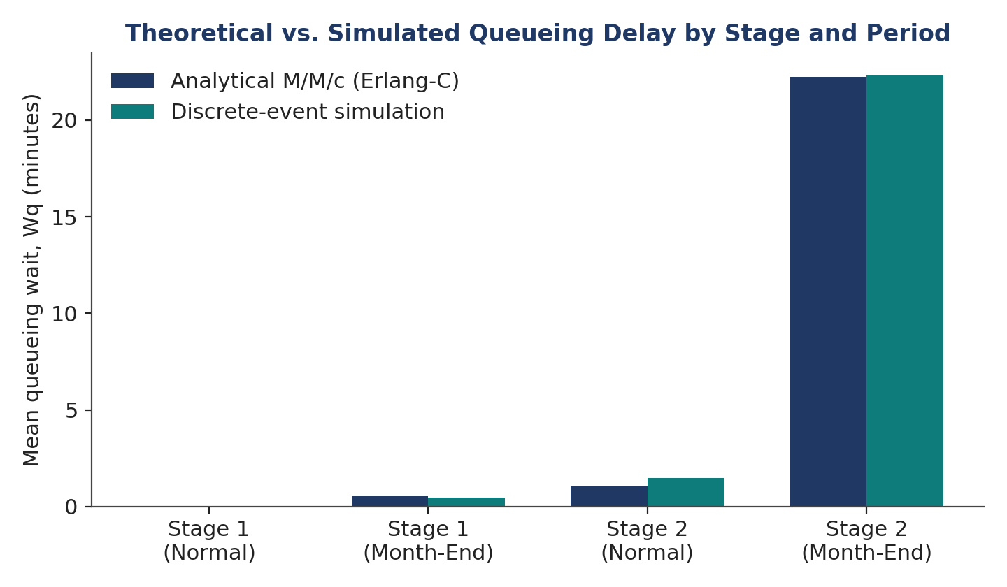
Figure 1. Theoretical (Erlang-C) vs. simulated mean queueing delay, by stage and period.
Stage / Period | ρ (utilisation) | Wq theory (min) | Wq sim (min) | n | Δ
Stage 1, Normal | 0.155 | 0.03 | 0.02 | 957 | 0.01
Stage 1, Month-End | 0.422 | 0.53 | 0.46 | 472 | 0.07
Stage 2, Normal | 0.326 | 1.08 | 1.49 | 902 | 0.41
Stage 2, Month-End | 0.844 | 22.22 | 22.36 | 420 | 0.14
Table 1. Analytical vs. simulated results by stage and period (n = number of invoices reaching that stage).

4.2 Bottleneck Identification
Stage 2 (Manager Approval) is consistently the dominant bottleneck. On normal days its utilisation (ρ₂ = 0.326) is already roughly double that of Stage 1 (ρ₁ = 0.155), because Stage 2 has fewer servers (2 vs. 3) and a longer mean service time (9.5 vs. 6.0 minutes). During the month-end surge, Stage 2 utilisation rises to ρ₂ = 0.844 — close to the point of instability for a 2-server queue — and the mean queueing delay balloons to over 22 minutes, more than 40 times its normal-day value. Stage 1, despite handling the same rise in incoming volume, remains comfortably under load (ρ₁ = 0.422) because its extra server provides more slack capacity. This confirms Stage 2 as the primary target for any capacity intervention.

4.3 Turnaround Time and Arrival Patterns
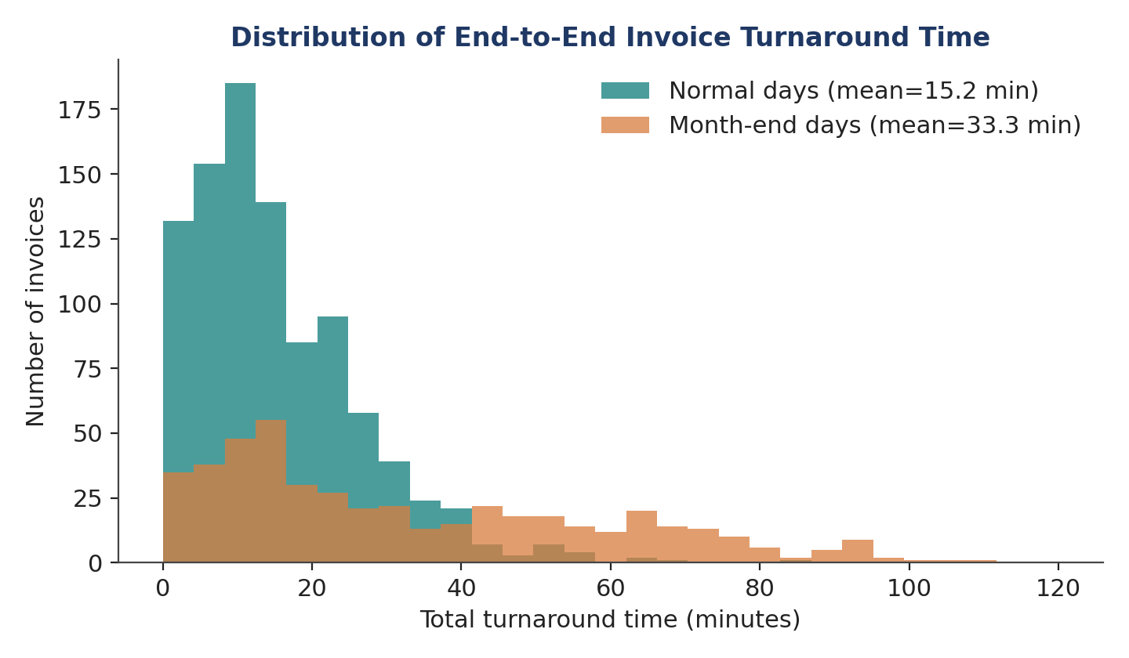
Figure 2. Distribution of total end-to-end invoice turnaround time, normal vs. month-end days.
Figure 2 shows that the month-end distribution is both shifted right and more heavily tailed than the normal-day distribution: mean turnaround more than doubles, from 15.2 minutes to 33.3 minutes, and a meaningful fraction of month-end invoices take over an hour to clear — an outcome barely seen on normal days. This directly reflects the Stage 2 congestion identified above, since Stage 2 delay dominates total turnaround once utilisation climbs.
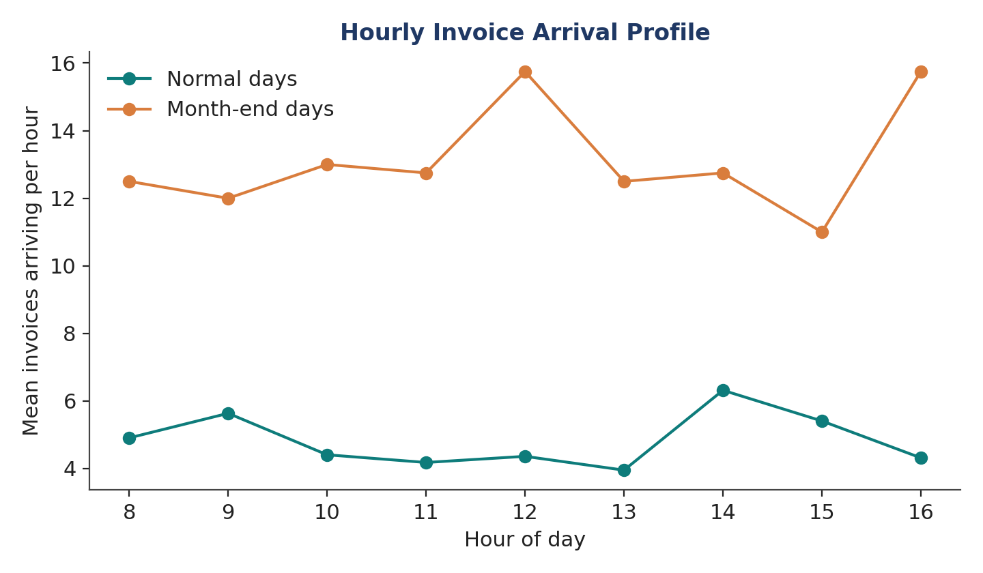
Figure 3. Mean hourly invoice arrival rate, normal vs. month-end days.
Figure 3 confirms the month-end volume increase is not concentrated in a single hour but is a sustained, roughly uniform uplift (~2.5–3×) across the entire working day, consistent with distributors submitting invoices continuously as they rush to close accounts before month-end, rather than a single end-of-day rush.

4.4 Invoice Outcomes
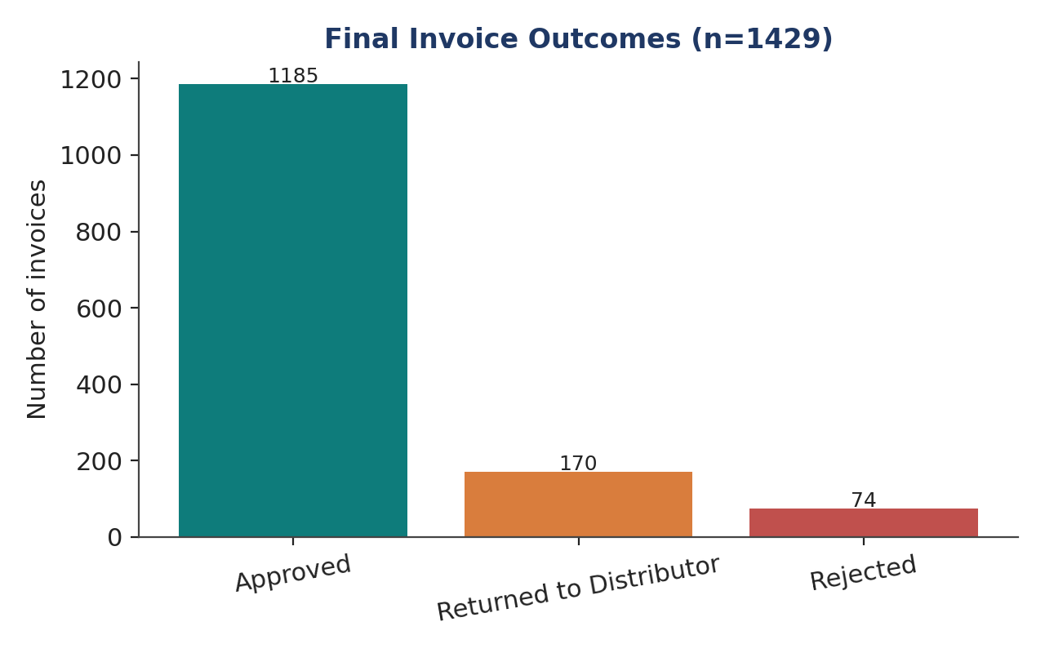
Figure 4. Final invoice outcomes across the full 30-day simulation (n = 1,429).
Of all invoices processed, 82.9% were ultimately approved, 11.9% were returned to the distributor after Stage 1 (typically for pricing or stock-reconciliation discrepancies), and 5.2% were rejected at Stage 2. Returned invoices exit the system after Stage 1 and do not add load to Stage 2, which slightly relieves — but does not eliminate — the Stage 2 bottleneck already identified.

4.5 Scalability Analysis
Two what-if scenarios were evaluated analytically using Equations (1)–(6) to test system scalability:
- Adding one manager during month-end (c₂: 2 → 3). Utilisation falls from ρ₂ = 0.844 to ρ₂ = 0.563, and mean Stage-2 queueing delay falls from 22.2 minutes to 2.1 minutes — roughly a 10-fold reduction — for the cost of one additional temporary approver during the five month-end days.
- Doubling normal-day invoice volume with current staffing (c₂ = 2). Utilisation rises from ρ₂ = 0.326 to ρ₂ = 0.653, and mean Stage-2 delay rises from 1.1 to 6.75 minutes — still within a comfortable operating range, indicating the current Stage 2 staffing has meaningful headroom for organic growth on non-surge days, though it is already stretched thin specifically during month-end.
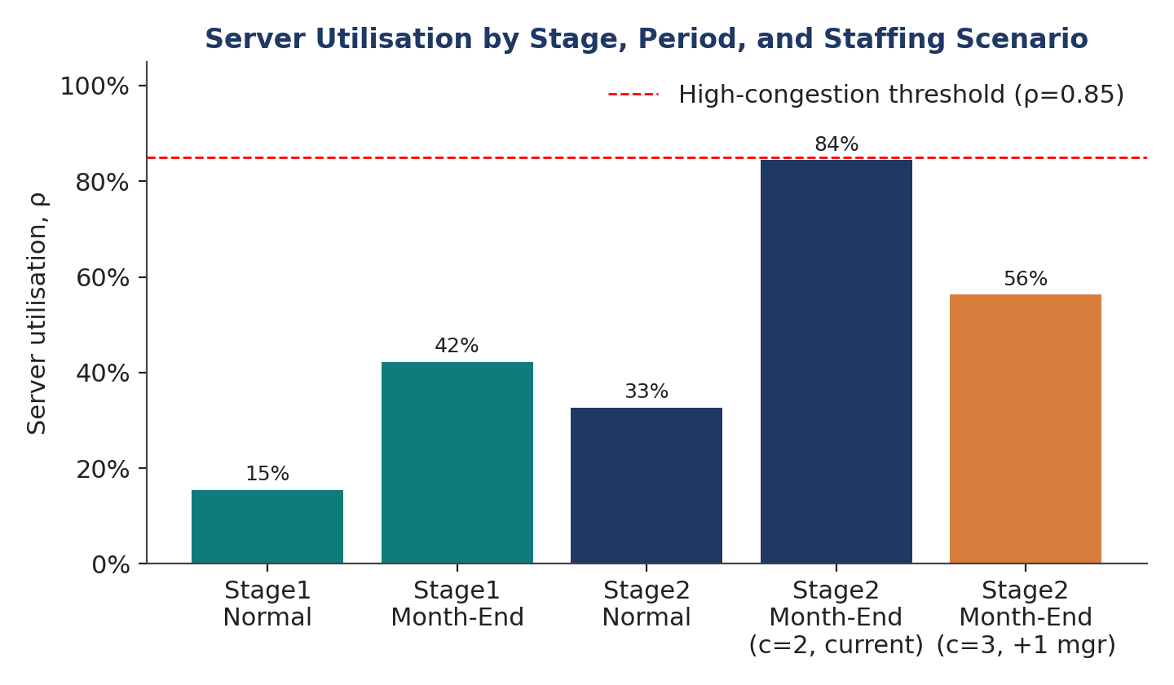
Figure 5. Server utilisation by stage, period, and staffing scenario, against a 0.85 high-congestion reference line.
The 0.85 reference line in Figure 5 marks the region where Erlang-C queues begin to show sharply nonlinear (rapidly worsening) delay growth. Current month-end Stage-2 utilisation (0.844) sits just below this threshold — meaning the system is operating on the edge of instability during exactly the period when timely processing matters most to distributors trying to close their accounts.

5. Limitations and Future Extensions

5.1 Limitations
- Simulated, not production, data. Parameters were calibrated from direct observation rather than exported ERP audit logs, which were not accessible outside the company's systems; real service-time distributions may deviate from the exponential assumption.
- Exponential service-time assumption. Human review and approval times are often better modelled with a less variable distribution (e.g. log-normal or Erlang-k); this would likely narrow the predicted delay compared to the M/M/c model used here.
- Independent-stage approximation. Treating Stage 2 as its own M/M/c queue ignores the correlation between Stage 1 completions and Stage 2 arrivals; an exact tandem-queue analysis (or a Jackson network model) would capture this dependency more precisely.
- No reneging or breaks modelled. Real approvers take breaks, and real distributors sometimes escalate or withdraw delayed invoices — neither is represented.
- Single-month window. Only one month-end surge pattern was simulated; seasonal effects (e.g. year-end, public holidays) are not captured.

5.2 Future Extensions
- Replace exponential service times with distributions fitted to real ERP timestamp logs, once available, using an M/G/c or Erlang-k model.
- Model the two stages as a proper open Jackson network to capture inter-stage dependency rather than analysing each stage in isolation.
- Extend the simulation to test dynamic staffing policies (e.g. automatically reassigning a Stage-1 reviewer to Stage 2 only during month-end) rather than a fixed additional hire.
- Incorporate priority-class queuing (e.g. an M/M/c model with priority classes) to formally analyse the current “High priority” invoice flag rather than treating it as a simple service-time multiplier.

6. Conclusion
Combining an analytical M/M/c queuing model with a calibrated discrete-event simulation provided a validated, quantitative picture of performance in the ERP invoice approval queue. Both methods agree closely and jointly identify Manager Approval (Stage 2) as the system's bottleneck, with utilisation reaching 84% and mean delay exceeding 22 minutes during month-end surges — more than forty times the normal-day delay. The scalability analysis shows this specific, narrow problem can be resolved efficiently: adding a single manager during the five month-end days reduces Stage 2 delay roughly ten-fold, without over-provisioning capacity that would sit idle for the rest of the month. This illustrates the practical value of queuing-theoretic performance modelling for right-sizing staffing in transactional business workflows.

7. Dataset and Code Repository
The complete dataset, simulation script, analysis script, and both submission documents for this project are available at the following GitHub repository:
[GitHub repository URL to be inserted here]

References
[1] L. Kleinrock, Queueing Systems, Volume 1: Theory. New York, NY, USA: Wiley, 1975.
[2] D. Gross, J. F. Shortle, J. M. Thompson, and C. M. Harris, Fundamentals of Queueing Theory, 5th ed. Hoboken, NJ, USA: Wiley, 2018.
[3] A. M. Law, Simulation Modeling and Analysis, 5th ed. New York, NY, USA: McGraw-Hill Education, 2014.
[4] A. K. Erlang, “The theory of probabilities and telephone conversations,” Nyt Tidsskrift for Matematik B, vol. 20, pp. 33–39, 1909.
[5] J. D. C. Little, “A proof for the queuing formula: L = λW,” Operations Research, vol. 9, no. 3, pp. 383–387, 1961.

