Grant writing workshop
Dakar, Senegal  21-23 November 2016 | 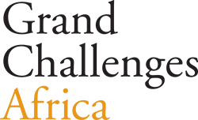  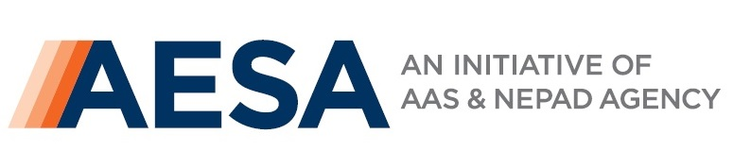  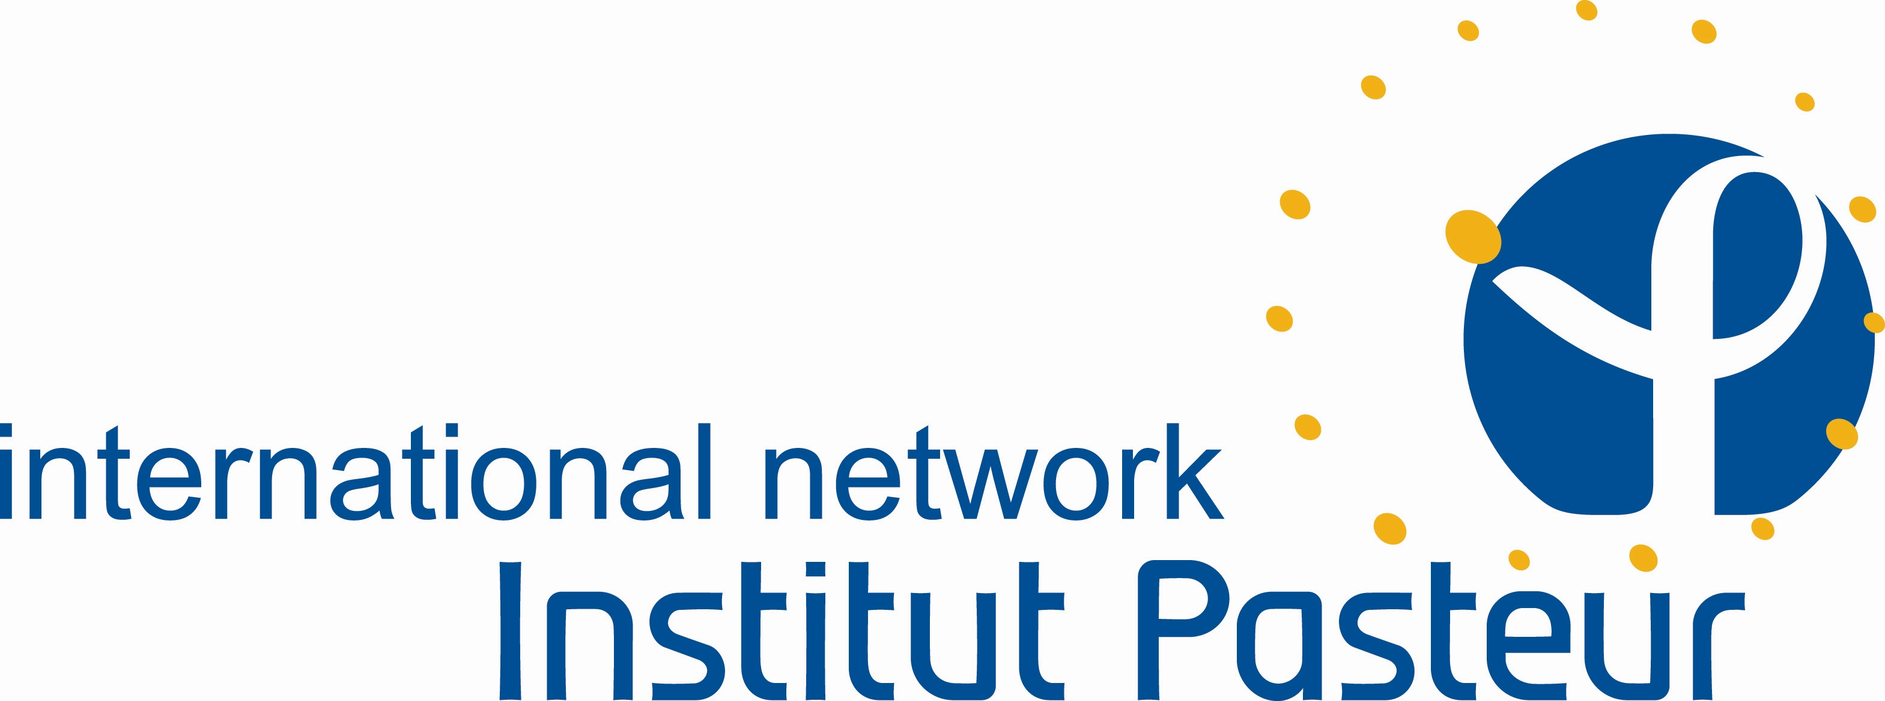  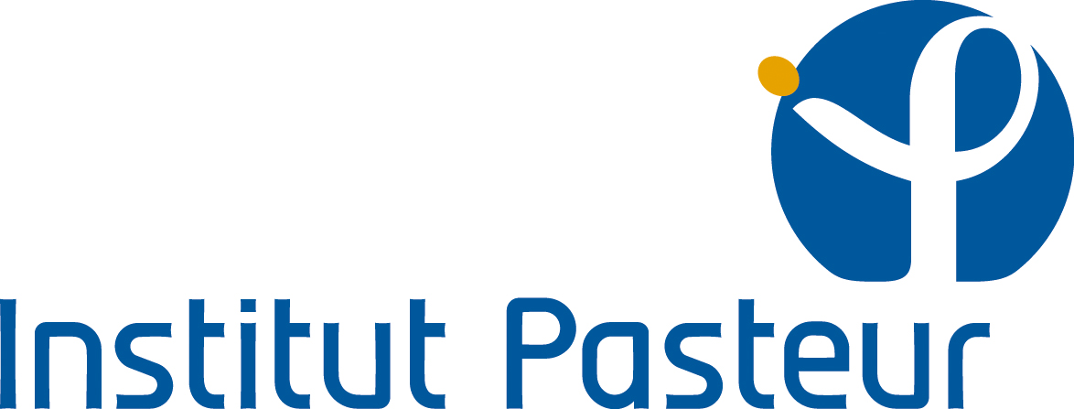  Organised by

Objectives
To improve the quality and number of grants submitted by French speakers applying to this joint call and to increase networking within and among African institutes.
Target audience
Francophone African scientists residing in Africa.
Application process
Please click here to download the application form and for more details on how to apply

to submit your application before November 2nd 2016.

The Grand Challenges Africa call

Challenges

Apply new technologies to enable rapid identification of exposures (communicable and non-communicable) that lead to poor outcomes in pregnancy, birth and in the first month of life.

Apply precision medicine approaches and techniques to identify microbes and other exposures in Africa that may increase susceptibility to non-communicable diseases (cancer, cardiovascular diseases etc.) in mothers and children under 5 years of age.

Provide innovative policy and clinical practice approaches and pathways that will enable the rapid and widespread adoption of:

Available well tested interventions whose uptake has been slow, but which would make a profound impact if adopted and incorporated into ongoing MNCH programmes;

New innovations and technologies that can help Africa leapfrog and achieve rapid progress, in preventing maternal and neonatal deaths.

Design creative ways to engage the public, policy and decision makers to pay attention to Research & Development (R&D), to encourage governments to dedicate funding for African R&D

Who can submit a project?
- African investigators working in African based, domestic organisations, including non-profit organisations, for-profit companies, international organisations, government agencies, research and academic institutions.
- Non-African investigators with an appointment/affiliation with any of the ten Institute Pasteur institutes in Africa, who are resident in Africa, with at least 18 months left on their tenure of service/affiliation.

The workshop

Refining your idea(s)
You will pitch your project, presenting a convincing oral abstract.

Personalised support
Facilitators from major funding bodies will assist participants in the shaping of the project and discuss best ways to present it.

Experience sharing
Previous local grantees will share their experience in the writing and submission process. Facilitators from major funding bodies will provide input to maximise chances of success.

Writing sessions
Time will be provided for you to write a modified version of your proposal so you would leave with a draft.

Review & support
A pool of expert reviewers will help you polish your proposal three weeks before the submission deadline.

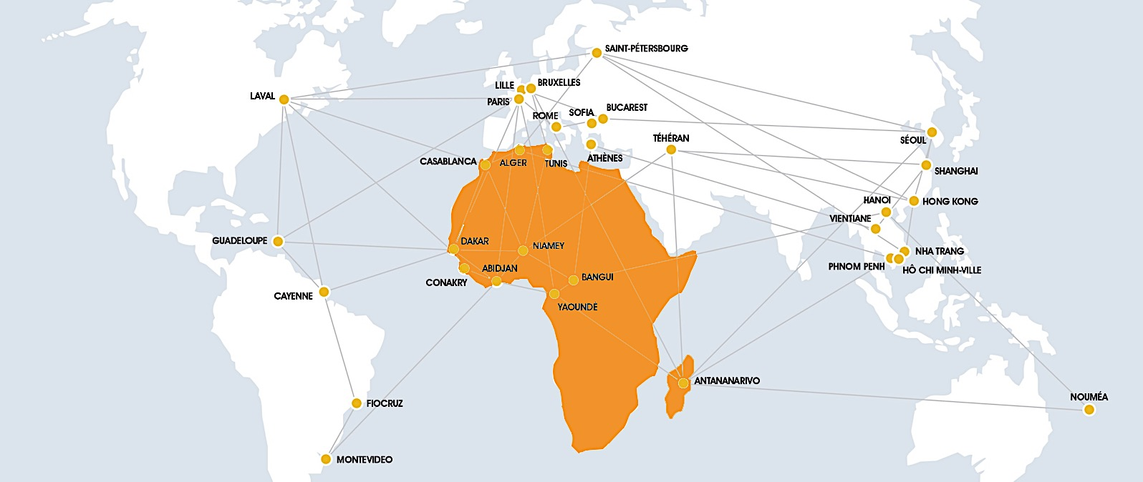

“If you want to go fast, go alone. If you want to go far, go together”

African proverb
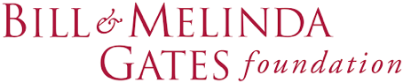
This Grand Challenges Africa call is sponsored by

