Assessment of Applicants  Executive Secretary of the Asian Development Bank Administrative Tribunal (ADBAT)  Ranking against the Terms of Reference | Prepared 10 September 2026 | Applicant list as of 1 September 2026 | 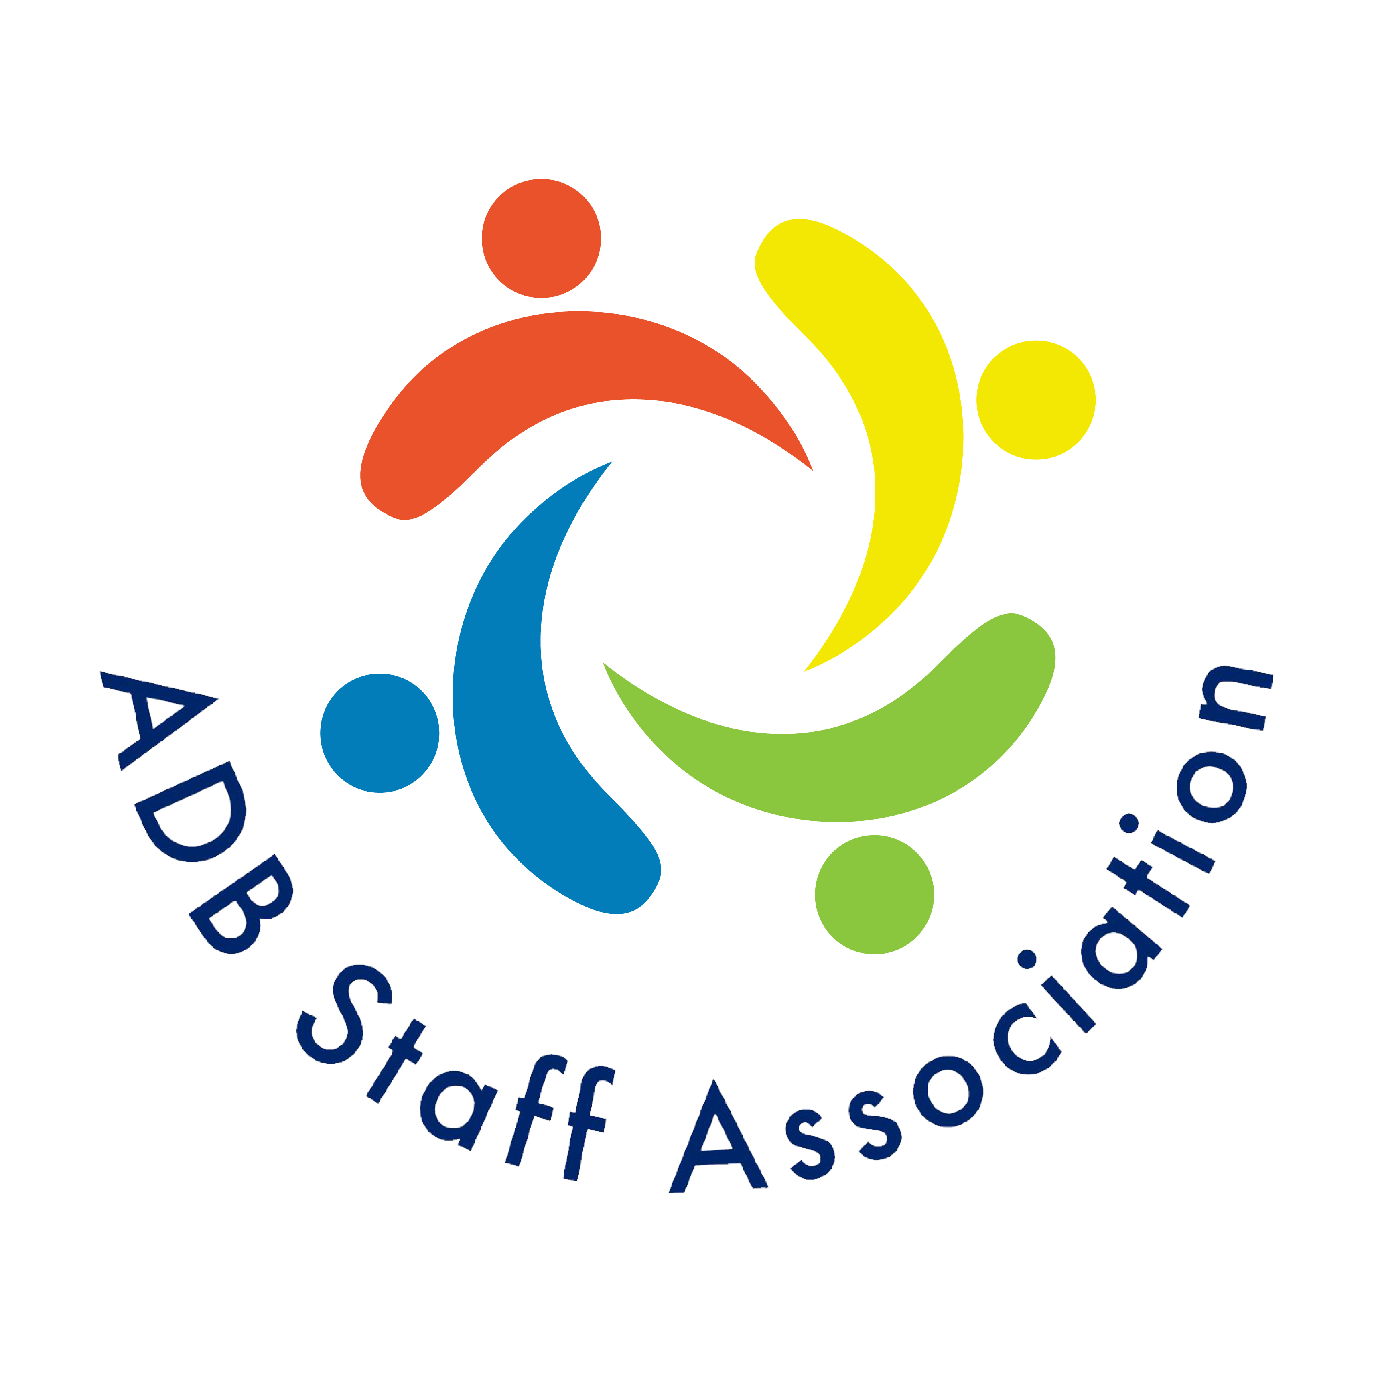
1. Purpose and Basis of Assessment
This note ranks the 16 applicants for Executive Secretary of ADBAT against the qualifications in the Terms of Reference (TOR). Eight applicants were received by the deadline and passed ADB’s basic screen, one was received a day late, and seven were screened out by ADB as not lawyers.
Limitation. The assessment relies on the employment history, education, and remarks recorded in ADB’s applicant list. The CVs and cover letters are stored on ADB SharePoint, which could not be opened from the environment used to prepare this note (the network policy blocks asiandevbank.sharepoint.com and the Microsoft 365 connector was not enabled). Scores are therefore judgments from the summary and should be confirmed against the full CVs before shortlisting.
2. Assessment Criteria
Table 1 sets out the criteria drawn from the TOR and the evidence used to score each one. C1 is a mandatory gate; C2 to C6 are scored from 0 (no evidence) to 5 (strong, direct evidence), for a maximum of 25.
Table 1: Assessment Criteria
Code | Criterion (from the TOR) | Evidence sought in the applicant summary
C1 | Suitably qualified lawyer (Statute, Article V) | Law degree and/or bar admission. Mandatory gate; no score.
C2 | At least 10 years administering administrative, judicial, arbitral, or similar proceedings | Length and directness of registry, secretariat, or tribunal roles (0–5).
C3 | International administrative law (preferred) | Work with international organization tribunals, appeals bodies, or staff disputes (0–5).
C4 | Case management, legal documentation, coordination of proceedings | Filings, records, notifications, minutes, publication of judgments (0–5).
C5 | Organizational, analytical, and communication skills | Office leadership, drafting, teaching, publications (0–5).
C6 | Judgment, discretion, and confidentiality | Confidential adjudicative or ethics responsibilities (0–5).
3. Ranking of Eligible Applicants
Table 2 ranks the nine lawyers in descending order of fit. The top two applicants stand clearly apart: both currently run the registry of an international administrative tribunal, which is the function described in the TOR.
Table 2: Ranking of Applicants Who Meet the Mandatory Requirement
# | Candidate | C2 | C3 | C4 | C5 | C6 | Total /25 | Basis of assessment (from applicant summary)
1 | Giuliana Cane  (Italy and UK) | 5 | 5 | 5 | 4 | 5 | 24 | Executive Secretary of the Inter-American Development Bank Administrative Tribunal for 10 years (2016–2026); now Executive Secretary of the AIIB Special Appeals Tribunal and Alternate Registrar of the OPEC Appeals Committee; earlier ICSID legal counsel. Direct, current experience in the identical function at peer multilateral development banks; two LLMs.
2 | Isaac Endeley  (United States) | 5 | 4 | 5 | 4 | 5 | 23 | Registrar of the United Nations Dispute Tribunal, the registry that administers UN staff employment cases. Fourteen years as legal officer at the UN International Criminal Tribunal for Rwanda and the Extraordinary Chambers in the Courts of Cambodia (2005–2019); senior UN mission legal roles. Juris Doctor and PhD.
3* | Peter Quayle  (United Kingdom) | 3 | 5 | 4 | 5 | 5 | 22 | Executive Secretary of the Commonwealth Secretariat Arbitral Tribunal; Executive Secretary of the OPEC Fund Administrative Tribunal (2023–2024); Chief Counsel at AIIB (2016–2020); senior counsel at EBRD; 8 years with the US Department of Justice foreign litigation office; ethics advisor to the African Development Bank Board. *Received one day after the deadline and provided a LinkedIn profile, not a CV. Eligibility is for the panel to decide.
4 | Juan Antonio Gallo Sallent  (Spain) | 4 | 3 | 3 | 4 | 4 | 18 | Founding President of the Catalan Public Procurement Tribunal (2012–2017); arbitrator at the Barcelona Court of Arbitration; member of international expert panels on administrative law; professor of administrative law; legal consultant to UNOPS; PhD in law. Adjudicative rather than registry experience; the international panel work is not specified in the summary.
5 | Krunimar Antonio Escudero III  (Philippines) | 4 | 1 | 4 | 3 | 4 | 16 | Twelve years in the Office for Legal Affairs of the Civil Service Commission (2008–2020), which handles administrative cases involving public servants; later Director III, Human Resource Relations Office, and Assistant Secretary, Department of Social Welfare and Development. Relevant domestic public-employment law; no international exposure.
6 | Patibandla Satyanarayana Prasad  (India) | 3 | 1 | 4 | 3 | 4 | 15 | Judicial Member of the National Company Law Tribunal (2019–2024); 21 years as legal adviser at the Reserve Bank of India; PhD in law. Adjudicative experience in a national tribunal; no registry or international administrative law experience shown.
7 | Siegfred Bueno Mison  (Philippines) | 2 | 1 | 3 | 4 | 4 | 14 | General Counsel of Philippine Airlines; Commissioner of the Bureau of Immigration (2011–2016); Commissioner on Bar Discipline (2003–2005); law professor; LLM. Broad senior legal and executive career, but limited direct administration of tribunal proceedings.
8 | Bayan Joseph Quiñones  (Philippines) | 2 | 0 | 3 | 4 | 3 | 12 | More than 20 years in litigation and dispute resolution practice; Deputy Director of the University of the Philippines Office of Legal Aid; corporate secretary roles. Advocacy rather than administration of proceedings; no international administrative law.
9 | Yin Sang Chan  (Australia) | 0 | 0 | 1 | 2 | 2 | 5 | Trainee solicitor 2023–2025, now consultant solicitor; 33 years in Hong Kong, China planning roles that were not legal. Does not meet the 10-year relevant legal experience requirement.
AIIB = Asian Infrastructure Investment Bank, EBRD = European Bank for Reconstruction and Development, ICSID = International Centre for Settlement of Investment Disputes, LLM = Master of Laws, OPEC = Organization of the Petroleum Exporting Countries, UNOPS = United Nations Office for Project Services. Scores are the assessor’s judgments from the applicant summary; see Section 1.
4. Observations on the Leading Applicants
Giuliana Cane (rank 1). The only applicant with a full decade in the identical role at a peer multilateral development bank tribunal, now repeated at AIIB. Points to confirm at interview: whether she would relinquish or retain her AIIB and OPEC appointments during a four-year ADB term, and how she would manage the Tribunal’s move to electronic filing and notifications required by the Rules of Procedure.
Isaac Endeley (rank 2). The UN Dispute Tribunal Registrar role is the closest analogue to the ADBAT Executive Secretary within the UN system, and his 14 years at international criminal tribunals evidence sustained case-record and hearing management. The start date of the UNDT appointment is not given in the summary and should be verified from the CV.
Peter Quayle (rank 3, conditional). Substantively the strongest international administrative law profile after Cane, with two tribunal secretariat roles and prior MDB general counsel experience. Two eligibility issues rest with the panel: the application arrived one day after the deadline, and no CV was submitted. The summary lists an LLM but no first law degree, so his solicitor qualification (Pinsent Masons, 2001–2003) should be confirmed against the Solicitors Regulation Authority register if he is admitted to the process.
Juan Antonio Gallo Sallent (rank 4). A credible reserve: five years presiding over a public procurement tribunal and current arbitral work show adjudicative competence, but the TOR asks for administration of proceedings, and his international organization panel work is not described in enough detail in the summary to score higher.
5. Applicants Screened Out by ADB
ADB recorded seven applicants as not qualified because none holds a legal qualification: Samson Agbaje (Nigeria, also not a national of an ADB member), Ruth Socorro Lontok Agor (Philippines), Ruchira Dolai (India), Nadia Farrukh (Pakistan), Sofia Kaba (United States), John Reve Buendia Maminta (Philippines), and Manoj IG (India). Their backgrounds are in logistics, business education, IT compliance, sales, medical administration, accounting, and executive secretarial work. None was scored.
6. Recommendation
- Invite Giuliana Cane and Isaac Endeley to interview as the clear front-runners, with Juan Antonio Gallo Sallent as a third interviewee if the panel wants a reserve.
- Decide on the admissibility of Peter Quayle’s late, CV-less submission before the shortlist is fixed. If admitted, he would displace Gallo Sallent as the third interviewee.
- Before interviews, verify from the full CVs the points flagged in Section 4, in particular bar admission status, start dates of current roles, and any concurrent tribunal appointments that could conflict with the independence and availability the Statute requires.
- Re-run this assessment against the full CVs and cover letters once SharePoint access is available; the ranking of the top two is unlikely to change, but the scores for ranks 4 to 7 depend on detail the summary does not provide.

