AUTOMATED STAFF ROSTERING SYSTEM
FOR INFINITY HOSPITALITY LIMITED
PRT631 Final Report
Submitted By:
MD Esfar Alam: ST383839
Afrida Nakiba: ST383962
Tasmim Rahman: ST384040
Kaniz Fatema: ST384167
Final Report

Contents
Executive Summary 7
1. Introduction 9
1.1 Project Context 9
1.2 Problem Overview 9
1.3 Project Aim 10
1.4 Project Objectives 10
1.5 Scope and Contribution of the Final Report 11
1.6 Report Organisation 11
2. Business Context and Pre-Development Baseline 12
2.1 Infinity Hospitality and Workforce Coordination 12
2.2 Original As-Is Rostering Process 12
2.3 Operational Problems 13
2.4 Need for a Centralised Decision-Support System 14
3. Literature and Technical Foundation 15
3.1 Employee Rostering as a Constraint Optimisation Problem 15
3.2 Hard and Soft Constraints 15
3.3 Skills-Based Workforce Allocation 16
3.4 Employee Preferences, Fairness and Workload Balance 16
3.5 Hospitality Compliance Context 17
3.6 Explainability and Human-in-the-Loop Decision Support 17
3.7 Algorithmic Management in Hospitality 18
3.8 Current Commercial Workforce Platforms 18
3.9 Identified Gap and ISERS Positioning 18
4. Requirements and Scope Evolution 19
4.1 Original Requirements Baseline 19
4.2 Original Non-Functional Requirements 20
4.3 Supervisor Feedback 20
4.4 Development-Driven Requirement Evolution 21
4.5 Final Scope 22
4.6 Requirements Traceability 23
5. Final System Design and Architecture 23
5.1 Final To-Be Process 23
5.2 DFD Level 0 / Context Diagram 24
5.3 DFD Level 1 25
5.4 DFD Level 2 - Generate and Validate Roster 25
5.5 Final Use Case Model 25
5.6 Final Data Model - Core ERD 26
5.7 Final Data Model - Advanced Automation ERD 27
5.8 Technical Architecture 28
5.9 Deployment Architecture 29
5.10 Security and Privacy Design 30
6. System Implementation 31
6.1 Development Environment and Technology Stack 31
6.2 Frontend Implementation 32
6.3 Manager Command Centre 32
6.4 Employee and Skill Management 33
6.5 Staffing Requirements 34
6.6 Employee Self-Service Portal 35
6.7 Authentication and Role-Based Access Control 36
6.8 Employee Offer Workflow 37
6.9 Non-Acceptance, Suspension and Reactivation 37
6.10 Attendance and Payroll-Ready Reporting 38
6.11 Notifications, Audit and Accountability 38
6.12 Responsive and Mobile Compatibility 39
7. Multi-Layer Rostering and Decision Engine 39
7.1 Rostering Engine Design 39
7.2 Hard Constraints 39
7.3 Soft Constraints 40
7.4 Candidate Eligibility Pipeline 41
7.5 Cross-Manager Assignment Protection 42
7.6 Workload and Fairness 43
7.7 Location and Travel-Aware Scheduling 43
7.8 CP-SAT Optimisation 44
7.9 Deterministic Fallback Solver 45
7.10 Explainable Candidate Ranking 45
7.11 Manager Override 47
7.12 Automated Replacement 47
7.13 Compliance Rules 48
8. Verification, Testing and Evaluation 49
8.1 Testing Strategy 49
8.2 Unit and Static Tests 50
8.3 Functional and Integration Testing 50
8.4 Role-Based Access Testing 51
8.5 Security Testing 51
8.6 Rostering Constraint Tests 51
8.7 Employee Workflow Testing 51
8.8 Responsive Interface Testing 52
8.9 Defects and Corrective Actions 52
8.10 Synthetic Scalability Benchmark 52
8.11 Workforce Intelligence and Scenario Testing 54
8.12 Evaluation Against Original Requirements 57
9. Pilot Program and Stakeholder Validation 57
9.1 Pilot Context 57
9.2 Housekeeping Appreciation Week 57
9.3 Participants 58
9.4 Functionality Used 58
9.5 Observed Value 58
9.6 Stakeholder Feedback 58
9.7 Pilot Limitations 59
10. Business Viability and Commercialisation 59
10.1 Commercial Value Proposition 59
10.2 Competitive Position 60
10.3 Competitive Advantage and Critical Stance 61
10.4 Subscription Model 62
10.5 Unit Economics 63
10.6 Scalability 64
11. Critical Discussion, Limitations and Lessons Learned 64
11.1 Achievement of Original Objectives 64
11.2 Major Improvements Beyond Original Scope 64
11.3 Comparison with Research 65
11.4 Technical Limitations 65
11.5 Evaluation Limitations 65
11.6 Ethical and Workforce Considerations 66
11.7 Lessons Learned 66
12. Recommendations and Future Development 66
13. Conclusion 67
References 69
Appendices 72
Appendix A - Final Requirements Traceability Summary 72
Appendix B - Representative API Endpoint Register 72
Appendix C - Constraint Catalogue 73
Appendix D - Verification and Test Evidence Summary 73
Appendix E - Synthetic Benchmark Dataset 73
Appendix F - Additional Interface Evidence 75

Executive Summary
Previously, Infinity Hospitality Limited did this with spreadsheets, telephone talks and messaging which meant their managers had to coordinate availability, leave, skills, existing staff assignments and the fluctuation of client demand. The project involved the design and testing of Intelligent Smart Employee Rostering System (ISERS) - a responsive web-based decision support system that aims to on centralize workforce information and create feasible and explainable hospitality employee rosters. Manager and employee portal, skill and certification records, availability and leave, client staffing needs, multiple layer constraint checking, Google OR-Tools CP-SAT optimisation, skill certification and availability manager override, Employee shift offers, automatic employee replacement, attendance and audit log, payroll ready reporting, configurable compliance controls and OpenStreetMap based candidate comparison.
Evaluation was performed based on automated tests, static tests and validation, API smoke tests, API regression tests, role-based access tests, CSRF tests, workflow scenarios and controlled synthetic tests. The final release was successful in meeting all 5 automated test requirements, passing all the python code, javaScript and CSS checks, and running through advanced workflow scenarios such as cross manager conflict prevention, suspension/reactivation and shift replacing. Generated test cases for the synthetic benchmarks cover 100% of the test cases, and it takes from 1.30 to 13.36 seconds to generate them. These outcomes prove technical feasibility and scale characteristics, not production service level performance.
There was a small blanket test of the Infinity pilot for Housekeeping Appreciation Week with qualitative stakeholder validation with around 15 members of the department. The CEO is genuinely interested and appreciative of the transparency of roster information. In summary, ISERS fulfills the core project goals and has proven to be practically and commercially viable, but significant roll-out into actual environments and to measure formal user acceptance, in addition to producing the desired improvements in hardware over time and subsequent measurement against business KPIs are required to substantiate Mature claims of commercial readiness. The project also illustrates how the initial analysis and design ideas could be updated using supervisor feedback and the continuous testing process, to result in a technically sound implementation that maintains the transparency of automation and retains manager control over the process.

1. Introduction

1.1 Project Context
The need for hospitality staff can vary significantly from one location to another, one role to another or time to time. Rostering will not be effective if you simply load available staff to available shifts. Availability, approved leave, skills and certifications, existing assignments and workload/operational requirements must all be taken into account before making an allocation confirmation.
Infinity Hospitality Limited is a provider of staffing services for hotels and event venues, thus directly experiencing these workforce coordination issues. The analysis prior to the development showed that spreadsheets, communication and messaging on a telephone were key application areas in preparing rosters. When responding to the need for staffing at the client's site, the managers had to carefully process the information on employee leave, skills, work experience, and assignments and then combine this manually. The more employees and shifts a business could add, the more challenging this decentralized approach became to keep up with accurate and up-to-date rosters.
The project aims to address these limitations by designing and developing a (ISERS) Intelligent Smart Employee Rostering System which is a Web-based workforce rosters and decision support system specifically for the hospitality industry. The final system goes beyond just keeping track of students' names electronically. It brings together the employee details, incorporates various eligibility and compliance filters, creates optimized staffing plans, offers the reasons for selection/rejection of employees, allows manager review and override, offers self-service features for employees, and offers employee attendance and payroll-ready reporting.

1.2 Problem Overview
The initial business challenge existed due to employee information being spread out between manual and semi-digital resources. Rosters and changes were not centralized throughout the availability, leave, skill, and roster process, making it more of a risk that an individual is double booked, skill mismatched, under staffed, or does not receive the updates, and therefore may not attend.
The problem also fits in the general range of the output of employee scheduling literature. Employee scheduling is a constrained optimisation problem in which both demand and legal requirements and employee-related considerations should be taken into account, according to Kletzander and Musliu (2020). The challenge is made harder because many of the scheduling variants are hard to solve even in theory, involving different sets of combinations of constraints. Therefore, a scalable hospitality rostering solution should involve more than just moving a spreadsheet on to the web. There should be rules at the operational level that are established and followed in determining feasible assignments.

1.3 Project Aim
The final objective of the project was to create, deploy and test an explains and constraint-based intelligent staff allocation web-based solution to aid and facilitate the management of staff allocation in the hospitality industry for infinity hospitality limited.
The desired outcome of the project was to go beyond the traditional method of implementing a piecemeal rostering arrangement and establish a centralised decision-support procedure, where staffing needs were compared with reliable employee data to ensure the right people were employed at the right times. The implementation designed was operational efficiency oriented and managerial control oriented. The automation process was therefore considered as a support for the decision making and not as a substitute of authorized managers.

1.4 Project Objectives
Several interrelated goals were developed to build this project. The first was to integrate employee profiles, roles, skills/certifications, experience, availability, leave, preferences and roster information into a single system. The second was to automate the candidate eligibility checking and roster generation with clearly defined operational constraints. Another goal was to ensure validation of assignments by flagging exceptions like insufficient staff assignments, leave approvals, unavailable staff, missing skills, heavy workload, and more, before they were published.
An additional objective of the project was to increase transparency of automated recommendations. Managers should not get an allocation with no explanation as to whether the employee is good or bad. Building participation was additionally a goal, therefore the system was extended to incorporate features that might be utilized by the employees such as viewing availability, leave, and shift response activities. Other goals were attendance logging, payroll-ready reporting, auditability, responsive desktop and mobile solution, and test of the system's performance with varying numbers of employees.

1.5 Scope and Contribution of the Final Report
This final report covers the entire project life cycle from the initial problem and requirements analysis, to design iterations, implementation, testing and implementation validation. The present report discusses the system that has actually been designed, and the results he/she got. The earlier report Assignment 2, described a proposed solution and anticipated result. The difference is related to the fact that a number of functions changed considerably during development.
ISERS's last service is to bring together several capabilities in a decision-support user workflow that is specific to the hospitality industry. Examples here are hard eligibility rules, softer preference and workload rules, candidate reasoning (that can be explained), rules for managers to override, rules for employee responses to candidates, geographic comparison of candidates, attendance / reporting. Additionally, the report considers the current state of implementation and identifies the technical evidence that has been measured as well as the business benefits that are anticipated.

1.6 Report Organisation
Section 2 sets the AIT preliminary environment and pre-development baseline in the original business environment. Section 3 provides an overview of the literature and the technical background of staff scheduling, skills, preferences, fairness, fatigue, and explainability and hospitality automation. Later sections detail the development of the requirement, the design and implementation of the architecture and application configuration, the multi-layered rostering engine, results from testing and benchmarking sessions, the Infinity Hospitality pilot project, the commercial viability of the project and a critical evaluation of the project's limitations and future development.

2. Business Context and Pre-Development Baseline

2.1 Infinity Hospitality and Workforce Coordination
Staff members in the setting of working for Infinity Hospitality Limited may find themselves working in several hotels, event spaces and hospitality roles. You can detail each request for a specific number of employees, number of staff hours etc. and date and time. Thus, it is imperative for the manager to find the appropriate employees under consideration of client needs and the condition of each employee.
The Project analysis has confirmed that to date this coordination activity is mostly manual in nature. The primary employee/resoster data was stored on spreadsheets with some information in the database, and the communication with employees was made exclusively by telephone and by messaging applications. Availability, leave status, required skills - the employee was already working elsewhere - these were some questions a manager had to ask before assigning an employee. The issue wasn't just not having an electronic calendar, however, anymore. The lack of a coherent and consistent decision process to help merge workforce data with staffing need.

2.2 Original As-Is Rostering Process
The pre-development process involved between the hotel or the client and the staff was for purposes of communicating the number and type of workers needed for a specific period. The Manager then checked the requirement, henceforth, he went through the current staff data to take out the names of suitable people. Availability and appropriate experience was established, frequently from fragmented records and/or communications. After that the employees were identified, and the roster information was manually communicated.
Changes created additional work. When an employee left after being initially assigned or when an employee wanted to leave after being assigned, the manager was required to revise the roster and inform employees of the change. Every change also introduced the opportunity for another potential conflict or shortage and has to be rechecked. Later attendance was recorded; this was used for information needed for payroll. In cases of disagreement or correction, several records and communication messages might have to be used to "re-construct" events, placing the managers in the position of having to do so.
Figure 1 provides a summary of the current process (As-Is) and identifies the lack of integration between the employees’ staffing requirement and the sequential steps of manual employee checking, allocation, communication, change management and attendance reporting.
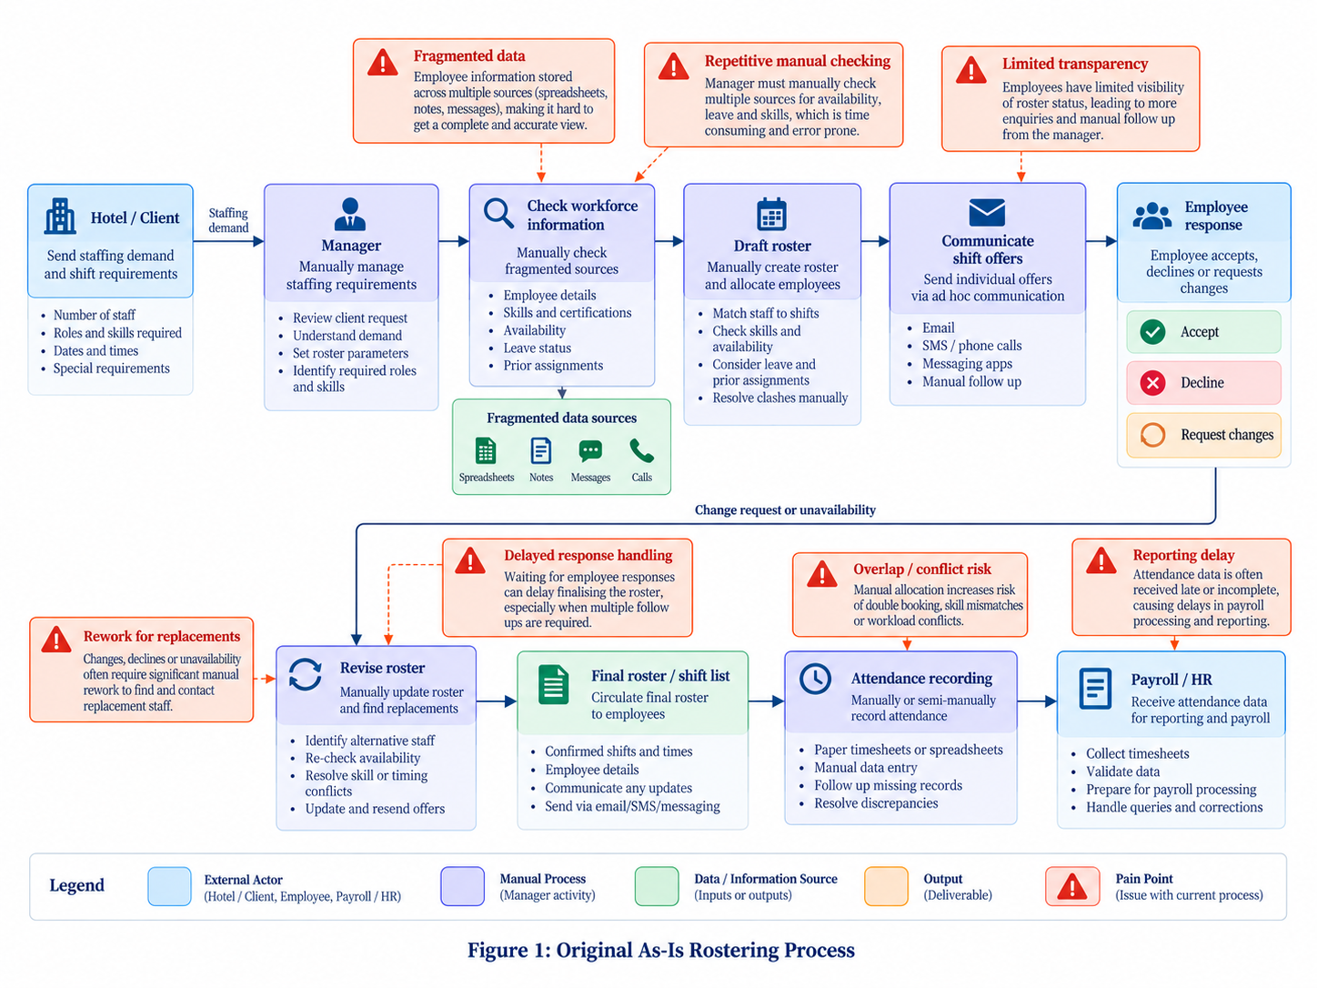
Figure 1: Original As-Is Rostering Process

2.3 Operational Problems
There were some flaws in this model. One was that manual staff versus workforce information comparisons put the need for the wrong number of staff at risk. It could lead to two managers having different understandings of the information or interpret same information as different due to missed awareness about other workers getting the job. Second, the information might be incorrect at the time of the manager's check, but be correct when the shift is confirmed. Third, it wasn't always possible to have just one record of the true version of the roster; communication over multiple channels led to the loss of trackability.
This business analysis, in particular, identified “last-minute changes-communication received” and “overlapping assignments”, as well as “under-staffed shifts” as potential implications. Accounting for attendance accuracy was also important as attendance data is also utilized for downstream reporting and payroll. These problems relevant to shift coverage extend to employee attendance, reporting and employee communication; a bad assignment will lead to broader issues in attendance.
In terms of operations research, this pattern can be expected in situations where the complexity of the decision itself rises proportionally to the complexity of existing tools to support decision-making. However, employee scheduling is not just about coverage requests and individual employee rules, and solutions become harder to find as more employees and rules are added (Kletzander & Musliu, 2020). A system to help improve this process must incorporate a structured model of the worker constraint aspects and should not be just memories of the manager or manual comparing.

2.4 Need for a Centralised Decision-Support System
The early idea offered in Assignment 2 was a central platform on the web which would have all of the employee information, skills, experience, availability, leave, client requirements, roster assignments and attendance. The aims were to compare staffing needs directly with workforce data, block unsuitable employees for exclusion and to enable a manager to view created staff rosters prior to publication.
This baseline continued to be applicable throughout development, but the project later proved that merit was created when centralisation was extended, established and reinforced by others. With information located in one place, there needed to be a constant way of interpreting the information. For instance, the system had to learn if availability was sufficient to accommodate a shift; if certification was still in effect; if someone else had booked an employee; if there was no impact on weekly workload; and how some possible shifts could be prioritised.
ISERS thus grew from initial concept of an 'ISERS' rosters, to a multi-layer decision-support system. The final design used human approval, but incorporated automated repetitive check(s) and the reasons behind the eligibility of the candidates were exposed. This will be formally studied in Section 4.

3. Literature and Technical Foundation

3.1 Employee Rostering as a Constraint Optimisation Problem
Employee rostering is a resource-allocation issue in which workers need to be assigned, to meet an organization's demand and worker-specific constraints. Kletzander and Musliu (2020) present combinations of heterogeneous rules and demonstrate scheduling problems to be computationally challenging, which justifies the need for an extensible constraint model in ISERS in this regard.
Covering later assignment choices, recent work by İşeri, Güner and Güner (2025) include skills, demand and preferences together with fairness. It reflects the ISERS principle that the feasibility should be known prior to the soft ranking considerations.
Similarly, Ma et al. (2024) demonstrate how tough the definition of standard shifts is for employee scheduling. The evidence-based study of the use of flexible scheduling in relation to changes in workload shows that staffing quality can be enhanced by working towards a flexible staffing schedule rather than a staffing schedule prescribed by assumptions. ISERS do not reproduce their algorithm, but the study stresses the more fundamental importance of dynamically modelling the staffing requirements and separating essential constraints from flexible optimisation criteria.

3.2 Hard and Soft Constraints
A helpful conceptual division into workforce optimisation is between hard and soft constraints. Hard constraint conditions are conditions which must be fulfilled for an assignment to be made feasible. For ISERS, the examples are: active employment status, full availability for the relevant period, absence of approved leave, the presence of a mandatory skill or certification, and no overlapping assignment and compliance to defined workload or rest requirements.
Soft constraints are constraints which can affect whether or not an assignment is desirable, but which are not beneficial. Examples can include preferred venue, preferred working period, equitable distribution of hours, experience level or proximity to the workplace. Why preferences and fairness should not take priority over feasibility, a feature that service-scheduling models developed by İşeri et al., (2025) illustrate. This separation was a core part of the endpoint ISERS decision engine – an acceptable person is never considered eligible if one of the required conditions is not met.

3.3 Skills-Based Workforce Allocation
Hospitality is not gay and straight. Experience, competence and/or qualifications may differ for different jobs. This typically leads to technically complete, but operationally suboptimal staffing schedules, if a staffing system is limited to worker availability. Through employee proficiency and skill variation, a number of literature on workforce scheduling include these factors in the decision of assigning an employee to a trade. İşeri et al. (2025) explicitly include worker skills and skill levels in the assignment decisions, and Ma et al. (2024) consider proficiency in determining appropriate combinations of employees.
The evidence will inform ISERS as to where this should be captured – a separate file from the general employee records and at the moment of the assignment to validate. It also allows skill info to be displayed while manager is over-riding skill. This is important because when managers see only an employee's name, and don't see what information is needed to make an smart replacement, this can distract them from the automated constraint system being effective

3.4 Employee Preferences, Fairness and Workload Balance
Efficient scheduling can't be judged solely in terms of employer's view. Whether an automated rostering system can be practically accepted can be impacted by schedule predictability and employee control along with equitable workloads. In 2020, Karhula et al. examined participatory working-time scheduling and examined how the nature of working hours and employee wellbeing changed if the workers became more involved in working hour scheduling. Although it occurred in hospitals, the study does offer some further evidence that the involvement of employees is worth keeping in mind when set up a shift-management system.
Like İşeri et al. (2025), apart from workforce allocation as a pure covering problem, employee shift and day-off preferences and employee fairness are also taken into consideration in workforce scheduling. For ISERS this is an enabling of usage of employee preferences as soft optimisation criteria and of the “employee” facing functionality. However, preferences have to be secondary to operational necessity and legal/safety issues.
This is because workload fairness is critical in terms of fatigue and operational sustainability. Xu and Hall (2021) state that fatigue is a multidimensional operational issue and demonstrate that the scheduling process and/or work-rest decisions could impact both the wellbeing of workers and organisational performance. This helps to ensure workload is shown in the rostering engine and also considers the effects of rest and not just an employee's availability.

3.5 Hospitality Compliance Context
There is also the extra complexity involved with the Australian hospitality context. The Hospitality Industry (General) Award 2020 contains provisions relating to ordinary hours, rostering, breaks, consultation on roster changes and other conditions of employment. This does not imply that the software gives legal advice about compliance for ISERS. Rather it illustrates how the use of configurable rostering rules is needed. Working hours and rest periods as well as organisational policies can change, with a maintainable system allowing the corresponding restrictions to be modified without the re-designing of the entire scheduling engine. Later worked into the development of configurable compliance controls.

3.6 Explainability and Human-in-the-Loop Decision Support
A question is in this case: how to inform users about the workflow recommendation – this is an additional design challenge while automating a workflow decision. Explainability is deemed to be a crucial part of business decision-making powered by AI, as users need to understand how systems make business decisions, as described by Coussement et al. (2024). Likewise, Kostopoulos et al. (2024) state that transparency, interpretability and trust are key issues in the context of explainable decision-support systems.
This principle is also relevant if there is no underlying machine-learning optimization algorithm instead it is mathematical optimization. But sometimes a roster recommendation can be murky if the manager can't figure out why some employees were recommended and others turned down. In the explainable decision support approach of ISERS, the candidate blockers, eligibility conditions and positive ranking factors are made visible to the manager.
The manager continues to be embedded in the decision loop. Automated recommendations may be reviewed and (where applicable) rejected but the final system verifies ‘must’ constraints and notes the basis for any key differences. This will prevent two extremes: manual control with inconsistent checks and full automation without control and responsibility of man.

3.7 Algorithmic Management in Hospitality
In the hospitality industry, transparency is particularly important as scheduling systems impact the front staff. In an interdisciplinary review of hospitality automation and algorithmic management, Spektor et al. (2023) propose that technological change in hospitality may lead to the reconfiguration of frontline work, and introduce them to the concepts of transparency, participation and context of deployment when designing technologies for their workplace.
This literature warns that a quick shift generation is not the only measure that can be used for the evaluation of an automated rostering system. The use of a technically efficient system can cause organisational issues when employees are unable to understand and use their schedule, decisions seem to be arbitrary, or management is not properly considering review mechanisms for the system. The following concerns had an impact on the final ISERS design: Employee-self service; Visible preferences; Shift reactions; Logical explanation of assignment logic, manager accountability.

3.8 Current Commercial Workforce Platforms
Digital rostering is now a proven market, with commercial systems stating this is "fully mature". Employment Hero, Deputy, Tanda and RosterElf offer a suite of features for both scheduling and employee self-service, compliance and workflow management. ISERS must be assessed based on the transparency and decision support features it provides and not only on the ability to automate rosters.
The project, on the other hand, should be evaluated on the actual mix of capabilities in implementation and evaluation, including the multi-layer eligibility verification, the rationale behind, and intuitiveness of the candidate response, manager override controls, employee response workflows, geographic comparison and seamlessly incorporating downstream attendance and reporting.

3.9 Identified Gap and ISERS Positioning
What the literature shows is that staff scheduling is a much more complex process than simply filling gaps. Research validates constraint based scheduling, skills matching, and skills proficiencies, preferences, fairness, workload. Human-centred research also underscores the principle of transparency and employee involvement, while recent hospitality solutions validate the growing demand for automation elements such as employee self-service, compliance monitoring and scheduling.
In this backdrop, ISERS is more of a system of work support for the hospitality industry, which will provide explanations of decisions made by the staff rather than claiming the invention of staff rostering. Its contribution to a project is to bring together a range of feasibility checks, candidate preference, workload, geographic and travel considerations, out-of-band explainability checks by the manager, workflows for employee response and later responses/reporting, all as part of one implemented system.
From here, the rest of the report is put together. Section 4 then looks at the evolution of the requirements from Assignment 2 into the scope that has been implemented, including change made based on supervisor feedback and experience and practice during implementation.

4. Requirements and Scope Evolution

4.1 Original Requirements Baseline
The pre-development report identified these 16 functional requirements: authentication, RBAC, employee and skill records, availability, hotels, staffing requirements, leave, automated rosters, conflict detection, review, publication, attendance, payroll-ready reporting, audit, exception handling. These standards set the ground rules as a baseline to which final implementation was compared.
Functional baseline was not changed during development. All the manager interfaces and employee interfaces had to be authenticated and role-separated before they could be safely exposed, skills and availability were necessary before the employee could be evaluated for eligibility, venue requirements were necessary before staffing demand could be determined, and all publication, attendance, reporting and audit functions were essential to complete the operational lifecycle. Development did not therefore dispense with the Assignment 2 specification. Rather, all sixteen of the original requirements were carried over into the final system and expanded over time as design conditions were found where the initial design did not adequately model the operational situations.

4.2 Original Non-Functional Requirements
It is not until the first non-functional requirements that security, usability, performance, availability, reliability, scalability, maintainability, auditability, data integrity and browser compatibility are brought into the picture. As the system grew more dynamic these requirements became more significant. For instance, scalability wasn't merely the ability to add more employee records – it was also needed to enable greater candidate population, added business rules and future production database deployments. The same goes for usability, and that extends to manager workflows, as well as desktop, tablet and mobile self-service for employees.
The final implementation focused on the practical steps to be taken to achieve these qualities. Hashed password, server managed session, role-based API authorization, CSRF protection and audit events were provided as means of security. Reliaibility and data integrity were supported by validated API schemas and the relational constraints - explicit exception states and not silent understaffing. The separation of maintainability of models, security, API logic and rostering services were added to code at the front end. As far as compatibility, responsive layouts and mobile navigation were offered and as far as performance is concerned, the synthetic benchmark described below in Section 8 was used.

4.3 Supervisor Feedback
The feedback from the supervisor was considered as a formal design input. The most obvious was that the DFD hierarchy had been as follows: Level 1: Using numbered major processes and data stores; Level 2: Detailed description of roster logic; Level 0: ISERS is one process and external entity. This corrected structure is used in the final report.
The feedback received was also broad with parents appreciating the value of the project beyond just an eRoster. The system had to demonstrate to them how useful it is, how decisions are going to be made; how can it be expanded to accommodate more people, and how does it resolve the needs of a calendar or spreadsheet replacement. An account of the added attention to explainability, reusability of constraints, response workflows of employees and evidence of system behavior made traceable to transparent evidence were developed based on this feedback.

4.4 Development-Driven Requirement Evolution
As the implementation process itself was in progress, it became clear that there were some requirements (edge cases) not anticipated in the original specification. The first big extension was for employee participation. This was a published assignment which was reworked as an offer an employee would be able to take on, or refuse. If the user's answer is decline/expiry, the replacement workflow could be initiated automatically instead of having it to be initiated by the manager manually. Repeatedly non-acceptance brought in a controlled suspension process, and a manual activation process was created that enabled the employee to give a reason for and substantiate the subsequent return to the manager?
Additional enhancements to improve decision quality. Work position, cross-manager conflicts, workload, rest, travel feasibility, preference and fairness were added to the field of candidate evaluation. The existing basic features were then extended to include OpenStreetMap based comparison as well as workforce intelligence and configurable compliance controls.
A third set of enhancements included to the solution focused on operational intelligence. For managerial decision making configurable compliance rules were added, a transparent reliability history was introduced, notifications were made available, workload and preference analytics were included, skill-gap views and non-destructive what-if scenarios were added and no human control was lost. This progression from the initial version of Assignment 2 to the v2.1 implementation, with feedback from supervisors, core development and exposure to pilot, is summarised in Figure 2.
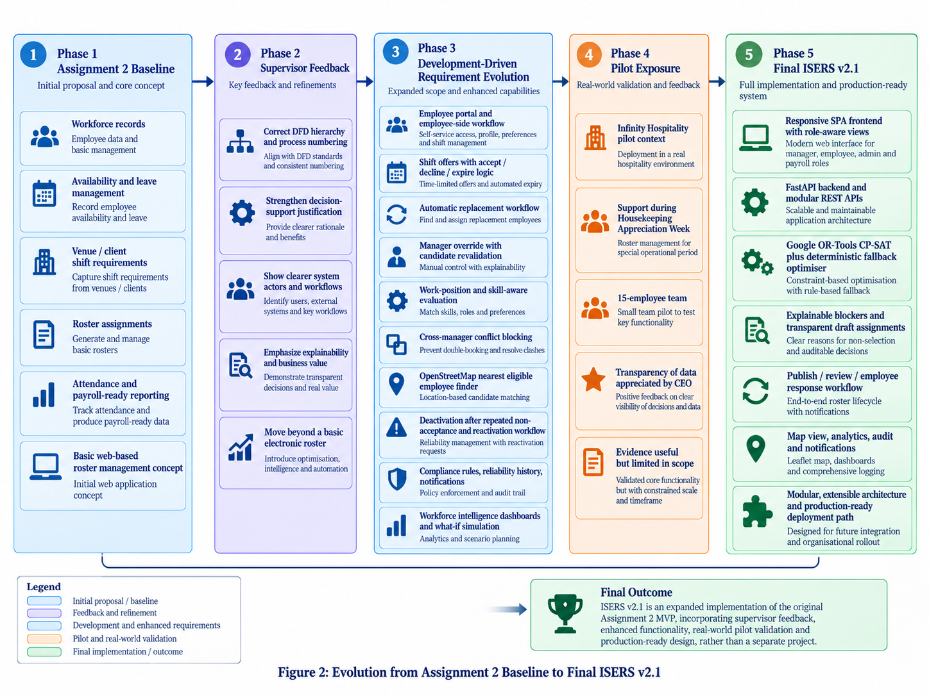
Figure 2: Evolution from Assignment 2 Baseline to Final ISERS v2.1

4.5 Final Scope
The final scope could then be considered as more of an extended version of the initial MVP project rather than a completely new one. It still covers the various workforce data, availability, leave, venue, staffing needs, roster generation, conflict detection, review and publication, attendance, reporting and audit. The final version introduces employee preferences and approved locations, explainable candidate reasoning, shift offers and responses, automatic replacement, suspension/reactivation and shift swaps, configurable compliance, map-based candidate comparison, notifications and workforce-intelligence functions.
There are still some boundaries that are purposely left. ISERS is not payroll, doesn't make pay when employees aren't at work, doesn't give you legal advice and doesn't track the GPS of employees constantly. This map is based on movement data that has been approved and not currently collected. This travel time is currently a planning estimate and the demand-forecasting piece is a transparent historical heuristic—not a production machine-learned forecast. The shown boundaries are significant as they distinguish between actual capability and further commercial expansion.

4.6 Requirements Traceability
The final implementation was compared to the original requirements and the scope growth did not diminish the original deliverables. The following is the traceability summary (see Table 1). All 16 original functional requirements that were listed were executed and some of the requirements were expanded upon with added functionality. This traceability describes the building blocks used to describe the more detailed verification evidence in Section 8.

5. Final System Design and Architecture

5.1 Final To-Be Process
Final To-Be process starts when manager records or confirms the client staffing need. The employment status, the position employed, eligibility, approved leave, skills and certification validity, existing assignments, workload and configured compliance conditions are then used in a layered eligibility process to evaluate workforce information. Other employees are rated subjectively (empirical non-factor) based on factors, including experience, preferences, workload balance and geographic suitability. The end result indicates that it provides an explainable draft roster in contrast to shrouded lists of names.
Manager review is always a control point. The manager will be able to review recommendations, candidate blockers and proposed alternativa beforehand. Completed assignments are confirmed employee shift ads when made public. Accepted orders continue to attend and report, Declined or “expired” orders can initiate the next “feasible” order process. This means that instead of the roster generation being the final process, it is now a closed loop from demand via response and arrival of employees and then to allocation. The achieved To-Be workflow is shown in Figure 3.
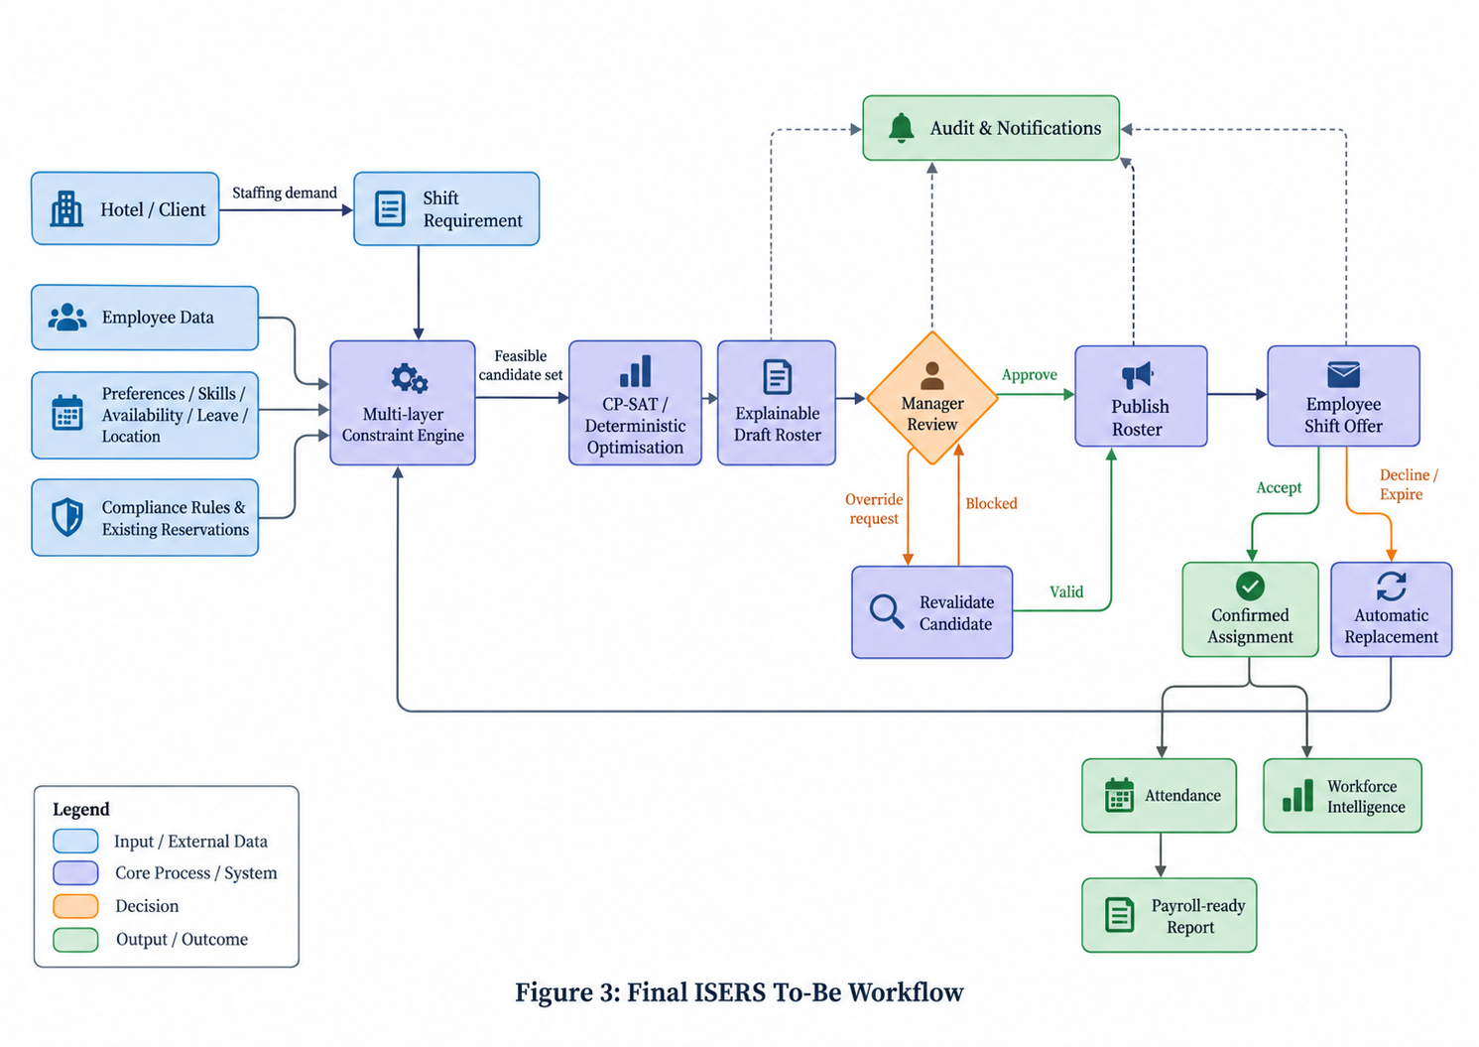
Figure 3: Final ISERS To-Be Workflow

5.2 DFD Level 0 / Context Diagram
The corrected level-0 DFD shows ISERS as one process that interacts with Manager, Employee, Hotel/Client and secondly with Payroll/HR. No internal data stores were intentionally left off because they were found during the supervisor review to be part of the hierarchy.
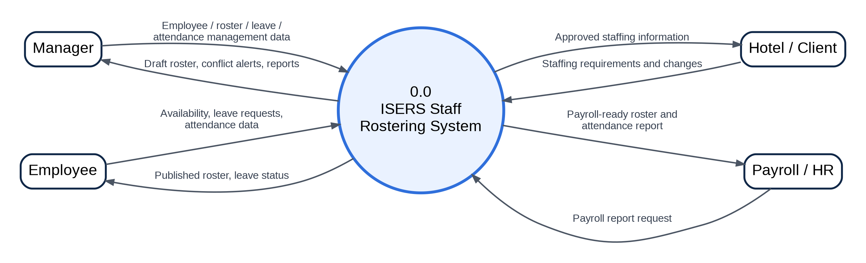
Figure 4: Corrected DFD Level 0 / Context Diagram

5.3 DFD Level 1
ISERS is broken down to five main processes at Level 1: Manage Workforce Data, Manage Staffing Requirements, Generate and Validate Roster, Review and Publish Roster, Attendance and Reporting. Because the diagram here is illustrating the internal structure of the system, internal data stores are shown at this level.
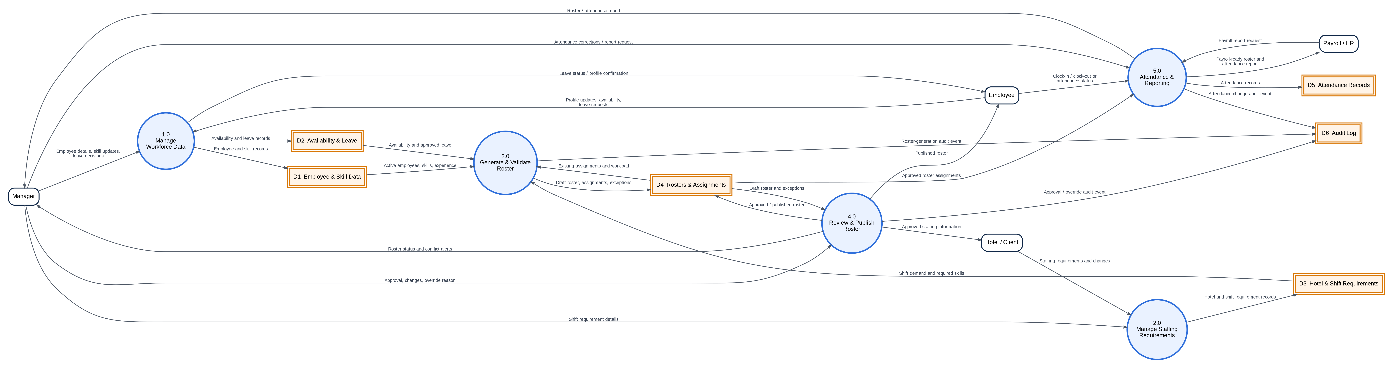

Figure 5: Corrected DFD Level 1

5.4 DFD Level 2 - Generate and Validate Roster
Process 3.0 is broken down into Level 2 errors as the generation of rosters is the area with the densest decision logic. The subprocesses involved include adding candidate data, ensuring the candidates are available, availability/leave checking, verifying candidates skills/roles, applying constraints, ranking the candidates found suitable and generating assignments/exceptions.
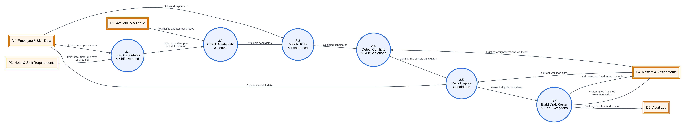

Figure 6: DFD Level 2 - Generate and Validate Roster

5.5 Final Use Case Model
The extended view of the original manager-centred USE case model is extended to role-specific workflows in the final model. Managers are responsible for employees, skills, venues, requirements, make leave decisions, generate rosters, review, publish, reactivate, compliance settings and reporting. Employees set their own availability, leave, preferences, approved doc location information; accept, reject and respond to shift offers; view rosters; engage in permitted swaps; record attendance with their assignments. The system level controls and accounts are being managed by the administrators and HR/Payroll accesses appropriately approved system level reporting outputs. This separation helps in terms of usability and reinforces least-privilege access.
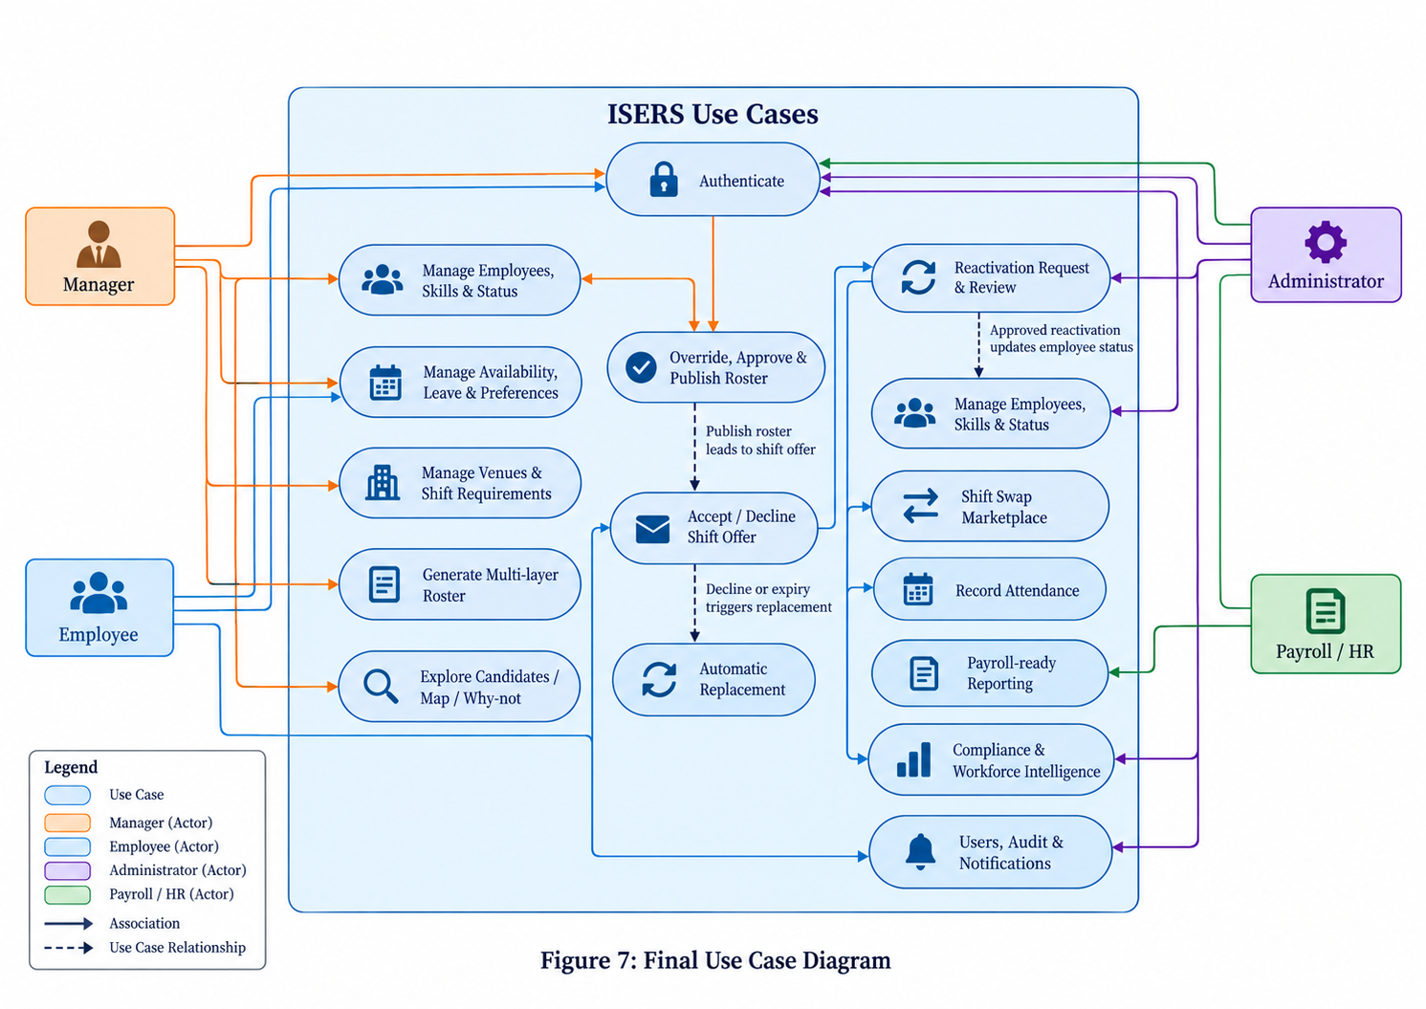
Figure 7: Final Use Case Diagram

5.6 Final Data Model - Core ERD
This ensures that the core model for the entities that needed to be preserved for Assignment 2 like Users, Leave, Skills, Availability, employees, Venue, requirement, rosters, assignments, attendance, audit are maintained. Foreign keys and association entities are used to implement relationships, to facilitate tracking of rostering decisions to workforce and demand data.
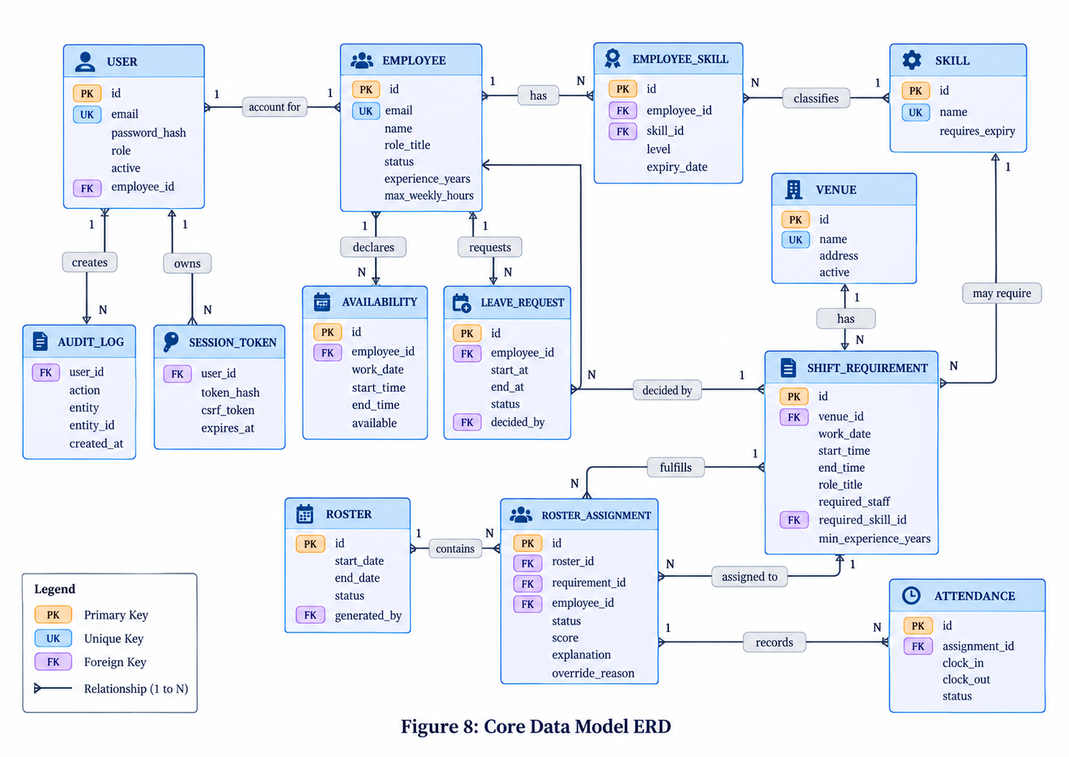
Figure 8: Core Data Model ERD

5.7 Final Data Model - Advanced Automation ERD
The advanced entities are extensions of the core schema. They can hold more preferences, location info, shift offers, history of responses, requests for activation, compliance settings, notifications and swap state. The separation enabled to keep the original data model, but also accommodate competition workflows in the future.
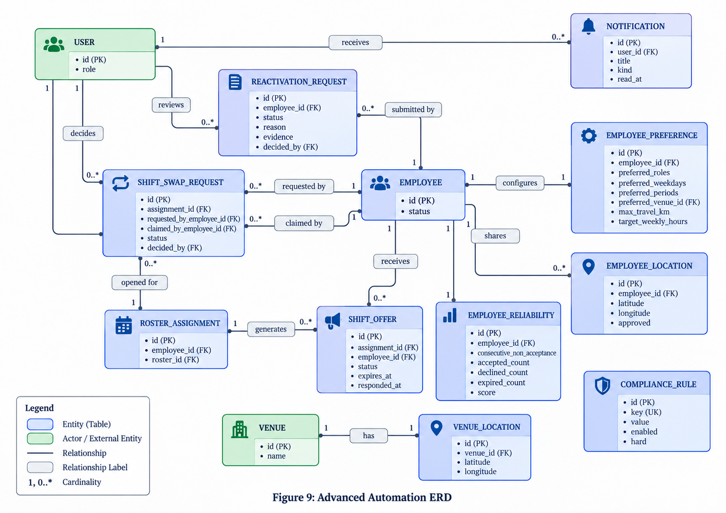
Figure 9: Advanced Automation ERD

5.8 Technical Architecture
ISERS has a layered Web architecture. A responsive HTML, CSS and JavaScript interface provides role-aware experiences for managers, employees, administrators and payroll users. The frontend interacts with a FastAPI REST layer which handles authentication and workforce management, roster management, offers, swaps, attendance, reporting, notifications, audit, intelligence functions. These workflows are orchestrated by an integrated candidate evaluator that ensures that roster generation, Candidate Explorer, override, nearest worker ranking, automatic replacement and worker swap validations have the same logic behind them instead of using different interpretations in each screen.
It takes a SQLAlchemy ORM as its persistence layer. In both cases, SQLite is used for local and demonstration use, and as for PostgreSQL, it can be supplied via the production database configuration. The optimisation layer is provided with Google OR-Tools CP-SAT, if available, and has a deterministic fallback solver such that the application continues to work in lightweight local environments. Mapping is done via Leaflet and OpenStreetMap tiles. This modular design allows separating presentation, application services, optimisation, and persistence; making it easier to introduce change in the future without re-designed the whole product.
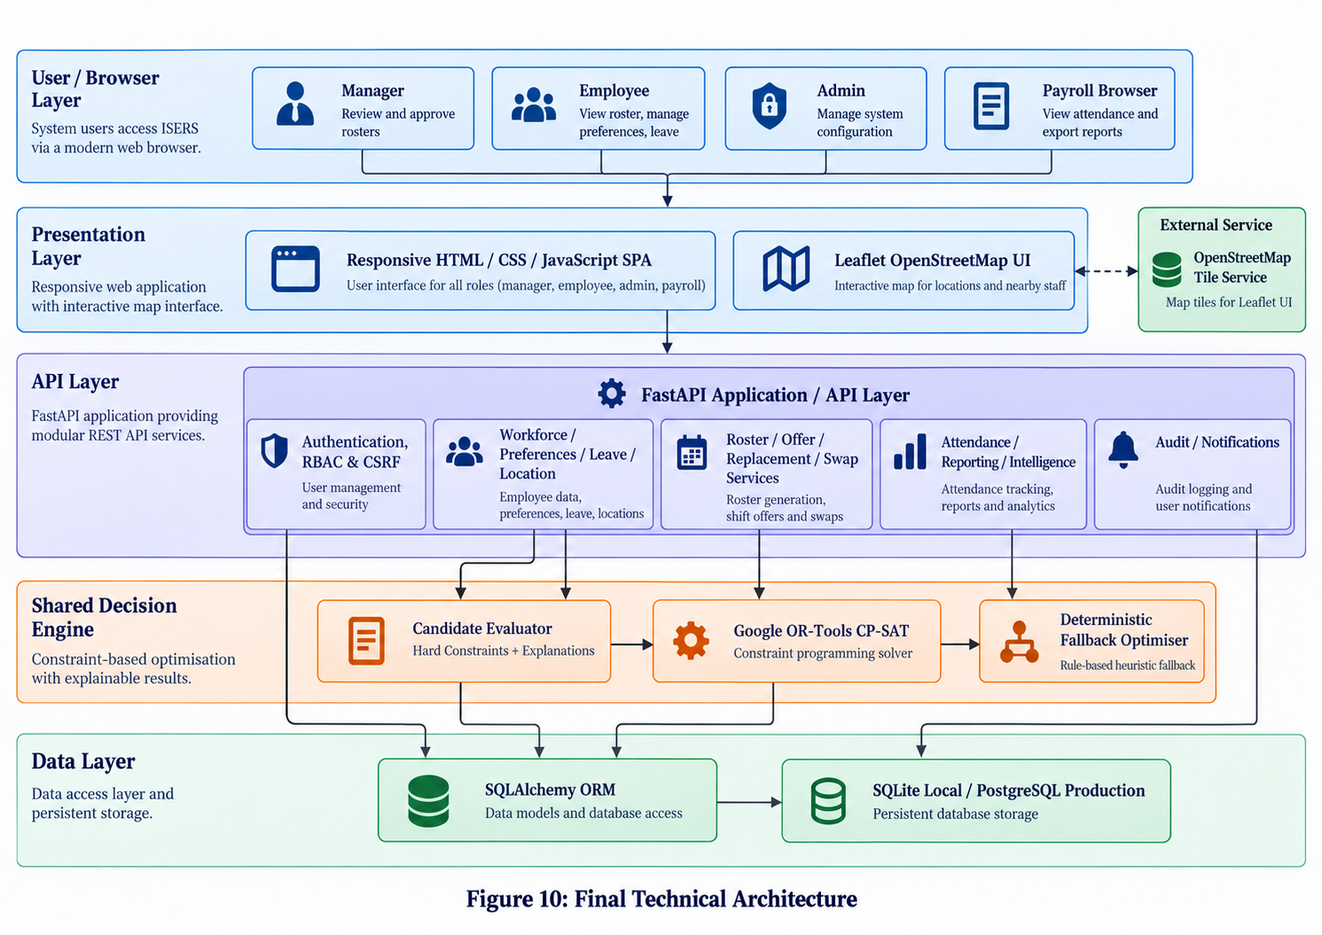
Figure 10: Final Technical Architecture

5.9 Deployment Architecture
This design encourages the deployment of the static web content, while keeping the long-lived Python backend separate. The frontend can be served on Netlify, the `/api/*` requests can be handled by Netlify as well and FastAPI and PostgreSQL sit on a suitable persistent host. It maintains the current Python optimisation and database routing methodologies without the pretence that the application is completely now hosted on Netlify.
The deployment boundary is deliberately configurable. Database credentials, secure-cookie configuration and production secrets are supplied through environment variables. The OpenStreetMap tile source is also isolated so that a higher-capacity OSM-compatible tile provider can be introduced if production traffic exceeds the public tile service's appropriate usage level.
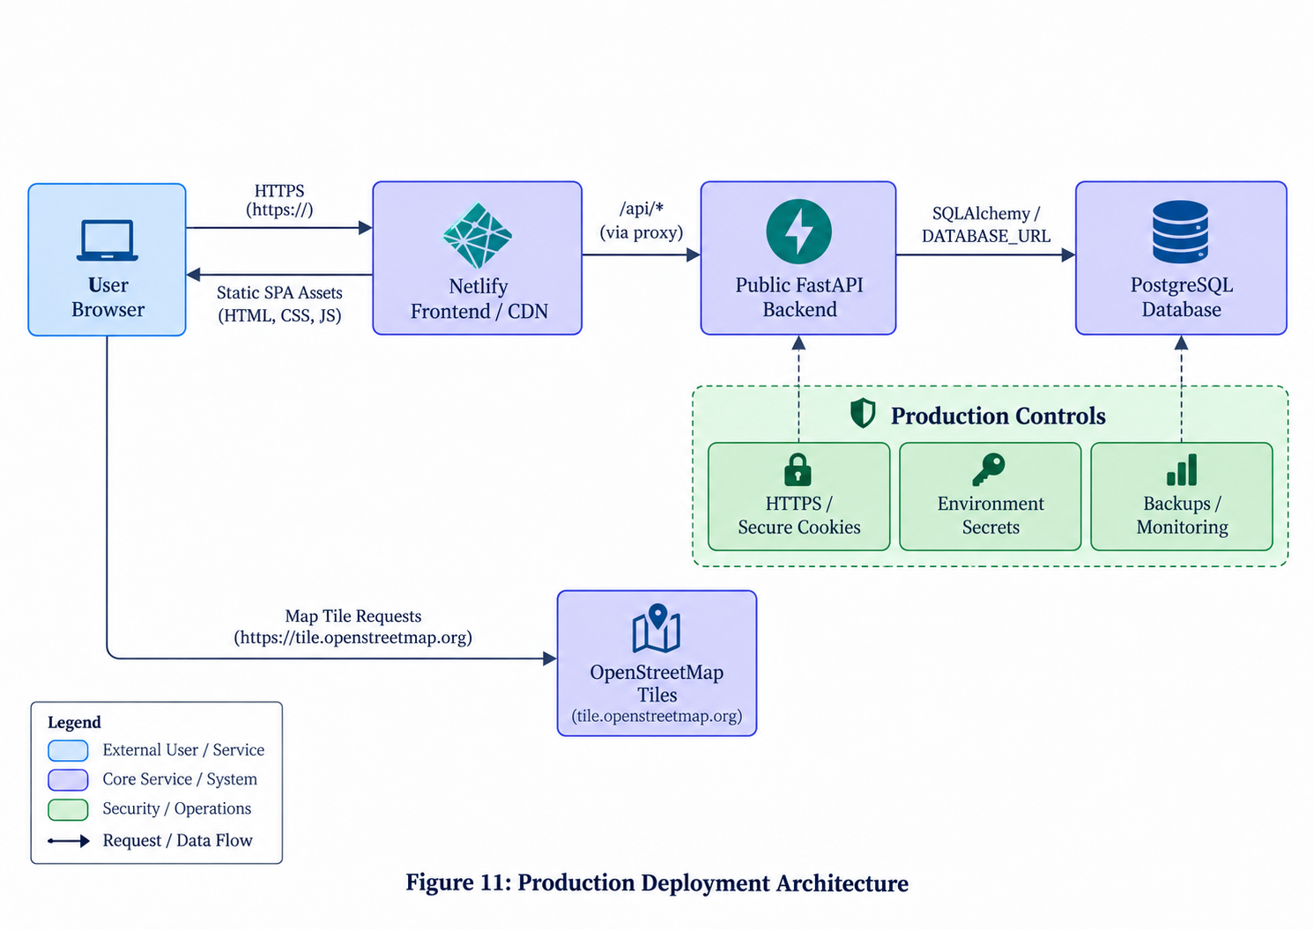
Figure 11: Production Deployment Architecture

5.10 Security and Privacy Design
Security was designed as a cross-cutting service rather than a single login screen. Passwords are stored using salted PBKDF2-SHA256 hashes, server-side sessions use opaque random tokens, cookies can be configured as HttpOnly, SameSite and Secure, and state-changing API requests require CSRF validation. Role-based authorization is enforced at the API layer, so hiding a navigation item is not relied upon as a security boundary. Important actions are written to the audit log, and uploaded reactivation evidence is size-limited in the supplied implementation.
These controls align with NIST SP 800-53 and OWASP guidance on authentication, access control, auditability and web-application risk (NIST, 2020; OWASP Foundation, 2021). OAIC privacy guidance also supports data minimisation. ISERS therefore uses employee-approved base coordinates rather than continuous tracking; production deployment would still require HTTPS, backups, privacy review and penetration testing.

6. System Implementation
The final ISERS application is realised as a responsive Web based workforce management and rostering system. The development was done in modular fashion, with the responsibilities for presentation, API, decision logic and persistence being distinct. This was case because the ultimate system created expanded significantly from the scope of Assignment 2. Reuseable backend services were created to hold business logic to enable the user interface to interface with business rules common to all operations such as roster generation, candidate exploration, override by managers, nearest employee classification ranking, automated replacement and validation of shifts for the purpose of changeover.

6.1 Development Environment and Technology Stack
The final product will include HTML, CSS and JavaScript, with a FastAPI REST backend, SQLAlchemy ORM (FastAPI, 2026; SQLAlchemy, 2026). Local demonstrations are possible in SQLite, and PostgreSQL for production. Google OR-Tools CP-SAT is responsible for optimisation if available while Leaflet and OpenStreetMap Foundation supplies the map interface (Leaflet, 2026; OpenStreetMap Foundation, 2026).
This work was intentionally aimed at having a single API and decision services for multiple use cases in order to have them as flexible as possible.The design of the project was intentionally created to ensure multiple user roles could be supported with the same API and decision services as much as possible. The browser interface thus does not have its own interface to the rostering rules. The validation of all state changing actions by the backend before the update is performed, lowers the risk of inconsistent record with stale browser information or other manager actions concurrently being performed.
Table 4: Final ISERS Technology Stack
Layer / Component | Technology | Implementation Role
Presentation / UI | HTML, CSS and JavaScript | Responsive role-aware web interface
Backend / API | FastAPI | REST services, workflows and authorization
ORM | SQLAlchemy | Relational persistence and database abstraction
Local database | SQLite | Local development and demonstration
Production database | PostgreSQL | Production persistence via DATABASE_URL
Optimisation | Google OR-Tools CP-SAT | Global constraint-based roster optimisation
Fallback optimisation | Deterministic solver | Roster generation where OR-Tools is unavailable
Mapping | Leaflet + OpenStreetMap | Interactive approved-location candidate map

6.2 Frontend Implementation
A single-page, responsive style interface is used on the front end with a role-aware interface. Shared API, modal, notification and rendering functions are shared among modules. Hidden interface controls are not considered a security boundary, the back end APIs are always authoritative for permissions and validation.
This implementation approach is compliant with the original non-functional requirement for the interface to function across different desktop and mobile browsers, but it does not require to have to build a huge frontend framework. It also enabled the interface changes to be done rather quickly as the needs of the project changed.

6.3 Manager Command Centre
The manager facing Command Centre is the entry point to ISERS. The dashboard does not ask managers to open several modules to view the employees' state across the organization, but instead gives an overview on information that needs intervention – such as roster coverage, employees pending to respond, vacant positions, suspended employees, shift-swap activity, and messages in the system. This helps to achieve the initial goal of fragment reduction by giving a single system for showing roster information.
The final manager dashboard and the information sharing of workforce data to a single operational picture are shown in Figure 12. Not only is it for ease of use, it is also a management layer on top of underlying rostering workflows. The manager can spot or detect if manpower is needed or any response issue, and go directly to the manpower roster, offer, staff member or employee requirement.
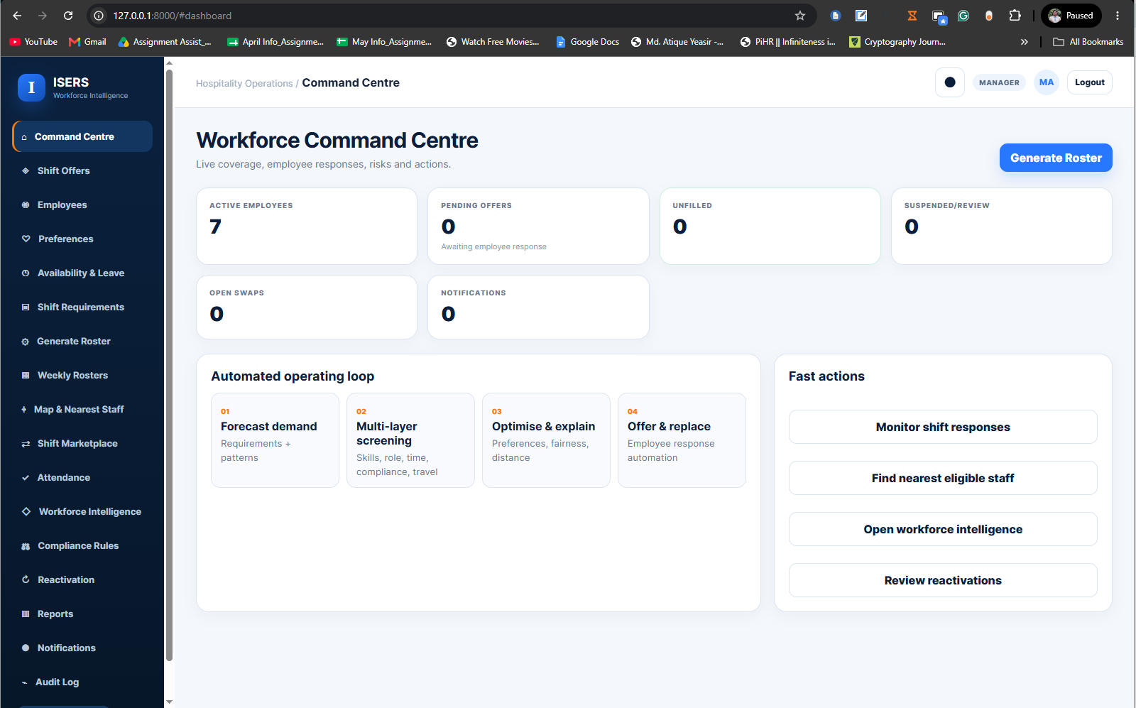
Figure 12: Manager Command Centre and Operational Dashboard

6.4 Employee and Skill Management
Employee management was put in place and was more than a contact directory. Information about role/work position, employment status, experience, work load use/limitation preference can be added to each employee record. Skills are maintained separately from the other data and tied to employees, enabling the system to track multiple skills and skill expiration without having to duplicate employee information. It extends the data defined during the previous analysis implementation while keeping the data to a normalised design that the final constraint engine needs.
Managers are able to create, edit, deactivate and observe employees as well as allocate skills or certifications to them. The reason that Status is paramount is that only employees that are active and eligible should be allocated to their normal roster, and notifications should be given accordingly. Later, the non-acceptation workflow may also place the employee in 'suspended' status and set them aside from other subsequent automatic assignment until the reactivation is done.
The interface in Figure 13 is public, letting managers know which skillsets and which job position are available for the employee. This data can also be reused in overrides and candidate comparison, minimizing any chance a manager may have of hiring someone just because they know their name and don't bother to find out if they are qualified for the job.
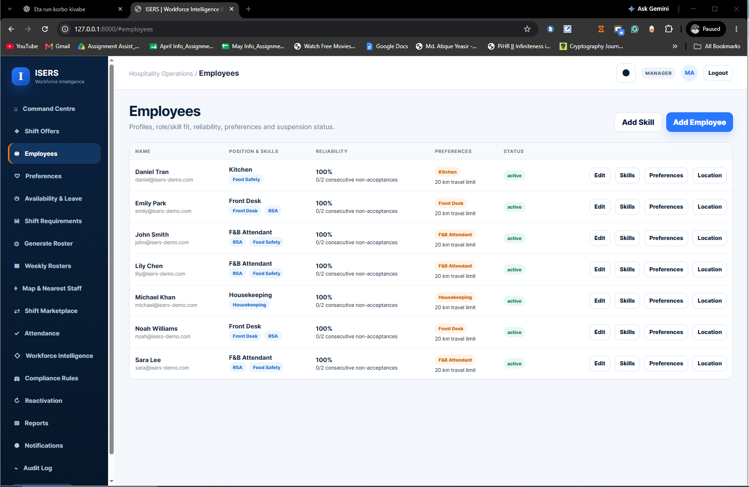
Figure 13: Employee Profiles, Positions and Skills

6.5 Staffing Requirements
Staffing requirement is expressed by venue or client's shift requirements. The manager is able to record the date of the shift, start and finish time, required position, required number of staff, required skills and minimum number of years of staff experience. Requirements can then be modified or disabled if there's a shift in client needs. This allows for a well-defined demand document, which can be referenced directly by the decision engine, instead of by unstructured messages or manual notes. The used interface for shifting the requirement is shown in figure 14. It's significant to wrap those concepts up - the “workforce available” is a workforce description and the “work to cover” is a requirement description. These two sources are added to only when there is formal requirement.
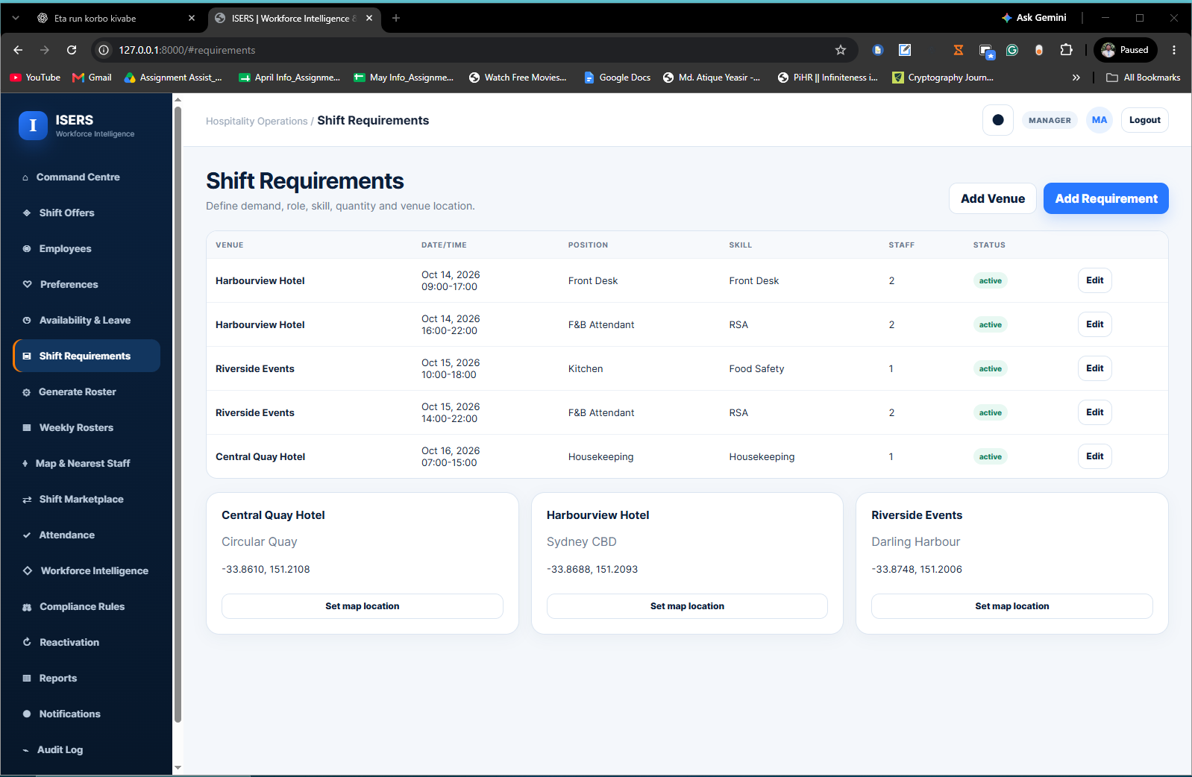
Figure 14: Shift Requirements and Venue Management

6.6 Employee Self-Service Portal
The final implementation isn't just a passive experience for employees where managers health and maintenance plans rosters – instead, there is a dedicated employee experience. Only appropriate employee self-service information and actions are allowed in the employee role accounts. Staff are able to keep their own leave/on duty details, view published employee roster, add or edit their preferences, acknowledge shift offers, view emails, engage in an approved shift-swap process and record attendance on permitted shifts. However, the preferred venue basis for the preference model was extended as the model was being developed. Each person is able to influence the final system that represents your preferred role, preferred time window, maximum travel radius, weekday, shift period, venue, and maximum target weekly hours. These preferences are considered primarily as optimization criteria and are not "required" availability. That means a staff member might choose a special venue or a specific working day but such a choice does not result in the system breaking a required rule of the business. The change control for shift offers is found on the employee portal as shown in figure 15. Having an employee interface is important to ensure operational accuracy and transparency, as the information you need to know, their availability and responses are stored all in the same system and not passed through disconnected channels.
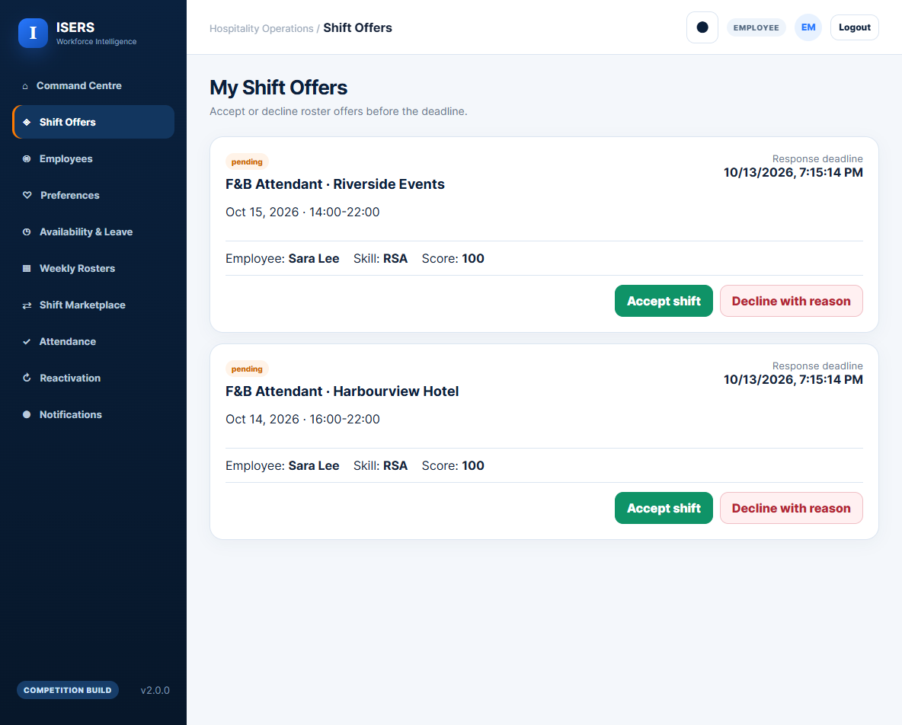
Figure 15: Employee Self-Service Portal and Shift Offer Actions

6.7 Authentication and Role-Based Access Control
Authentification and authorisation was firstly applied in API level and not hidden navigation items. High entropy opaque tokens are used during authenticated session and password are stored with PBKDF2-SHA256 hashing + random salts! HttpOnly, SameSite=Lax are session cookies and secure cookies can be configured for HTTPS production deployment. State changing requests need to be signed with a CSRF token attached to the server side session.
Role-based access separates-administer, manage, employee and payroll-related operations. For instance, an employee account is unable to call out for any unaudited inputted worker details or Organisation wide Audit log, and the employee can edit only the availability, attendances and leave of his/her personal account (via employee authorised endpoints). The operational functions for employee, roster and workflow management are given to managers and administrators. This is in line with access principles on legitimate operational need and as security controls are foreseen in the original design. Access control, identification/authentication and audit/accountability also are described as important classes of information-system controls in NIST SP 800-53 (NIST, 2020).

6.8 Employee Offer Workflow
Do not presume that as soon as the roster is published, all employees have accepted an appointment. Once a roster is published, the system offers employees their employee shift where they can accept/reject via the employee portal. The "pending" offers will be visible to management, and will help to distinguish an assignment that is proposed or published regardless of if a person has confirmed an assignment.
You can also leverage the offer workflow to leverage automatic exception handling. A decrease in response or the depletion of responses can lead to a search for the next viable employee consistent with a common constraint evaluator employed to create the rosters the first time. This prevents a common error where rules that replace a scheduler are less stringent than its original rules. This implementation chapter does not repeat the detailed evidence of a decline and replacement as separate screenshots, but rather the evidence for decline and replacement is presented in the workflow analysis and appendix.

6.9 Non-Acceptance, Suspension and Reactivation
In development, an additional reliability workflow was added to solve the reoccurring non-acceptance. The system maintains an history of offers and the responses without a mysterious and esoterical ‘score’ being the only means by which the responses are split. If the first drop or drop period exceeds, it will add the history up, and may result in a warning. If the employee has been rejected a second time, this rejects employee status becomes suspended_non_acceptance, removes the employee from normal future allocations and releases pending offers that are not accepted for allocation, in order to consider a replacement.
Suspension is NOT considered as "permanent deletion". The employee shall submit an explanation and supporting evidence in a reactivation request and continue to be authenticated. Authorised Manager/Administrator may approve/reject or request for further information. If approved, the consecutive "non-acceptance" counter is reset and active status is restored. The drawback of this review step is that it can create the impression that there's no human review process for the automated status decision, which otherwise would prevent this step.

6.10 Attendance and Payroll-Ready Reporting
Attendance being a free-form event is not recorded but is instead tied to rosters. At the time of actual implementation, attendance may only occur if a student's name is on a roster of accepted assignments (canned or published) to allow for the protection of downstream reporting of draft and/or unconfirmed data. Employees may log information regarding their approved attendance for any assignment that they make, and authorised managers may take the necessary action for such information, as appropriate, or make the necessary adjustments to attendance.
The reporting module creates payroll ready CSV data based on the validated roster and attendance information. ISERS is not a payroll processor, does not calculate payroll, but only serves as an exported controlled border for downstream payroll processor. This helps keep the scope of the original project as it was planned – with replacement of the entire payroll system being outside the boundary of the system.

6.11 Notifications, Audit and Accountability
Audit information is generated for important system operations, allowing to trace changes to users or system processes. Major roster, assignment, employee and workflow activities are covered during audits. Along with the audit trail, notifications bring to the user's attention events, like new offers, new workflow, or status updates related to the rosters. The difference exists in that a notification will enable you to be aware during the current session, while an audit record will enable you to begin to be held to account when the problem occurs. The final system also maintains manager rationale for any sensitive action including overrides of rosters. This will increase accountability for any backend override by making it necessary to pass the validation and documenting the override reason. These are the complete audit, reports and notification screens (in order to avoid including too many graphics of the screens in the main narrative of the implementation).

6.12 Responsive and Mobile Compatibility
They did not consider responsive behaviour as an aesthetic addition but as essential to implementing the wants. While developing this early version I noticed a problem with the alignment arising from the combination of a fixed sidebar, a set of offsets for content, and grid layout. Another usability problem seemed to be the lack of a sidebar counterpart in small-screen mode. Responsive drawer navigation pattern, breakpoint-specific grids behaviour, contained table scrolling, mobile-friendly modal and form layouts were addressed to correct these issues. Collapsed interface at desktop breakpoint, wider and more concise navigation and content, at tablet breakpoint, and more condensed navigation and content at mobile breakpoint. This affords for the possibility of browsing through the mobile medium without suggesting ISERS as a mobile native app. Anticipated future improvements would be the implementation of a dedicated iOS or Android application, which is important for the final evaluation, but not implemented.

7. Multi-Layer Rostering and Decision Engine

7.1 Rostering Engine Design
Rostering engine checks the feasibility set first before providing candidates ranked. The first or most severe rules are assessed, and then the less critical ones are evaluated. The same evaluator supports generation, Candidate Explorer, overrides, nearest-writer ranking and nearest-writer replacement to prevent the application of conflicting rules on different screens. Shared engine works in all roster generation, candidate exploration, manager overrides, map based nearest staff search and automatic replacement. When you rely on multiple evaluators on these functions, there's the possibility the two screens might see this employee differently, which could lead to separate conclusions.Different screens could come to different decisions about the same employee with multiple evaluators using these functions. The final implementation also contains the reasons that justify accepting an eligible candidate and the specific blocker which makes a candidate infeasible. The shifts from demand to publication by the manager are summarised in Figure 16.

7.2 Hard Constraints
Hard constraints are conditions that can't be infringed by an assignment generated automatically. ISERS reviews employment status, position, full-shift availability, approved leave, mandatory skills/certifications, draft/published assignment conflicts, weekly-hour limits, minimum experience requirements, rest rule, consecutive-day rule and travel feasibility. If any hard rule is “enabled” and it is not met, the candidate is “excluded” with the specific reason recorded for Manager review.
The conflict rule is not just published rosters – it is meant to be comprehensive. Active assignments in both an employee's "draft" and "published" rosters are counted and cannot be simultaneously counted as "free. The validity of certification is computed based on the date requested shift and workload is computed from the workload reservations made, along with workload being added during the current generation run. If location is known and available, estimated travel time between venues is also taken into account when using rest checking.
Table 5: Hard Constraints Implemented in ISERS
Constraint | Implementation | Failure outcome
Employment status | Employee must be active and not suspended. | Candidate excluded.
Position match | Employee role must match the required shift position. | Candidate excluded.
Availability | Availability must cover the complete shift window. | Candidate excluded.
Approved leave | Approved leave must not overlap the shift. | Candidate excluded.
Skill/certification | Required skill must exist and any expiry must remain valid on shift date. | Candidate excluded.
Reservation conflict | No overlapping active assignment in draft/published rosters or current generation. | Exact conflict returned.
Weekly hours | Existing, provisional and proposed hours must remain within employee limit. | Candidate excluded.
Minimum experience | Employee experience must meet the shift requirement. | Candidate excluded.
Rest / consecutive days | Configured rest and consecutive-day limits are evaluated. | Block or advisory, by rule.
Travel feasibility | Travel radius and inter-venue time must be feasible when location data exist. | Candidate excluded if hard rule fails.

7.3 Soft Constraints
If feasible, ISERS then determines an unbiased score for each candidate. The implementation starts with a minimum point value, which is supplemented by experience, skill level, matches of preferences, work balance, reliability history, and distance contributions, all of which are bound. Preferences may comprise role, weekday, shift period, venue and preferred time window. Under workload scoring, staff are more likely to score points if they are below their chosen target hours; situation scoring encourages less stringent employees who fall in the range of origin to score points by completing jobs that are closest to them.
Reliability is specifically excluded as a form of guarantee and is minimised to a small extent. This score is based on “visible response” (including accepted offers, declined offers & expired offers as well as shifts completed). This way, transparency is enhanced while preventing an opaque behavioural score winning over allocation. The difference between something hard to fulfill and something softer (preference/fairness) to fulfill is in line with the multi-objective nature of workforce scheduling where one sets mandatory coverage and sets employee-centred objectives separately (İşeri et al., 2025).
Table 6: Soft Ranking Criteria Used by ISERS
Criterion | How it is used | Purpose
Experience | Rewards relevant experience, with a capped contribution. | Supports competence-based ranking.
Skill level | Adds weight for stronger recorded skill level. | Distinguishes feasible skilled candidates.
Preferences | Role, weekday, shift period, venue and time-window matches. | Improves employee-fit when feasible.
Workload balance | Considers target weekly hours after proposed assignment. | Supports more balanced allocation.
Reliability history | Small bounded contribution from transparent response history. | Informative, not dominant.
Distance | Rewards closer eligible staff within approved travel radius. | Supports practical deployment.

7.4 Candidate Eligibility Pipeline
Each of the potential employees is assigned the sequence in figure 16. A failure at any hard-constraint will result in an blocked candidate being stored with a blocking reason. Those that make it through all layers to the feasible candidate pool are then ranked, based on preference, experience, skill, workload, reliability and travel. The scores obtained as a result of these are then sent to the optimisation stage. ISERS reports the explicit shortage of a mandatory constraint in place if there are not sufficient feasible employees.
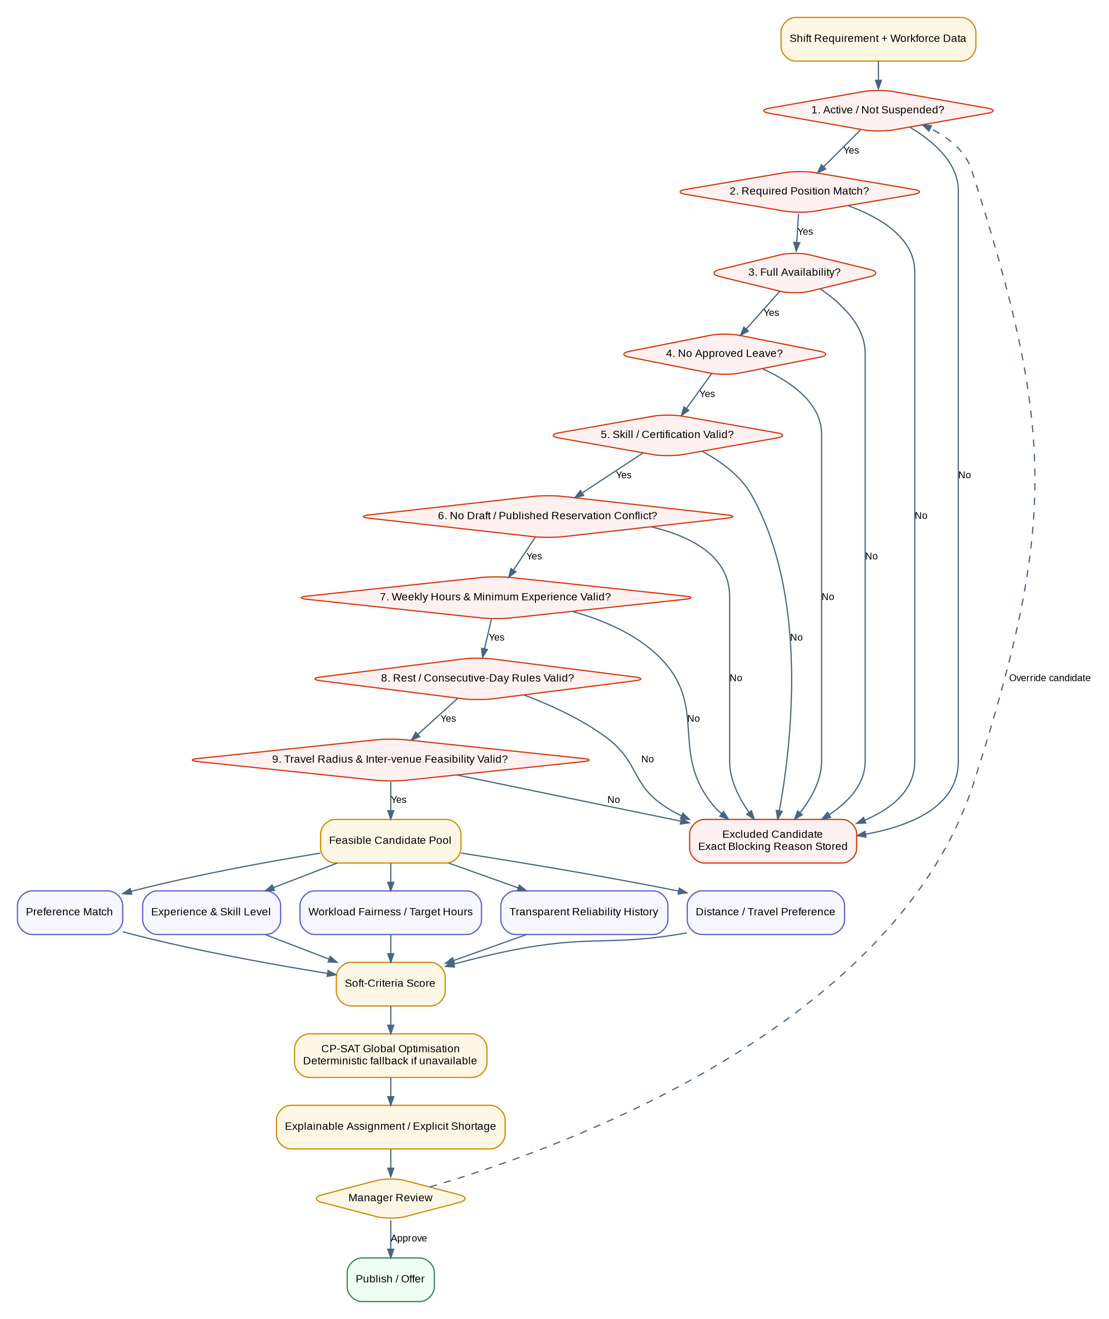
Figure 16: Multi-Layer Constraint and Optimisation Engine

7.5 Cross-Manager Assignment Protection
The cross-manager protection resolves a practical race-relation issue of multi-user rostering. Two different managers can schedule the appearance of an employee at around the same time, and the first manager may reserve the employee before the second manager makes an assignment to the employee. ISERS doesn't therefore depend on the availability seen in the browser before this. Once a manager overrides an exception, and/or a roster is prepared for publication, the eligibility of candidates will be re-evaluated on the server.
An existing active assignment will be searched in both draft and published rosters. If an overlap is identified the candidate response will contain the conflicting roster, venue, time, and account responsible for the reservation. The backend also tries to use row-level locking in databases with such capabilities, revalidation is the main protection in modes supported by the backend. The purpose of this design is to ensure that a manager can't make an assignment simply because that employee was still visible yesterday.

7.6 Workload and Fairness
The weekly workload is also a constraint and ranking criterion for ISERS. Existing reserved hours, provisional hours generated during the current run and the proposed shift duration are added together and form a hard ceiling for Maximum Weekly Hours: before eligibility is granted the current run generates provisional hours, which are then added to existing reserved hours. Each employee can have a target weekly-hours preference on their own. The higher a candidate scores on their soft allocations, the more work is distributed, thus aiding those candidates to get closer to their reasonable allocation.
This mechanism is not designed to ensure an abstract idea of perfection for the computing system, as real availability and qualification of a computer, coupled with real demands, are legitimate, and may result in different workloads. Rather, the system is transparent regarding to workload, and based on it it makes an understandable determination. In line with the literature, which argues that not only organisational coverage should be taken into account for scheduling quality, but also the employee-centred objectives, as empirical results of Karhula et al. (2020) and İşeri et al. (2025) suggest.

7.7 Location and Travel-Aware Scheduling
The final system brings feasibility beyond mere overlap of clock time. Straight-line distance calculated according to Haversine formula with approved employee-base coordinates and venue coordinates. The application then calculates travel time, based on a travel speed and buffer, defined in configuration. If an employee specifies a maximum travel radius, then a venue outside that radius is a "blocker". The configured minimum rest policy can also be applied to the travel time between multiple venues and evaluations for sequential assignments.
The candidate finder uses OSM as shown in figure 17. The candidates who meet the eligibility criteria or rejected are shown with candidate position, candidate skills, distance, estimated time and exact reasons. Importantly, the map does not constantly track the employee's GPS location, but rather only track GPS data that has been given consent by the employee. This is a planning travel estimate and not actual traffic navigation.
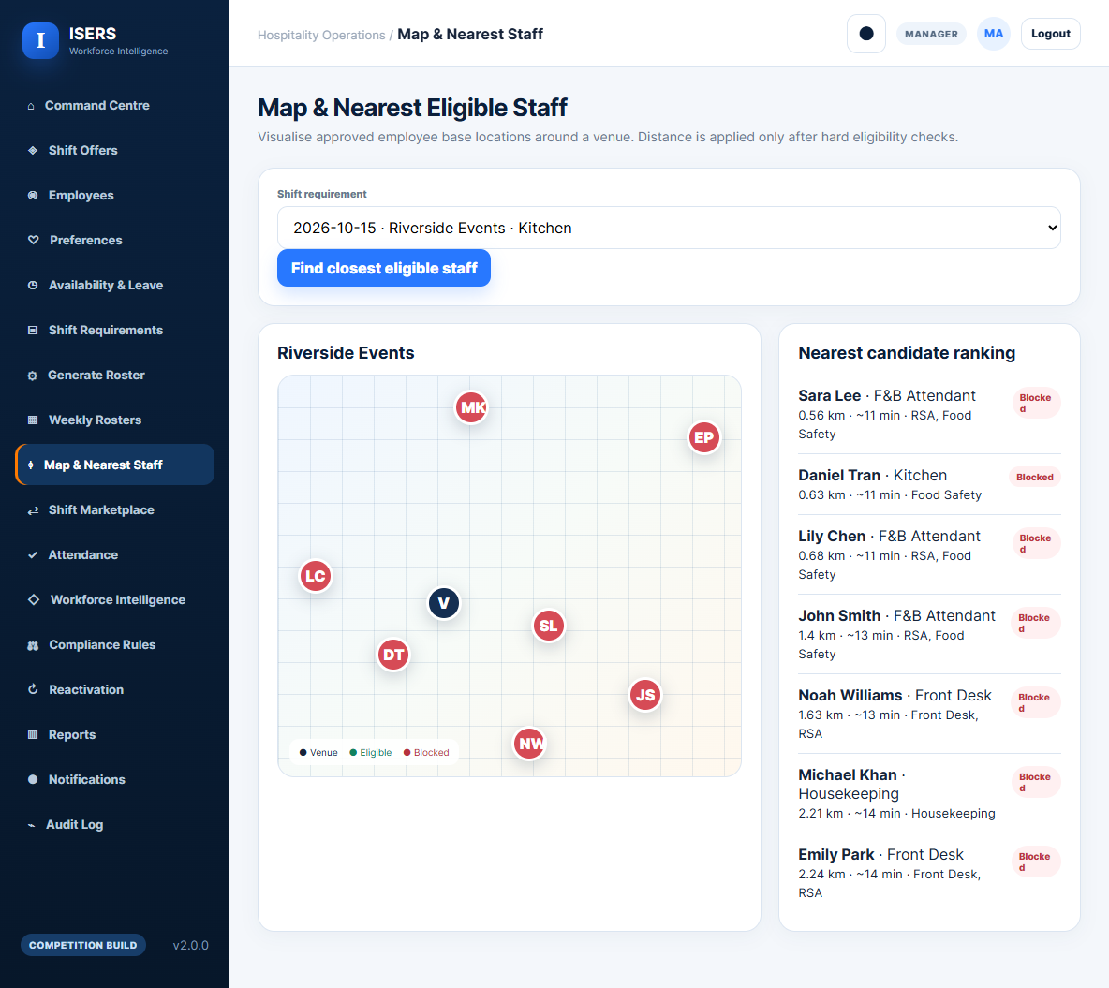
Figure 17: Location-Aware Candidate Finder

7.8 CP-SAT Optimisation
If Google OR-Tools is available ISERS can use CP-SAT solver to optimise assignments over the whole set of shifts (as opposed to optimising each shift greedily). CP-SAT is used for combinatorial constraint problems, it can be used for employee scheduling with a Boolean assignment of decisions (Google, 2026; Perron, Didier and Gay, 2023).
ISERS formulates a binary assignment variable and a understaffing variable for every possible assignment of a employee to a shift and for every requirement. Constraints are used to prevent overlaps and to limit hours per week. A strong bias against being understaffed: once an understaffed roster is generated, higher-weighted feasible ones will be selected more preferentially, but only after some point which will be capped by a bound on the solve time.

7.9 Deterministic Fallback Solver
ISERS has a backup deterministic path when OR-Tools is not available. When assessing candidates' applications, they are assessed in the same multi-layered approach, and stable date-and-time order is used to select candidates that are the highest "rank" applicable to the criteria, up to the number required. Provisional assignments are automatically made into subsequent conflict/workload checks. If an assignment cannot be met, an unfilled assignment is generated with an explanation that there is no staff member that met all the hard constraints.
The fallback mode is sequential and has less global optimality than CP-SAT, but all feasibility logic is the same and can serve as a light-weight operating mode for demonstrations locally, or where computation is constrained. This is a clear distinction instead of using both approaches as an algorithmically identical method.

7.10 Explainable Candidate Ranking
Explainability is achieved at the level of the candidate. The manager will be able to check both a score and the positive and/or negative elements behind each candidate. Successful explanation factors are: position match, full availability, valid certification, cross roostering conflict, workload compliance, experience, preference match, distance, reliability history. Blockers tell what exact condition has failed, instead of a vague "not eligible" message.
A few implementations in the Candidate Explorer are shown in figure 18. Clarity is achieved through the availability of operational information tied to the design allowing a manager to compare employees and make a decision of their own.Clarity is achieved by visibility of operational information, allowing the manager to compare employees and make his own decision without relying on an opaque recommendation. Additionally, if there are any data quality issues that need fixing outside the optimiser, such as an expired certification or lack of an availability record, these issues can be identified more easily.
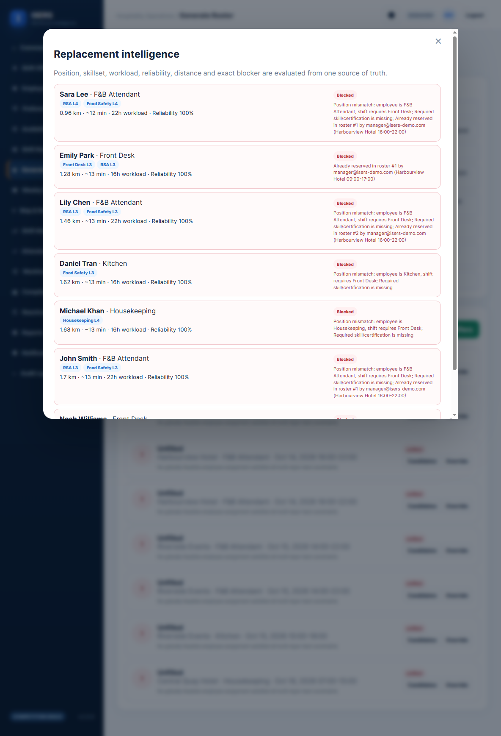
Figure 18: Explainable Candidate Matching and Blockers

7.11 Manager Override
Translating licensed employees to other positions is not a free-for-all override. The other: The selected replacement goes through the same candidate evaluator as with automatic generation. If the person has become unavailable, is reserved in another roster, does not have the necessary qualification, exceeds workload limits or violates another hard rule, the server returns back the blocker, which is invalid. If successful, it records the employee's recalculated score and rationale and the manager's reason is recorded in the audit history.
This enables the continuation of managerial authority without allowing the override to be a back-door to where it's not desired. It also gives an account for a human decision being made that is not what the optimiser had previously recommended.

7.12 Automated Replacement
Roster publishing generates employee shift offers instead of assuming that all staff members who are recommended have taken on. Offers have a response date, dependent on the shift's date, which will be determined by the time that it is posted. Acceptance means the assignment is accepted. A non-acceptance record results in a decreased offer and triggers the candidate-ranking engine to find the next reasonable available worker that hasn't been offered that assignment. When no replacement becomes available, the assignment becomes a standing unfilled and notifies managers.When there is no eligible replacement, the assignment becomes explicitly unfilled and managers are notifiable. If two consecutive decreases or expulsions occur, the employee that is still employed becomes suspended_non_acceptance and all other offers for that employee resume, which initiates replacement searches. The employee can then submit a reactivation request to the manager/administrator along with a reason and supporting evidence reviewed. This end to end workflow is illustrated in following figure 19. This mechanism is meant to sustain the operational reliability, not with its permanent removal without explanation.
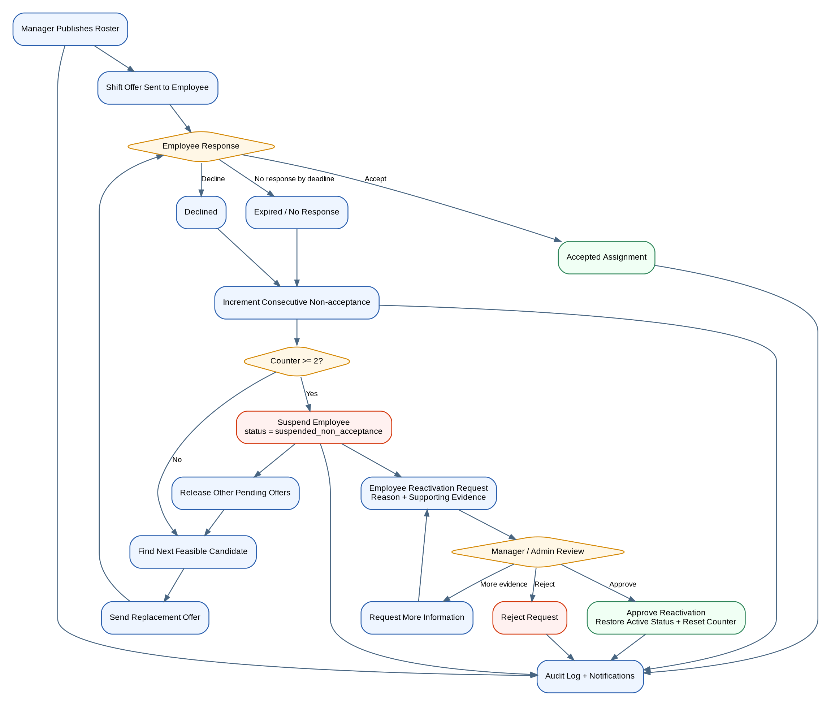
Figure 19: Employee Offer, Replacement and Reactivation Workflow

7.13 Compliance Rules
Rostering controls are not hardcoded into source code, but are selectable. The compliance model used implements a rule key, value, status and hard or advisory rule. Examples in the current practice are the minimum hours of rest, maximum days in a row worked, and the planning working speed for feasibility in between venues. The values are updateable by authorised managers/administrators via the application, and are subject to audit.
The compliance interface that has been implemented is on figure 20. This design makes the code easier to maintain since the rules of operation are changed without needing to rewrite the optimiser. It is not intended to circumvent legal understanding, the conditions of employment must still be set through an application of an appropriate organisational policy and in reference to the applicable industrial instrument. Working-time and roster controls in an Australian hospitality context: The Hospitality Industry (General) Award 2020.
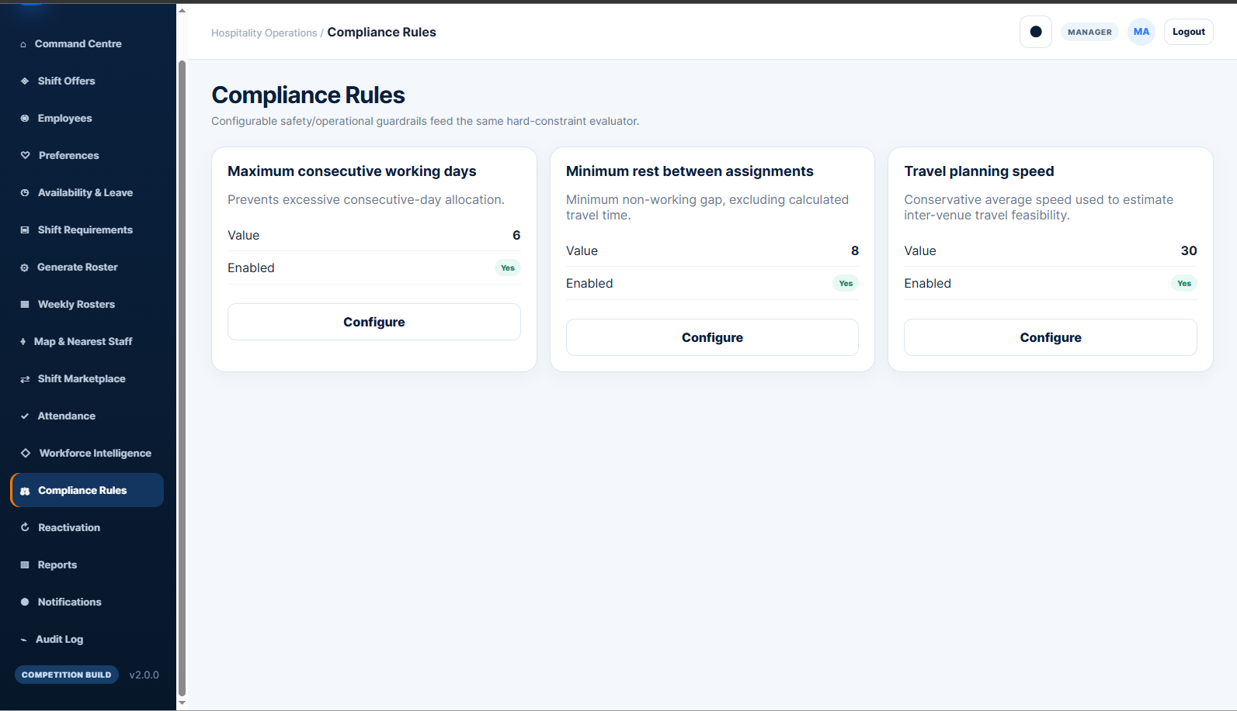
Figure 20: Configurable Compliance Rules and Constraints

8. Verification, Testing and Evaluation

8.1 Testing Strategy
Tested for technical and operational suitability. The previous report, Assignment 2, suggested functional, integration, usability, security and roster accuracy testing, and in the final project, this was put into action by creating tests against the system implemented. Evaluation was employed to assess the functional suitability, security, reliability, compatibility, performance and auditability of software, consistent with ISO/IEC 25010:2023 being a reference model for the definition of software quality testing objectives and acceptance criteria.
On 4 October 2026, the release was compared to the clean SQLite database. Evidence included automated tests, static code checks, API smoke test and regression test, role-based access check, and live workflow scenarios and controlled synthetic benchmarks. Infrastructure dependent claims were separated: The current configuration of the system includes it for production use, and the results of the benchmark aren't guaranteed as a service as delivered by the system as a commercial product.
Evidence was evaluated as to its strength and not brought together in a conjunction to a success claim. Repeatable proofs of code and API behaviour was provided by automated unit and regression tests, end-to-end state changes was provided by live scenarios, syntax or packaging errors was provided by the static test, presentation across breakpoints was provided by the responsive review and finally the pilot was provided by qualitative stakeholder evidence. This hierarchy is important since each method is addressing a different question. Automated tests are a demonstration of the repeatability of defined behaviours rather than user satisfaction or commercial performance. Similarly, a positive pilot comment can contribute to the practical relevance but cannot be a substitute for the controlled before and after study. The final evaluation then reports on each type of evidence individually rather than making unreliable quantitative conclusions from the observed limited evidence.
Table 7: Summary of Final Verification Activities
Test area | Evidence / method | Result
Automated tests | Root-level python -m pytest -q | 5/5 passed
Python integrity | Compilation of 21 Python files | Passed
Frontend JavaScript | node --check frontend/app.js | Passed
CSS parsing | tinycss2 parser | 0 errors
Production-mode startup | Fresh database, demo seeding disabled | Passed
API health | /api/health | 200 OK
RBAC regression | Manager/employee/admin restrictions | Passed
Advanced workflows | Offers, replacement, reactivation, swaps, map, intelligence | Passed
Synthetic benchmark | 50–500 employee datasets | Completed

8.2 Unit and Static Tests
The following five tests were passed by the automated test suite provided. Added static verification for syntax and parsing errors prior to runtime: all 21 Python files were compiled, main JavaScript file passed Node syntax validation, CSS parser gave no errors. While these checks confirmed that the code was intact, it did not prove it was exhibiting the required business behaviour, in this case, additional integration and live scenario testing was added to confirm it.

8.3 Functional and Integration Testing
The modules for the original requirements plus any enhancements made thereafter were functional tested. A new demo database was used for verification of the Frontend, Authentication, Employee records, Venues, Staff Needs, Roster gen/public, Attendance, Reporting, Audit & compliance, Workforce Intelligence, Staff or Skill reactivation, swaps, Offers & notifications. The following part of the presentation was on integration testing which was used to exercise chained workflows in the browser, in the Fast API services, in the persistence layer and in the rostering engine. All the publications: employee offers, employee decline, automatic replacement, accepted assignment attendance and payroll-ready exports were all completed as expected.

8.4 Role-Based Access Testing
Access was tested for based on the various roles, not through dependent interface elements. Operational access was validated for manager and employee access – employee accounts had their own profile, preferences and location information. Staff access to resources for manager use, including staffing requirements, audit, compliance configuration and workforce intelligence, was cut off. This is because the only security boundary is what is visible in the frontend menu, so if you want to perform an action that wasn't allowed, the server is still responsible to reject it.

8.5 Security Testing
Security verification: application environment would be the area where security controls could be demonstrated. Authentication, sessions and role checks were used during smoke/regression phase, invalid CSRF requests were rejected, passwords applied salted PBKDF2-HMAC-SHA256 and critical actions resulted in Audit events. Clean start in production mode, with demo seeding disabled was also verified.

8.6 Rostering Constraint Tests
Constraint tests: Do operationally invalid assignment lead to correct explanation of rejection? Examples included unavailable employees, approved leaves, role/s skill gap, certification expiration, in-roster conflicts, cross manager conflicts, weekly hour limits, location/travel restriction and rest feasibility. Perhaps the most important case was the cross-manager one: a programmer who had been reserved in another roster existing at the time was unable to be so reserved again, and his reservation in the other roster was returned as the reason. During replacement, Candidate Explorer also remembered the information on position and skills.

8.7 Employee Workflow Testing
The employee workflow was trialled through the publication, response, and recovery process. If published generated shift offers, they were accepted and it confirmed the assignment, or they were declined or expired, a new feasibility search is carried out and the next assignment candidate is offered, if applicable. If two consecutive non-acceptances came the player was automatically suspended, other pending offers were cancelled and replacement searches were started. Then a request to reactivate with reason/evidence would be considered and a determination made as to whether to restore an active status. Open states with acceptable claimances/manger approval and attendance to accepted assignments in published rosters were used to test shifts.

8.8 Responsive Interface Testing
Responsive behaviour checked at desktop, tablet and mobile. These have been identified through early tests and resolved using the following approaches: drawer navigation pattern, responsive grid design, contained scrolling of tables and mobile form/card designs for navigation.

8.9 Defects and Corrective Actions
Multiple flaws found in the process of successive verification did significantly enhance the final release. A selection of these representative examples with corrective action is given in Table 8.
Table 8: Representative Defects and Corrective Actions
Issue | Impact | Corrective action | Status
Desktop alignment / mobile navigation | Content shifted; narrow-screen navigation incomplete | Reworked shell layout, breakpoints and mobile drawer | Resolved
Python 3.10 datetime.UTC incompatibility | Backend crashed during startup | Replaced with timezone.utc in affected modules | Resolved
Draft roster in attendance/payroll path | Risk of unapproved assignment reporting | Required published roster and accepted assignment | Resolved
Override lacked candidate context | Replacement decision had insufficient evidence | Added position, skills, blockers, workload, preferences and distance | Resolved
Simulated coordinate map | Weak geographic implementation | Replaced with Leaflet/OpenStreetMap | Resolved
Netlify missing backend URL | Build failed without required configuration | Added environment guidance and graceful frontend-only mode | Resolved

8.10 Synthetic Scalability Benchmark
One synthetic benchmark with control is used to study the running time of rosters for growing workforce sizes. Four datasets used 50, 100, 250 and 500 employees. Their combined staffing levels had risen from 15 to 300, while the number of staffing places effort had been increased by 300. All of the synthetic positions were habitable, and 100% coverage was achieved. Come up with calculations that show that if the number of employees doubles, there will be no more than 5 times the amount of employees.Make calculations to prove that the number of employees does not exceed 5 times when the number is doubled.
Table 9: Measured Synthetic Benchmark Results
Employees | Req. | Positions | Filled | Unfilled | Coverage | Runtime
50 | 15 | 30 | 30 | 0 | 100% | 1.2955 s
100 | 15 | 60 | 60 | 0 | 100% | 2.5303 s
250 | 15 | 150 | 150 | 0 | 100% | 6.3657 s
500 | 15 | 300 | 300 | 0 | 100% | 13.3572 s
Figures 21 and 22 visualise the measurements. The runtime increased as for the number of candidates or of positions. All four controlled cases were run within the range measured, but not all of them took longer that the runtime. Please note that the 100% coverage result is not to be equated with full coverage of real client rosters since there were synthetic rosters that were easy to build but for the latter, it would depend on availability, qualification, leave, travel and demand status. The benchmark, therefore, reflects a controlled technical behaviour and not a production SLA.
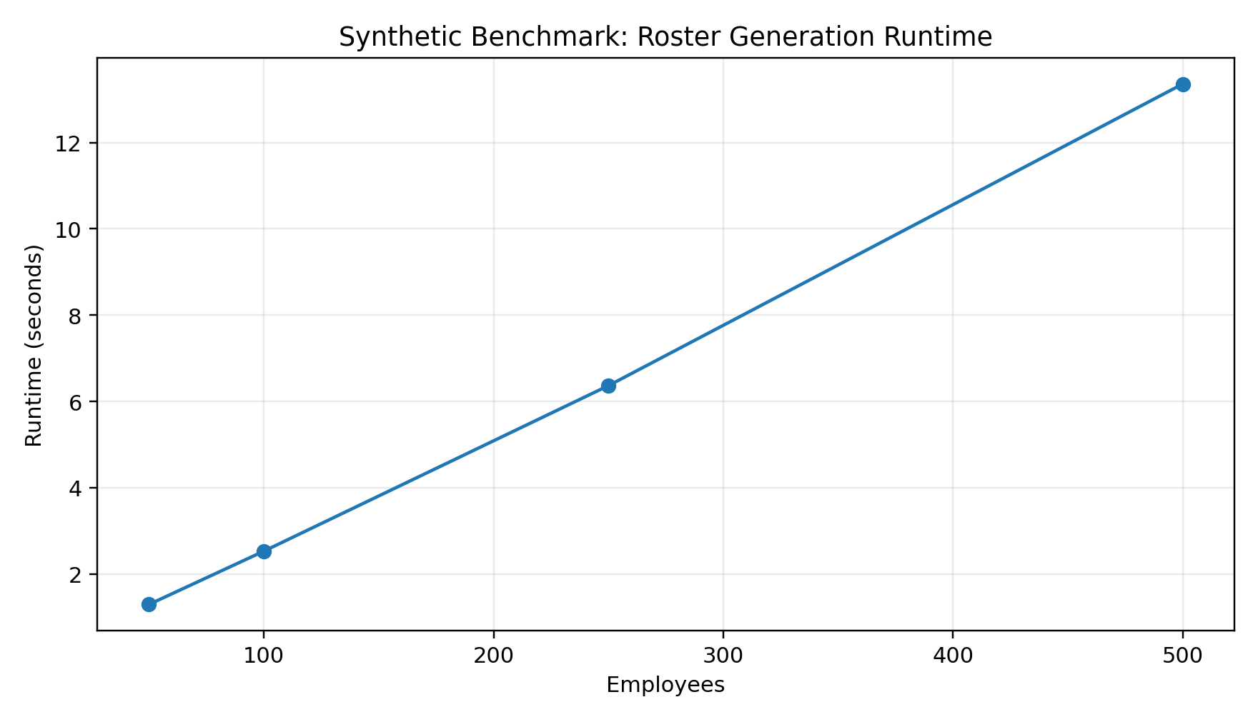
Figure 21: Synthetic Benchmark Runtime by Workforce Size
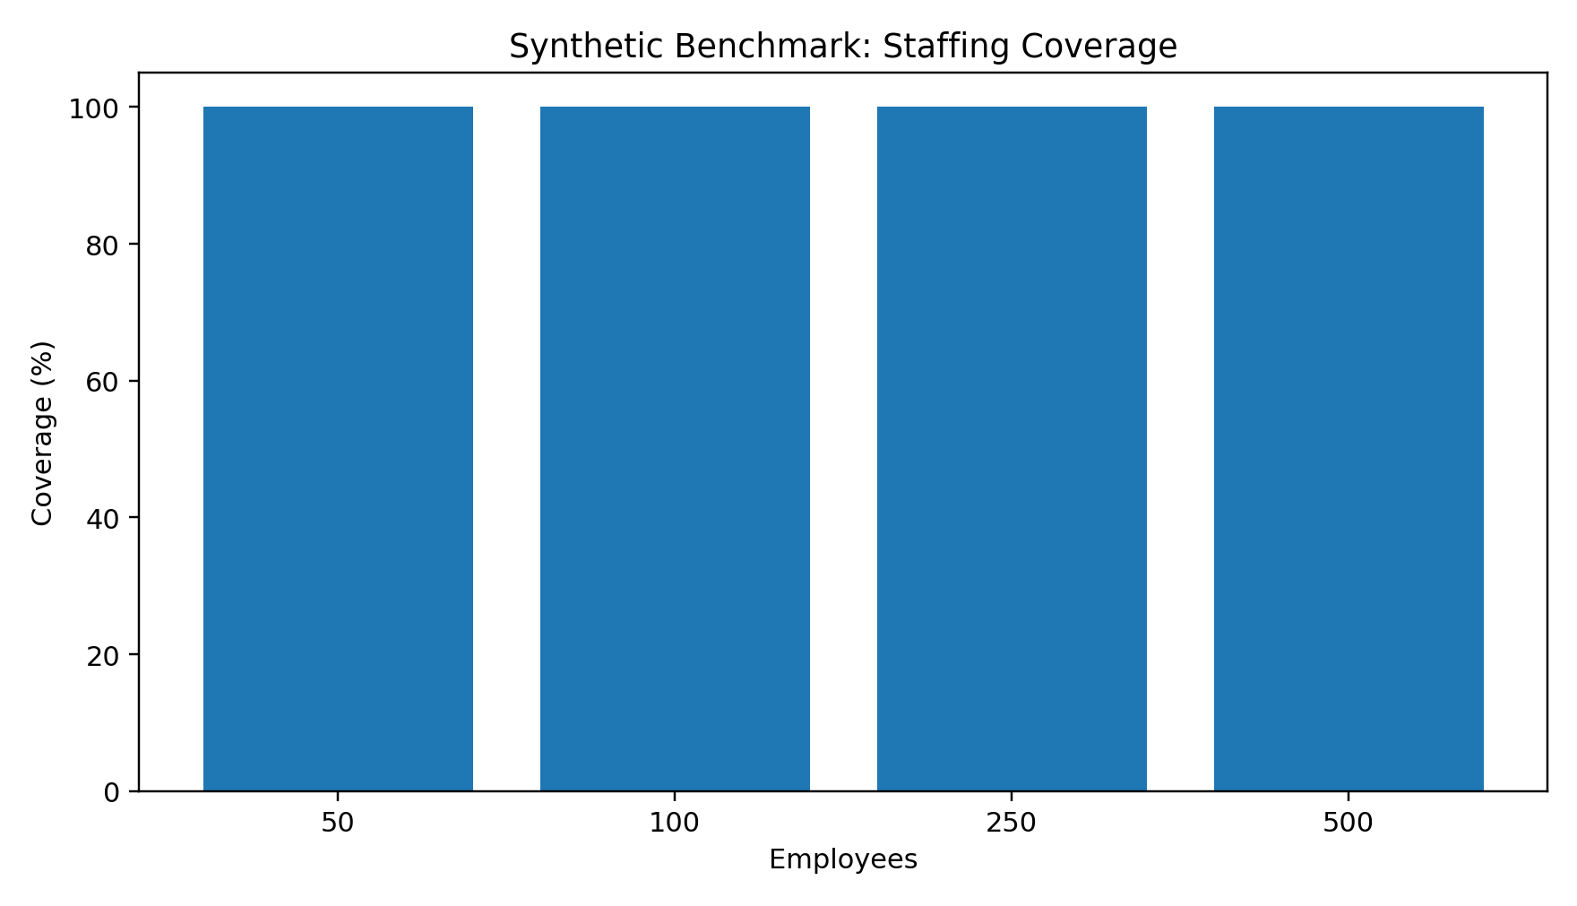
Figure 22: Synthetic Benchmark Staffing Coverage
The benchmark also helps one understand the importance of seeing the runtimes along with the problem structure. The number of candidates and number of shifts, the number of "skills" in short supply, the number of overlaps, and the number of feasible assignments for competing candidates may be significant factors in CP-SAT search behavior. This 500 employee success illustrates that the adopted model can scale to a much larger synthetic workforce within the tested setup, but does not provide a universal upper bound or any assurances on its production performance with any production dataset. A production evaluation should repeat and use real demand pattern, set production restriction, and use concurrent users and database/network overhead. A set of solver status, objective value, constraint density and repeated-run variation would offer a much better framework for service level planning than just one synthetic series.

8.11 Workforce Intelligence and Scenario Testing
Rosters/workforce data was used as an analytical layer for Workforce Intelligence. The interface implemented includes/presents indicators related to consequences of workload distribution, indicators related to satisfaction of preferences, indicators related to skill deficits, and indicators related to the indicator of the demand. This results in the final analytics interface as illustrated in Figure 23.
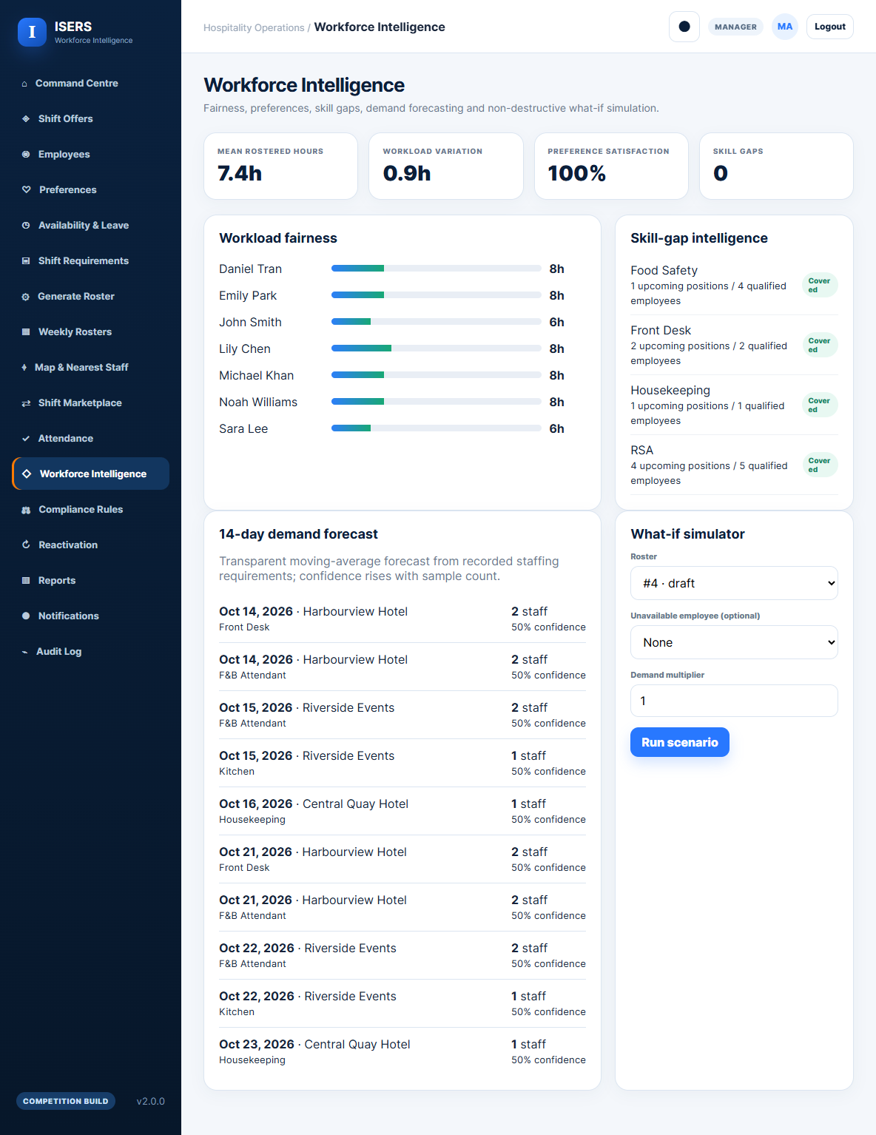
Figure 23: Workforce Intelligence Analytics
The Function What-If was subjected to testing as a scenario tool, which was not destructive. A manager could potentially replace a player or put a demand multiplier on to a player to see the impact without changing the current roster. This is a 1.5 times demand scenario that is illustrated in Figure 24. The demand component is not a forecast made using machine learning algorithms, but is much better explained as a historical heuristic that was clear to see, therefore not a valid predictive-accuracy claim.
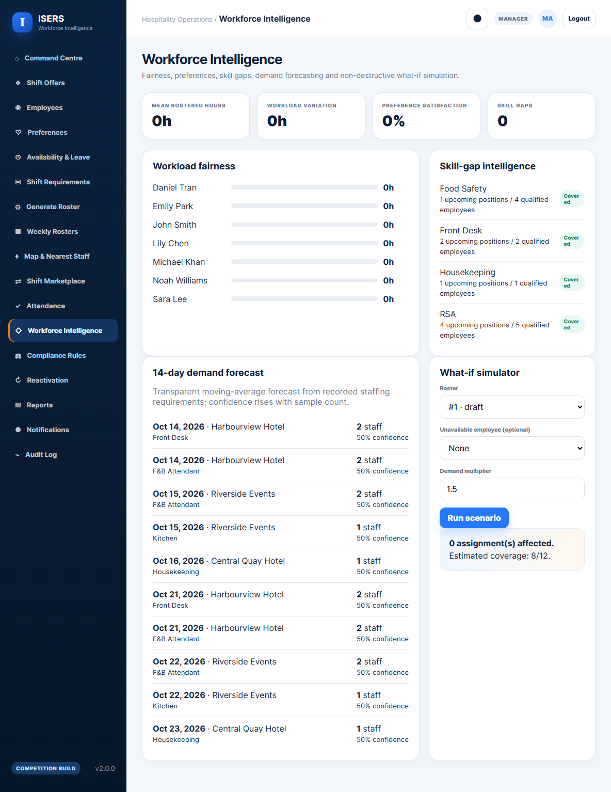
Figure 24: What-If Simulation with 1.5× Demand

8.12 Evaluation Against Original Requirements
The final implementation met the functional core from Assignment 2 and added some requirements to the ones in the text. Identity/access, workforce data, availability/leave, client requirements, automated rostering, conflict detection, review/publication, attendance/reporting, audit and exception handling were all implemented. Subsequent enhancements included preferences, precise blocker explanations, cross-manager security, location/travel ranking, responses to employee offers, background replacement, reactivation, swaps, and customizable compliance and staff intelligence.
Table 10: Final Evaluation Against Original Requirement Groups
Requirement group | Original IDs | Final status | Evidence
Authentication and access | FR-01–FR-02 | Implemented and tested | RBAC/CSRF regression passed
Workforce and skills data | FR-03–FR-06 | Implemented | Employee/skill/venue workflows passed
Requirements and leave | FR-07–FR-08 | Implemented | Functional workflow passed
Roster generation/conflicts | FR-09–FR-12 | Implemented and extended | Multi-layer tests and publish workflow passed
Attendance/reporting | FR-13–FR-14 | Implemented | Published/accepted data restriction passed
Audit/exceptions | FR-15–FR-16 | Implemented and extended | Audit, notifications and unfilled handling passed
This test summary is to be read in conjunction with the detailed traceability matrix in Section 4 and Appendix B. The bottomline is that the top-notch features are forging a steady pathway for the scope that has evolved from the original functionality without being replacements for lack of finished core work.

9. Pilot Program and Stakeholder Validation

9.1 Pilot Context
There was a restricted opportunity to practically validate this item through the cooperation of the ‘Infinity Hospitality' brand. In this context the project team assisted with roster management of an operational group throughout Housekeeping Appreciation Week only using the existing rostering system and not synthetic data. This put the project in a context that was similar to the conditions that led to its birth: in the hospitality sector, and enabled qualitative comments to be made on the simplicity of the roster-management approach.

9.2 Housekeeping Appreciation Week
This activity was geared towards housekeeping, specifically coordinating rosters for Housekeeping Appreciation Week. Rather than being a controlled experiment of feasibility, it was designed to test the viability of a "multi-layer" roster-management system for a working hospitality team and the manner in which data about the workgroup was displayed. As such, the pilot is not taken as validation data for efficiency.Thus, the pilot itself is not used as evidence for efficiency but rather as a qualitative, evidenced validation.

9.3 Participants
The active group had about 15 employees. It was a considerable smaller dataset than the synthetic datasets (to be used as the benchmark), but it was a true business-to-customer test environment for staffing in the hospitality sector. The sample was not designed to be representative to the broader hospitality labor market, and no inferences are made on the size of the sample.

9.4 Functionality Used
The pilot focused on rostering and information regarding staffing at multiple levels. It offered greater clarity into employee and roster information and more structure to the allocation process than just communicating. While some later competition version functions were operationally tested during this pilot, others, like the large-scale CP-SAT optimisation, a long-term forecasting model, integration with commercial payroll, and policy impacts of automated suspension are to be assessed independently at production.

9.5 Observed Value
The key the parameter that was observed was transparency. It simplified information on staffing assignments and rosters to review, reinforcing the project principle that it should be easier to show information and constraints of the system, not an unexplainable schedule. The pilot also facilitated the separation of employee, skill, availability and requirement data that supports the architectural separation of the above mentioned information afforded the opportunity to make the concept of the same workflow scalable beyond a small group who are involved in the operations. This is further supported by the larger synthetic benchmark which is not considered to be the same actual evidence.

9.6 Stakeholder Feedback
The CEO of the Infinity Hospitality was not only interested in the solution, but was impressed with the visibility they offered, in particular the transparency of the data presented as opposed to what this organisation saw in its current method of operation. This feedback helps to accentuate the project's focus on explaining and accessible information about the workforce. There was no formalised polls, questionnaire or an independent before and after KPI table that captured satisfaction before and after, however. Therefore, the report does not calculate a percentage response nor state that the response is an efficiency gain.

9.7 Pilot Limitations
The pilot was small, short, and could not be compared, directly or indirectly, to a manual vs ISERs. It also did not rely on a structured research tool that gathered employee/manager responses. Such restrictions do not allow for claims of commercial efficacy or any focus on operational improvement that's statistically significant. Nevertheless, the pilot offers some evidence that the project did touch a real 'hospitality stakeholder' and that 'data transparency' was considered to be of value. Claims for business performance are stronger with longer production pilot with defined KPIs, system logs and structured manager/employee feedback.
Figure 25: Infinity Hospitality Pilot Validation and Evidence Boundary

10. Business Viability and Commercialisation

10.1 Commercial Value Proposition
ISERS proves itself to have a feasible commercially viable trajectory, other than its applied university project. The value proposition is not just about making a digital roster as that's something that can be done on any workforce platform as the existence of platforms exists. The best of the above is found in a hospitality-specific approach that features transparent multi-layer constraint checking, explainable candidate reasoning, employee response workflows, geographical matching, manager-controlled overrides, and workforce intelligence. The modular approach can also be used to evolve the rostering engine, employee portal, reporting layer and external integrations independently. A key aspect of this positioning is transparency. Managers have the ability to review the reasons for candidate's acceptance or rejection, and employee can see and action assignments. This is in line with the responses received in the pilot which confirmed that workforce and roster information is visible and is well-received. ISERS would then focus on explainability, built on explainable automation and configurability instead of mirroring the scope of HR and payroll of larger vendors.

10.2 Competitive Position
Interestingly, current pricing in Australia validates rostering as a fully-developed market. The costs of the deputy and Lite versions of Lite are AUD 6.75 per user/month and AUD 6 per employee/month respectively, billed annually, while Lite's RosterElf Core version goes to AUD 12.80 plus GST and covers a wider package. Employment Hero's plan pricing is wider ranging, and has an option for rostering available as an add-on. ISERS thus sees AUD 4.99, not as the complete half-price, but as playing a competitive game. The proposed ISERS position is not thus one of superior universal price but the one of lower cost and rostering based. Its differentiation is a mix of obvious eligibility filters, location-smart candidate identification, employee-response automation and manager supervision.
Table 11: Indicative Current Market Pricing Comparison (October 2026)
Platform / model | Published price | Comparison note
ISERS (proposed) | AUD 4.99 / active employee / month | Roster-focused proposed model; not yet commercially validated
Deputy Lite | AUD 6.75 / user / month | Basic rostering, timesheets, availability and replacement features
RosterElf Core | AUD 6.00 / employee / month | Rostering and time & attendance; annual billing
Tanda All-in-One | AUD 12.80 + GST / user / month | HR, payroll and workforce management bundle
Employment Hero | AUD 10 HR Essentials + AUD 4 rostering add-on | Module-based pricing; minimums and plan conditions apply

10.3 Competitive Advantage and Critical Stance
What comes across the previous work of Slide Analysis and following implementation work is joined together in the Competitive Stance in figure 26. The comparison doesn't try to claim that ISERS is better than all commercial workforce platforms. Rather it highlights the specific areas of the deployed system that offer a ‘value proposition’ to the hospitality sector for hospitality rostering: transparent decision logic, multi-layer constraint validation, location-aware candidate discovery, employee response automation and the modular extensibility of the system without the need to redesign the system in its entirety.
The number one competitive advantage is explaining. Managers are able to see why a candidate is eligible and why another candidate is blocked, the reason for the rule that has blocked the candidate and how an override is revalidated before publication in ISERS. The level of visibility is particularly crucial in the hospitality industry where last minute swaps, fair play and compliance restrictions all come into play. The arguments are further complemented by aprendiferentiators like OpenStreetMap support for discovering the nearest accepted employee, workforce intelligence dashboards, what-if simulation and the re-enlistment workflow after repeated non-acceptance, which are also indicated in Figure 26.
However this does require a critical reading to be done to be fully understood. Commercial solutions like Employment Hero, Deputy, Tanda and RosterElf are more developed in terms of use in the market, adoption of the solution ecosystem and scale of their organisations. ISERS may not therefore be seen as a replacement for all HR, payroll & workforce-management activities. This changes its competitive position in a better way because if it is a rostering option, it is a cheaper and more transparent one, and it has a more flexible software, as well as a more extensible technical base for those organisations that prioritise explainable and transparent staffing choices, flexibility in staffing and an extensible software back.
So does the competitive position. The pricing comparison does not constitute a market study, but rather a price comparison, and the system has only been tested with a limited pilot, not on a large scale in a commercial environment. As a result it must deliver an equivalent strategic benefit in a narrowed niche, and it must acknowledge that the broad testing of the field, hardening it into production, measures of customer support, and more integrations are still needed to make viable commercial claims.
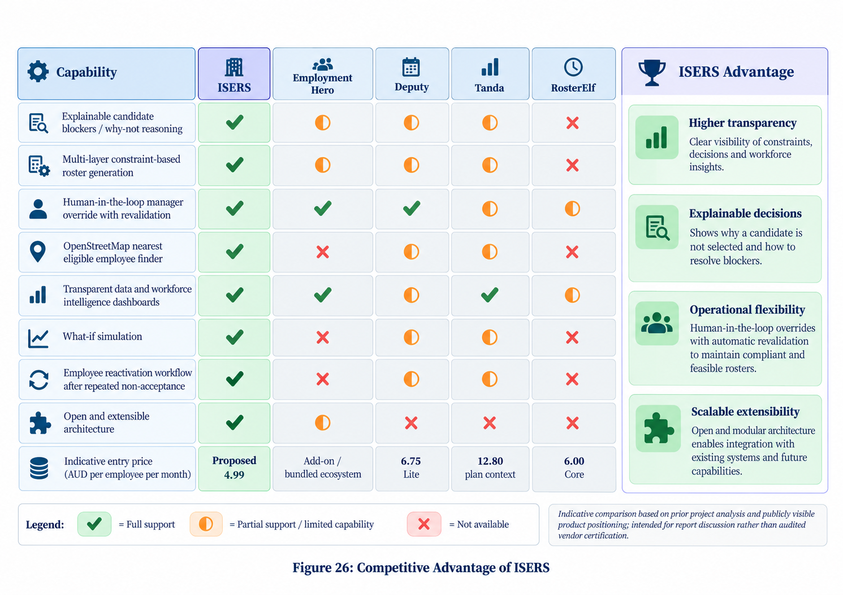
Figure 26: Competitive Advantage of ISERS

10.4 Subscription Model
The offer for a commercial model is AUD 4.99 per active employee per month. 100 active employees would be about AUD 499 in MRR (gross) a month and 500 would be about AUD 2,495 in MRR (gross) a month before GST. These are working figures, not revenue projections that have been validated. Willingness-to-pay testing, customer interviews, support-cost modelling, and definition of the scope of the base subscription would be needed for a production launch.
The pricing model should be straightforward and scale with number of workers active. The current benchmark does, however, only have tested operations up to 500 synthetic employees, therefore the project cannot be called unlimited production capacity.

10.5 Unit Economics
The team has made an assumption about the price of acquiring the company of about AUD 0.90. This number does not reflect the result of a well documented paid marketing effort, and is thus considered an indicative rather than achieved customer acquisition cost. A true CAC-payback calculation would come with onboarding, payment fees, support/service delivery cost and churn. Ongoing development and maintenance, digital marketing, and customer support/compliance are expected cost-drivers in the cloud infrastructure and hosting. Reliable gross margin is available based on the lack of an audited cost basis. The next commercial step should therefore measure infrastructure cost per active employee, support time per customer, paid acquisition cost, conversion rate and retention during a controlled pilot.
Table 12: Proposed ISERS Unit-Economics Assumptions and Evidence Status
Metric | Current assumption | Evidence status
Subscription price | AUD 4.99 per active employee/month | Proposed planning assumption
100 active employees | AUD 499 monthly recurring revenue | Illustrative revenue only
500 active employees | AUD 2,495 monthly recurring revenue | Illustrative revenue only
Customer acquisition cost | AUD 0.90 | Team-supplied assumption; not campaign-validated
Major cost categories | Hosting/infrastructure; development; digital marketing; support/compliance | Expected cost structure
Not yet established | Gross margin, churn, LTV, payment fees, onboarding/support cost | Requires production evidence

10.6 Scalability
ISERS provides a separation of frontend, API, data, optimisation and mapping modules which enable future expansion of the service offering in addition to support for replacing services. The controlled benchmark worked fully up to 500 employees where the runtime was increased from approximately 1.30 seconds/employee for 50 employees to 13.36 seconds/employee for 500 employees. This indicates scale for the scenarios tested but it does not represent infinite scale. PostgreSQL, concurrency tests, tenant isolation, monitoring, backing up, and larger tests for concurrency would also be needed for commercial deployment.

11. Critical Discussion, Limitations and Lessons Learned

11.1 Achievement of Original Objectives
The results from the final system fulfilled the basic goals set for the pre-development. Data around workforce, skills, availability, leave, venues, shift requirements, rosters and attendance and audit data were centralised. Conflict prevention, manager review and publication, employee self-service and payroll-ready reporting were some of the functionalities automated to generate the roster. As per requirement Evaluation For Part-8 it can be seen that all the functional groups mentioned in the original design are implemented in the final design.
The best result is the transition from a data-management idea to a working system to support decisions. Availability is not the only criterion used for candidate selection; rather several feasibility conditions are assessed and then softer ranking criteria are utilized.

11.2 Major Improvements Beyond Original Scope
Development added features not expected from Assignment 2 such as richer preferences, shift offers and responses, automatic replacement, non-acceptance handling, reactivation calls, cross-manager conflict protection features, OpenStreetMap candidate discovery, schedule feasibility, configurable compliance rules, workflow intelligence and scenario simulation. The additions show iterative, but also emphasize the need to manage scope and only include features that address the main problem of the business and can be tested.

11.3 Comparison with Research
The final design fits with the research that relates to separating the goals of feasibility from those of preference and fairness (Kletzander & Musliu, 2020; İşeri et al., 2025). Fatigue research behind workload/rest controls, and human-centred scheduling and recent implementations of explainable scheduling (Karhula et al., 2020; Shia et al., 2026) behind the two types of employee involvement, and explainable manager review.
ISERS should however not be seen as a one-size-fits-all scheduling system. Integrations are different for commercial platforms; they are often more widely used and more production ready; scheduling needs differ significantly in organizations; and file sizes are different for different types of video. Overall project contribution thus is the implementation and evaluation of a transparent integrated approach.

11.4 Technical Limitations
Certain details regarding the employee's location is derived from base locations for which approval has been sought rather than through the constant tracking of their location via GPS so as not to compromise their privacy, thus reducing the accuracy of proximity tracking that taking place in real time. Rough rather than precise estimate of travel time, based on live routing or traffic information. Demand forecasting is based on a transparent historical heuristic, non validated as machinelearning prediction. Payroll-ready CSV export is made (not direct payroll-provider integration).
The competition build hasn't been transformed into a mature multi-tenant SaaS application yet either. The production deployment would involve tenant isolation, observability, automated (autoreturn) recovery, infrastructure scaling, penetration testing and well-developed secrets management. Results from a controlled CP-SAT can not be trivially scaled up or down for any arbitrary size of a workforce and/or any moderately to severely limited real-world data.

11.5 Evaluation Limitations
Evaluation consisted of automated tests, workflow checks, synthetic benchmark data and small practical pilot. Execution and scaling behaviour is shown as sufficient workers were generated for the benchmark when executed in its scenarios, resulting in full coverage rather than “typical” operational coverage. First: The amount of time to prepare; second: The reduction of payroll errors or long-term satisfaction compared to the manual process; were not measured in a controlled before-and-after study.
Approximately 15 employees and based on their qualitative feedback was the subject of the Infinity Hospitality pilot, not UAT. Therefore, earlier KPI targets, like the reduction of conflict (or preparation-time) must be kept as a target until measured through longer deployment.

11.6 Ethical and Workforce Considerations
Enhancing user control, results of reliability information, automatic suspension control can contribute to a better control, but also lead to unfair outcomes due to these technologies, if not moved with transparency. ISERS therefore does not need to perform continuous GPS tracking, disclose decisions' reasons and offers a reactivation procedure. Reliability is not a mysterious "sole decision rule," but rather one of the limited ranking aspects.
The two-consecutive-non-acceptance rule does not have to be embedded in a policy for everyone to accept, but rather it can be an organisational rule for those wishing to apply it. In the event of a workplace policy and contractual obligations/employee consultation requirements, production use should be reviewed. Access to work requires human manager oversight in certain instances.

11.7 Lessons Learned
Several lessons emerged. Feedback the supervisor had given the original DFD proved how important good modelling is, and needed to produce clearer context, Level 1 and Level 2 models. A couple of problems with responsive-design and datetime for Python 3.10.Compatibility tests were made in the real target environment by UTC error. When multiple constraints were evaluated, the cost of maintaining them in different ways across various parts of the matrix was prevented because they were re-used by a shared constraint evaluator optimizer. Third, evidence quality is as important as evidence quantity: synthetic benchmarks address other questions and should not be regarded as evidence that is interchangeable with pilot information and/or commercial projections.

12. Recommendations and Future Development
There's a bigger focus that needs to be the immediate one: A longer controlled deployment with Infinity Hospitality or another hospitality partner. Roster preparation is a process that needs to be tracked, captured and reported as other elements of a pilot: Frequency of conflicts, percentage of those accepted, manager effort and employee feedback/exceptions. These measures would allow it to be compared to the KPI targets set during the design.
Technical features should be about production PostgreSQL hosting, ability to isolate tenants, automated backups, observability, formal penetration testing, and increased deployment automation. Real payroll or HR integrations should be provided via documented APIs and not be hand made by the exchange of files. This location module may be expanded with an appropriate routing service that could compute actual travel times, while maintaining the opt in privacy controls. Push, email or SMS notifications may help boost respond to offers when timing is critical.
Implementing more advanced demand forecasting should not be implemented before adequate real time and staffing and demand information is available. Later stage commercial features such as A native mobile app, enterprise SSO, subscription billing, and a much wider possibility of configuring the award-rule can, reasonably, be planned for later stages after real-world users have tried them and seen success.
Moving forward should, therefore, be along a roadmap process that aims to be evidence led. Stage 1 should toughen up the current system and test its operational pilot for longer. Stage 2 should incorporate integrations to eliminate effective administrative friction, specifically payroll, alerts and routing. Multi tenant commercial infrastructure is not addressed in stage 3 until there is sufficient repeated use. Predictive / machine learning: These tools should be added at the end after considerable amount of historical data to test against an explicit baseline. This ordering minimises the chances of adding to the roster with technologically high quality features, which have no impact on actual rostering.

13. Conclusion
The challenge for this project was to solve a real problem encountered by hospitality workers, which had been to manually prepare the rosters from spreadsheets, call lists, texts, availability, leave plans, etc. manually and intermittently. ISERS has taken that baseline and turned it into a working, web-based decision-support system which consolidates workforce information and imposes multi-layer constraints before it shows 2D staffing recommendations, all of which are explained. The system your manager has created for you and employees includes interfaces, skills and certifications management, availability and leave, staffing requirements, rosters optimisation, conflict check, explainable reason of candidate blocking, manager override, shift offering, replacement automation, attendance, reporting, audit actions, compliance management, OpenStreetMap candidate comparing and more candidate management. Automated testing, workflow testing, responsive-interface review, security and role-based access control testing, as well as synthetic scalability benchmarks were conducted to verify. The pilot Infinity Hospitality also offered a small but significant amount of hands-on experience with stakeholders. This evidence provides basis for a discussion of technical feasibility, but does not provide basis for an unrestricted commercial scale claim. Synthetic results are used for benchmarking, feedback from the pilot tests is qualitative, and the results of long term business KPIs are missing. As such, ISERS should be seen as a program that has been put in practice and tested and has demonstrated a viable commercial market value, and production deployment, longitudinal testing, and broader testing by customers will be the final steps as it would establish mature market readiness. Important as well, is the amount of defensible paths from the academic level of consideration to the status of a working piece of software: the original requirements were given a place, the supervisor's comments addressed the weaknesses in the modelling, follow-up features were incorporated through co-decision rules, and the limitations in the evaluation were formally stated. The result of this traceability enhances the argumentation of the final artefact as not only a prototype interface but as a fully implemented decision support platform that has areas that are not yet met and can be tested.

References
Coussement, K., Abedin, M. Z., Kraus, M., Maldonado, S., & Topuz, K. (2024). Explainable AI for enhanced decision-making. Decision Support Systems, 184, 114276. https://doi.org/10.1016/j.dss.2024.114276
Deputy. (2026). Deputy pricing - Australia. https://www.deputy.com/au/pricing
Employment Hero. (2026). Pricing to suit your business. https://employmenthero.com/pricing/
Fair Work Commission. (2026). Hospitality Industry (General) Award 2020 [MA000009], consolidated to 1 July 2026. https://awards.fairwork.gov.au/MA000009.html
FastAPI. (2026). FastAPI documentation. https://fastapi.tiangolo.com/
Google. (2026). Employee scheduling with OR-Tools. https://developers.google.com/optimization/scheduling/employee_scheduling
International Organization for Standardization. (2023). ISO/IEC 25010:2023 Systems and software engineering - Systems and software Quality Requirements and Evaluation (SQuaRE) - Product quality model. https://www.iso.org/standard/78176.html
İşeri, A., Güner, H., & Güner, A. R. (2025). Pareto-optimal workforce scheduling with worker skills and preferences. Operational Research, 25, Article 27. https://doi.org/10.1007/s12351-025-00903-7
Karhula, K., Turunen, J., Hakola, T., Ojajärvi, A., Puttonen, S., Ropponen, A., Kivimäki, M., & Härmä, M. (2020). The effects of using participatory working time scheduling software on working hour characteristics and wellbeing: A quasi-experimental study of irregular shift work. International Journal of Nursing Studies, 112, 103696. https://doi.org/10.1016/j.ijnurstu.2020.103696
Kletzander, L., & Musliu, N. (2020). Solving the general employee scheduling problem. Computers & Operations Research, 113, 104794. https://doi.org/10.1016/j.cor.2019.104794
Kostopoulos, G., Davrazos, G., & Kotsiantis, S. (2024). Explainable artificial intelligence-based decision support systems: A recent review. Electronics, 13(14), 2842. https://doi.org/10.3390/electronics13142842
Leaflet. (2026). Leaflet quick start guide. https://leafletjs.com/examples/quick-start/
Ma, K., Yang, C., Xu, H., et al. (2024). A fast-flexible strategy based approach to solving employee scheduling problem considering soft work time. Scientific Reports, 14, 6170. https://doi.org/10.1038/s41598-024-56745-4
National Institute of Standards and Technology. (2020). Security and privacy controls for information systems and organizations (NIST SP 800-53 Rev. 5). https://doi.org/10.6028/NIST.SP.800-53r5
Office of the Australian Information Commissioner. (2026). Australian Privacy Principles guidelines. https://www.oaic.gov.au/privacy/australian-privacy-principles/australian-privacy-principles-guidelines
OpenStreetMap Foundation. (2026). Tile usage policy. https://operations.osmfoundation.org/policies/tiles/
OWASP Foundation. (2021). OWASP Top 10:2021. https://top10.owasp.org/2021/
Perron, L., Didier, F., & Gay, S. (2023). The CP-SAT-LP solver. In 29th International Conference on Principles and Practice of Constraint Programming (CP 2023), LIPIcs, 280, 3:1-3:2. https://doi.org/10.4230/LIPIcs.CP.2023.3
RosterElf. (2026). Workforce management software pricing. https://www.rosterelf.com/pricing
Shia, B.-C., Peng, S.-M., Zhang, Q.-Y., Lo, C.-Y., & Wang, S.-R. (2026). Explainable AI for equitable nurse scheduling: Pragmatic pre-post implementation study. JMIR Nursing, 9, e94450. https://doi.org/10.2196/94450
Spektor, F., Fox, S. E., Awumey, E., Begleiter, B., et al. (2023). Charting the automation of hospitality: An interdisciplinary literature review examining the evolution of frontline service work in the face of algorithmic management. Proceedings of the ACM on Human-Computer Interaction, 7(CSCW1), Article 33. https://doi.org/10.1145/3579466
SQLAlchemy. (2026). SQLAlchemy 2.1 documentation. https://docs.sqlalchemy.org/en/21/
Tanda. (2026). Pricing. https://www.tanda.com.au/pricing
Xu, S., & Hall, N. G. (2021). Fatigue, personnel scheduling and operations: Review and research opportunities. European Journal of Operational Research, 295(3), 807-822. https://doi.org/10.1016/j.ejor.2021.03.036

Appendices

Appendix A - Final Requirements Traceability Summary
The table below summarises the sixteen original functional requirements and their status in the final implementation. Detailed evidence is discussed in Sections 6-8.
ID | Requirement | Status | Evidence
FR-01 | Authenticate users | Implemented | Login/session tests
FR-02 | Role-based access control | Implemented | RBAC regression tests
FR-03 | Manage employee records | Implemented | Manager portal/API
FR-04 | Manage skills and experience | Implemented | Skills/certifications module
FR-05 | Manage availability | Implemented | Employee/manager availability
FR-06 | Manage hotel/client records | Implemented | Venue management
FR-07 | Create staffing requirements | Implemented | Shift requirement module
FR-08 | Submit and decide leave | Implemented | Leave workflow
FR-09 | Generate automated roster | Implemented + extended | CP-SAT/fallback engine
FR-10 | Detect scheduling conflicts | Implemented + extended | Shared constraint evaluator
FR-11 | Review and adjust roster | Implemented | Candidate Explorer/override
FR-12 | Approve and publish roster | Implemented | Publish + employee offers
FR-13 | Record attendance | Implemented | Published accepted assignments only
FR-14 | Payroll-ready reports | Implemented | CSV export
FR-15 | Maintain audit log | Implemented | Audit events
FR-16 | Flag exceptions/unfilled shifts | Implemented + extended | Unfilled state + automated replacement

Appendix B - Representative API Endpoint Register
Representative endpoints from the final API are listed below. The application also includes additional supporting endpoints for preferences, offers, notifications, compliance, intelligence and administrative functions.
Endpoint | Purpose
POST /api/auth/login | Authenticate a user
GET /api/dashboard | Retrieve role-aware dashboard data
GET/POST /api/employees | Retrieve/create employee records
POST /api/availability | Record availability
POST /api/leave | Submit leave request
PATCH /api/leave/{id} | Approve/reject leave
POST /api/requirements | Create staffing requirement
POST /api/rosters/generate | Generate draft roster
GET /api/rosters/{id} | Retrieve roster and assignments
PATCH /api/rosters/{id}/publish | Publish roster and create offers
POST /api/attendance | Record attendance
GET /api/reports/payroll-ready | Export validated payroll-ready data
GET /api/audit | Retrieve authorised audit history
GET /api/intelligence/summary | Retrieve workforce intelligence
GET /api/requirements/{id}/candidates | Evaluate candidate eligibility

Appendix C - Constraint Catalogue
Type | Rule | Implementation effect
Hard | Active status / suspension | Inactive or suspended employees are excluded
Hard | Position/role match | Candidate must satisfy required position where enabled
Hard | Availability | Availability must cover the full shift
Hard | Approved leave | Overlapping approved leave blocks assignment
Hard | Skill/certification | Mandatory skill and valid certification required
Hard | Shift conflict | Draft and published overlaps are blocked
Hard | Weekly hours | Configured maximum cannot be exceeded
Hard | Rest / consecutive days | Compliance rules applied when enabled
Hard | Travel feasibility | Insufficient inter-venue travel time blocks assignment
Soft | Experience | Greater relevant experience can improve rank
Soft | Preferences | Venue/role/day/time preferences improve rank
Soft | Workload balance | Lower existing workload can improve rank
Soft | Distance | Closer eligible workers can receive higher rank
Soft | Reliability history | Small transparent contribution based on response history

Appendix D - Verification and Test Evidence Summary
Test area | Result | Evidence
Automated test suite | 5/5 passed | Optimizer, security and workflow checks
Python compilation | Passed | 21 Python files compiled
JavaScript syntax | Passed | Frontend syntax validation
CSS parsing | Passed | 0 reported parser errors
RBAC regression | Passed | Employee/manager/admin boundaries verified
CSRF enforcement | Passed | Invalid state-changing request blocked
Cross-manager conflict | Passed | Conflicting replacement blocked with cause
Offer workflow | Passed | Publish, accept, decline, expiry and replacement
Suspension/reactivation | Passed | Two non-acceptances and review pathway
Responsive review | Passed after fixes | Desktop/tablet/mobile layouts reviewed

Appendix E - Synthetic Benchmark Dataset
These results are controlled synthetic benchmarks and should not be interpreted as real-client production service levels.
Employees | Requirements | Positions | Filled | Unfilled | Coverage | Runtime (s)
50 | 15 | 30 | 30 | 0 | 100% | 1.2955
100 | 15 | 60 | 60 | 0 | 100% | 2.5303
250 | 15 | 150 | 150 | 0 | 100% | 6.3657
500 | 15 | 300 | 300 | 0 | 100% | 13.3572

Appendix F - Additional Interface Evidence
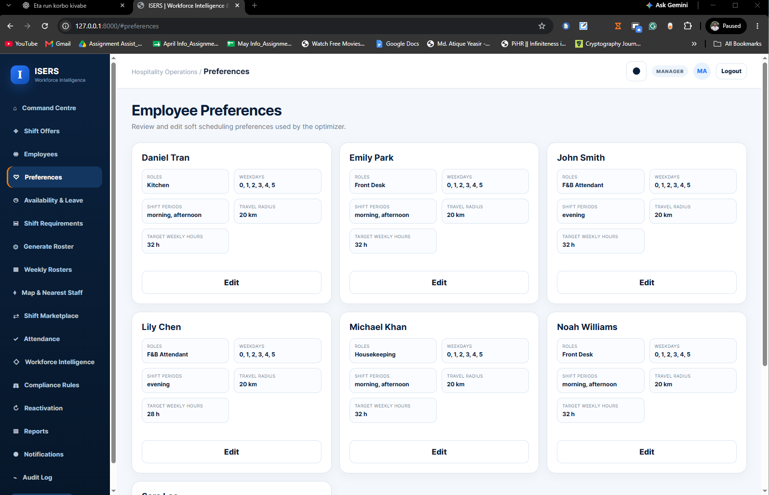
Figure F1: Employee preference details
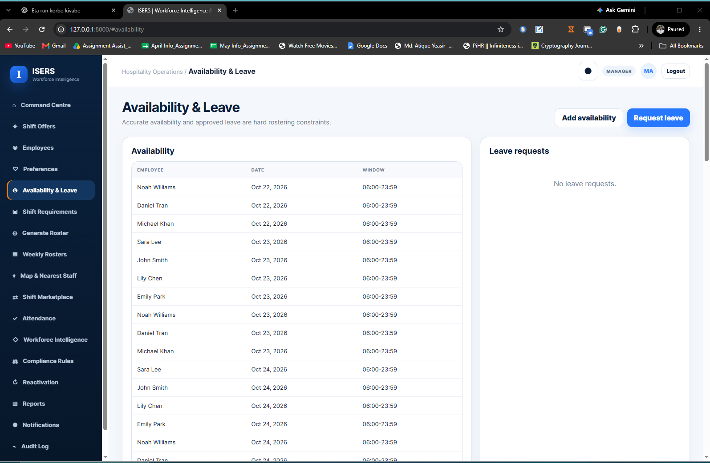
Figure F2: Employee availability and leave interface
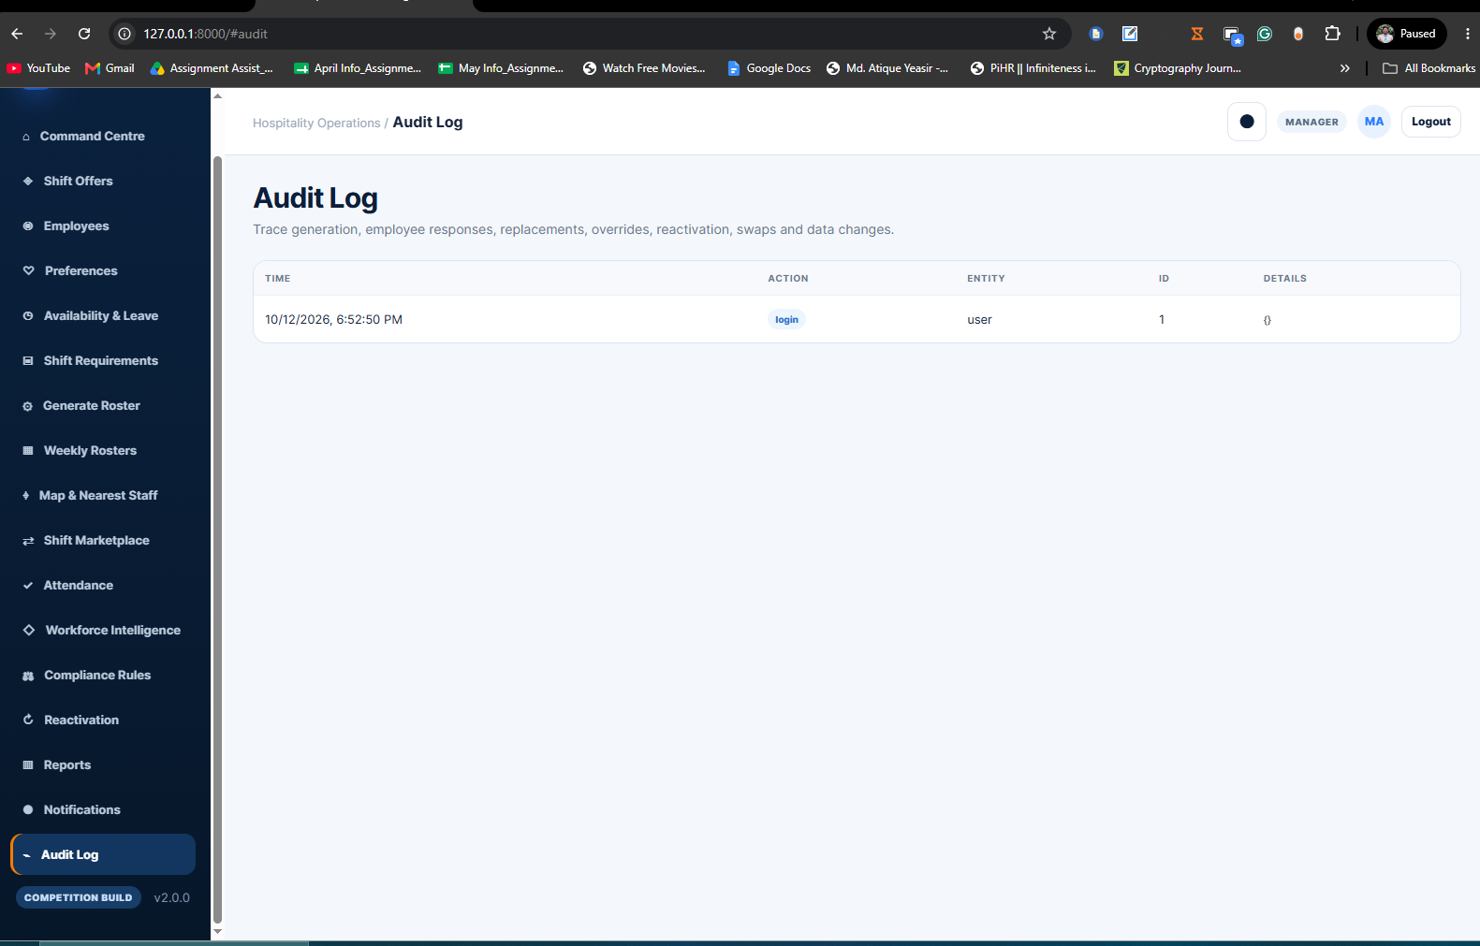
Figure F3: Audit-log evidence
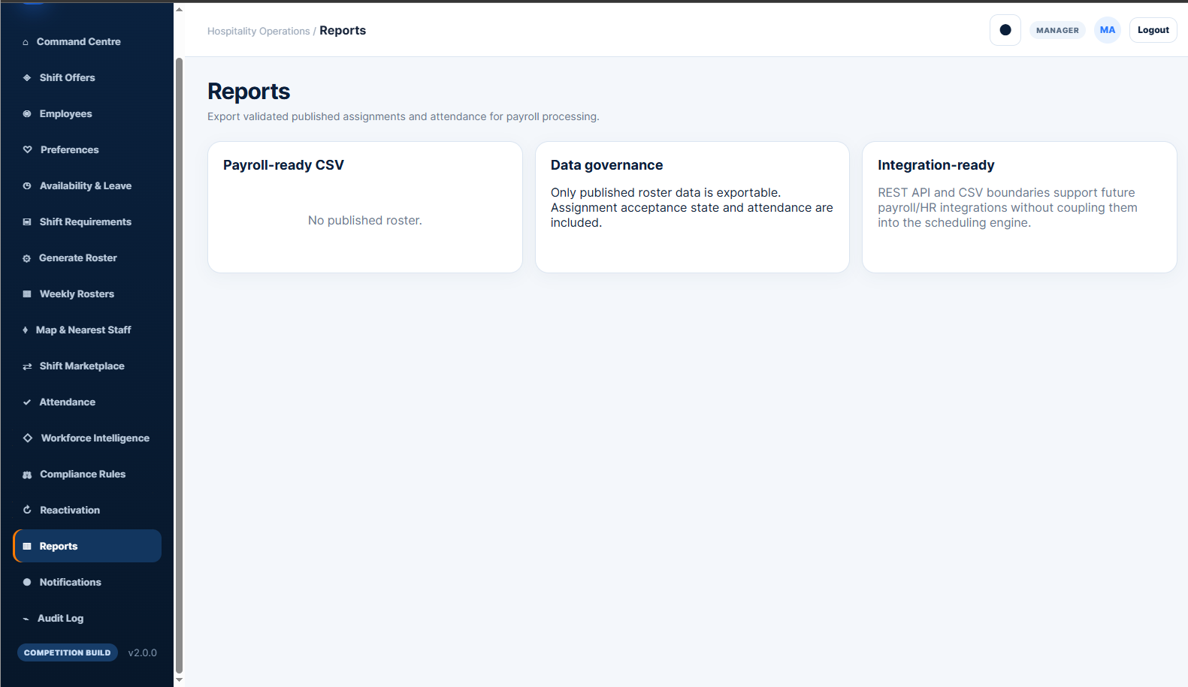
Figure F4: Reporting interface before roster publication

