**Database Testing Document**

**Database Schema (Classicmodels)**

**The MySQL sample database schema consists of the following tables:**

* customers
* employees
* offices
* orderdetails
* orders
* payments
* productlines
* products

**Tables:**

customers

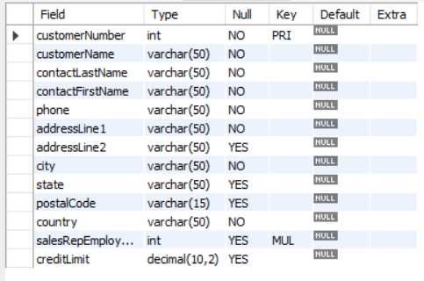

employees

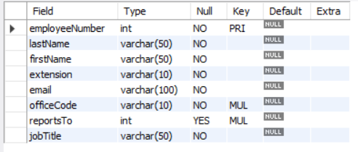

offices

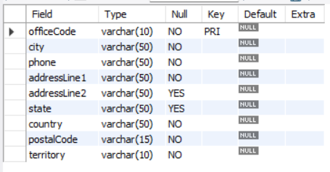

orderdetails

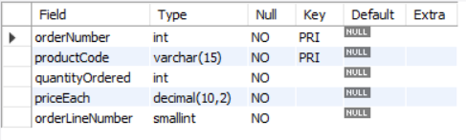

orders

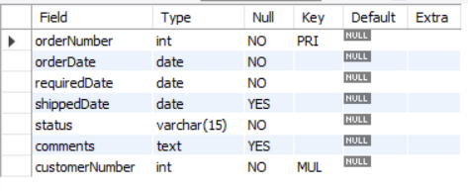

payments

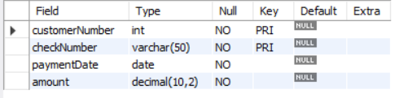

productlines

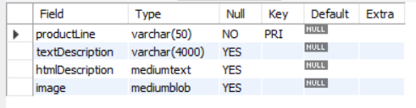

products

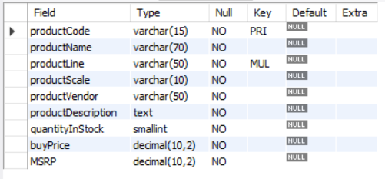

**Test Cases:**

* Check table presence in the database schema
* Check table name conventions
* Check the number of columns in a table
* Check the column name in a table
* Check the data type of columns in the table
* Check the size of the columns in a table
* Check null fields in a table
* Check column keys in a table