**Configuration – Administrative**  
Bug Report

Cycle 4

Afrida Rahman

Last Executed: 05/06/2024

**Asset Product**

1. Option not showing in “CL Sub Type” in Asset Product Master module.

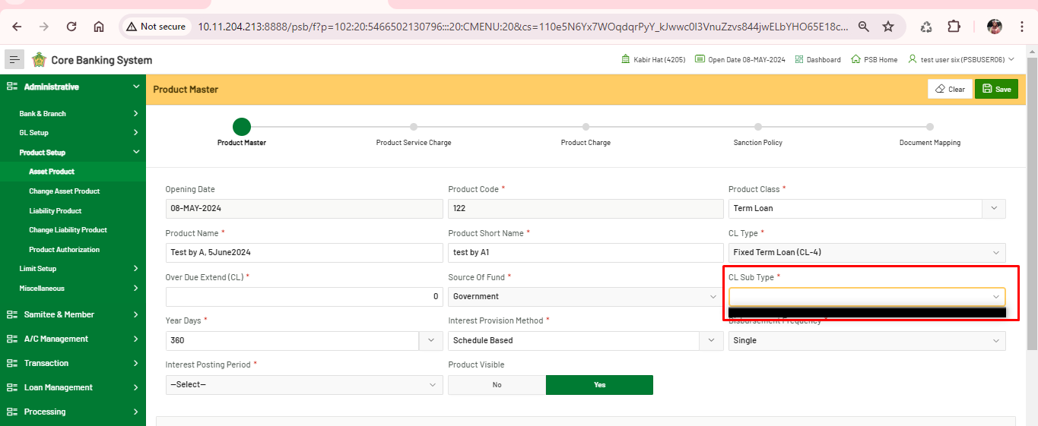

**Liability Product**

1. After save the form the “Next” button does not work as per expectation. It’s not user friendly.

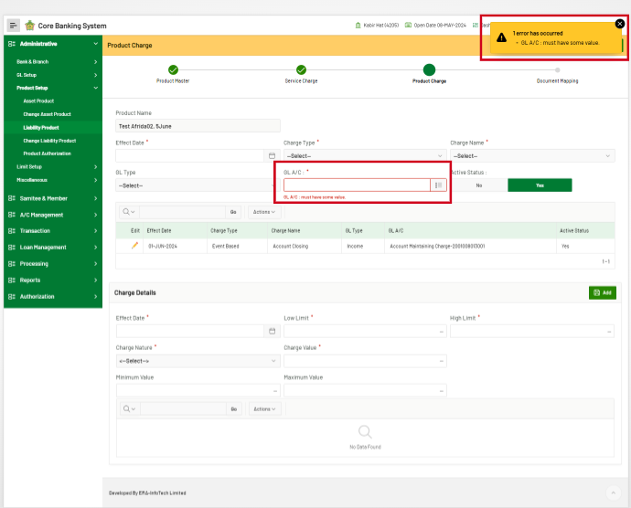

1. Lower limit and higher limit issue. This issue occurs when inputting the Higher limit >10.

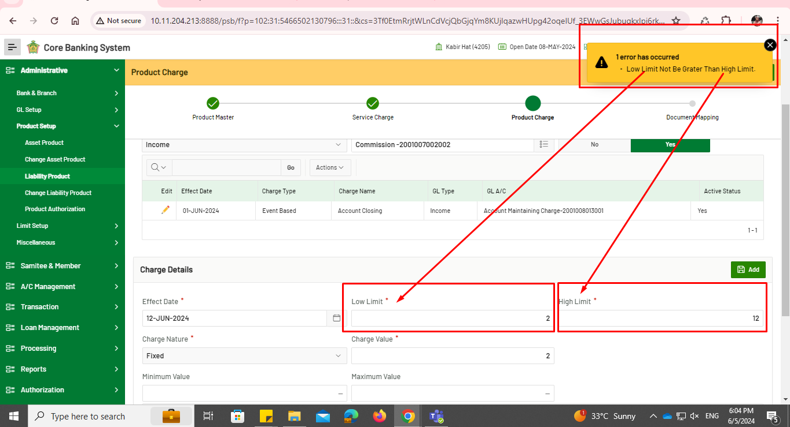

**Product Authentication**

1. An incomplete account should not appear here.

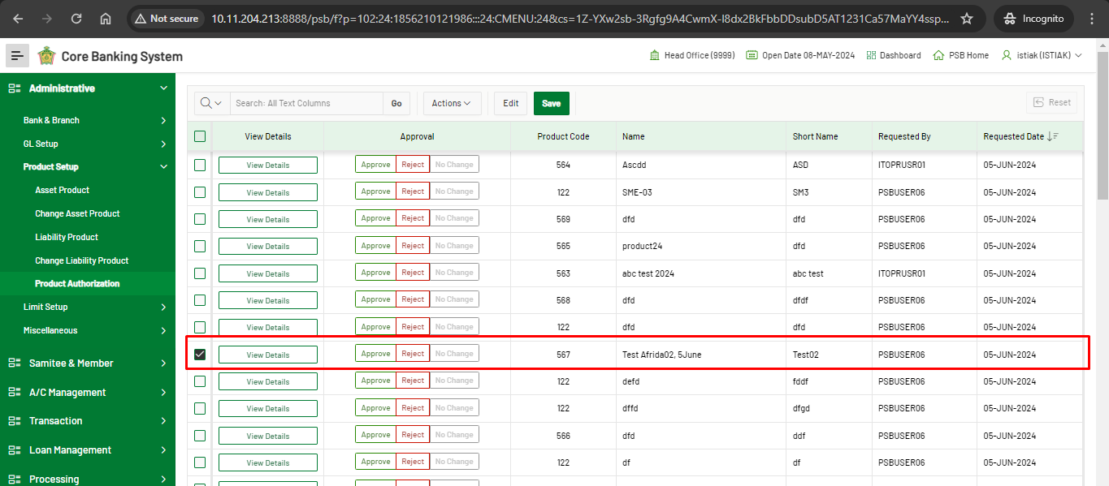

1. By using “Search Option”, can’t approve or reject a user’s account.

