# **PSB**

**Configuration – Dashboard**  
Bug Report

Cycle 1

Afrida Rahman

Last Executed: 29-30/05/2024

**Dashboard**

1. Mismatch between SRS’s prototype view and system’s dashboard. Time Duration is missing in the system’s dashboard.

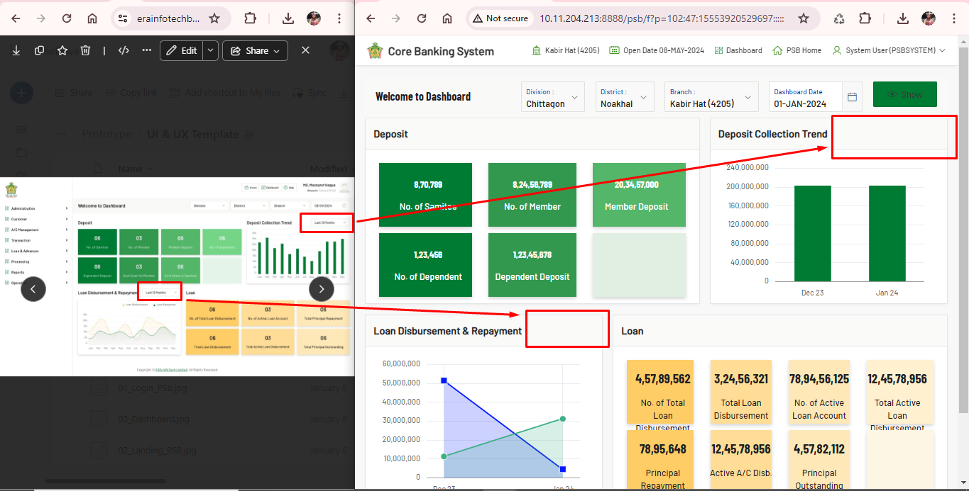

1. Problem in scroll Year. **- Fixed**

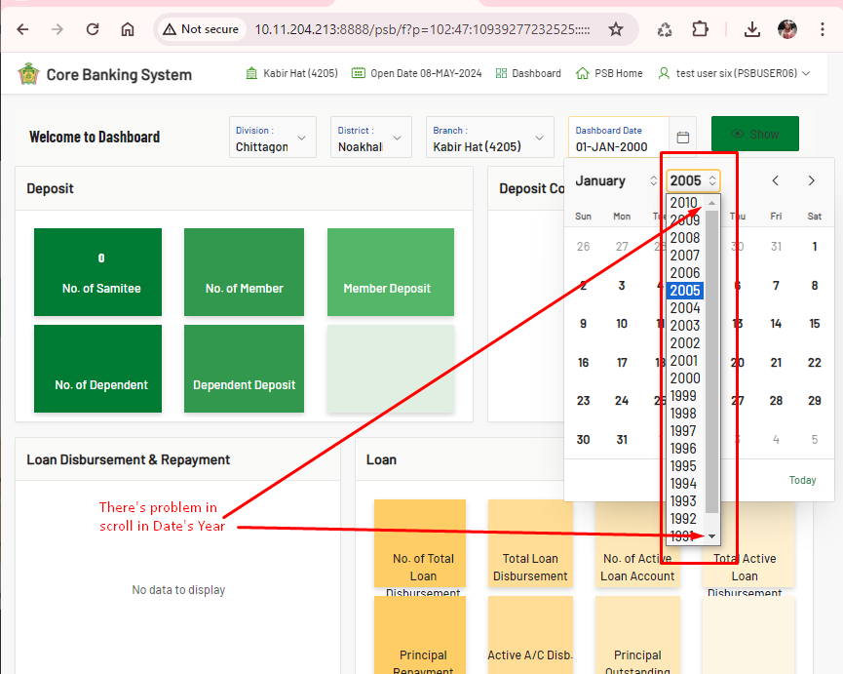

1. Show button’s text is hard to see. “Show” font text color in White will be more user visible. **- Fixed**

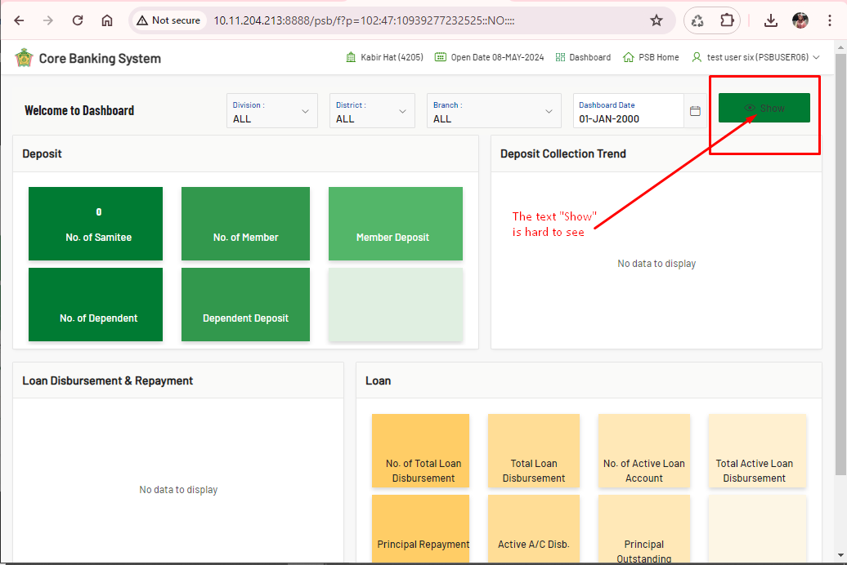

1. Refresh problem. System does not refresh the data. By refreshing, the system should clear data on previous results.

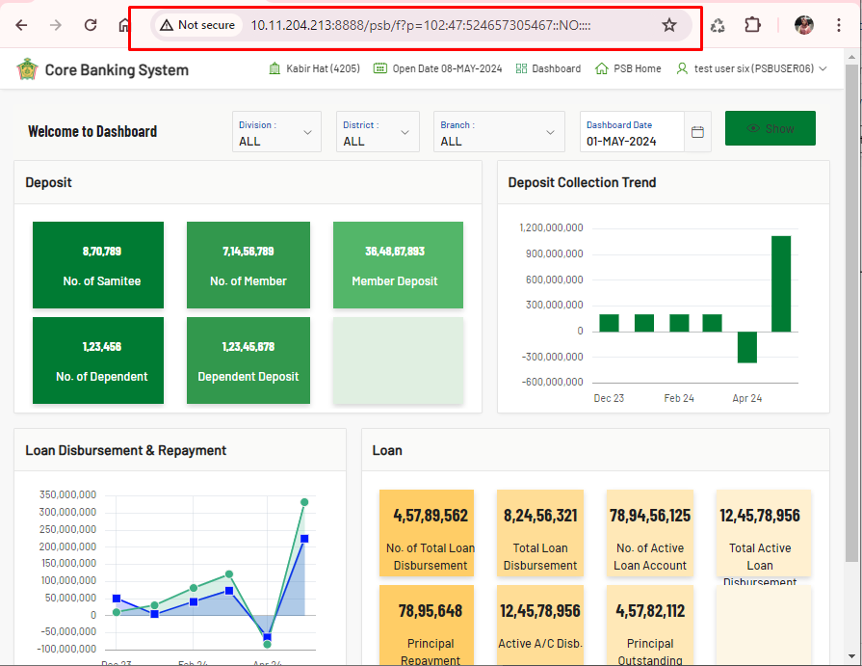

1. Information needed for “Loan Disbursement & Repayment”. In SRS information is given. And giving information above chart is more user friendly.

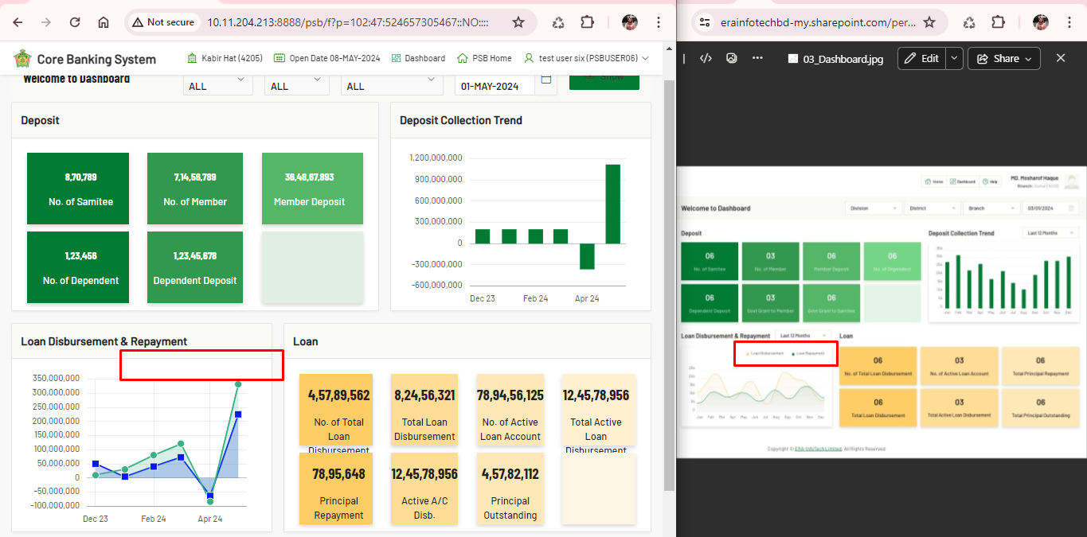

**Observation (Good to Have):**

1. System is not responsive. If the site will responsive, it will be more user-friendly.

