**Configuration – Dead Member Identification**   
Bug Report

Cycle 2

Afrida Rahman

Last Executed: 06/06/2024

**Dead Member Identification**

1. Error showing in “Death Declare Request” form in submit the form.

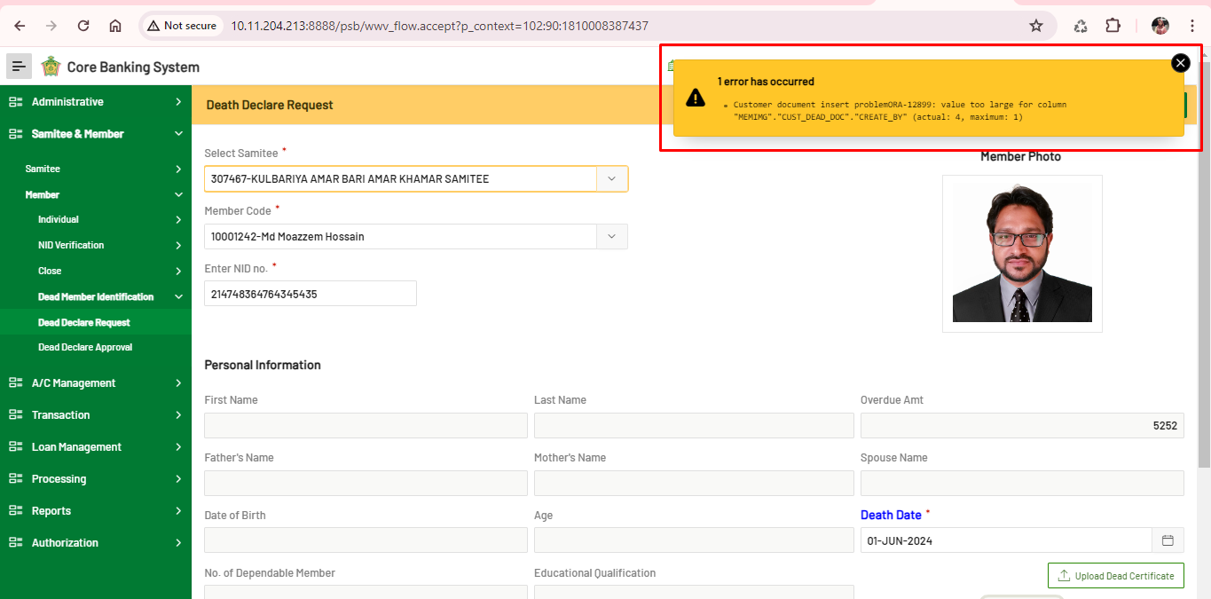

1. Error showing in “Death Declare Approval”, in “**Reject**” the request.

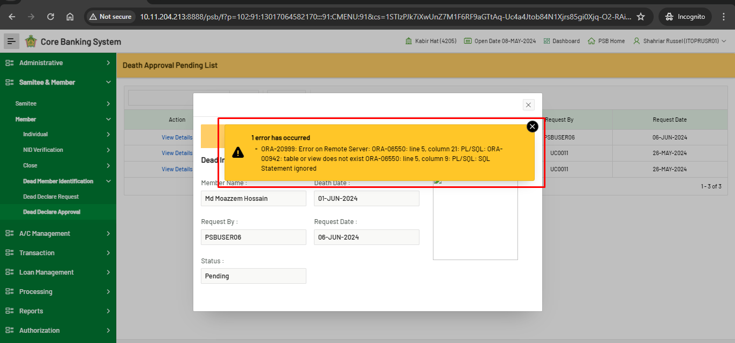

1. Once death member request authorized by “Approve”, the error message should be user readable and understanding.

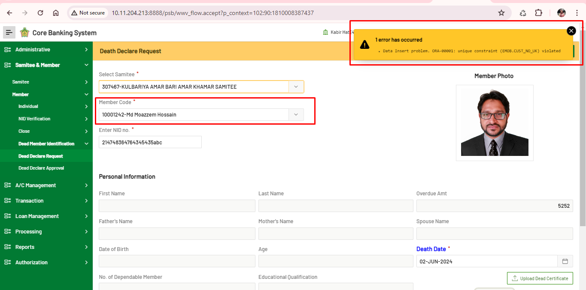

1. **In database “Active Asset/Loan A/C information: IS_PROV_ALLOW and PROVISION_STOP_DTAE” is not updated.**