**Configuration – Dead Member Identification**   
Bug Report

Cycle 3

Afrida Rahman

Last Executed: 06/06/2024

**Dead Member Identification**

1. Error showing in “Death Declare Request” form in submit the form.

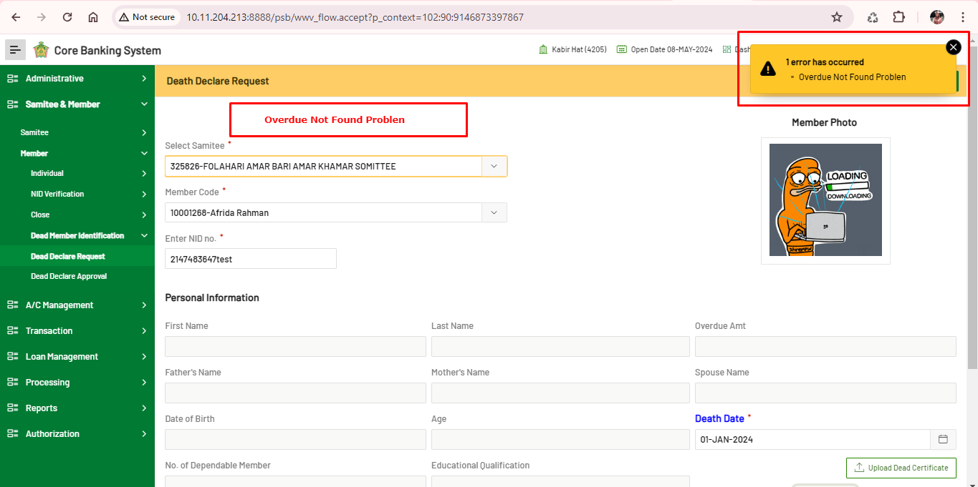

1. Error showing in “Death Declare Approval”, in “**Reject**” the request

