**Configuration – Administrative, Product Setup**  
Bug Report

Cycle 1

Afrida Rahman

Last Executed: 27/05/2024

**Liability Product**

1. System accepts user's input, not filled up the mandatory field.

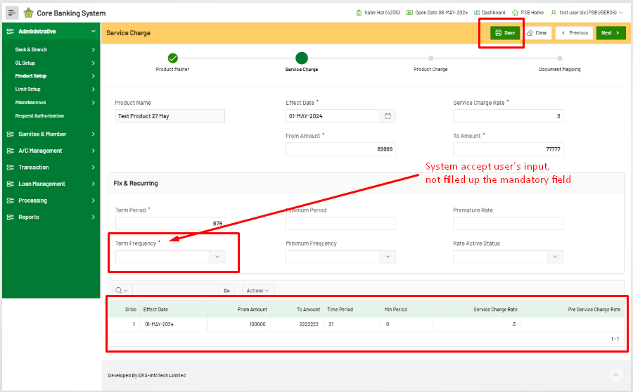

Deposit = “Regular”

1. Error’s “Premature Rate” does not exist in the form of Liability Product module

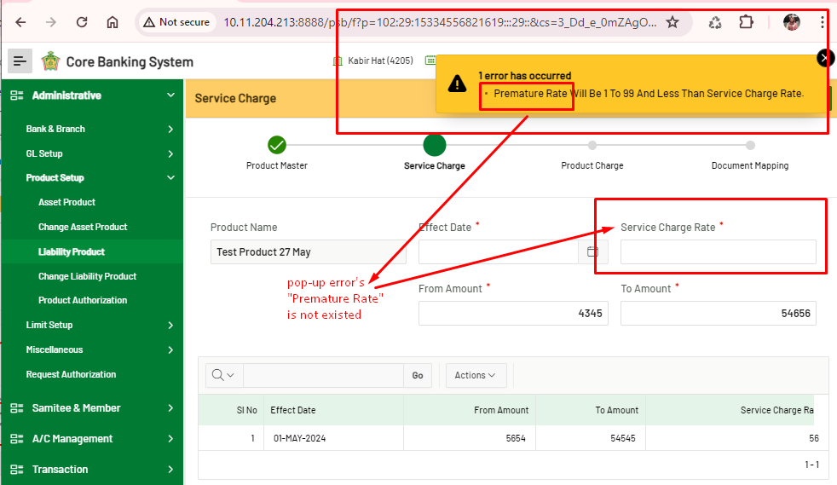

1. After saving the service charge form, the “Next” button doesn’t allow to go next. It shows Json error.

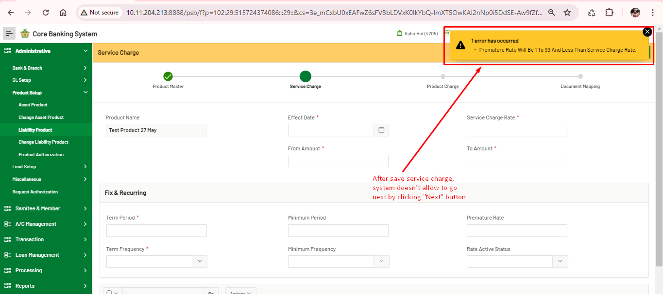

1. By clicking “Approve” button shows an error message.

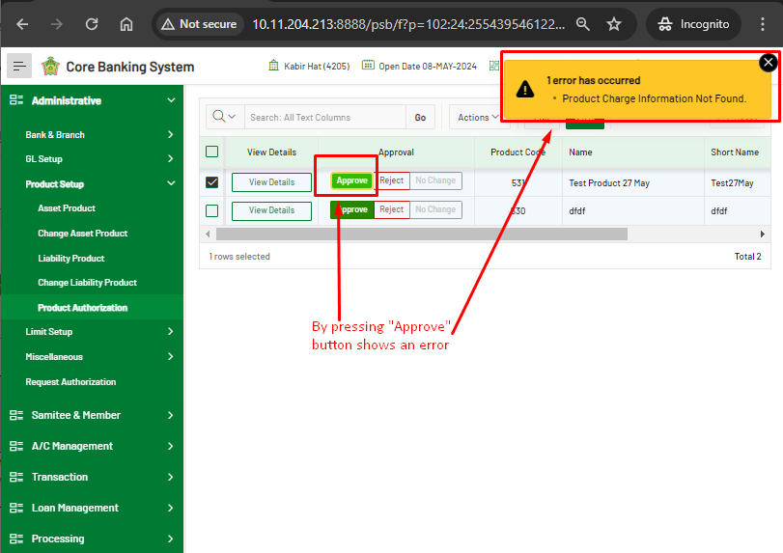

1. The incomplete form should not be in “Product Authorization” list, that should be in draft, in Liability Product module.

