# **PSB**

**Configuration – Loan Management**  
Bug Report

Cycle 1

Afrida Rahman

Last Executed: 28/05/2024

**Sanction**

* Request
* Authorization
* Information Change
* Limit Change Request
* Limit Change Approval

**Account Open**

* Request
* Authorization

**Disbursement**

* Request
* Authorization

**Reschedule**

* Request
* Authorization

**Account Close**

* Request
* Authorization

**Account Open:**

1. in Loan Account Opening “Sector Code” and “Loan Period” fields cannot input, if the user had not given input in Sanction Request. System doesn’t take user’s input in this form, and without this 2field cannot go next page.

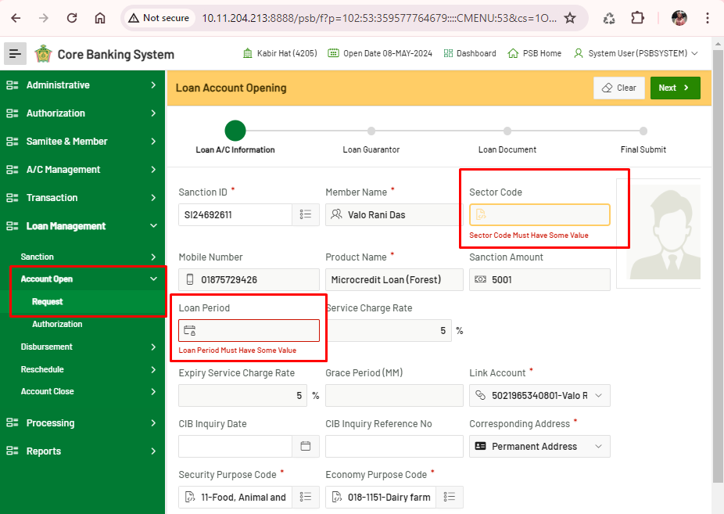

1. If “Link Account” is not selected before, the account is not in “List Account” list. Without this field selection, the system doesn't allow to go to the next page.

