**Configuration – Reports**  
Bug Report

Cycle 1

Afrida Rahman

Last Executed: 22/05/2024

**Reports Module has been tested:**

* Account Statement
* Account Balance Parameter
* Daily Transaction List
* GL Statement

**Account Statement**

1. In SRS "To Date" will be current module date. but in system the "To Date" is not matching according to SRS

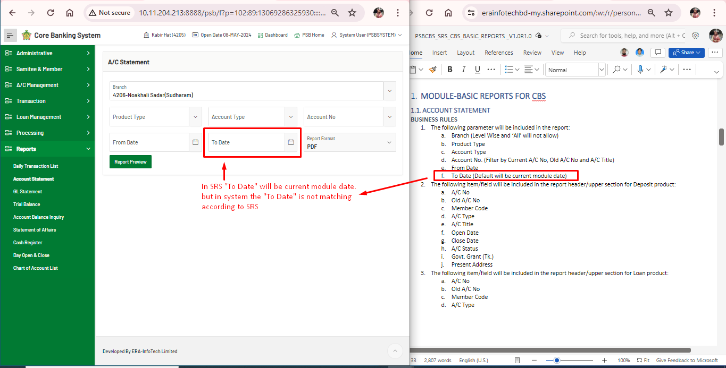

2. Mismatch between SRS and System. (There's no mandatory field marked as per SRS)

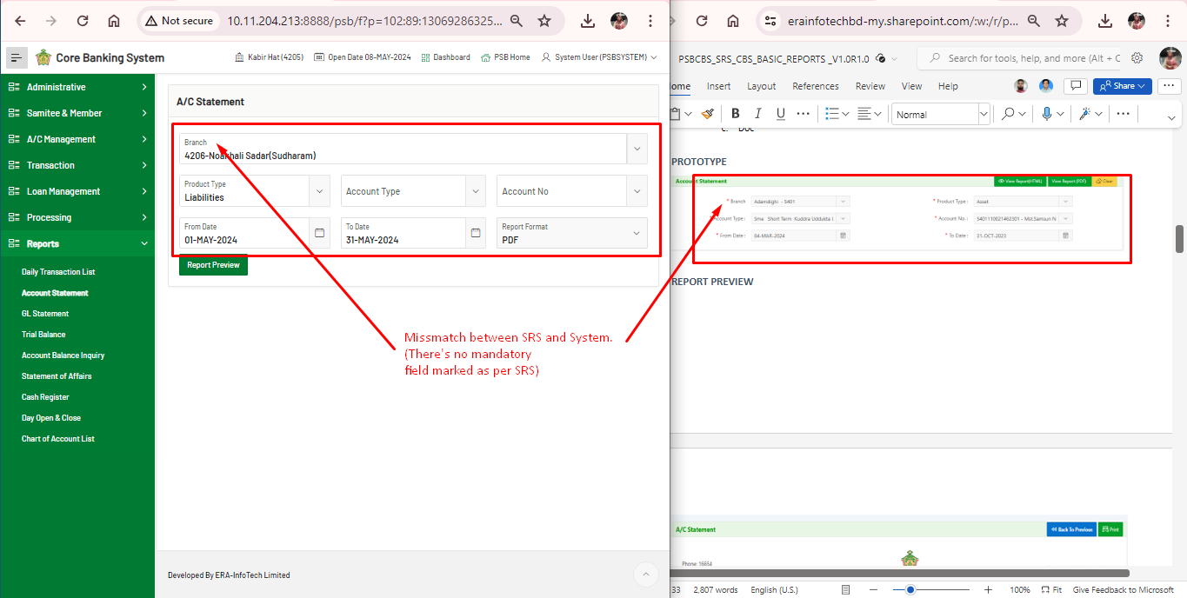

1. Mismatch in generated view report between SRS and Generated Report.

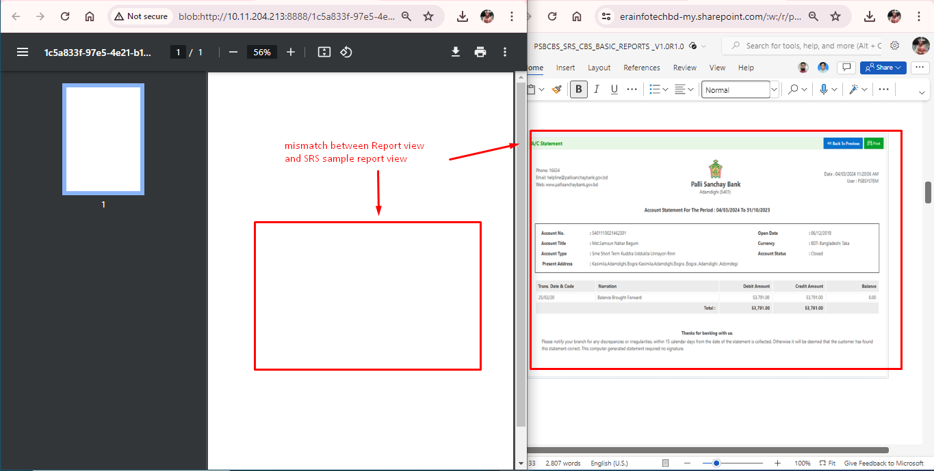

**Account Balance Parameter**

1. Mismatch field name on between SRS and System in Account Balance Inquiry

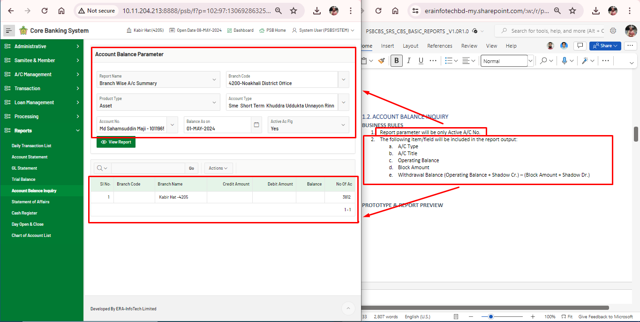**Daily Transaction List**

1. Mismatch between SRS and System. In SRS the "Date" will take the default current module date. Which is missing on the System

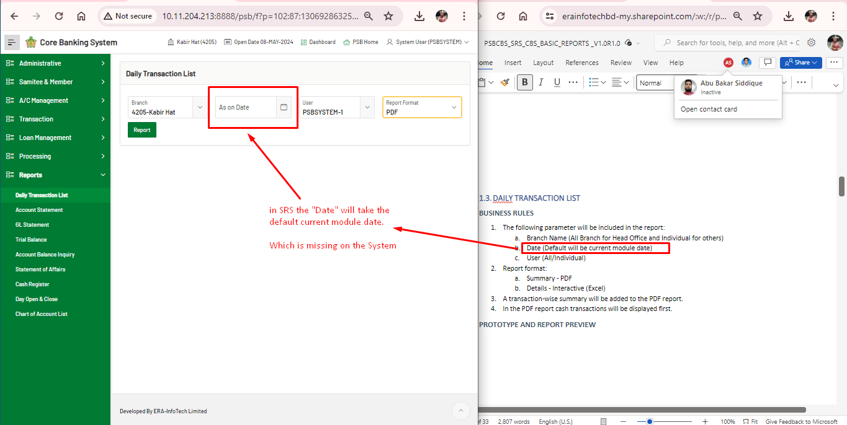

1. Generated PDF report shows nothing, it is not as per SRS

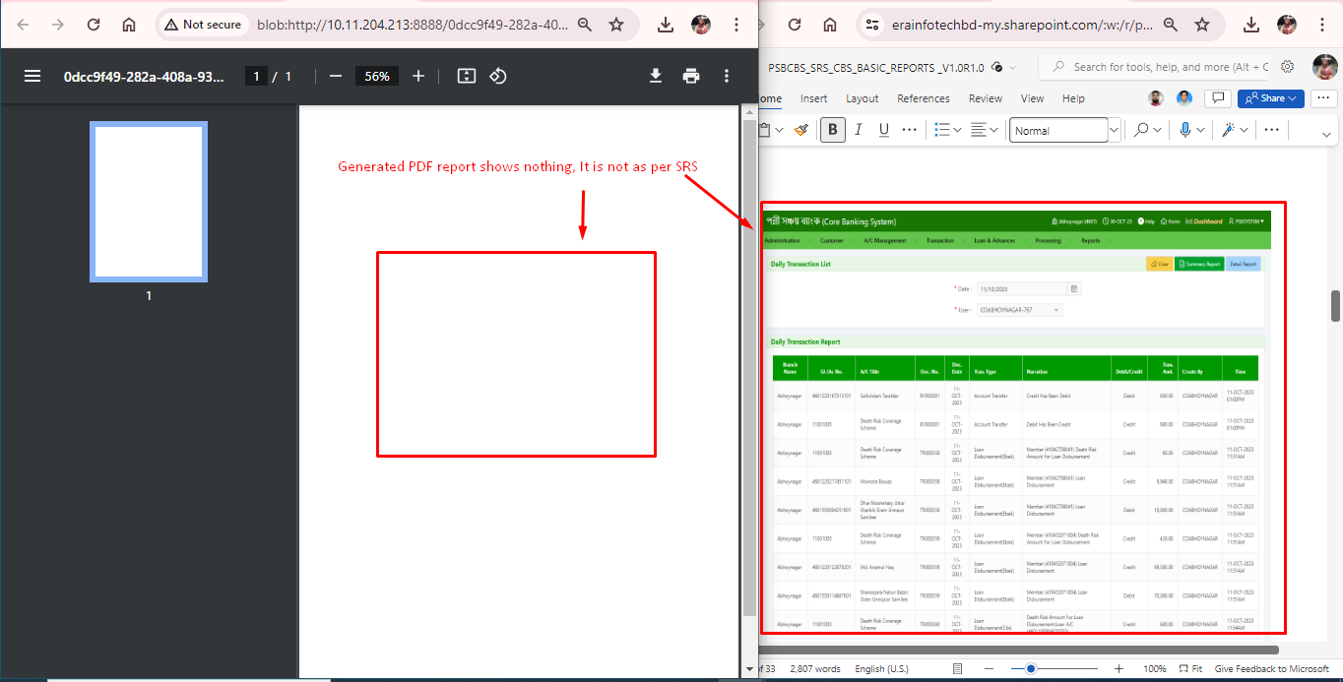

**GL Statement**

1. GL Account balance report is not the same as SRS.

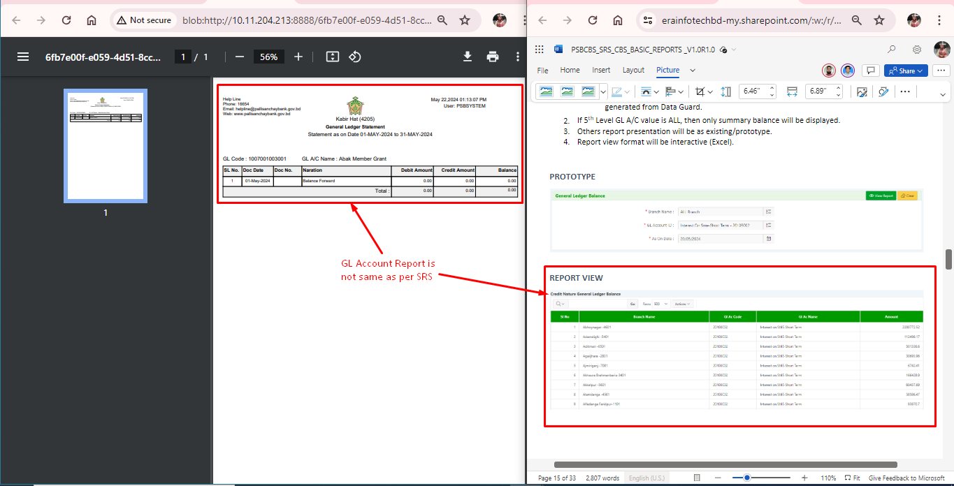

1. Alignment problem in GL Account report

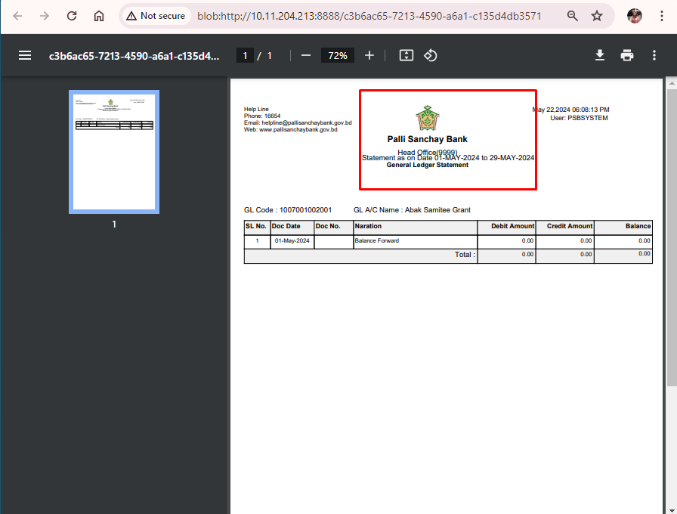

1. Spelling mistake in GL Account report. It should be “Narration” instead on “Naration”.

