**Configuration – Reports**  
Bug Report

Cycle 2

Afrida Rahman

Last Executed: 25/05/2024

**Account Statement**

1. Mismatch in generated view report between SRS and Generated Report.

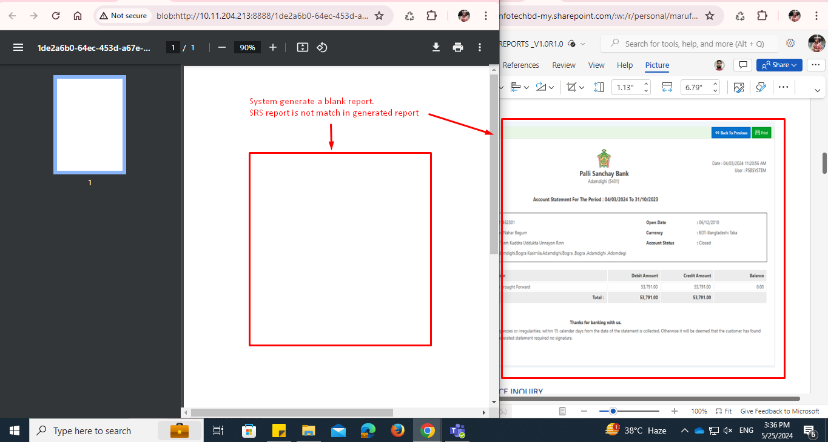

**GL Statement**

1. Generated reports issues.
   * The font size of the right side’s information and the left side’s information are not the same.

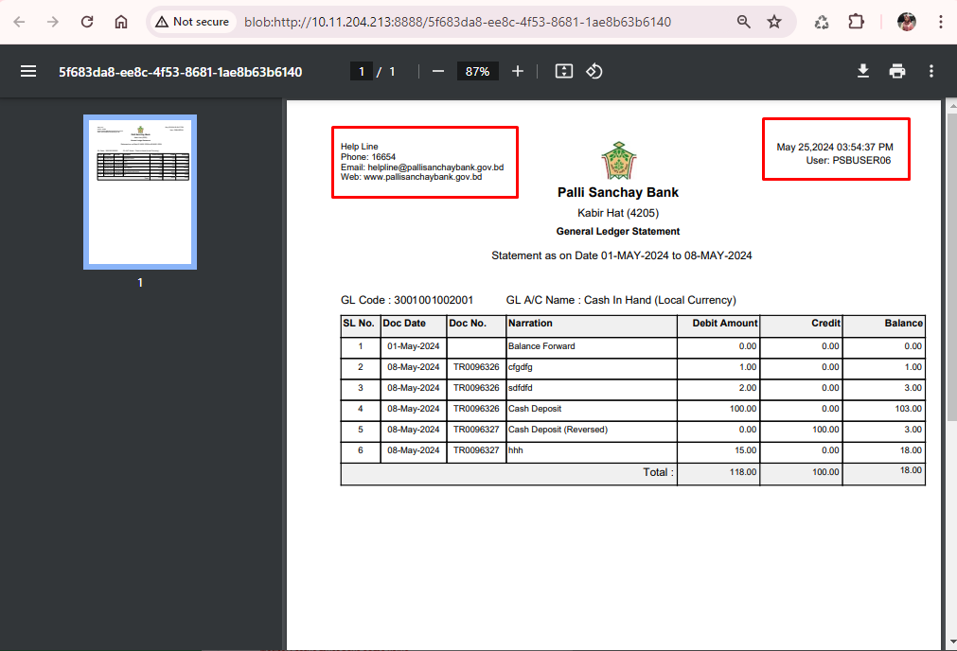

1. “Amount” word missing in “Debit” amount in “General Ledger Statement” module.

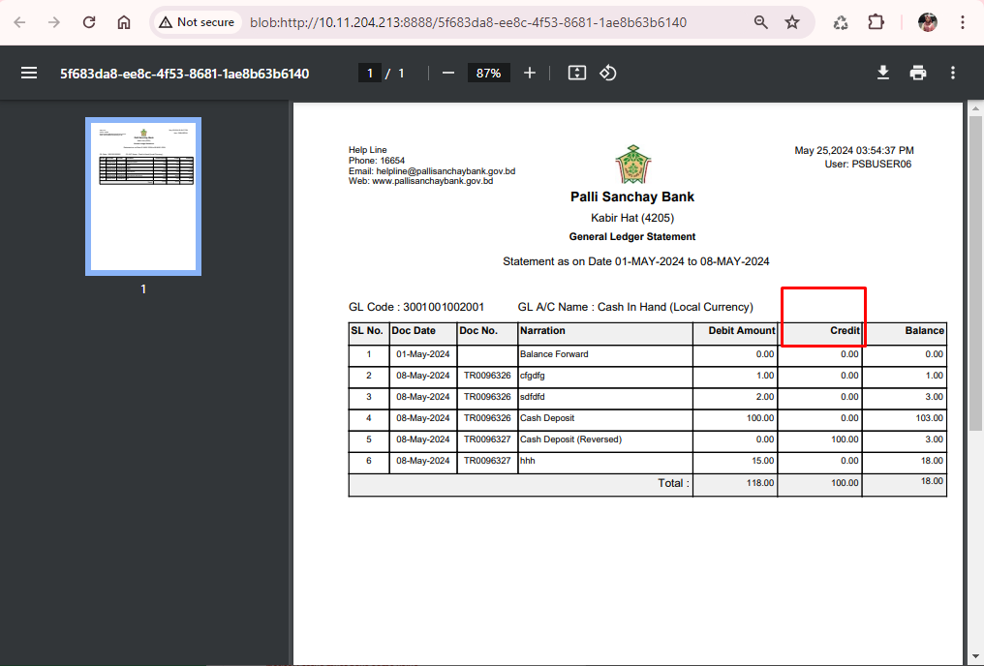

1. In doc file basic left side’s information missing.

