BistroSaaS
Restaurant Management & Online Ordering System
Project Report

Course: _______________________
Instructor: _______________________
Department: _______________________
Submission Date: _______________________

Group Member Information
Name | Roll / Reg. No. | Email | Responsibilities
Mussa Afridi |  | mussaafridi8240@gmail.com | Backend, Deployment

(Fill in the remaining group members above.)

Introduction
BistroSaaS is a full-stack, web-based restaurant management and online ordering system developed using the Django web framework. It allows customers to browse a digital menu, search and filter dishes, place orders online, and track their order status in real time. At the same time, it provides restaurant administrators with powerful tools to manage menu items, categories, and incoming orders through a clean, responsive interface as well as the built-in Django admin panel.
The application follows Django's Model-View-Template (MVT) architecture and includes a REST API (built with Django REST Framework) that exposes menu data in JSON format. The user interface is styled with Bootstrap 5 to ensure a modern, mobile-friendly experience.

Problem Statement
Many small and medium restaurants still rely on manual, paper-based methods for taking and tracking orders. This leads to several problems:
- Order errors caused by manual writing and verbal communication.
- No central, searchable record of the menu or past orders.
- Customers cannot view the menu or order online, limiting reach.
- Difficulty tracking the live status of an order (pending, preparing, completed).
- Menu updates (prices, availability, images) are slow and inconsistent.
BistroSaaS solves these problems by digitizing the entire ordering workflow in a single, easy-to-use web application.

Objectives
- Provide secure user registration and login with two roles: Customer and Admin.
- Allow customers to browse a categorized menu with search, filtering, and pagination.
- Enable customers to place orders online and view their order history.
- Allow admins to perform full CRUD operations on menu items (including image uploads).
- Implement an order confirmation workflow with status updates and customer notifications.
- Provide a user profile module to edit personal information and change passwords.
- Expose menu data through a RESTful API in JSON format.
- Deliver a responsive, modern UI using Bootstrap 5.

System Design
The system is built on Django's MVT (Model-View-Template) architecture:
- Model (models.py): Defines the database tables - CustomerProfile, Category, MenuItem, and Order.
- View (views.py): Contains the logic for each page using both function-based and class-based views.
- Template (HTML files): Bootstrap 5 pages that present the data to the user.
- URLs (urls.py): Map web addresses to the correct views.
- Forms (forms.py): Validate and process user input.
- REST API (serializers.py + viewset): Serve menu data as JSON.
User Roles:
- Guest: can browse the menu and read the API; must register/login to order.
- Customer: can place orders, view order history, and manage their profile.
- Admin (superuser): full access - menu management, order confirmation, and the Django admin panel.
A key workflow is the order lifecycle: a customer places an order (status = Pending); an admin confirms and updates it (Preparing -> Completed, or Cancelled); the customer is then notified of the status change via an in-app notification badge.

Database Design (ER Diagram)
The database is implemented in SQLite and consists of four main tables plus Django's built-in User table. Their relationships are:
- User - CustomerProfile : One-to-One (each user has one profile).
- User - Order : One-to-Many (a user can place many orders).
- Category - MenuItem : One-to-Many (a category contains many items).
- Order - MenuItem : Many-to-Many (an order has many items; an item can be in many orders).
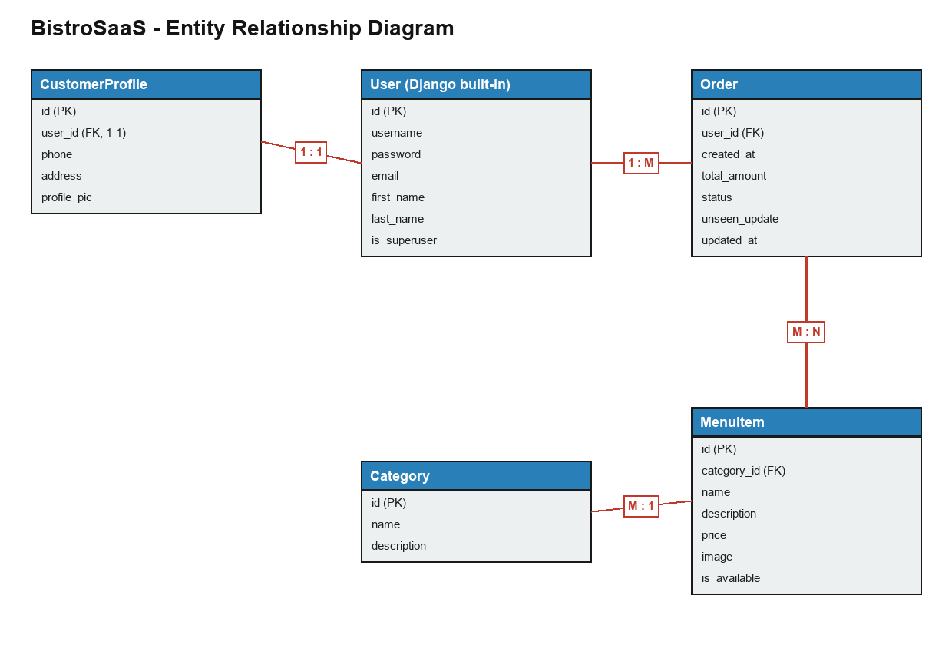
Figure 1: Entity-Relationship Diagram

Screenshots
Insert screenshots of the running application below. Recommended pages to capture (from your live site):
Screenshot 1: Home / Menu page (with search and category filters)
[ Paste screenshot here ]
Screenshot 2: Registration page (showing the Role dropdown and Secret Key)
[ Paste screenshot here ]
Screenshot 3: Login page
[ Paste screenshot here ]
Screenshot 4: Menu item detail page
[ Paste screenshot here ]
Screenshot 5: Add / Edit menu item form (admin)
[ Paste screenshot here ]
Screenshot 6: Place Order page (with live total)
[ Paste screenshot here ]
Screenshot 7: My Orders page (with status badges and notifications)
[ Paste screenshot here ]
Screenshot 8: Manage Orders page (admin order confirmation)
[ Paste screenshot here ]
Screenshot 9: User Profile page
[ Paste screenshot here ]
Screenshot 10: Django Admin panel
[ Paste screenshot here ]
Screenshot 11: REST API page (/api/menu/)
[ Paste screenshot here ]

Tools & Technologies Used
Tool / Technology | Purpose
Python 3 | Core programming language
Django 6.0.5 | Backend web framework (MVT architecture)
Django REST Framework 3.17 | Builds the JSON REST API
SQLite | Database (file-based, db.sqlite3)
Bootstrap 5 | Frontend CSS framework for responsive UI (via CDN)
HTML5 + Django Templates | Page structure and dynamic content
Pillow | Image handling for uploads (menu/profile pictures)
Git & GitHub | Version control and code hosting
PythonAnywhere | Cloud hosting / live deployment
VS Code / Cursor | Code editor / IDE

Conclusion
BistroSaaS successfully demonstrates a complete, real-world restaurant management system built with Django. It covers the full software stack: database modeling, authentication and role-based access control, CRUD operations, file uploads, an order management workflow with notifications, a REST API, and a responsive Bootstrap interface. The project was version controlled with Git/GitHub and deployed live on PythonAnywhere.
Through this project we gained practical experience in full-stack web development, the MVT design pattern, relational database design, and cloud deployment. Future enhancements could include online payment integration, email notifications, and a customer ratings/reviews system.

References
- Django Documentation - https://docs.djangoproject.com/
- Django REST Framework - https://www.django-rest-framework.org/
- Bootstrap 5 Documentation - https://getbootstrap.com/
- Pillow (PIL) Documentation - https://pillow.readthedocs.io/
- SQLite - https://www.sqlite.org/
- PythonAnywhere Help - https://help.pythonanywhere.com/
- Project Repository - https://github.com/afridi-mussa/Resturant-Management-System

