
OpenSIEM
Atom v1
User Manual
Version 1.0 • March 2026
For Security Analysts and Administrators

1. Introduction
Welcome to OpenSIEM Atom v1. OpenSIEM is a Security Information and Event Management (SIEM) platform that collects logs from across your network, detects suspicious patterns, and presents everything through a simple web interface.

This manual covers every screen in the web interface. I named the named the web interface Chronicler. I tried to keep it as simple as possible, for me and for eveyone else who would se it. This is the reason, you do not need any programming knowledge to use it. If you can read a log line and recognize an alert, you have everything you need.

1.1 What OpenSIEM Does
- Collects logs from Linux servers, firewalls, web servers, and databases in real time.
- Checks every log line against a database of known malicious indicators (IOCs).
- Applies correlation rules, if a series of suspicious events happen in sequence from the same source, an alert is raised automatically.
- Presents all of this through Chronicler, a web dashboard you access from any browser.

1.2 Key Concepts

Term | What it means
Alert | A notification that something suspicious has been detected. Alerts have a severity level: Low, Medium, High, or Critical.
Artifact / IOC | A known malicious string, IP address, domain, or keyword. If any log line contains an artifact, an alert is raised immediately.
Correlation Rule | A sequence of events that together indicate an attack. For example: failed login + successful login from the same IP = brute force rule.
EPS | Events Per Second, how many log messages the server is currently processing. A healthy number depends on your environment.
The Watcher | A lightweight agent running on each monitored host. It reads log files and forwards them to the OpenSIEM server.
Source IP | The IP address of the host that generated the log. Used to group correlated events together.
Severity | Low (green), Medium (yellow), High (red), Critical (dark red). Higher severity alerts need faster attention.

1.3 Logging In
Open your browser and navigate to the Chronicler URL provided by your administrator (typically http://your-server-ip or https://your-server-ip). You will see the login screen.

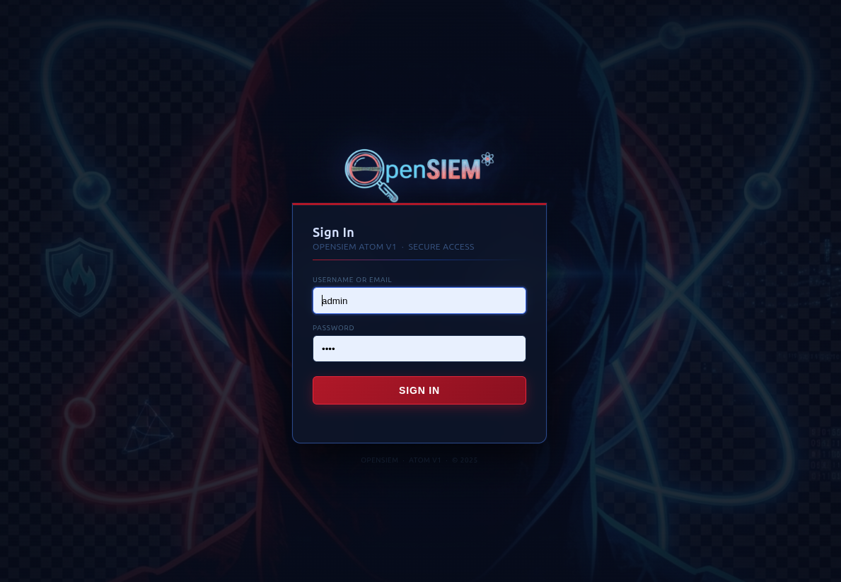
Figure 1.1: Login page

Enter your username and password, then click Sign In. If you have forgotten your credentials, contact your OpenSIEM administrator. The default credentials are
Username | Password
admin | atom

⚠ Note
Your session will expire after a period of inactivity. If you see the login page unexpectedly, your session has timed out, simply log in again.

⚠ Note
The default username will be admin and password will be after the code name of OpenSIEM version.

2. Dashboard
The Dashboard is the first screen you see after logging in. It gives you a live overview of everything happening in your environment right now.

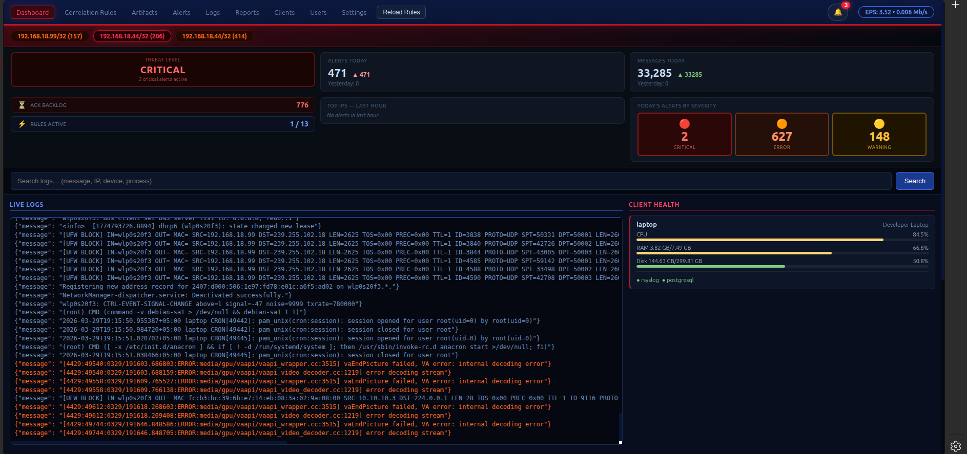
Figure 2.1: Dashboard overview

2.1 Navigation Bar
The dark blue bar at the top of every page contains links to all sections of Chronicler. The currently active page is highlighted with a red underline.

Figure 2.2: Navigation bar

On the right side of the navigation bar is the notification bell. The number badge shows how many unacknowledged alerts are waiting. Click the bell to see a dropdown list of recent alerts. Clicking any alert in the dropdown takes you directly to that alert's detail view.

2.2 Alert Ribbon
The coloured bar below the navigation shows a live count of active alerts grouped by severity. Colours from left to right are: Critical, High, Medium, Low. These counts update automatically every few seconds.

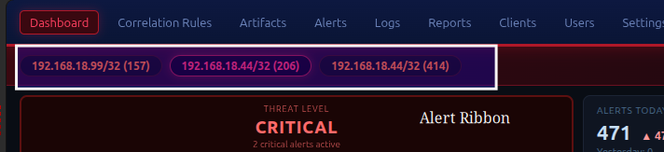
Figure 2.3: Alert ribbon

2.3 Widget Strip
The row of cards below the alert ribbon gives you a snapshot of the current system state:

Widget | What it shows
Threat Level | An overall risk rating (Low / Elevated / High / Critical) calculated from the number and severity of active alerts.
Alerts Today | Total alerts triggered today compared to yesterday. A green arrow means fewer today; red means more.
Messages Today | Total log messages processed today compared to yesterday.
Backlog / Rules | Backlog = alerts that have not been acknowledged. Rules = number of active correlation rules loaded.
Top IPs (last 1h) | The five source IP addresses that generated the most alerts in the last hour.
Alert Spike (6h) | A small sparkline chart showing alert volume over the last 6 hours. A sudden spike is worth investigating.
Today's Alerts by Severity | A simple widget showing messages with Severity level of Critical, Error and warning.

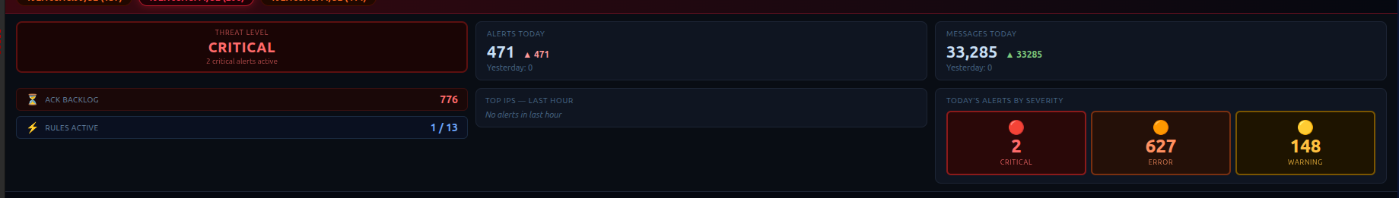
Figure 2.4: Widget strip

2.4 Search Bar
The search bar in the middle of the dashboard lets you do a quick search across all stored log messages. Type a keyword or IP address and press Enter. You will be taken to the Logs page with your search pre-filled.

2.5 Live Logs Panel
The left panel shows the most recent log lines arriving at the server in real time, refreshing every 3 seconds. This is useful for confirming that log collection is working and for spotting unusual activity at a glance.

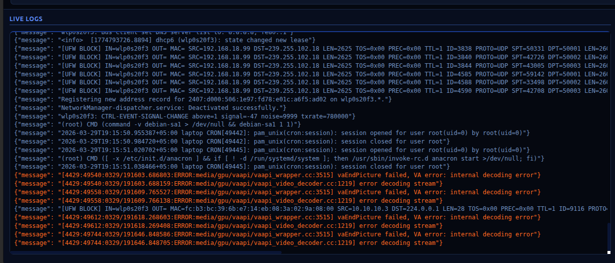
Figure 2.5: Live logs and client health panels

2.6 Client Health Panel
The right panel shows the current health of every monitored host. The Watcher send this information. For each host you can see:
- CPU usage: bar turns yellow above 65%, red above 85%.
- RAM: used versus total.
- Disk: used versus total, with the same colour thresholds.
- Service pills: green if the service is running, red if it is stopped.

If a host stops appearing in this panel, the watcher agent on that host has disconnected. Contact your administrator.

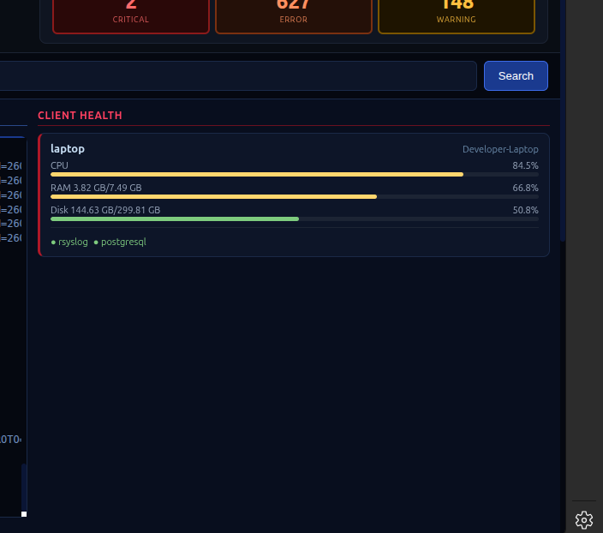
Figure 2.6: Clients health widget

2.7 Charts Section
The bottom of the dashboard contains two charts:
- EPS over time: shows how many events per second the server has been processing. A flat line at zero may indicate a collection problem.
- Alert activity: shows the volume of alerts over the past few hours, broken down by severity.

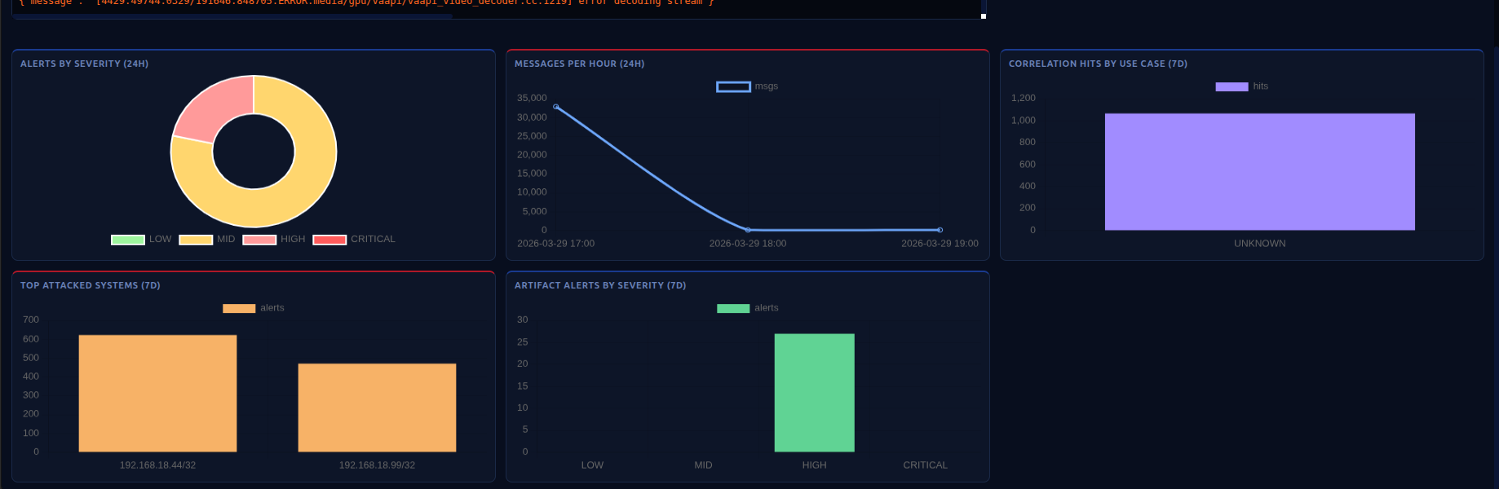
Figure 2.7: Dashboard charts

3. Alerts
The Alerts page is where you manage every security event that OpenSIEM has detected. This is likely where you will spend most of your time.

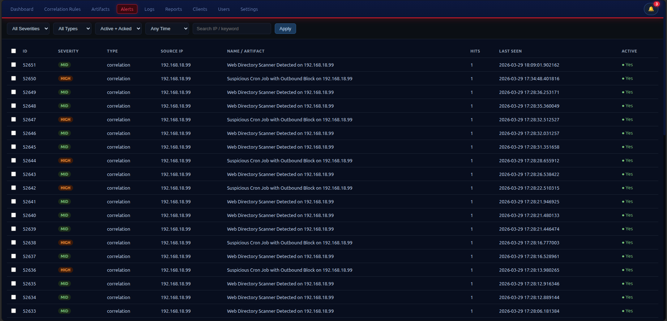
Figure 3.1: Alerts page

3.1 The Alerts Table
Each row in the table represents one alert. The columns are:

Column | Meaning
Checkbox | Select this alert for a bulk action.
Type | What kind of alert this is, "correlation" (a rule fired), "artifact" (a known IOC was found), or "blacklist" (a blacklisted IP was seen).
Source IP | The IP address the suspicious activity came from.
Severity | Low, Medium, High, or Critical. Colour-coded for quick scanning.
Hits | How many times this same alert has fired. A count of 50 means the same suspicious pattern happened 50 times.
Alerts | Number of distinct alert occurrences linked to this alert instance.

Click any row to open the Alert Detail modal.

3.2 Alert Detail
The Alert Detail modal shows the full picture for a single alert:

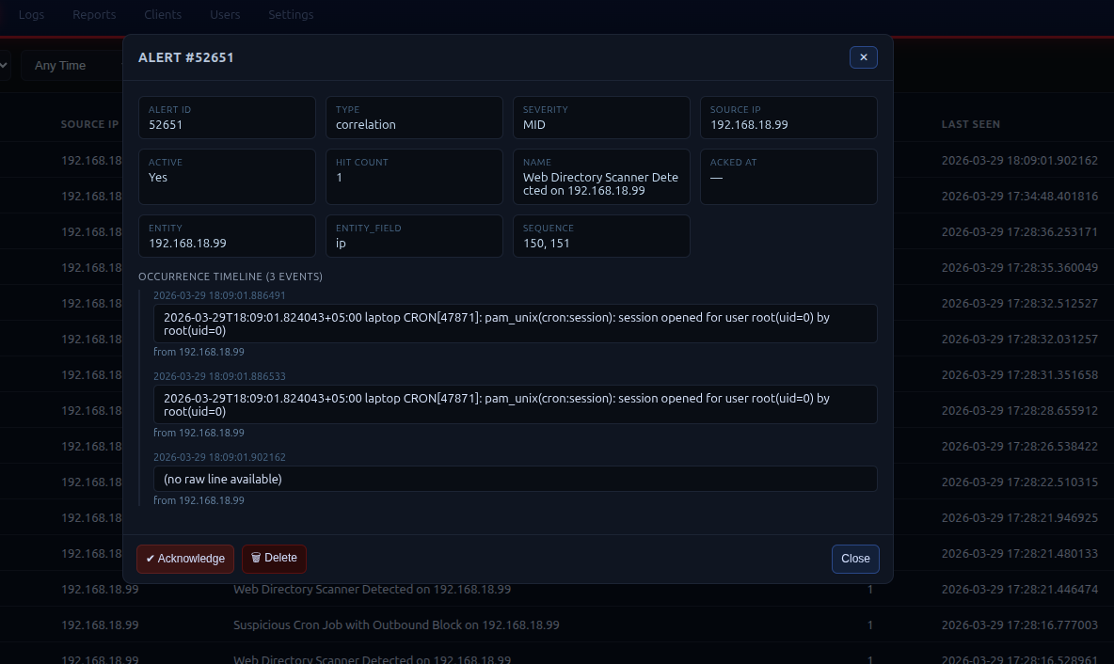
Figure 3.2: Alert detail modal

- The top section shows the alert type, source IP, severity, and total hit count.
- The key-value grid shows all technical details extracted from the alert.
- The occurrence timeline at the bottom lists every individual time this alert fired, with timestamps. This tells you whether the activity is ongoing or historical.

Two action buttons appear in the modal footer:
- Acknowledge: marks this alert as reviewed. The alert remains in the table but is no longer counted in the unacknowledged backlog. Use this once you have investigated and understand what happened.
- Delete: permanently removes the alert from the database. Only delete alerts you are sure are false positives or have been fully resolved.

💡 Tip
You can deep-link directly to an alert from the notification bell dropdown. The URL format is /alerts.html?id=N, you can bookmark or share these links.

3.3 Bulk Actions
Select multiple alerts using the checkboxes, then use the action bar that appears at the top of the table:

- Delete Selected: removes all selected alerts.
- Ack Selected: acknowledges all selected alerts at once.
- Clear: deselects all checkboxes.

⚠ Note
Deletion is permanent. There is no undo. If you are unsure, use Acknowledge instead of Delete.

3.4 Alert Workflow
Recommended workflow when a new alert appears:
- Read the alert type and source IP. Is this IP a known internal host or an external address?
- Open the detail modal and look at the occurrence timeline. Is this a one-off or is it ongoing?
- Search the Logs page for the source IP to see the full context of what that host was doing.
- If the alert is a real threat, take action on the affected system and add the source IP or relevant keyword to the Artifacts page as an IOC.
- Acknowledge the alert once you have completed your investigation.
- If it is a false positive, note it in the Admin Note field (if available) and delete it.

4. Logs
The Logs page lets you search and browse all log messages that OpenSIEM has collected. It has two modes: live tail and search.

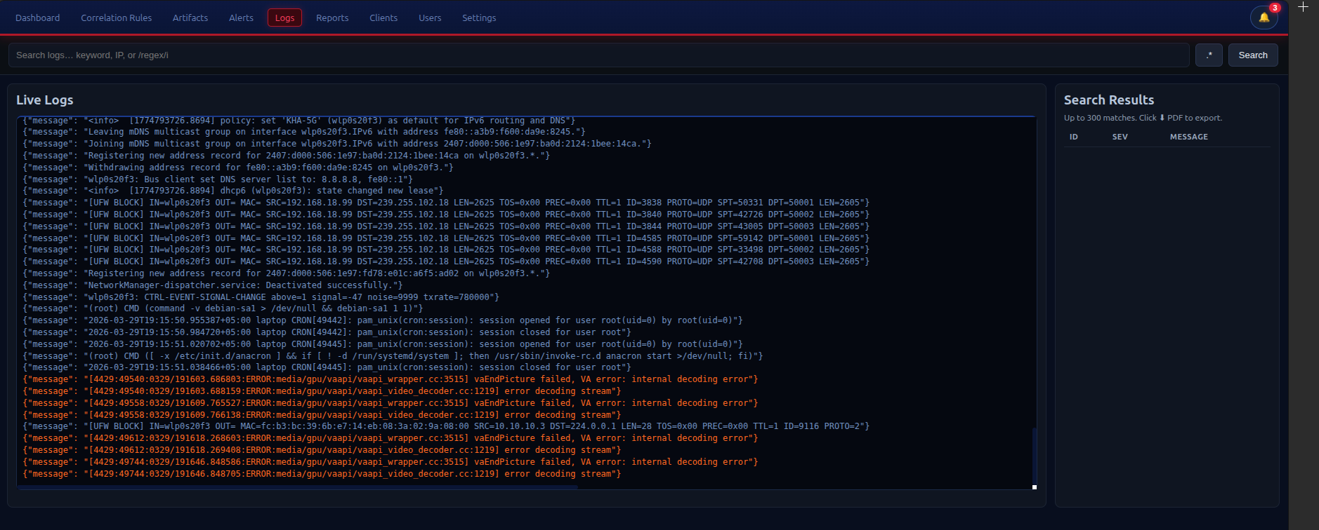
Figure 4.1: Logs page

4.1 Live Logs
When you first open the Logs page, it shows the most recent log messages in real time, newest at the top. The feed updates automatically every 3 seconds. This is the same view as the Live Logs panel on the Dashboard but with more space.

The live tail pauses automatically when you start typing in the search box, so new messages do not push your results off the screen.

4.2 Search
Type any text in the search box and press Enter or click Search. The system will search all stored log messages for lines containing your query.

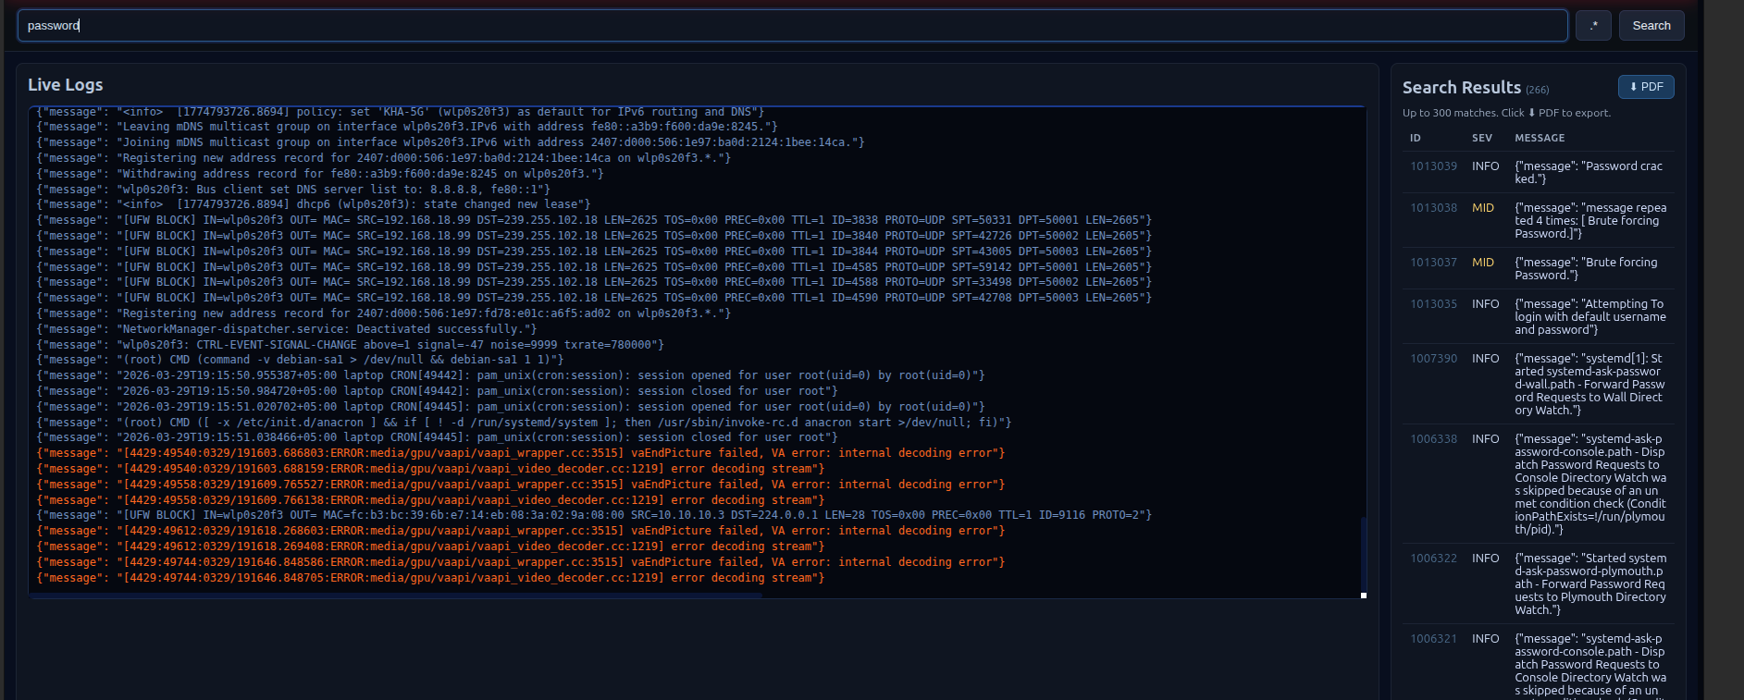
Figure 4.2: Log search results

Search supports two modes:
- Plain text: type a keyword, username, or IP address. The search uses a case-insensitive substring match. Example: "Failed password" will find all SSH login failures.
- Regular expression: click the .* button to toggle regex mode (the button turns blue when active). You can also wrap your search in forward slashes: /pattern/flags. Example: /root|admin/ finds lines mentioning either root or admin. Example with flags: /error/i for case-insensitive.

💡 Tip
To find all activity from a specific IP address, search for the IP in plain text mode. All log sources, syslog, auth, nginx, firewall, are searched together.

4.3 Exporting Logs to PDF
After running a search, click the Export PDF button to download a formatted PDF report of the results. The PDF includes:
- The OpenSIEM logo and report header on every page.
- The search query and export timestamp.
- All matched log lines in a table, with severity colour indicators.

The PDF filename includes the date and search query for easy filing, for example: opensiem-logs-2026-03-21-failed-password.pdf

5. Artifacts (IOC Management)
The Artifacts page is where you manage your Indicators of Compromise, the list of known malicious keywords, IP addresses, domain names, file hashes, or any other string that should trigger an immediate alert if it appears in a log.

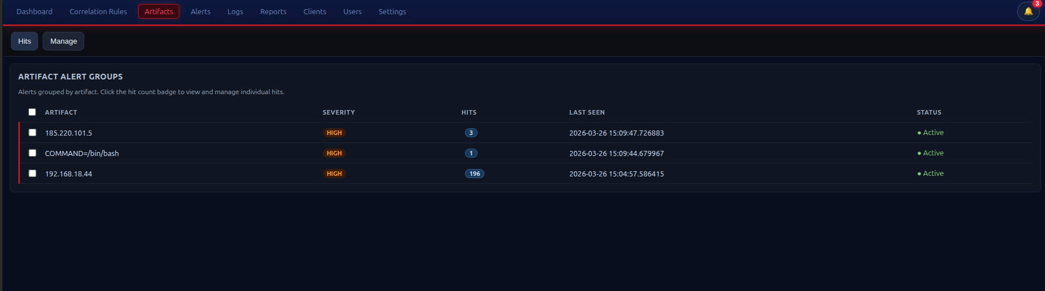
Figure 5.1: Artifacts page

The page has two tabs: Hits and Manage.

5.1 Hits Tab
The Hits tab shows every time a known artifact was seen in a log line, grouped by the artifact string. This is also the default Tab.

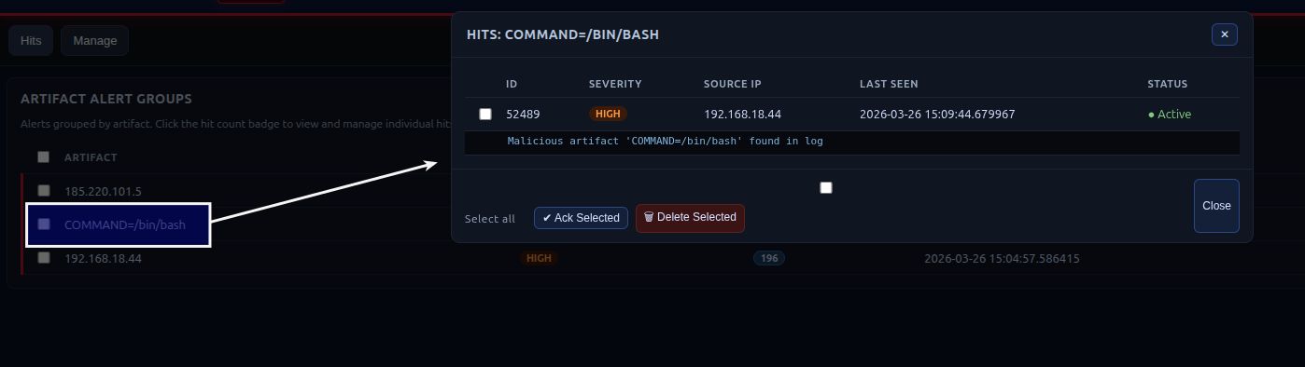
Figure 5.2: Artifacts Hits tab

Each row shows the artifact text and a badge with how many times it has been seen. Click the row to open a group detail modal showing the individual hits with timestamps, source IPs, and log context.

Inside the group detail modal you can:
- Ack Selected: acknowledge selected hit occurrences.
- Delete Selected: remove selected hit records.

5.2 Manage Tab
The Manage tab shows all artifact strings currently in the database and lets you add or remove them.

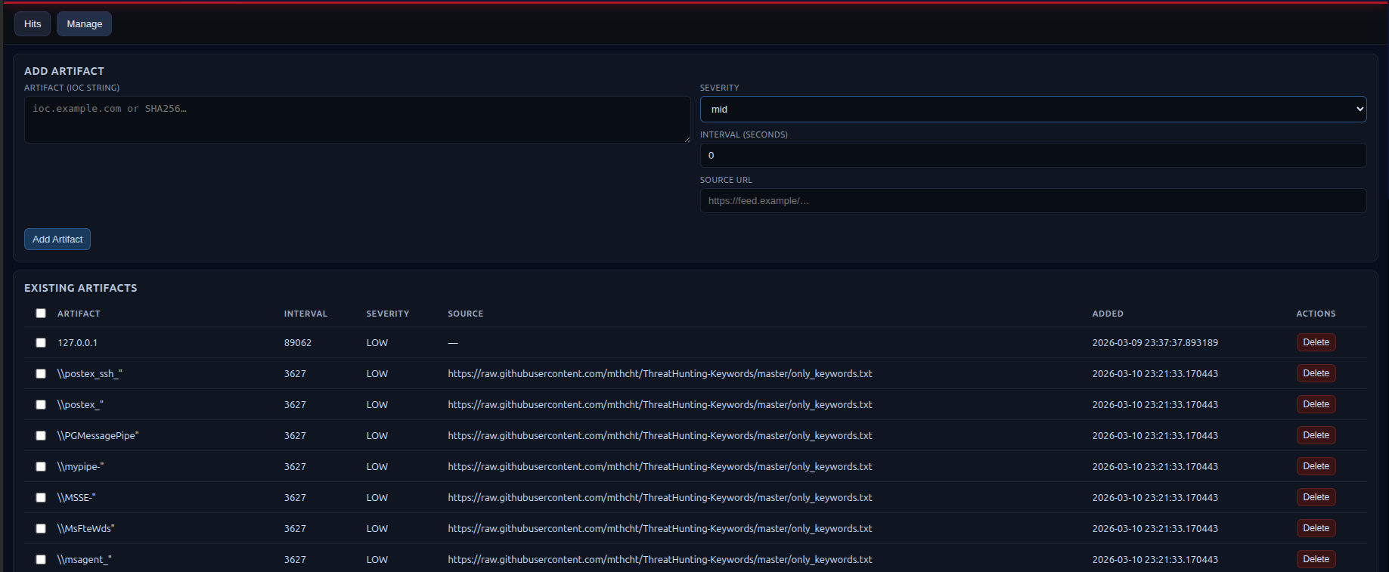
Figure 5.3: Artifacts Manage tab

Adding an Artifact
To add a new IOC:
- Click the Add Artifact button.
- Enter the artifact string. This can be an IP address, a domain name, a malicious command substring, a file hash, or any string you want to detect.
- Select the severity: Low, Medium, or High.
- Click Save. The artifact is active immediately, no restart required.

Deleting an Artifact
Click the delete button (bin icon) next to an artifact, or select multiple artifacts using the checkboxes and click Delete Selected. Deletions are permanent.

⚠ Note
Artifacts added automatically by the IOC feed updater are also managed here. Deleting them means they will not be re-imported on the next feed update because the updater uses ON CONFLICT DO NOTHING, once deleted, a feed artifact will only return if you manually re-import or if the updater is given a new source that includes it.

5.3 Artifact Severity Levels
Severity | When to use
High | Confirmed malicious: known C2 IP, malware hash, known exploit string. Should trigger immediate investigation.
Medium | Suspicious but not confirmed: scanning tool signatures, suspicious command patterns, grey-listed domains.
Low | Informational: deprecated software strings, unusual but not necessarily malicious keywords.

6. Correlation Rules
The Correlation Rules page is where you manage the detection logic at the heart of OpenSIEM. A correlation rule defines a sequence of events that, when seen together from the same source, indicate a potential attack.

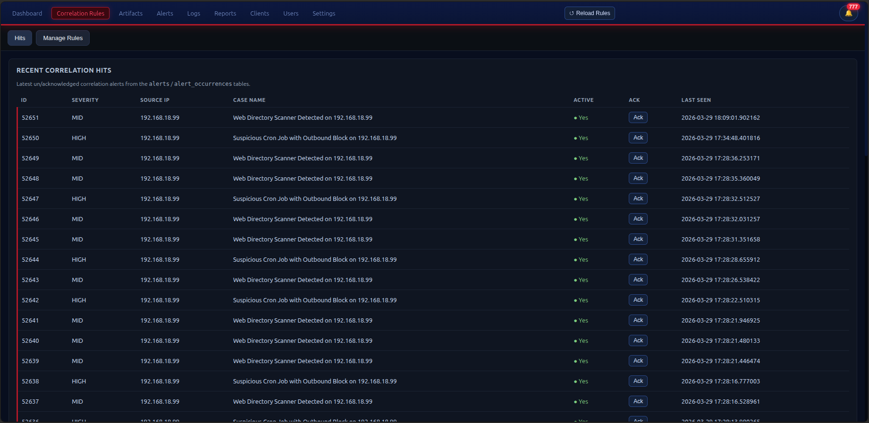
Figure 6.1: Correlation Rules page

6.1 Understanding Correlation Rules
Every rule has two parts:

- Use Case: the name and category of the scenario being detected. For example: "SSH Brute Force to Successful Login".
- Message Patterns: a list of text patterns that must all appear in log lines from the same source IP (or username). For example: "SSH login failed" followed by "SSH login accepted".

The engine checks every incoming log line against all patterns. When all patterns for a rule have been seen from the same source, the rule fires and an alert is created.

Rule concept | What it means for you
Entity field | "IP" means patterns are grouped by source IP, all events from 10.0.0.5 are compared. "User" means patterns are grouped by username, useful for detecting credential sharing across multiple hosts.
Can Repeat | Whether a pattern is allowed to appear multiple times. A brute-force pattern (Failed password) should have Can Repeat = Yes.
Order | If enabled, patterns must appear in the listed order. Useful for detecting attack sequences where step 1 must precede step 2.

6.2 Creating a New Rule
Scroll to the Create New Use Case section at the top of the page.

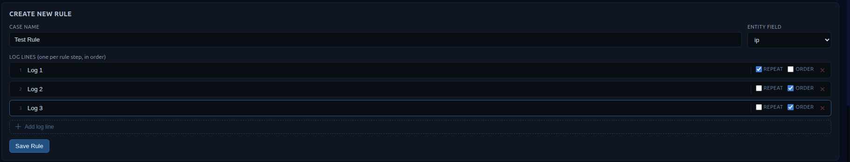
Figure 6.2: Create use case form

- Enter a descriptive Use Case Name. Be specific, you will see this name in every alert the rule generates.
- Select the Entity Field: IP (most rules) or User (for user-based correlation).
- Add each message pattern:
  - Enter the Message Text, this must be a substring of what the log parser extracts. If you are unsure, check the Logs page and find a real example of the log line you want to match, then use part of its message text.
  - Set Can Repeat and Order as appropriate.
  - Click Add Pattern to add more patterns to the rule.
- Click Save Rule.
- The rule is loaded into the correlation engine automatically, no restart is needed.

💡 Tip
Test your rule after creating it. Use the test scripts provided by your administrator, or manually generate the trigger events from a test machine using the logger command on Linux.

6.3 Editing a Rule
Existing rules are listed in the table below the create form. Click the Edit button on any rule to open the edit modal. You can change the use case name, entity field, and all message patterns. Click Save to update,the engine reloads automatically.

6.4 Deleting a Rule
Click the Delete button on a rule row. You will be asked to confirm. Deleted rules stop firing immediately. Previously generated alerts are not affected.

6.5 Pre-installed Rules
OpenSIEM comes with 13 pre-installed correlation rules covering the most common attack patterns:

Rule | What it detects
SSH Brute Force to Successful Login | Repeated SSH failures followed by a success from the same IP.
SSH Invalid User Scan | Multiple invalid-user probes: username enumeration.
Firewall Block with Continued SSH Attempt | An IP being blocked by the firewall but still attempting SSH.
SSH Login followed by Sudo Escalation | Login then immediate privilege escalation via sudo.
Database Auth Failure with Web Probe | PostgreSQL auth failure + HTTP request from same IP, SQLi recon.
Web Directory Scanner Detected | Multiple 404 errors from the same IP, automated scanner.
AppArmor Denial with OOM Kill | MAC policy violation followed by memory exhaustion, sandbox escape attempt.
MySQL Auth Failure with Web Request | MySQL failure + HTTP POST, CMS credential stuffing.
Suspicious Cron Job with Outbound Block | New cron job execution + outbound firewall block, malware persistence + C2 attempt.
Multi-Service Credential Stuffing | SSH failure + HTTP 401 from same IP, attack across multiple services.
Audit Syscall After SSH Login | SSH login followed by kernel audit syscall, post-exploitation.
Web 500 Errors with Database Error | HTTP 500 + database error from same IP, injection attack.
Repeated SELinux AVC Denial | Two SELinux policy violations from the same process, rootkit or tampered binary.

7. Reports
The Reports page generates a comprehensive security summary for a selected time period. It is designed to support management reporting, compliance documentation, and incident retrospectives.

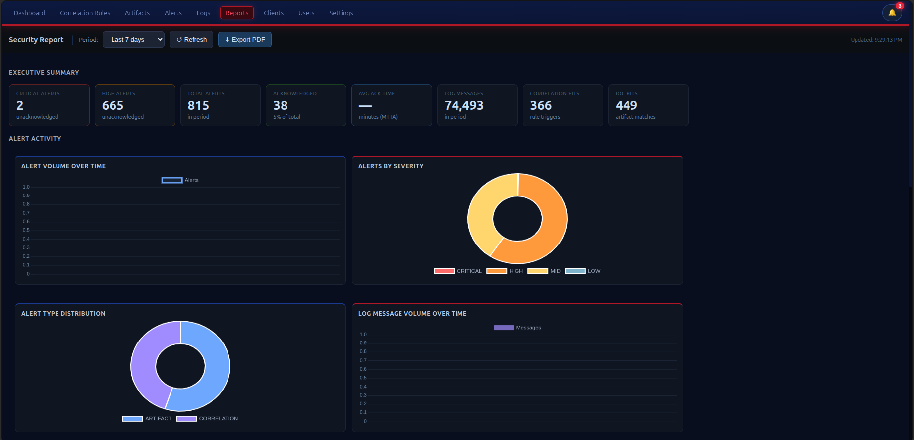
Figure 7.1: Reports page

7.1 Selecting a Time Period
Use the period selector at the top of the page to choose the reporting window: Last 24 hours, 48 hours, 7 days, 14 days, or 30 days. All metrics on the page update instantly when you change the period.

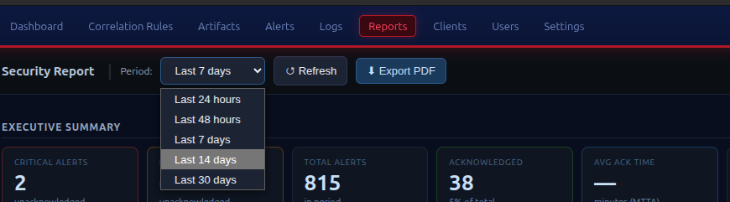
Figure 7.2: Period selector

7.2 Executive KPI Cards
The eight metric cards give you a quick summary of the period:

KPI | What it means
Total Alerts | All alerts triggered in the period, regardless of severity.
Critical Alerts | Alerts with Critical severity: these should have been investigated immediately.
High Alerts | Alerts with High severity.
Acknowledged | Alerts that a human analyst has reviewed and acknowledged.
Unacknowledged | Alerts still waiting for review. A high number here means investigation backlog.
MTTA | Mean Time to Acknowledge: average time between an alert being raised and an analyst acknowledging it. Lower is better.
Top Source IP | The IP address that generated the most alerts in the period.
Active IOC Hits | Total number of times a known malicious artifact was seen in a log line.

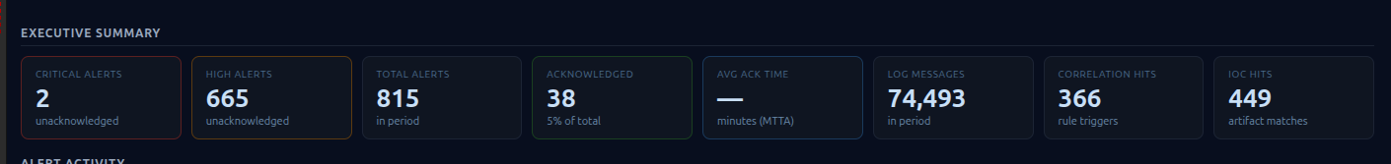
Figure 7.3: Executive KPI cards

7.3 Alert Activity Charts
Four charts show alert patterns over the period:
- Alert Volume Over Time: bar chart showing total alerts per hour or per day depending on the period selected.
- Alerts by Severity: pie chart breaking down the proportion of each severity level.
- Top Attacked Systems: bar chart of the most targeted internal IP addresses.
- Top Correlation Rule Triggers: which detection rules fired most often.

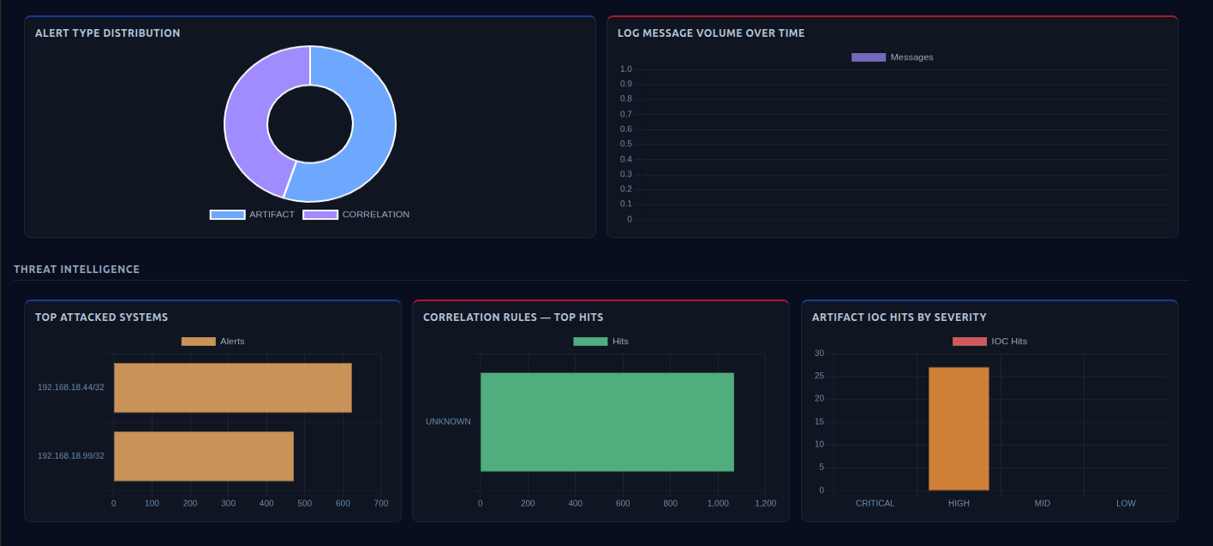
Figure 7.4: Alert activity charts

7.4 Threat Intelligence Section
The Threat Intelligence section shows:
- Top IOC Artifacts: the malicious keywords or indicators that appeared most frequently.
- Open Critical/High Alerts: a table of unacknowledged high-severity alerts, sorted by hit count.

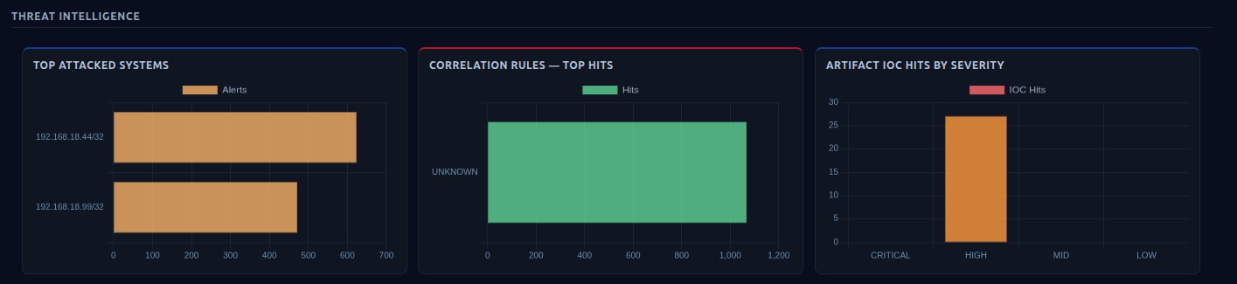
Figure 7.5: Threat intelligence section

7.5 Exporting Reports to PDF
Click Export PDF to generate a three-page branded PDF report. The PDF is structured as:
- Page 1: KPI summary grid and open critical/high alerts table.
- Page 2: Alert volume chart and severity breakdown.
- Page 3: Top attacked IPs, top rule triggers, and top IOC artifacts.

The PDF includes the OpenSIEM logo, the report period, and the generation timestamp on every page. The filename format is opensiem-report-YYYY-MM-DD-Xdays.pdf

💡 Tip
Export a report at the end of every week and save it to your incident log. Even if nothing serious happened, the report provides evidence of normal baseline behaviour for comparison during future incidents.

8. Clients
The Clients page shows real-time health information for every monitored host that has an active watcher agent connected to OpenSIEM.

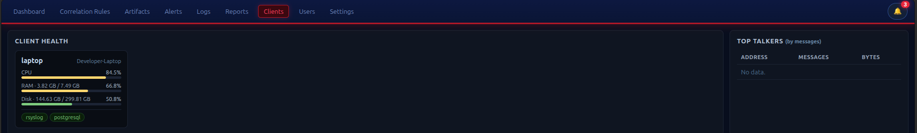
Figure 8.1: Clients page

8.1 Reading Client Cards
Each connected host appears as a card showing:

Indicator | What to look for
CPU bar | Green = normal, Yellow = above 65%, Red = above 85%. Sustained red CPU may indicate a crypto-mining infection or runaway process.
RAM bar | Same colour thresholds. Sudden RAM spike on a server that has been stable may indicate a memory injection or leak.
Disk bar | Watch for disk filling up, a full disk can stop log collection and cause the watcher to disconnect.
Service pills | Green = running, Red = stopped. If rsyslog or your database service shows red, log collection from that host may have stopped.

If a host that should be monitored is not appearing in this page, the watcher agent on that host has disconnected. Common causes: the watcher process crashed, the host was rebooted and the watcher was not configured to start automatically, or a network firewall is blocking the connection to port 11514.

9. Settings
The Settings page is for administrators only. It lets you update the system configuration without editing files on the server. Changes take effect after the relevant service is restarted (for database changes) or immediately (for email and alert settings).

⚠ Note
Settings are only accessible to users with the Admin role. If you cannot see the Settings link in the navigation bar, you do not have administrator privileges.

9.1 Database Tab
Configure the PostgreSQL database connection used by the server. Fields:
- Host: IP address or hostname of the database server (usually 127.0.0.1).
- Port: database port (default 5432).
- Database name: the name of the OpenSIEM database (default: museum).
- User: the database username.
- Password: leave blank to keep the current password unchanged.

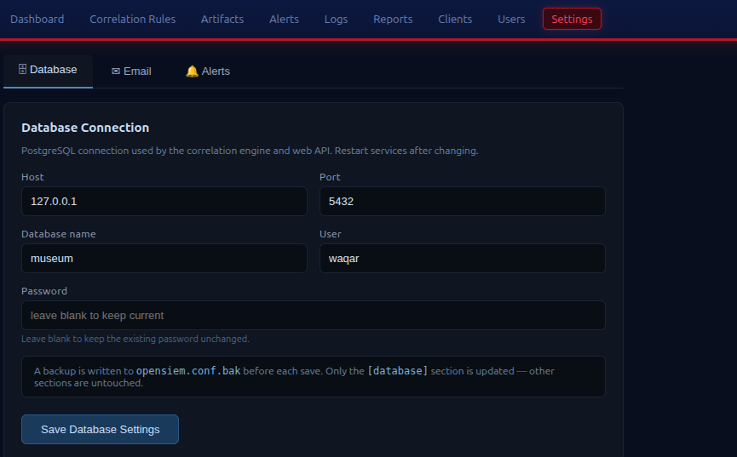
Figure 9.2: Database settings tab

⚠ Note
Incorrect database settings will prevent the web interface and correlation engine from working. If you change these settings, test the connection before restarting any services.

9.2 Email Tab
Configure SMTP settings for alert email notifications:
- Enable email notifications: master toggle. Turn this off to pause all email alerts without deleting the configuration.
- SMTP Server: your outgoing mail server address (e.g. smtp.gmail.com).
- SMTP Port: typically 587 for TLS or 465 for SSL.
- Sender Email: the "from" address for alert emails.
- Sender Password: leave blank to keep the current password unchanged.
- Admin Emails: comma-separated list of addresses that will receive alert notifications.
- Use TLS: keep this enabled unless your mail server specifically requires it off.

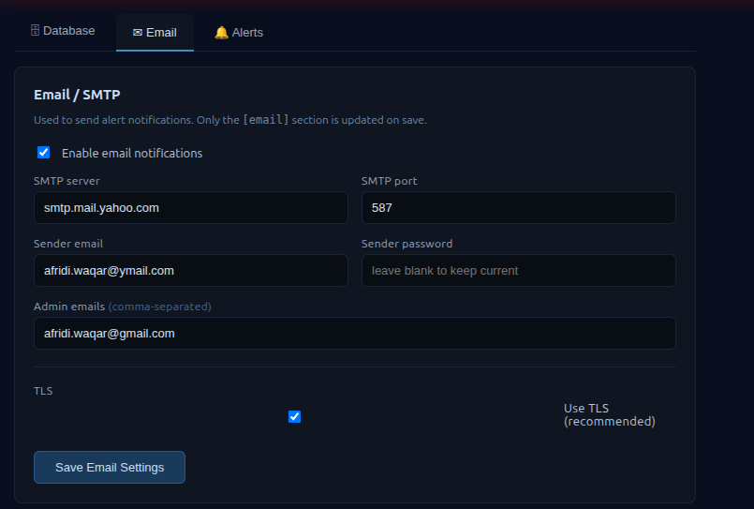
Figure 9.3: Email settings tab

9.3 Alerts Tab
Control which severity levels trigger notifications and how often:

- Email severities: click the coloured chips to toggle which severity levels send an email. For example: enable only High and Critical to avoid email noise from low-severity events.
- UI severities: which severities appear in the alert ribbon, the bell notification, and the live alert count. Typically all four levels are enabled here.
- Cooldown period: number of seconds that must pass before the same alert type fires again. Default is 300 (5 minutes). Increase this to reduce noise from repeated events; decrease it if you need faster repeated alerting.

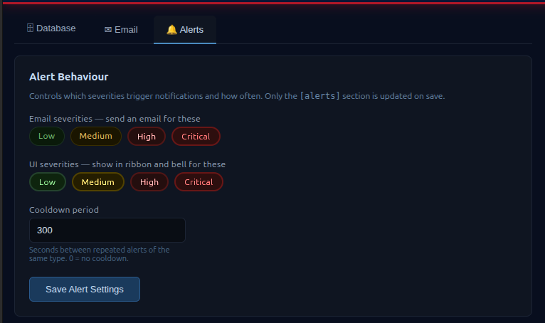
Figure 9.4: Alerts settings tab

Click the Save button for the tab you are on. Only that section of the configuration is updated, changes to Database settings do not affect Email settings, and vice versa.

10. Users
The Users page lets administrators create and manage the accounts that have access to Chronicler.

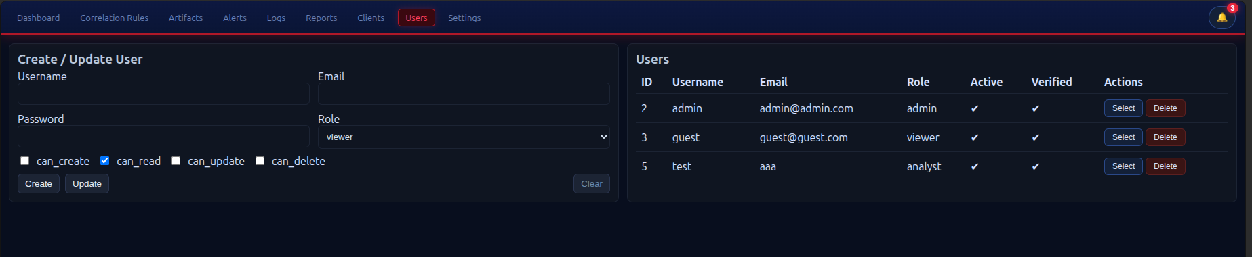
Figure 10.1: Users page

⚠ Note
Only administrators can access the Users page.

10.1 User Roles
Role | Access level
Admin | Full access: all pages, settings, user management, delete operations.
Analyst | Operational access: can view all pages, acknowledge and delete alerts, manage artifacts and correlation rules. Cannot access Settings or Users pages.
Viewer | Read-only: can view dashboards, logs, alerts, and reports but cannot make any changes.

10.2 Creating a User
- Click the Create New User button.
- Enter the username, email address, and initial password.
- Select the role (Admin, Analyst, or Viewer).
- Set the fine-grained permissions using the toggles (Create, Read, Update, Delete).
- Click Save.

The new user can log in immediately with the password you set. Ask them to change it after their first login (password change is done through the profile, if no profile page is available in v1, the administrator must update it).

10.3 Editing a User
Click the Edit button on any user row to update their details, role, or permissions. Enter a new password to change it, or leave the password field blank to keep the existing one.

10.4 Disabling a User
To prevent a user from logging in without deleting their account, set their account to inactive using the Active toggle in the edit form. Inactive users cannot log in but their historical actions (acknowledged alerts, etc.) remain in the audit trail.

11. Common Scenarios and Responses
This section walks through the most common situations you will encounter when using OpenSIEM day-to-day.

11.1 You Receive a Critical Alert
- Click the notification bell and then the alert to open it directly.
- Note the source IP and alert type.
- Go to the Logs page and search for the source IP to see what that host was doing before and after the alert.
- If the alert is confirmed malicious, add the source IP as a High-severity artifact on the Artifacts page so future connections from it are flagged immediately.
- Take remediation action on the affected system (block the IP, isolate the host, change credentials) outside of OpenSIEM.
- Acknowledge the alert in OpenSIEM and add a note explaining what you did.

11.2 The Alert Backlog is Growing
A growing unacknowledged count means alerts are being generated faster than they are being reviewed. Steps to address this:
- Filter alerts by Severity on the Alerts page and deal with Critical and High first.
- Use bulk Acknowledge for groups of similar Medium/Low alerts you have reviewed and found to be benign.
- If a specific rule is generating excessive false positives, go to the Correlation Rules page, edit the rule, and tighten the message patterns.
- If a specific source IP is generating noise and is a known-safe host, remove or refine the correlation rules that match its traffic.

11.3 A Client Disappears from the Clients Page
If a monitored host stops appearing:
- Check whether the host is still running (ping it, or connect via SSH).
- On the host, check whether the watcher process is still running: ps aux | grep watcher
- If the watcher is not running, restart it.
- If the host was rebooted, ensure the watcher is configured to start automatically on boot (contact your administrator to set this up as a systemd service).
- Check that TCP port 11514 is accessible from the host to the OpenSIEM server.

11.4 EPS Drops to Zero on the Dashboard
EPS = 0 means no logs are being received. Possible causes:
- All watcher agents have disconnected: check the Clients page.
- The OpenSIEM server process has stopped: contact your administrator.
- A network change has blocked the connection on port 11514.

Note that EPS is updated every 60 seconds by the server, a brief dip to 0 that recovers quickly may just be a timing gap between updates, not a real outage.

11.5 You Want to Add a Detection for a New Threat
- Identify the log lines that indicate the threat. Find real examples on the Logs page by searching for keywords.
- Note the exact message text as extracted by OpenSIEM (the message column in search results).
- Go to the Correlation Rules page and create a new use case with the relevant message patterns.
- Test it using the test method described in the Correlation Rules section.
- If the threat involves a specific string (malware name, IP, domain), also add it as an Artifact on the Artifacts page for immediate detection.

12. Tips and Best Practices

12.1 Daily Habits
- Check the Dashboard when you start your shift. The alert ribbon and widget strip tell you in 5 seconds whether anything needs attention.
- Review and acknowledge all Critical and High alerts daily. Do not let the backlog grow for more than 24 hours.
- Glance at the Client Health panel at least once per day. A host that has gone silent is as concerning as one generating alerts.

12.2 Weekly Habits
- Export a weekly report from the Reports page and file it. This creates a baseline that makes anomalies easier to spot over time.
- Review the Top Correlation Rule Triggers in the report. If one rule is firing far more than others, investigate whether it reflects a real threat pattern or needs tuning.
- Review the Artifacts page and remove any IOCs that are no longer relevant (old test IPs, decommissioned servers).

12.3 Reducing Alert Noise
- Use the Cooldown Period setting to prevent the same alert type from firing more than once every N minutes.
- For known-safe internal scanners (vulnerability scanners, monitoring tools), consider adjusting the correlation rules so their IPs do not trigger brute-force detections.
- If a specific artifact is generating too many false positives, reduce its severity to Low rather than deleting it, it will still be tracked but will not generate high-priority notifications.

12.4 When Something Goes Wrong
- If the dashboard shows no data but the server is running, try a hard refresh: Ctrl+Shift+R (Windows/Linux) or Cmd+Shift+R (Mac).
- If you cannot log in, contact your administrator, sessions can be cleared from the database if necessary.
- If an alert seems wrong or a rule keeps firing incorrectly, use the Logs page to find the actual log lines that triggered it, then edit the rule to be more specific.

Appendix: Quick Reference

A. Page Navigation Reference
Page | What you do there
Dashboard | Monitor real-time system health, EPS, active alert counts, live log feed, and client health.
Alerts | View, investigate, acknowledge, and delete security alerts.
Logs | Search all stored log messages; export search results to PDF.
Artifacts | Manage known-bad IOC strings; view hit history.
Correlation Rules | Create and manage detection logic (use cases and message patterns).
Reports | Generate summary reports for any time period; export to PDF.
Clients | Monitor the health of all connected watcher agents.
Settings | Configure database, email, and alert behaviour (admin only).
Users | Manage user accounts and permissions (admin only).

B. Severity Level Reference
Severity | Typical response time
Critical | Investigate immediately. Stop what you are doing.
High | Investigate within the hour.
Medium | Investigate within the day.
Low | Review during your next scheduled check. May be informational.

C. Alert Type Reference
Alert type | What caused it
correlation | A sequence of events matched a correlation rule. The alert name will tell you which rule fired.
artifact | A log line contained a known malicious IOC string from the Artifacts database.
blacklist | A connection was seen from an IP address that is in the blacklist (malicious artifacts with IP-type entries).

D. Keyboard Shortcuts
Action | Shortcut
Hard refresh page | Ctrl+Shift+R (Windows/Linux) / Cmd+Shift+R (Mac)
Open link in new tab | Ctrl+Click (Windows/Linux) / Cmd+Click (Mac)
Search in Logs page | Click the search box and press Enter after typing
Toggle regex mode | Click the .* button in the Logs search bar

