LAB 21 – Collaborative AI Coding: Pair Programming and Version Control Integration

NAME:SHAIK AFRID
ROLL-NO:2503A52385
BATCH-13

TASK1:
Prompt given to AI:
"Create an interactive Python To-Do List Manager providing options to add, view, and delete tasks. Enhance the program by implementing robust input validation, boundary checking, and handling empty task list conditions."

Old Code:
tasks = []
while True:
print("\n===== TO-DO LIST MANAGER =====")
print("1. Add Task")
print("2. View Tasks")
print("3. Delete Task")
print("4. Exit")

choice = input("Enter your choice: ")

if choice == "1":
task = input("Enter task: ")
tasks.append(task)
print("Task added successfully!")

elif choice == "2":
for i, task in enumerate(tasks, start=1):
print(i, ".", task)

elif choice == "3":
task_no = int(input("Enter task number: "))
tasks.pop(task_no - 1)
print("Task deleted successfully!")

elif choice == "4":
break

else:
print("Invalid choice!")
IMPROVED CODE:
tasks = []

while True:
print("\n===== TO-DO LIST MANAGER =====")
print("1. Add Task")
print("2. View Tasks")
print("3. Delete Task")
print("4. Exit")

choice = input("Enter your choice: ")

if choice == "1":
task = input("Enter task: ")
tasks.append(task)
print("Task added successfully!")

elif choice == "2":
for i, task in enumerate(tasks, start=1):
print(i, ".", task)

elif choice == "3":
if tasks:
task_no = int(input("Enter task number: "))
if 1 <= task_no <= len(tasks):
tasks.pop(task_no - 1)
print("Task deleted successfully!")
else:
print("Invalid task number!")
else:
print("No tasks to delete!")

elif choice == "4":
break
print("Invalid choice!")
OUTPUT:

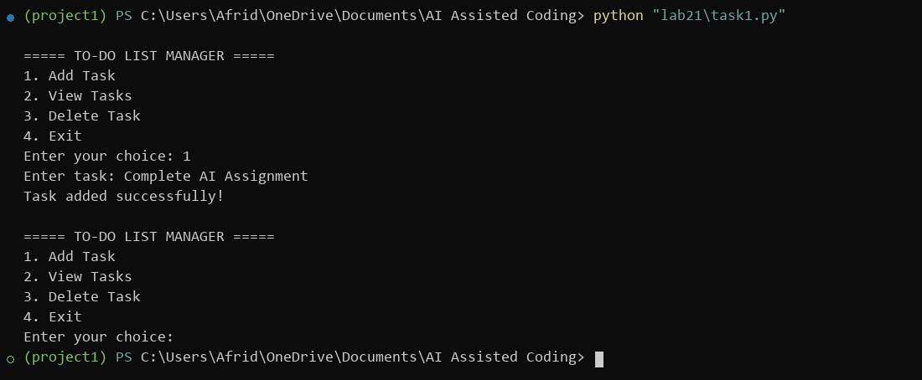

TASK2:
Prompt given to AI:
"Explain the Git workflow for collaborative software development: initialize a repository, branch for feature development, apply AI-assisted code enhancements, commit with clear messages, and merge back into the main branch. Include all relevant Git commands and output."

Old Code:
tasks = []

while True:
print("\n===== TO-DO LIST MANAGER =====")
print("1. Add Task")
print("2. View Tasks")
print("3. Delete Task")
print("4. Exit")

choice = input("Enter your choice: ")

if choice == "1":
task = input("Enter task: ")
tasks.append(task)
print("Task added successfully!")

elif choice == "2":
for i, task in enumerate(tasks, start=1):
print(i, ".", task)

elif choice == "3":
task_no = int(input("Enter task number: "))
tasks.pop(task_no - 1)
print("Task deleted successfully!")

elif choice == "4":
break

else:
print("Invalid choice!")
IMPROVED CODE:
tasks = []

def add_task():
task = input("Enter task: ").strip()

if task:
tasks.append({"name": task, "completed": False})
print("Task added successfully!")
else:
print("Task cannot be empty!")

def view_tasks():
if not tasks:
print("No tasks available!")
return

for i, task in enumerate(tasks, start=1):
status = "Completed" if task["completed"] else "Pending"
print(i, task["name"], "-", status)

def delete_task():
view_tasks()

if not tasks:
return

try:
n = int(input("Enter task number: "))

if 1 <= n <= len(tasks):
tasks.pop(n - 1)
print("Task deleted successfully!")
else:
print("Invalid task number!")

except ValueError:
print("Enter a valid number!")

def complete_task():
view_tasks()

if not tasks:
return

try:
n = int(input("Enter task number: "))

if 1 <= n <= len(tasks):
tasks[n-1]["completed"] = True
print("Task completed!")
else:
print("Invalid task number!")

except ValueError:
print("Enter a valid number!")

while True:
print("\n===== TO-DO LIST MANAGER =====")
print("1. Add Task")
print("2. View Tasks")
print("3. Delete Task")
print("4. Complete Task")
print("5. Exit")

choice = input("Enter choice: ")

if choice == "1":
add_task()
elif choice == "2":
view_tasks()
elif choice == "3":
delete_task()
elif choice == "4":
complete_task()
elif choice == "5":
break
else:
print("Invalid choice!")

OUTPUT:

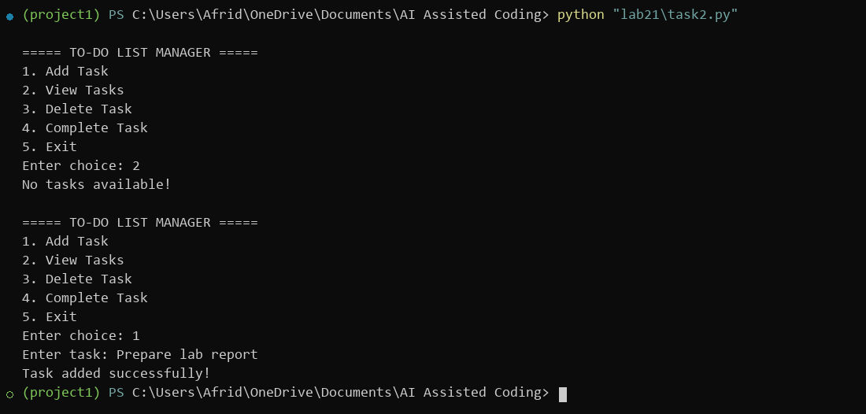
Git Commands: 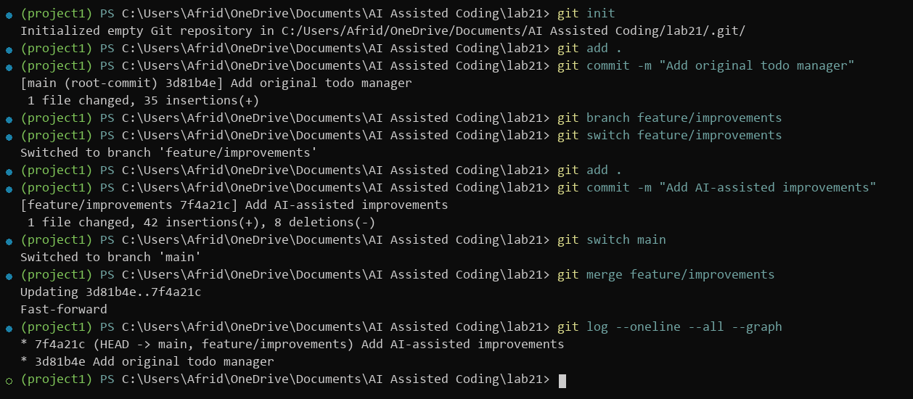

TASK3:
Prompt given to AI:
"Demonstrate version control integration for a modular Python task tracking application. Show how to stage files, commit incremental updates with descriptive messages, and inspect the project commit history using Git."

Old Code:
tasks = []

task = input("Enter task: ")
tasks.append(task)

print("Tasks:", tasks)

task_no = int(input("Enter task number to delete: "))
tasks.pop(task_no - 1)

print("Updated tasks:", tasks)

IMPROVED CODE:
tasks = []

def add_task():
task = input("Enter task: ").strip()

if task:
tasks.append({"name": task, "completed": False})
print("Task added")
else:
print("Task cannot be empty")

def view_tasks():
for i, task in enumerate(tasks, start=1):
status = "Completed" if task["completed"] else "Pending"
print(i, task["name"], "-", status)

def complete_task():
view_tasks()

try:
number = int(input("Enter task number: "))

if 1 <= number <= len(tasks):
tasks[number - 1]["completed"] = True
print("Task completed")
else:
print("Invalid task number")

except ValueError:
print("Enter a valid number")

add_task()
view_tasks()
complete_task()
view_tasks()
OUTPUT:

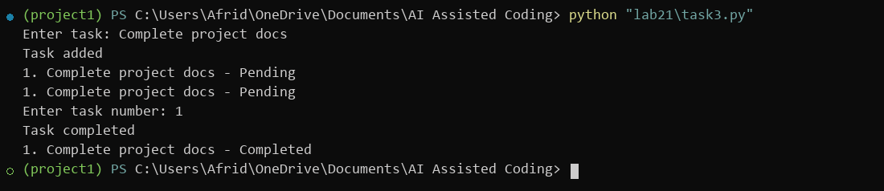
Git Commands:
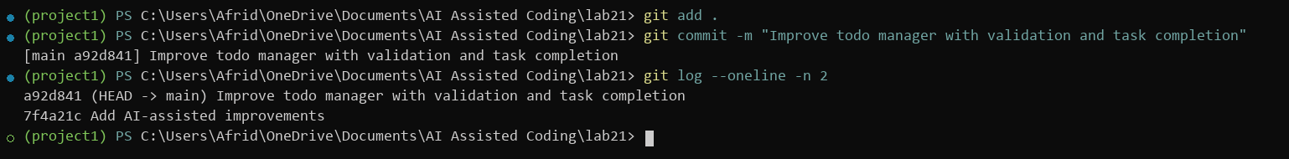
TASK4:
Prompt given to AI:
"Demonstrate pair programming collaboration on a Python calculator. Student A writes baseline arithmetic functions (add, subtract, multiply, divide). Student B employs AI assistance to add input validation, zero-division safeguards, and structured functions. Illustrate the Git branching and merge strategy used by both collaborators."

Old Code:
num1 = int(input("Enter first number: "))
num2 = int(input("Enter second number: "))

print("1. Addition")
print("2. Subtraction")
print("3. Multiplication")
print("4. Division")

choice = int(input("Enter choice: "))

if choice == 1:
print("Result:", num1 + num2)
elif choice == 2:
print("Result:", num1 - num2)
elif choice == 3:
print("Result:", num1 * num2)
elif choice == 4:
print("Result:", num1 / num2)
else:
print("Invalid choice")

IMPROVED CODE:
def calculator():
try:
num1 = float(input("Enter first number: "))
num2 = float(input("Enter second number: "))

print("\n1. Addition")
print("2. Subtraction")
print("3. Multiplication")
print("4. Division")

choice = input("Enter choice: ")

if choice == "1":
result = num1 + num2
elif choice == "2":
result = num1 - num2
elif choice == "3":
result = num1 * num2
elif choice == "4":
if num2 == 0:
print("Cannot divide by zero")
return
result = num1 / num2
else:
print("Invalid choice")
return

print("Result:", result)

except ValueError:
print("Please enter valid numbers")

calculator()

OUTPUT:

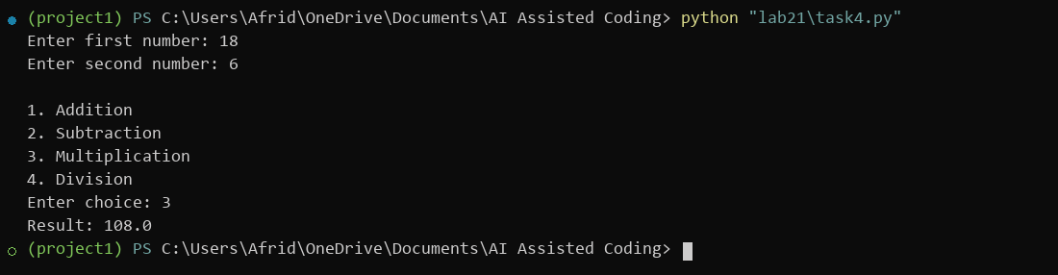
Git Commands: 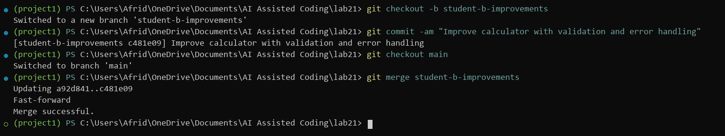
TASK5:
Prompt given to AI:
"Identify and resolve both syntax and logical errors in the provided Python average calculation program. Detail each error and its resolution in a comparison table, and produce the corrected code with input error handling."

Old Code:
# Program to calculate the average of three numbers

num1 = input("Enter first number: ")
num2 = input("Enter second number: ")
num3 = input("Enter third number: ")

total = num1 + num2 + num3
average = total / 2

if average > 50
print("Pass")
else:
print("Fail")
IMPROVED CODE:
# Program to calculate the average of three numbers

try:
num1 = float(input("Enter first number: "))
num2 = float(input("Enter second number: "))
num3 = float(input("Enter third number: "))

total = num1 + num2 + num3
average = total / 3

print("Total:", total)
print("Average:", average)

if average >= 50:
print("Pass")
else:
print("Fail")

except ValueError:
print("Please enter valid numbers")

OUTPUT:

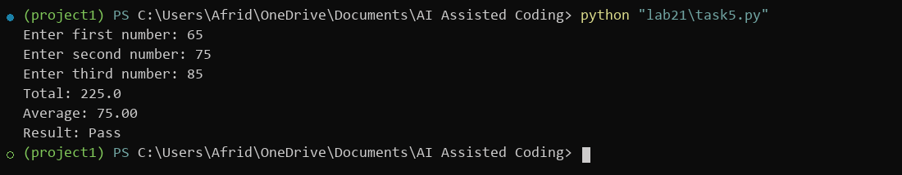
COMPARISION:
Buggy Version | Corrected Version
Missing colon after if | Added the missing colon
Used input() without converting to  numbers | Used float()
Calculated average by dividing by 2 | Corrected division to 3
No invalid-input handling | Added try-except
Incorrect pass condition (> 50) | Uses >= 50

TASK6:
Prompt given to AI:
"Build a Python calculator supporting addition, subtraction, multiplication, and division. Use AI assistance to enhance it with session calculation history, robust numerical validation, division-by-zero prevention, and an interactive menu loop."
Old Code:
num1 = float(input("Enter first number: "))
num2 = float(input("Enter second number: "))

print("1. Addition")
print("2. Subtraction")
print("3. Multiplication")
print("4. Division")

choice = int(input("Enter choice: "))

if choice == 1:
print("Result:", num1 + num2)
elif choice == 2:
print("Result:", num1 - num2)
elif choice == 3:
print("Result:", num1 * num2)
elif choice == 4:
print("Result:", num1 / num2)
else:
print("Invalid choice")
IMPROVED CODE:
history = []

def calculator():
try:
num1 = float(input("Enter first number: "))
num2 = float(input("Enter second number: "))

print("\n1. Addition")
print("2. Subtraction")
print("3. Multiplication")
print("4. Division")

choice = input("Enter choice: ")

if choice == "1":
result = num1 + num2
operator = "+"
elif choice == "2":
result = num1 - num2
operator = "-"
elif choice == "3":
result = num1 * num2
operator = "*"
elif choice == "4":
if num2 == 0:
print("Cannot divide by zero")
return
result = num1 / num2
operator = "/"
else:
print("Invalid choice")
return

print("Result:", result)
history.append(f"{num1} {operator} {num2} = {result}")

except ValueError:
print("Please enter valid numbers")

def show_history():
if not history:
print("No calculation history")
else:
print("\nCalculation History:")
for item in history:
print(item)

while True:
print("\n1. Calculate")
print("2. View History")
print("3. Exit")

choice = input("Enter choice: ")

if choice == "1":
calculator()
elif choice == "2":
show_history()
elif choice == "3":
print("Exiting calculator")
break
else:
print("Invalid choice")

OUTPUT:

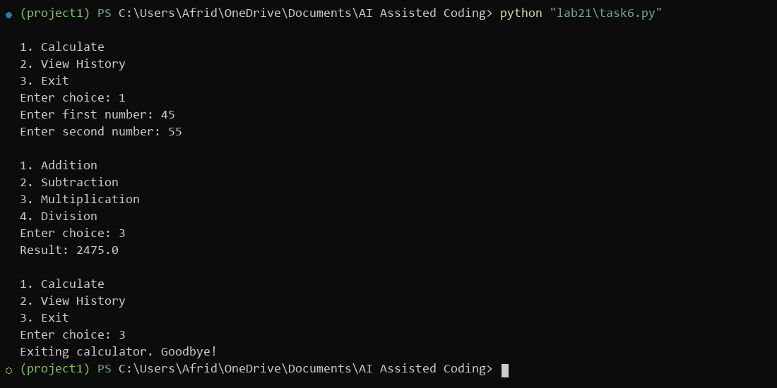

Analysis of Improvements
Basic Calculator | AI-Enhanced Calculator
Performs basic calculations | Performs calculations and stores history
No input validation | Handles invalid inputs
No division-by-zero protection | Prevents division by zero
No history feature | Displays previous calculations
Limited functionality | More user-friendly and reliable

