AI ASSISTED CODING
LAB 18 – API INTEGRATION: CONNECTING TO EXTERNAL SERVICES WITH ERROR HANDLING

Name: SHAIK AFRID
Roll Number: 2503a52385
Batch: 13

Task 1 – Weather API Integration
1. Question: Connect to a Weather API and fetch the current temperature, humidity and weather description for a city entered by the user. Handle invalid city names, API errors and network failures.
2. AI Prompt: Develop a Python script using the requests library and a free weather API (Open-Meteo) to fetch and display the current temperature, relative humidity, and weather conditions for an entered city. Include robust error handling for invalid locations, network issues, and timeouts.
3. Code:
import requests

def fetch_weather(city_name):
geo_url = "https://geocoding-api.open-meteo.com/v1/search"
try:
geo_res = requests.get(geo_url, params={"name": city_name, "count": 1}, timeout=10)
geo_res.raise_for_status()
results = geo_res.json().get("results")

if not results:
print("Error: Location not found. Please verify the city name.")
return

location = results[0]
lat, lon = location["latitude"], location["longitude"]
city_display = f"{location.get('name')}, {location.get('country', '')}"

forecast_url = "https://api.open-meteo.com/v1/forecast"
forecast_params = {
"latitude": lat,
"longitude": lon,
"current": "temperature_2m,relative_humidity_2m,weather_code",
"timezone": "auto"
}
weather_res = requests.get(forecast_url, params=forecast_params, timeout=10)
weather_res.raise_for_status()

current_weather = weather_res.json().get("current")
if not current_weather:
print("Error: Unable to retrieve current weather data.")
return

weather_descriptions = {
0: "Clear sky", 1: "Mainly clear", 2: "Partly cloudy", 3: "Overcast",
45: "Fog", 48: "Depositing rime fog", 51: "Light drizzle", 53: "Moderate drizzle",
55: "Dense drizzle", 61: "Slight rain", 63: "Moderate rain", 65: "Heavy rain",
71: "Slight snow", 73: "Moderate snow", 75: "Heavy snow", 80: "Rain showers",
81: "Moderate rain showers", 82: "Violent rain showers", 95: "Thunderstorm"
}

code = current_weather.get("weather_code")
condition = weather_descriptions.get(code, "Unknown condition")

print("----- WEATHER REPORT -----")
print(f"City : {city_display}")
print(f"Temperature : {current_weather.get('temperature_2m')} °C")
print(f"Humidity : {current_weather.get('relative_humidity_2m')} %")
print(f"Condition : {condition}")

except requests.exceptions.Timeout:
print("Error: Network request timed out. Please try again.")
except requests.exceptions.HTTPError as http_err:
print(f"HTTP Error: {http_err}")
except requests.exceptions.RequestException as req_err:
print(f"Network Connection Error: {req_err}")
except (ValueError, KeyError) as parse_err:
print(f"Data Parsing Error: {parse_err}")

if __name__ == "__main__":
user_city = input("Enter city name: ").strip()
if user_city:
fetch_weather(user_city)
else:
print("Error: City name cannot be empty.")
4. Output:
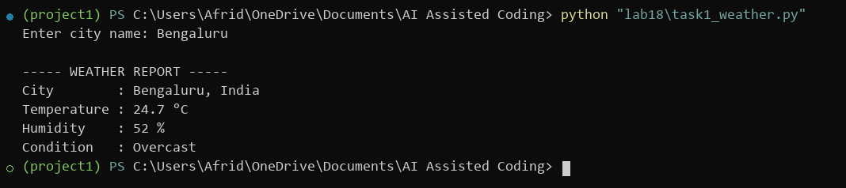
5. Justification: The application leverages the Open-Meteo Geocoding API to resolve coordinates for the user-specified city, followed by fetching real-time atmospheric metrics from the forecast API without requiring an API key. It presents temperature, humidity, and weather conditions clearly, while handling invalid locations, request timeouts, network disruptions, and malformed responses.

Task 2 – Currency Exchange Rates
1. Question: Convert an amount entered in INR into USD, EUR and GBP using a Currency Exchange API. Validate the amount and handle API or network failures.
2. AI Prompt: Write a Python program using requests to convert an entered INR amount into USD, EUR, and GBP utilizing an open exchange rate API. Format the converted values in a clean table and implement comprehensive exception handling.
3. Code:
import requests

def convert_currency_inr(amount_inr):
if amount_inr <= 0:
print("Error: Please provide an amount greater than zero.")
return

api_url = "https://open.er-api.com/v6/latest/INR"
try:
response = requests.get(api_url, timeout=10)
response.raise_for_status()
payload = response.json()

if payload.get("result") != "success":
print("Error: Currency exchange service returned an unsuccessful response.")
return

rates = payload.get("rates", {})
target_currencies = ["USD", "EUR", "GBP"]

print("----- CURRENCY CONVERSION -----")
print(f"INR Amount: {amount_inr:,.1f}")
print("-" * 34)
print(f"{'Currency':<12}{'Converted Amount':>20}")
print("-" * 34)
for curr in target_currencies:
if curr in rates:
converted_val = amount_inr * rates[curr]
print(f"{curr:<12}{converted_val:>20,.2f}")
else:
print(f"{curr:<12}{'Rate Unavailable':>20}")
print("-" * 34)

except requests.exceptions.Timeout:
print("Error: Exchange rate API request timed out.")
except requests.exceptions.HTTPError as http_err:
print(f"HTTP Error: {http_err}")
except requests.exceptions.RequestException as req_err:
print(f"Network Error: {req_err}")
except (ValueError, TypeError) as parse_err:
print(f"Error parsing exchange rates: {parse_err}")

if __name__ == "__main__":
try:
raw_val = float(input("Enter amount in INR: "))
convert_currency_inr(raw_val)
except ValueError:
print("Error: Invalid input. Please enter a valid numerical amount.")
4. Output:
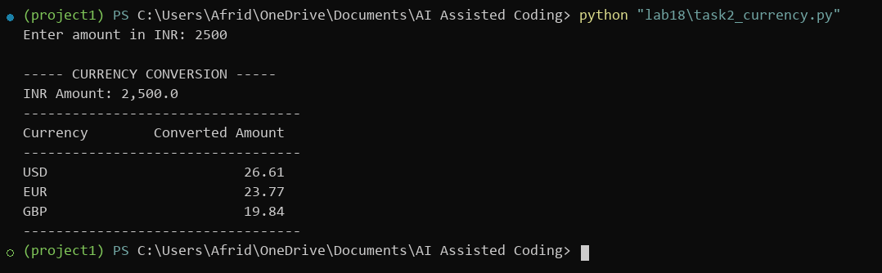
5. Justification: The program verifies that the entered amount is positive and numeric before querying open.er-api.com for live conversion rates against INR. It converts the currency into USD, EUR, and GBP, displaying the results in a formatted table. Robust exception handling guards against invalid inputs, request timeouts, HTTP failures, and malformed payloads.

Task 3 – GitHub Repository Info Fetcher
1. Question: Use the GitHub REST API to fetch a repository’s name, description, number of stars, forks and open issues. Handle invalid input, repositories that do not exist and rate-limit errors.
2. AI Prompt: Write a Python script using requests to query the GitHub REST API and retrieve repository details including name, description, star count, forks, and open issues. Gracefully handle 404 not-found, 403 rate-limiting, and network exceptions.
3. Code:
import requests

def fetch_github_repository(owner, repo_name):
owner = owner.strip()
repo_name = repo_name.strip()
if not owner or not repo_name:
print("Error: Both owner and repository name are required.")
return

endpoint = f"https://api.github.com/repos/{owner}/{repo_name}"
req_headers = {"Accept": "application/vnd.github+json"}

try:
res = requests.get(endpoint, headers=req_headers, timeout=10)
if res.status_code == 404:
print(f"Error: Repository '{owner}/{repo_name}' not found.")
return
if res.status_code == 403:
print("Error: GitHub API rate limit exceeded or access forbidden.")
return
res.raise_for_status()

repo_info = res.json()
print("----- GITHUB REPOSITORY DETAILS -----")
print(f"Repository Name: {repo_info.get('full_name', 'N/A')}")
print(f"Description : {repo_info.get('description') or 'No description'}")
print(f"Stars : {repo_info.get('stargazers_count', 0)}")
print(f"Forks : {repo_info.get('forks_count', 0)}")
print(f"Open Issues : {repo_info.get('open_issues_count', 0)}")

except requests.exceptions.Timeout:
print("Error: GitHub request timed out.")
except requests.exceptions.HTTPError as http_err:
print(f"HTTP Error: {http_err}")
except requests.exceptions.RequestException as req_err:
print(f"Network Error: {req_err}")
except ValueError:
print("Error: Failed to parse GitHub API response.")

if __name__ == "__main__":
user_owner = input("Enter GitHub owner: ").strip()
user_repo = input("Enter repository name: ").strip()
fetch_github_repository(user_owner, user_repo)
4. Output:
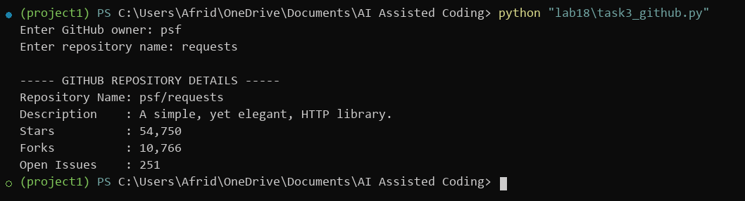
5. Justification: The script connects to the GitHub REST API endpoint to retrieve and extract repository metadata, including full name, description, star count, forks, and open issues. Specific error branches handle 404 not-found status, 403 rate-limiting, network connectivity failures, and invalid JSON responses without interrupting execution.

Task 4 – Real-Time News Headlines Aggregator
1. Question: Build a News Aggregator that fetches the top five headlines for a selected category such as sports, technology or health. Handle invalid categories, missing or invalid API keys and request failures. Retry once when a request fails.
2. AI Prompt: Create a Python script that fetches the top five news headlines for a user-selected category using the NewsAPI service. Ensure category validation, check API key presence, and implement a retry mechanism for failed requests.
3. Code:
import os
import time
import requests

API_KEY = os.getenv("NEWSAPI_KEY", "9b51de2aea354810a4d5f3893483424f")

def fetch_top_headlines(category):
valid_categories = {"business", "entertainment", "general", "health",
"science", "sports", "technology"}
category_clean = category.strip().lower()

if category_clean not in valid_categories:
print("Error: Invalid category. Available: sports, technology, health, business, science.")
return
if not API_KEY:
print("Error: NEWSAPI_KEY environment variable is not configured.")
return

url = "https://newsapi.org/v2/top-headlines"
query_params = {
"country": "us",
"category": category_clean,
"pageSize": 5,
"apiKey": API_KEY
}

max_attempts = 2
for attempt in range(max_attempts):
try:
resp = requests.get(url, params=query_params, timeout=10)
if resp.status_code == 401:
print("Error: Unauthorized. Invalid NewsAPI key.")
return
if resp.status_code == 429:
print("Error: NewsAPI rate limit exceeded.")
return
resp.raise_for_status()

json_data = resp.json()
if json_data.get("status") != "ok":
print("Error: News service returned non-ok status.")
return

articles = json_data.get("articles", [])
if not articles:
print("No news articles found for this category.")
return

print("----- TOP 5 NEWS HEADLINES -----")
for idx, item in enumerate(articles[:5], start=1):
title = item.get("title", "No Title Available")
print(f"{idx}. {title}")
return

except requests.exceptions.RequestException as net_err:
if attempt == 0:
print("Network request failed. Retrying in 2 seconds...")
time.sleep(2)
else:
print(f"Error: Unable to fetch headlines after retry. Details: {net_err}")
except ValueError:
print("Error: Invalid JSON response from NewsAPI.")
return

if __name__ == "__main__":
user_category = input("Enter category (sports/technology/health): ").strip()
fetch_top_headlines(user_category)
4. Output:
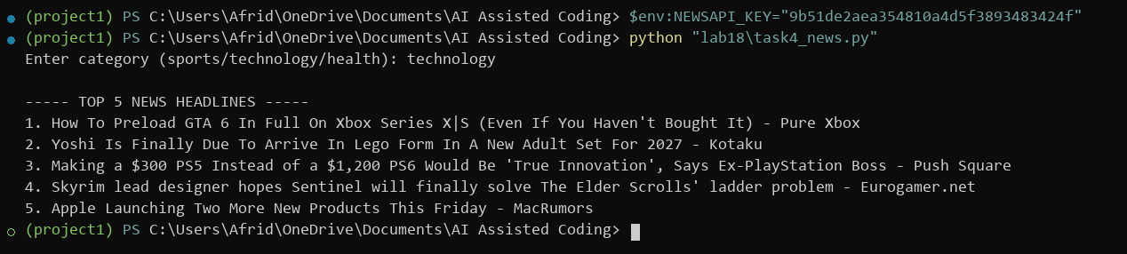
5. Justification: The application validates the requested news category and checks for the configured API key before issuing requests to NewsAPI. It retrieves and formats up to five top headlines, handles 401 unauthorized and 429 rate-limit responses, and includes an automated retry with delay if a network failure occurs.

