Lab 11 – Data Structures with AI: Implementing Fundamental Structures

Name: SHAIK AFRID
Roll no:2503a52385
Batch-13

Task 1 – Stack Implementation

1. Question
Use AI to generate a Stack class with push, pop, peek, and is_empty methods.

2.Prompt:
Complete this Python Stack class for a beginner data structures lab. Add push(), pop(), peek(), and is_empty(), handle an empty stack, include short docstrings/comments, and add a small test section.

3. Code:
class Stack:
"""A simple Stack implementation using a Python list."""
def __init__(self):
"""Initialize an empty stack."""
self.items = []
def push(self, item):
"""Add an item to the top of the stack."""
self.items.append(item)
def pop(self):
"""Remove and return the top item."""
if self.is_empty():
return None
return self.items.pop()
def peek(self):
"""Return the top item without removing it."""
if self.is_empty():
return None
return self.items[-1]
def is_empty(self):
"""Check whether the stack is empty."""
return len(self.items) == 0
# Testing the Stack
stack = Stack()
stack.push(10)
stack.push(20)
stack.push(30)
print("Stack:", stack.items)
print("Top element:", stack.peek())
print("Removed element:", stack.pop())
print("Stack after pop:", stack.items)
print("Is stack empty?", stack.is_empty())

4. Output :
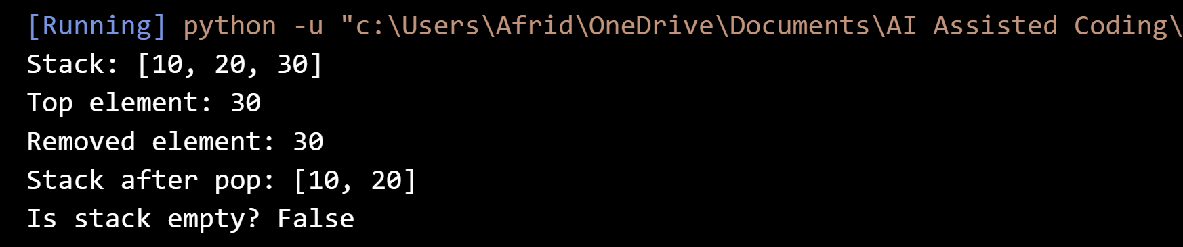

5. Final Justification
The Stack was implemented successfully with the required methods. It follows the LIFO principle and was tested with sample operations.

Task 2 – Queue Implementation

1. Question
Use AI to implement a Queue using Python lists.

2. Prompt:
Complete this Python Queue class using a list. Add enqueue(), dequeue(), peek(), and size(), follow FIFO, handle an empty queue, and add short comments plus a small test section.

3. Code
class Queue:
"""A simple Queue implementation using a Python list."""

def __init__(self):
"""Initialize an empty queue."""
self.items = []

def enqueue(self, item):
"""Add an item to the rear of the queue."""
self.items.append(item)

def dequeue(self):
"""Remove and return the front item."""
if self.size() == 0:
return None
return self.items.pop(0)

def peek(self):
"""Return the front item without removing it."""
if self.size() == 0:
return None
return self.items[0]

def size(self):
"""Return the number of items in the queue."""
return len(self.items)

# Testing the Queue
queue = Queue()

queue.enqueue(10)
queue.enqueue(20)
queue.enqueue(30)

print("Queue:", queue.items)
print("Front element:", queue.peek())
print("Removed element:", queue.dequeue())
print("Queue after dequeue:", queue.items)
print("Queue size:", queue.size())

4. Output Screenshot:
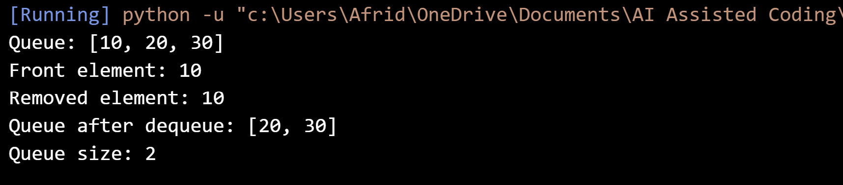

5. Final Justification
The Queue was implemented using a Python list and tested with sample operations. It follows the FIFO principle as required.
Task 3 – Linked List

1. Question
Use AI to generate a Singly Linked List with insert and display methods.

2. Prompt
Create a beginner-friendly singly linked list in Python with Node and LinkedList classes. Add insert() and display(), with short comments/docstrings and a small test section.

3. Code
class Node:
"""Represents one node in the linked list."""

def __init__(self, data):
"""Initialize a node with data."""
self.data = data
self.next = None

class LinkedList:
"""A simple singly linked list."""

def __init__(self):
"""Initialize an empty linked list."""
self.head = None

def insert(self, data):
"""Insert a new node at the end of the list."""
new_node = Node(data)

if self.head is None:
self.head = new_node
return

current = self.head

while current.next is not None:
current = current.next

current.next = new_node

def display(self):
"""Display all elements in the linked list."""
current = self.head

while current is not None:
print(current.data, end=" -> ")
current = current.next

print("None")

# Testing the Linked List
linked_list = LinkedList()

linked_list.insert(10)
linked_list.insert(20)
linked_list.insert(30)

print("Linked List:")
linked_list.display()

4. Output :
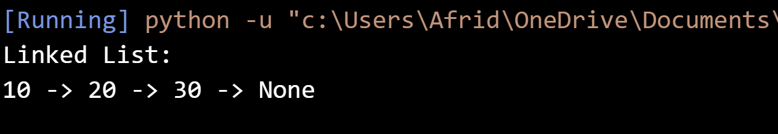

5. Final Justification
The singly linked list was implemented with nodes connected through next references. Insert and display operations were tested successfully.

Task 4 – Binary Search Tree (BST)

1. Question
Use AI to create a BST with insert and in-order traversal methods.

2. GitHub Copilot Prompt
Create a beginner-friendly Python BST with recursive insert() and in-order traversal. Add short comments/docstrings and test it with sample values.

3. Code
class Node:
"""Represents a node in the Binary Search Tree."""

def __init__(self, data):
"""Initialize a BST node."""
self.data = data
self.left = None
self.right = None

class BST:
"""A simple Binary Search Tree."""

def __init__(self):
"""Initialize an empty BST."""
self.root = None

def insert(self, data):
"""Insert data into the BST."""
self.root = self._insert_recursive(self.root, data)

def _insert_recursive(self, node, data):
"""Recursively insert data into the correct position."""

if node is None:
return Node(data)

if data < node.data:
node.left = self._insert_recursive(node.left, data)

elif data > node.data:
node.right = self._insert_recursive(node.right, data)

return node

def in_order(self):
"""Perform and display an in-order traversal."""
self._in_order_recursive(self.root)
print()

def _in_order_recursive(self, node):
"""Recursively visit left, root, and right."""
if node is not None:
self._in_order_recursive(node.left)
print(node.data, end=" ")
self._in_order_recursive(node.right)

# Testing the BST
tree = BST()

values = [50, 30, 70, 20, 40, 60, 80]

for value in values:
tree.insert(value)

print("In-order traversal:")
tree.in_order()

4. Output :
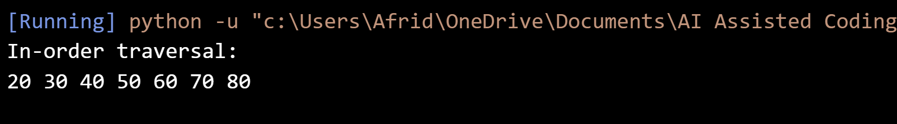

5. Final Justification
The BST was implemented using recursive insertion and in-order traversal. The traversal produced the values in sorted order.

Task 5 – Priority Queue

1. Question
Use AI to implement a priority queue using Python's heapq module.

2. Prompt
Create a simple Python PriorityQueue using heapq. Implement enqueue(priority), dequeue(), and display(), handle an empty queue, and add short comments plus tests.

3. Code:
import heapq

class PriorityQueue:
"""A simple Priority Queue using heapq."""

def __init__(self):
"""Initialize an empty priority queue."""
self.queue = []

def enqueue(self, item, priority):
"""Add an item with a priority."""
# Negative priority makes larger numbers come out first.
heapq.heappush(self.queue, (-priority, item))

def dequeue(self):
"""Remove and return the highest-priority item."""
if len(self.queue) == 0:
return None

priority, item = heapq.heappop(self.queue)
return item

def display(self):
"""Display all items in the priority queue."""
print("Priority Queue:", self.queue)

# Testing the Priority Queue
pq = PriorityQueue()

pq.enqueue("Normal Task", 1)
pq.enqueue("Important Task", 3)
pq.enqueue("Urgent Task", 5)

pq.display()

print("Removed:", pq.dequeue())
print("Removed:", pq.dequeue())
print("Removed:", pq.dequeue())

4. Output
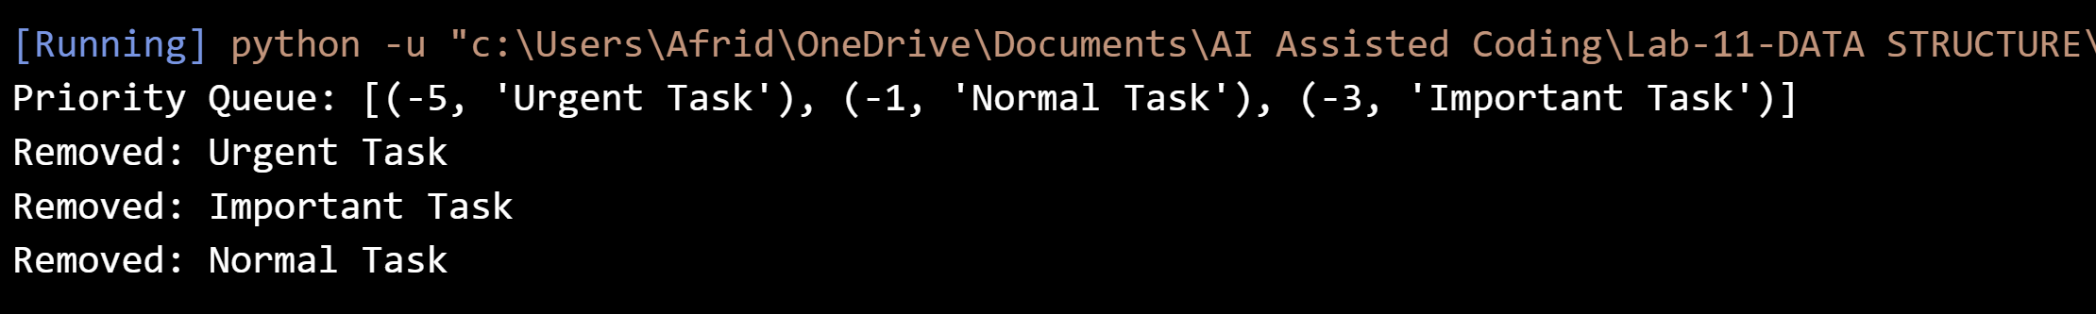

5. Final Justification
The Priority Queue was implemented using Python's heapq module. Items were inserted and removed according to their assigned priority.
Task 6 – Deque

1. Question
Use AI to implement a double-ended queue using collections.deque.

2. Prompt
Create a beginner-friendly DequeDS class using collections.deque. Implement insertion and removal from both ends, display(), empty handling, and short comments/docstrings.

3. Code:
from collections import deque

class DequeDS:
"""A double-ended queue using collections.deque."""

def __init__(self):
"""Initialize an empty deque."""
self.items = deque()

def insert_front(self, item):
"""Insert an item at the front."""
self.items.appendleft(item)

def insert_rear(self, item):
"""Insert an item at the rear."""
self.items.append(item)

def remove_front(self):
"""Remove and return the front item."""
if len(self.items) == 0:
return None
return self.items.popleft()

def remove_rear(self):
"""Remove and return the rear item."""
if len(self.items) == 0:
return None
return self.items.pop()

def display(self):
"""Display the deque."""
print("Deque:", list(self.items))

# Testing the Deque
d = DequeDS()

d.insert_front(10)
d.insert_rear(20)
d.insert_front(5)

d.display()

print("Removed from front:", d.remove_front())
print("Removed from rear:", d.remove_rear())

d.display()

4. Output :
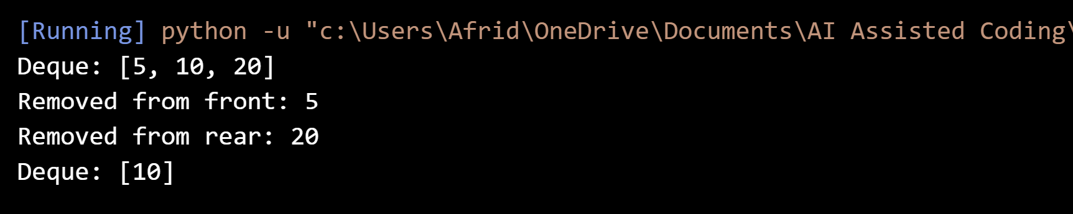

5. Final Justification
The Deque was implemented using collections.deque and tested from both ends. It supports insertion and removal at the front and rear.

Task 7 – Real-Time Application Challenge – Choose the Right Data Structure

1. Question
For the Campus Resource Management System, select a suitable data structure for each feature, justify each choice briefly, and implement one feature.

2. Prompt
For the five Campus Resource Management features, choose a suitable data structure and give a short justification for each. Then implement one selected feature as a simple Python program with comments.

3. Code:
class CafeteriaQueue:
"""Queue for managing cafeteria orders."""

def __init__(self):
"""Initialize an empty order queue."""
self.orders = []

def add_order(self, student_name, food):
"""Add a student's order to the queue."""
order = f"{student_name} - {food}"
self.orders.append(order)
print("Order added:", order)

def serve_order(self):
"""Serve the first order in the queue."""
if len(self.orders) == 0:
print("No orders to serve.")
return

order = self.orders.pop(0)
print("Order served:", order)

def display_orders(self):
"""Display all pending orders."""
if len(self.orders) == 0:
print("No pending orders.")
else:
print("Pending Orders:")
for order in self.orders:
print(order)

# Testing the Cafeteria Order Queue
cafeteria = CafeteriaQueue()

cafeteria.add_order("Rahul", "Burger")
cafeteria.add_order("Priya", "Pizza")
cafeteria.add_order("Arjun", "Sandwich")

print()

cafeteria.display_orders()

print()

cafeteria.serve_order()

print()

cafeteria.display_orders()

4. Output :
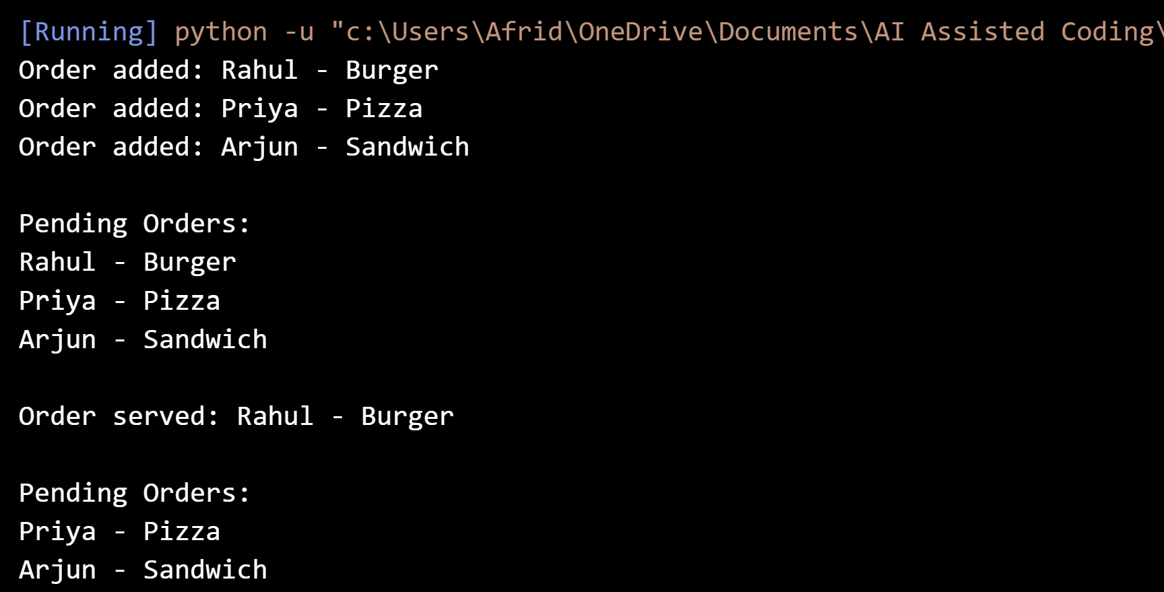

5. Final Justification
Suitable data structures were selected for the campus features based on their required operations. One feature was implemented as a working Python program with AI assistance.

Task 8 – Smart E-Commerce Platform – Data Structure Challenge

1. Question
For the Smart Online Shopping System, select a suitable data structure for each feature, justify each choice briefly, and implement one feature.

2. Prompt
For the five e-commerce features, choose a suitable data structure and give a short justification for each. Then implement one selected feature as a simple Python program with comments.

3. Code
class OrderQueue:
"""Queue for processing e-commerce orders."""

def __init__(self):
"""Initialize an empty order queue."""
self.orders = []

def add_order(self, order_id, customer):
"""Add a new order to the queue."""
order = f"{order_id} - {customer}"
self.orders.append(order)
print("Order added:", order)

def process_order(self):
"""Process the first order in the queue."""
if len(self.orders) == 0:
print("No orders to process.")
return

order = self.orders.pop(0)
print("Order processed:", order)

def display_orders(self):
"""Display all pending orders."""
if len(self.orders) == 0:
print("No pending orders.")
else:
print("Pending Orders:")
for order in self.orders:
print(order)

# Testing the Order Queue
order_queue = OrderQueue()

order_queue.add_order("ORD001", "Rahul")
order_queue.add_order("ORD002", "Priya")
order_queue.add_order("ORD003", "Arjun")

print()

order_queue.display_orders()

print()

order_queue.process_order()

print()

order_queue.display_orders()

4. Output
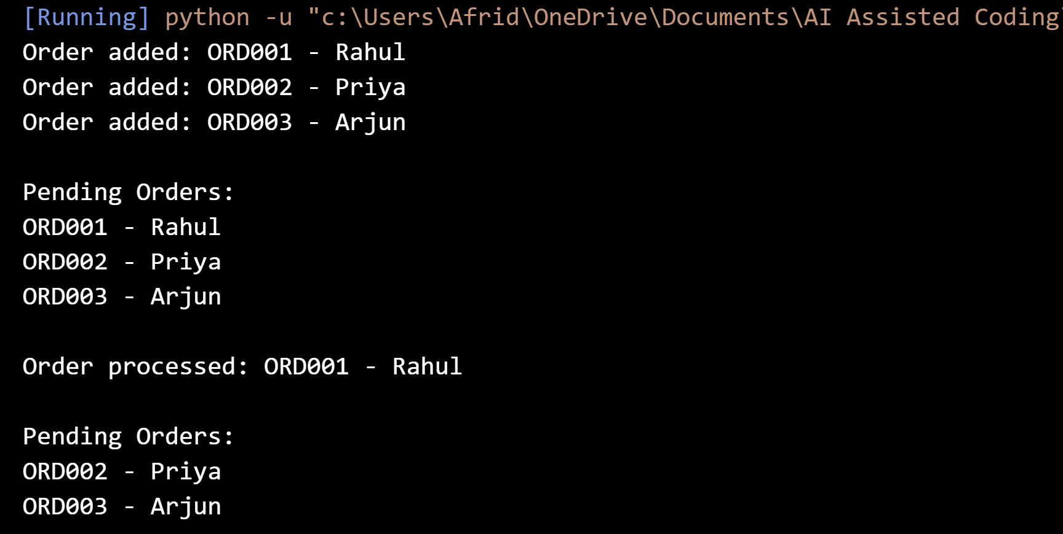

5. Final Justification
Suitable data structures were selected for the e-commerce features according to their operations. One feature was implemented as a working Python program with AI assistance.

Task 7 – Campus Resource Management: Data Structure Selection
Campus Feature | Data Structure | Reason
Student Attendance Tracking | Queue | Students can be processed in the order they enter the campus.
Event Registration | Hash Table | It provides fast search using a student or participant ID.
Library Book Borrowing | Priority Queue | Borrowing requests can be handled according to due dates or priority.
Bus Scheduling | Graph | Bus stops and routes can be represented as connected nodes and edges.
Cafeteria Order Queue | Queue | Orders are served in the same order in which students place them.

Task 8 – Smart E-Commerce Platform: Data Structure Selection
E-Commerce Feature | Data Structure | Reason
Shopping Cart Management | Deque | Products can be added or removed efficiently from either end.
Order Processing System | Queue | Orders are processed in the same order in which they are placed.
Top-Selling Products Tracker | Priority Queue | Products can be handled according to their sales priority.
Product Search Engine | Hash Table | Product IDs can be used for fast lookup.
Delivery Route Planning | Graph | Warehouses and delivery locations can be represented as connected nodes.

