Lab 17 – AI for Data Processing

Name: SHAIK AFRID

Roll.no:2503A52385

Batch:13
Task 1 – Customer Data Cleaning
Task:
Use AI to generate a Python script for cleaning a customer
Prompt:
Generate a Python script using Pandas to clean the customer dataset. Handle missing values in age, income, and city, remove duplicate records, convert city names to lowercase, and encode gender and city categorical variables.
Code:

import pandas as pd

# Load dataset
data = pd.read_csv("shopping_trends.csv")

print("Original Dataset:")
print(data.head())

# Handle missing values
data['Age'] = data['Age'].fillna(data['Age'].median())

# Handle Income if available
if 'Income' in data.columns:
data['Income'] = data['Income'].fillna(data['Income'].median())

# Use Location as City
if 'Location' in data.columns:
data['Location'] = data['Location'].fillna(data['Location'].mode()[0])
data['Location'] = data['Location'].str.lower().str.strip()

# Remove duplicate records
data = data.drop_duplicates()

# Encode categorical variables
data['Gender'] = data['Gender'].astype('category').cat.codes

if 'Location' in data.columns:
data['Location'] = data['Location'].astype('category').cat.codes

# Display cleaned dataset
print("\nCleaned Dataset:")
print(data.head())

# Check missing values
print("\nMissing Values:")
print(data.isnull().sum())

# Save cleaned dataset
data.to_csv("cleaned_customer_data.csv", index=False)

print("\nData Cleaning Completed Successfully!")
Output:
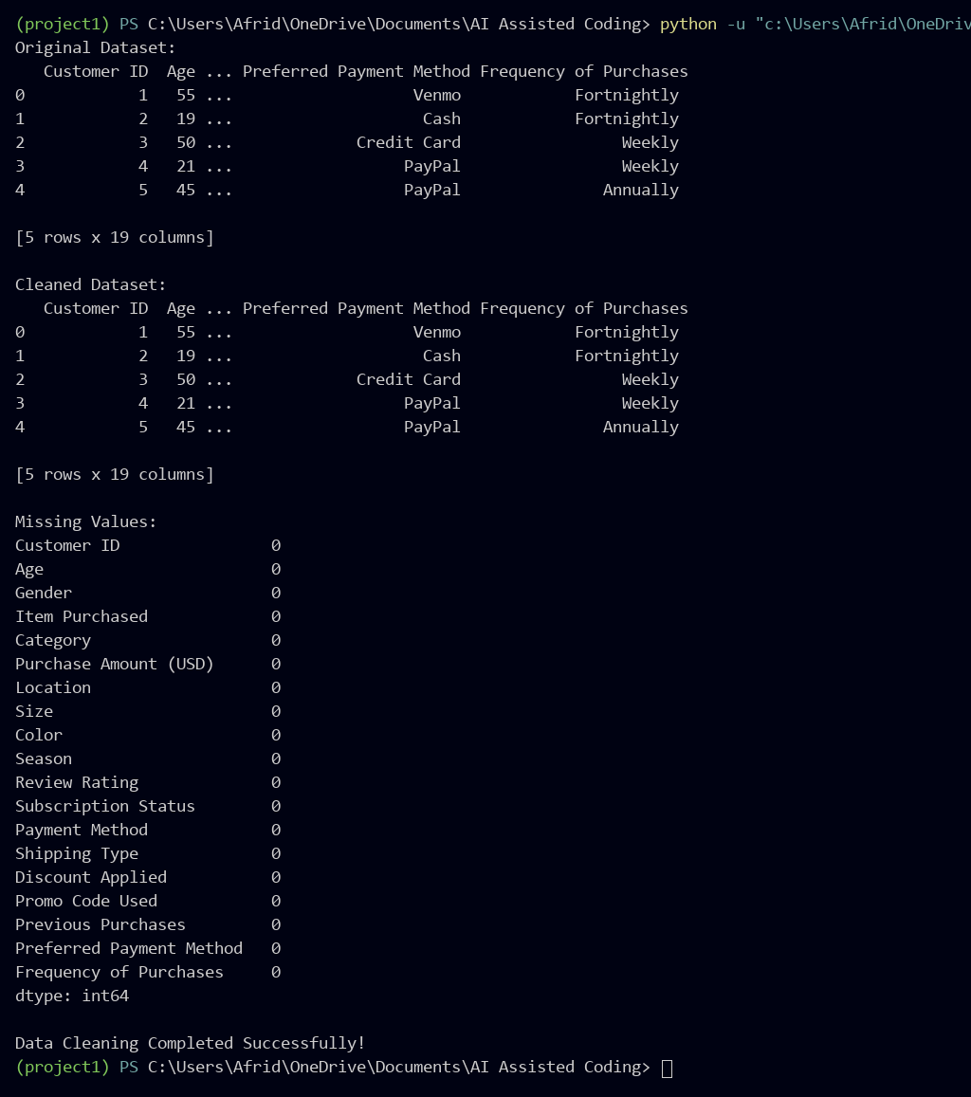
Justification:
Cleaned the customer dataset by handling missing values, removing duplicates, standardizing city names, and encoding categorical variables using Pandas.

Task 2 – Sales Data Preprocessing
Task:
Preprocess sales transaction data using AI assistance.
Prompt:
Generate a Python script using Pandas to preprocess sales data. Convert date columns into datetime format, create month, year, and day-of-week features, normalize the sales amount column, and detect and handle outliers.
Code:

import pandas as pd

# Load dataset
data = pd.read_csv("sales_data.csv")

print("Original Dataset:")
print(data.head())

# Convert Sale_Date into datetime format
data['Sale_Date'] = pd.to_datetime(data['Sale_Date'])

# Create new date features
data['Month'] = data['Sale_Date'].dt.month
data['Year'] = data['Sale_Date'].dt.year
data['Day_of_Week'] = data['Sale_Date'].dt.dayofweek

# Normalize Sales Amount
sales_column = 'Sales_Amount'

data[sales_column] = data[sales_column].fillna(
data[sales_column].median()
)

min_value = data[sales_column].min()
max_value = data[sales_column].max()

if max_value != min_value:
data['Normalized_Sales'] = (
(data[sales_column] - min_value) /
(max_value - min_value)
)
else:
data['Normalized_Sales'] = 0

# Detect and remove outliers using IQR
Q1 = data[sales_column].quantile(0.25)
Q3 = data[sales_column].quantile(0.75)
IQR = Q3 - Q1

data = data[
(data[sales_column] >= Q1 - 1.5 * IQR) &
(data[sales_column] <= Q3 + 1.5 * IQR)
]

# Display preprocessed dataset
print("\nPreprocessed Dataset:")
print(data.head())

# Save processed dataset
data.to_csv("cleaned_sales_data.csv", index=False)

print("\nSales Data Preprocessing Completed Successfully!")
Output:
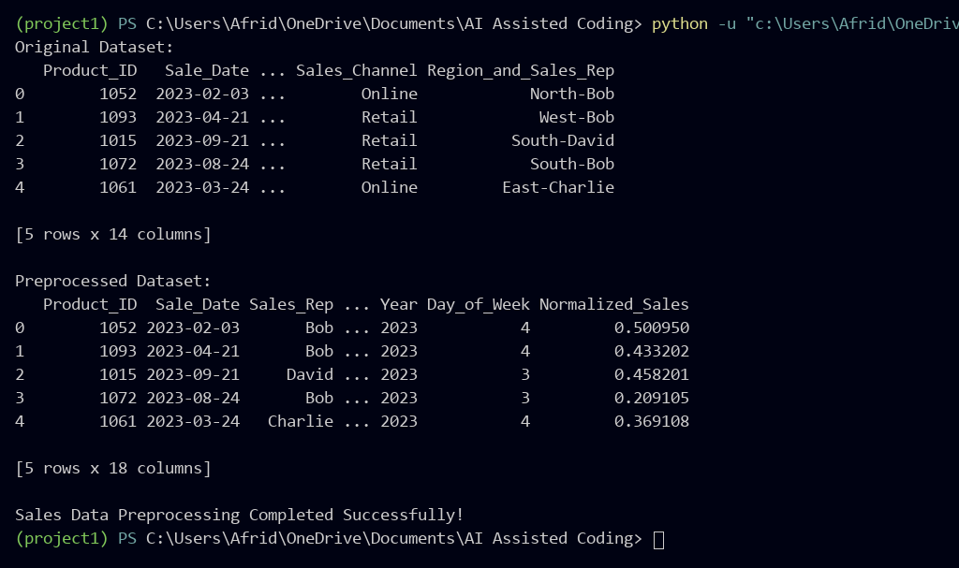
Justification:
Preprocessed the sales dataset by converting dates into datetime format, creating month, year, and day-of-week features, normalizing sales amounts, and handling outliers using the IQR method.
Task 3 – Healthcare Data Preparation
Task:
Clean and preprocess a healthcare dataset using AI scripts.
Prompt:
Generate a Python script using Pandas and scikit-learn to prepare the healthcare dataset. Handle missing values in blood_pressure and cholesterol, encode categorical features, scale numerical features using Min-Max scaling, and split the dataset into training and testing sets.
Code:

import pandas as pd
from sklearn.preprocessing import LabelEncoder, MinMaxScaler
from sklearn.model_selection import train_test_split

# Load dataset
data = pd.read_csv("dirty_v3_path.csv")

print("Original Dataset:")
print(data.head())

# Remove unnecessary noise columns
data = data.drop(columns=["random_notes", "noise_col"], errors="ignore")

# Handle missing values
for col in data.columns:
if pd.api.types.is_numeric_dtype(data[col]):
data[col] = data[col].fillna(data[col].median())
else:
if not data[col].mode().empty:
data[col] = data[col].fillna(data[col].mode()[0])

# Encode categorical columns
encoder = LabelEncoder()

for col in data.select_dtypes(include=["object", "string"]).columns:
data[col] = encoder.fit_transform(data[col].astype(str))

# Display dataset columns
print("\nDataset Columns:")
print(data.columns.tolist())

# Separate features and target
X = data.iloc[:, :-1]
y = data.iloc[:, -1]

# Scale numerical features
scaler = MinMaxScaler()
X_scaled = scaler.fit_transform(X)

# Split into training and testing sets
X_train, X_test, y_train, y_test = train_test_split(
X_scaled, y, test_size=0.2, random_state=42
)

# Display results
print("\nTraining Data Shape:", X_train.shape)
print("Testing Data Shape:", X_test.shape)

print("\nPreprocessed Dataset:")
print(data.head())

# Save cleaned dataset
data.to_csv("cleaned_healthcare.csv", index=False)

print("\nHealthcare preprocessing completed successfully!")
Output:
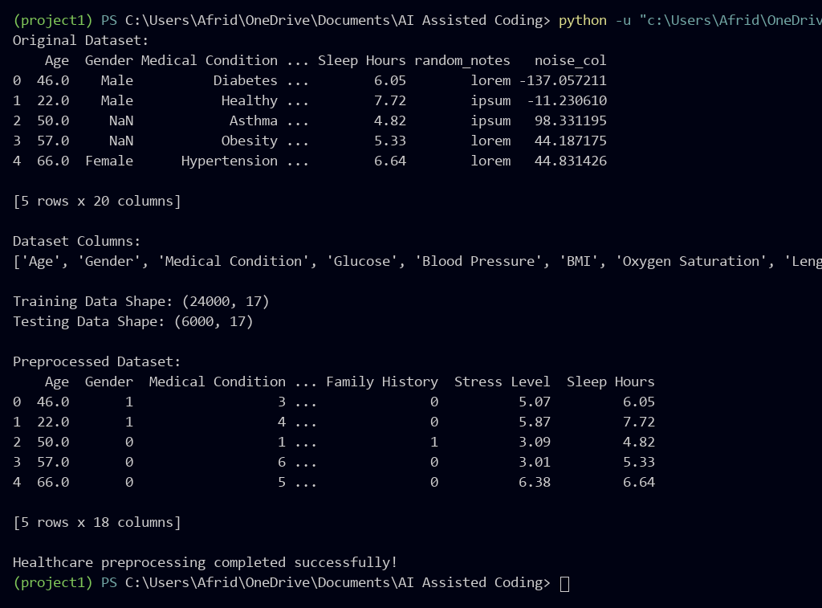

Justification:
Prepared the healthcare dataset by handling missing values, removing unnecessary noise columns, encoding categorical features, scaling numerical data using Min-Max scaling, and splitting the dataset into training and testing sets.
Task 4 – Employee Salary Data Preprocessing
Task:
Clean and preprocess an employee salary dataset using AI scripts.
Prompt:
Generate a Python script using Pandas and scikit-learn to preprocess employee salary data. Handle missing values, detect and remove salary outliers using the IQR method, convert department names to lowercase, and label encode job location and department columns. Display and save the cleaned dataset.
Code:

import pandas as pd
from sklearn.preprocessing import LabelEncoder

# Load employee salary dataset
data = pd.read_csv("Employee_Salary_Dataset.csv")

print("Original Dataset:")
print(data.head())

# Handle missing values
for col in data.columns:
if pd.api.types.is_numeric_dtype(data[col]):
data[col] = data[col].fillna(data[col].median())
else:
data[col] = data[col].fillna(data[col].mode()[0])

# Standardize department names if available
if "Department" in data.columns:
data["Department"] = data["Department"].str.lower().str.strip()

# Detect and remove salary outliers using IQR
Q1 = data["Salary"].quantile(0.25)
Q3 = data["Salary"].quantile(0.75)
IQR = Q3 - Q1

lower_limit = Q1 - 1.5 * IQR
upper_limit = Q3 + 1.5 * IQR

data = data[
(data["Salary"] >= lower_limit) &
(data["Salary"] <= upper_limit)
]

# Encode available categorical columns
encoder = LabelEncoder()

for col in ["Gender", "Job_Location", "Department"]:
if col in data.columns:
data[col] = encoder.fit_transform(data[col].astype(str))

# Display cleaned dataset
print("\nCleaned Dataset:")
print(data.head())

print("\nFinal Dataset Shape:", data.shape)

# Save cleaned dataset
data.to_csv("cleaned_employee_salary.csv", index=False)

print("\nEmployee salary preprocessing completed successfully!")
Output:
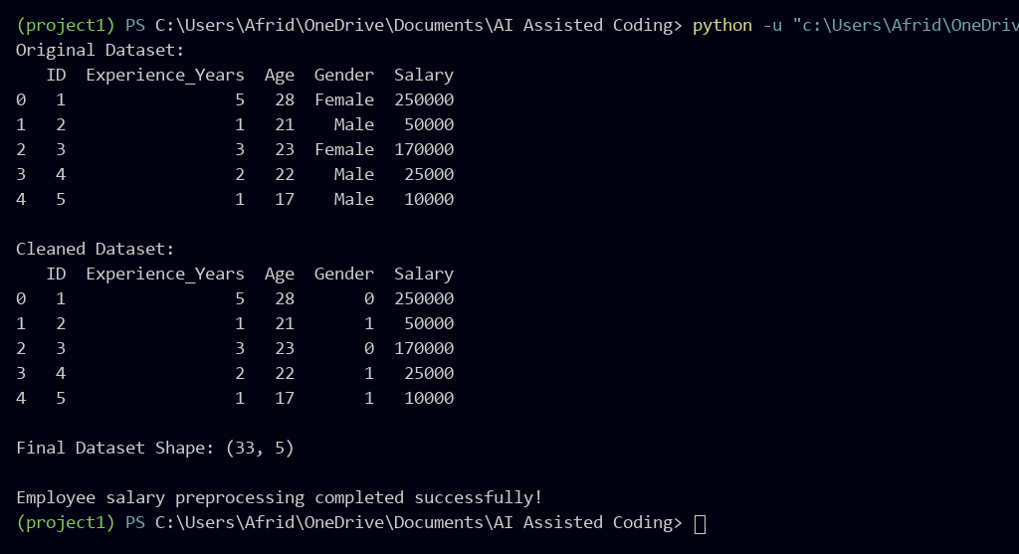
Justification:
Preprocessed the employee salary dataset by handling missing values, detecting and removing salary outliers using the IQR method, and encoding available categorical features such as gender. Saved the cleaned dataset for further analysis.

