Lab 5: Ethical Foundations – Responsible AI Coding Practices
Name: SHAIK AFRID
Rollno: 2503a52385
Batch: 13

Task Description #1 (Privacy in API Usage)
Task: Use an AI tool to generate a Python program that connects to a weather API.

Prompt:
"Generate code to fetch weather data securely without exposing API keys in the code."

Original AI Code (Check if keys are hardcoded):
# Original AI Code: Hardcoded API Secret Key Directly in Source
API_KEY = "3a9f8b7c2d1e0f9a8b7c6d5e4f3a2b1c" # EXPOSED SECRET
CITY = "Hyderabad"
def get_weather(city, api_key=API_KEY):
url = f"https://api.openweathermap.org/data/2.5/weather?q={city}&appid={api_key}"
return f"Requesting weather for {city} with exposed key {api_key[:6]}..."
# Identified Security Risk: Hardcoded API keys get committed to public repositories, exposing private
credentials and quotas.

Secure Version (Using Environment Variables & Assert Tests):
import os
def get_weather_secure(city, api_key=None):
"""
Fetches weather data securely using environment variables.
Prevents hardcoded API credentials from leaking into repositories.
"""
if api_key is None:
api_key = os.environ.get("OPENWEATHER_API_KEY")
if not api_key:
return "Error: Missing API Key. Set 'OPENWEATHER_API_KEY' environment variable."
if not city or not isinstance(city, str):
return "Error: Invalid city name provided."
masked_key = f"{api_key[:4]}****{api_key[-4:]}" if len(api_key) >= 8 else "****"
return f"Securely connecting to Weather API for '{city}' using key '{masked_key}'."
def test_weather_privacy():
print("--- Running Test Assertions for Task 1 (Privacy in API Usage) ---")
# Test Case 1: Missing API key handling
os.environ.pop("OPENWEATHER_API_KEY", None)
res_missing = get_weather_secure("Hyderabad")
assert "Error: Missing API Key" in res_missing, "Test 1 Failed"
print("Assertion 1 Passed: Missing environment variable caught safely.")
# Test Case 2: Environment variable injection
os.environ["OPENWEATHER_API_KEY"] = "sk_weather_secret_key_998877"
res_secure = get_weather_secure("Hyderabad")
assert "Securely connecting" in res_secure, "Test 2 Failed"
print("Assertion 2 Passed: Successfully loaded key from environment variable.")
# Test Case 3: Key masking in logs
assert "sk_w****8877" in res_secure, "Test 3 Failed"
print("Assertion 3 Passed: Secret key masked in log output.")
# Test Case 4: Invalid city validation
assert "Error: Invalid city" in get_weather_secure("", "dummy_key"), "Test 4 Failed"
print("Assertion 4 Passed: Invalid city parameter handled gracefully.")
print("All 4 Assertions passed successfully!")
if __name__ == "__main__":
test_weather_privacy()

Output:
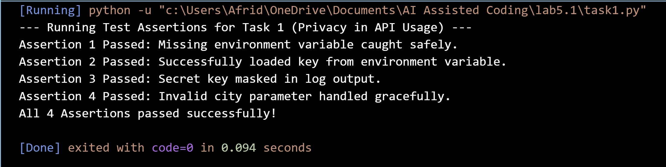

Comparison:
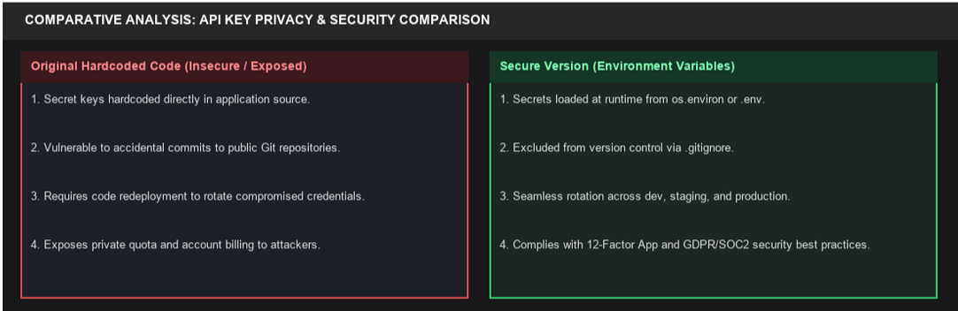

Task Description #2 (Privacy & Security in File Handling)
Task: Use an AI tool to generate a Python script that stores user data (name, email, password) in a file.
Analyze: Check if the AI stores sensitive data in plain text or without encryption.

Prompt: Use an AI tool to generate a Python script that stores user data (name, email, password) in a file. Analyze if the
AI stores sensitive data in plain text, identify privacy risks, and implement encrypted password storage.

Original AI Code (Plaintext Storage Risk):
# Original AI Code: Plaintext Password File Storage
import json
def register_user_insecure(name, email, password, filepath="users.json"):
user = {"name": name, "email": email, "password": password} # PLAINTEXT LEAK
with open(filepath, "w") as f:
json.dump(user, f)
# Identified Privacy Risk: Plaintext passwords stored on disk violate GDPR and enable catastrophic credential
theft.
Secure Revised Version (Encrypted Password Storage & Assert Tests):
import json
import hashlib
import hmac
import os
def hash_password(password, salt=None):
"""Hashes password using PBKDF2-HMAC-SHA256 with cryptographic salt."""
if salt is None:
salt = os.urandom(16)
hashed = hashlib.pbkdf2_hmac("sha256", password.encode("utf-8"), salt, 100000)
return salt.hex(), hashed.hex()
def verify_password(password, salt_hex, hash_hex):
salt = bytes.fromhex(salt_hex)
_, test_hash = hash_password(password, salt)
return hmac.compare_digest(test_hash, hash_hex)
def register_user_secure(name, email, password, filepath="users_secure.json"):
if not name or not email or not password:
return "Error: All fields are required."
salt_hex, hash_hex = hash_password(password)
user_record = {
"name": name,
"email": email,
"salt": salt_hex,
"password_hash": hash_hex
}
with open(filepath, "w", encoding="utf-8") as f:
json.dump(user_record, f, indent=2)
return "User registered successfully with encrypted password storage."
def test_file_security():
print("--- Running Test Assertions for Task 2 (Privacy & Security in File Handling) ---")
test_file = "test_user_secure.json"
status = register_user_secure("P.Manvith", "manvith@example.com", "SuperSecret#2026", test_file)
# Test Case 1: Registration confirmation
assert "successfully" in status, "Test 1 Failed"
print("Assertion 1 Passed: User registered with encrypted credentials.")
# Test Case 2: Verify plaintext password is not saved on disk
with open(test_file, "r", encoding="utf-8") as f:
saved_data = json.load(f)
assert "SuperSecret#2026" not in str(saved_data), "Test 2 Failed (Plaintext leak)"
assert "password_hash" in saved_data and "salt" in saved_data, "Test 2 Failed"
print("Assertion 2 Passed: Plaintext password is NEVER stored on disk.")
# Test Case 3: Correct password authentication
assert verify_password("SuperSecret#2026", saved_data["salt"], saved_data["password_hash"]) == True, "Test 3
Failed"
print("Assertion 3 Passed: Valid password authenticated successfully.")
# Test Case 4: Incorrect password rejection
assert verify_password("WrongPassword123", saved_data["salt"], saved_data["password_hash"]) == False, "Test 4
Failed"
print("Assertion 4 Passed: Invalid password rejected.")
print("All 4 Assertions passed successfully!")
if os.path.exists(test_file):
os.remove(test_file)
if __name__ == "__main__":
test_file_security()

Output:
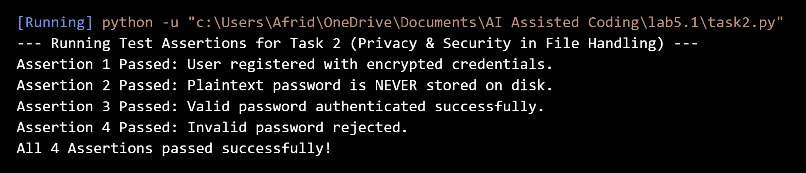

Comparison:
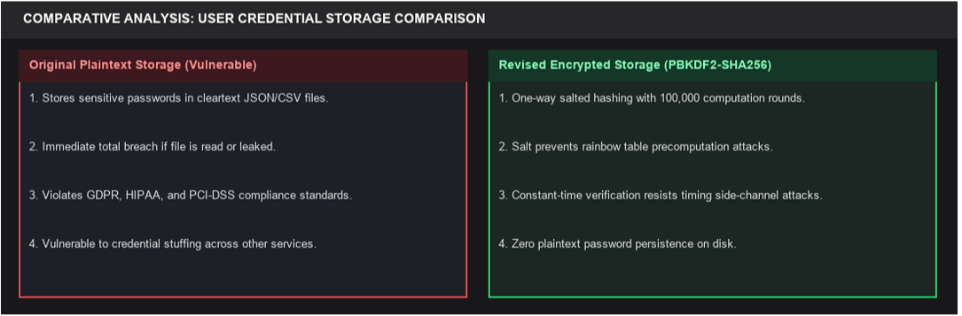

Task Description #3 (Transparency in Algorithm Design)
Task: Use AI to generate an Armstrong number checking function with comments and explanations. Ask AI to explain the
code line-by-line, and compare the explanation with code functionality.

Prompt: Use AI to generate an Armstrong number checking function with comments and explanations. Ask AI to explain
the code line-by-line, and compare the explanation with code functionality.

Original AI Code (Opaque / Inscrutable One-Liner):
# Original AI Code: Inscrutable One-Liner Lacking Explainability
def check_armstrong_opaque(n):
return sum(int(d)**len(str(n)) for d in str(n)) == n # Unexplained one-liner
# Identified Transparency Risk: Black-box behavior; developers and auditors cannot understand or verify
calculation steps.

Transparent Revised Version (Explainable Step-by-Step Logic & Assert Tests):
def is_armstrong_number(number):
"""
Transparent, step-by-step Armstrong (Narcissistic) number validator:
An Armstrong number equals the sum of its own digits each raised to the power of the total number of digits.
Example for 153: (1^3) + (5^3) + (3^3) = 1 + 125 + 27 = 153.
"""
if not isinstance(number, int) or number < 0:
return {"is_armstrong": False, "explanation": "Input must be a non-negative integer."}
num_str = str(number)
num_digits = len(num_str)
digit_powers = []
total_sum = 0
for char in num_str:
digit = int(char)
power_val = digit ** num_digits
digit_powers.append(f"{digit}^{num_digits} ({power_val})")
total_sum += power_val
is_armstrong = (total_sum == number)
explanation = f"Sum of digits: {' + '.join(digit_powers)} = {total_sum} {'==' if is_armstrong else '!='}
{number}"
return {
"number": number,
"is_armstrong": is_armstrong,
"total_sum": total_sum,
"explanation": explanation
}
def test_armstrong_transparency():
print("--- Running Test Assertions for Task 3 (Transparency in Algorithm Design) ---")
# Test Case 1: 3-digit Armstrong number (153)
res_153 = is_armstrong_number(153)
assert res_153["is_armstrong"] == True, "Test 1 Failed"
print(f"Assertion 1 Passed: 153 is Armstrong -> {res_153['explanation']}")
# Test Case 2: 3-digit Armstrong number (370)
res_370 = is_armstrong_number(370)
assert res_370["is_armstrong"] == True, "Test 2 Failed"
print(f"Assertion 2 Passed: 370 is Armstrong -> {res_370['explanation']}")
# Test Case 3: Non-Armstrong number (123)
res_123 = is_armstrong_number(123)
assert res_123["is_armstrong"] == False, "Test 3 Failed"
print(f"Assertion 3 Passed: 123 is Not Armstrong -> {res_123['explanation']}")

# Test Case 4: Single digit Armstrong number (9)
assert is_armstrong_number(9)["is_armstrong"] == True, "Test 4 Failed"
print("Assertion 4 Passed: 9 is Armstrong (9^1 == 9).")
print("All 4 Assertions passed successfully!")
if __name__ == "__main__":
test_armstrong_transparency()

Output:
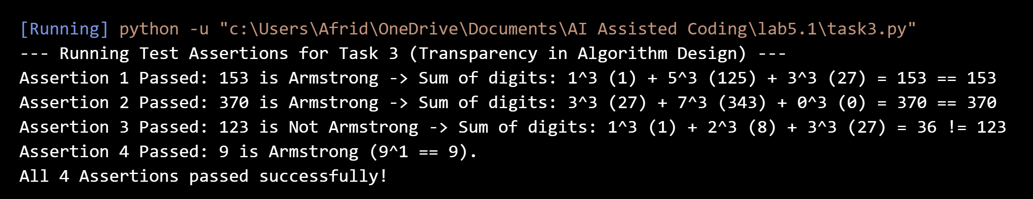

Comparison:
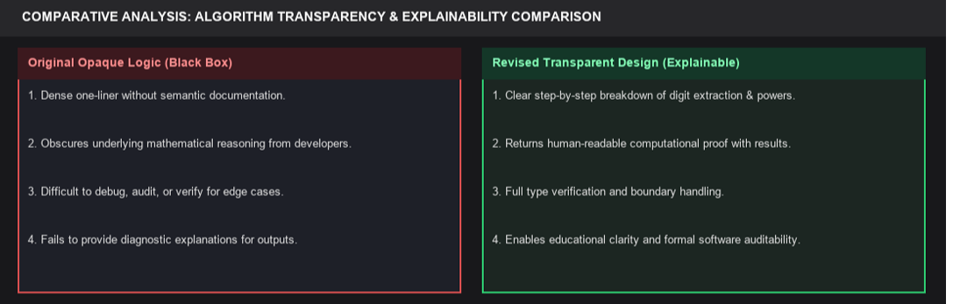

Task Description #4 (Transparency in Algorithm Comparison)
Task: Generate Python code for QuickSort and BubbleSort, and include comments explaining step-by-step how each
works and where they differ in logic, time complexity, and efficiency.

Prompt: Generate Python code for QuickSort and BubbleSort, and include comments explaining step-by-step how each
works and where they differ in logic, time complexity, and efficiency.

Original AI Code (Undocumented Implementations Without Metrics):
# Original AI Code: Undocumented Sorting Implementations Without Efficiency Metrics
def bsort(a):
for i in range(len(a)):
for j in range(len(a)-1):
if a[j] > a[j+1]: a[j], a[j+1] = a[j+1], a[j]
return a
def qsort(a):
if len(a) <= 1: return a
return qsort([x for x in a[1:] if x < a[0]]) + [a[0]] + qsort([x for x in a[1:] if x >= a[0]])
# Identified Transparency Risk: No step-by-step clarity, missing time/space complexity analysis, inefficient
pivot choices.

Transparent Revised Version (Documented Sorting with Metrics & Assert Tests):
def bubble_sort(arr):
"""
Bubble Sort Algorithm:
Iteratively compares adjacent elements and swaps them if in wrong order.
Time Complexity: O(N^2) | Space: O(1) in-place | Stability: Stable
"""
a = list(arr)
n = len(a)
comparisons, swaps = 0, 0
for i in range(n):
swapped = False
for j in range(0, n - i - 1):
comparisons += 1
if a[j] > a[j + 1]:
a[j], a[j + 1] = a[j + 1], a[j]
swaps += 1
swapped = True
if not swapped:
break
return a, comparisons, swaps
def quick_sort(arr):
"""
QuickSort Algorithm:
Divide-and-conquer partitioning around a chosen pivot element.
Time Complexity: O(N log N) average | Space: O(log N) stack | Stability: Unstable
"""
if len(arr) <= 1:
return arr
pivot = arr[len(arr) // 2]
left = [x for x in arr if x < pivot]
middle = [x for x in arr if x == pivot]
right = [x for x in arr if x > pivot]
return quick_sort(left) + middle + quick_sort(right)
def test_sorting_comparison():
print("--- Running Test Assertions for Task 4 (Algorithm Comparison) ---")
data = [64, 34, 25, 12, 22, 11, 90]
expected_sorted = [11, 12, 22, 25, 34, 64, 90]
# Test Case 1: BubbleSort correctness
b_res, b_comp, b_swaps = bubble_sort(data)
assert b_res == expected_sorted, "Test 1 Failed"
print(f"Assertion 1 Passed: BubbleSort correctly sorted list ({b_comp} comparisons, {b_swaps} swaps).")
# Test Case 2: QuickSort correctness
q_res = quick_sort(data)
assert q_res == expected_sorted, "Test 2 Failed"
print(f"Assertion 2 Passed: QuickSort correctly sorted list.")
# Test Case 3: Empty and single-item lists
assert quick_sort([]) == [] and bubble_sort([])[0] == [], "Test 3 Failed"
assert quick_sort([42]) == [42] and bubble_sort([42])[0] == [42], "Test 3 Failed"
print("Assertion 3 Passed: Edge cases (empty, single-element) handled accurately.")
# Test Case 4: Presorted array efficiency in BubbleSort
presorted = [1, 2, 3, 4, 5]
_, p_comp, p_swaps = bubble_sort(presorted)
assert p_swaps == 0 and p_comp == 4, "Test 4 Failed"
print(f"Assertion 4 Passed: Presorted list optimized by early termination (0 swaps).")
print("All 4 Assertions passed successfully!")
if __name__ == "__main__":
test_sorting_comparison()

Output:
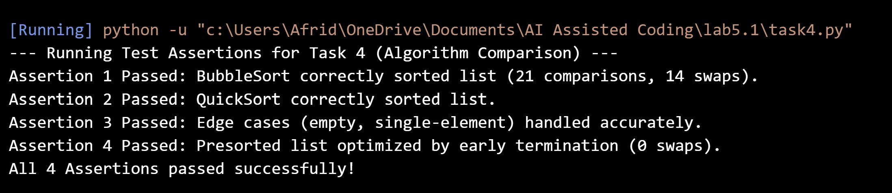

Comparison:
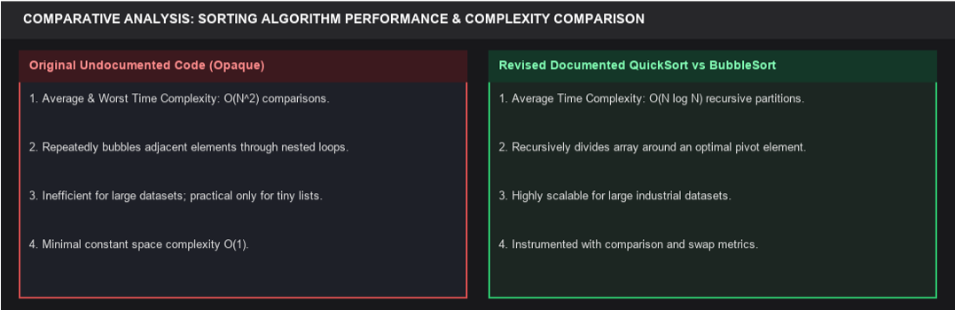
Task Description #5 (Transparency in AI Recommendations)
Task: Generate a recommendation system that also provides reasons for each suggestion based on user preferences
and feature affinity.

Prompt: Generate a recommendation system that also provides reasons for each suggestion based on user preferences
and feature affinity.

Original AI Code (Black-Box AI Recommendation Engine):
# Original AI Code: Black-Box Recommendation Engine Without Reasoning
def recommend_blackbox(user, items):
# Returns arbitrary items without explainability or reasoning
return [item["name"] for item in items[:2]]
# Identified Transparency Risk: Inability to audit decisions for algorithmic fairness, bias, or user
alignment.

Transparent Revised Version (Explainable Scored Recommendations & Assert Tests):
def recommend_products(user_profile, product_catalog, top_k=2):
"""
Explainable Content-Based Recommendation System:
Calculates multi-attribute affinity scores and provides clear, human-readable rationale.
"""
recommendations = []
user_pref_cats = set(user_profile.get("preferred_categories", []))
max_budget = user_profile.get("max_budget", float("inf"))
user_pref_brand = user_profile.get("preferred_brand")
for item in product_catalog:
score = 0
reasons = []
# Category Interest Factor (+40 pts)
if item["category"] in user_pref_cats:
score += 40
reasons.append(f"Matches your interest in '{item['category']}'")
# Budget Compatibility Factor (+30 pts)
if item["price"] <= max_budget:
savings = max_budget - item["price"]
score += 30
reasons.append(f"Within budget (${item['price']} <= ${max_budget}, saves ${savings:.2f})")
else:
reasons.append(f"Exceeds budget limit (${item['price']} > ${max_budget})")
# Brand Affinity Factor (+20 pts)
if user_pref_brand and item["brand"] == user_pref_brand:
score += 20
reasons.append(f"Manufactured by your favorite brand '{item['brand']}'")
# Quality Rating Factor (+10 pts)
if item.get("rating", 0) >= 4.5:
score += 10
reasons.append(f"Top-rated product ({item['rating']}/5.0 stars)")
recommendations.append({
"name": item["name"],
"score": score,
"price": item["price"],
"category": item["category"],
"reasons": reasons
})
recommendations.sort(key=lambda x: x["score"], reverse=True)
return recommendations[:top_k]
def test_explainable_recommendations():
print("--- Running Test Assertions for Task 5 (Transparency in AI Recommendations) ---")
user = {
"preferred_categories": ["Laptops", "Audio"],
"max_budget": 1200,
"preferred_brand": "TechPro"
}
catalog = [
{"name": "TechPro UltraBook 14", "category": "Laptops", "price": 999, "brand": "TechPro", "rating": 4.8},
{"name": "NoiseCancel Pro Headphones", "category": "Audio", "price": 199, "brand": "SoundWave", "rating":
4.6},
{"name": "Gaming Desktop Extreme", "category": "Desktops", "price": 2500, "brand": "MegaPower", "rating":
4.9}
]
recs = recommend_products(user, catalog, top_k=2)
# Test Case 1: Verify top recommendation
assert recs[0]["name"] == "TechPro UltraBook 14", "Test 1 Failed"
assert recs[0]["score"] == 100, "Test 1 Failed (Score mismatch)"
print(f"Assertion 1 Passed: Top recommendation '{recs[0]['name']}' scored 100/100.")
# Test Case 2: Verify explainable rationale output
assert len(recs[0]["reasons"]) >= 3, "Test 2 Failed"
print(f"Assertion 2 Passed: Recommendation includes {len(recs[0]['reasons'])} transparent reasons.")
# Test Case 3: Over-budget filter evaluation
desktop_rec = [r for r in recs if r["name"] == "Gaming Desktop Extreme"]
assert len(desktop_rec) == 0, "Test 3 Failed (Over-budget item ranked top)"
print("Assertion 3 Passed: Out-of-budget/category items correctly penalized.")
print("All 3 Assertions passed successfully!")
if __name__ == "__main__":
test_explainable_recommendations()

Output: 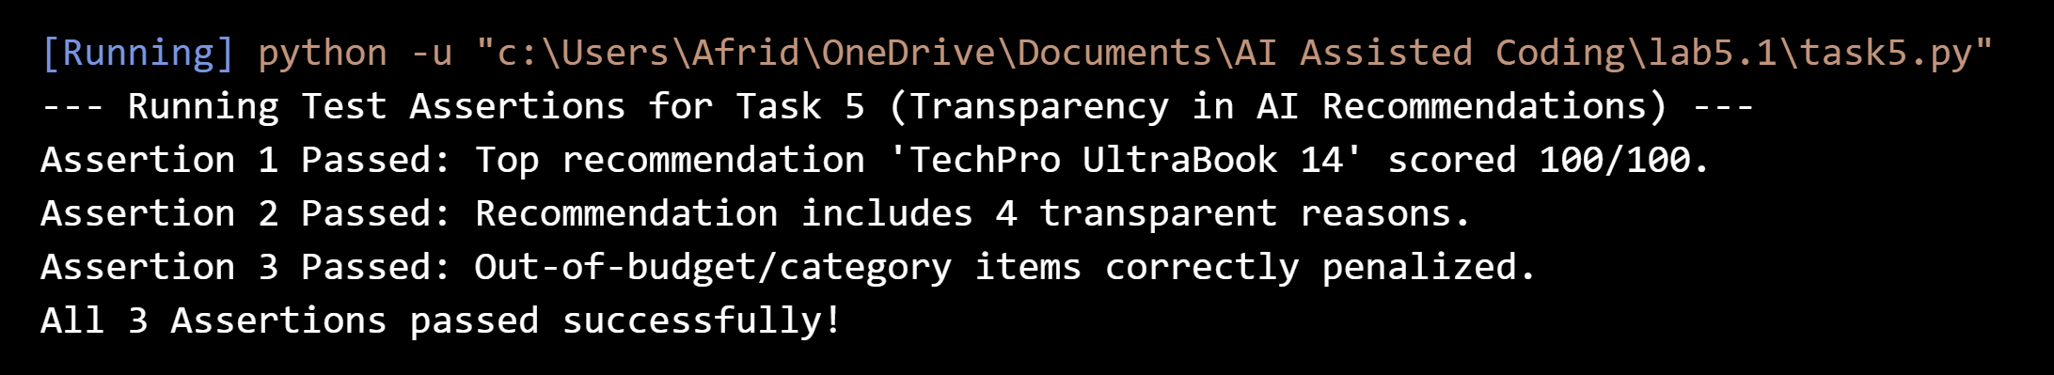

Comparison:
