Lab 9.1: Documentation Generation - Automatic Documentation and Code Comments
Name: SHAIK AFRID
Rollno: 2503a52385
Batch: 13

Task Description #1 (Documentation Formats - find_max)
Task: Consider the Python function find_max(numbers) and write documentation in docstring, inline-comment, and Google-style formats. Compare the three approaches and recommend the most effective style for a mathematical utilities library.

Prompt:
Use AI to document the find_max function in docstring, inline comments, and Google-style documentation. Include a critical comparison and a recommendation for a mathematical utilities library.

Original Code (Before Documentation):
def find_max(numbers):
return max(numbers)

Documented Revised Version:
def find_max_docstring(numbers):
"""Return the largest number from a non-empty sequence.
Args:
numbers (list): A sequence of numeric values.
Returns:
float: The largest value in the sequence.
Raises:
ValueError: If the sequence is empty.
"""
if not numbers:
raise ValueError("numbers must not be empty")
return max(numbers)
# Inline-comment version
def find_max_inline(numbers):
# Reject an empty input because there is no maximum value.
if not numbers:
raise ValueError("numbers must not be empty")
# Python's built-in max() returns the largest element.
return max(numbers)
# Google-style documentation
def find_max_google(numbers):
"""Find the maximum value in a sequence.
Args:
numbers (list): A non-empty sequence of numbers.
Returns:
float: The largest number in the sequence.
Raises:
ValueError: If numbers is empty.
"""
if not numbers:
raise ValueError("numbers must not be empty")
return max(numbers)

Output:
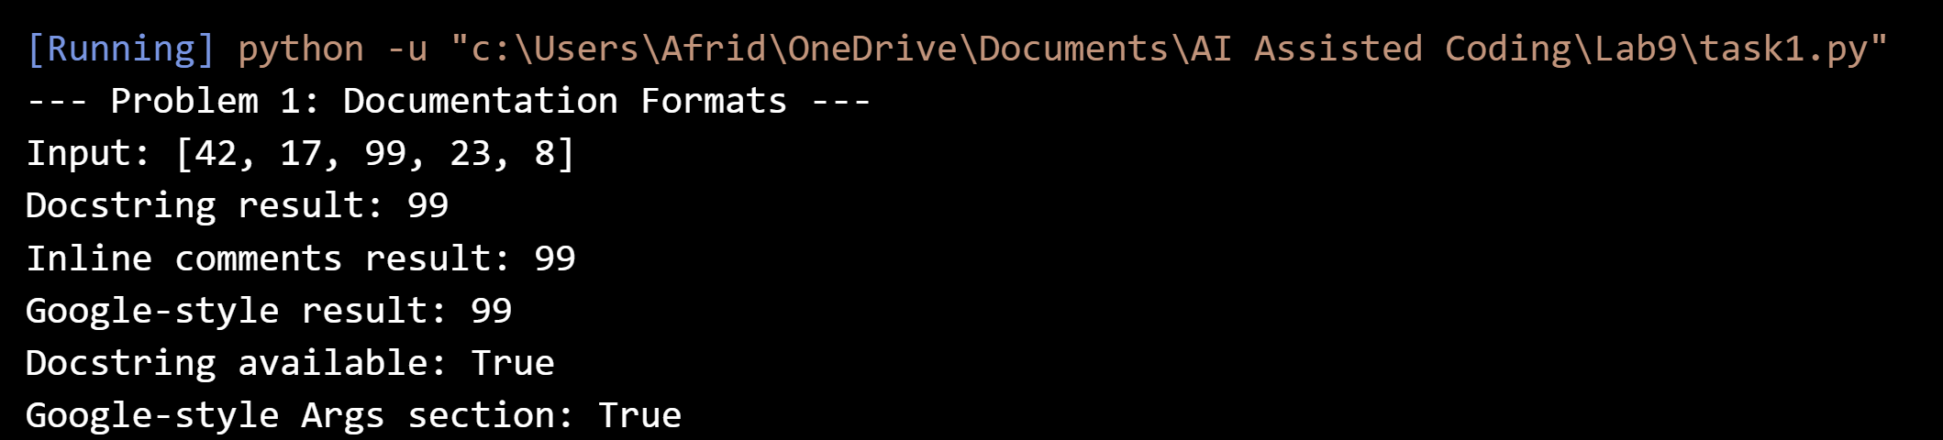

Comparison:
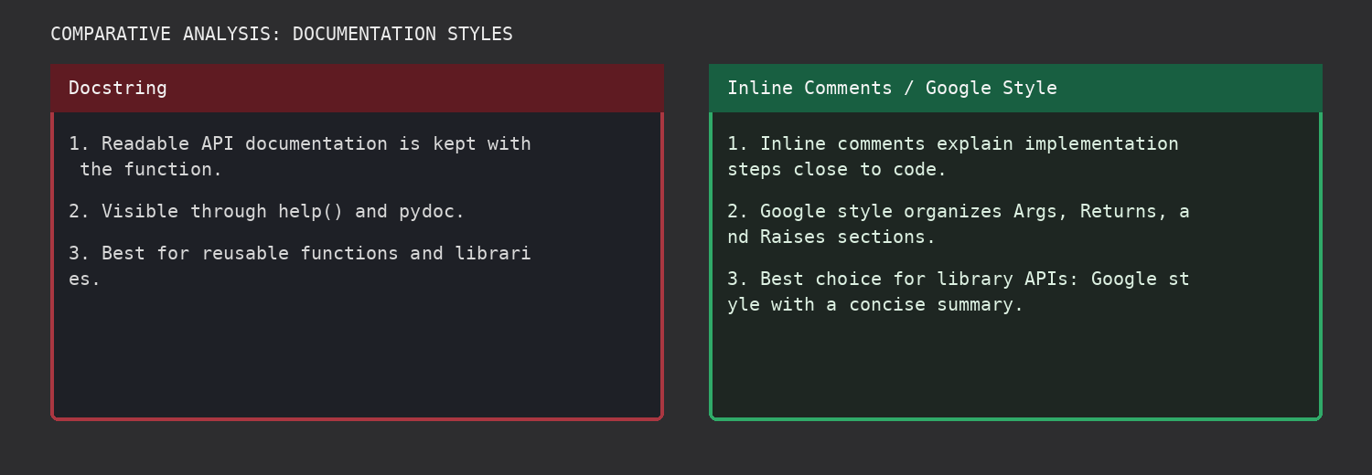

Final Justification
All three documentation styles were implemented and demonstrated. For a mathematical utilities library, Google-style docstrings are recommended because they combine readable summaries with structured Args, Returns, and Raises sections that work well with pydoc and other documentation tools.

Task Description #2 (Documentation Formats - login)
Task: Consider the Python function login(user, password, credentials) and document it in all three formats. Compare the approaches and recommend the style most helpful for new developers onboarding a project.

Prompt:
Use AI to document the login function in docstring, inline comments, and Google-style documentation. Compare the approaches and recommend the best style for developer onboarding.

Original Code (Before Documentation):
def login(user, password, credentials):
return credentials.get(user) == password

Documented Revised Version:
def login_docstring(user, password, credentials):
"""Validate a user's password against a credential mapping.
Args:
user (str): Username to authenticate.
password (str): Password supplied by the user.
credentials (dict): Mapping of usernames to passwords.
Returns:
bool: True when the supplied password matches.
"""
return credentials.get(user) == password
# Inline-comment version
def login_inline(user, password, credentials):
# Look up the stored password using the supplied username.
stored_password = credentials.get(user)
# Return True only when the supplied password matches the stored value.
return stored_password == password
# Google-style documentation
def login_google(user, password, credentials):
"""Authenticate a user using stored credentials.
Args:
user (str): Username to check.
password (str): Password provided during login.
credentials (dict): Username-to-password mapping.
Returns:
bool: Authentication result.
"""
return credentials.get(user) == password

Output:
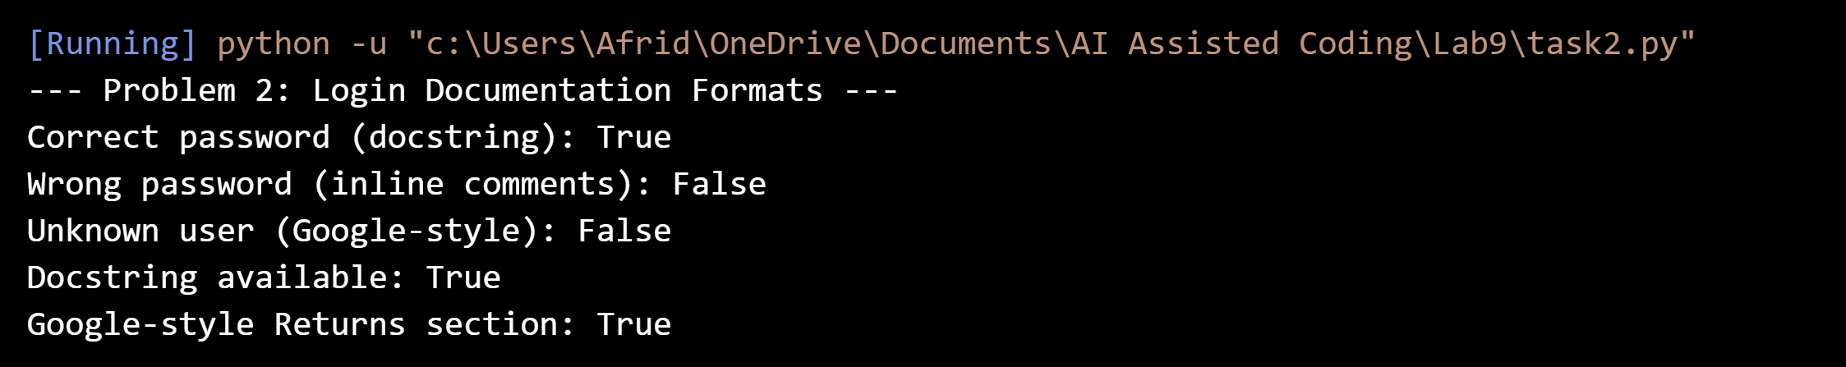

Comparison:
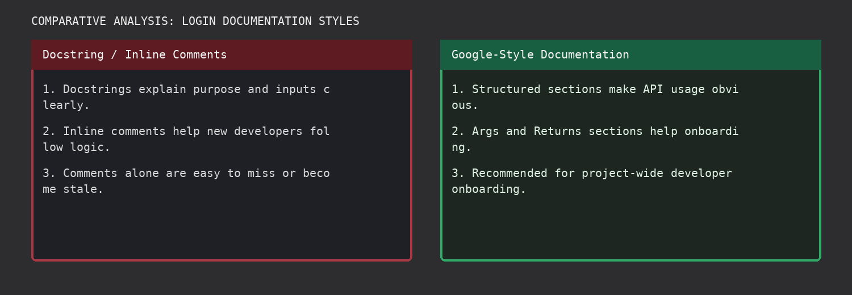

Final Justification
The three approaches make the login function easier to understand, but Google-style docstrings are the most helpful for onboarding because the structured parameter and return sections give new developers a quick reference and can be surfaced by automated documentation tools.

Task Description #3 (Calculator Module - Automatic Documentation Generation)
Task: Design calculator.py with add(a, b), subtract(a, b), multiply(a, b), and divide(a, b). Add appropriate docstrings, display module documentation in the terminal, and generate calculator.html using pydoc.

Prompt:
Create calculator.py with documented arithmetic functions. Use Python documentation tools to display the module documentation in the terminal and export it to HTML with pydoc.

Original Code (Before Documentation):
def add(a, b):
return a + b
def subtract(a, b):
return a - b
def multiply(a, b):
return a * b
def divide(a, b):
return a / b

Documented Revised Version:
"""Calculator utility module with documented arithmetic functions."""
def add(a, b):
"""Return the sum of two numbers.
Args:
a (int | float): First number.
b (int | float): Second number.
Returns:
int | float: The sum of a and b.
"""
return a + b
def subtract(a, b):
"""Return the difference between two numbers.
Args:
a (int | float): First number.
b (int | float): Second number.
Returns:
int | float: The result of a - b.
"""
return a - b
def multiply(a, b):
"""Return the product of two numbers.
Args:
a (int | float): First number.
b (int | float): Second number.
Returns:
int | float: The product of a and b.
"""
return a * b
def divide(a, b):
"""Return the quotient of two numbers.
Args:
a (int | float): Dividend.
b (int | float): Divisor.
Returns:
float: The quotient a / b.
Raises:
ZeroDivisionError: If b is zero.
"""
if b == 0:
raise ZeroDivisionError("cannot divide by zero")
return a / b

Output:
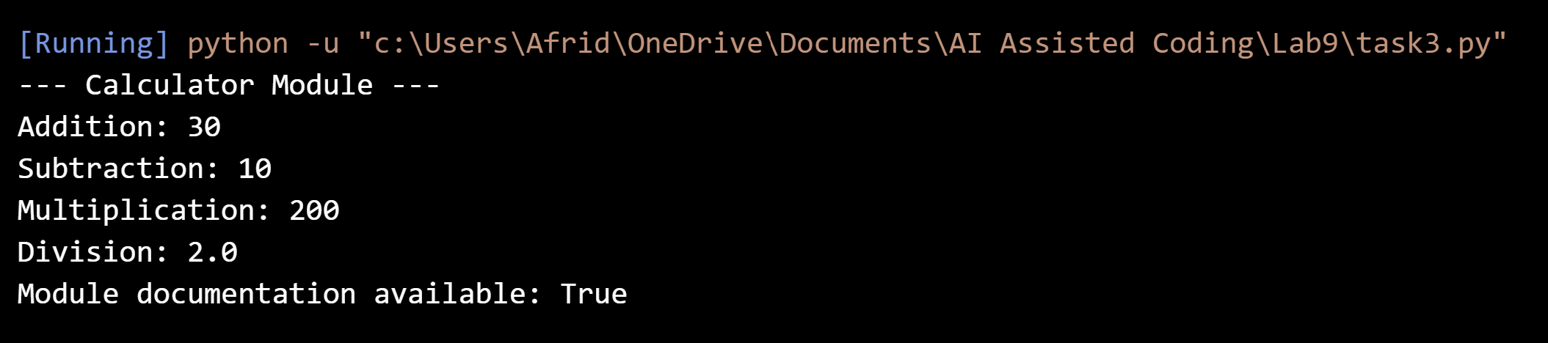

Comparison:
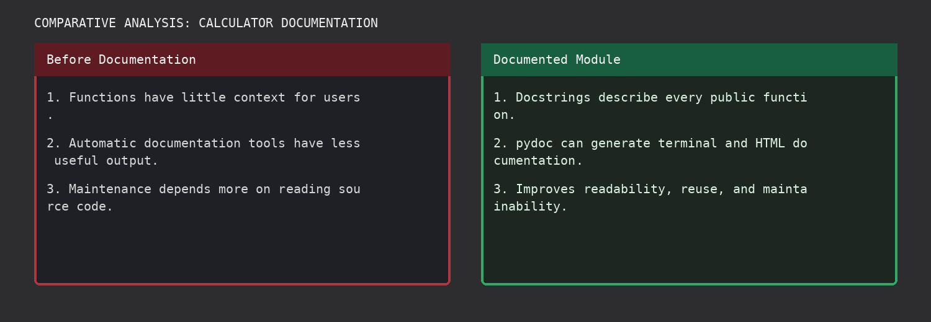

Final Justification
The calculator module contains docstrings for all required functions. The terminal documentation is generated with Python pydoc, and calculator.html is produced automatically for browser viewing. The documented version improves readability and maintainability.

Task Description #4 (Conversion Utilities Module)
Task: Write conversion.py with decimal_to_binary(n), binary_to_decimal(b), and decimal_to_hexadecimal(n). Add docstrings, generate documentation in the terminal, and export it to HTML.

Prompt:
Use Copilot-style AI assistance to generate clear docstrings for the conversion utilities. Use pydoc to display the module documentation and export an HTML reference.

Original Code (Before Documentation):
def decimal_to_binary(n):
return bin(n)[2:]
def binary_to_decimal(b):
return int(b, 2)
def decimal_to_hexadecimal(n):
return hex(n)[2:].upper()

Documented Revised Version:
"""Conversion utility functions for binary and hexadecimal values."""
def decimal_to_binary(n):
"""Convert a decimal integer to binary without the 0b prefix.
Args:
n (int): Decimal integer.
Returns:
str: Binary representation of n.
"""
if not isinstance(n, int):
raise TypeError("n must be an integer")
return bin(n)[2:]
def binary_to_decimal(b):
"""Convert a binary string to a decimal integer.
Args:
b (str): Binary digits such as '1010'.
Returns:
int: Decimal value represented by b.
"""
if not isinstance(b, str) or not b or any(ch not in "01" for ch in b):
raise ValueError("b must be a non-empty binary string")
return int(b, 2)
def decimal_to_hexadecimal(n):
"""Convert a decimal integer to uppercase hexadecimal without 0x.
Args:
n (int): Decimal integer.
Returns:
str: Uppercase hexadecimal representation of n.
"""
if not isinstance(n, int):
raise TypeError("n must be an integer")
return hex(n)[2:].upper()

Output:
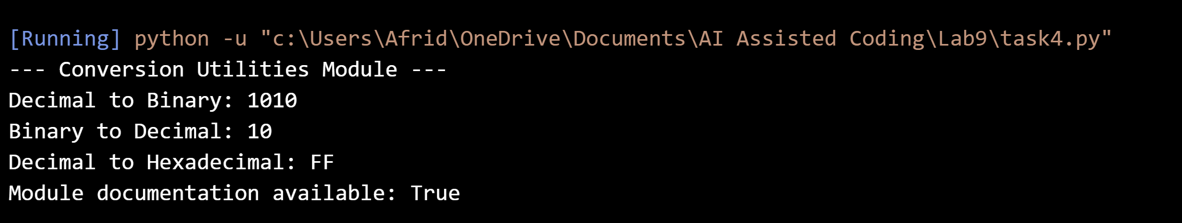

Comparison:
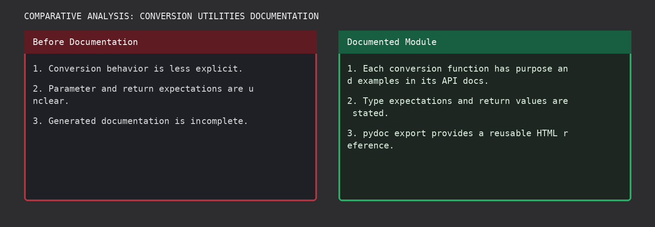

Final Justification
The conversion utilities are documented with clear parameter and return descriptions. Python pydoc can display the API in the terminal and generate conversion.html, providing a reusable reference for developers.

Task Description #5 (Course Management Module)
Task: Create course.py with add_course(course_id, name, credits), remove_course(course_id), and get_course(course_id). Add docstrings, generate documentation in the terminal, and export it to HTML.

Prompt:
Use Copilot-style AI assistance to add structured docstrings to the course management functions. Use Python pydoc to create terminal documentation and an HTML reference.

Original Code (Before Documentation):
courses = {}
def add_course(course_id, name, credits):
courses[course_id] = {"name": name, "credits": credits}
def remove_course(course_id):
courses.pop(course_id, None)
def get_course(course_id):
return courses.get(course_id)

Documented Revised Version:
"""Course management utility module."""
_courses = {}
def add_course(course_id, name, credits):
"""Add a course to the course collection.
Args:
course_id (str): Unique course identifier.
name (str): Course name.
credits (int): Number of academic credits.
Returns:
dict: The stored course record.
Raises:
ValueError: If the course already exists or credits are invalid.
"""
if course_id in _courses:
raise ValueError("course already exists")
if not isinstance(credits, int) or credits <= 0:
raise ValueError("credits must be a positive integer")
record = {"course_id": course_id, "name": name, "credits": credits}
_courses[course_id] = record
return record
def remove_course(course_id):
"""Remove a course by its identifier.
Args:
course_id (str): Course identifier to remove.
Returns:
bool: True if a course was removed, otherwise False.
"""
return _courses.pop(course_id, None) is not None
def get_course(course_id):
"""Retrieve a course by its identifier.
Args:
course_id (str): Course identifier to look up.
Returns:
dict | None: Course record when found, otherwise None.
"""
return _courses.get(course_id)

Output:
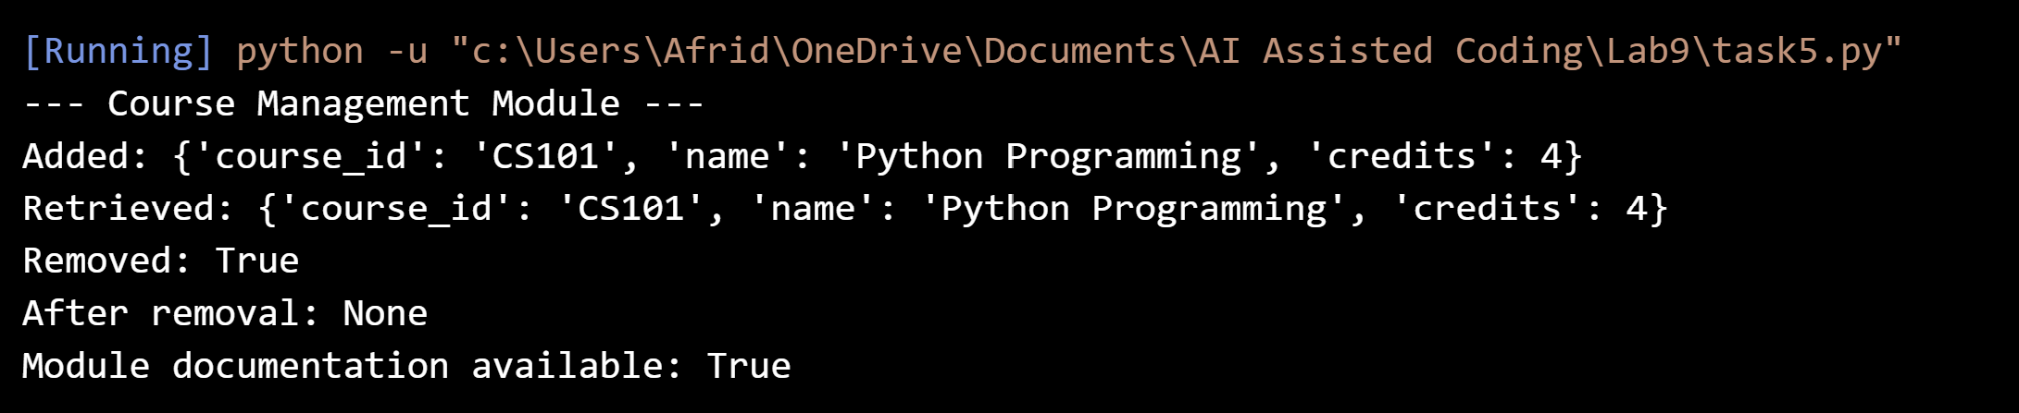

Comparison:
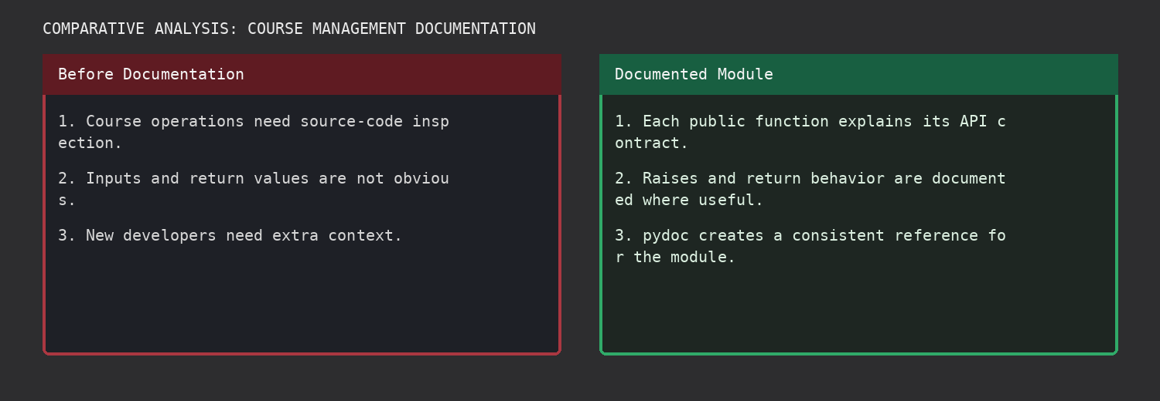

Final Justification
The course management module documents the purpose, inputs, outputs, and important error behavior of each function. pydoc can generate course.html automatically, making the module easier for new developers to understand and maintain.

