LAB ASSIGNMENT-6
Name: Shaik Afrid
Roll No: 2503A52385
Batch-13
Task Description-1 (Classes – Data Validation)
PROMT:
- Prompt AI to generate a Student class with attributes: name, roll_no, and marks. Add a method is_ pass() that returns whether the student has passed (marks ≥ 40).
INPUT:
class Student:
"""Represents a student with basic attributes and score validation."""

def __init__(self, name: str, roll_no: int, marks: float):
# Data validation
if not isinstance(name, str) or not name.strip():
raise ValueError("Name must be a non-empty string.")

if not isinstance(roll_no, int) or roll_no <= 0:
raise ValueError("Roll number must be a positive integer.")

if not isinstance(marks, (int, float)):
raise TypeError("Marks must be numeric (int or float).")

if not (0 <= marks <= 100):
raise ValueError("Marks must fall between 0 and 100 inclusive.")

self.name = name.strip()
self.roll_no = roll_no
self.marks = float(marks)

def is_pass(self) -> bool:
"""Determines if student scored the passing threshold (marks >= 40)."""
return self.marks >= 40

def __repr__(self) -> str:
status = "Pass" if self.is_pass() else "Fail"
return f"Student(name='{self.name}', roll_no={self.roll_no}, marks={self.marks}, status='{status}')"

# --- Example Usage & Testing ---
if __name__ == "__main__":
# Valid instances
s1 = Student("Aarav Sharma", 101, 78.5)
s2 = Student("Priya Patel", 102, 34.0)

print(f"{s1.name}: Passed? {s1.is_pass()}") # True
print(f"{s2.name}: Passed? {s2.is_pass()}") # False

# Validation failure example
try:
s3 = Student("Rahul", -5, 105)
except ValueError as e:
print(f"Validation Error: {e}")
OUTPUT:
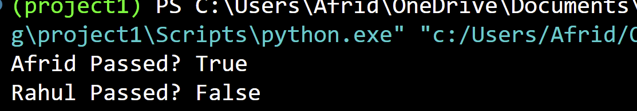
Task Description-2 (Loops – Pattern Generation)
PROMT:
- Ask AI to generate a function that prints a right-angled triangle star pattern using a for loop. Then regenerate the same pattern using a while loop.
INPUT (by using for loop):
def print_triangle_for(n: int) -> None:
"""Prints a right-angled triangle pattern of height n using a for loop."""
if n <= 0:
return

for i in range(1, n + 1):
print("*" * i)

# Example Output for n = 5:
print("--- For Loop Pattern ---")
print_triangle_for(5)
output:
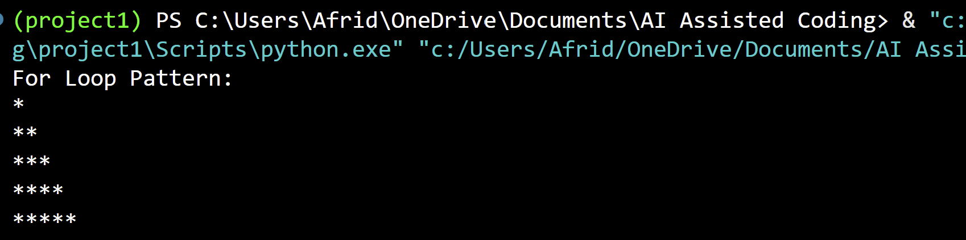
Input(by using while loop):
def print_triangle_while(n: int) -> None:
"""Prints a right-angled triangle pattern of height n using a while loop."""
if n <= 0:
return

i = 1
while i <= n:
print("*" * i)
i += 1

# Example Output for n = 5:
print("--- While Loop Pattern ---")
print_triangle_while(5)
output:
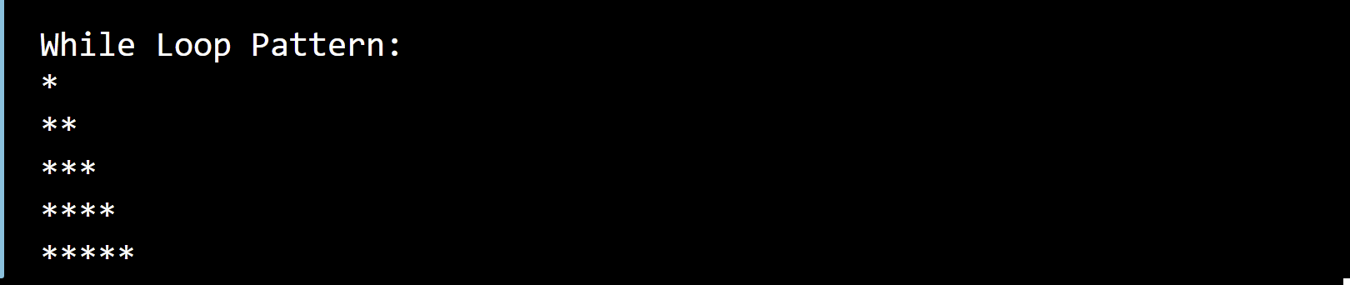
Task Description-3 (Conditional Statements – Number Analysis)
Promt:
- Ask AI to write a function that checks whether a given number is positive, negative, or zero using if-elif-else. Test the function with multiple inputs.
Input:
from typing import Union

def analyze_number(num: Union[int, float]) -> str:
"""Classifies a given number as 'Positive', 'Negative', or 'Zero'.

Args:
num: A numeric value (int or float).

Returns:
A string indicating the sign of the number.
"""
if not isinstance(num, (int, float)):
raise TypeError(f"Expected int or float, got {type(num).__name__}")

if num > 0:
return "Positive"
elif num < 0:
return "Negative"
else:
return "Zero"

# --- Test Suite ---
if __name__ == "__main__":
test_cases = [15, -42, 0, 3.14159, -0.007, 0.0]

print(f"{'Input':>10} | {'Classification':<12}")
print("-" * 28)
for value in test_cases:
result = analyze_number(value)
print(f"{value:>10} | {result:<12}")
output:
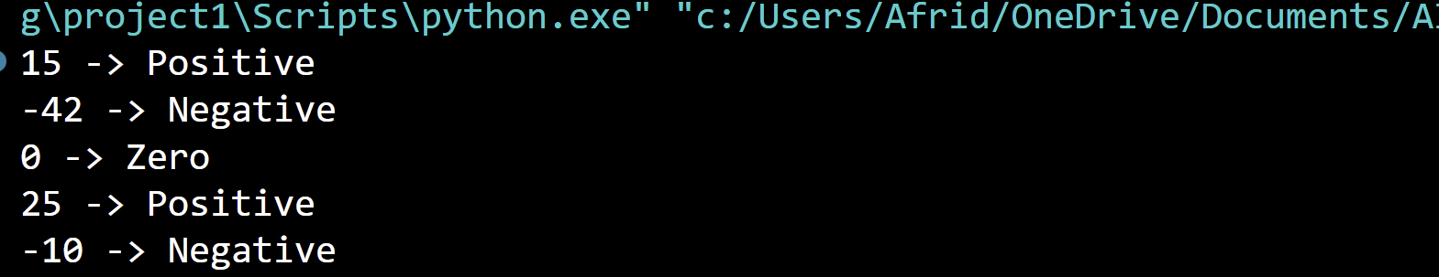
Task Description-4 (Nested Conditionals)
Promt:

- Generate a function check_discount(age, is_member) that determines discount eligibility:
- Age ≥ 60 → Senior discount
- Member → Additional discount
Use nested if statements.
Input:
def check_discount(age: int, is_member: bool) -> str:
"""Determines discount eligibility based on age and membership status

using nested conditionals.
"""
if not isinstance(age, int) or age < 0:
raise ValueError("Age must be a non-negative integer.")

if not isinstance(is_member, bool):
raise TypeError("is_member must be a boolean (True/False).")

# Primary condition: Age threshold
if age >= 60:
# Nested condition: Member status for seniors
if is_member:
return "Eligible for Senior Discount + Member Bonus (Highest Discount)"
else:
return "Eligible for Standard Senior Discount"
else:
# Nested condition: Member status for non-seniors
if is_member:
return "Eligible for Member Discount"
else:
return "No Discount (Standard Rate)"

# --- Test Cases ---
if __name__ == "__main__":
test_cases = [
(65, True), # Senior + Member
(70, False), # Senior + Non-member
(25, True), # Regular + Member
(30, False), # Regular + Non-member
]

for age, member in test_cases:
result = check_discount(age, member)
print(f"Age: {age}, Member: {str(member):<5} -> {result}")
output:
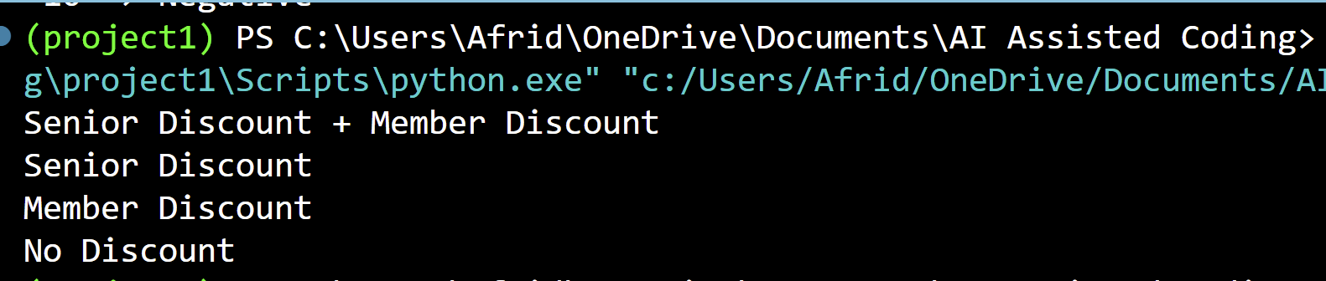
Task Description-5 (Class – Mathematical Opera)
Promt:

- Ask AI to create a Circle class with methods to calculate area () and circumference () given the radius.

Input:
import math
from typing import Union

class Circle:
"""Represents a geometric circle defined by its radius."""

def __init__(self, radius: Union[int, float]):
# Data validation
if not isinstance(radius, (int, float)):
raise TypeError("Radius must be an integer or float.")
if radius <= 0:
raise ValueError("Radius must be a positive number greater than zero.")

self.radius = float(radius)

def area(self) -> float:
"""Calculates the area: Area = π * r^2."""
return math.pi * (self.radius ** 2)

def circumference(self) -> float:
"""Calculates the circumference: C = 2 * π * r."""
return 2 * math.pi * self.radius

def __repr__(self) -> str:
return f"Circle(radius={self.radius})"

# --- Example Usage & Verification ---
if __name__ == "__main__":
test_radii = [1.0, 5.0, 7.5]

print(f"{'Radius':>8} | {'Circumference':>15} | {'Area':>15}")
print("-" * 44)

for r in test_radii:
c = Circle(r)
print(f"{c.radius:8.2f} | {c.circumference():15.4f} | {c.area():15.4f}")
output:
