Abstract

In real world projects handling millions of request per minutes, thousands of error and exceptions are generated. These Exceptions can be expected exception e.g business exceptions or can be result of critical flaw in system causing runtime exception. Hence all the exceptions caused in system has to be analysed. Analysing thousands of exceptions is time consuming and often repetitive. However Exceptions caused in system needs to be addressed. There are many tools which aggregate exceptions but non of them are cable of classifying exceptions as business or runtime. Therefore we propose Exception Classifier.
Exception Classifier tackles the challenge of analysing errors in software more quickly by introducing a clever system that sorts errors into two main types: business errors and runtime errors. Exception Classifier uses Natural Language Processing (NLP) and Machine Learning algorithms to carefully classify Exceptions. The goal is to help developers skip the time-consuming process of figuring out the root cause of business errors and jump straight into solving the problem.
The key Exception classifier is preprocessing using NLP and best picked machine learning models. Exception Classifier focuses on pulling out important information from error messages and looking at the context in which errors happen. This helps classifier learn and recognize different patterns, making it easier for developers to spot business-related errors without diving too deep into complicated investigations.
For training machine learning model dataset of 1,00,000 exceptions containing equal number of both business and runtime exceptions is used. Dataset is first tokenized then split and trained on 3 best picked Machine Learning models. Further models are analysed on performance based on widely used performance parameters. Trained model are then stored for further prediction.
The Exception Classifier is like a helpful assistant for developers. It understands if errors are business or runtime nature and helps categorise them, so developers don't have to spend as much time looking at business errors which are expected and does not need root cause analysis. By doing this, we're not only making the fixing process faster but also freeing up developers to concentrate on solving problems directly, making the whole software-building process smoother.

Keywords- Exception-Classifier, NLP, Naive Baye’s, SVM, XGBoost, TF-IDF.
Introduction

The current software development process involves the occurrence of numerous exceptions, varying from expected business exceptions to critical runtime errors. Distinguishing between these exceptions is time-consuming and often leads to developers spending significant effort analysing expected business exceptions that do not require immediate attention. This situation hampers developer productivity and delays the resolution of actual runtime exceptions that demand immediate intervention.
The objective of this proposed system is to design and implement a machine learning model that accurately classifies exceptions into two distinct categories: business exceptions and runtime exceptions. The primary goal is to facilitate developers in identifying and prioritising exceptions that signify potential problems within the system, thereby saving crucial developer time and resources.
The proposed solution aims to streamline the development process by automating the classification of exceptions, allowing developers to focus their attention on resolving critical runtime issues rather than investing time in analysing expected business exceptions. This project will not only enhance developer efficiency but also contribute to a more effective and rapid resolution of genuine system problems, thereby improving overall software reliability and performance.

- Motivation
In the dynamic landscape of software development, There are thousands of exceptions are generated every hour. Analysing causes of exceptions is very crucial for stable software product. Distinguishing between runtime exceptions and business exceptions is pivotal yet time-consuming. This project aims to automate this classification process, freeing developers from the arduous task of manual exception analysis. By categorizing exceptions into distinct groups, it enables swift identification of critical issues, saving developers invaluable time previously spent on exhaustive manual analysis. With an emphasis on accuracy and efficiency, this classifier empowers developers to prioritize and resolve critical runtime issues promptly, thereby enhancing system stability and minimizing potential downtimes. Ultimately, the Exception Classifier streamlines the development workflow, fostering a more efficient and productive environment for software development teams.
- Problem Statement
The current software development process involves the occurrence of numerous exceptions, varying from expected business exceptions to critical runtime errors. Distinguishing between these exceptions is time-consuming and often leads to developers spending significant effort analysing expected business exceptions that do not require immediate attention. This situation hampers developer productivity and delays the resolution of actual runtime exceptions that demand immediate intervention.
The objective of this project is to design and implement a machine learning model that accurately classifies exceptions into two distinct categories: business exceptions and runtime exceptions. The primary goal is to facilitate developers in identifying and prioritising exceptions that signify potential problems within the system, thereby saving crucial developer time and resources.
The proposed solution aims to streamline the development process by automating the classification of exceptions, allowing developers to focus their attention on resolving critical runtime issues rather than investing time in analysing expected business exceptions. This project will not only enhance developer efficiency but also contribute to a more effective and rapid resolution of genuine system problems, thereby improving overall software reliability and performance.
- Objective
  - To built a Machine Learning mode that classifies Business and Runtime Exceptions.
  - To help developer address critical runtime exceptions.
  - To save invaluable time of developers from analysing non crucial business exception.
  - To automate segregation of Business exceptions and runtime exceptions.
  - To save cost in project development by saving time of developers.

- Scope
The project scope involves the development and implementation of a Machine Learning classifier utilizing Natural Language Processing (NLP) techniques to categorize exceptions into two distinct classes: Business Exceptions and Runtime Exceptions. The classifier will be trained using three distinct models: Naive Bayes, Support Vector Machines (SVM), and XGBoost. The primary objectives include the creation of a robust training pipeline, incorporating feature extraction, model training and evaluation to ensure optimal performance across all three models. Additionally, the project encompasses the saving of the trained models for future use and implementing a reliable loading mechanism to seamlessly integrate these models into the system for real-time exception classification.

Proposed System
An Exception Classifier is a NLP based Machine Learning model which classifies Exceptions into two categories as Business Exception or Runtime Exception. For training such model dataset is first preprocessed using NLP. TF-IDF vectoriser is used to represent textual exception content into numerical values which can be used to feed machine learning model. For training machine learning model data is split into training and test data as 80:20 ratio. Furthermore, best machine learning model is picked as Naive Baye’s, SVM, XGBoost. After training performance parameters are chosen such as precision, recall and f1. Based on performance parameters further analysis and improvement is done until desired results are received. Upon satisfactory training and testing performance models are saved.
Furthermore, saved model are then loaded back to accept inputs from real world projects. Unknown and unseen exceptions are then fed to well trained and tested model to classify exception as either business exception or runtime exception.

- Data Collection and Preparation:
Gather Diverse Exception Data: Acquire a diverse dataset containing a wide range of exception texts derived from software logs, system errors, application failures, and other sources. Ensure the dataset reflects various types of business and runtime exceptions observed in real-world scenarios.
- Data Preprocessing:
Cleanse the raw exception texts by removing irrelevant characters, punctuation, HTML tags, and special symbols. Standardise text by converting to lowercase, handling abbreviations, and normalising specific patterns. Implement tokenization techniques to break text into words or tokens. Normalise the text data by removing stop words, stemming or lemmatization, and handling numerical values or URLs.
- Model Building and Evaluation:
Divide the preprocessed dataset into training, validation, and testing sets, ensuring a representative distribution of business and runtime exceptions in each set. Utilise advanced text representation techniques like TF-IDF, word embeddings (Word2Vec, GloVe) to convert text data into numerical features suitable for model training. In our case, we will use the TF-IDF vectorization technique.
Employ Naive Bayes, Support Vector Machine (SVM), and XGBoost algorithms to build classification models using the training data. Evaluate these models using robust evaluation metrics such as F1-score, recall, and precision on the validation and test sets.
- Performance Analysis:
Conduct a comprehensive analysis of model performance based on multiple metrics and validation techniques. Compare F1-score, recall, and precision across different models to determine the most effective classifier for classifying business and runtime exceptions.
- Saving the Model:
Serialise or save the models using appropriate serialisation techniques provided by the programming language or machine learning framework. The model is saved along with relevant metadata for seamless future access and deployment.
- Future Predictions:
Load the saved model when required for making predictions on new exception texts. Apply the preprocessing steps utilised during training to clean and transform new exception data into a format compatible with the model's input requirements. Deploy the loaded model to predict the category (business or runtime) of new exceptions encountered in real-time applications or system monitoring. Monitor and adapt the model as needed based on feedback and new data.

System Architecture
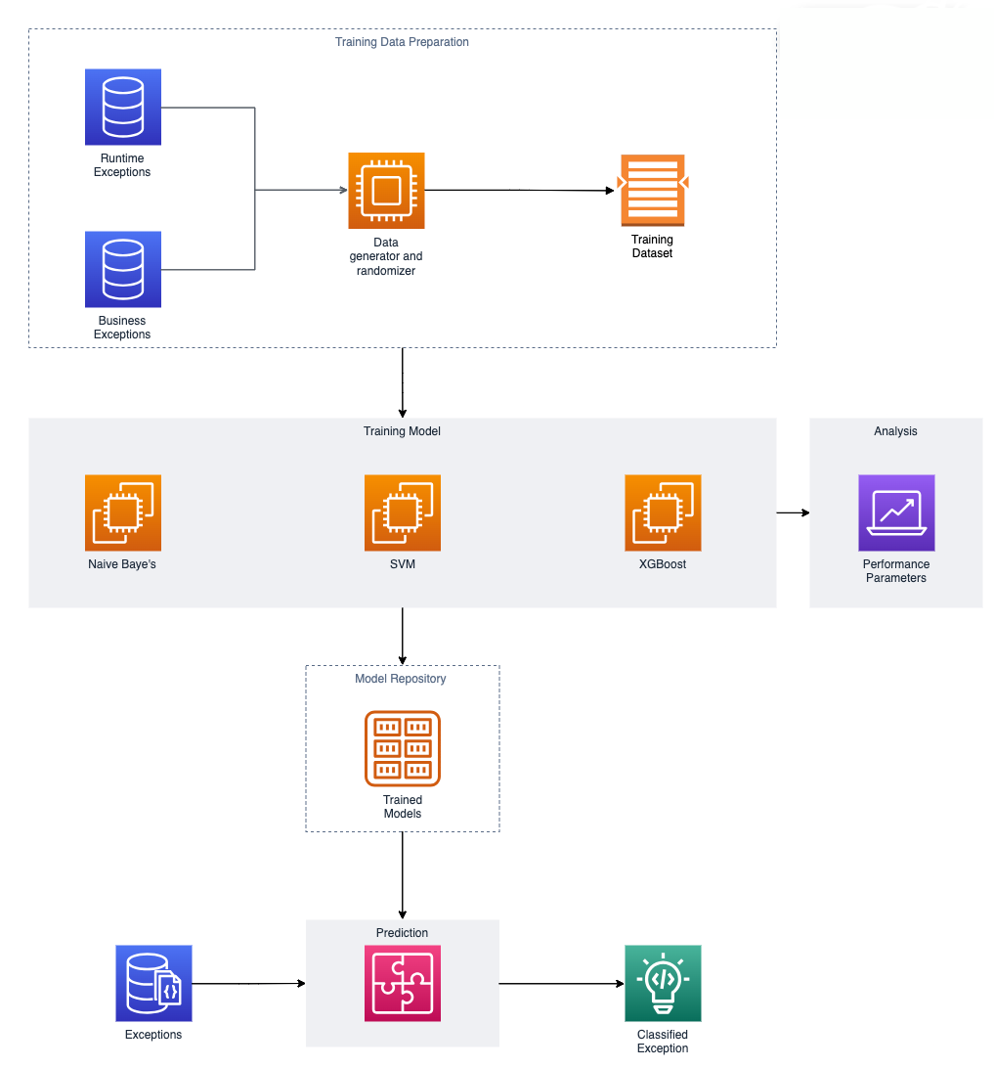

Implementation

Tools & Libraries:
- Python: Primary language used for preposing, training and deploying the model.
- Scikit-learn: Famous Scikit learn library to prepose & train the model.
- Joblib: To save trained model and load saved model for future use.
- Flask: To deploy model as rest api which will serve http requests to classify exceptions.
- Github: For source code management.

Algorithms:
- TF-IDF: TF-IDF (Term Frequency-Inverse Document Frequency) is an NLP technique gauging term importance in a document within a larger corpus. It weighs term frequency in a document against its occurrence across multiple documents. TF measures term frequency within a specific document, while IDF assesses term rarity in the corpus. Combining these values assigns weights to terms, prioritizing those relevant to a document but less common overall. TF-IDF aids tasks like text classification and information retrieval by identifying significant terms.
- Naive Bayes: It is a classification algorithm based on Bayes' theorem, assuming independence among features. It calculates the probability of a data point's class given its features' probabilities. Despite its simplifying assumption of feature independence (naivety), it's efficient, especially for text classification and spam filtering tasks, handling large datasets due to its speed and simplicity.
- Support Vector Machines (SVM): These are robust supervised learning models adept at finding the optimal hyperplane in a high-dimensional space to classify data points into different classes. By maximizing the margin—distance between the hyperplane and support vectors—SVMs achieve superior generalization. They utilize various kernel functions for linear and nonlinear data, enabling capture of intricate data relationships.
- XGBoost: eXtreme Gradient Boosting is an acclaimed machine learning algorithm recognized for its ensemble-based approach and exceptional performance in predictive tasks. Employing a gradient boosting framework, XGBoost iteratively improves weak learners, like decision trees, to minimize loss and enhance predictive accuracy. Leveraging techniques like regularization and parallel computing, it excels in scalability and efficiency for classification and regression tasks.

Training Analysis:
 | Naive Baye’s | SVM | XGBoost
precision | 1 | 1 | 1
recall | 1 | 1 | 1
f1-score | 1 | 1 | 1

Results

Model Training:
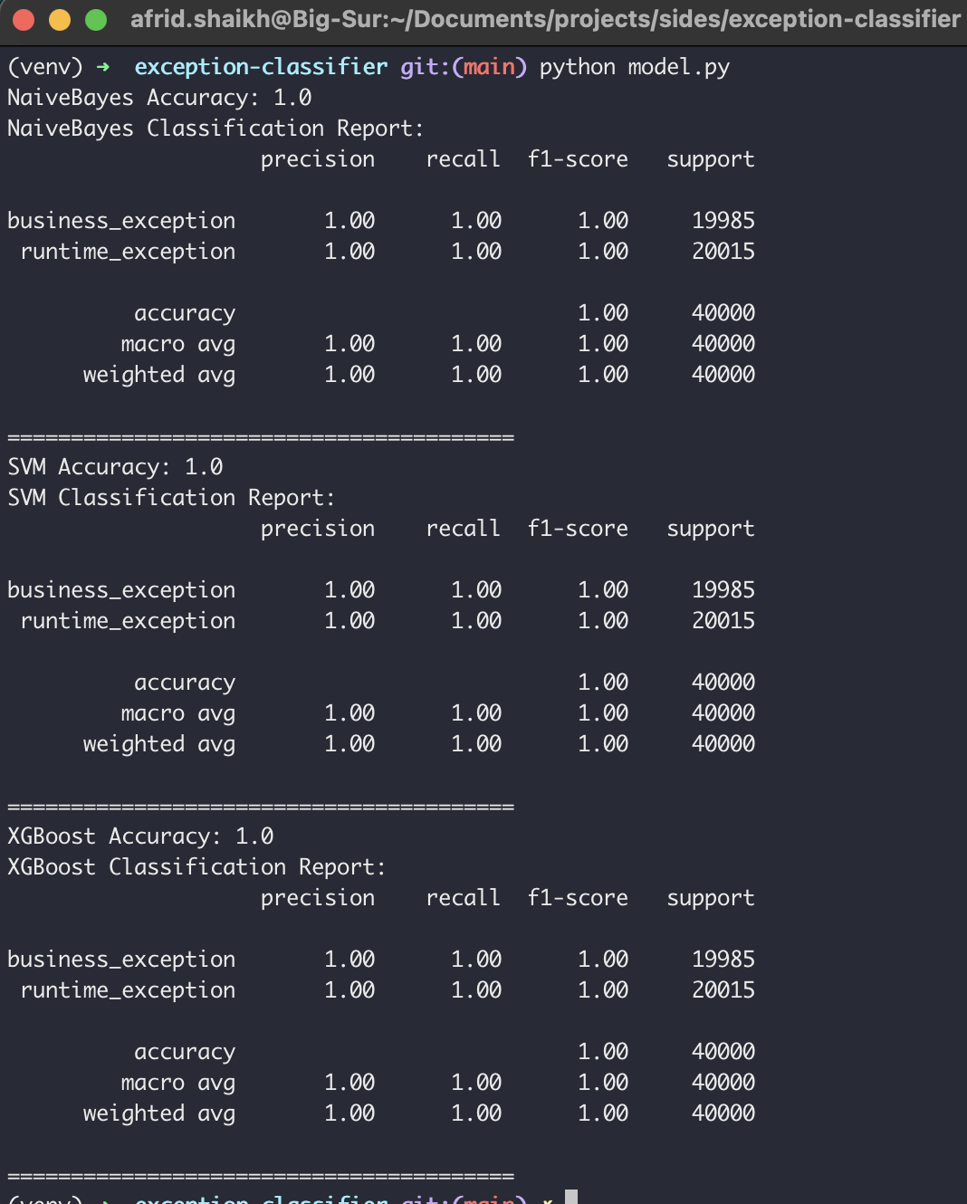

Model Prediction:
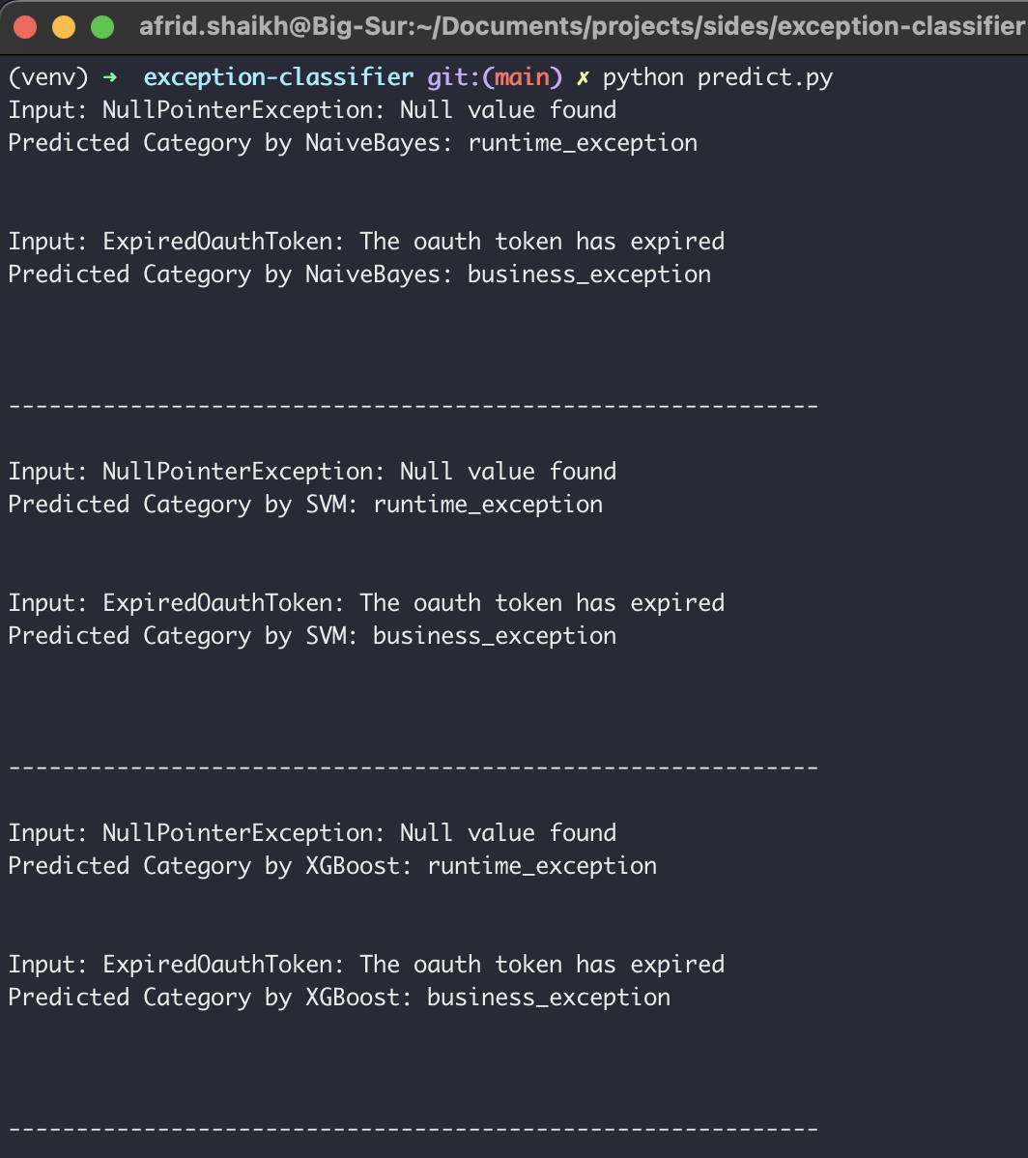

Deployed Model Custom Data Prediction:
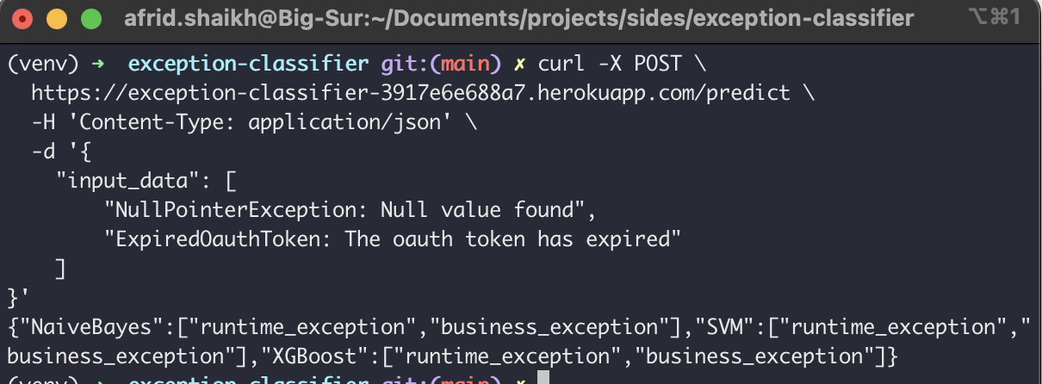

Conclusion

In conclusion, the structured approach outlined in this system enables the effective classification of business and runtime exceptions by leveraging diverse datasets and employing advanced machine learning algorithms. Through data preprocessing, including cleaning, normalisation, and feature extraction, the models are equipped to comprehend and categorise exception texts accurately. The evaluation process, employing metrics like F1-score, recall, and precision, ensures the models are capable of classifying the exception.
This systematic methodology enables the selected models to consistently provide optimal performance in distinguishing between business and runtime exceptions. These efforts give classifiers that showcase superior accuracy, precision, and recall, effectively capturing the nuances of diverse exception types encountered in software systems. By deploying the model, which reflects the culmination of rigorous training, evaluation, and selection, organisations can confidently utilise it for real-time exception categorization, facilitating prompt identification and resolution of issues in software applications.

