AFRIMAPESA
A Unified Cross-Border Financial Comparison & Intelligence Platform for Africa

Founder & Chief Executive Officer: | Claudio Mlamka
Chief Technology Officer & Co-Founder: | Bruno Ganontha
Company Name: | AFRIMAPESA International Limited
Registered Jurisdiction: | London, UK
1. Executive Summary & Project Vision
AfrimaPesa is an upcoming African financial intelligence and aggregator platform designed to empower individuals, diaspora communities, institutional investors, and businesses with real-time financial transparency. The African continent suffers from severe financial market fragmentation, opaque foreign exchange (FX) pricing, hidden cross-border fees, and disparate banking and sovereign yield data.
The primary objective of this project is to build a high-performance, modular, and scalable web and API platform that aggregates, normalizes, and compares data across six core financial pillars:
- Pillar 1: Remittance Cost Comparison Engine - Real-time cost comparison across money transfer operators (MTOs) and fintechs for major diaspora corridors connecting the US, UK, and EU to key African economies (Nigeria, Ghana, Kenya, Tanzania, Egypt, and South Africa).
- Pillar 2: Commercial Banking Rates Comparison - Side-by-side tracking of retail/commercial deposit interest rates (Fixed Deposits, Savings) and lending rates (Personal, Business, Mortgages) across Tier-1 and Tier-2 banks in the six target countries.
- Pillar 3: Sovereign Yield & Debt Tracker - Real-time and daily tracking of African government Treasury Bills (T-Bills), local currency sovereign bonds, and foreign currency Sovereign Eurobonds to evaluate yield curves, inflation-adjusted real returns, and credit risk.
- Pillar 4: Expert Commentary & Insights - A platform enabling financial experts to publish commentaries, analysis, and insights on African economies, market trends, and financial dynamics.
- Pillar 5: Local FX Rates Comparison - Side-by-side tracking and comparison of local interbank and retail foreign exchange rates across target markets (future expansion).
- Pillar 6: Insurance Products Comparison - Evaluation and side-by-side comparison of life, non-life, and specialized insurance products across target markets (future expansion).
Note: Users can select a specific country of focus or the region as a whole upon initial entry, establishing a global default setting across all pages that remains adjustable at any time. Furthermore, users may voluntarily submit contact details to receive tailored updates and notifications regarding specific countries or regional developments.

2. Geographic Scope & Target Markets
The platform's initial rollout is strictly bounded by the following geographic and corridor specifications. The system data schema is designed to dynamically scale to additional countries without requiring code refactoring.
Sending Region / Currency | Receiving Country | Receiving Currency | Key Financial Hub / Regulator
US / UK / EU | Nigeria | NGN (Nigerian Naira) | Central Bank of Nigeria (CBN)
US / UK / EU | Ghana | GHS (Ghanaian Cedi) | Bank of Ghana (BoG)
US / UK / EU | Kenya | KES (Kenyan Shilling) | Central Bank of Kenya (CBK)
US / UK / EU | Tanzania | TZS (Tanzanian Shilling) | Bank of Tanzania (BoT)
US / UK / EU | Egypt | EGP (Egyptian Pound) | Central Bank of Egypt (CBE)
US / UK / EU | South Africa | ZAR (South African Rand) | South African Reserve Bank (SARB)
3. Core Module: Remittance Cost Comparison Engine
The Remittance Engine calculates the true effective cost of sending money across 18 active corridor pairs (3 Origins x 6 Destinations). Most providers advertise 'zero transfer fees' while hiding markup in foreign exchange rates. AfrimaPesa reveals the true total cost to the end user.
3.1 Mathematical Model & Calculation Engine
The calculation engine processes specific user inputs, including the Sending Country/Currency (C_send), Receiving Country/Currency (C_recv), and Transfer Amount (A), to evaluate and rank the top 5 providers offering the best deal based on net payout:
- Real time Exchange Rate (FX_mid): The real-time interbank reference rate retrieved from official FX feeds for the selected currency pair. FX pairs involving USD (e.g., USD/NGN) are sourced from Open Exchange Rates, while EUR pairs (e.g., EUR/NGN) are sourced from Exchange Rate-API and GBP pairs (e.g., GBP/NGN) are sourced from Currency Freaks. For other currency combinations, the cross rate is calculated using USD pairs (for example, NGN/KES is calculated as 1/(USD/NGN) × (USD/KES)).
- Provider Offered Rate & Effective Rate: The actual exchange rate offered by the MTO, and the effective rate calculated as Effective Rate = Net Received Amount / Amount.
- Explicit Transfer Fee: The upfront fixed or percentage-based fee charged by the provider (F_transfer = F_flat + (A * F_pct)).
- Net Payout Amount: The actual payout received: A_net = (A - Explicit_Transfer_Fee) * FX_prov.
- Top 5 Deal Ranking Logic: Providers are sorted and ranked 1 through 5 in descending order of Net Recipient Amount (A_net), clearly presenting the best financial value to the user alongside the live mid-market rate (FX_mid), effective exchange rate, and total transfer time.
3.2 Target Providers & Integration Methods
Provider Name | Supported Corridors | Primary Data Source | Update Frequency
Wise (formerly TransferWise) | US, UK, EU -> NG, GH, KE, ZA, EG | Public REST API / Webhooks | Real-Time (5 mins)
Remitly | US, UK, EU -> All 6 Countries | Headless Browser / Playwright | Hourly
WorldRemit | US, UK, EU -> All 6 Countries | Internal API Scraper | Hourly
Western Union | US, UK, EU -> All 6 Countries | Web Scraping / HTML Parsing | Every 3 Hours
MoneyGram | US, UK, EU -> All 6 Countries | Web Scraping / HTML Parsing | Every 3 Hours
LemFi | US, UK, EU -> NG, GH, KE, TZ | Mobile App API Reverse Eng / Web | Hourly
Sendwave | US, UK, EU -> NG, GH, KE, TZ, EG | Mobile App API Reverse Eng | Hourly
NALA | US, UK, EU -> NG, GH, KE, TZ, ZA | Partner API / Web Scraper | Hourly
Chipper Cash | US, UK -> NG, GH, KE, ZA | Partner API / Mobile App API | Hourly
Flutterwave (Send by FLW) | US, UK, EU -> NG, GH, KE, TZ, ZA, EG | Public API / Partner API | Hourly
OPay | US, UK, EU -> NG, EG | Mobile App API Reverse Eng | Hourly
Revolut | UK, EU -> NG, GH, KE, ZA, EG | Public API / Headless Browser | Hourly
Taptap Send | US, UK, EU -> NG, GH, KE, EG | Mobile App API Reverse Eng | Hourly
OFX | US, UK, EU -> ZA, KE, NG | Public API / Web Scraping | Every 3 Hours
XE Money Transfer | US, UK, EU -> All 6 Countries | XE Public API / Web Scraping | Hourly

Below is a sample mockup illustrating the proposed dashboard layout for the Remittance Cost Comparison tool:
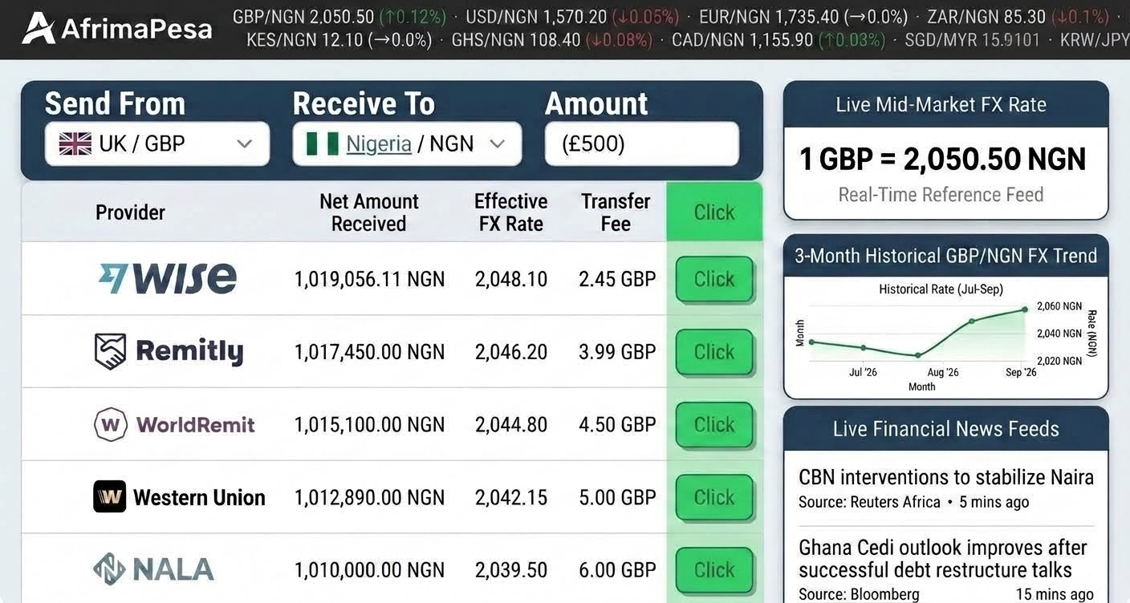
4. Core Module: Commercial Banking Rates Comparison
This section allows users to select a country to view commercial banking rates, featuring nominal interest rates sorted from lowest to highest across lending rates (including mortgage rates), deposit rates, and inflation-adjusted deposit rates. Users can also select or add a bank if it does not appear in the predefined list.
4.1 Financial Metrics & Definitions
- Nominal Interest Rate (%): The unadjusted annualized interest rate published by the commercial bank.
- Annual Percentage Yield (APY %): The effective annual rate taking into account compounding frequency: APY = (1 + r/n)^n - 1.
- Tenor / Maturity Duration: Standardized buckets: 30 Days, 91 Days, 180 Days, 365 Days (Fixed Deposits) or 1Y, 3Y, 5Y, 15Y, 20Y (Lending).
4.2 Sample Target Commercial Banks Matrix
Country | Central Bank | Sample Tier-1 Commercial Banks Tracked
Nigeria | CBN | Zenith Bank, GTBank, Access Bank, FirstBank, UBA, Stanbic IBTC
Ghana | BoG | Ecobank Ghana, GCB Bank, Stanbic Bank, Absa Bank Ghana, CalBank
Kenya | CBK | Equity Bank, KCB Bank, NCBA Bank, Co-operative Bank, Absa Kenya
Tanzania | BoT | CRDB Bank, NMB Bank, Stanbic Bank Tanzania, NBC Tanzania
Egypt | CBE | National Bank of Egypt (NBE), Banque Misr, CIB Egypt, QNB Alahli
South Africa | SARB | Standard Bank, FirstRand (FNB), Absa Group, Nedbank, Capitec
4.3 Sample Display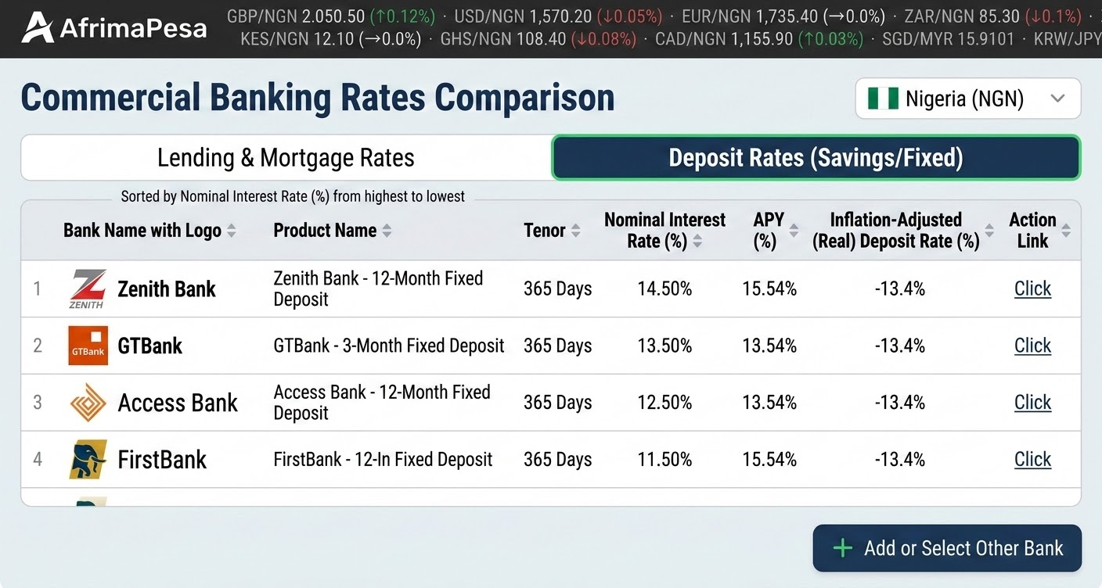
5. Core Module: Sovereign Debt Yield Tracker
The Sovereign Debt Engine tracks national Treasury Bills, local currency government bonds, and foreign currency Eurobonds across the 6 focus African nations. This provides macroeconomic insight for investors and institutional users.
5.1 Debt Instrument Categories
- Treasury Bills (T-Bills): Short-term sovereign debt instruments issued at a discount with tenors of 91 Days, 182 Days, and 364 Days.
- Local Currency Government Bonds: Medium-to-long term sovereign debt (2Y, 5Y, 10Y, 15Y, 20Y, 30Y) issued in local currencies (NGN, KES, ZAR, etc.).
- Sovereign Eurobonds: USD or EUR denominated international bonds issued by African sovereigns traded on Euroclear / London Stock Exchange.
5.2 Key Analytics & Calculated Metrics
- Yield to Maturity (YTM %): The total annualized return anticipated on a bond if held until maturity.
- Real (Inflation-Adjusted) Yield: Real Yield = [(1 + Nominal YTM) / (1 + Annual Inflation Rate)] - 1. Crucial for assessing real wealth preservation in high-inflation environments (e.g., Nigeria, Egypt).
- Credit Ratings Matrix: Tracking S&P, Fitch, and Moody's ratings for each sovereign (e.g., B-, B3, AAA).
- Yield Curve Interpolation: Algorithmic generation of full yield curves using Cubic Spline or Nelson-Siegel model based on benchmark tenors.
5.3 Sovereign Debt Metrics Reference Table
Country | T-Bill Tenors Tracked | Local Bond Tenors | Eurobond Currencies | Primary Data Source
Nigeria | 91D, 182D, 364D | 2Y, 5Y, 10Y, 20Y, 30Y | USD | CBN / Debt Management Office (DMO) / FMDQ
Ghana | 91D, 182D, 364D | 2Y, 3Y, 5Y, 10Y, 15Y | USD | Bank of Ghana (BoG) / Ghana Stock Exchange
Kenya | 91D, 182D, 364D | 2Y, 5Y, 10Y, 15Y, 25Y | USD | Central Bank of Kenya (CBK) / NSE
Tanzania | 35D, 91D, 182D, 364D | 2Y, 5Y, 7Y, 10Y, 15Y, 20Y, 25Y | USD | Bank of Tanzania (BoT) / DSE
Egypt | 91D, 182D, 273D, 364D | 2Y, 3Y, 5Y, 7Y, 10Y | USD, EUR | Central Bank of Egypt / Ministry of Finance
South Africa | 1M, 3M, 6M, 12M | R186 (3Y), R2030 (7Y), R2048 (24Y) | USD | SARB / JSE (Johannesburg Stock Exchange)
6. Admin Management Panel & Overrides
The developer must build a secure, internal Web Admin Dashboard (accessible at `admin.afrimapesa.com`) built with Next.js Admin components or Retool integration.
- Manual Rate Override Interface: Ability for AfrimaPesa operations staff to manually set or update bank interest rates or MTO fees if a scraper breaks or during market volatility.
- Scraper Health Monitor Dashboard: Live monitoring of all scheduled scraper tasks, showing success/failure logs, execution timestamps, and error traces.
- Audit Logging System: Every manual edit or automatic rate update must generate an immutable audit log entry recording `user_id`, `field_changed`, `old_value`, `new_value`, and `timestamp`.
7. Developer Implementation Roadmap
The development phase is broken down into four sequential 4-week sprints (16 weeks total to Production V1.0 launch).
Sprint Phase | Core Focus & Deliverables | Target Completion
Phase 1 (Weeks 1-4) | Infrastructure setup (AWS/GCP, Docker, Postgres/TimescaleDB, Redis). Core database schema migration. Remittance Ingestion Engine & Wise/Remitly API integrations. | End of Month 1
Phase 2 (Weeks 5-8) | Commercial Banking Module setup. Bank rate web scrapers for NG, GH, KE, TZ, EG, ZA. Admin CMS for manual rate verification and override workflow. | End of Month 2
Phase 3 (Weeks 9-12) | Sovereign Yield Tracker setup. Central Bank & DMO PDF/web scrapers. Yield curve calculation algorithms & Recharts visualization frontend. | End of Month 3
Phase 4 (Weeks 13-16) | End-to-End system integration, UI polish, load testing (Locust), Redis cache optimization, security auditing, production deployment on Kubernetes/ECS. | End of Month 4

