Ideation Phase
Empathize & Discover

Date | 31 January 2025
Team ID
Project Name | Script-Controlled ACL – Restrict Record Access Based on Field Value
Maximum Marks | 4 Marks

Empathy Map Canvas:
An empathy map is a simple, easy-to-digest visual that captures knowledge about a user’s behaviours and attitudes.

It is a useful tool to helps teams better understand their users.
Creating an effective solution requires understanding the true problem and the person who is experiencing it. The exercise of creating the map helps participants consider things from the user’s perspective along with his or her goals and challenges.

Example: Script-Controlled ACL – Restrict Record Access Based on Field Value

What does he THINK AND FEEL?
• “Will restricted records leak to users who should not see them?”
• “Will my script accidentally block legitimate users?”
• Worried about audit findings and data-privacy compliance
• Wants precise, record-level security that is easy to maintain
What does he HEAR?  • Manager: “Sensitive records must only be visible to the right people.”  • Colleagues: “Role-based ACLs are simpler, just use those.”  • Auditors: “Show how access is restricted per record.”  • Users: “I can’t open my own ticket!” | What does he SAY AND DO?  • Writes ACL scripts that check a field value (e.g., Confidential) using current.<field>  • Sets answer = true / false based on user role and field value  • Tests with impersonation and different roles  • Reviews ACL evaluation order and system logs | What does he SEE?  • Role-only ACLs exposing every record in a table to all role holders  • Sensitive records visible in lists and reports  • Inconsistent results between users  • ACL script errors and hard-to-trace denials in logs
PAIN  • Role-based ACLs are too coarse for record-level rules  • Scripts are hard to test and debug  • Fear of over-blocking or leaking data  • Confusing ACL evaluation order | GAIN  • Only authorized users see records with restricted field values  • Compliance and audit confidence  • Least-privilege access with clear, reusable logic  • Fewer support tickets about access issues

Reference: https://www.mural.co/templates/empathy-map-canvas

Ideation Phase
Define the Problem Statements

Date | 31 January 2025
Team ID
Project Name | Script-Controlled ACL – Restrict Record Access Based on Field Value
Maximum Marks | 2 Marks

Customer Problem Statement Template:
Create a problem statement to understand your customer's point of view. The Customer Problem Statement template helps you focus on what matters to create experiences people will love.
A well-articulated customer problem statement allows you and your team to find the ideal solution for the challenges your customers face. Throughout the process, you’ll also be able to empathize with your customers, which helps you better understand how they perceive your product or service.

Reference: https://miro.com/templates/customer-problem-statement/
Example:


Problem Statement(PS) | I am (Customer) | I’m trying to | But | Because | Which makes  me feel
PS-1 | A ServiceNow admin protecting student data | restrict access so only EEE branch users can view EEE records | any user with table access can see records of every branch | the table has no role check or Branch field condition on read access | Worried and concerned about data exposure
PS-2 | An EEE branch user with the bb1 role | view, create, edit and delete only my branch's student records | I can only view records and cannot create, edit or delete them | Create, Write and Delete ACLs each need separate roles (bb2, bb3, bb4) | Frustrated and blocked from doing my work

Ideation Phase
Brainstorm & Idea Prioritization Template

Date | 31 January 2025
Team ID
Project Name | Script-Controlled ACL – Restrict Record Access Based on Field Value
Maximum Marks | 4 Marks

Brainstorm & Idea Prioritization Template:

Brainstorming provides a free and open environment that encourages everyone within a team to participate in the creative thinking process that leads to problem solving. Prioritizing volume over value, out-of-the-box ideas are welcome and built upon, and all participants are encouraged to collaborate, helping each other develop a rich amount of creative solutions.

Use this template in your own brainstorming sessions so your team can unleash their imagination and start shaping concepts even if you're not sitting in the same room.

Reference: https://www.mural.co/templates/brainstorm-and-idea-prioritization

Step-1: Team Gathering, Collaboration and Select the Problem Statement

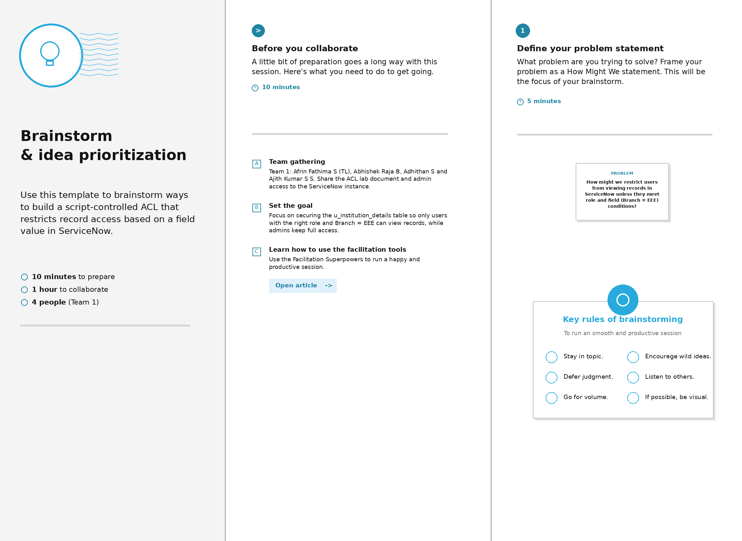

Step-2: Brainstorm, Idea Listing and Grouping

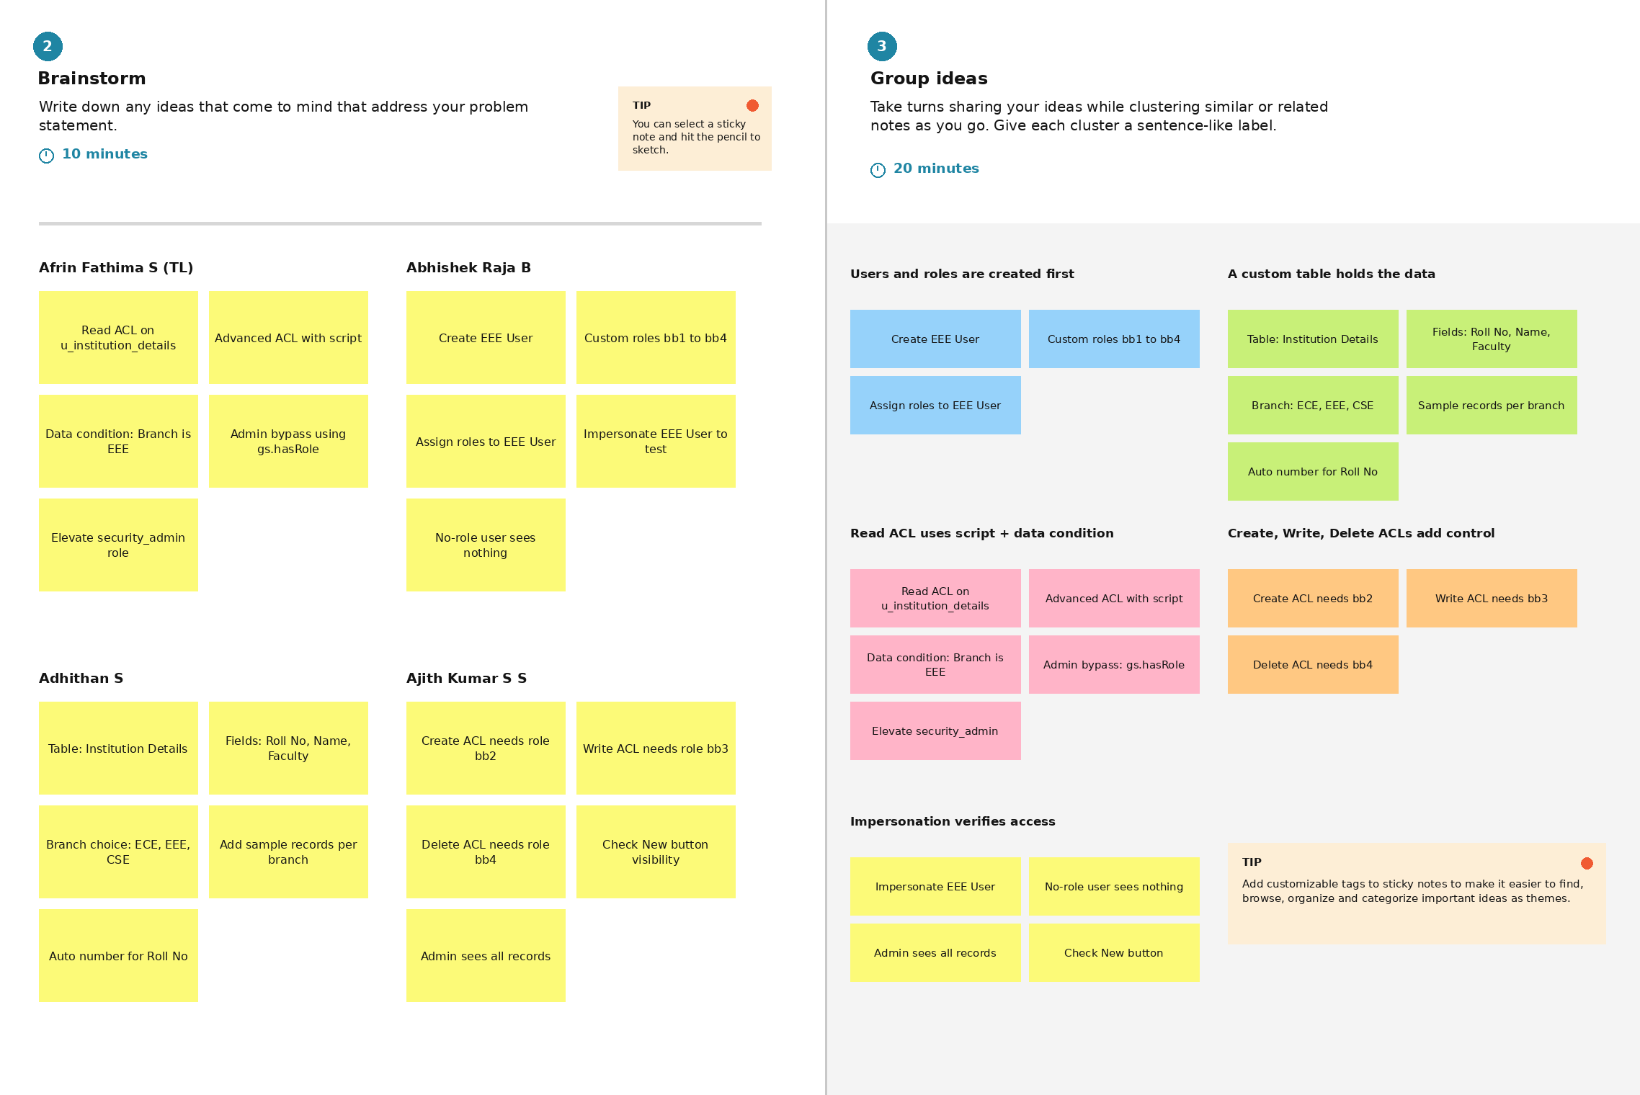

Step-3: Idea Prioritization

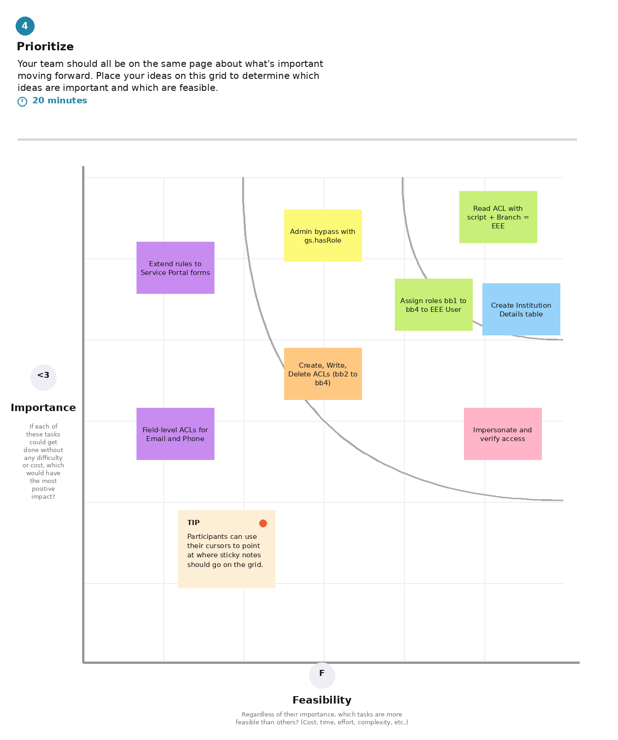

Project Task Assignment – Milestones

Milestone (Epic) | Task | Assigned to | Time | Level | Status
Milestone-1: Creation of Users and Roles | Users Creation | Abhishek Raja B | 30m | Easy | To do
Milestone-1: Creation of Users and Roles | Roles Creation | Adhithan S | 30m | Easy | To do
Milestone-2: Tables Creation | Creation of Table | Abhishek Raja B | 20m | Easy | To do
Milestone-3: Creation of Access Control List - READ | ACL Configuration (READ) | Adhithan S | 1h 0m | Easy | To do
Milestone-4: Creation of Access Control List - CREATE | Creation of ACL - Create | Afrin Fathima (Team Leader) | 6h 4m | Easy | To do
Milestone-5: Creation of Access Control List - WRITE | Creation of ACL - Write | Ajith Kumar S S | 3h 0m | Easy | To do
Milestone-6: Creation of Access Control List - DELETE | Creation of ACL - Delete | Ajith Kumar S S | 30m | Easy | To do
Milestone-7: Conclusion | Project Outcome | Afrin Fathima (Team Leader) | 10m | Easy | To do

