Project Planning Phase
Project Planning Template (Product Backlog, Sprint Planning, Stories, Story points)

Date | 03 October 2026
Team ID
Project Name | Script-Controlled ACL – Restrict Record Access Based on Field Value
Maximum Marks | 5 Marks

Planning Logic
Team Members: Afrin Fathima S (Team Lead), Adhithan S, Abhishek Raja, Ajith Kumar S S
Sprint: a fixed period or duration in which the team works to complete a set of tasks.
Epic: a big task or project that is too large to complete in one sprint. It is broken down into smaller tasks (stories) that can be completed over multiple sprints.
Story: a small task that is part of an Epic.
Story Point: a number that represents how much effort a story takes to complete (usually in the form of the Fibonacci series). Story point scale used: 1 – Very Easy task, 2 – Normal task, 3 – Moderate task, 5 – Difficult task.

Product Backlog, Sprint Schedule, and Estimation (4 Marks)
Use the below template to create product backlog and sprint schedule
Sprint | Functional Requirement (Epic) | User Story Number | User Story / Task | Story Points | Priority | Team Members
Sprint-1 | Requirement Analysis | USN-1 | As an administrator, I can analyse the requirement and identify the table and the field whose value will be used to restrict record access. | 2 | High | Afrin Fathima S
Sprint-1 |  | USN-2 | As an administrator, I can create the custom table and the restricting field (e.g., Confidentiality / Department) and load sample records. | 3 | High | Adhithan S
Sprint-1 | Role & Access Setup | USN-3 | As an administrator, I can create the required roles and groups and assign them to test users. | 2 | High | Abhishek Raja
Sprint-1 | ACL Script Development | USN-4 | As a developer, I can create a read ACL with a script condition that checks the field value so that users see only the permitted records. | 5 | High | Afrin Fathima S, Ajith Kumar S S
Sprint-1 |  | USN-5 | As a developer, I can create a write ACL script that restricts editing of records based on the field value. | 3 | Medium | Adhithan S
Sprint-2 | Testing & Validation | USN-6 | As a tester, I can impersonate users with different roles and verify that restricted records are hidden or visible as expected. | 3 | High | Abhishek Raja
Sprint-2 |  | USN-7 | As a tester, I can validate edge cases (empty field value, changed field value, administrator access). | 3 | Medium | Ajith Kumar S S
Sprint-2 |  | USN-8 | As a developer, I can fix the defects found during testing and re-validate the ACL scripts. | 2 | Medium | Adhithan S
Sprint-2 | Deployment & Documentation | USN-9 | As an administrator, I can move the ACL configuration to the target instance using an update set. | 3 | Medium | Afrin Fathima S
Sprint-2 |  | USN-10 | As a team member, I can prepare the project documentation and demo of the script-controlled ACL. | 2 | Low | Abhishek Raja

Project Tracker, Velocity & Burndown Chart: (4 Marks)
Sprint | Total Story Points | Duration | Sprint Start Date | Sprint End Date (Planned) | Story Points Completed (as on Planned End Date) | Sprint Release Date (Actual)
Sprint-1 | 15 | 6 Days | 05 Oct 2026 | 10 Oct 2026
Sprint-2 | 13 | 6 Days | 12 Oct 2026 | 17 Oct 2026

Velocity:
Imagine we have a 10-day sprint duration, and the velocity of the team is 20 (points per sprint). Let’s calculate the team’s average velocity (AV) per iteration unit (story points per day)

Velocity calculation for our project:
Sprint-1 = 2+3+2+5+3 = 15 story points
Sprint-2 = 3+3+2+3+2 = 13 story points
Total story points = 15 + 13 = 28; number of sprints = 2
Velocity = Total Story Points Completed / Number of Sprints = 28 / 2 = 14 story points per sprint
Sprint duration = 6 days, so Average Velocity (AV) = 14 / 6 ≈ 2.33 story points per day
Our team’s velocity is 14 story points per sprint.

Burndown Chart:
A burn down chart is a graphical representation of work left to do versus time. It is often used in agile software development methodologies such as Scrum. However, burn down charts can be applied to any project containing measurable progress over time.
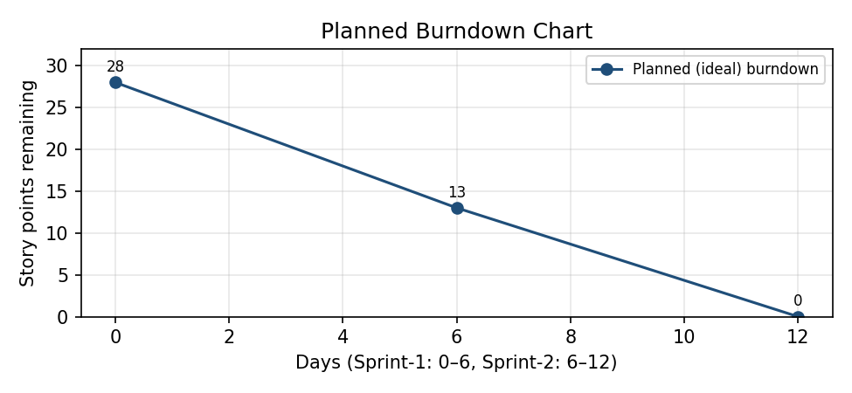
https://www.visual-paradigm.com/scrum/scrum-burndown-chart/
https://www.atlassian.com/agile/tutorials/burndown-charts

Reference:
https://www.atlassian.com/agile/project-management
https://www.atlassian.com/agile/tutorials/how-to-do-scrum-with-jira-software
https://www.atlassian.com/agile/tutorials/epics
https://www.atlassian.com/agile/tutorials/sprints
https://www.atlassian.com/agile/project-management/estimation
https://www.atlassian.com/agile/tutorials/burndown-charts

