**Creating a static website on GCS.**

1. Creating a bucket on GCS as <afrinmomin> bucket name.
2. Using wget to install all the requirements for the website which will be a zip file.

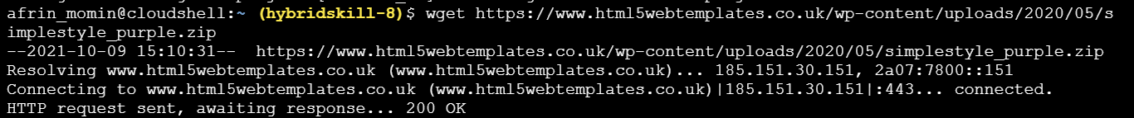

1. Create a directory called web for storing all the files.

Cmd: mkdir web

1. Move that folder simple_purple.zip) to the newly created directory called web.

Cmd: mv simplestyle_purple.zip web/



1. Unzip simplestyle_purple.zip

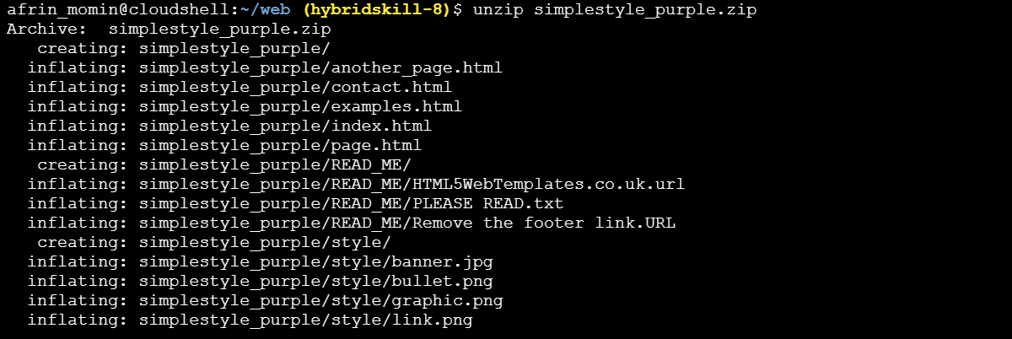



1. Copy the files to the bucket.

Cmd: gsutil –m cp –r simplestyle_purple gs://afrinmomin

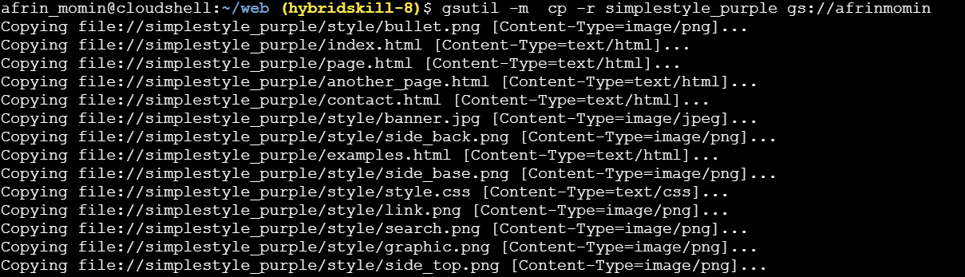

1. All the files can be seen within the bucket called gs://afrinmomin

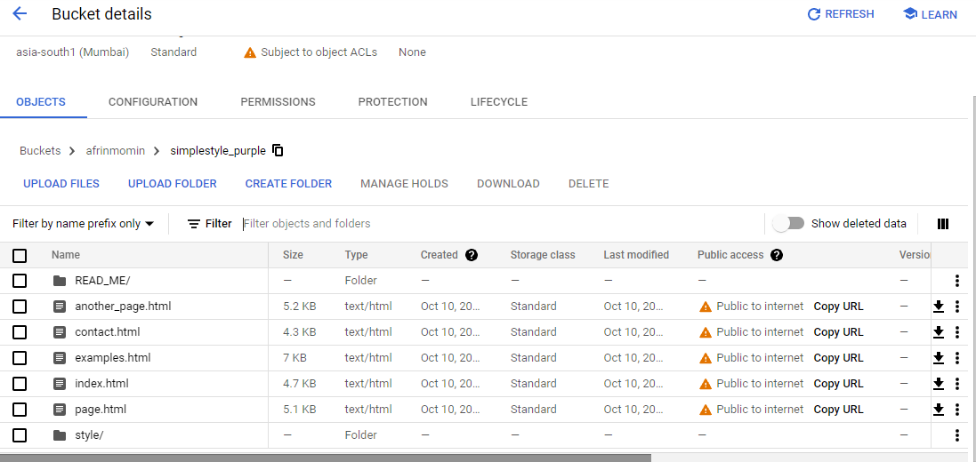

1. Click on the index.html page URL.

