Exploratory Data Analysis
Question 1: Distribution of Order Values and Delivery Time
1. Introduction
This analysis examines the distribution of order values and delivery times in the online food delivery dataset containing 100,000 orders. The objective is to understand customer spending patterns, typical delivery duration, and potential areas for operational improvement.
2. Visualisation
Histograms were generated using Python, Pandas, Matplotlib, and Seaborn to examine the distributions of order values and delivery times. The average order value was 1,786.94, compared with a median of 1,197. The average delivery time was 124.98 minutes, while the median was 120 minutes. Both distributions showed positive skewness.
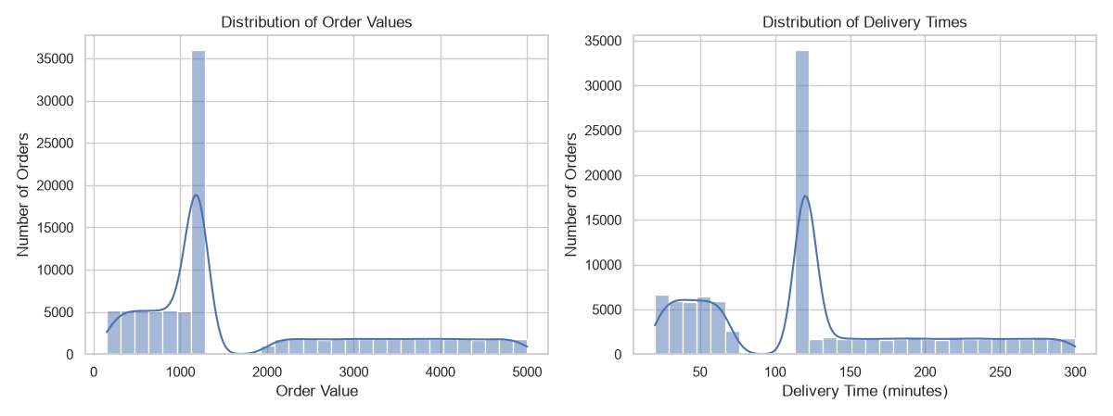
3. Analytical Insights — Problems Identified
The order value distribution is positively skewed (0.972), indicating that higher-value orders pull the average above the median. Delivery time is also positively skewed (0.601), suggesting that some longer deliveries increase the overall average. The mean delivery duration of approximately 125 minutes highlights a potential area for further operational investigation. However, the dataset alone does not establish whether this duration violates the company's delivery target.
4. Analytical Insights — Solutions and Recommendations
The business should investigate the causes of longer delivery times by comparing delivery duration with distance, city, and order demand patterns. Delivery performance should be monitored using median and percentile measures alongside averages. Customer spending can be segmented into value bands to support targeted promotions and menu strategies. These findings should be validated against the original, non-imputed records where possible, because median imputation may influence the observed distributions.

Question 2: City-wise and Cuisine-wise Order Analysis
1. Introduction
This analysis examines the distribution of online food orders across cities and cuisine types. Its objective is to identify locations and food categories with the highest order volumes and understand how these patterns can support operational planning and business decisions.
2. Visualisation
Horizontal bar charts were generated using Python to compare order counts by city and cuisine. Hyderabad recorded the highest city-wise volume, with 33,610 orders (33.61% of the dataset). Indian cuisine was the most frequently ordered cuisine, with 33,570 orders (33.57%). The other four cities and four cuisines each represented approximately 16.5–16.7% of total orders.
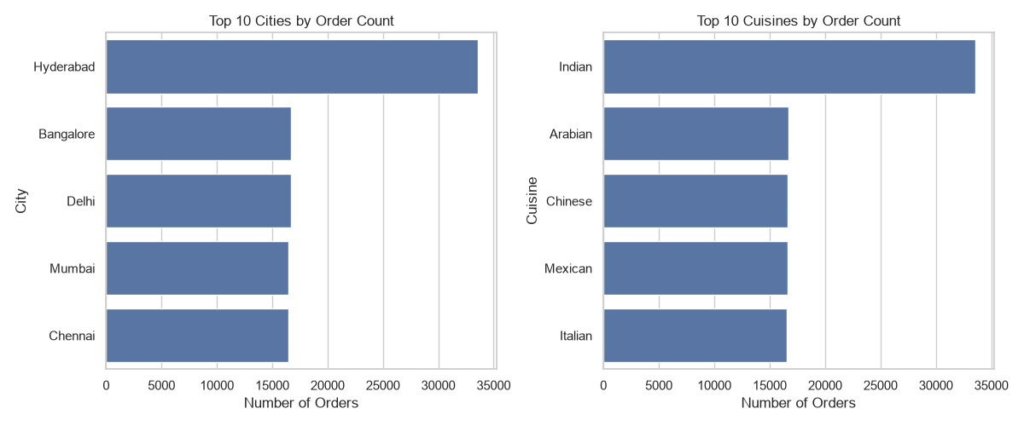.
3. Analytical Insights — Problems Identified
Order volumes are concentrated in Hyderabad and Indian cuisine, each accounting for approximately one-third of all records. This concentration may create operational planning challenges if restaurant capacity, delivery-partner availability, or inventory does not match demand. However, order counts alone cannot confirm resource shortages or poor performance. Further analysis of delivery times, cancellations, revenue, and profitability is required.
4. Analytical Insights — Solutions and Recommendations
The business should review restaurant capacity, inventory availability, and delivery-partner allocation in Hyderabad and for Indian cuisine. Demand forecasts can be used to plan staffing and inventory, while the other cities and cuisine categories should be monitored for growth opportunities. Before allocating additional resources, management should compare revenue, delivery performance, cancellation rates, and profit margins across cities and cuisines to determine where improvements would create the greatest value.
Question 3: Weekend vs Weekday Demand
1. Introduction
This analysis compares online food delivery order volumes on weekdays and weekends. Understanding day-of-week demand helps businesses plan staffing, restaurant capacity, inventory, and delivery-partner availability.
2. Visualisation
A bar chart was generated in Python to compare weekday and weekend order counts. Among the 98,986 records with a known day type, 70,618 orders (71.35%) occurred on weekdays, while 28,368 orders (28.65%) occurred on weekends.
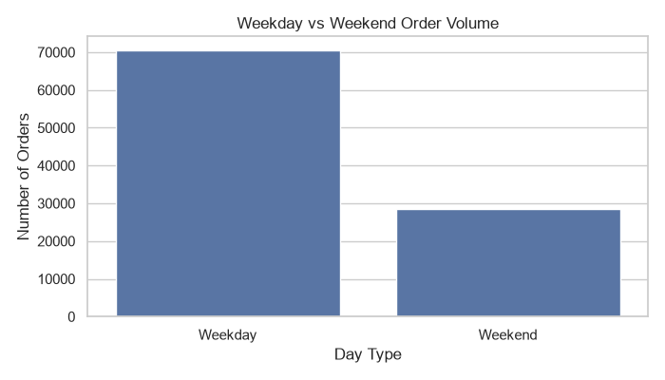3. Analytical Insights — Problems Identified
The dataset contains substantially more weekday orders than weekend orders. This pattern suggests that operational planning should account for differences in demand across the week. However, total counts alone do not establish that an average weekday is busier than an average weekend day, because a typical week contains five weekdays and two weekend days. Average daily order counts should therefore be compared before identifying a specific capacity or staffing problem.
4. Analytical Insights — Solutions and Recommendations
The business should compare average daily orders and delivery performance by day type before adjusting staffing or delivery-partner allocation. If weekday demand is consistently higher per day, staffing and inventory can be scheduled accordingly. Weekend promotions may be considered if daily demand is lower, but their effectiveness should be assessed using revenue, profit margin, and customer engagement rather than order volume alone.
Question 4: Distance vs Delivery Delay Relationship
1. Introduction
The purpose of this analysis is to examine the relationship between delivery distance and delivery time in the online food delivery dataset. Distance is an important operational factor because longer trips may require more travel time. Understanding this relationship can help identify whether delivery distance is a useful indicator for estimating delivery duration and improving delivery operations.
The analysis uses the cleaned food delivery dataset containing 100,000 order records. Python, Pandas, Matplotlib, and Seaborn were used to calculate the correlation coefficient and visualise the relationship between distance in kilometres and delivery time in minutes.
2. Visualisation
A scatter plot with a regression line was created to visualise the relationship between Distance_km and Delivery_Time_Min. The Pearson correlation coefficient was calculated to measure the strength and direction of their linear relationship.
The calculated Pearson correlation coefficient is 0.002. This value is extremely close to zero, indicating that there is virtually no linear correlation between delivery distance and delivery time in the analysed dataset.
The scatter plot can be used to observe how delivery times vary across different distances. The regression line represents the overall linear trend, while the spread of points indicates the variation in delivery duration at different distances.
Figure 4: Relationship Between Delivery Distance and Delivery Time
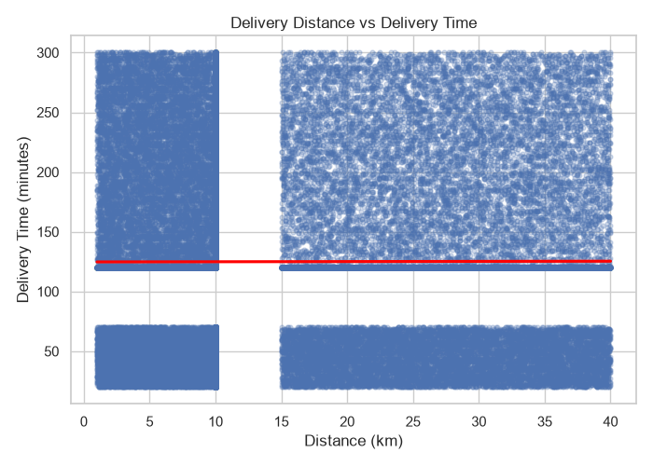3. Analytical Insights (Problems Identified)
The correlation result of 0.002 suggests that delivery distance alone is not a useful predictor of delivery time in this dataset. Orders with different delivery distances may have similar delivery durations, while orders covering similar distances may take different amounts of time.
This finding indicates that other operational factors may influence delivery duration. Potential factors include traffic conditions, restaurant food preparation time, delivery-partner availability, weather conditions, and city-level infrastructure. However, these factors require separate analysis before their actual influence can be established.
A limitation of this analysis is that the cleaned dataset contains median-imputed values for distance and delivery time. These imputed values may influence the observed relationship. In addition, correlation measures linear association and does not establish causation or rule out more complex relationships.
4. Analytical Insights (Solutions/Recommendations)
The organisation should avoid relying on delivery distance alone when estimating delivery time or evaluating delivery performance. A more comprehensive approach should consider additional operational variables.
The following recommendations are suggested:
- Analyse additional factors: Examine delivery time by city, order value, restaurant, order preparation time, and delivery-partner availability where these variables are available.
- Investigate delivery delays: Identify orders with unusually long delivery times and compare their characteristics to determine potential operational bottlenecks.
- Develop a multivariable model: Consider using multiple regression or another suitable predictive method to assess whether several factors together can explain delivery duration more effectively than distance alone.
- Validate the results: Repeat the analysis using records with originally observed distance and delivery-time values to assess the impact of imputation.
- Monitor delivery performance: Track median delivery time and higher percentiles, such as the 90th percentile, to identify unusually slow deliveries and support service improvements.
In conclusion, the Pearson correlation coefficient of 0.002 indicates virtually no linear relationship between delivery distance and delivery time in the analysed data. Further investigation of other operational factors is necessary before making decisions about delivery-time prediction or process improvement.
Question 5: Cancellation Reasons Analysis
1. Introduction
The purpose of this analysis is to identify the major reasons for order cancellations in the online food delivery system. Order cancellations can affect customer satisfaction, restaurant operations, delivery-partner utilisation, and business revenue. Understanding the distribution of cancellation reasons can help identify areas where operational improvements may be required.
The analysis uses the cleaned food delivery dataset containing 100,000 order records. Cancelled orders were selected using the Order_Status column, and the Cancellation_Reason column was analysed to determine the frequency and percentage of each recorded reason.
A total of 15,036 cancelled orders were identified. The reasons were grouped into four categories: Not Recorded, Late Delivery, Customer Cancelled, and Restaurant Issue.
2. Visualisation
A bar chart was created using Python, Pandas, Matplotlib, and Seaborn to compare the number of cancelled orders across the different cancellation reasons.
The analysis produced the following results:
Cancellation Reason | Number of Orders | Percentage
Not Recorded | 6,005 | 39.94%
Late Delivery | 3,059 | 20.34%
Customer Cancelled | 2,993 | 19.91%
Restaurant Issue | 2,979 | 19.81%
Total | 15,036 | 100.00%
The largest category is Not Recorded, accounting for 39.94% of cancellations. Late Delivery is the largest specifically identified reason, representing 20.34% of cancelled orders. Customer Cancelled and Restaurant Issue account for approximately 20% each.
Figure 5: Distribution of Order Cancellation Reasons
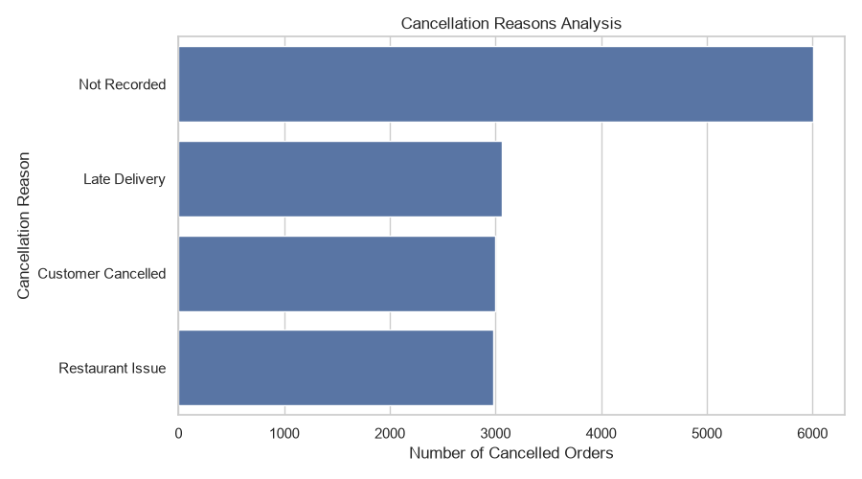3. Analytical Insights (Problems Identified)
The analysis identifies several issues that may require further investigation.
High proportion of unrecorded reasons: A total of 6,005 cancelled orders, representing 39.94%, have no specific cancellation reason recorded. This limits the organisation's ability to understand the underlying causes of cancellations and develop targeted solutions.
Late delivery: Late Delivery accounts for 3,059 cancellations, or 20.34%. This suggests that delivery delays may be an important operational concern. Further investigation is required to identify whether these cancellations
Optional additional analysis: recorded reasons only
The three recorded categories total 9,031 orders. Their percentages among orders with known reasons are:
Recorded reason | Percentage of known reasons
Late Delivery | 33.87%
Customer Cancelled | 33.14%
Restaurant Issue | 32.97%
These percentages describe only the cancellations with a recorded reason; they do not represent all cancellations.

Question 6: Correlation Analysis Among Numeric Features
1. Introduction
The objective of this analysis is to examine the relationships among numerical variables in the online food delivery dataset. Correlation analysis helps identify whether changes in one variable are associated with changes in another variable. These relationships can support business understanding, operational planning, and further data analysis.
The analysis uses the cleaned dataset containing 100,000 order records. Selected numerical features include Order Value, Delivery Time, Distance, Delivery Rating, Restaurant Rating, Final Amount, and Profit Margin. Python, Pandas, Matplotlib, and Seaborn were used to calculate the Pearson correlation matrix and generate a heatmap.
The Pearson correlation coefficient ranges from -1 to +1. A value near +1 indicates a strong positive linear relationship, a value near -1 indicates a strong negative linear relationship, and a value near zero indicates little or no linear relationship.
2. Visualisation
A correlation heatmap was generated to display the relationships among the selected numerical variables. Different colours represent the direction and strength of the correlations, while the values inside the cells indicate the correlation coefficients.
The most notable result is the correlation of 0.998 between Order Value and Final Amount. This indicates an extremely strong positive linear relationship between these two variables.
In contrast, most other variable pairs have correlation coefficients close to zero. For example, the correlation between Delivery Time and Distance is 0.002, indicating virtually no linear relationship in the analysed dataset. The correlations between Order Value and Restaurant Rating (-0.003), and between Final Amount and Profit Margin (-0.006), are also very close to zero.
Figure 6: Correlation Heatmap of Numerical Features
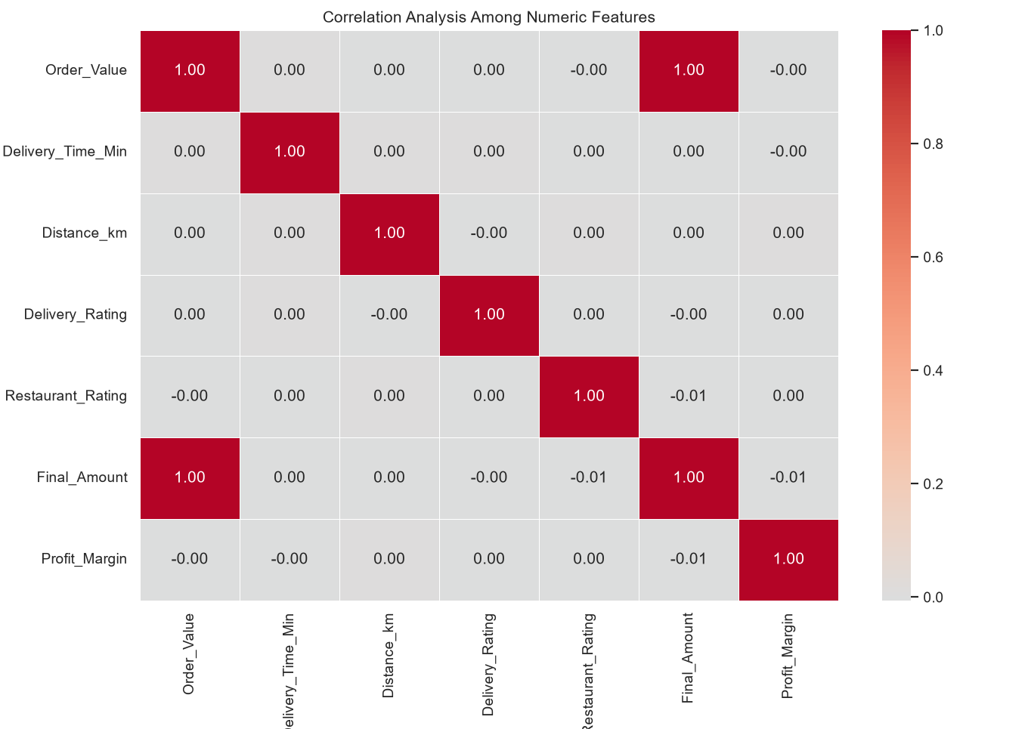3. Analytical Insights (Problems Identified)
The correlation analysis identifies the following observations and potential limitations.
Strong relationship between Order Value and Final Amount: The correlation coefficient of 0.998 indicates that the two variables move very closely together. This may be expected because the final amount is related to the original order value, discounts, and other adjustments. However, the correlation alone does not establish the exact calculation used to derive the final amount.
Weak relationships among most other variables: Most correlation coefficients are close to zero. In particular, delivery time and distance have a correlation of 0.002. This suggests that distance alone does not explain delivery duration through a linear relationship in this dataset.
Limited linear association with ratings: Restaurant Rating has a correlation of -0.003 with Order Value and -0.005 with Final Amount. These values indicate virtually no linear association between these pairs in the analysed data. They do not prove that customer satisfaction has no relationship with purchasing behaviour.
Potential data-quality limitations: The cleaned dataset contains median-imputed values for some numerical variables, and the Final Amount column contains missing values. Imputation may affect the observed correlation coefficients. The strong correlation between Order Value and Final Amount should also be investigated to understand whether the variables contain overlapping information.
Overall, correlation analysis identifies statistical relationships but does not establish causation. Additional analysis is needed to understand business drivers and operational outcomes.
4. Analytical Insights (Solutions/Recommendations)
The following recommendations can help make better use of the correlation analysis.
- Review Order Value and Final Amount: Verify how Final Amount is calculated, including the treatment of discounts and missing values. If both variables are used in predictive models, assess whether their strong relationship introduces redundant information.
- Investigate delivery performance: Analyse delivery time alongside distance, city, and other available operational variables to identify factors that may help explain delivery duration.
- Examine ratings with additional variables: Compare customer and restaurant ratings with cancellation rates, delivery performance, and repeat-order behaviour where suitable data is available.
- Validate correlations: Repeat the analysis using records with originally observed values where possible, and compare the results with those from the cleaned dataset.
- Use suitable statistical methods: Consider additional techniques, such as multiple regression or group-based comparisons, when investigating business questions that cannot be answered through correlation alone.
- Monitor relevant KPIs: Track order value, final amount, delivery time, ratings, and profit-related measures over time to identify meaningful changes in business performance.
In conclusion, the correlation analysis reveals an extremely strong positive relationship between Order Value and Final Amount, with a Pearson correlation coefficient of 0.998. Most other selected numerical variable pairs show very weak linear relationships. These findings provide a starting point for further analysis, while data-quality checks and additional statistical methods are needed before drawing broader business conclusions.

ONLINE FOOD DELIVERY ANALYSIS
Data Analysis Using Python, Exploratory Data Analysis (EDA), and MySQL
Question 1: Identify the Top-Spending Customers
1. Introduction
Customer spending analysis is an important aspect of business analytics because it helps an organization identify its most valuable customers. In the online food delivery industry, understanding customer purchasing behaviour enables businesses to develop effective customer retention strategies, personalized offers, and loyalty programs.
The objective of this analysis is to identify the top-spending customers based on their total spending, number of orders, and average order value. These measures help determine which customers contribute significantly to the business and how frequently they purchase food through the platform.
2. Visualization with Graphs
A horizontal bar chart can be used to compare the total spending of the top ten customers. A second bar chart can compare their average order values. A combination of these visualizations helps distinguish customers who spend frequently from those who place fewer but higher-value orders.
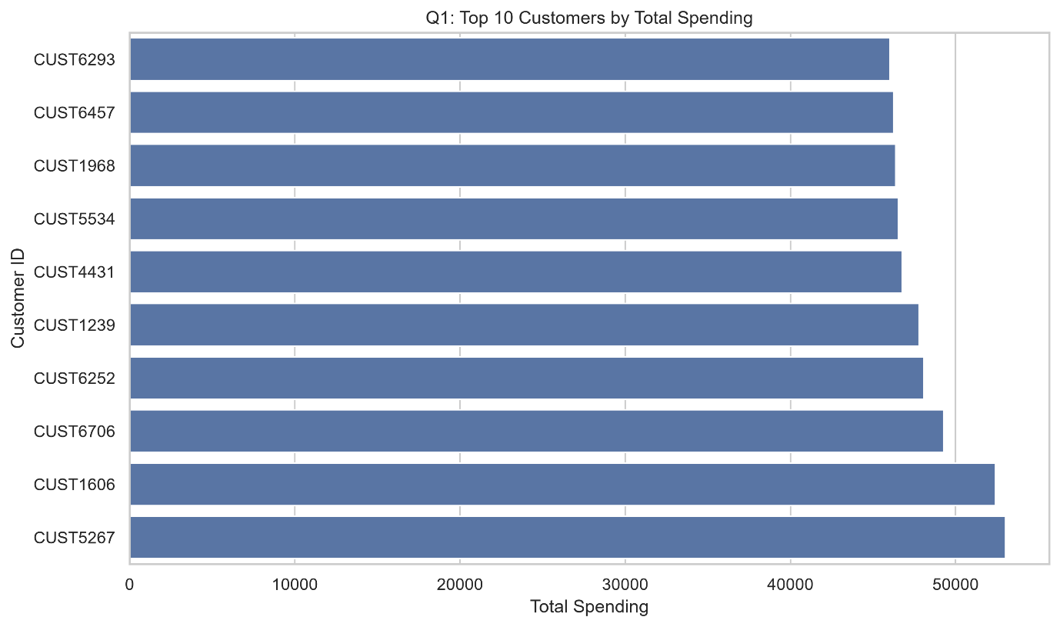3. Analytical Insights — Interpretation and Findings
The analysis identified CUST5267 as the highest-spending customer, with total spending of 49,767 across 19 orders. CUST6706 ranked second, spending 49,269 across 18 orders. CUST1239 and CUST1606 also demonstrated high spending, with totals of 44,959 and 44,935, respectively.
Among the top ten customers, CUST5267, CUST3471, and CUST5530 placed the highest number of orders, with 19 orders each. However, CUST8524 recorded the highest average order value among these customers, at 2,872.80, despite placing 15 orders.
These results demonstrate that customer value depends on both purchase frequency and spending per transaction. A customer who orders frequently may generate high total revenue, while a customer who places fewer but more expensive orders may also contribute significantly.
4. Analytical Insights — My Point of View and What Can Be Done
In my view, the company should develop customer retention strategies based on purchasing behaviour rather than treating all customers equally. High-frequency customers could receive loyalty points, free delivery benefits, and personalized promotions.
Customers with high average order values could be offered premium meal combinations, family packages, and exclusive restaurant recommendations. The company should also monitor changes in spending patterns to identify customers whose activity is declining.
However, spending alone does not indicate profitability. The business should also consider discounts, delivery costs, refunds, and customer acquisition expenses before classifying customers as the most profitable.
Conclusion
Customer spending analysis helps identify valuable customers and supports targeted marketing and retention strategies. Combining total spending, order frequency, and average order value provides a more complete understanding of customer contribution.

Question 2: Analyse the Relationship Between Age Groups and Order Value
1. Introduction
Understanding purchasing behaviour across age groups helps online food delivery companies design marketing strategies for different customer segments. Age can be associated with differences in food preferences, purchasing frequency, spending capacity, and preferred ordering occasions.
The objective of this analysis is to compare the number of orders, average order value, and total order value across different age groups.
2. Visualization with Graphs
chart can display total order value, while a separate chart can compare order counts. These visualizations help distinguish between groups that spend more per transaction and those that contribute more through order volume.
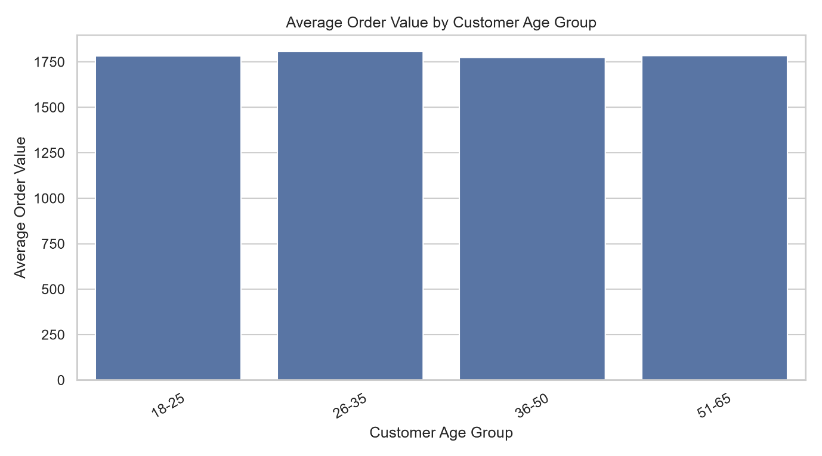3. Analytical Insights — Interpretation and Findings
The 26–35 age group recorded the highest average order value, at 1,811.31, with 9,971 orders and a total order value of 18,060,598.
The 36–50 age group recorded the highest order volume, with 14,805 orders, and the highest total order value, at 26,348,918. Its average order value was 1,779.73.
The 51–65 age group recorded an average order value of 1,792.88, while the 18–25 age group recorded an average of 1,786.67 across 7,883 orders.
The differences in average order value are relatively small. The results suggest that the 26–35 group spends slightly more per order, while the 36–50 group contributes more total value because of its larger number of orders.
4. Analytical Insights — My Point of View and What Can Be Done
In my view, age-based segmentation can support personalized marketing, but it should not be the only factor used to classify customers. The company could test premium meal recommendations for the 26–35 age group and family meal packages or convenience-focused promotions for customers in the 36–50 age group.
Promotional campaigns should be evaluated using conversion rates, repeat purchases, average order value, and profit contribution. The company should avoid assuming that age directly causes spending differences, because income, household size, location, and food preferences may also influence purchasing behaviour.
Conclusion
Age-group analysis reveals modest differences in average order value and substantial differences in total contribution due to order volume. Combining demographic information with actual purchasing behaviour can improve customer segmentation and marketing effectiveness.

Question 3: Compare Weekend and Weekday Ordering Behaviour
1. Introduction
Demand patterns can vary between weekdays and weekends because of differences in work schedules, leisure activities, family gatherings, and eating habits. Analysing these patterns helps food delivery companies plan staffing, delivery capacity, restaurant partnerships, and promotional campaigns.
The objective is to compare delivered order volume and average order value between weekdays and weekends.
2. Visualization with Graphs
A bar chart can compare delivered orders on weekdays and weekends. Another bar chart can compare average order values. If the data covers multiple calendar days, average orders per observed day should also be calculated to account for the different numbers of weekdays and weekend days.
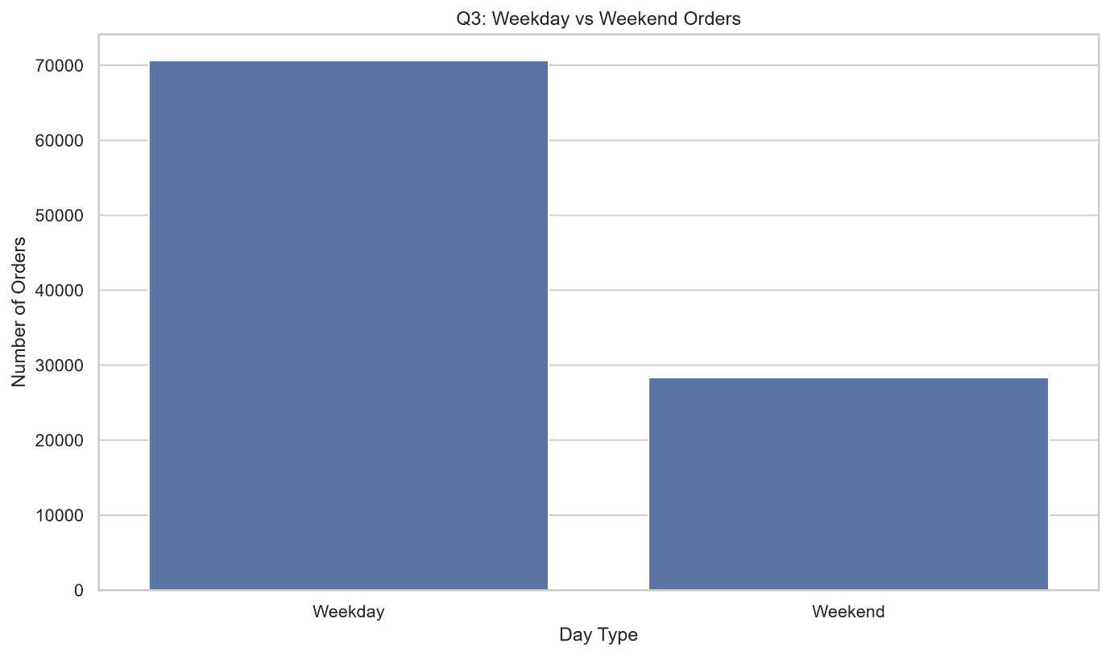Weekday vs Weekend Orders and Average Order Value.
3. Analytical Insights — Interpretation and Findings
The analysis identified 59,991 delivered weekday orders and 24,109 delivered weekend orders in the records used for the SQL analysis. The weekday average order value was 1,790.88, while the weekend average was 1,780.52.
Weekdays therefore recorded a slightly higher average order value. However, the larger weekday order count should not automatically be interpreted as stronger daily demand because a dataset usually contains more weekdays than weekend days.
A separate examination of valid weekend indicators found that weekdays accounted for 71.35% of records and weekends accounted for 28.65%. Average orders per observed calendar day were approximately 270.57 on weekdays and 272.77 on weekends. This indicates that average daily demand was nearly identical, with weekends approximately 0.8% higher in that calculation.
The dataset contains 1,014 missing order dates, which may affect day-based comparisons.
4. Analytical Insights — My Point of View and What Can Be Done
In my view, staffing and delivery planning should be based on average daily demand and hourly demand rather than total weekday and weekend counts alone.
The company should maintain sufficient delivery capacity on weekends while monitoring whether specific restaurants or locations experience higher demand during particular periods. Weekend-specific promotions could be tested, but they should be introduced only where additional orders or profit are likely.
Improving the completeness of order dates would also increase the reliability of future demand analysis.
Conclusion
Weekday and weekend analysis helps support operational planning. Although weekdays account for more orders overall, the average daily demand figures suggest that weekend demand should not be overlooked.

Question 4: Analyse Monthly Order Trends and Revenue
1. Introduction
Monthly trend analysis helps businesses understand changes in demand, identify seasonal patterns, and plan inventory, marketing campaigns, and staffing requirements. For online food delivery platforms, examining order volume and order value across months can reveal periods of relatively high and low activity.
The objective is to evaluate monthly delivered orders, total order value, and recorded final revenue during 2024.
2. Visualization with Graphs
A line chart can display monthly delivered orders, while another line chart can compare monthly order value and recorded final revenue. The charts should use chronological month labels to make increases, decreases, and seasonal patterns easier to identify.
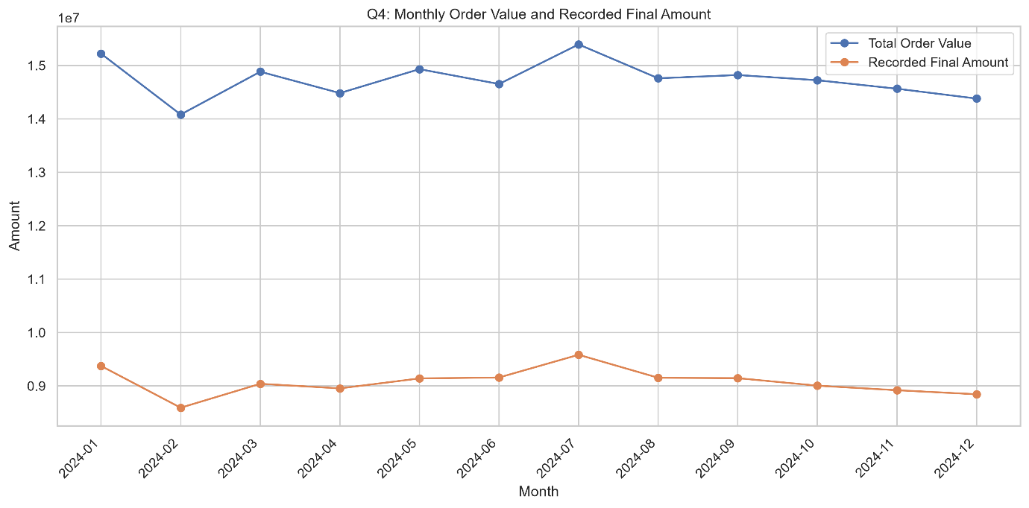Monthly Order Volume and Revenue Trends for 2024.
3. Analytical Insights — Interpretation and Findings
The analysis shows relatively stable monthly order activity throughout 2024. July recorded the highest delivered order count, at 7,244, and the highest total order value, at 13,115,045. Its recorded final revenue was 8,166,035.
February recorded the lowest delivered order count, at 6,748, and the lowest total order value, at 12,017,097. Recorded final revenue was 7,337,183.
Although some monthly variations are visible, the results do not indicate a dramatic upward or downward trend. July may represent a relatively strong period, while February was comparatively weaker in this dataset. Further years of data would be required to establish whether these patterns repeat seasonally.
An important limitation is that final amounts contain substantial missingness. Monthly recorded final revenue is therefore incomplete and should not be treated as the definitive revenue figure. Negative final amounts may also require validation against the discount and refund rules.
4. Analytical Insights — My Point of View and What Can Be Done
In my view, monthly trends should be used to support planning rather than to make decisions based on one month's results alone. The company could examine whether higher demand in July is associated with holidays, weather, promotions, or changes in restaurant participation.
The business should validate the calculation of final revenue and investigate missing or negative values before using this measure for financial reporting. It should also compare year-over-year performance once additional years of reliable data become available.
Conclusion
Monthly analysis reveals relatively consistent order activity, with July performing strongest and February weakest in the observed period. Reliable revenue data and longer-term comparisons are necessary for stronger conclusions about seasonality and business growth.

Question 5: Evaluate the Impact of Discounts on Order Value and Profit Margin
1. Introduction
Discounts are widely used in online food delivery to attract customers, increase conversion, and encourage repeat purchases. However, excessive discounting can reduce revenue or profitability if the additional demand does not compensate for the cost of the promotion.
The objective of this analysis is to compare order volume, average discount, average order value, and average profit margin across discount categories.
2. Visualization with Graphs
A bar chart can compare average order value across discount categories. A second chart can compare average profit margin, while a combined visualization can display order volume. This helps assess whether larger discounts correspond to higher order values or meaningful changes in margins. 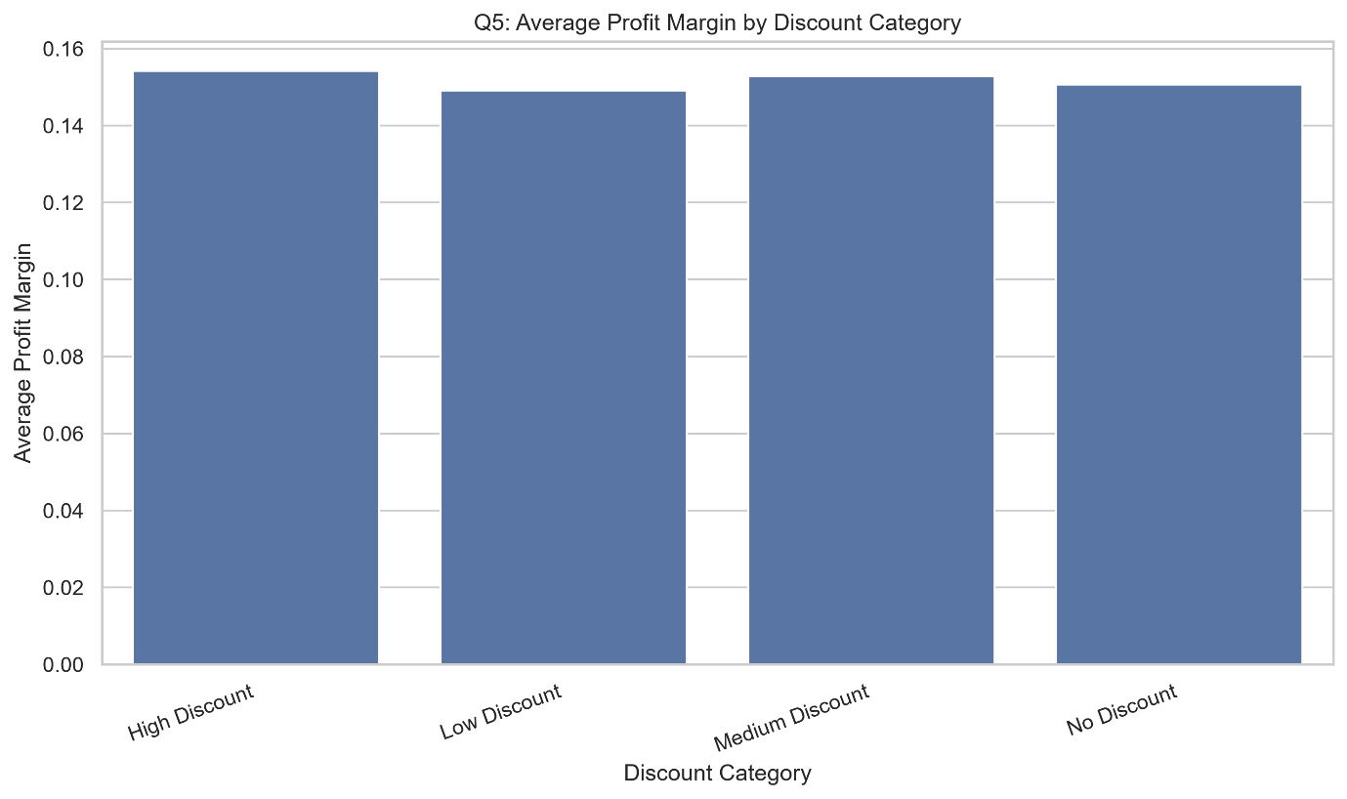
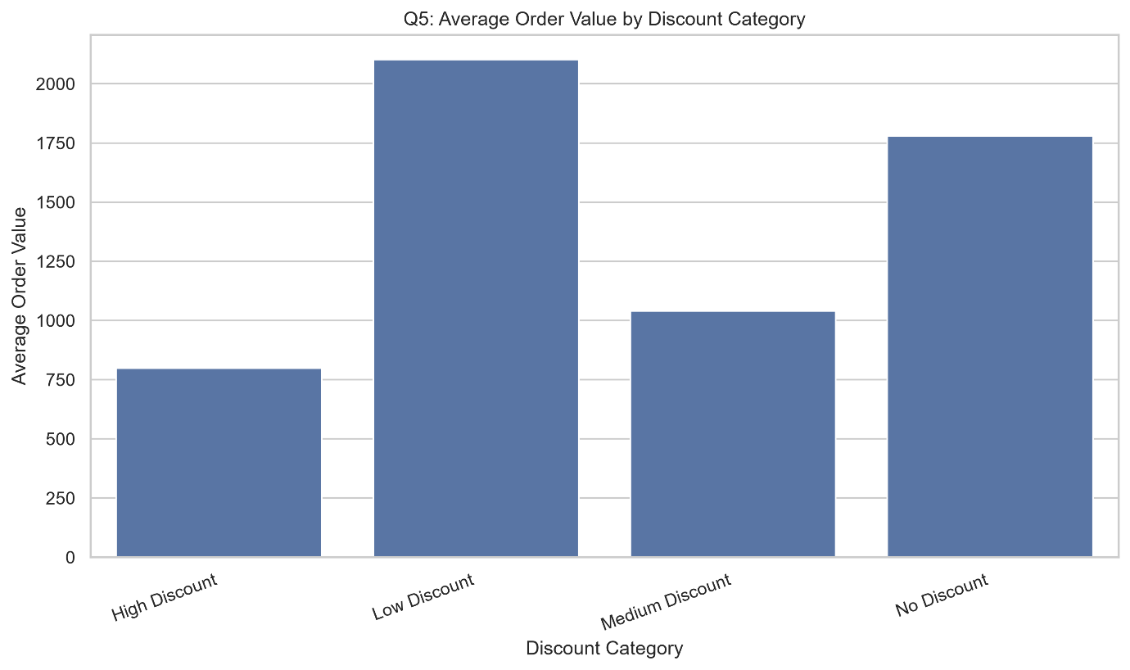: Discount Category vs Average Order Value and Profit Margin.
3. Analytical Insights — Interpretation and Findings
The low-discount category contained 52,572 orders and recorded the highest average order value, at 2,102.85. Its average discount was 66.76.
The no-discount category contained 14,236 orders and recorded an average order value of 1,777.50. The medium-discount category contained 6,211 orders, with an average order value of 1,045.46 and an average discount of 130.79.
The high-discount category contained 11,945 orders and recorded the lowest average order value, at 799.51, alongside an average discount of 253.50.
Average profit margin ranged from approximately 14.92% to 15.27% across the categories, indicating relatively small differences in the reported averages. The high-discount category recorded an average margin of 15.27%, while the low-discount category recorded 14.92%.
These findings do not establish that discounts cause lower order values or improve profit margins. Differences in basket size, customer characteristics, restaurant selection, and the way discount categories are defined may influence the results.
4. Analytical Insights — My Point of View and What Can Be Done
In my view, discounts should be evaluated according to their incremental business value, not simply the number of orders generated. The company should test different discount levels through controlled experiments and compare conversion rates, repeat purchases, average order value, and total profit.
Promotions could be targeted at customers who are less likely to order without an incentive, rather than being offered uniformly to all customers. The business should also validate the profit-margin formula and ensure that discounts, refunds, delivery costs, and other relevant expenses are accounted for consistently.
Conclusion
Discount analysis shows that the low-discount category has the highest average order value, while the high-discount category has the lowest. Controlled testing and reliable profitability measures are necessary to determine which discount strategies create sustainable value.

Question 6: Identify the Highest-Performing Cities and Cuisines
1. Introduction
Geographical and cuisine-based analysis helps food delivery companies understand where demand is concentrated and which food categories contribute most to order value. These insights can support restaurant partnerships, marketing investments, delivery capacity planning, and menu expansion.
The objective is to identify the leading cities and cuisines based on order volume and total order value.
2. Visualization with Graphs
A bar chart can compare total order value by city, and another can compare total order value by cuisine. Order volume can be displayed in separate charts to distinguish high order value from high transaction volume.
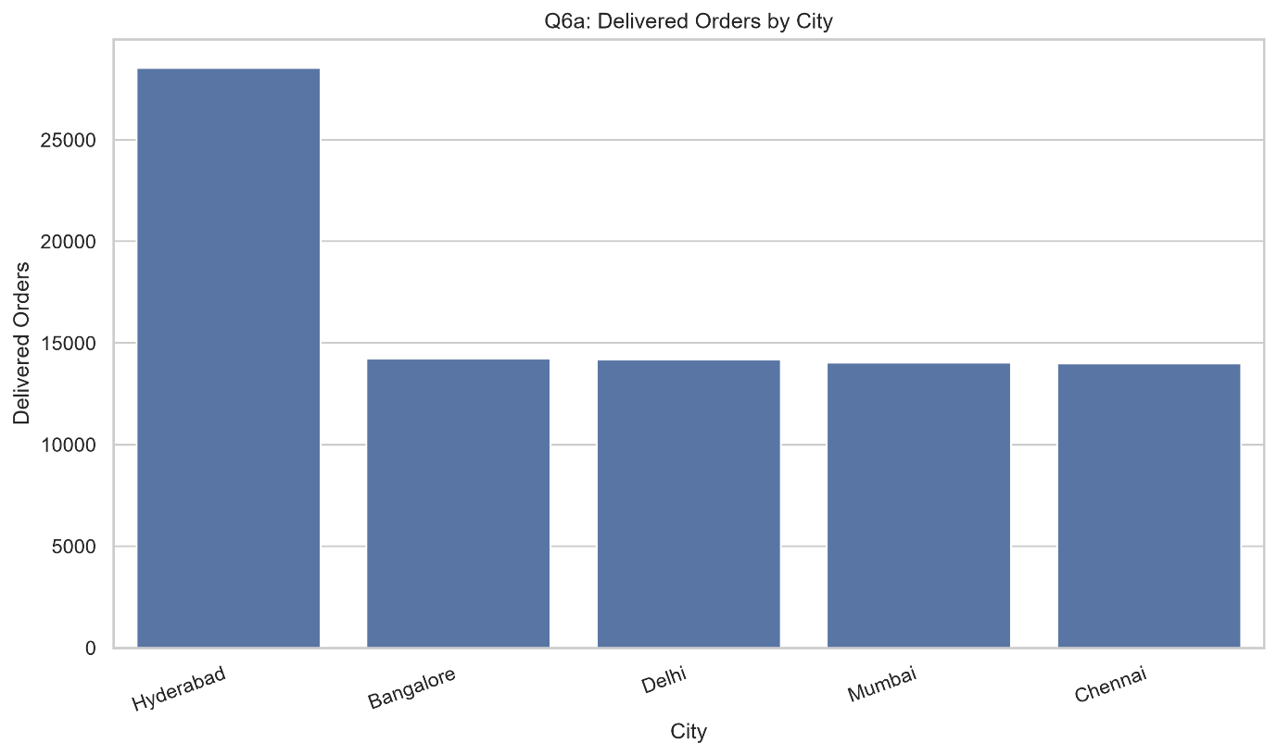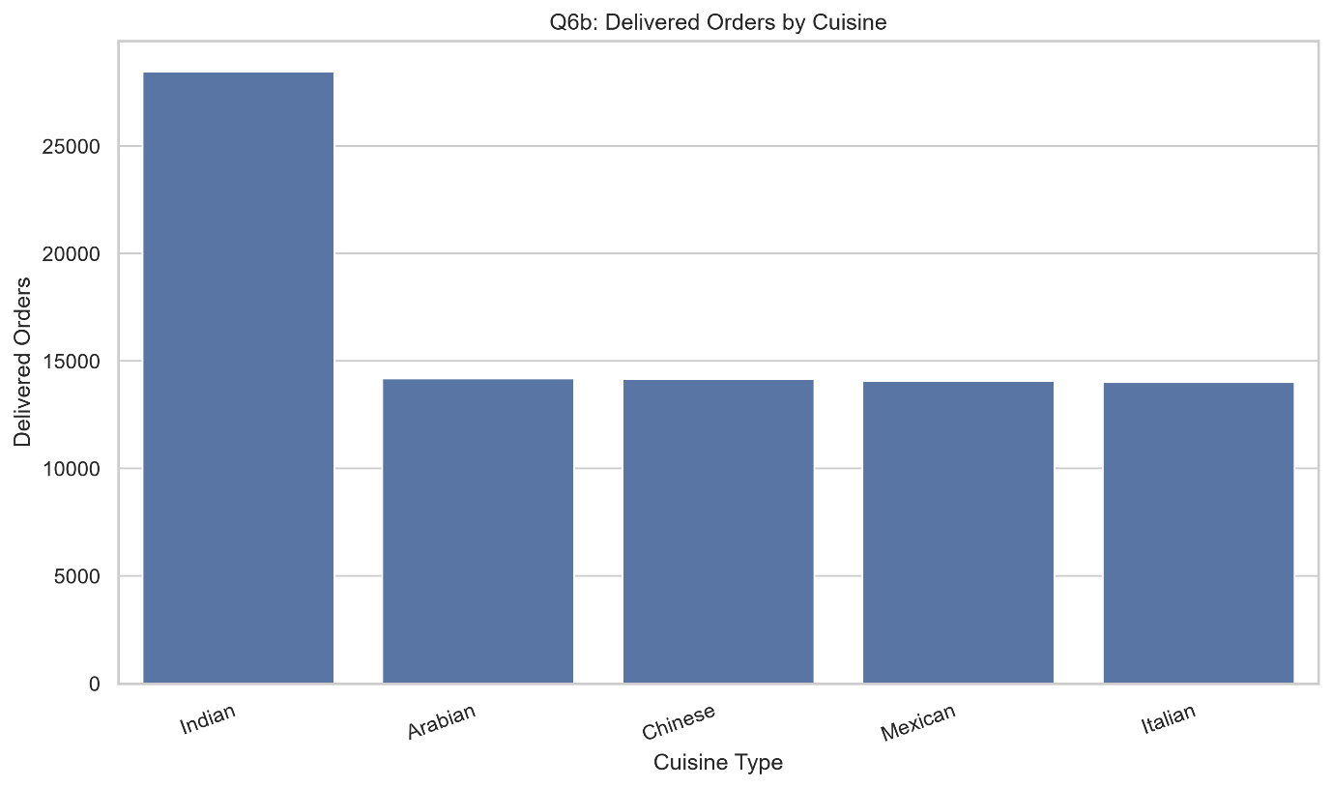City-Wise and Cuisine-Wise Order Value.
3. Analytical Insights — Interpretation and Findings
Hyderabad was the leading city, recording 28,532 delivered orders and a total order value of 50,890,433 in the SQL analysis. Bangalore followed with 14,231 delivered orders and an order value of 25,603,768. Delhi recorded 14,181 delivered orders and an order value of 25,246,974.
Chennai recorded 13,988 delivered orders and an order value of 25,097,223, while Mumbai recorded 14,032 delivered orders and an order value of 25,060,836.
Indian cuisine was the leading category, with 28,473 delivered orders and a total order value of 51,132,986. Chinese cuisine followed with 14,173 delivered orders and an order value of 25,401,778. Mexican cuisine recorded 14,090 delivered orders and an order value of 25,371,630.
Hyderabad and Indian cuisine therefore account for the highest order values in their respective groups. These totals measure order value, not necessarily net revenue or profit.
4. Analytical Insights — My Point of View and What Can Be Done
In my view, Hyderabad deserves attention when planning restaurant partnerships and delivery capacity because of its substantial order contribution. However, the company should also investigate whether the city's performance reflects population, customer coverage, restaurant availability, or differences in dataset representation.
Indian cuisine may offer opportunities for menu expansion and promotional campaigns because of its high volume. Other cuisines should not be neglected, as their performance may vary by city and customer segment.
The company should compare order value with cancellation rates, delivery performance, customer ratings, and profit contribution before deciding where to invest.
Conclusion
City-wise and cuisine-wise analysis identifies Hyderabad and Indian cuisine as leading contributors in the observed data. Combining demand with profitability and operational performance can support better resource allocation.

Question 7: Compare Average Delivery Time Across Cities
1. Introduction
Delivery time is a critical performance indicator for online food delivery companies because it affects customer satisfaction, service reliability, and the overall ordering experience. Comparing delivery times across cities can help identify operational differences and opportunities for improvement.
The objective of this analysis is to compare average delivery time and the observed minimum and maximum delivery times across cities.
2. Visualization with Graphs
A bar chart can compare average delivery time by city. A box plot can provide additional information about variation, median values, and extreme delivery times. Where possible, the analysis should also include the percentage of orders exceeding an operational threshold.
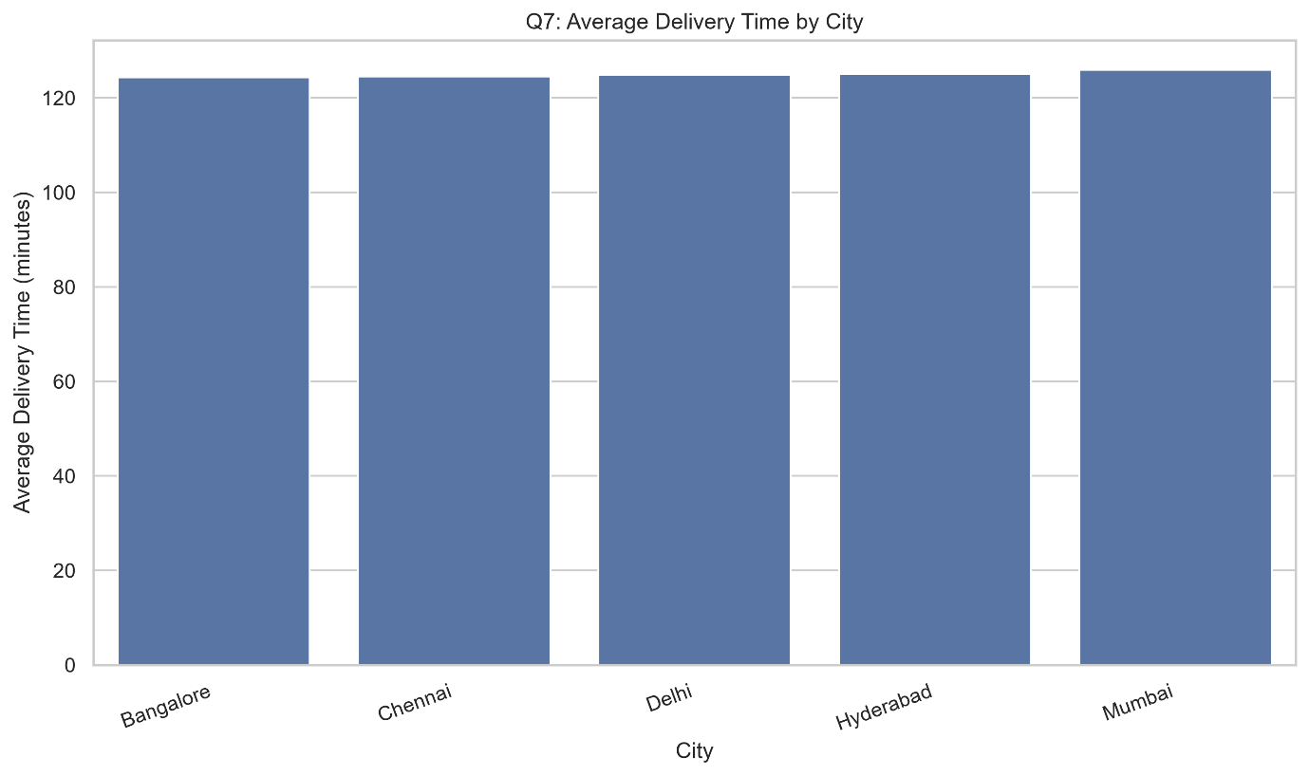Average Delivery Time by City.
3. Analytical Insights — Interpretation and Findings
Bangalore recorded the lowest average delivery time, at 124.33 minutes, followed closely by Chennai at 124.34 minutes. Delhi recorded an average of 125.03 minutes, Hyderabad 125.19 minutes, and Mumbai 125.79 minutes.
The difference between the highest and lowest city averages was only 1.46 minutes. This suggests that average delivery times were relatively similar across the five cities.
However, the minimum recorded delivery time was 20 minutes and the maximum was 300 minutes in every city. These extreme values indicate that average delivery time alone may not provide a complete picture of service quality. A small number of very long deliveries can affect customer experience even when the city average appears acceptable.
4. Analytical Insights — My Point of View and What Can Be Done
In my view, the company should investigate the distribution of delivery times rather than relying exclusively on average values. It should calculate the percentage of deliveries exceeding 150 or 180 minutes and identify whether long delays are concentrated in particular locations, restaurants, or distance categories.
The company should also compare actual delivery times against promised delivery times. This would provide a more meaningful measure of delays than delivery duration alone.
Operational improvements could include better delivery-partner allocation, restaurant preparation monitoring, and route planning where the data identifies specific bottlenecks.
Conclusion
Average delivery times are similar across the observed cities, but the wide range of recorded times suggests that extreme delays deserve further investigation. Distribution-based metrics would support more effective service improvement.

Question 8: Examine the Relationship Between Delivery Distance and Delivery Time
1. Introduction
Delivery distance can influence travel duration, fuel consumption, delivery-partner availability, and customer experience. Understanding the relationship between distance and delivery time helps businesses evaluate delivery zones, estimate service times, and improve delivery operations.
The objective is to compare delivery time across distance categories and determine whether longer distances are associated with longer delivery durations.
2. Visualization with Graphs
A scatter plot can display delivery distance against delivery time, with each point representing an order. A line of best fit can help identify a linear relationship. A bar chart comparing average delivery time across distance categories can provide a simpler summary.
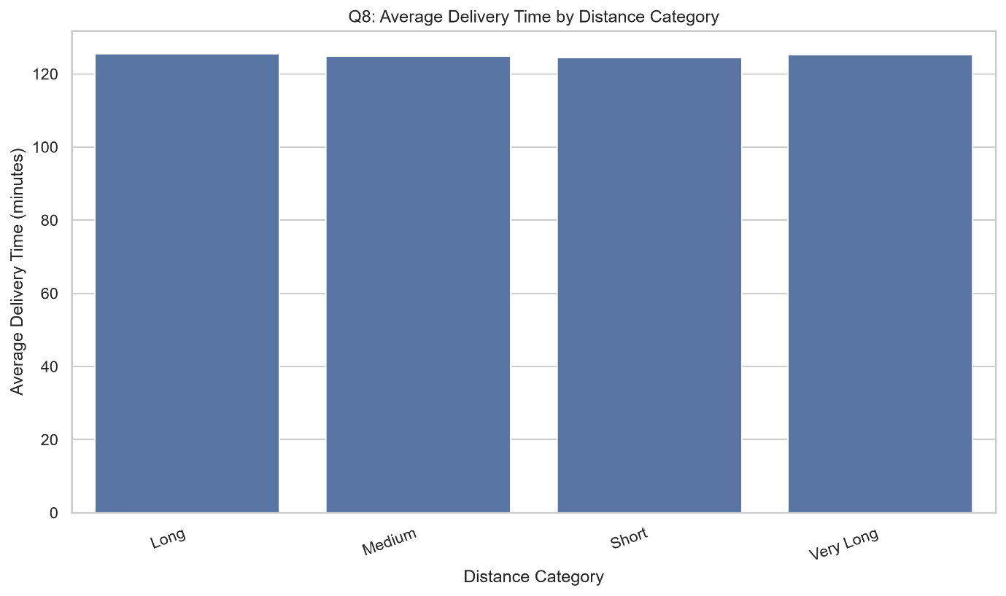Delivery Distance vs Delivery Time.
3. Analytical Insights — Interpretation and Findings
The short-distance category had 12,655 orders and an average distance of 2.99 km, with an average delivery time of 124.15 minutes.
The medium-distance category had 44,096 orders, an average distance of 9.09 km, and an average delivery time of 124.82 minutes. The long-distance category had 5,675 orders, an average distance of 17.49 km, and an average delivery time of 125.71 minutes.
The very-long-distance category had 22,538 orders, an average distance of 29.98 km, and an average delivery time of 125.57 minutes.
Delivery time rises slightly from the short-distance to the long-distance category, but the very-long-distance category has a marginally lower average than the long-distance category. The Pearson correlation between distance and delivery time is approximately 0.002, indicating virtually no linear relationship in the dataset.
This result does not necessarily mean distance has no operational effect. Other factors, including traffic, preparation time, delivery allocation, data quality, and the definition of delivery duration, may influence the observed relationship.
4. Analytical Insights — My Point of View and What Can Be Done
In my view, the company should investigate whether the recorded delivery-time field accurately represents travel time or total order duration. If it includes restaurant preparation time, the effect of distance may be masked.
A more detailed analysis should compare distance with travel time, promised delivery time, actual delay, traffic conditions, and restaurant preparation duration. The business could also evaluate whether very long delivery distances are profitable after accounting for delivery costs.
Conclusion
The analysis reveals almost no linear relationship between distance and recorded delivery time. Further investigation into the definition of delivery time and other operational factors is necessary before drawing conclusions about distance-related delays.

Question 9: Analyse Delivery Ratings in Relation to Delivery Time
1. Introduction
Customer delivery ratings provide insight into the perceived quality of the delivery experience. Analysing ratings alongside delivery duration can help determine whether longer delivery times are associated with lower customer satisfaction.
The objective is to compare average delivery time and profit margin across delivery-rating categories.
2. Visualization with Graphs
A bar chart can compare average delivery time for each rating from one to five stars. A second chart can compare order counts across rating categories. A box plot can reveal whether lower-rated orders contain a larger proportion of unusually long deliveries.
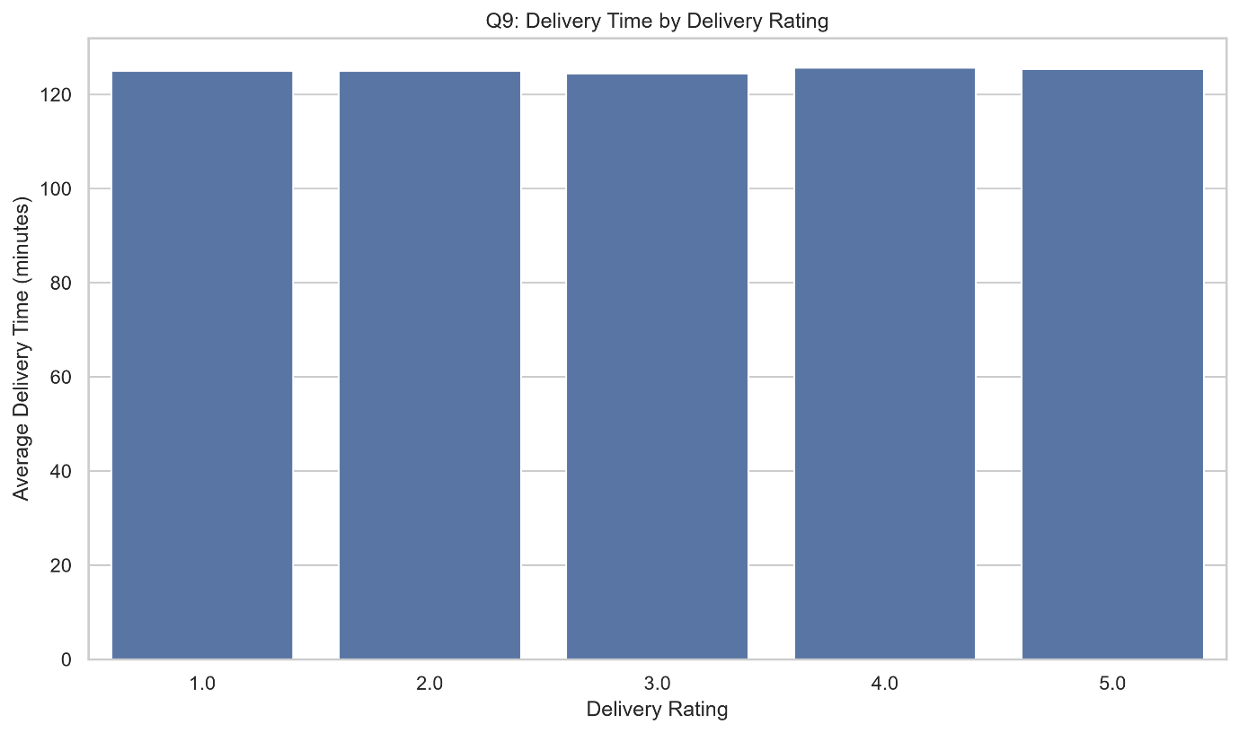Delivery Rating vs Average Delivery Time.
3. Analytical Insights — Interpretation and Findings
The four-star rating group recorded the highest average delivery time, at 126.00 minutes, across 14,375 orders. The three-star group recorded the lowest average delivery time, at 124.54 minutes, across 27,913 orders.
The five-star group recorded an average delivery time of 125.07 minutes across 14,007 orders. The two-star and one-star groups recorded averages of 124.64 and 125.05 minutes, respectively.
These differences are relatively small, and the results do not show a clear pattern in which lower ratings consistently correspond to longer delivery times. The recorded average profit margins are also similar across rating groups, ranging from approximately 14.25% to 14.32%.
Customer ratings may reflect several factors beyond delivery duration, including food quality, packaging, order accuracy, restaurant communication, and customer expectations.
4. Analytical Insights — My Point of View and What Can Be Done
In my view, delivery ratings should be analysed together with more detailed service indicators. The company should investigate low-rated orders to determine whether they involve late arrivals, incorrect items, damaged packaging, or poor communication.
It would also be useful to compare ratings against promised delivery times rather than absolute delivery duration. A delivery lasting 40 minutes may be satisfactory if promised within 45 minutes but unsatisfactory if promised within 25 minutes.
The company could use these findings to prioritize service improvements based on the issues most closely associated with low ratings.
Conclusion
The available data does not demonstrate a strong relationship between delivery time and delivery ratings. Combining ratings with promised delivery times and order-level complaints would provide a more reliable assessment of customer satisfaction.

Question 10: Identify the Top-Rated Restaurants
1. Introduction
Restaurant ratings influence customer trust, restaurant visibility, and ordering decisions. Identifying highly rated restaurants helps food delivery platforms recognize strong performers and understand which partners deliver a positive customer experience.
The objective is to rank restaurants according to their average restaurant rating and compare their delivered order counts.
2. Visualization with Graphs
A horizontal bar chart can compare the average ratings of the top ten restaurants. A second chart can display delivered order counts for the same restaurants. Displaying both measures helps distinguish highly rated restaurants from those with greater order volume.
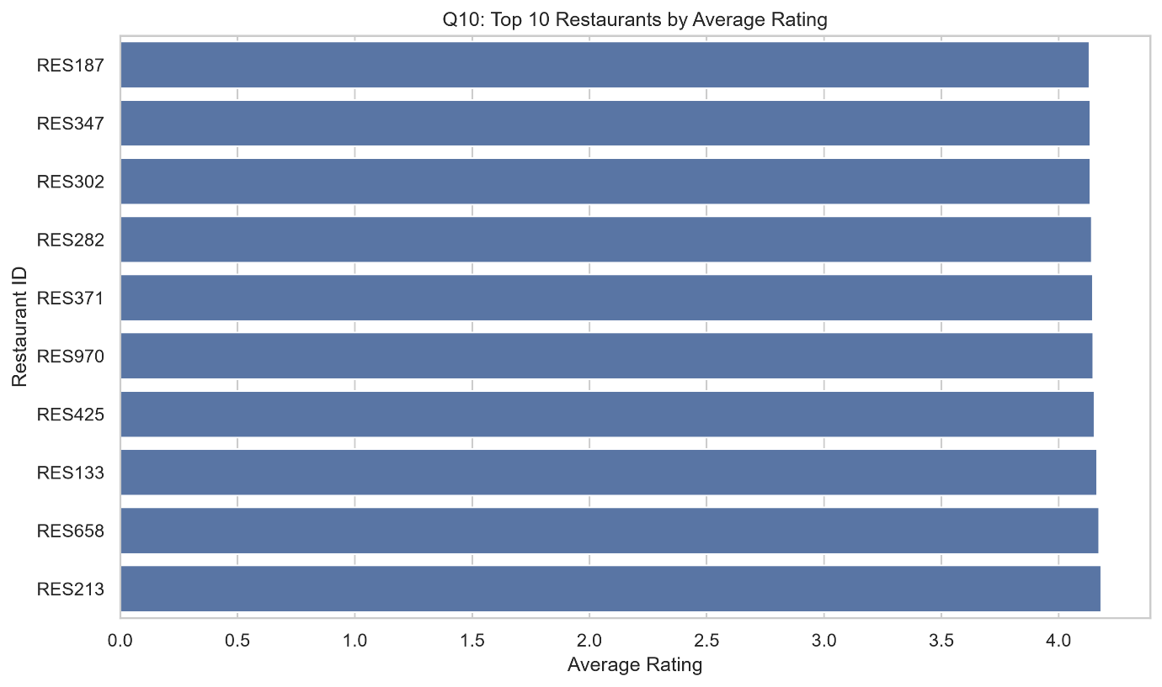Top 10 Restaurants by Average Rating.
3. Analytical Insights — Interpretation and Findings
Restaurant_1 recorded the highest average restaurant rating, at approximately 4.13, across 165 delivered orders. Restaurant_462 followed with an average rating of approximately 4.12 across 150 delivered orders.
Restaurant_218 and Restaurant_393 each recorded average ratings of approximately 4.11. Restaurant_105 had an average rating of approximately 4.10 and the highest delivered order count among the top ten, at 192.
The differences between the leading restaurants are relatively small. The results suggest that several restaurants maintain similarly strong average ratings.
However, delivered order counts should not automatically be interpreted as the number of ratings received. In addition, average ratings can be influenced by the number of customer reviews and by differences in the types of customers who provide feedback.
4. Analytical Insights — My Point of View and What Can Be Done
In my view, the platform should recognize highly rated restaurants and use their performance to identify potentially effective practices in food quality, packaging, preparation, and customer service.
Before making final recommendations, the company should include the number of actual ratings, rating distributions, and a minimum rating-count threshold. This would reduce the risk of ranking restaurants based on limited feedback.
Highly rated restaurants could also be evaluated for opportunities to expand their menu visibility or participate in promotional campaigns, provided their delivery reliability and operational capacity remain strong.
Conclusion
Restaurant rating analysis identifies several strong performers, with Restaurant_1 recording the highest average rating. Rating counts and delivery performance should also be considered before using these rankings for business decisions.

Question 11: Identify Restaurants with the Highest Cancellation Rates
1. Introduction
Order cancellations can lead to lost revenue, wasted food preparation, customer dissatisfaction, and additional operational costs. Comparing cancellation rates across restaurants helps identify partners that may require operational support or closer monitoring.
The objective is to identify restaurants with high cancellation rates by comparing cancelled orders with total orders.
2. Visualization with Graphs
A horizontal bar chart can display the cancellation rates of the ten restaurants with the highest recorded rates. A second chart can compare the absolute number of cancelled orders. This distinction is important because a restaurant may have a high cancellation rate but fewer cancellations than a larger restaurant.
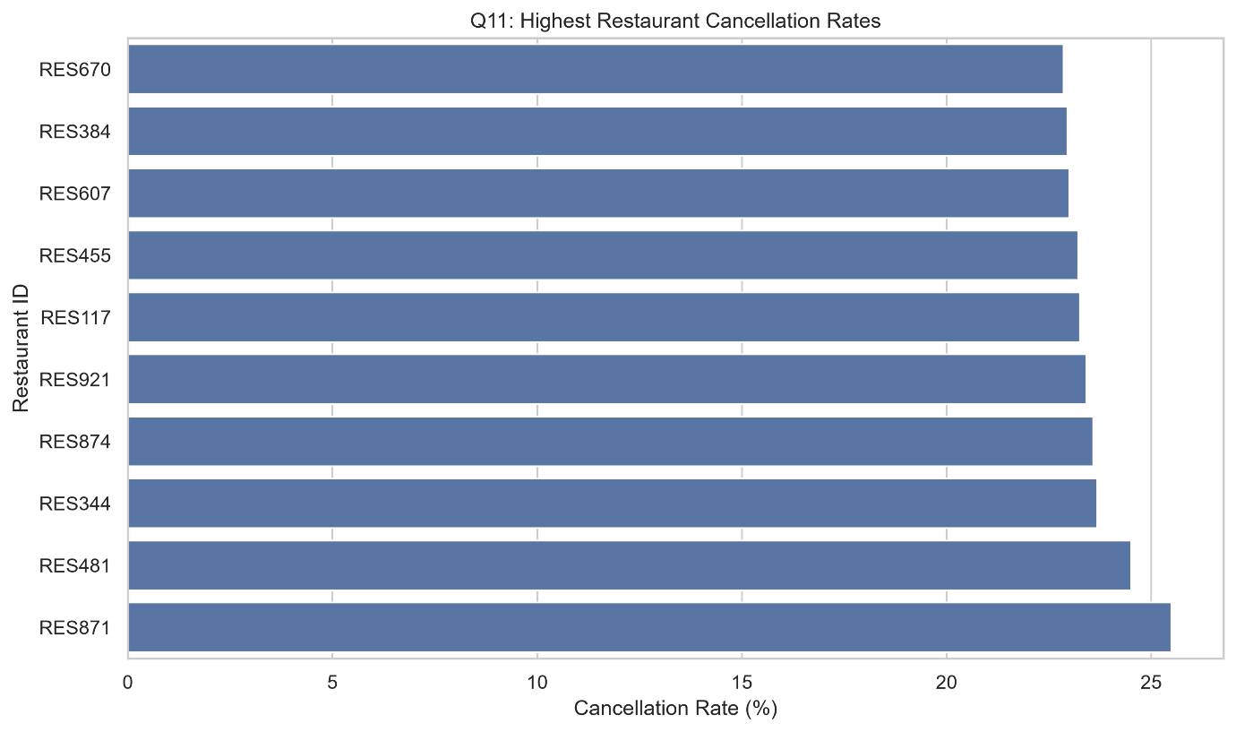Top 10 Restaurants by Cancellation Rate.
3. Analytical Insights — Interpretation and Findings
Restaurant_391 recorded the highest cancellation rate among the restaurants shown, at 21.94%, with 43 cancellations out of 196 orders.
Restaurant_390 followed with a cancellation rate of 21.89%, with 44 cancellations out of 201 orders. Restaurant_477 recorded a rate of 21.59%, while Restaurant_202 recorded 21.57%.
Restaurant_426 had 45 cancellations, the highest absolute cancellation count among the ten restaurants shown, and a cancellation rate of 21.23%.
These results demonstrate the importance of comparing both relative and absolute measures. A high cancellation rate indicates that cancellations represent a substantial proportion of a restaurant's orders, while the cancellation count reflects the total number of affected transactions.
The analysis identifies where further investigation may be useful, but it does not establish the reasons for the cancellations.
4. Analytical Insights — My Point of View and What Can Be Done
In my view, the platform should investigate high-cancellation restaurants by examining cancellation reasons, order preparation times, stock availability, customer complaints, and delivery-partner allocation.
Restaurants should be compared using consistent time periods and sufficient order volumes. The company could introduce partner-level performance reviews and work with restaurants to resolve recurring issues.
It should also track whether corrective actions reduce cancellation rates over time, rather than assuming that a single high rate identifies the root cause.
Conclusion
Cancellation-rate analysis highlights restaurants that may require further attention. Combining cancellation rates with cancellation reasons and operational data would help the platform develop more effective corrective actions.

Question 12: Compare Performance Across Cuisine Categories
1. Introduction
Cuisine-wise performance analysis helps food delivery businesses understand customer preferences, identify high-demand food categories, and evaluate operational performance. It can support menu planning, restaurant partnerships, targeted promotions, and delivery service improvements.
The objective is to compare total orders, delivered orders, cancelled orders, delivery success rates, average order values, and restaurant ratings across cuisine categories.
2. Visualization with Graphs
A bar chart can compare total orders across cuisines, while another can display delivery success rates. A third chart can compare average order values. These visualizations provide a balanced view of demand, operational performance, and transaction value.
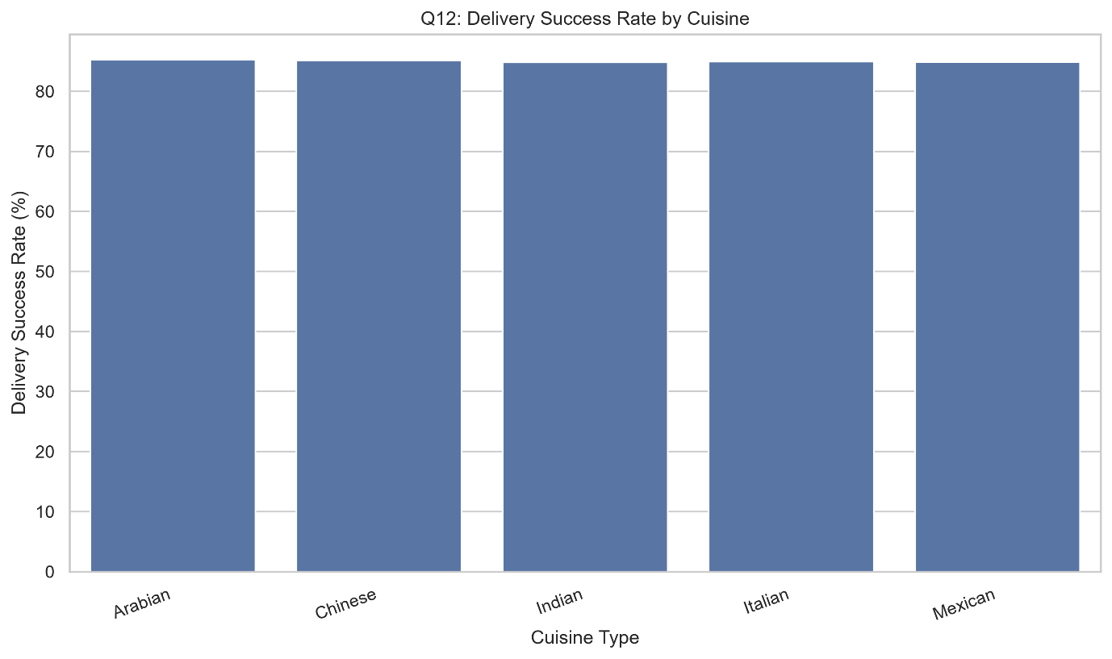Cuisine-Wise Order Volume and Delivery Success Rate.
3. Analytical Insights — Interpretation and Findings
Indian cuisine recorded the highest total order count, at 33,570, including 28,473 delivered orders and 5,097 cancelled orders. Its delivery success rate was 84.82%, its average order value was 1,796.68, and its average restaurant rating was 4.02.
Arabian cuisine recorded 16,658 orders and a delivery success rate of 85.24%, the highest among the listed categories. Its average order value was 1,769.79, and its average restaurant rating was 4.02.
Chinese cuisine recorded 16,651 orders, with a delivery success rate of 85.12% and an average order value of 1,787.15. Mexican cuisine recorded 16,602 orders and an average order value of 1,792.86. Italian cuisine recorded 16,519 orders and an average order value of 1,778.29.
The average restaurant ratings were very similar across all five cuisine categories, at approximately 4.01–4.02. Indian cuisine leads in order volume, while Arabian cuisine has the highest delivery success rate.
4. Analytical Insights — My Point of View and What Can Be Done
In my view, the company should maintain a strong selection of Indian cuisine because of its high demand while also exploring opportunities to improve the performance of other cuisine categories.
Arabian cuisine's relatively high delivery success rate may provide useful examples of effective restaurant or fulfilment practices, but further investigation is needed before attributing the difference to specific causes.
The platform should also examine cancellation rates, profit margins, customer retention, and city-level preferences within each cuisine category. These measures would help identify where menu expansion and operational improvements are most valuable.
Conclusion
Cuisine-wise analysis shows that Indian cuisine contributes the highest order volume and value, while Arabian cuisine records the highest delivery success rate. Combining demand with operational and financial metrics can guide more effective cuisine-level decisions.

Question 13: Analyse Order Demand by Peak-Hour Category
1. Introduction
Understanding peak ordering periods is important for managing delivery-partner availability, restaurant preparation capacity, and customer waiting times. Food delivery platforms can use reliable time-based data to identify demand peaks and allocate resources accordingly.
The objective is to compare order counts and delivery outcomes across the available peak-hour categories.
2. Visualization with Graphs
A bar chart can compare total orders and delivered orders across peak-hour categories. A second chart can compare cancellations. The categories should be clearly labelled after confirming what each value represents.
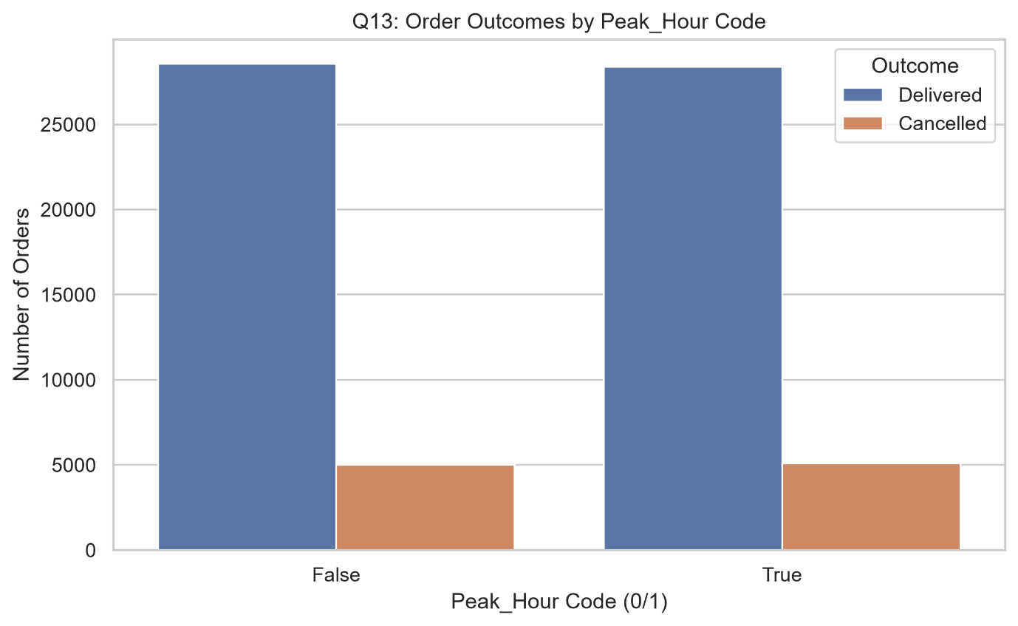Order Volume by Peak-Hour Category.
3. Analytical Insights — Interpretation and Findings
After excluding records with missing peak-hour classifications, the analysis identified 33,585 orders in category 0 and 33,453 orders in category 1.
Category 0 contained 28,564 delivered orders and 5,021 cancelled orders. Category 1 contained 28,370 delivered orders and 5,083 cancelled orders.
The two categories have very similar order volumes. Category 0 has slightly more delivered orders, while category 1 has slightly more cancelled orders.
However, the meaning of the values 0 and 1 must be confirmed before making operational conclusions. In addition, the order-time field contains many values recorded as 0:00, and peak-hour classifications have substantial missingness. These limitations reduce confidence in conclusions about actual busy hours.
4. Analytical Insights — My Point of View and What Can Be Done
In my view, the current results should be treated as a comparison of two coded categories rather than definitive evidence of peak ordering times.
The company should validate the definition of the Peak_Hour field and investigate why order times are recorded as 0:00. Accurate timestamps should be used to classify orders into meaningful periods, such as breakfast, lunch, evening, and late night.
Once the data is corrected, the platform could use hourly order counts and delivery-partner utilization to plan staffing and improve delivery reliability during high-demand periods.
Conclusion
The two available peak-hour categories have similar order volumes, but data-quality limitations prevent reliable conclusions about actual peak ordering periods. Accurate timestamps and documented category definitions are necessary for effective time-based planning.

Question 14: Analyse Order Distribution by Payment Method
1. Introduction
Payment-method analysis helps online food delivery platforms understand customer payment preferences and the distribution of transactions across payment channels. This information can support payment-system improvements, fraud monitoring, transaction processing, and customer convenience.
The objective is to compare total orders and delivered orders across card, wallet, cash on delivery (COD), and UPI payment methods.
2. Visualization with Graphs
A bar chart can compare total orders across payment methods. A second chart can compare delivered order counts or delivery success rates. A pie chart may also be used to show the relative share of each payment method, provided the categories are clearly labelled.
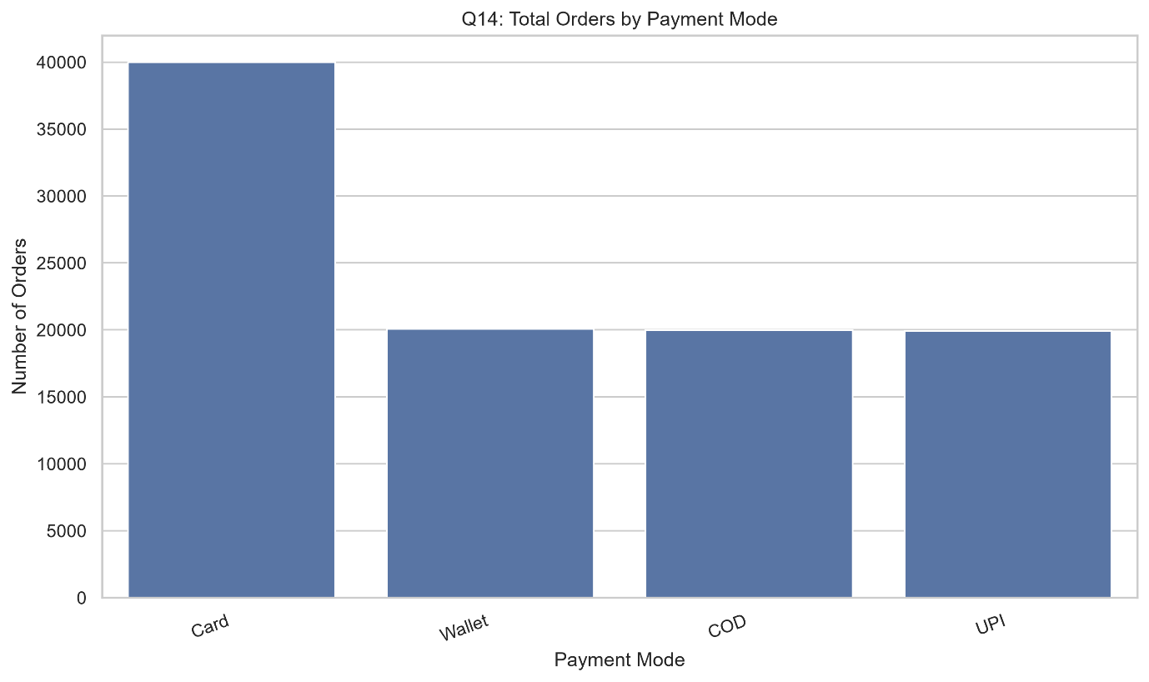Order Distribution by Payment Method.
3. Analytical Insights — Interpretation and Findings
Card payments accounted for 40,005 orders, representing approximately 40.01% of the dataset used in the analysis. Of these, 33,977 orders were delivered.
Wallet payments accounted for 20,086 orders, with 17,081 delivered orders. Cash on delivery accounted for 19,977 orders, with 16,964 delivered orders. UPI accounted for 19,932 orders, with 16,942 delivered orders.
Card payments were therefore the most frequently used payment method, accounting for approximately twice the volume of each of the other individual payment categories. Wallet, COD, and UPI each represented approximately one-fifth of the orders.
The results indicate that customers use multiple payment channels, with card payments having the largest share. The reasons behind these preferences cannot be determined from payment counts alone.
4. Analytical Insights — My Point of View and What Can Be Done
In my view, the platform should maintain a variety of reliable payment options to support different customer preferences. Card payments deserve particular attention because of their substantial transaction volume.
The company should also compare payment methods by cancellation rate, failed transaction rate, refunds, processing costs, and customer retention. This could identify whether particular payment channels create operational difficulties.
Payment promotions should be tested carefully to determine whether they generate additional orders or simply shift customers from one payment method to another.
Conclusion
Card payments are the leading payment method in the observed dataset, while wallet, COD, and UPI have similar volumes. Maintaining reliable payment options and analysing payment-related failures can improve customer convenience and operational performance.

Question 15: Analyse Order Cancellations by Cancellation Reason
1. Introduction
Understanding why customers cancel food delivery orders is essential for reducing lost transactions, improving service quality, and identifying operational problems. Cancellation analysis can reveal issues related to delivery delays, restaurant operations, customer decisions, or incomplete recordkeeping.
The objective is to examine the distribution of cancellation reasons and identify the most frequently recorded reasons for cancelled orders.
2. Visualization with Graphs
A bar chart can compare cancellation counts by reason. A pie chart can display each reason's percentage of all cancellations. For clearer interpretation, the analysis should distinguish between documented reasons and cancellations for which the reason was not recorded.
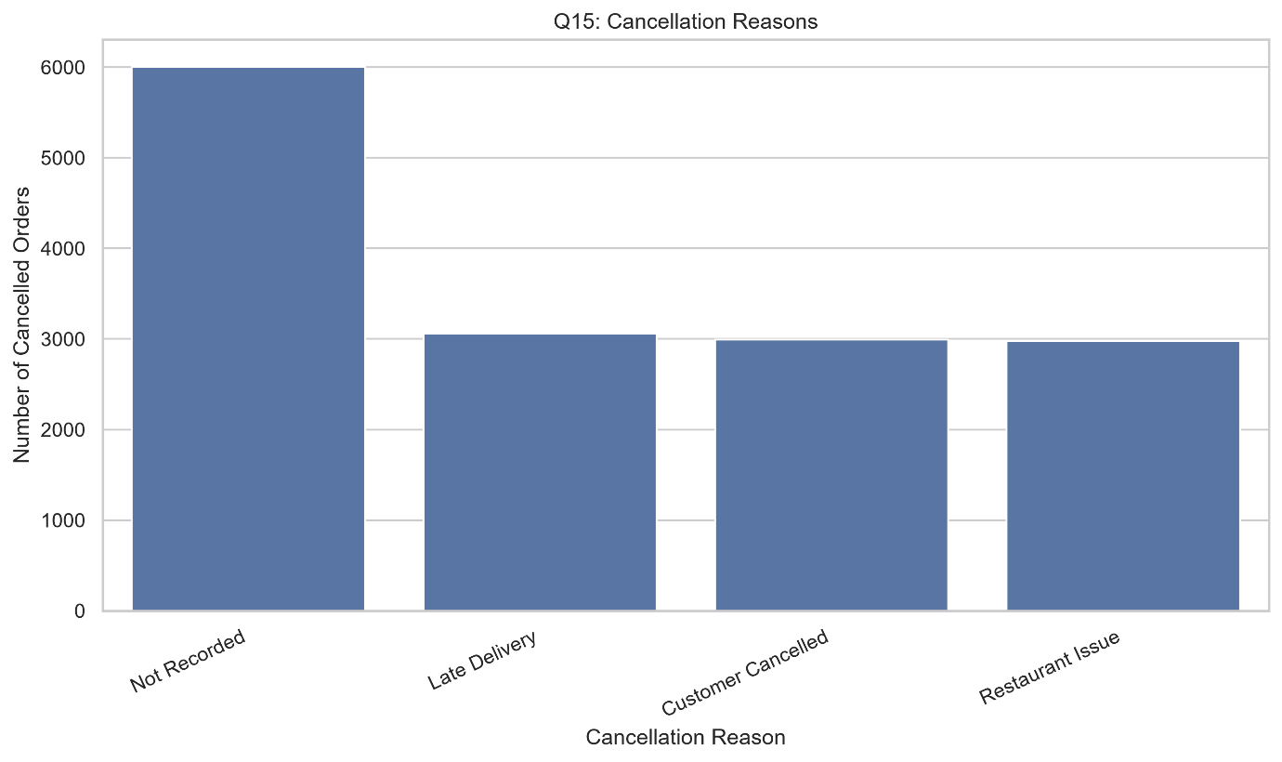
3. Analytical Insights — Interpretation and Findings
The dataset contained 15,036 cancelled orders. Of these, 6,005 cancellations, or 39.94%, were marked as Not Recorded.
Late Delivery accounted for 3,059 cancellations, representing 20.34% of all cancellations. Customer Cancelled accounted for 2,993 cancellations, or 19.91%, while Restaurant Issue accounted for 2,979 cancellations, or 19.81%.
Among cancellations with a recorded reason, Late Delivery was the most common, representing approximately 33.87% of documented reasons. Customer Cancelled accounted for approximately 33.14%, and Restaurant Issue accounted for approximately 32.97%.
The three documented categories are therefore relatively evenly distributed. However, the large proportion of cancellations without a recorded reason limits the ability to identify the main underlying cause of cancellations.
4. Analytical Insights — My Point of View and What Can Be Done
In my view, improving cancellation-reason tracking should be a priority. If approximately 40% of cancellation records lack a documented reason, the company may struggle to identify the most effective operational improvements.
The platform should introduce consistent cancellation categories and encourage the recording of a reason whenever an order is cancelled. It should then investigate late-delivery cancellations through promised-versus-actual delivery times, restaurant preparation times, and delivery-partner availability.
Customer-initiated cancellations and restaurant-related issues should also be analysed separately because they may require different interventions. Cancellation rates should be monitored over time to evaluate whether corrective actions are effective.
Conclusion
Late Delivery is the most common recorded cancellation reason, but missing reason data represents a substantial limitation. Improving record completeness and investigating the documented causes can help reduce cancellations and improve the customer experience.

Overall Conclusion
This online food delivery analysis demonstrates how Python, exploratory data analysis, and MySQL can be combined to investigate customer spending, demographic patterns, demand trends, discounts, geographical performance, delivery operations, restaurant ratings, payment methods, and cancellations.
The analysis identifies several important patterns. CUST5267 is the highest-spending customer in the reported top-ten results. Hyderabad and Indian cuisine contribute the highest order values in their respective categories. July records the strongest monthly performance in the observed 2024 data. Card payments account for the largest payment-method share, and Late Delivery is the most frequently recorded cancellation reason.
The findings also highlight limitations that must be considered when making business decisions. Missing final amounts affect revenue analysis, missing cancellation reasons limit root-cause investigation, and unreliable order-time values restrict peak-hour analysis. The near-zero correlation between distance and recorded delivery time also indicates the need to validate the time measure and investigate additional operational variables.
Overall, the project demonstrates the value of data-driven decision-making in the online food delivery industry. Reliable data collection, clear metric definitions, appropriate visualizations, and continued performance monitoring can help businesses improve customer satisfaction, operational efficiency, and profitability.

