**ASSIGNMENT 10: FINAL EVALUATION**

Create scenario with: AT → CSQ → CMGF → CMGS → CMGR

|  |  |  |  |
| --- | --- | --- | --- |
| **COMMAND** | **EXPECTED RESPONSE** | **ACTUAL RESPONSE** | **NOTES** |
| AT | OK | OK | SUCCESS |
| AT+CSQ | +CSQ: <rssi>,<ber>  OK | +CSQ: 21,0  OK | SUCCESS |
| AT+CMFG=1 | OK | OK | SUCCESS |
| AT+CMGS=”8590519478”  >MESSAGE^Z | +CMGS: 1  OK | +CMGS: 1  OK | SUCCESS |
| AT+CMGR=1 | MESSAGE  OK | ERROR | FAIL |

Issue Encountered:

While testing AT+CMGR=1, the emulator returned an ERROR despite a message being sent using AT+CMGS

Root Cause:

After analysis, it was identified that the CelerSMS AT Emulator does not support message storage retrieval, hence the CMGR command fails even though CMGS shows success.

**COMMAND FLOW**

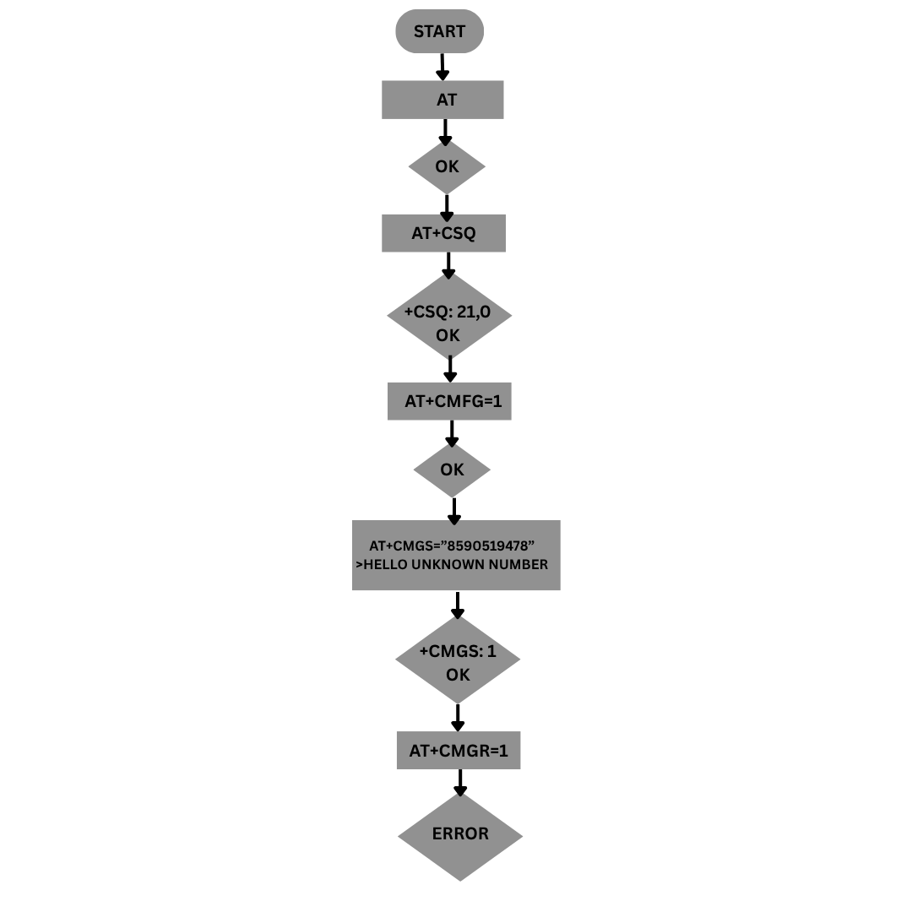

SUMMARY

Explored basic AT commands like AT, ATI, and ATZ to check connectivity, then moved on to reading signal strength and SIM status using AT+CSQ and AT+CPIN?. SMS functions were tested using AT+CMGF=1 to set text mode and AT+CMGS to send messages. Reading messages using AT+CMGR resulted in an error, which was traced back to a limitation in the emulator that doesn’t simulate message storage. Different command types like test, read, and write were explored, and topics such as PDP context setup and socket communication using AT+QIOPEN were researched. A few custom AT commands were proposed based on Cavli module documentation. Automation was done using AutoHotkey to simulate a full command sequence.