Project Design Phase-II
Technology Stack (Architecture & Stack)

Date | 27 September 2026
Team ID | SWTID-2026-3866
Project Name | AI Study Buddy
Maximum Marks | 4 Marks

Technical Architecture:
The Deliverable shall include the architectural diagram as below and the information as per the table1 & table 2
AI Study Buddy — System Architecture Diagram
Guidelines:
Include all the processes (As an application logic / Technology Block)
Provide infrastructural demarcation (Local / Cloud)
Indicate external interfaces (third party API’s etc.)
Indicate Data Storage components / services
Indicate interface to machine learning models (if applicable)
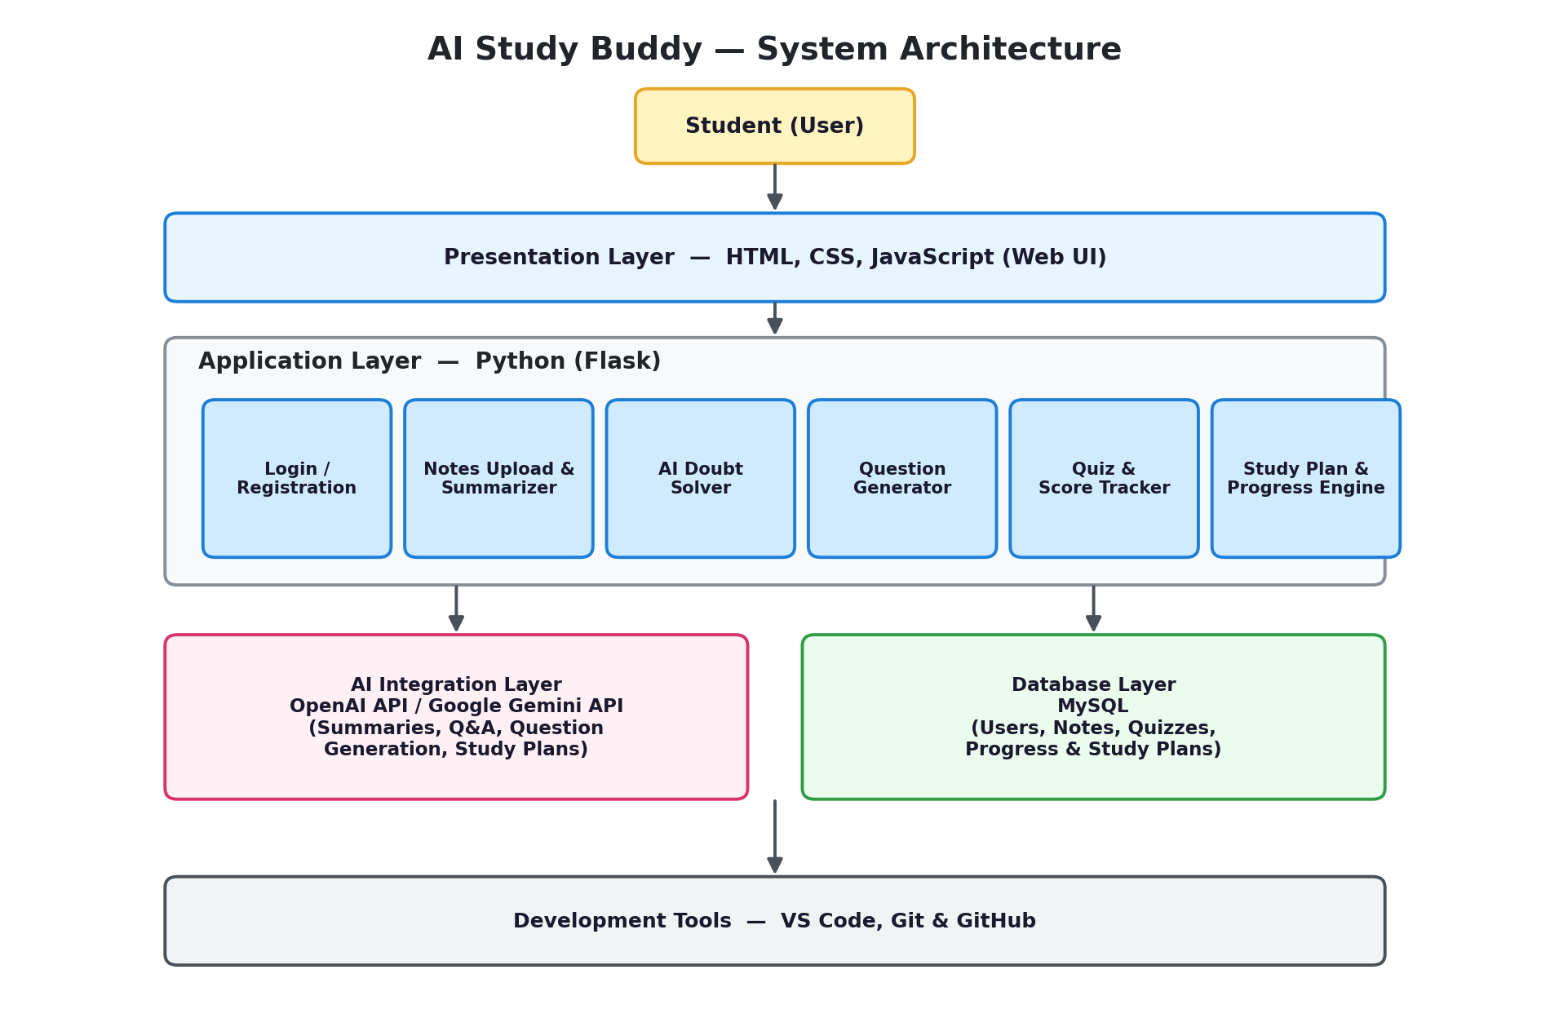

Table-1 : Components & Technologies:
S.No | Component | Description | Technology
 | User Interface | Web-based interface where students log in, upload notes, take quizzes and view their study plan / progress. | HTML, CSS, JavaScript
 | Application Logic-1 | User Registration, Login and session/database management. | Python (Flask)
 | Application Logic-2 | Notes Upload module and AI Notes Summarizer that condenses uploaded notes/PDFs into key points. | Python (Flask) + OpenAI API / Gemini API
 | Application Logic-3 | AI Doubt Solver that answers student questions instantly with clear explanations. | OpenAI API / Gemini API
 | Database | Stores user profiles, notes, quiz results, study plans and progress data. | MySQL
 | Cloud Database | Not used in the current scope; can be extended to a managed cloud database for multi-device access. | Not Used (future scope: AWS RDS / Azure Database for MySQL)
 | File Storage | Stores uploaded notes/PDF files before they are summarized. | Local Filesystem / Server Storage
 | External API-1 | AI Question Generator — generates 2/5/10 mark questions for a chosen subject & topic at different difficulty levels. | OpenAI API / Gemini API
 | External API-2 | AI Quiz Engine — generates quizzes, evaluates answers and returns instant results & feedback. | OpenAI API / Gemini API
 | Machine Learning Model | AI Exam Preparation Engine — analyses quiz performance, detects weak topics and builds a personalized study plan. | LLM-based model (OpenAI GPT / Google Gemini)
 | Infrastructure (Server / Cloud) | Application deployment.  Local Server Configuration: Flask development server on localhost.  Cloud Server Configuration: Optional deployment on a cloud PaaS. | Local (Flask dev server); Cloud option: Render / Heroku / AWS

Table-2: Application Characteristics:
S.No | Characteristics | Description | Technology
 | Open-Source Frameworks | Flask (Python micro web framework) for the backend; plain HTML, CSS and JavaScript for the frontend. | Flask, HTML5, CSS3, JavaScript
 | Security Implementations | Password hashing for stored credentials, session-based authentication for login, and input validation on all forms. | Werkzeug/bcrypt password hashing, Flask session management
 | Scalable Architecture | Follows a 3-tier architecture (Presentation, Application/AI logic, Data) so the UI, backend and database can be scaled or updated independently. | 3-Tier Architecture (Flask + MySQL)
 | Availability | Designed to run on a single server for the project; can be made highly available in production using a WSGI server behind a load balancer. | Gunicorn + Nginx (optional, for future scaling)
 | Performance | Caching of repeated AI API responses and indexed database queries keep quiz scoring and progress-tracking dashboards fast. | Response caching, MySQL indexing

References:
https://c4model.com/
https://developer.ibm.com/patterns/online-order-processing-system-during-pandemic/
https://www.ibm.com/cloud/architecture
https://aws.amazon.com/architecture
https://medium.com/the-internal-startup/how-to-draw-useful-technical-architecture-diagrams-2d20c9fda90d

