
STATE UNIVERSITY OF BANGLADESH
Project Title :
Course Code : CSE-0400
Course Title : Project Works.
Submitted To

Muhammad Masud Tarek
Head of the Department of Computer Science And Engineering, State University of Bangladesh.


Team Name : Poles of Power
Presented by
Md.Arif Hossen
ID-UG02-50-19-005
Sumaiya Rashmi UG02-51-19-012
Afrin Sultana
UG02-50-19-015

Contents
- Introduction
- Why is the online admission examination system important
- Literature Review
- Projects tools
- Features
- Projects Details
- Team works schedule
- Project Cost
- Gantt Chart
- Impacts on the environment
- Conclusion
INTRODUCTION:
- Beneficial for Education System.
- Institution Can Host Online Examination
- It will reduce the hectic job of assessing the answer script manually
- It will allow the faculty to create test and answer key
- It will reduce paperwork
- Automatic grading and manual grading opportunity
- Support of Online Result Publishing System
- Update Version of Existing Examination System
- Its more popular after Covid-19

Overview of Online admission Examination System-
- Create Account
- login
- Verifying password
- Online Question
- Automation of planning and schedule
- Efficiency to create a question bank
- Use Rich Text and Images
➢and Images
Why is online admission examination system important?
- It saves paper.
- Save money .
- It's more secure.
- Quick Result Processing
- Readiness for Cases of Emergency during Exams  It saves time.
- ensure 100% attendance
- Space reduce
- Traffic jams reduce

Literature Review-
Many researchers have already researched about online admission examination system and we have developed a online examination system to keep an eye on this researches as a reference and these all are the following: 

Comparison among Poles of Power , SIETTE, and JETIR
Attribute | Poles Of Power | SIETTE | JETIR
1.Admin (log in) | ✔ | ✕ | ✕
2.Login(Teacher) | ✔ | ✔ | ✕
3.Apply | ✔ | ✕ | ✕
4.Login(Student) | ✔ | ✔ | ✔
5.Save Profile | ✔ | ✕ | ✕
6.Fixed Exam Date | ✔ | ✔ | ✔
7.Questions(SQ, MCQ). | ✔ | ✕  (MCQ) | ✔
8.Question Set | ✔ | ✕ | ✔
9.File Submission option | ✔ | ✕ | ✔
10.Result Published | ✔ | ✔ | ✔
11.Turning Camera on. | ✔ | ✕ | ✕
12.Security manager | ✕ | ✕ | ✔
13.Andriod and Desktop version. | ✔ | ✕  (Desktop) | ✕  (Desktop)
SIETTE (System of intelligent Evaluation using Tests for Tele education). JETIR(Journal of Emerging Technologies and Innovative Research )

Project tools-
▪ Front end:
- Java
- Swing(GUI)
- HTML
- CSS
- JavaScript
▪ Back end:
- MySQL
- PHP
- Java
Project Details
The system has three modules. They are
- Administrators
- Teachers
- Users

Admin
Teacher |  | User
Online admission examination system

Part of the Admin
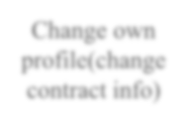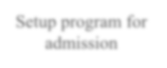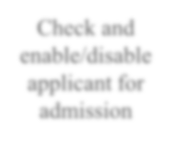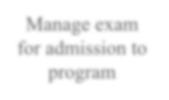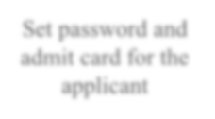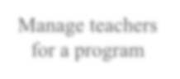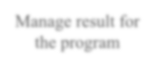
Change own
profile(change
contract info)
Setup program for
admission
Check and
enable/disable
applicant for
admission
Manage exam
for admission to
program
Set password and
admit card for the
applicant
Manage teachers
for a program
Manage result for
the program
Published
Result
Online admission examination system

Part of the Teacher
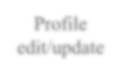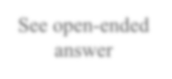
Profile
edit/update
See open
-
ended
answer
Enter marks

Submit result

Part of the Applicants
Online admission examination system
  Give permission |  | Enter exam
  Submit
See Result

Delivery
So, we will need 7 to 8 months for development and 1 month for testing purposes.


Online admission Examination System Gantt chart-
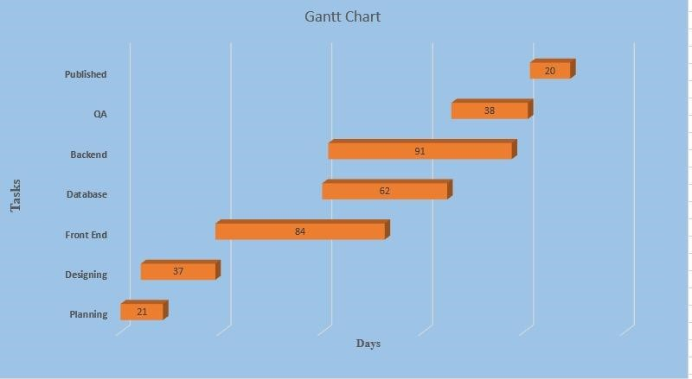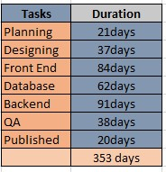

Team works schedule -
Team members | Working Hours (weekly) | Cost-per-hour
Arif Hossen | 12-14 | 100৳
Sumaiya Rashmi | 12-14 | 100৳
Afrin Sultana | 12-14 | 100৳
Project Cost➢ Per hour charge 100/606(hour)*100 = 60,600/-

➢ Server Cost 2,000/➢ Domain Cost 1,000/Total Cost = 60,600 /-

Good Impacts of environment and society –

- Increase present rate in exam
- Air pollution reduce
- Less traffic jam
- Environment fresh
- Time consuming

Bad Impacts of environment and society –
 Copy and cheating


CONCLUSION-
This system aims at the popular examination system research at present, designing a set of common examinations for the any educational platform and providing a good condition for organizing all kinds of tests, and also have a great reference value for other institutions.

Thank You
[1]Zhenming et al (2003):They developed an online examination system based on web browser/server framework.
[2]SIETTE Guzman and Cenejo (2005):They developed an online examination system called as SIETTE; (System of intelligent Evaluation using Tests for Tele education).
[3]Ayo et a (2007):They proposed a model of e-examination.
[4]Jim and sean (2006):They justified the eassessment can be taken in different ways.
[5]Zhenming et al (2003):They developed an online examination system based on web browser/server framework.
[1]SWeaver, D., et al. (2005). Evaluation: WebCT and the student experience. Evaluations and Assessment Conference.
[2]Tate, L. (2002). "Using the interactive whiteboard to increase student retention, attention, participation, interest, and success in a required general education college course." Retrieved January 30: 2007. [3]Tallent-Runnels, M. K., et al. (2006). "Teaching courses online: A review of the research." Review of educational research 76(1): 93- 135.
[4]Downing, D., et al. (2000). Dictionary of computer and Internet terms, Barron's Educational series.
[5]Ainscough, T. L. (1996). "The Internet for the rest of us: marketing on the World Wide Web." Journal of consumer marketing 13(2): 36- 47.

