**Input Histogram:**

Input histogram is calculated from the input image and then the pdf, cdf and rounded cdf are calculated from the histogram.

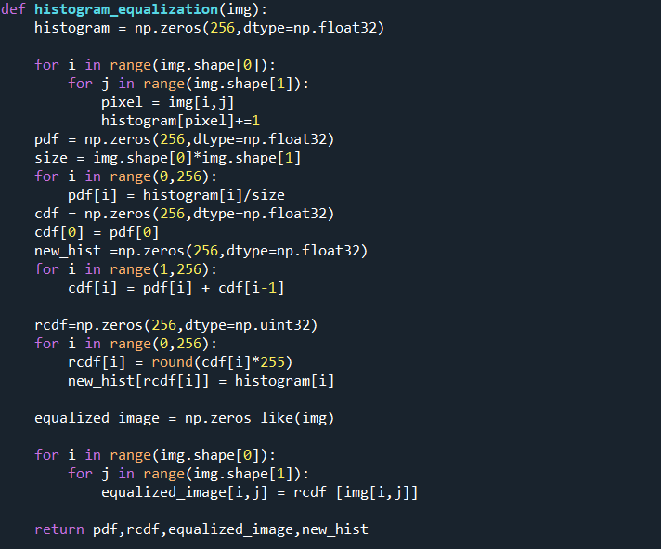

**Fig 3.1:** Code for calculating input histogram , pdf, cdf of input Image.

**Output Plots:**

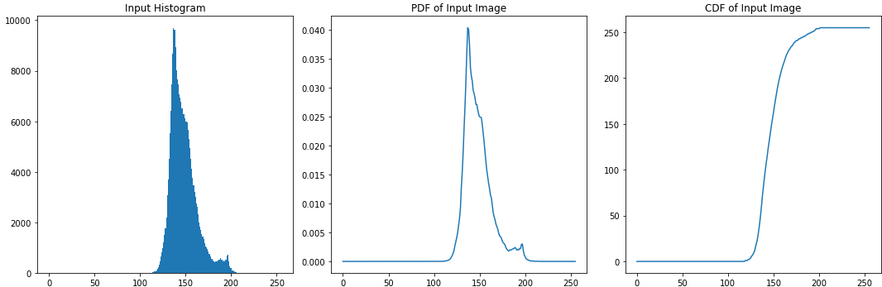

**Fig 3.2:** Histogram, pdf, and cdf of input image

**Target Histogram:**

Target histogram is calculated from Erlang distribution and its pdf, cdf, and rounded cdf are calculated from the histogram.

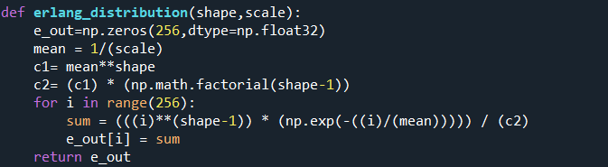

**Fig 3.3:** Code for target histogram.

**Input shape and rate parameter:**



**Fig 3.4:** Shape parameter and rate parameter

**Output Plots:**

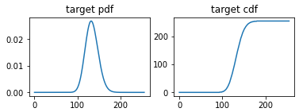

**Fig 3.5:** Pdf, and cdf of target distribution

**Histogram Matching**

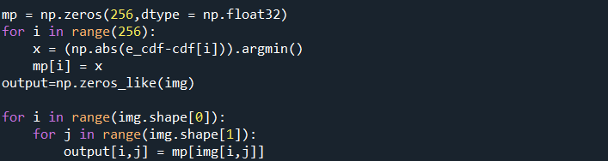

**Fig 3.6:** Code for histogram matching.

**Output Plots:**

The output plots are shown for shape parameter=80 and rate parameter=0.6 for target histogram.

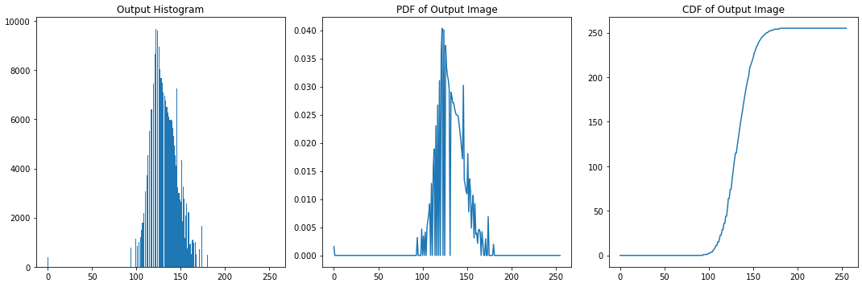

**Fig 3.7:** Histogram, pdf, and cdf for output image.

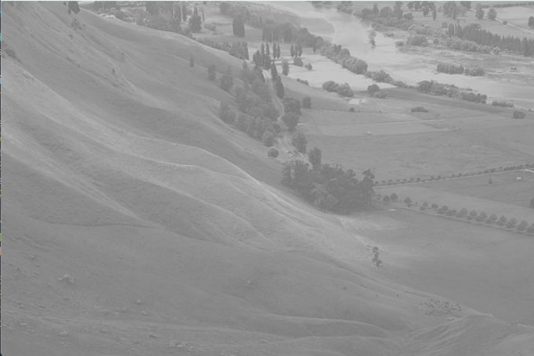 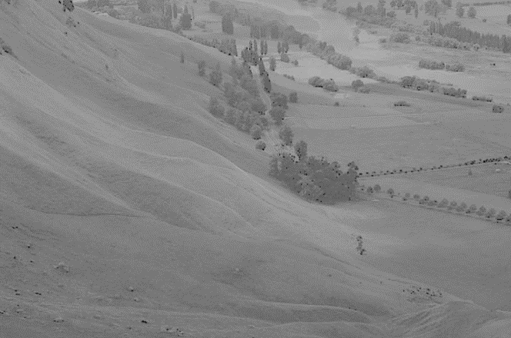

**Fig 3.8:** Input image. Fig 3.9: output image after histogram matching.

The output plots are shown for shape parameter=70 and rate parameter=0.3 for target histogram.

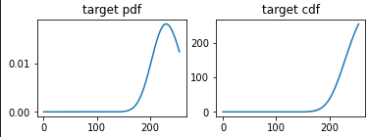

**Fig 3.10:** Pdf, and Cdf of target distribution.

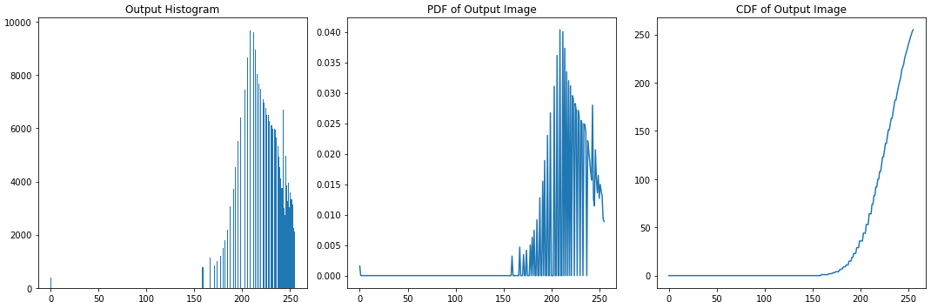

**Fig 3.11:** Histogram, pdf, and cdf for output image.

 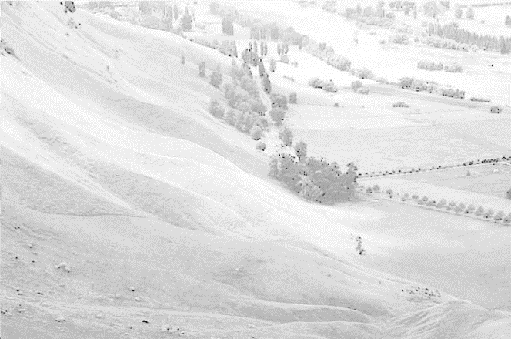

**Fig 3.12:** Input image Fig 3.13: output image after histogram matching.