CODE SNIPPET:

Erlang Distribution:

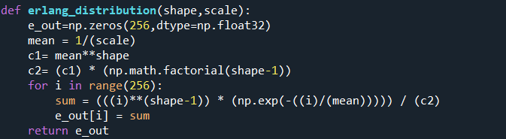

Histogram Equalization:

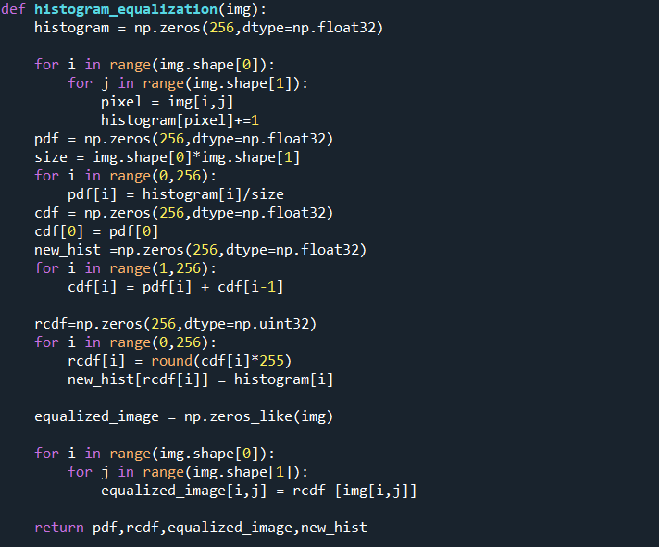

Input Image:

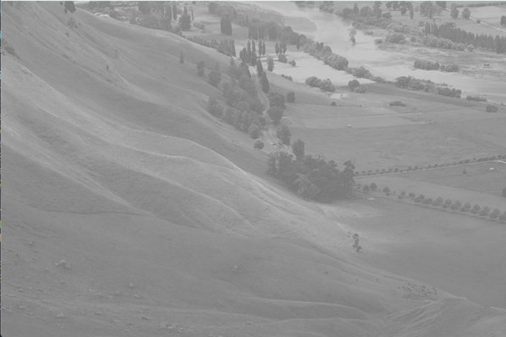

Input Equalized Image:

