Software Requirements Specification
for
Brew Day!
Version 4 approved
Jerry Zou Yiming l630003072
Turing Qiu Yifu l630003044
LeBron Zheng Hao l630003067
Alex Yuan Yicong l630003062

Engelbart
26/3/2019
Table of Contents
Table of Contents ii
Revision History ii
1. Introduction 1
1.1 Purpose 1
1.2 Document Conventions 1
1.3 Intended Audience and Reading Suggestions 1
1.4 Project Scope 1
1.5 References 1
2. Overall Description 2
2.1 Product Perspective 2
2.2 Product Features 2
2.3 User Classes and Characteristics 3
2.4 Operating Environment 3
2.5 Design and Implementation Constraints 3
2.6 User Documentation 3
2.7 Assumptions and Dependencies 3
3. System Features 3
3.1 System Feature 1 3
3.2 System Feature 2 (and so on) 4
4. External Interface Requirements 8
4.1 User Interfaces 8
4.2 Hardware Interfaces 13
4.3 Software Interfaces 13
4.4 Communications Interfaces 13
5. Other Nonfunctional Requirements 13
5.1 Performance Requirements 13
5.2 Safety Requirements 13
5.3 Security Requirements 13
5.4 Software Quality Attributes 14
6. Other Requirements 14
Appendix A: Glossary 14
Appendix B: Analysis Models 15
Appendix C: Issues List 16

Revision History
Name | Date | Reason For Changes | Version
Brew day! | 3/5/2019 |  | 1
Brew day! | 3/12/2019 |  | 1.1
Brew day! | 3/20/2019 |  | 1.2
Brew day! | 3/26/2019 |  | 4

Introduction

Purpose -Yuan Yicong
This document, the version 1.0, describes the requirements of the software – Brew Day software which is used for the Home Brewing people to brew beer in a more ordered way to brew beer. This document describes all the details of this software.

Document Conventions -Yuan Yicong
TBD

Intended Audience and Reading Suggestions -Yuan Yicong
User: Brew Day software is aimed at help the brewer to write down, tidy and calculate information of brewing the beer which can help them more easily to brew the beer.

Developer: 1.1The Brew Day software should record the recipe and the different ingredients of the specify recipes.
1.2 The Brew Day also can change the data of the different ingredient we have.
1.3 The Brew Day also needs to calculate the best brewing scheme base on the ingredients we have and the capacity of the different equipment.
1.4 Also the brewers can also change the recipes when they want.
1.5 The Brew Day also has the comments section which the user and the brewers can also submit the comment.

Project Scope -Yuan Yicong
The Brew Day software is designed for the brewers to become easier to manage their resources and decide scheme is the best one in the specify day. The brewers is the person who can get the most benefit from this software.
This software can record all the recipes and ingredients, maintain a list of recipes, giving the best schemes which is bases on the though which is basing on the use of the ingredients and the batch sizes and “what should I brew today?” feature.
This is the product which we want to use it to enter the brewing market.

References -Yuan Yicong
Kung, D. (2013). Object Oriented Software Engineering.
Sommerville, I. (2011). , Software Engineering (9th edition).

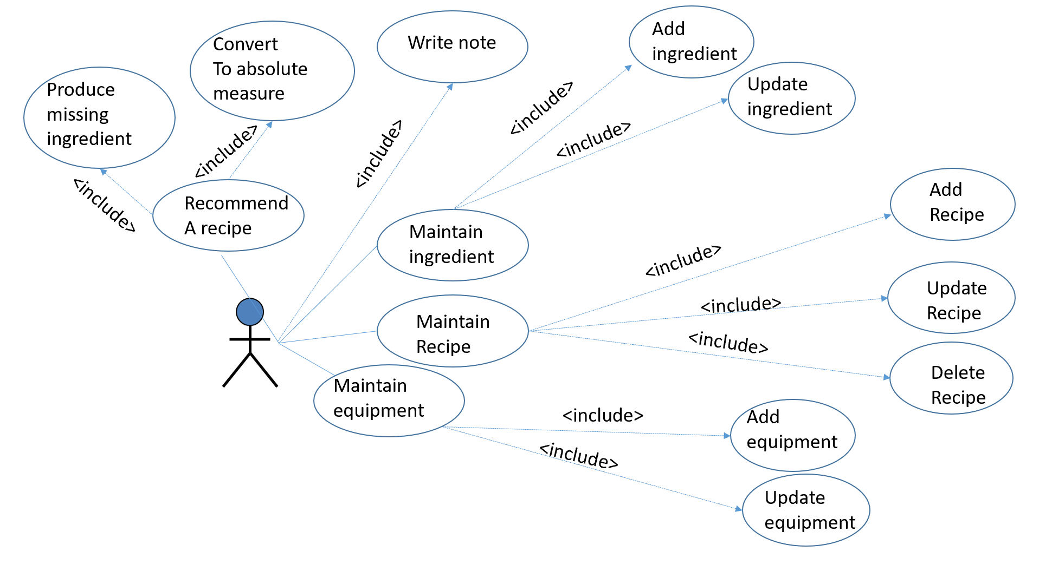
Overall Description -Zheng Hao, Yuan Yicong, Qiu Yifu, Zou Yiming

Product Perspective -Zheng Hao
Message share system
Notes database and recorded previous recipe database

Beer brew system
User authentication system

Security system

Ingredient database
And
Recipe database

Product Features -Zheng Hao, Yuan Yicong, Qiu Yifu, Zou Yiming

If you choose "what should I brew today?" function, then our product will check the ingredient you have and the actual amount of them and find out recipes that is available. Our product will choose a recipe from these recipes which can maximize the use of the ingredient while at the same time, take the capacity into consideration.

User Classes and Characteristics -Zheng Hao
There are two mainly kind of users:
1: Users who knows the detailed procedure of brewing a beer, they use our product to manage the ingredient and improve their own recipes.
2: Users who not knows much about brewing a beer, they reference our recipes to know the procedure and ingredient needed.

Operating Environment -Zheng Hao
standalone Windows

Design and Implementation Constraints -Zheng Hao
We use java on windows, Mysql database, all modification must commit and push to github, before you make modification, you need to pull the project first.

User Documentation -Zheng Hao
We will offer user manuals to help user to understand the procedure of using our product for function, explain all the icon and the consequence of press the button. We will also offer a video online to give a short explain about the functions and demonstrate a process of using our product to brew the beer.

Assumptions and Dependencies -Zheng Hao
We use JDK for developers

System Features-- Zheng Hao, Yuan Yicong, Qiu Yifu, Zou Yiming

System Feature 1 Maintain the Recipes Feature
    - Description and Priority
User select “Maintain Recipes”
System ask: Add, Delete or Update?
User select: Add, Delete or Update
User operate: do the relevant operations or back to “Maintain Receipts”.
System ask: move to page showing the new list or back to “Maintain Receipts”.
    - Stimulus/Response Sequences

3.1.3 Functional Requirements
The add page can include some recommended information and fixed table which arrow the users to add the receipts conveniently and directly.
Before the users do the operations, the system should give a chance and remind the users to double check.

System Feature 2 Recommend a Recipe--Zheng Hao, Yuan Yicong, Qiu Yifu, Zou Yiming
    - Description and Priority
The “Brew day!” system provides a feature recommending a recipe maximizing the use of the ingredients, the batch size of the equipment and so on. When system handle the recommend require, the system will group the recipes in database:
• Available recipes: system will show them in a list page and goes through them to select the recommended recipe.
• Recommended recipe: system will show its details such as the absolute measure of ingredients, the batch size requirement for the equipment and so on.
• Unavailable recipes: system will show the missing ingredients for those unavailable ingredients for each of them.
    - Stimulus/Response Sequences

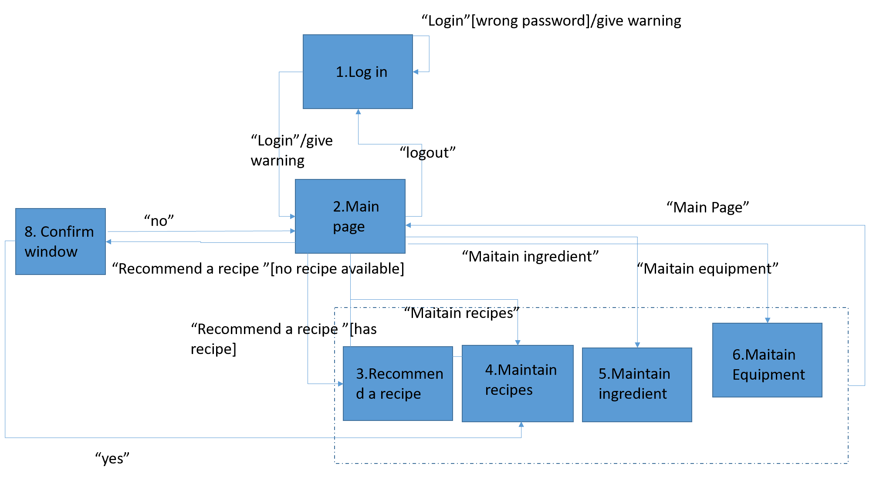
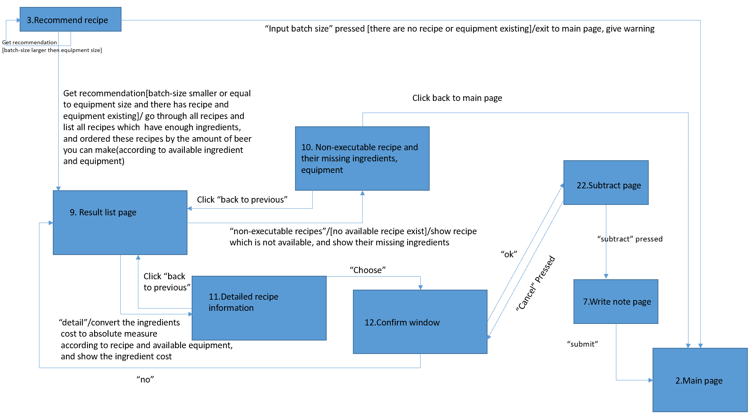
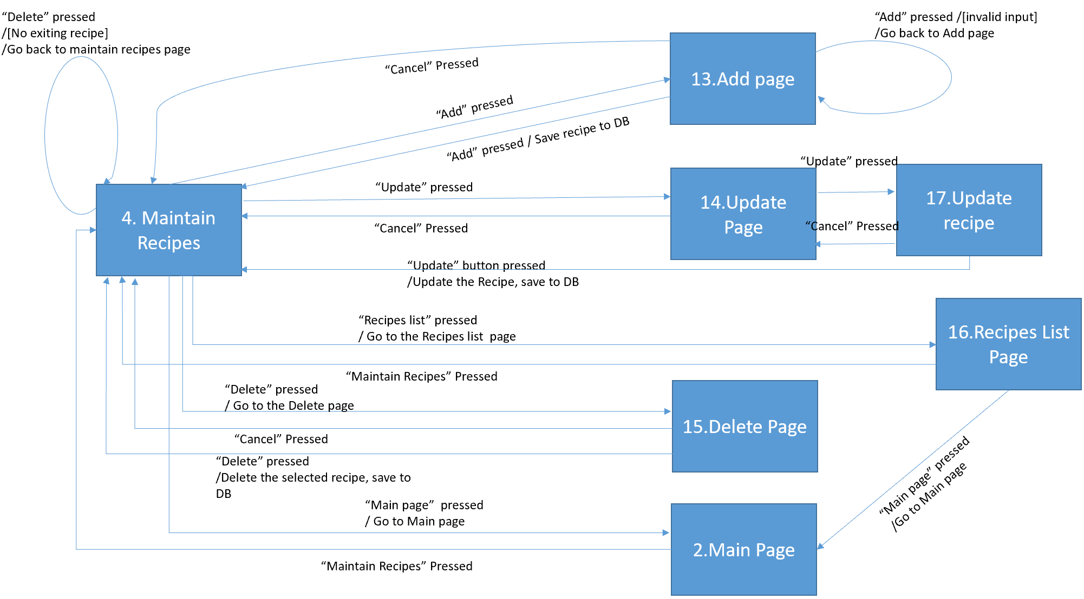
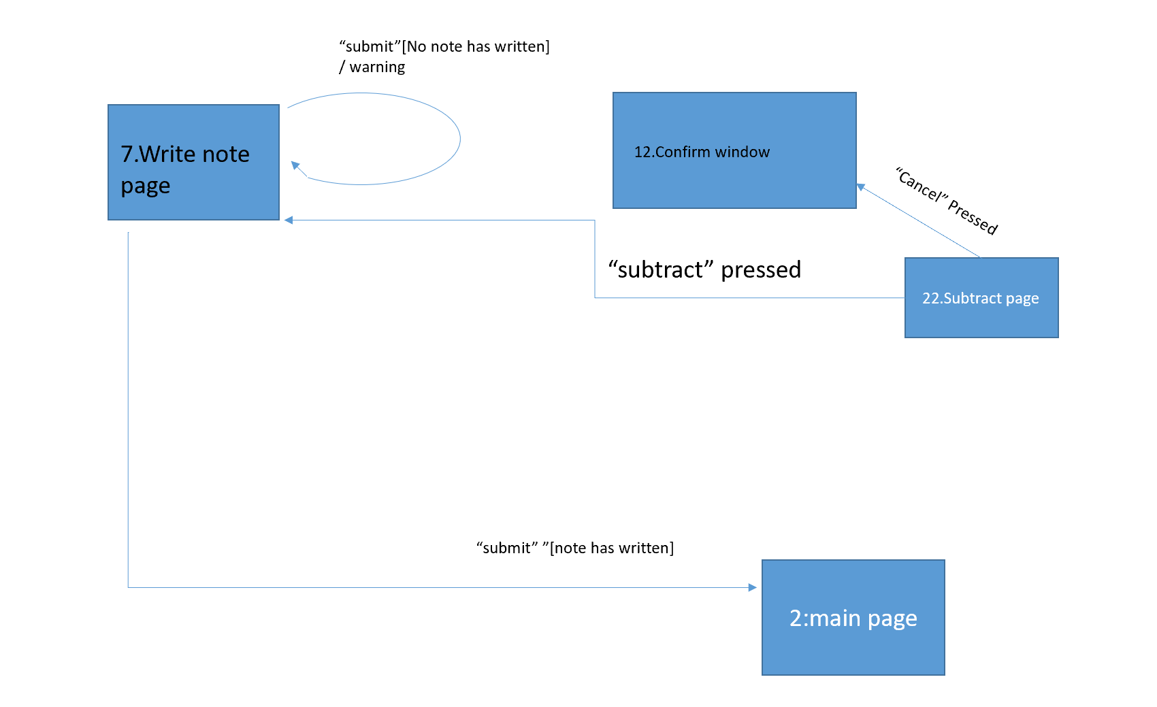
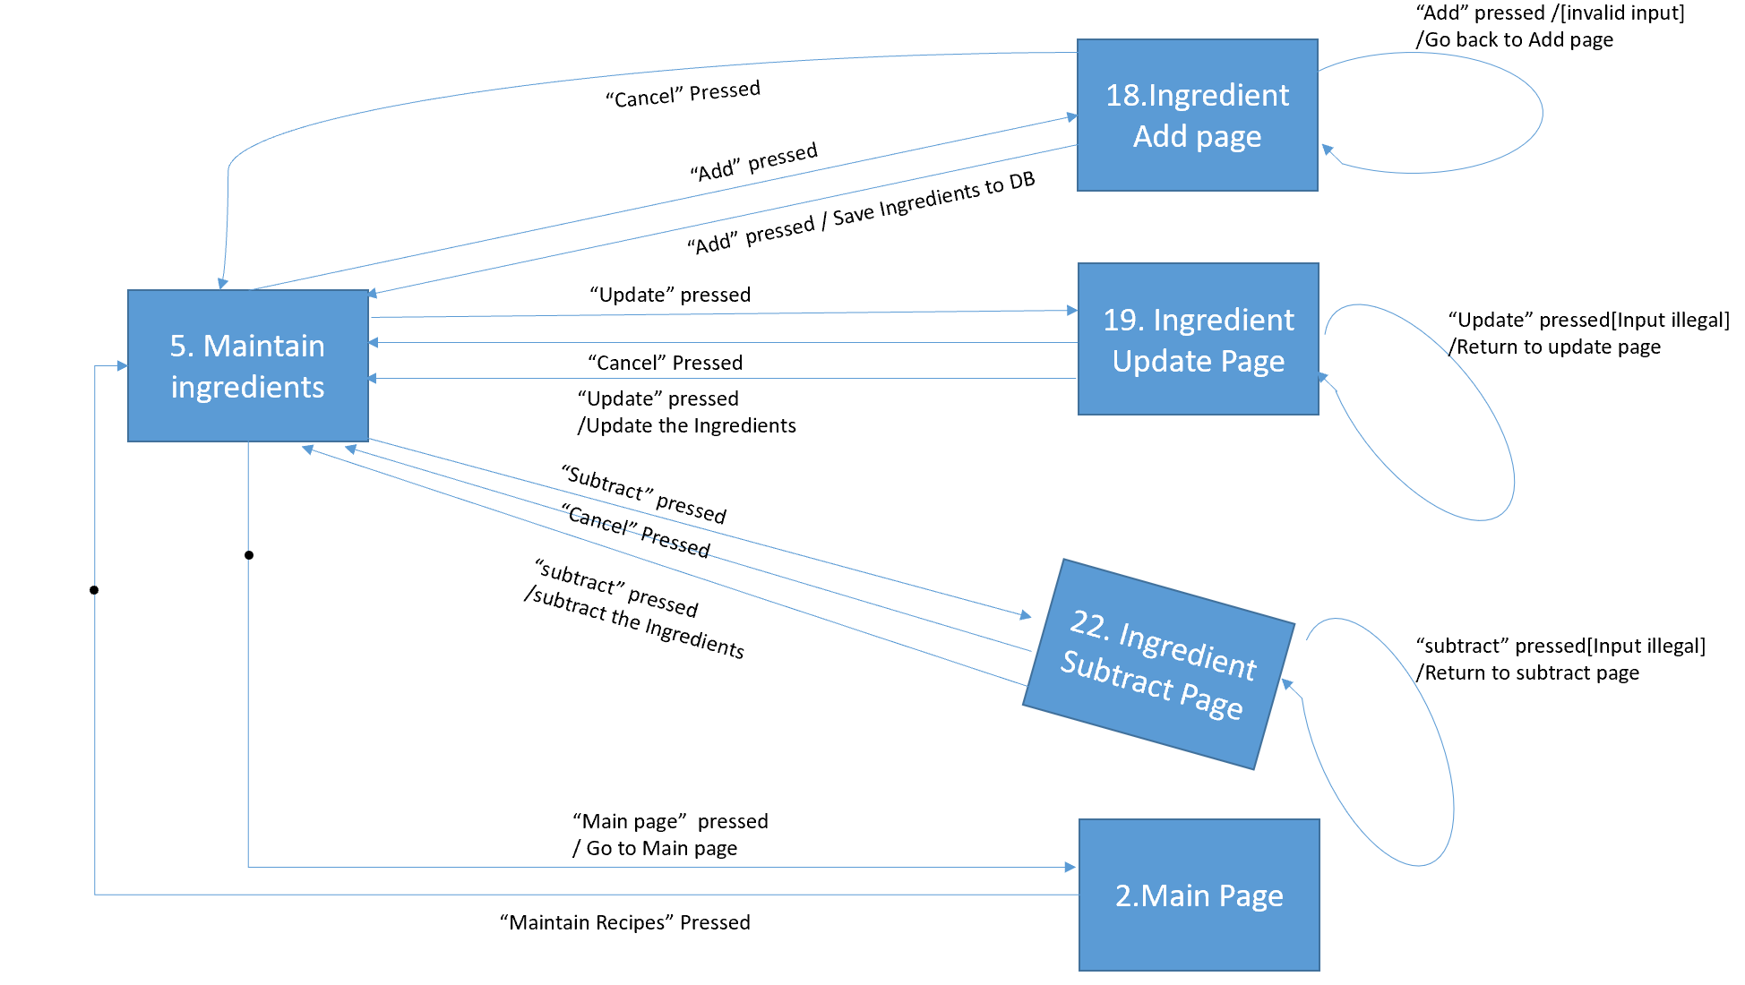
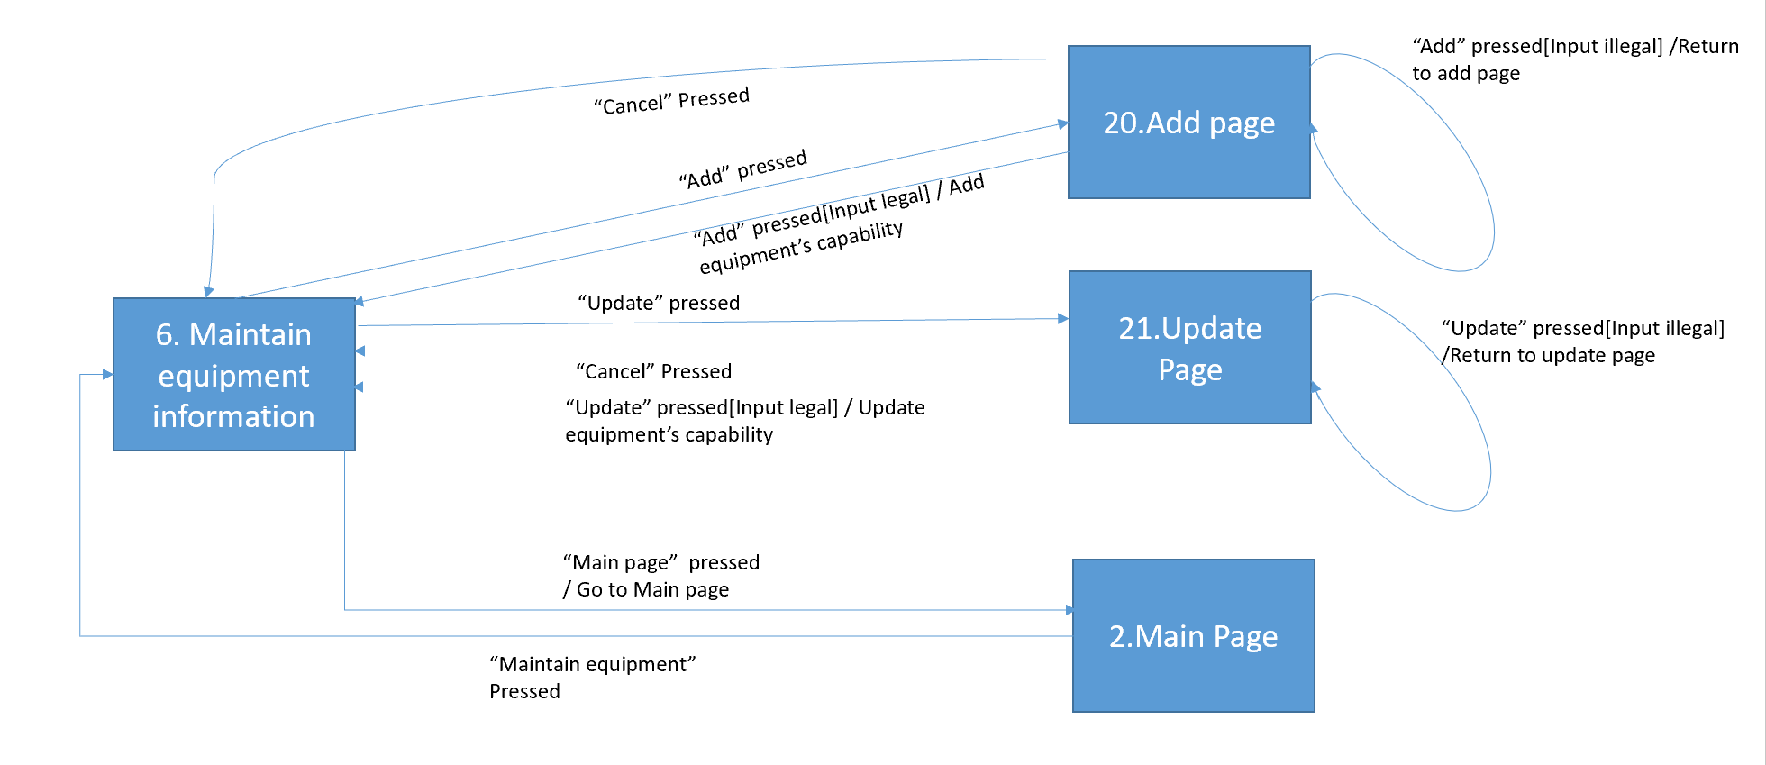

3.2.3 Functional Requirements
For each recipe in these list page, the system will show the state indicating whether the recipe is available based on current ingredients and equipment’s batch size, and the absolute measure for each ingredient.
The recommendation of the available recipe is based on the ordering algorithm defined by us, which considers the factors including the available ingredients, brewing capacity of the equipment and the maximizing use of the ingredients and batch size.
The list page will provide a button connecting with another list page showing all unavailable recipes and the unavailable reason for them (e.g. the missing ingredients).

External Interface Requirements --Zheng Hao, Yuan Yicong, Qiu Yifu, Zou Yiming

User Interfaces- Zheng Hao, Yuan Yicong, Qiu Yifu, Zou Yiming

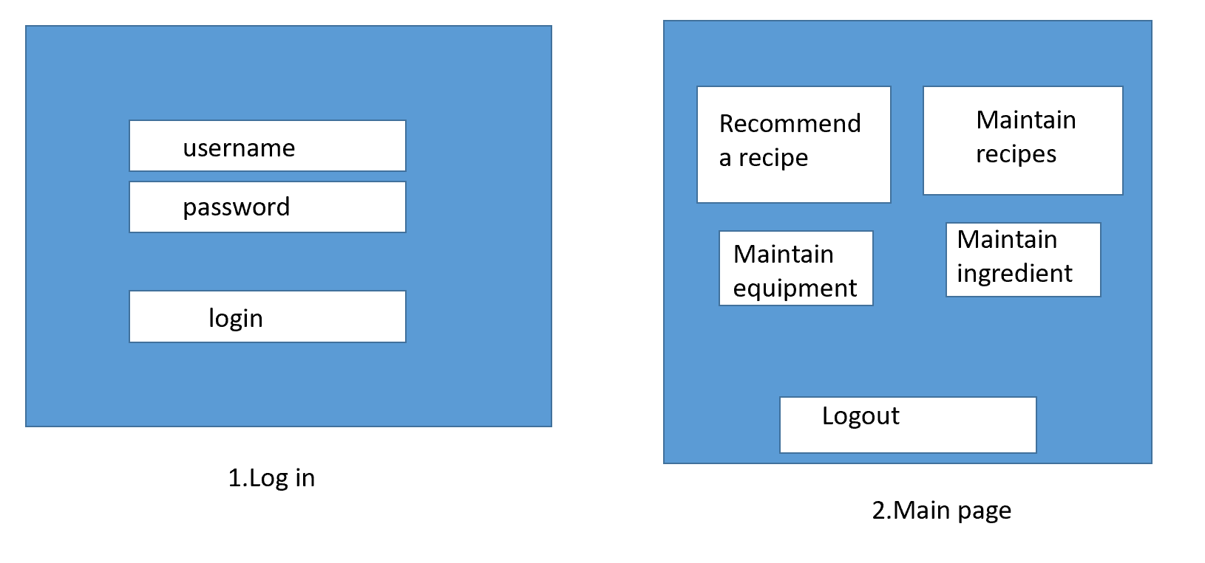

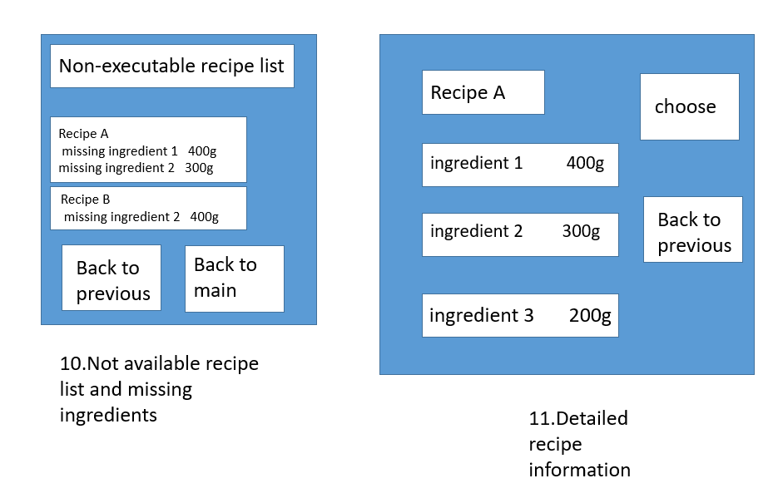

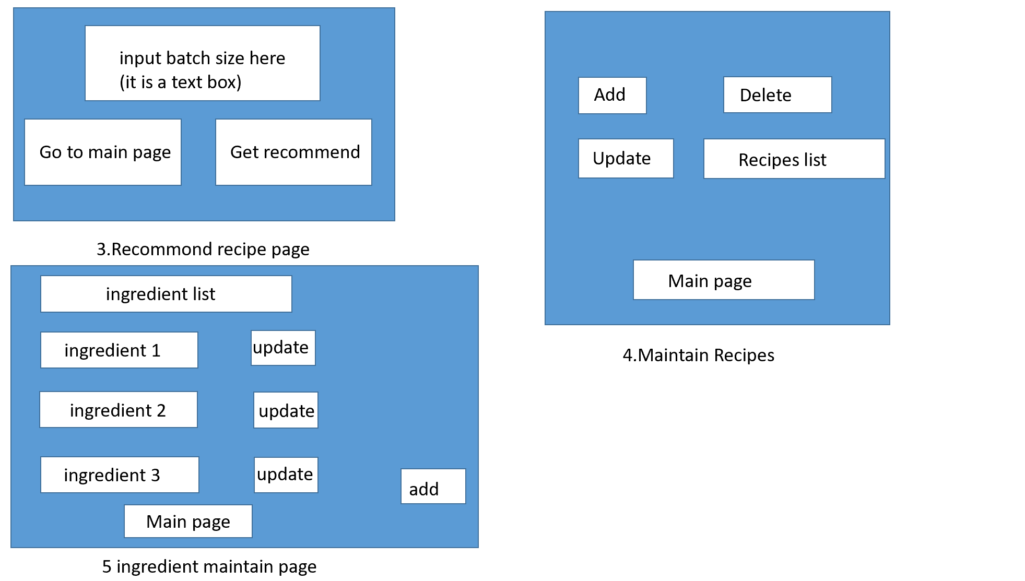
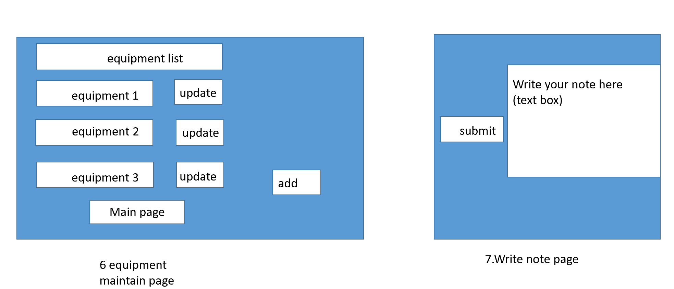

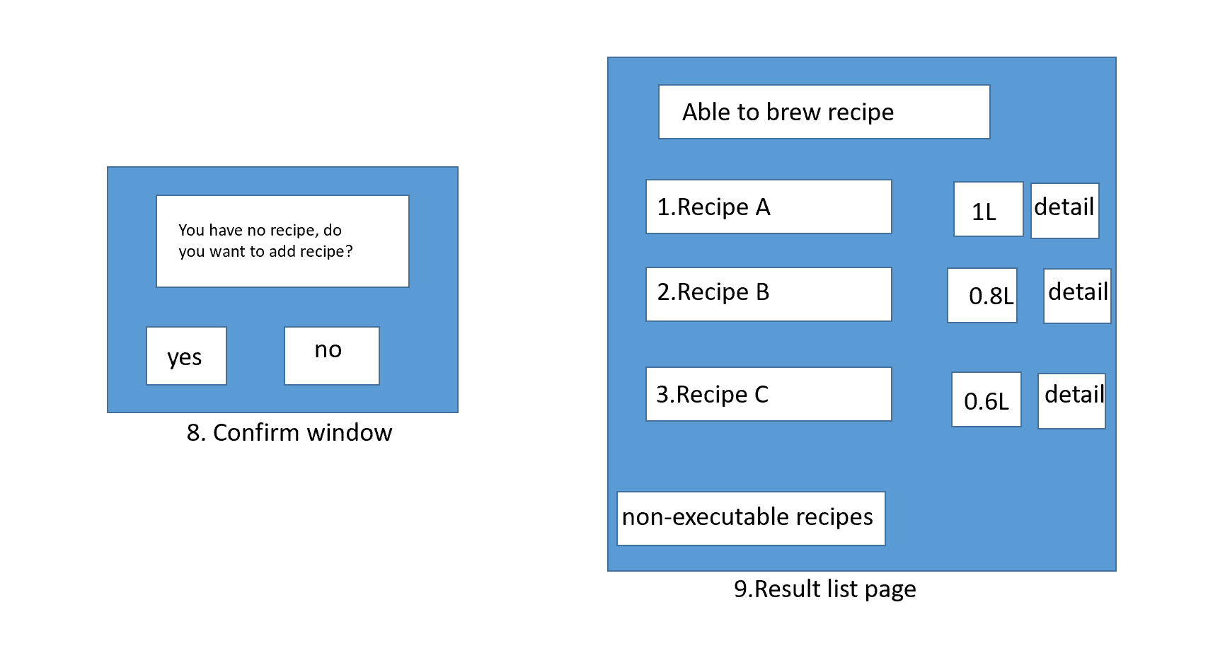

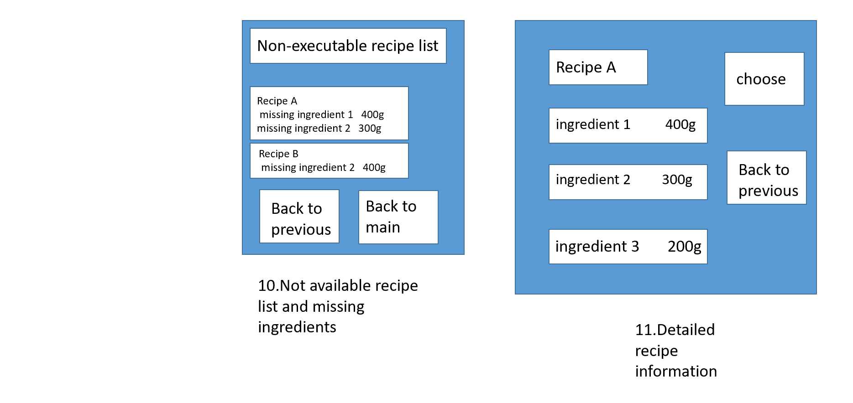

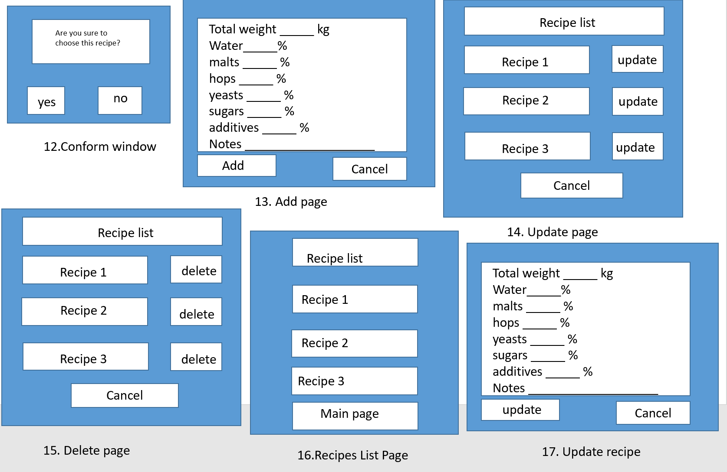
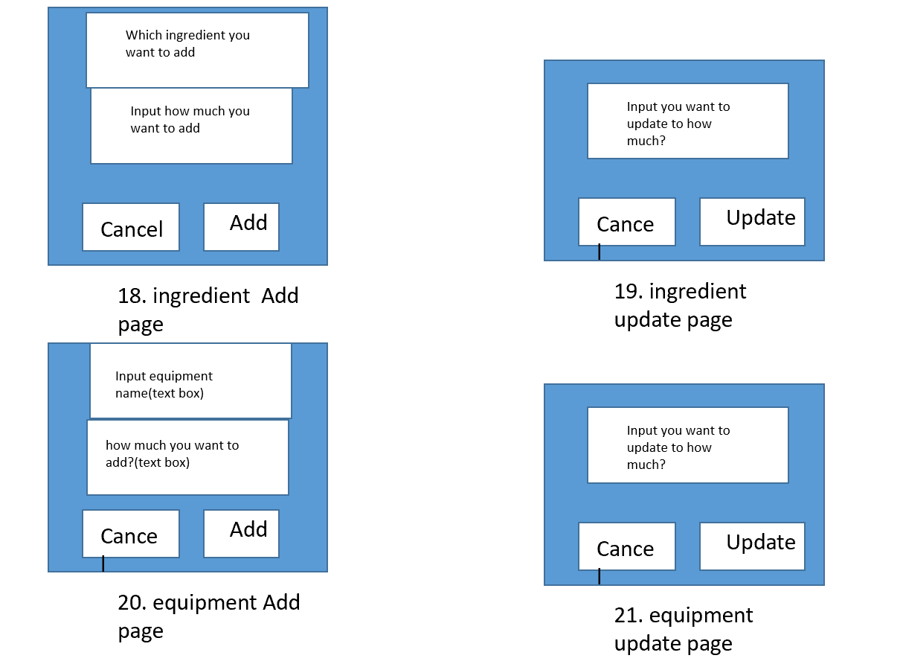
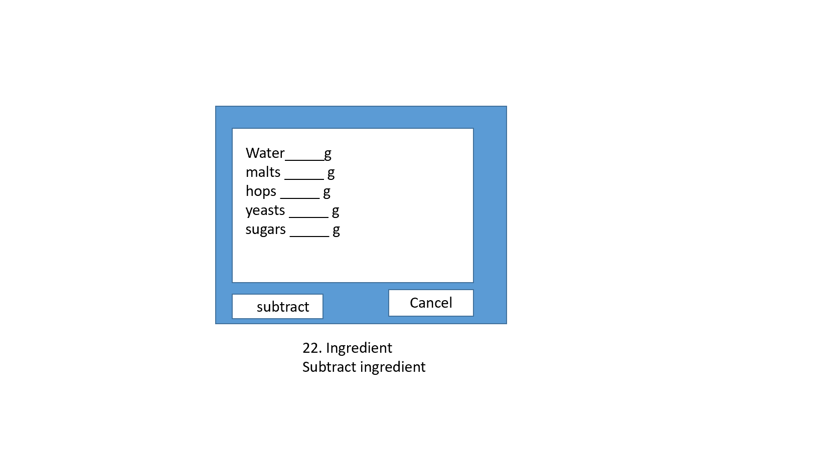

Hardware Interfaces – Qiu Yifu
None.

Software Interfaces – Qiu Yifu
As the users will login/logout, fetch the receipt from the database and we will recommend them for the brewing product, our software need to connect with MySQL system. We will use Java standard library to do the development.

Communications Interfaces – Qiu Yifu
All the message’s content should be contained standard Unicode scheme. The brewing system shall use the HTTP protocol for communication over the internet and for the intranet communication will be through TCP/IP protocol. For the encryption and transfer rates, we have no special requirement.

Other Nonfunctional Requirements –Zou Yiming

Performance Requirements –Zou Yiming
DESCRIPTION: The response time of a search is the overall time beginning with the initial user action (click on the button) on the device, the request going to server, the response received from the server, and finally the response processing by the application.
METER: Measurements obtained from 1000 searches during testing (Windows 10).
MUST: No more than 2 seconds during 100% of the searches during testing.
WISH: No more than 1 second during 100% of the searches during testing.

Safety Requirements –Zou Yiming
The list of products and information provided by our software is for reference only, if there are related security issues, it has nothing to do with this software. Clients need to pay attention to safety issues when purchasing raw ingredients (such as wine). In addition, the wine recipe is also for reference only. We are not responsible for any dissatisfaction with the wine made by the formula of the software.

Security Requirements –Zou Yiming
Before using our software, we must pass the information security certification and upload the necessary information (including name, age, mobile phone number, home address, etc.) in order to facilitate our security and positioning. At the same time the user needs to create an account with a password and some security question for changing password. In addition to entering the password, the user who forgot the password can appeal, we will verify and find the user password from the background according to the database. Alternatively, since the software mainly involves alcohol, we need to restrict the use of this software to minors in accordance according to the National Law on the Protection of Minors.

Software Quality Attributes –Zou Yiming
This software is suitable for users who are interested in winemaking. The menus offered are easy to learn and a variety of ingredients are relatively easy to find. The software is relatively maintainable since our code is streamlined and object-oriented, modular, and meaningful.

Other Requirements
Database requirement: MySQL

Appendix A: Glossary
Pending

Appendix B: Analysis Models
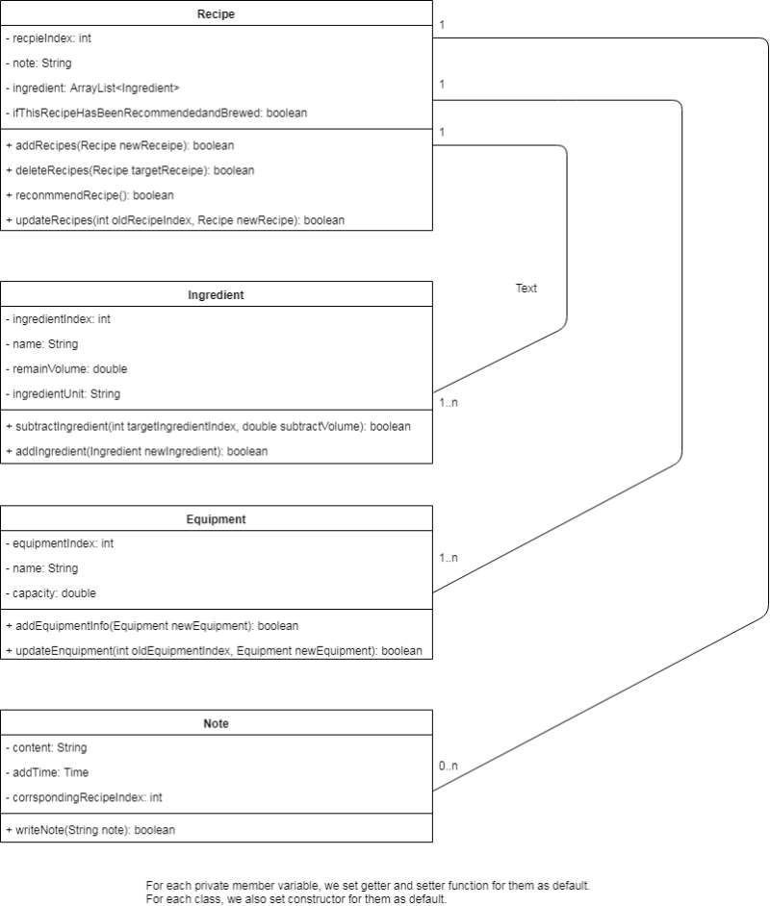

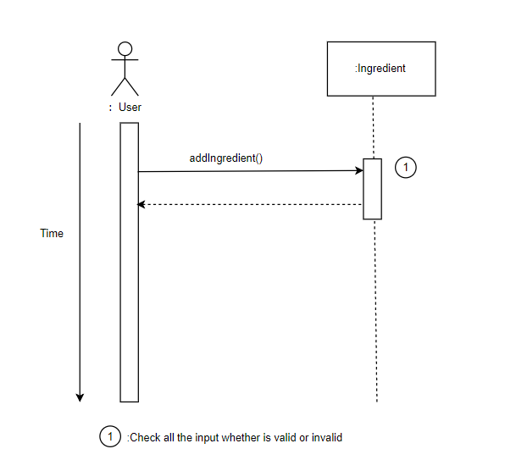

Appendix C: Issues List
Pending

