INTERNSHIP REPORT
ON
FIELD OUTREACH AND COMMUNITY ENGAGEMENT AT SANLAAP

Submitted To
School of Computer Science and Engineering
IILM University, Greater Noida, U.P.

In partial fulfilment of the requirement of degree of
B.Tech CSE



By
NAME OF STUDENT: AFROJA KHATUN
ROLL NUMBER: 25SCS1003005160
BATCH: 2026–27

1.CANDIDATE’S DECLARATION
I, AFROJA KHATUN, do hereby declare that the internship report titled “Field Outreach and Community Engagement at Sanlaap” has been completed by me to fulfil the requirement for the award of the degree of Bachelor of Technology in CSE. All the references have been quoted and I have not taken as such any material from any other source. I affirm that this report is my own work and has not been submitted to any other institute for any degree/diploma requirement. I shall be solely responsible for any kind of copyright violation in this regard.
Signature:
Student Name: AFROJA KHATUN
Roll No.: 25SCS1003005160

2. ACKNOWLEDGEMENT
I am using this opportunity to express my gratitude to everyone who supported me throughout the Internship Program. I am thankful to the organization and its team members for their guidance, constructive feedback and support during the internship. I am sincerely grateful for the opportunity to learn about field outreach, child protection, community engagement and the practical processes followed during outreach activities.
I would also like to express my gratitude to my faculty members and the School of Computer Science and Engineering, IILM University, for their academic guidance and support. I am thankful to my parents for their blessings and encouragement throughout the internship.
Signature:
Student Name: AFROJA KHATUN
Roll No.: 25SCS1003005160

TABLE OF CONTENTS
1. Candidate’s Declaration
2. Acknowledgement
3. Internship Completion Certificate
4. Project Description
4.1 Introduction
4.2 Organization Profile
4.3 Problem Statement
4.4 Project Objectives
4.5 Scope of the Project
4.6 Technologies and Tools Used
4.7 System Architecture
4.8 Methodology
4.9 Expected Outcomes
4.10 Certificates and Communication Mail Proof
5. Bibliography / References

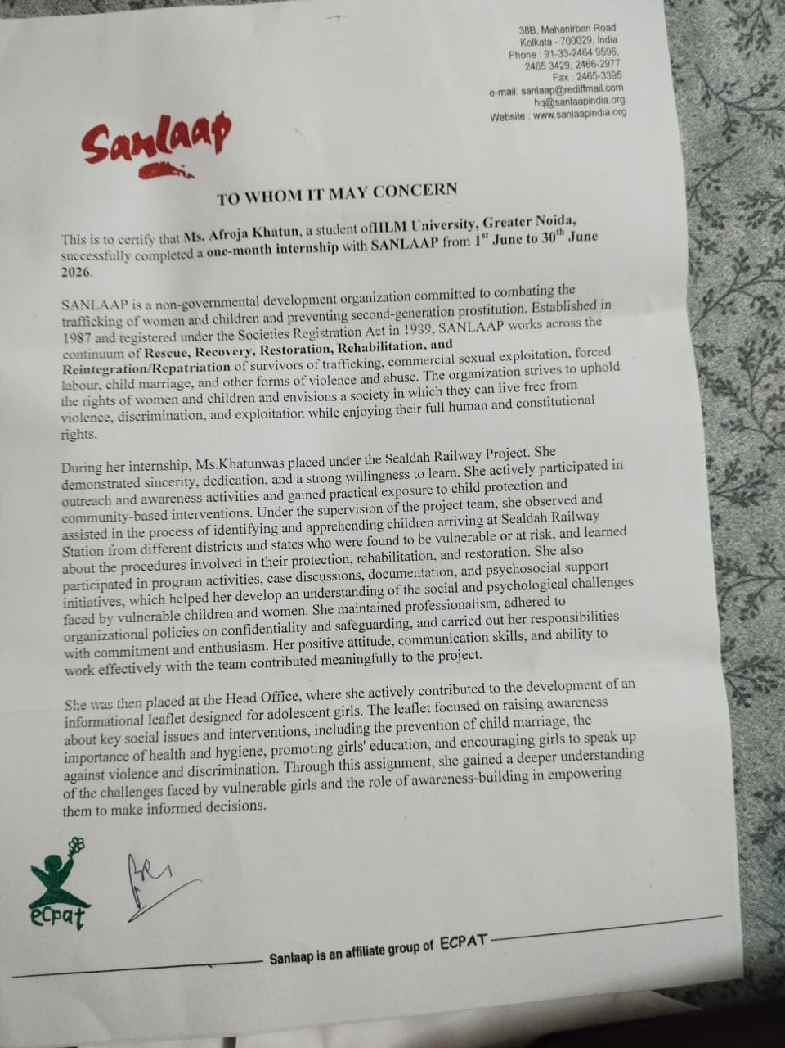
3. INTERNSHIP COMPLETION CERTIFICATE

Internship Offer Letter

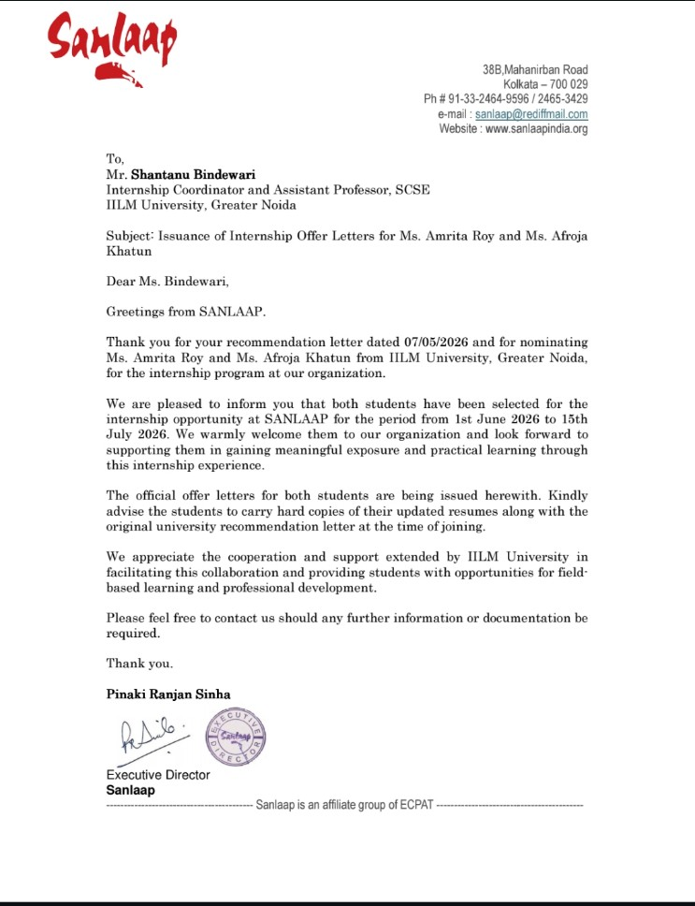

4. PROJECT DESCRIPTION
4.1 INTRODUCTION
The internship at Sanlaap provided practical exposure to community outreach and social intervention activities, particularly in the context of children and vulnerable groups. The internship involved field-based observation, outreach activities, interaction with children, understanding of child protection procedures, awareness activities and preparation of educational material.
A major part of the internship was carried out around Sealdah station. The work helped in understanding how outreach teams identify children who may be vulnerable or separated from their families and how such cases are taken forward through the Child Help Desk and related support systems. The internship also included learning about the Juvenile Justice (JJ) Act, visits to a DIC, leaflet preparation and participation in an awareness programme.
4.2 ORGANIZATION PROFILE
Sanlaap is an organization working in the area of prevention of trafficking and the rehabilitation and empowerment of women and children. During the internship, the organization provided exposure to field outreach and community-oriented activities. The internship centre was associated with Sealdah station, where outreach work focused on identifying and responding to children who might require protection and assistance.
The internship also provided an opportunity to observe how field-level work connects with support mechanisms such as the Child Help Desk, railway groups, station authorities, medical support and institutional care when required.
4.3 PROBLEM STATEMENT
Children present in and around railway stations may be vulnerable because of separation from family, unsafe circumstances, lack of supervision or other social and economic factors. A key challenge is to identify such children at an early stage, understand their immediate needs and connect them with appropriate child-protection mechanisms.
The internship therefore focused on understanding the practical process of outreach and observation, safe interaction with children, collection of relevant basic information and coordination with appropriate support systems.
4.4 PROJECT OBJECTIVES
• To understand the purpose and process of field outreach.
• To observe and identify children who may be vulnerable or separated from their families.
• To understand the role of the Child Help Desk in supporting children.
• To learn the basic outreach process followed at a railway station.
• To gain awareness of the Juvenile Justice (JJ) Act and its relevance to child protection.
• To develop communication and observation skills through interaction with children and field staff.
• To contribute to awareness-material preparation, including a women’s leaflet.
• To understand community-based social work through visits and awareness programmes.
4.5 SCOPE OF THE PROJECT
The scope of the internship was primarily experiential and field-oriented. It included observation of children at and around the railway station, participation in outreach, understanding of the Child Help Desk process, learning about child-protection procedures, preparation of awareness material, a DIC visit and participation in an awareness programme.
The internship also helped develop soft skills such as communication, teamwork, responsible observation, documentation and sensitivity while working with vulnerable groups.
4.6 TECHNOLOGIES AND TOOLS USED
The internship was primarily field-based rather than software-development based. The main tools and working methods involved documentation and communication. These included:
• Microsoft Word / word-processing tools for report and leaflet preparation.
• Digital communication tools and email for sharing reports and internship-related communication.
• Basic documentation methods for recording relevant observations and information.
• Printed/digital awareness material for community and women-focused awareness work.
4.7 SYSTEM ARCHITECTURE
Since the internship project was field-based, the system architecture can be understood as an outreach and support-flow model rather than a software architecture. The observed process can be represented as:
→ Observation at station / outreach area
→ Identification of a child who may be vulnerable or separated from family
→ Safe interaction and collection of basic identity information
→ Approaching the Child Help Desk / concerned support mechanism
→ Coordination with relevant railway groups and station authorities where required
→ Medical/support assessment where required
→ Further referral and institutional/home support through the appropriate organization process
4.8 METHODOLOGY
The methodology followed during the internship was based on observation, guided field participation, interaction, documentation and reflection. The work progressed from an introduction to the organization and observation training to practical outreach activities.
The major activities and learning stages included:
• Orientation and introduction to the internship environment.
• Observation of children and understanding of field outreach.
• Learning the outreach process and the importance of identifying vulnerable children.
• Participation in outreach activities around Sealdah station.
• Learning about the JJ Act and child-protection procedures.
• Understanding the Child Help Desk and coordination process.
• Preparation of a women-focused leaflet using basic and accessible language.
• Visit to a DIC and observation of community-oriented work.
• Participation in the International Day Against Drug Abuse and Illicit Trafficking programme at Vidyanagar College.
• Preparation of weekly internship documentation and report material.
4.9 EXPECTED OUTCOMES
The internship was expected to provide practical understanding of social outreach and child protection work. The major outcomes include improved observation and communication skills, better understanding of field outreach, awareness of child-protection mechanisms, experience in preparing awareness material and greater understanding of teamwork and responsible community engagement.
The internship also provided an opportunity to connect classroom learning with real-world situations and to understand the importance of sensitivity, confidentiality, communication and responsible conduct while working with vulnerable children and communities.
4.10 CERTIFICATES AND COMMUNICATION MAIL PROOF
The weekly reports were submitted as part of the internship documentation and helped maintain a systematic record of the work and learning throughout the internship.
Weekly Reports Attached:
Week 1 – Internship activities and initial learning
Week 2 – Field outreach and child observation
Week 3 – Outreach activities and child-protection procedures
Week 4 – Awareness-material/leaflet preparation and other activities
Week 5 – Internship activities and learning outcomes
Week 1 -
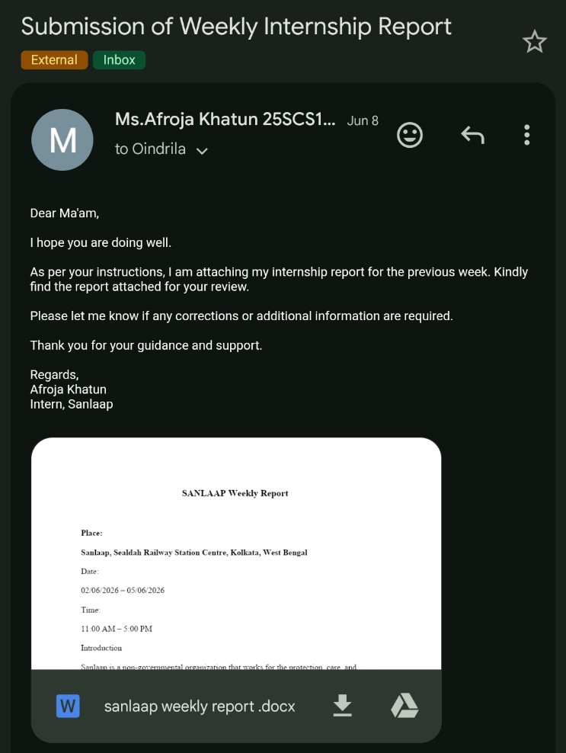
Week 2-
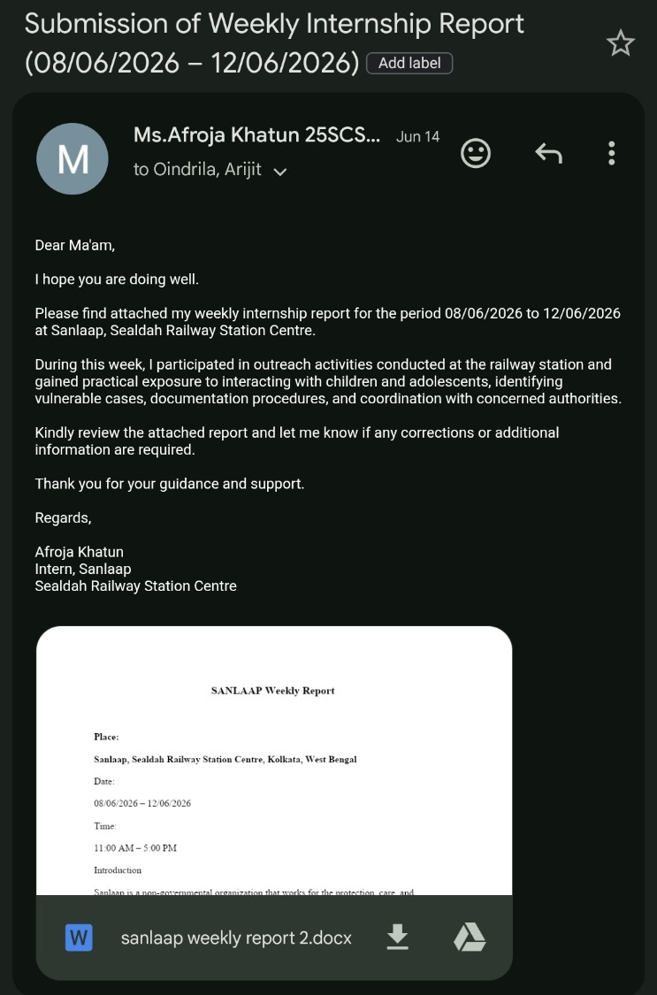

Week 3-
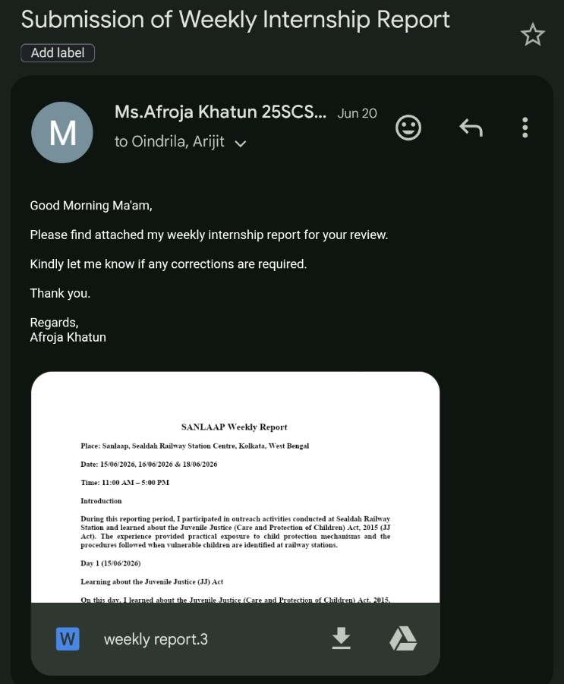
Week 4-
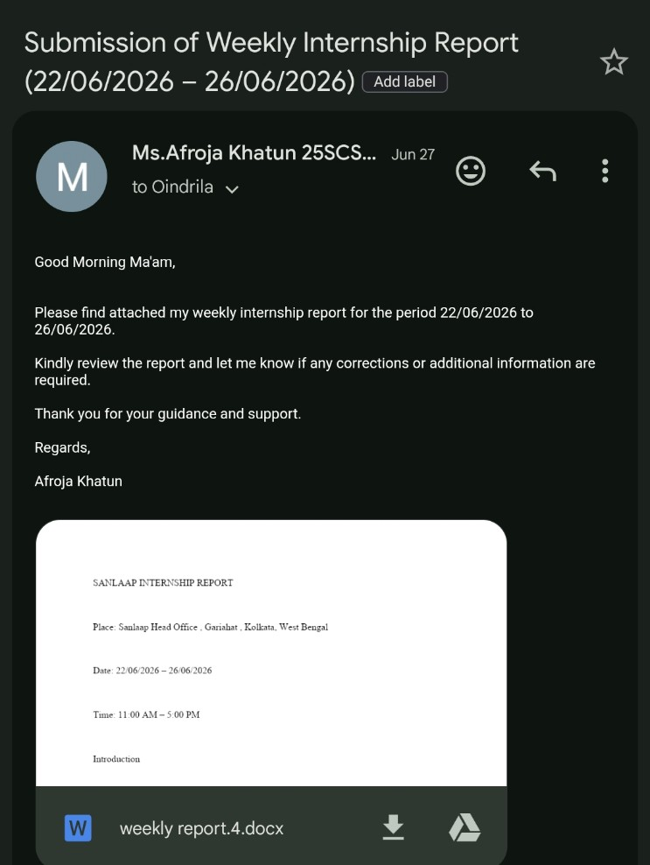
5. BIBLIOGRAPHY / REFERENCES
1. Sanlaap — organizational and internship-related information provided during the internship.
2. Juvenile Justice (JJ) Act — learning material/session covered during the internship.
3. Internship instructions, field guidance and communication shared by the internship organization and IILM University.

